### Are Industry 4.0 Technologies Enablers of Lean? Evidence from Manufacturing Industries

**Abstract**

##### Purpose

The study aims to propose a conceptual model indicating the impact of Industry 4.0 (I4.0) technologies on lean tools. Additionally, it prioritizes I4.0 technologies for the digital transformation of lean plants

##### Methodology

##### The authors conducted a questionnaire-based survey to capture the perception of 115 experts of manufacturing industries from Germany, India, Taiwan, and China. The impact of I4.0 on lean tools, using analysis of variance (ANOVA). Further, we drew a prioritization map of I4.0 on the employment of lean tools in manufacturing, using the Best-Worst Method (BWM).

**Findings**

The findings indicate that cloud manufacturing, simulation, industrial internet of things, horizontal and vertical integration impact 100% of the lean tools, while both cyber-security. Big data analytics impact 93% of the lean tools, and advanced robotics impact 74% of the lean tools. On the other hand, it is observed that augmented reality and additive manufacturing will impact 21% and 14% of the lean tools, respectively.

**Originality and Value**

Studies exploring the influence of I4.0 on lean manufacturing lack comprehensiveness, testing, and validation. Importantly, no studies in the recent past have explored mapping and prioritizing I4.0 technologies in the ‘lean’ context. This study thereby attempts to establish a conceptual model, indicating the influence of I4.0 technologies on lean tools and presents the hierarchy of all digital technologies.

**Practical Implications**

The results of this study would help practitioners draw up a strategic plan and roadmap for implementing lean 4.0. The amalgamation of lean with I4.0 technologies in [the right combination would](https://www.bcg.com/en-au/publications/2017/lean-meets-industry-4.0.aspx) enhance speed productivity and facilitate autonomous operations.

**Keywords:** Industry 4.0; Lean manufacturing; Digitalisation; Smart manufacturing; Best worst method (BWM).

**1** **Introduction**

Lean manufacturing (LM) focuses on reducing waste continually from all areas of the value stream while simultaneously maximizing productivity, efficiency, and delivery of final value to customers at the lowest cost (Nallusamy, 2016; De Oliveira et al., 2019). Having its roots from Taiichi Ohno's ingenuity at the Toyota production system, lean can be regarded as a versatile manufacturing methodology encompassing a range of tools focused on recognizing value-adding processes from the consumer point (Adam et al., 2016; Abu et al., 2019). Over the years, many companies have widely used LM as a fundamental methodology to increase productivity and reduce non-value-added waste (Hallam et al., 2018; Ghobadian et al., 2020). On the other hand, these days, when LM has become deeply rooted in the core of several organizations, lean methodologies seem unable to find any advantage since the scope for flawlessness has reduced (Shrafat and Ismail, 2019).

Today, most organizations still struggle to efficiently metamorphose into lean corporations (Abu et al., 2019; Shrafat and Ismail, 2019). Some businesses fail to contemplate the strategic fitment of lean methodologies and attempt to employ them in settings where they should not be (Schonberger et al., 2019; Kumar and Mathiyazhagan, 2020). The amalgamation of I4.0 with lean may enrich the implementation of LM to identify and reduce wastages and is redefining the nature of manufacturing (Kamble et al., 2020). For businesses globally, digital technologies of I4.0 hold the potential of building highly efficient and digitally integrated smart factories (Wagner et al., 2017; Satoglu et al., 2018). It is a prospect to take the lead in influencing one of the utmost significant shifts in LM (Tortorella et al., 2019).

I4.0, characterized by increasing digitization, connectedness, and real-time integration in global value chains, has fundamentally transformed production systems (Mayr et al., 2018; Vaidya et al., 2018). Lean 4.0 helps to automate the processes and procedures for real-time analysis and actions (Mayr et al., 2018). Rapidly emerging digital technologies stimulate the development of new manufacturing methods to identify and eradicate wastes (Wagner et al., 2017; Lai et al., 2019; Sony and Naik, 2019).

Herein, it is intended to reiterate that companies today need to assimilate novel technologies of I4.0 into their overall processes (Wagner et al., 2017; Lai et al., 2019; Sony and Naik, 2019). However, they often find themselves at a loss, as they seem to be unclear in matching the two, i.e., I4.0 technologies with lean tools (Wagner et al., 2017). Notably, both LM and I4.0 are philosophies that share a common ground of improving efficiency (Wagner et al., 2017 and Mayr et al., 2018). However, the choice of selecting specific I4.0 technologies and lean tools to best complement each other is abstract (Mayr et al. 2018; Rossini et al., 2019; Lai et al., 2019; Tortorella et al.2019; Kamble et al., 2020).

Further, both Wagner et al. (2017) and Satoglu et al. (2018) recognized that I4.0 can enable lean implementation. Yet, unlike I4.0, which relies on digital technologies to address the present-day difficulties that firms face, LM centers on people, procedures, and continuous improvement principles (Leyh et al., 2017; Buer et al., 2018). While investigating 108 European companies, Rossini et al. (2019) established the positive impact of lean on I4.0 technologies. Tortorella et al. (2019), studying 147 manufacturing companies in Brazil, harped on the role of lean in instilling the mindset and systems for implementing I4.0. They also recognized that, since lean 4.0 is a comparatively recent topic, particularly in developing countries, further research is needed in this domain. Similarly, Yin et al. (2018) suggested for future research a rigorous examination of the role of I4.0 in managing LM. Furthermore, Tortorella et al. (2019) also recognized that, since lean 4.0 is a comparatively recent topic, particularly in developing countries, there is a need for further research work in this domain.

A critical review of extant literature illustrates that most of the earlier works have presented the influence of I4.0 on lean at a generic level (Tortorella and Fettermann, 2018; Sony and Naik, 2019; Kamble et al., 2020). However, alongside the positive correlations of I4.0 with LM, numerous scholars have also highlighted the need for further research to examine the impact of digital technologies on lean (Tortorella et al. 2019; Núñez-Merin et al., 2020; Rosin et al., 2020). Furthermore, although earlier studies have viewed LM as the baseline for I4.0, integrating the same into organizational structures still seems to be a challenge (Tortorella et al. 2019; Núñez-Merin et al., 2020).

Therefore, further research is required to integrate I4.0 and LM (Núñez-Merin et al., 2020; Rosin et al., 2020). Companies that have applied lean tools need a framework for responding to the impact of I4.0 (Satoglu et al., 2018; Mayr et al., 2018). Conversely, it is still unclear which practices and techniques could be pooled together to supplement each other (Lai et al., 2019). From the literature discussed in the previous paragraph, it may be noted that most of the work done in the past on integrating lean and I4.0 has purely been conceptual, wherein the studies are addressing the integration are limited (Kumar and Mathiyazhagan, 2020; Núñez-Merino et al., 2020).

## Extant literature specifically seems to have focused on the deployment of digital technologies of I4.0, which in turn, could assist prevailing lean practices or vice versa (Núñez-Merin et al., 2020; Bittencourt et al., 2021). From our comprehensive literature review on the integration of LM with I4.0, it is assumed that there has been a broad consensus that both I4.0 and LM are harmonizing rather than conflicting (Hoellthaler et al., 2018; Sony and Naik, 2019; Kamble et al., 2020). Prominent researchers also have emphasised the need for a more realistic and critical approach to studying the interrelationship between I4.0 and LM (Lai et al., 2019; Tortorella et al., 2019; Núñez-Merin et al., 2020; Bittencourt et al., 2021). Based on our literature review, a few research gaps have been identified and are enlisted below:

## Studies investigating the impact of I4.0 and lean lack exhaustiveness, wherein testing and validation are applied limitedly.

* Prioritization of I4.0 technologies in the context of lean manufacturing has not been evaluated.
* The availability of a suitable guideline/framework/model for assessing LM under I4.0 technology changes is limited.
* No recent study seems to have carried out an empirical analysis of the impact of I4.0 on LM.

These gaps essentially impair firms understanding of the influence of I4.0 on lean tools. Therefore, this study aims to answer the following questions:

* What is the impact of I4.0 on LM?
* How will LM evolve into lean 4.0?
* Which technologies of I4.0 should be focused on the digital transformation of lean plants?

This investigation is motivated to answer the aforementioned research questions and thereby attempts to advance the knowledge and theory of technology management in manufacturing to develop a conceptual model, proposing the influence of I4.0 on current LM tools. The main contribution of this study precisely is to carry out an expert-based investigation of the impact of I4.0 technologies on lean tools, along with the prioritization of I4.0 technologies for the digital transformation of lean plants. Specifically, it is aimed to do this by carrying out a study for the following research objectives:

* To investigate the impact of I4.0 on lean tools.
* To propose a conceptual model indicating the impact of I4.0 on lean tool; and
* To prioritize the I4.0 technologies for the digital transformation of lean plants.

This study starts with a critical review of scholarly articles from the theories of I4.0 and LM. The objective was to develop a basic understanding of these theories while identifying the research gaps. The next step offers an overview of the research methodology and an expert-based survey with industry leaders and subject matter experts working towards a lean transformation of their respective organizations. Thereafter, the perception of experts on the impact of I4.0 technologies on lean tools is evaluated, using the mean score of experts feedback and analysis of findings by ANOVA. Subsequently, the hierarchy of each I4.0 tool, using the best-worst method and discussion, is summarised. The last section offers the conclusion, research implications, limitations of work, and future research directions.

# 2 Literature review

This section offers a review of extant literature of lean manufacturing, I4.0, integration of I4.0 with lean, and identification of the research gap.

**2.1 Lean manufacturing**

LM is all about process optimization to cut down the wastages by better management of workplaces and just in time (JIT) production by value-stream mapping and pull production (Nallusamy, 2016). Womack et al. (1990) promoted lean theory in a book entitled “The machine that changed the world.” The authors explained that LM is a vibrant methodology of change, motivated by methods, targeted at continuous improvement. LM has the objective of persistently inhibiting wastages in the complete value chain while optimizing the process flow (Yadav et al., 2020). LM also emphasizes satisfying consumer needs while ensuring a competitive advantage (Hallam et al., 2018). The primary objective herein is to optimize products and services, together with all aspects of the value chain, which empowers matching demand and supply through all processes (De Oliveira et al., 2019; Yadav et al., 2020).

* 1. **Lean tools**

LM is a management approach focused on reducing wastages in organizations, improving efficiency, and offer added value to customers at an optimal cost (Shah and Patel, 2018; Singh et al., 2018; Leksic et al., 2020). The implementation of LM includes a set of tools like Jidoka, JIT, Hoshin-Kanri, 5S, Single minute exchange dies (SMED), Visual factory, Line balancing, Poke-yoke, Continuous flow, PDCA, Work standardization, Kaizen, TPM, Kanban, Muda, mura, muri (3M), and Value stream mapping (Nordin et al., 2010; Shah and Patel, 2018). Prominent scholars have established that these tools are used for implementing lean in almost all the manufacturing industries across the globe, irrespective of scale, location, and sector (Hoellthaler et al., 2018; Shah and Patel, 2018; Singh et al., 2018; Leksic et al., 2020). Figure 1 offers a summary of the lean tools used in this work to establish a relation between I4.0 technologies and individual lean tools.

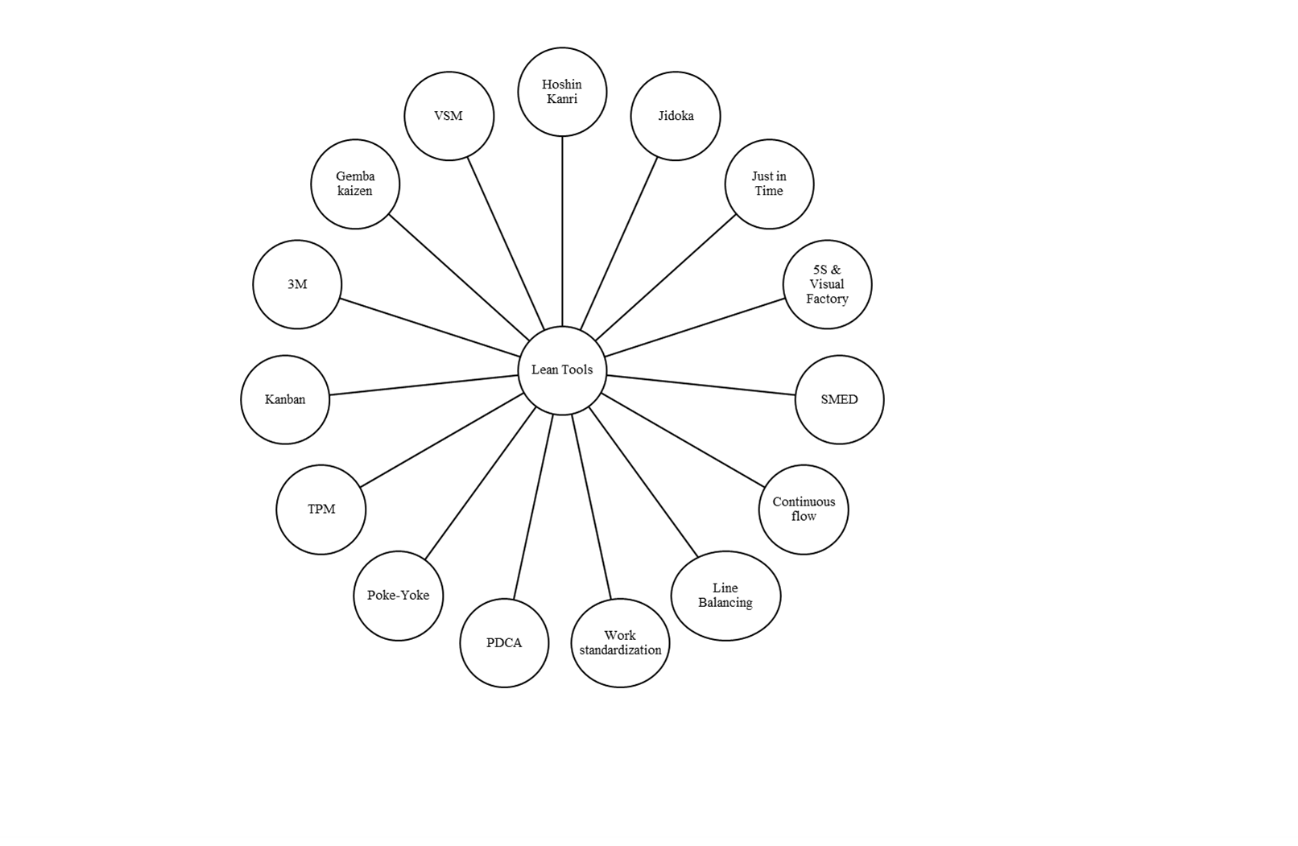

**Figure 1**: Overview of lean tools

## Overview of I4.0

I4.0 is well and truly here to change the way organizations function (Wagner et al., 2017; Ghobakhloo, 2018; Villalba et al., 2019). I4.0 technologies facilitate lean plants to transform into smart, interoperable, autonomous, and flexible factories, using instantaneous generation and data communication (Hoellthaler et al., 2018; Tortorella and Fettermann, 2018; Sony and Naik, 2019), which effectively helps in real-time data analysis and decentralized decisions (Sony and Naik, 2019; Lai et al., 2019). I4.0 technologies are projected to move towards a prospect of smart factories with smart machinery and systems. Interconnected and networked procedures are brought together to inspire a greater level of efficiency, suppleness, waste reduction, and cost-effectiveness (Lai et al., 2019; Sony and Naik, 2019). I4.0 primarily works for automation and data exchange while focusing on the digitalization of the manufacturing process (Ghobakhloo, 2018; Sony and Naik, 2019). Moreover, it looks to integrate digital environments with value-chain partners, cascading right up to the customer (Vaidya et al., 2018). Today, I4.0 has become synonymous with concepts like 'smart manufacturing' and 'IIoT'. The former is a broad category that employs digital information technologies to achieve higher flexibility, productivity, quality levels, and mass customization (Kang et al., 2016).

This encompasses autonomous information exchange between all value chain partners, thereby triggering information between all the elements within a value chain while initiating whereabouts and self-regulating themselves (Almada-Lobo, 2015; Vaidya et al., 2018). The future of the industrialized sector, as projected by I4.0, comprises ubiquitous integration (Buer et al., 2018; Mayr et al., 2018; Vaidya et al., 2018).

I4.0 technologies have fashioned new realities for the industrial sector (Adam et al., 2016; Rüttimann and Stöckli, 2016). Its key objectives include decentralization, virtualization, technical assistance, interoperability, modularity, and real-time capability (Hermann et al., 2016). Innovation by integrating digital and physical technologies can boost manufacturing systems connect organizations more closely to their customers and the supply chains at large (Almada-Lobo, 2015; Leyh et al., 2017; Buer et al., 2018). It also helps to facilitate real-time feedback loops for the product, process, and system improvements and shortens time-to-market (Almada-Lobo, 2015; Leyh et al., 2017). I4.0 can transform the core of a business, facilitating modern business models that offer sustainable economic growth (Kiel et al., 2017). Based on the studies mentioned above, one can relate I4.0 with nine major technologies. They include augmented reality (AR), industrial internet of things (IIoT), advanced robotics, 3D printing, cloud computing, horizontal and vertical integration (HAVI), simulation, cyber security, and big data analytics (Almada-Lobo, 2015; Adam et al., 2016). These nine technologies are used in this work for analysis.

## Integrating Lean with I4.0

Scholars in the past have believed that I4.0 effectively is a subset of lean; in fact, a highly digitally-enabled lean (Adam et al., 2016). Holistically speaking, I4.0 may be perceived as a slice of the lean approach (Rüttimann and Stöckli, 2016; Hoellthaler et al., 2018).

The study of Frank (2014) indicated that both lean and I4.0 share similar goals of amplified productivity and flexibility.

Later, Adam et al. (2016) discussed how I4.0, together with lean, could increase efficiency, decrease unwanted wastages, and reduce costs and examine whether I4.0 could function as a catalyst for LM.

In line with the study of Adam et al. (2016), Rüttimann and Stöckli (2016) predicted the need to incorporate I4.0 technologies into the prevailing lean frameworks and their role in improving the lean application. Bloechl and Schneider (2016) argued that manufacturing procedures planned as per lean concepts could be further improved to manage greater complexity applying I4.0 technologies.

Building upon the study of Bloechl and Schneider (2016), Dombrowski et al. (2017) categorized the interrelation between LM and I4.0 under two perspectives, i.e., "LM as an enabler of smart manufacturing" and "I4.0 as evolving LM". Further, Bloechl and Schneider (2016), Dombrowski et al. (2017) also presented a ‘center of excellence' model for lean 4.0 that encompassed lean product development, production systems, coupled with sales and services systems. However, the validation of the concept is not carried out. Later on, Leyh et al. (2017) studied the existing literature of 31 papers to analyze the I4.0 models from the perspective of lean and highlighted that lean methodology is not entirely integrated with the current models of I4.0. However, the proposed model also lacked testing and validation.

Wagner et al. (2017) proposed a model of the influence of I4.0 technologies on an LM system. However, they did not consider the effect of digital technologies, specifically advanced robotics, additive manufacturing, and IIoT. Moreover, their proposed model also lacked rigor in testing and validation. Hoellthaler et al. (2018) indicated that digitalization effectively enables lean production. They presented a framework for digitalization within the LM system. However, their proposed model too lacked rigor and comprehensiveness.

Satoglu et al. (2018) offered a conceptual framework for integrating lean and I4.0 technologies. However, their proposed framework has not been tested and validated. The study of Tortorella and Fettermann (2018) recognized that I4.0 has a formative influence on implementing lean. However, this research was focused only on Brazilian industries. It highlighted the need to conduct future research to establish a more general perspective of this relationship. While investigating the impact of digital technologies on LM, Buer et al. (2018) stated that I4.0 technologies could enhance both the effectiveness and implementation of lean and vice versa.

Powell et al. (2018) presented an explorative study highlighting the possible impacts of I4.0 on lean in a case-based methodology. However, one must acknowledge that it is challenging to create a precise theoretical generalization for the topics under exploration. Ma et al. (2017) established a smart Jidoka system focusing on one of the methodologies of lean automation, while the study of Villalba et al. (2019) identified the neurological characteristics of problem resolving patterns in I4.0 scenarios. In line with the same, the research of Ma et al. (2017) established a smart Jidoka system focusing on one of the methodologies of lean automation.

Further, the study of Varela et al. (2019) established a link between lean and sustainability. However, the impact of I4.0 on lean or vice versa has remained unaddressed. Sony and Naik (2019) proposed a theoretical model of integrating I4.0 with lean, focusing on integrating a complete value chain. Interestingly, this model did not include all aspects of I4.0 and lean and was based only on a literature review. Matteo et al. (2019) did establish the interrelation between I4.0 and lean, albeit in European industries. They highlighted that I4.0 technologies influence lean and vice versa. However, the influence of individual I4.0 technologies on lean methodologies has not been evaluated and highlighted as a future research area.

Powell et al. (2018) presented an explorative study highlighting the possible impacts of I4.0 on lean in a case-based methodology. However, one must acknowledge that it is challenging to create a precise theoretical generalization for the topics under exploration. Ma et al. (2017) established a smart Jidoka system focusing on one of the methodologies of lean automation, while the study of Villalba et al. (2019) identified the neurological characteristics of problem resolving patterns in I4.0 scenarios. Further, the study of Varela et al. (2019) established a link between lean and sustainability. However, the impact of I4.0 on lean or vice versa has remained unaddressed. Sony and Naik (2019) proposed a theoretical model of integrating I4.0 with lean, focusing on integrating a complete value chain. Interestingly, this model did not include all aspects of I4.0 and lean and was based only on a literature review. Matteo et al. (2019) did establish the interrelation between I4.0 and lean, albeit in European industries. They highlighted that I4.0 technologies influence lean and vice versa. However, the influence of individual I4.0 technologies on lean methodologies has not been evaluated and highlighted as a future research area.

Building upon the extensive range of digital technologies that were the outcome of the third industrial revolution, I4.0 may primarily be driven by a combination of innovations within the physical, digital and biological space (Leyh et al., 2017; Powell et al., 2018; Rosin et al., 2020). By assimilating I4.0 technologies, companies that apply lean methodologies may experience the combined benefits of real-time information and waste elimination (Adam et al., 2016; Kamble et al., 2020; Bittencourt et al., 2021). The emergence of digital technologies and information technology advancements has opened new avenues for new dimensions of lean practices (Ghobakhloo, 2018; Satoglu et al., 2018; Sony and Naik, 2019). Assimilating lean with I4.0 technologies may be termed as 'digitized lean', or 'lean 4.0' (Matteo et al., 2019). This assimilation could provide companies with the necessary tools to explore newer horizons (Lai et al., 2019; Kamble et al., 2020; Bittencourt et al., 2021).

A few scholars stated that lean tools act as a baseline for I4.0 implementation, and facilitate its implementation (Rüttimann and Stöckli, 2016; Buer et al., 2018; Kamble et al., 2020; Bittencourt et al., 2021). They improve flexibility in reducing costs, downtime, and delivery time while enhancing the overarching quality of typical performance benefits of integrating lean with I4.0 (Adam et al., 2016; Buer et al., 2018). Real-time communication offers deep insights into problems for the entire value chain. Additionally, it continually reduces waste (Sony and Naik, 2019).

Many authors have stated that I4.0 and lean have a direct relationship, whereby I4.0 primarily supports the implementation of lean at a conceptual level (Adam et al., 2016; Hoellthaler et al., 2018; Sony and Naik, 2019; Kamble et al., 2020). Other authors have also recognized that I4.0 technologies support lean implementation at the conceptual level (Adam et al., 2016; Hoellthaler et al., 2018; Ghobakhloo, 2018; Satoglu et al., 2018; Varela et al., 2019; Sony and Naik, 2019; Kamble et al., 2020). A few prominent scholars have highlighted the need for an investigation to evaluate the impact of I4.0 on LM (Buer et al., 2018; Hoellthaler et al., 2018; Ghobakhloo, 2018; Bittencourt et al., 2021). The following section presents the research methodology used in this work.

# Research Methodology

# This section explains the research methodology; the authors used an expert survey, data analysis by ANOVA, and the BWM method. Specifically, in the first phase, a critical review of extant literature of I4.0 and lean was carried out. This was followed by selecting the experts and conducting surveys, post which the data is analysed. Figure 2 offers an overview of the research methodology.

**Figure 2.** Overview of the research methodology

The authors conducted a comprehensive literature review to explore contemporary literature on I4.0 and its integration with lean from the following databases, including Scopus, Web of Science, Taylor & Francis, and Science Direct. The keywords used included 'Industry 4.0', 'Digital Lean,' 'Smart factory,' 'Lean tools,' 'Fourth Industrial revolution,' 'Lean 4.0', 'Integrating lean with I4.0', 'Lean thinking", 'Digital factory' and Lean,' 'TPM 4.0', 'Digital smart factory,' 'Smart lean,' 'Intelligent lean factory,' 'future of the manufacturing,' and 'Lean automation.' The sources just concentrated on single technology of I4.0, and a possible lack of contemplation for diverse aspects was left out. Initially, it is identified that a total of 897 papers from the databases; the breakup of papers from each database was as follows: (Scopus 215, Taylor and Francis 260, Scopus 212, and Science direct 210). From them, 74 papers were shortlisted as per the above-mentioned inclusion criteria. The samples for assessing the influence of I4.0 on individual lean tools by basic descriptive statistics and ANOVA included the responses collected from 115 experts and lean practitioners from manufacturing industries. These industries have corporate offices in Germany, India, Taiwan, and China and have manufacturing plants in India. The sample for prioritization of I4.0 technologies by the BWM method comprised industry leaders and policymakers responsible for the digital transformation of LM in respective organizations.

Data was collected from Oct 2019 to Feb 2020 from experts in Germany (15), India (35), Japan (20), Taiwan (20), and China (25). These experts' profiles include operation heads, digitalization heads, and managers from I4.0 implementing organizations. The sample size (115) is statically valid given the purposive sampling technique (Etikan et al., 2016; Mishra et al., 2021). Prominent scholars have highlighted that a sample size >100 is statistically valid in evaluating new concepts, and they too have applied the same in manufacturing industries (Sreedharan et al., 2018; Mishra et al., 2021). The response rate of the survey was 32 %. The experts selected had an average experience of 17 years. Certain procedures and protocols were followed as the experts were extraordinarily proficient and senior pros. For example, at first, an e-mail is sent to the selected experts to describe the aim of the study and requested them to contribute. The authors used the following criteria to choose the experts:

1. The minimum requirement for the respondent was a bachelor's degree in technology/engineering,
2. Work experience as a manager or above in the manufacturing sector, with connection to lean and I4.0, and
3. Willingness to participate in the study throughout the research period.

An expert survey was selected bearing in mind that very few LM organizations have employed digital technologies of I4.0. The response rate of the survey was 32%. Notably, before the survey, a prior inquiry is made by checking the websites and annual reports of the applicable manufacturing enterprises and exchanged a conversation to confirm if they have implemented I4.0 and lean in their respective organizations. If yes, it is also enquired whether its management had given due importance in facilitating the implementation.

In the first phase of the work, the data was collected using a survey form in which the authors asked the experts to rate if I4.0 technologies enabled the application of selected lean tools (refer to Figure 1). This was carried out using a Likert scale, ranging from 1 to 5, whereby 1 represents that I4.0 did not influence the employment of respective lean tools, while five indicates that I4.0 technologies influenced the implementation of lean tools highly. The obtained responses are further used for analysis. Notably, the mean score of the impact of each of the I4.0 technologies on individual lean tools was evaluated.

The data analysis included the generation of basic descriptive statistics with the help of the ANOVA general linear model. The outcomes of the analysis are Figure 2 and Figure 3. The primary purpose was to see the overall rating and variations at a glance. Then, we evaluated the relations of the nine I4.0 technology drivers on multiple lean tools by ANOVA. Interestingly, the model compared the effect of numerous factors on response. For instance, a low p-value (< 0.05) and high R-squared value indicate a significant impact and adequacy of the model. The study of McGraw and Wong (1996) and Green and Salkind (2012) highlighted that researchers can use the t-test or ANOVA method for assessing the influence of independent factors (I4.0 technologies) on the dependent factors (lean tool). The most crucial difference between t-test and ANOVA in our case was that t-test can only be used to compare two groups; on the other hand, ANOVA can be used to compare two or more groups. Furthermore, the study of Green and Salkind (2012) highlighted that ANOVA aids in controlling the type 1 error compared to the t-test. ANOVA also helps in evaluating the effect of multiple factors on response. However, this method does have its limitations in prioritizing the factors being assessed, which effectively triggered the usage of BWM for prioritizing I4.0 technologies.

In the second phase of the work, BWM was used to prioritize I4.0 technologies in the digital transformation of lean plants. Rezaei (2015) and Rezaei et al. (2016) explained that BWM supports the decision-makers while opting for the significant criteria instead of carrying out many pairwise comparisons. Moreover, in comparison with other multi-criteria analysis methods like the analytical hierarchy process (AHP), complex proportional assessment (COPRAS), the technique of order preference (TOPSIS), BWM offers more reliable and consistent results (Rezabestei, 2015; Rezaei et al., 2016). Notably, BWM offers a flexible decision-making environment while using a limited number of pairwise comparisons instead of other techniques (e.g., AHP).

Further, it also determines the preference of all the criteria over the worst criterion on a scale of 1 to 9 (Guo and Zhao, 2017; Kaswan and Rathi, 2001). Prominent scholars have used this method in a wider range of applications, including sustainability and supply chain (Ahmad et al., 2017); innovation and technology (Gupta and Barua, 2016), identification of risks (Torabi et al., 2016); selection of the best suppliers (Rezaei et al., 2016). For this study, BWM determined the best I4.0 technologies for implementing LM tools in manufacturing tools. The following section offers an overview of the analysis of findings and results.

# Data Analysis and Results

This section analyses the findings to determine the influence of I4.0 on lean tools to enable us to propose a conceptual model demonstrating the impact of I4.0 on lean tools while prioritizing the technologies for the digital transformation of lean plants.

* 1. **Investigation of the impact of I4.0 technologies on lean tools**

The summary of the expert's feedback on the impact of each I4.0 technology on the implementation of lean in manufacturing industries is given in Figure 2.



**Figure.3** Radar chart of the impact of each of the I4.0 technologies on the implementation of lean

The radar chart in Figure 3 shows that four I4.0 technologies, i.e., cloud manufacturing, simulation, IIoT, HVAI, impact 100% (14/14) of lean tools. In contrast, big data analytics and cyber-security enable 93% (13/14) of the investigated lean tools, considering the high rating ≥3 in Figure 2. Advanced robotics influences 74 % (10/14), augmented reality enables 21% (3/14), and additive manufacturing 14% (2/14) of the investigated lean tools.

Table 1 summarizes one-way ANOVA to estimate the association between I4.0 technologies and lean tools. Notably, in our case, a p-value of less than 0.05 was essential to confirm the impact; and is noticed in all the cases, alluding to the fact that each I4.0 technology enables at least one of the lean tools. Thus, the impact of I4.0 technologies on lean tools in our conceptual model is summarised, assessing the influence of I4.0 on lean, as shown in Figure 4. However, the prioritization of each I4.0 technology in the above analysis is not evaluated. Herein, the BWM method is used to assess the priority of I4.0 technologies for the digital transformation of lean manufacturing.

**Table 1**: Summary of the ANOVA

|  |  |  |  |  |  |  |  |  |  |  |
| --- | --- | --- | --- | --- | --- | --- | --- | --- | --- | --- |
|  | | **DF** | **Adj SS** | **Adj MS** | **F-Value** | **P-Value** | **S** | **R-sq** | **R-sq** | **R-sq** |
| **(adj)** | **(pred)** |
| Autonomous robotics | Lean tools | 13 | 221.26 | 17.1 | 437.89 | 0.01 | 0.09 | 95.30% | 94.38% | 92.92% |
| vs. | Error | 342 | 13.64 | 0.03 | - | - |  | | | |
| lean tools | Total | 355 | 234.90 | - | - | - |
| Additive manufacturing | Lean tools | 13 | 139.48 | 9.29 | 455.06 | 0.02 | 0.24 | 95.74% | 94.23% | 94.19% |
| vs. | Error | 342 | 7.64 | 0.03 | - | - |  | | | |
| lean tools | Total | 355 | 147.12 | - | - | - |
| Cloud manufacturing | Lean tools | 13 | 4.80 | 0.06 | 2.56 | 0.01 | 0.27 | 94.30% | 94.28% | 92.62% |
| vs. | Error | 342 | 29.20 | 0.04 | - | - |  | | | |
| lean tools | Total | 355 | 34.00 | - | - | - |
| Augmented reality | Lean tools | 13 | 82.65 | 7.36 | 225.35 | 0.03 | 0.27 | 99.28% | 87.77% | 88.17% |
| vs. | Error | 342 | 9.92 | 0.04 | - | - |  | | | |
| lean tools | Total | 355 | 92.57 |  |  |  |
| Simulation | Lean tools | 13 | 27.72 | 2.98 | 55.4 | 0.02 | 0.22 | 84.72% | 83.22% | 80.54% |
| vs. | Error | 342 | 16.64 | 0.07 | - | - |  | | | |
| lean tools | Total | 355 | 44.36 | - | - | - |
| IIoT | Lean tools | 13 | 47.67 | 3.9 | 66.54 | 0.01 | 0.29 | 85.76% | 83.78% | 82.34% |
| vs. | Error | 342 | 13.72 | 0.06 | - | - |  | | | |
| lean tools | Total | 355 | 61.39 | - | - | - |
| Horizontal & vertical integration vs. | Lean tools | 13 | 54.33 | 4.23 | 123.48 | 0.01 | 0.29 | 82.45% | 80.63% | 79.62% |
| lean tools | Error | 342 | 12.92 | 0.05 | - | - |  | | | |
|  | Total | 355 | 67.25 | - | - | - |
| Big data analytics | Lean tools | 13 | 32.63 | 2.42 | 43.12 | 0.01 | 0.22 | 82.40% | 79.94% | 78.23% |
| vs. | Error | 342 | 39.28 | 0.03 | - | - |  | | | |
| lean tools | Total | 355 | 71.91 | - | - | 0.015 |
| Cybersecurity | Lean tools | 13 | 23.08 | 1.78 | 314.16 | 0 | 0.17 | 93.62% | 92.53% | 91.89% |
| vs. | Error | 342 | 5.84 | 0.03 | - | - |  | | | |
| lean tools | Total | 355 | 28.92 | - | - | - |

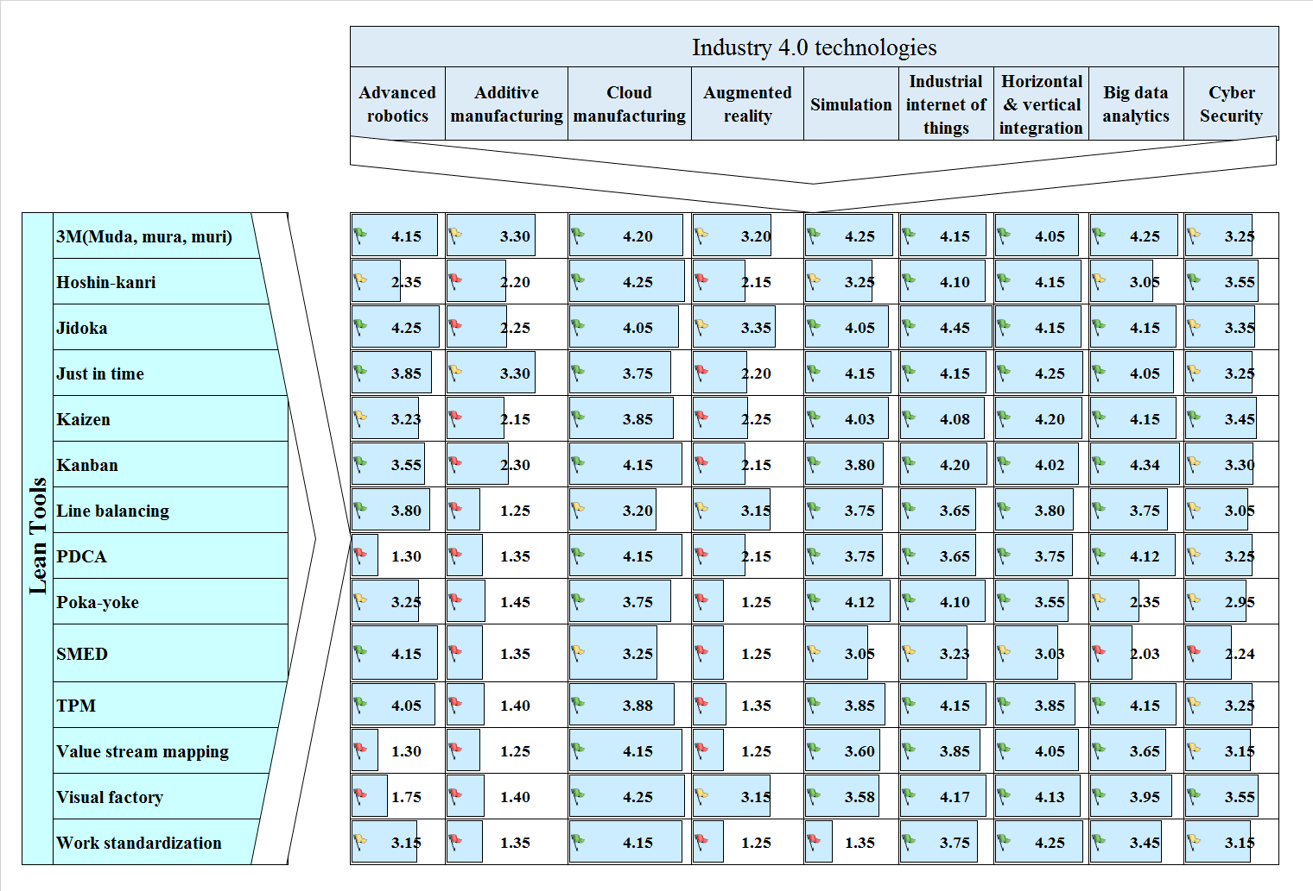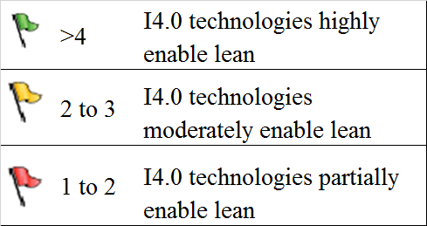

**Figure 4.** Conceptual model evaluating the influence of digital technologies on lean

Figure 4 provides a summary of the mean score of expert feedback, pointing out that 100% of the I4.0 technologies evaluated (9/9) influence 3M (Muda, mura, and muri), Kaizen, and Total productive maintenance (TPM). Furthermore, 88 % (8/9) of the I4.0 technologies influence Jidoka, Kanban, line-balancing, single-minute exchange of dies (SMED), and work standardization. Also, 77% (7/9) of I4.0 technologies influence poka-yoke, plan–do–check–act (PDCA), and visual factory.

* 1. **Prioritization of the I4.0 technologies for the digital transformation of lean Plants**

**Step 1**: *Selection of criteria*

As per the methodology of BWM, it is intended to determine the relative weightage of each I4.0 technology that impacts LM. The technologies of I4.0 are shown in Table 2 below.

**Table 2.** List of I4.0 technologies chosen

|  |  |
| --- | --- |
| **Nomenclature of technology** | **I4.0 technology** |
| C1 | IIoT |
| C2 | Advanced robotics |
| C3 | Cloud manufacturing |
| C4 | Additive manufacturing |
| C5 | Augmented reality |
| C6 | Simulation |
| C7 | HVAI |
| C8 | Big data analytics |
| C9 | Cybersecurity |

**Step 2:** *Choosing the best and worst criteria*

A questionnaire is floated among various decision-makers to collect their perception of the best and worst criteria. The collected perception is used to understand the most desirable and least preferred criteria. As per the obtained responses, the most desirable and least preferred criteria are IIoT and Additive manufacturing.

**Step 3:** *Determining the dominance of best over the rest of the criteria*

In this step, the perception of the dominance of best criteria over the rest of the selected criteria from the decision-makers is collected on the Satty scale (1-9). This results in a vector that is represented as a best-to-others vector. An example of one of the responses obtained from an expert is shown as Eq 1.

(1)

Where, is the best- to-other vector developed using the responses obtained from Expert-1

**Step 4:** *Determining the dominance of criteria over the worst criteria*

Similar to the exercise performed in Step-3, in this step, perception of the dominance of all criteria over the worst criteria is collected on the Satty scale (1-9). This results in a column vector and is referred to as a criteria-to-worst vector. An example vector developed from the responses obtained from Expert-1 is shown in Eq 2.

(2)

Where, is the best-to-other vector developed using the responses obtained from Expert-1

**Step 5:** *Finding the weightage of each criterion*

The weights that can result in the absolute minimum differences for all criteria are the weightage of each criterion. This objective can mathematically be represented as Eq 3.

(3)

Eq 3 can eventually be transformed into a set of linear programming equations as shown in Eq 4, and the solutions of the formed linear equations are the resultant weights of each criterion.

Min (4)

So that

Constraints:

In view of the current study, the formulated linear programming problem is shown as Eq 5.

Min

s.t.

The above set of linear equations are solved using the simplex method, and the obtained weightage of each criterion is shown in Figure 5.

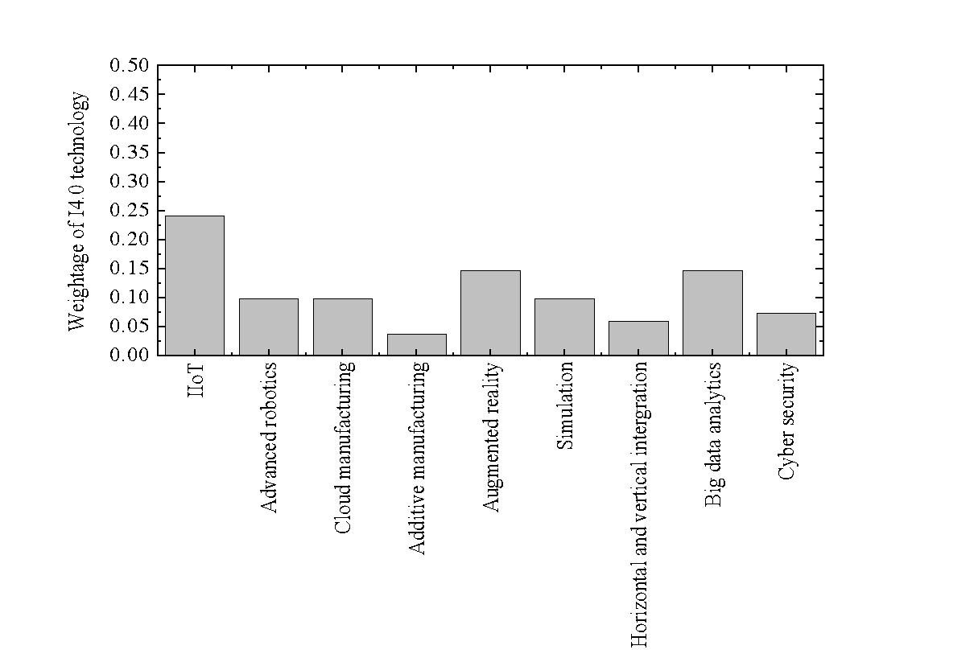

**Figure 5.** Graphical representation of prioritization of digital technologies by the BWM

Further, the consistency ratio is observed to be 0.05, which is satisfactory (since close to zero) and exemplifies that the decision-makers perception is consistent.

**4.3. Sensitivity analysis**

For validating any developed framework, sensitive analysis is essential (Gupta and Baua, 2016). Performing sensitivity analysis helps to examine the behavior of a model under various working

environments (Bai and Sarkis, 2014). IIoT technology is the most prioritized digital technology, and augmented reality, and big data analytics are the second preferred digital technologies

followed in order. This implies that any change in the weight of IIoT will influence the weights of other digital technologies. To examine the sensitivity, the weight of IIoT is multiplied by 0.9,

and change is distributed to the rest of the digital technologies proportionally, as shown in Table 3. From the analysis, the hierarchy of big data analytics, cybersecurity, and augmented reality is

sensitive to the changes in weight of IIoT.

**Table 3**. Sensitivity of digital technology weights to the change in weight of IIoT technology

|  |  |  |  |  |  |  |  |  |  |  |
| --- | --- | --- | --- | --- | --- | --- | --- | --- | --- | --- |
| Weights | Normal | Multiplicative factor | | | | | | | | |
| 0.9 | 0.8 | 0.7 | 0.6 | 0.5 | 0.4 | 0.3 | 0.2 | 0.1 |
| IIoT | 0.23 | 0.21 | 0.19 | 0.16 | 0.14 | 0.12 | 0.09 | 0.07 | 0.05 | 0.02 |
| Advanced robotics | 0.10 | 0.10 | 0.11 | 0.11 | 0.11 | 0.11 | 0.12 | 0.12 | 0.12 | 0.13 |
| Cloud manufacturing | 0.10 | 0.10 | 0.11 | 0.11 | 0.11 | 0.12 | 0.12 | 0.12 | 0.13 | 0.13 |
| Additive manufacturing | 0.03 | 0.03 | 0.04 | 0.04 | 0.04 | 0.04 | 0.04 | 0.04 | 0.04 | 0.05 |
| Augmented reality | 0.15 | 0.15 | 0.16 | 0.17 | 0.18 | 0.18 | 0.19 | 0.20 | 0.20 | 0.21 |
| Simulation | 0.10 | 0.10 | 0.11 | 0.12 | 0.12 | 0.13 | 0.14 | 0.14 | 0.15 | 0.15 |
| Horizontal and vertical integration | 0.06 | 0.06 | 0.06 | 0.07 | 0.08 | 0.08 | 0.09 | 0.09 | 0.10 | 0.10 |
| Big data analytics | 0.15 | 0.15 | 0.16 | 0.20 | 0.21 | 0.23 | 0.24 | 0.26 | 0.27 | 0.29 |
| Cyber security | 0.07 | 0.08 | 0.08 | 0.14 | 0.17 | 0.19 | 0.21 | 0.24 | 0.26 | 0.28 |

1. **Discussion of findings**

The analysis of experts' feedback yielded that both lean and I4.0 can co-exist, and digital technologies may influence the implementation of lean tools in manufacturing industries. Notably, the proposed model in Figure 3 evaluating the impact of I4.0 on LM indicates that LM and I4.0 are often well-matched; this observation concurs with the research of Satoglu et al. (2018) and Adam et al. (2016).

Analysis of the experts' feedback indicates the impact of big data analytics, cloud manufacturing, simulation, IIoT, HVAI, and cyber security on LM. Our findings also allude that these technologies have a very high enabling impact on the digital transformation LM. These findings are in line with the manufacturing case study of the European food production plant, addressed by Küpper et al. (2017), which highlighted the benefits of IIoT, big data analytics by the real-time data offered by horizontal and vertical integration across the value chain to improve the transparency and efficiency.

For example, applying I4.0 technologies with the principles of technical assistance, information transparency, interconnection, and decentralized decision-making with IIoT may advance the employment of new dimensions of lean (Mayr et al., 2018). 3M explains all sorts of waste to overwhelm under LM, and companies are looking to take a significant stride to eliminate 3M (Singh et al., 2018). The role of I4.0 technologies to eradicate 3M is endorsed by experts' feedback scores, ranging from 3.20 to 4.25 (Figure 3). Hoshin-Kanri, for instance, is an excellent strategic management process that involves everyone in the organization, right down to the shop floor (Singh et al., 2018). IIoT, cloud manufacturing, HVAI, simulation, cyber security, and big data analytics have a high impact on Hoshin-Kanri, given the scores of 3.05 to 4.25 (Figure 3). For businesses around the world, I4.0 offers an opportunity to win a competitive edge through enhanced productivity, agility, and agility.

Jidoka is another essential tool of lean; and designing processes, using the principles of Jidoka in smart factories would mean that you build in sensors that detect a problem when it first occurs, enabling thereby immediate corrective action to be taken (Ma et al., 2017; Singh et al., 2018; Ding et al., 2021). Kaizen is a methodology of continuous improvement of work processes, especially on the shop floor (Buer et al., 2018). A high rating ranging from 3.23 to 4.20 in the 7 out of 9 technologies confirms the impact of I4.0 on Kaizen (Figure 3). The expert participants of our study strongly feel that the work of Kanban is enhanced by the implementation of cloud manufacturing, IIoT, simulation, advanced robotics, big data analytics, and cyber security. Notably, the same is validated by mean score (3.30 to 4.34) in seven out of nine I4.0 technologies considering the (Figure 3).

Value Stream Mapping (VSM) visually shows all aspects of the process steps, right from start to finish, and will be enhanced by IIoT, cloud manufacturing, simulations, augmented reality, real-time integration of value chain, and big data analytics. This is also confirmed by the score in the range of 3.15 to 4.15 (Figure 3). The study of Wagner et al. (2017) also highlighted that I4.0 could improve the lean methodology of value-stream mapping by the real-time collection of data and information. A visual factory is a lean tool that creates displays to show how data and information are transmitted (Leksic et al., 2020). The experts believe that its use would be enabled by cloud manufacturing, simulation, IIoT, HVAI, augmented reality, big data analytics, and cyber security, as indicated by the mean score in the range from 3.15 to 4.25 (Figure 3).

TPM is a process of proactively maintaining production machines and equipment in optimal conditions (Adam et al., 2016); herein, the scores are 3.25 to 4.15 in terms of the impact of I4.0 on TPM score in seven out of nine technologies (Figure 3). Poke-Yoke methods are used to mistake-proof the process by ensuring that the right conditions exist to produce a hundred percent correct output (Leksic et al., 2020). Data from experts' feedback in the range from (3.05 to 4.12), as shown in Figure 3, confirm that the experts strongly believe that Poke-yoke could be digitized by applying simulation, cloud manufacturing, IIOT, big data analytics, and real-time integration.

Furthermore, the PDCA cycle serves to continuously enhance a process (Leksic et al., 2020). The scores range from 3.25 to 4.15 indicates that PDCA will be enhanced with the help of cloud manufacturing, IIoT, cloud computing, simulation, and big data analytics. Line balancing is perfectly achieved when each manufacturing step takes the same amount of time, which is essential for attaining productivity (Lam and Tuyen, 2016). The experts reiterate that a smart factory would need to use simulation, IIoT, cloud manufacturing, advanced robotics, HVAI, and big data

analytics to achieve line balancing, as indicated in the score of experts#39;s feedback in the range

from 3.05 to 3.80 (Figure 3).

SMED is used for the rapid changeover from running one type of batch to another, within a smart factory application (Buer et al., 2018). SMED is critical when the goal is mass manufacturing, with a batch size of one, with the condition that batch switchover would only be possible without incurring any additional cost. Importantly, these findings validate the research of Buer et al. (2018) in terms of the role of SMED for I4.0. Continuous flow is a one-piece flow without any in-process inventory, and it is necessary for JIT while balancing production exactly with order intake (Adam et al., 2016). When I4.0-enabled smart factories can achieve mass customization, it would simultaneously help to achieve JIT supplies in manufacturing (Adam et al., 2016; Buer et al., 2018). The experts strongly believed that achieving continuous flow does require focusing on cloud manufacturing and real-time integration of the value chain. Interestingly, the same is in line with Buer et al.'s (2018) study. Continuous and instantaneous inputs of usage data from intelligent products and end customers would enable companies to customize products quickly, leading to mass customization. Hence, most of the I4.0 technologies seem to be enabling lean tools.

## Implications, Limitations, and directions of future research

**6.1. Practical implications**

Due to the increasing complexity of operations, numerous firms have started finding that LM is not sufficient alone to address the increasingly competitive business environment. LM is a well-established methodology for value flow improvement, which has now got turbocharged by integration with I4.0. The benefits of integrating I4.0 and LM are evident to many manufacturers, but the challenge lies in integrating them in a way that yields optimal results. By [deploying the correct amalgamation of I4.0 with lean](https://www.bcg.com/en-au/publications/2017/lean-meets-industry-4.0.aspx), companies can increase swiftness and proficiency, and even enable self-managing operations. The conceptual model evaluating the influence of I4.0 on lean would help companies prioritize I4.0 implementation in LM. Notably, the prioritization of I4.0 technologies for the digital transformation, and our proposed conceptual model, would form the basis to drive the implementation of I4.0 in manufacturing organizations. Further, this model would help in prioritizing I4.0 technologies, while designing strategies and a roadmap for lean 4.0 transformations.

The analysis specifies that I4.0 technologies impact 3M, Kaizen, TPM, Jidoka, Kanban, line-balancing, SMED, work standardization, poke yoke, PDCA, and visual factory. Our analysis indicates the high impact of five technologies, i.e. IIoT, big data analytics, cloud manufacturing, HVAI, and simulations for the digital transformation of the lean plants. LM aims to eradicate unwanted wastages in the value chain and I4.0 technologies are instrumental to this pursuit. Additionally, it may be reiterated that integration of I4.0 with lean could further augment human-machine interactions, leading to new dimensions of improvement.

## Research implications

This research has contributed to advancing knowledge in the field of technology management by providing a conceptual model, whereby it has discussed the integration between the theory of lean and I4.0, through an expert-based investigation of the perceived impact of I4.0 on LM. The results gotten in this study are original and novel compared to preceding literature, as most of the past research works have primarily been at an abstract level, with no explicit or empirically tested indication of the prioritization of I4.0 technologies in implementing lean (Núñez-Merin et al., 2020; Rosin et al., 2020; Bittencourt et al., 2021). This work has attempted to fill this research gap by prioritizing I4.0 technologies using BWM.

## Limitations and directions of future research

This work primarily focused on an expert-based analysis to evaluate the impact of I4.0 technologies on lean tools, while probable technological solutions are yet to reach the matured level of implementation in manufacturing industries. The adoption of I4.0 in the industry for LM is in the early stage; hence, the relatively smaller sample of the study would possibly act as a basis for future research into I4.0 and lean with larger sample size and application-based case studies. Nevertheless, this investigative study does offer a key indication for the requirement of creating more structured models that would be established with larger samples. Future studies might want to explore infrastructural, technological, organizational, and management challenges in the journey of lean 4.0. There have to be real cases to study the impact of I4.0 within their existing LM systems and within a larger value chain. There is undoubtedly a need to create an index that offers a real-world and usable charter for organizations to decide how to start and scale, and sustain the initiatives of lean 4. 0.

## Conclusion

This research aimed to investigate the influence of each of the digital technologies of I4.0 on lean tools in a conceptual model and prioritize I4.0 technologies by an expert survey within the manufacturing industry. The summary of the experts' feedback indicates 100% of I4.0 technologies do go on to impact 3M, Kaizen, and TPM; 88% of technologies impact Jidoka, Kanban, line-balancing, SMED, and work standardization; 77% of technologies impact poka-yoke, PDCA, and visual factory. Furthermore, these statistics also indicate that these technologies enable most of the evaluated lean tools in the digital transformation of LM plants. Additionally, the experts' feedback suggests that four I4.0 technologies, i.e. cloud manufacturing, simulation, IIoT, horizontal, and vertical integration, impact 100% of lean tools, big data analytics, and cyber-security enable 93%, advanced robotics influences 74% of lean tools. However, the perceived impact of augmented reality and additive manufacturing on lean tools was noted to be relatively low, i.e. 21% and 14 %, respectively. The proposed model would possibly act as a baseline to determine the hierarchy of I4.0 technologies.

# References

Ahmad, W. N. K. W., Rezaei, J., Sadaghiani, S., & Tavasszy, L. A. (2017). Evaluation of the external forces affecting the sustainability of the oil and gas supply chain using Best Worst Method. Journal of cleaner production, 153, 242-252.

Adam, S., Elangeswaran, C., & Wulfsberg, J. P. (2016). Industry 4.0 implies lean manufacturing: Research activities in industry 4.0 function as enablers for lean manufacturing. Journal of Industrial Engineering and Management, 9(3), 811-833.

Abu, F., Gholami, H., Saman, M. Z. M., Zakuan, N., & Streimikiene, D. (2019). The implementation of lean manufacturing in the furniture industry: A review and analysis on the motives, barriers, challenges, and the applications. Journal of Cleaner Production, 234, 660-680.

Almada-Lobo, F. (2015). The Industry 4.0 revolution and the future of Manufacturing Execution Systems (MES). Journal of innovation management, 3(4), 16-21.

[Bai, C.](https://www.emerald.com/insight/search?q=Chunguang%20Bai) and [Sarkis, J.](https://www.emerald.com/insight/search?q=Joseph%20Sarkis) (2014), "Determining and applying sustainable supplier key performance indicators", [Supply Chain Management](https://www.emerald.com/insight/publication/issn/1359-8546), 19(3), 275-291

Bittencourt, V. L., Alves, A. C., & Leão, C. P. (2021). Industry 4.0 triggered by Lean Thinking: insights from a systematic literature review. International Journal of Production Research, 59(5), 1496-1510.

Buer, S. V., Strandhagen, J. O., & Chan, F. T. (2018). The link between Industry 4.0 and lean manufacturing: mapping current research and establishing a research agenda. International Journal of Production Research, 56(8), 2924-2940.

Bloechl, S. J., & Schneider, M. (2016). Simulation game for intelligent production logistics–The PuLL® learning factory. Procedia Cirp, 54, 130-135.

De Oliveira, R. I., Sousa, S. O., & De Campos, F. C. (2019). Lean manufacturing implementation: bibliometric analysis 2007–2018. The International Journal of Advanced Manufacturing Technology, 101(1), 979-988.

Ding, B., Ferràs Hernández, X., & Agell Jané, N. (2021). Combining lean and agile manufacturing competitive advantages through Industry 4.0 technologies: an integrative approach. Production Planning & Control, 1-17.

Dombrowski, U., Richter, T., & Krenkel, P. (2017). Interdependencies of Industrie 4.0 & lean production systems: A use cases analysis. Procedia Manufacturing, 11, 1061-1068.

Etikan, I., Musa, S. A., & Alkassim, R. S. (2016). Comparison of convenience sampling and purposive sampling. American journal of theoretical and applied statistics, 5(1), 1-4.

Fareri, S., Fantoni, G., Chiarello, F., Coli, E., & Binda, A. (2020). Estimating Industry 4.0 impact on job profiles and skills using text mining. Computers in industry, 118, 103222.

Frank, H. (2014). Lean Production versus Industrie 4.0: Gegner oder Verbündete. Industrie Management, 30(6), 17-20.

Ghobakhloo, M. (2018). The future of the manufacturing industry: a strategic roadmap toward Industry 4.0. Journal of Manufacturing Technology Management. 29 (6), 910-936

Ghobadian, A., Talavera, I., Bhattacharya, A., Kumar, V., Garza-Reyes, J. A., & O'regan, N. (2020). Examining legitimization of additive manufacturing in the interplay between innovation, lean manufacturing, and sustainability. International Journal of Production Economics, 219, 457-468.

Gupta, H., & Barua, M. K. (2016). Identifying enablers of technological innovation for Indian MSMEs using best–worst multi-criteria decision-making method. Technological Forecasting and Social Change, 107, 69-79.

Guo, S., & Zhao, H. (2017). Fuzzy best-worst multi-criteria decision-making method and its applications. Knowledge-Based Systems, 121, 23-31.

Green, S. B., & Salkind, N. J. (2012). Using SPSS for Windows and Macintosh: Analyzing and understanding data. Prentice-Hall.

Hermann, M., Pentek, T., & Otto, B. (2016). Design principles for Industrie 4.0 scenarios. In 2016 49th Hawaii international conference on system sciences (HICSS) 3928-3937. IEEE.

Hallam, C. R., Valerdi, R., & Contreras, C. (2018). Strategic lean actions for sustainable competitive advantage. International Journal of Quality & Reliability Management. 35 (2), 481-509

Hoellthaler, G., Braunreuther, S., & Reinhart, G. (2018). Digital Lean Production Approach to Identify Potentials for the Migration to a Digitalized Production System in SMEs from a Lean Perspective. Procedia Cirp, 67, 522-527.

Kamble, S., Gunasekaran, A., & Dhone, N. C. (2020). Industry 4.0 and lean manufacturing practices for sustainable organizational performance in Indian manufacturing companies. International Journal of Production Research, 58(5), 1319-1337.

Kang, H. S., Lee, J. Y., Choi, S., Kim, H., Park, J. H., Son, J. Y., ... & Do Noh, S. (2016). Smart manufacturing: Past research, present findings, and future directions. International journal of precision engineering and manufacturing-green technology, 3(1), 111-128.

Kaswan, M. S., & Rathi, R. (2021). Investigation of life cycle assessment barriers for sustainable development in manufacturing using grey relational analysis and best worst method. International Journal of Sustainable Engineering, 1-14.

Kiel, D., Müller, J. M., Arnold, C., & Voigt, K. I. (2017). Sustainable industrial value creation: Benefits and challenges of industry 4.0. In Digital Disruptive Innovation. 21(08):1740015

Kumar, N., & Mathiyazhagan, K. (2020). Sustainability in lean manufacturing: a systematic literature review. International Journal of Business Excellence, 20(3), 295-321.

Küpper, D., Heidemann, A., Ströhle, J., Spindelndreier, D., Knizek, C. (2017), “When lean meets Industry 4.0: The next level of operational excellence”, <https://image-src.bcg.com/Images/BCG-When-Lean-Meets-Industry-4.0-Dec-2017_tcm104-179091.pdf> (Accessed on 4 June 2020).

Lam, N. T., & Tuyen, V. T. T. (2016). Lean line balancing for an electronics assembly line. Procedia CIRP, 40, 437-442.

Lai, N. Y. G., Wong, K. H., Halim, D., Lu, J., & Kang, H. S. (2019). Industry 4.0 enhanced lean manufacturing. In 2019 8th international conference on Industrial technology and management (ICITM) IEEE. 206-211

Leksic, I., Stefanic, N., & Veza, I. (2020). The impact of using different lean manufacturing tools on waste reduction. Advances in Production Engineering & Management, 15(1), 81-92

Leyh, C., Martin, S., & Schäffer, T. (2017). Analyzing industry 4.0 models with a focus on lean production aspects. In Information technology for management. Ongoing Research and Development (pp. 114-130). Springer, Cham.

Mayr, A., Weigelt, M., Kühl, A., Grimm, S., Erll, A., Potzel, M., & Franke, J. (2018). Lean 4.0-A conceptual conjunction of lean management and Industry 4.0. Procedia Cirp, 72, 622-628.

Ma, J., Wang, Q., & Zhao, Z. (2017). SLAE–CPS: Smart lean automation engine enabled by cyber-physical systems technologies. Sensors, 17(7), 1500.

Matteo, R., Costa, F., Tortorella, G. L., & Alberto, P. S. (2019). The interrelation between Industry 4.0 and lean production: an empirical study on European manufacturers. The International Journal of Advanced Manufacturing Technology, 102(9-12), 3963-3976.

McGraw, K. O., & Wong, S. P. (1996). Forming inferences about some intraclass correlation coefficients. Psychological methods, 1(1), 30.

[Mishra, M.N.](https://www.emerald.com/insight/search?q=Mrigendra%20Nath%20Mishra), [Mohan, A.](https://www.emerald.com/insight/search?q=Ashutosh%20Mohan) and [Sarkar, A.](https://www.emerald.com/insight/search?q=Arghya%20Sarkar) (2021), "Role of Lean Six Sigma in the Indian MSMEs during COVID-19", [International Journal of Lean Six Sigma](https://www.emerald.com/insight/publication/issn/2040-4166). [doi.org/10.1108/IJLSS-10-2020-0176](https://doi.org/10.1108/IJLSS-10-2020-0176)

Nallusamy, S. (2016). Lean manufacturing implementation in a gear shaft manufacturing company using value stream mapping. In International Journal of Engineering Research in Africa. Trans Tech Publications Ltd. 21, 231-237.

Nordin, N., Deros, B. M., & Abd Wahab, D. (2010). A survey on lean manufacturing implementation in the Malaysian automotive industry. International Journal of Innovation, Management, and Technology, 1(4), 374.

Núñez-Merino, M., Maqueira-Marín, J. M., Moyano-Fuentes, J., & Martínez-Jurado, P. J. (2020). Information and digital technologies of Industry 4.0 and Lean supply chain management: a systematic literature review. International Journal of Production Research, 58(16), 5034-5061.

Powell, D., Romero, D., Gaiardelli, P., Cimini, C., & Cavalieri, S. (2018, August). Towards digital lean cyber-physical production systems: Industry 4.0 technologies as enablers of leaner production. In IFIP International Conference on Advances in Production Management Systems. Springer, Cham. 353-362.

Rezaei, J. (2015). Best-worst multi-criteria decision-making method. Omega, 53, 49-57.

Rezaei, J., Nispeling, T., Sarkis, J., & Tavasszy, L. (2016). A supplier selection life cycle approach integrating traditional and environmental criteria using the best worst method. Journal of Cleaner Production, 135, 577-588.

Rüttimann, B. G., & Stöckli, M. T. (2016). Lean and Industry 4.0—twins, partners, or contenders? A due clarification regarding the supposed clash of two production systems. Journal of Service Science and Management, 9(6), 485-500.

Rosin, F., Forget, P., Lamouri, S., & Pellerin, R. (2020). Impacts of Industry 4.0 technologies on Lean principles. International Journal of Production Research, 58(6), 1644-1661.

Rossini, M., Costa, F., Tortorella, G. L., & Portioli-Staudacher, A. (2019). The interrelation between Industry 4.0 and lean production: an empirical study on European manufacturers. The International Journal of Advanced Manufacturing Technology, 102(9), 3963-3976.

Satoglu, S., Ustundag, A., Cevikcan, E., & Durmusoglu, M. B. (2018). Lean production systems for Industry 4.0. In Industry 4.0: Managing the digital transformation. Springer, Cham. 43-59

Schonberger, R. J. (2019). The disintegration of lean manufacturing and lean management. Business Horizons, 62(3), 359-371.

Shrafat, F. D., & Ismail, M. (2019). Structural equation modeling of lean manufacturing practices in a developing country context. Journal of Manufacturing Technology Management. 30 (1), 122-145

Shah, D., & Patel, P. (2018). Productivity improvement by implementing lean manufacturing tools in the manufacturing industry. International Research Journal of Engineering and Technology, 5(3), 3-7.

[Singh, J.](https://www.emerald.com/insight/search?q=Jagdeep%20Singh), [Singh, H.](https://www.emerald.com/insight/search?q=Harwinder%20Singh), and [Singh, G.](https://www.emerald.com/insight/search?q=Gurpreet%20Singh) (2018), "Productivity improvement using lean manufacturing in the manufacturing industry of Northern India: A case study", [International Journal of Productivity and Performance Management](https://www.emerald.com/insight/publication/issn/1741-0401), 67 (8), 1394-1415.

Sony, M., & Naik, S. (2019). Key ingredients for evaluating Industry 4.0 readiness for organizations: a literature review. Benchmarking: An International Journal. 27 (7), 2213-2232

[Sreedharan V., R.](https://www.emerald.com/insight/search?q=Raja%20Sreedharan%20V.), [G., S.](https://www.emerald.com/insight/search?q=Sandhya%20G.), and [Raju, R.](https://www.emerald.com/insight/search?q=R.%20Raju) (2018), "Development of a Green Lean Six Sigma model for public sectors", [International Journal of Lean Six Sigma](https://www.emerald.com/insight/publication/issn/2040-4166), 9 (2), 238-255.

Tortorella, G. L., & Fettermann, D. (2018). Implementation of Industry 4.0 and lean production in Brazilian manufacturing companies. International Journal of Production Research, 56(8), 2975-2987.

Tortorella, G. L., Giglio, R., & Van Dun, D. H. (2019). Industry 4.0 adoption as a moderator of the impact of lean production practices on operational performance improvement. International journal of operations & production management. 39, 860-886

Torabi, S. A., Giahi, R., & Sahebjamnia, N. (2016). An enhanced risk assessment framework for business continuity management systems. Safety Science, 89, 201-218.

Vaidya, S., Ambad, P., & Bhosle, S. (2018). Industry 4.0–a glimpse. Procedia Manufacturing, 20, 233-238.

Varela, L., Araújo, A., Ávila, P., Castro, H., & Putnik, G. (2019). Evaluation of the relationship between lean manufacturing, Industry 4.0, and sustainability. Sustainability, 11(5), 1439.

Villalba-Diez, J., Zheng, X., Schmidt, D., & Molina, M. (2019). Characterization of industry 4.0 lean management problem-solving behavioral patterns using EEG sensors and deep learning. Sensors, 19(13), 2841.

Wagner, T., Herrmann, C., & Thiede, S. (2017). Industry 4.0 impacts lean production systems. Procedia Cirp, 63, 125-131.

Womack, J. P., Jones, D. T., & Roos, D. (1990). The machine that changed the world: The story of lean production. New York: Rawson Associates, 85.

Yadav, G., Luthra, S., Huisingh, D., Mangla, S. K., Narkhede, B. E., & Liu, Y. (2020). Development of a lean manufacturing framework to enhance its adoption within manufacturing companies in developing economies. Journal of Cleaner Production, 245, 118726.

Yin, Y., Stecke, K. E., & Li, D. (2018). The evolution of production systems from Industry 2.0 through Industry 4.0. International Journal of Production Research, 56(1-2), 848-861.