Reviewing the Applications of Artificial Intelligence in Sustainable Supply Chains: Exploring Research Propositions for Future Directions

Abstract: The sustainable supply chain (SSC) has received significant attention worldwide in the last few years because it integrates sustainability dimensions into its process. Recent artificial intelligence (AI) based advancements in technology make it possible to overcome many problems associated with supply chain (SC) networks. The current study was performed to explore the role of AI in establishing a SSC. The research contribution in the field of AI and SSC was examined through a systematic literature review. A total of 353 articles were gathered from the SCOPUS database in the selected research field. A big data based approach, namely Structural Topic Modelling (STM), was applied to generate emerging thematic topics from shortlisted articles of AI in SSC. Moreover, using R-package, a bibliometric analysis was conducted to examine the research trends in the field of AI in SSC. The research trends were then analyzed, with generated thematic topics discussed. The proposed research framework can help researchers and practitioners to develop an SSC model using AI-based techniques. Propositions for future research are given and implications are suggested.
Keywords: Artificial intelligence, Big data analytics, Business strategy, Carbon emissions, Environment, Sustainable supply chain, Sustainability, Sustainable development.

- Introduction
In recent years, companies have been facing societal, governmental and competitive pressures to focus on the social and environmental consequences of their supply chain (SC) processes (Hartmann, 2021). Businesses globally now have accountability for sustainability; companies should adopt practices that involve economic, social and environmental benefits, along with the administration of resources, to make these resources available for future generations (Costa, 2021). In cost control, quality customer experiences and the ability of a company to tackle uncertainties and opportunities, the SC plays a crucial role (Riahi et al., 2021). SC has become a source of competitive advantage for sustainable business models rather than just focusing on delivery. As companies pursue reliability, faster delivery and traceability (Belhadi et al., 2021), their foremost aim should be to discern their impact on sustainability (Costa, 2021). However, the fact is that most adverse outcomes do not result from direct operations; instead, they come from activities related to sourcing, manufacturing, delivery and logistics. These end-to-end SC activities pose direct or indirect economic, social and environmental threats (Sanders et al., 2019).
Researchers have concluded that around 90 percent of carbon emissions occur in SCs (Shi et al., 2019); this necessitates an increased emphasis on sustainable supply chain (SSC) activities to curb environmental and social threats. For instance, greenhouse gas emissions, electronic waste, conflict minerals sourcing or human trafficking may occur because of supply chain management (SCM). Effective management should address issues in supply chains within an operational or marketing framework (Sanders et al., 2019). Companies have adopted several activities and procedures to overcome challenges hampering an efficient SC network (Ivanov, 2021). However, monitoring, prediction, forecasting and optimization are required for these activities and processes to create a more responsive and robust SC (Riahi et al., 2021). In recent years, AI-based applications have progressed in numerous fields, including SC (Olan et al., 2021); this has enabled systems to automatically perform tasks and make decisions without human interference (Riahi et al., 2021).
Artificial intelligence (AI) is classified as the capability of machines to imitate humans’ capabilities and communicate with them (Song et al., 2022). AI can solve problems with higher speed, accuracy and with a large number of inputs. At present, every industry and almost all supply chains are involved with digital applications (Klumpp and Zijm, 2019). Trends to achieve sustainability in business come from the technology that involves AI, robotics, big data, digitization and internet of things (IoT). (Sanders et al., 2019). Machine learning and AI are available in many sectors with the main goals to manage intelligent products, provide information and services by distributing information to make sustainable and optimal value (Nayal et al., 2021). Consequently, AI has not only transformed the way we use and generate the required information for making decisions and solving problems (Mikalef et al., 2018), it has also revolutionized ways of doing business (Schneider and Leyer, 2019). It has made the SC more efficient and transparent, a crucial requirement for SSC (Sanders et al., 2019).
Some scholars have stressed that developing incremental innovations and improving existing operations is no longer effective based on current understanding and technology (Nilsson and Göransson, 2021). Revolutionary innovations are now required, which usually arise from paradigm shifts with huge potential for sustainability (Nilsson and Göransson, 2021). Ripanti and Tjahjono (2019) advocated doing business in completely new ways, such as transforming to circular SCs from one-way or linear SCs. Although employing innovation at the SC level brings new requirements and demands for openness, cooperation and trust between involved actors or partners (Yun and Liu, 2019), these actors can make transformations into practicing, sustainable innovation (Vaisman et al., 2021). In addition, big data and digitization have generated better understanding of the social and environmental impacts of the SC (Sanders et al., 2019).
A systematic literature review was delivered by collecting and discussing articles in the field of AI and SSC. Existing literature has driven the implementation, integration and discussion of SCs and AI to enable organizational, social and environmental procedures to achieve sustainability in SC operations. Therefore, the current study was conducted to develop an insight into previous research that has identified the impact of AI in SSCs. The SCOPUS database was used to gather relevant papers by using appropriate keywords concerning the current field of research. In total, 640 papers were generated from the SCOPUS database including all types of papers but this study has only included journal papers. Therefore, after excluding other kinds of documents, 353 journal papers were included for an investigation to perform the systematic review. This study was conducted to answer the following research questions:
RQ1. What are the AI-based techniques which could help make an SSC?
RQ2. What are the current research trends associated with AI and SSC?
RQ3. What are the prospective future research directions for an SSC based on AI?
To address these questions, this study first carried out a systematic literature review as presented in section 2. Bibliometric analysis was applied to explore the research trends in section 3 and network analysis in section 4. In section 5, we employed an STM-based text-mining technique to generate relevant topics followed by section 6, with a review of articles based on generated topics and future propositions. Several characteristics of SSC and AI were investigated, and various AI-based techniques were considered to achieve sustainability in the SC. Discussion is presented in section 7 with section 8 detailing the study's conclusions. The study has also proposed a conceptual framework to provide insights into adopting AI techniques in SSCs.
- Systematic literature review
According to Fink (2005), a systematic literature review is defined as “a systematic, explicit, comprehensive, and reproducible method for identifying, evaluating, and synthesizing the existing body of completed and recorded work produced by researchers, scholars, and practitioners.” A systematic literature review is different from a narrative review as it adopts scientific, transparent and replicable procedures (Tranfield et al., 2003). It presents the quality and content of already existing knowledge and efficiently presents the significance of previous studies to the reader (Okoli and Schabram, 2010). In the current study, a systematic literature review (SLR) methodology is used to accomplish a comprehensive insight into the above-mentioned research topic of AI and SSC by investigating and discussing previously conducted research work.
A detailed and comprehensive methodological approach is crucial to conducting any form of literature review (Okoli and Schabram, 2010). In this study, the SCOPUS database was used to collect relevant published articles in the concerned field. The SCOPUS database is one of the largest databases with a considerable number of peer-reviewed scientific papers. By defining appropriate keywords and then using defined keywords to search relevant articles, a SLR was presented (Vinodh et al., 2020). Several researchers were involved to overcome individual bias (Tranfield et al., 2003); a four-stage review approach presented in Figure 1 is employed for SLR.
The four-stage methodology used in this study initially comprises the retrieval of articles on the selected field of research from the SCOPUS database using the shortlisted keywords. The second step corresponds to the bibliometric study of the selected papers using the R package and VOS viewer. Then, structural topic modelling (STM) was used to analyse the research fields of the appropriate area. To perform the STM approach, we used R-package; this generated ten emerging research themes in AI and SSC. The generated research themes were then discussed and propositions for future research suggested in the third stage. Lastly, a comprehensive framework for future research was proposed in the fourth stage. Based on the results acquired and comprehensive discussions, a conclusion was made.

Title-Abs-Key ("AI"

AND "SSC")

Preliminary Search
Search result:
N=34

“(“Sustainable Supply Chain” OR “Closed Loop Supply Chain” OR “Reverse Logistic”) AND ("Artificial Intelligence" OR "Machine Learning" OR "Deep Learning" OR "Neural Network" OR "Decision Tree" OR "Natural Language Processing" OR "Clustering" OR "Genetic Algorithm" OR "Support Vector Machine" OR "Bayesian Network" OR "Back Propagation" OR "Linear Regression" OR "Fuzzy Logic" OR "Logistic Regression")”

Detailed Search
Search result:
N= 640

Studies included:
Journal
Studies excluded:
- Conference paper (N=212)
- Conference review (N=33)
- Book chapter (N=8)
- Erratum (N=3)
- Articles in other language (N=31)
Inclusion and exclusion criteria
Search result:
N=353

Search Scheme
SCOPUS Database
- Bibliometric and network analysis to analyse the trends of articles and collaboration network
- Structural Topic Modelling
- AI in SSC and its emerging research themes were discussed
- Discussion on the investigating field and proposed future research directions

Figure 1. Systematic review flow of the study

- Bibliometric study
To evaluate the structure of existing knowledge of AI in SSC, we employed a bibliometric analysis to achieve the primary goal of this research. The bibliometric analysis enables a researcher to perform a reproducible, transparent and systematic literature review. Unlike other techniques, it provides more reliable and unbiased analyses (Aria and Cuccurullo, 2017). This type of analysis uses a systematic analysis technique which helps identify the most prominent scholars, most used keywords, affiliations and related academic works (Wahyuni et al., 2019). It is a suitable method to evaluate the present significance of a particular discipline using various indicators; for instance, journals, authors, countries, academic institutions and most cited published papers. Also, it allows one to review research collaboration between countries, institutions and scholars (Rejeb et al., 2020). Likewise, bibliometric analysis is regarded as the most acknowledged and best-recognized method of meta-analytical research (Fetscherin and Heinrich, 2015). In previous research, this method was extensively employed to investigate a massive volume of studies in various fields including SSC management (Zhang et al., 2020), AI in SSC (Sanders et al., 2019), sustainability (Marvuglia et al., 2020), green SCM (Fahimnia et al., 2015), big data and SSC (Mishra et al., 2018). Hence, the present study is conducted using bibliometric analysis as an appropriate technique to investigate current knowledge of the implementation of AI in SSC.
Table 1 shows the primary information from scientific papers in the field of AI in SSC. It indicates the relevant data of those articles selected between the years 2000 to 2021, with literature sourced from journals using the Scopus database. Table 1 also illustrates the number of scientific papers published in the selected journals, including authors, co-authors and document statistics. From Table 1, a total of 353 documents were identified in the field of AI in SSC with 347 articles and six review papers, after excluding other types of documents like conference papers, reports, book chapters, etc. The total number of researchers whose articles are extracted from the SCOPUS database was 860; among these, 21 are single-authored documents.
Table 1. Data of selected articles in the field of AI in SSC
Data information
Timespan  Documents  Sources (Journals, Books, etc)  References | 2000:2021  353  174  15970
Types of Documents
Review  Article | 6  347
Content of Documents
Authors  Authors of multi-authored documents  Single-authored documents  Author's Keywords (De)  Keywords Plus (Id) | 860  841  21  1025  1901

Figure 2 depicts the changing trend of published articles from 2002 to mid-2021 in the selected journals. From Figure 2, it is apparent that the number of published articles related to AI in SSC has increased slowly from 2002 to 2014, but after that, there has been a drastic change in the number of publications (more than 20 publications per year) in the selected journals. Furthermore, AI has received increasing attention in the last decade; it is noted that in the year 2020 the number of publications has increased sharply with more than 60 produced. This indicates that research on the application of AI in the field of SSC is attracting growing attention. The reason behind an increase in studies in the field of AI and sustainability could be explained by the rising focus on big data in 2012 (Zhang et al., 2020); also, the 2015 Paris Agreement on Climate Change and UN Sustainable Development Goals Agenda 2030 came into existence in the year 2015. Since then, many industries and academic scholars have focused on practical and theoretical applications of AI and sustainable practices in businesses throughout the market.
Table 2 shows the total citations per year. It can be seen that average citations per year were highest in 2007 when the concept of SSC began to emerge.

Figure 2. Annual trend of articles published in the selected field of study
Table 2. Annual total citation per year
Year | N | Citation per article | Citation per year | Total citable year
2000 | 0 | 0.00 | 0.00 | 0
2001 | 0 | 0.00 | 0.00 | 0
2002 | 1 | 1.00 | 0.05 | 19
2003 | 0 | 0.00 | 0.00 | 0
2004 | 0 | 0.00 | 0.00 | 0
2005 | 1 | 15.00 | 0.94 | 16
2006 | 4 | 133.00 | 8.87 | 15
2007 | 4 | 192.75 | 13.77 | 14
2008 | 5 | 83.20 | 6.40 | 13
2009 | 13 | 46.77 | 3.90 | 12
2010 | 15 | 98.07 | 8.92 | 11
2011 | 10 | 65.40 | 6.54 | 10
2012 | 16 | 43.69 | 4.85 | 9
2013 | 17 | 47.71 | 5.96 | 8
2014 | 21 | 35.14 | 5.02 | 7
2015 | 24 | 45.00 | 7.50 | 6
2016 | 24 | 22.71 | 4.54 | 5
2017 | 27 | 28.89 | 7.22 | 4
2018 | 44 | 18.09 | 6.03 | 3
2019 | 39 | 11.49 | 5.74 | 2
2020 | 66 | 3.53 | 3.53 | 1
2021 | 22 | 0.95 | 0.00 | 0

The selected scientific papers belong to different subject areas as presented in Figure 3. Research and publications in the field of AI in SSC covered several subject areas over the selected period. Among these subject areas, the greatest number of articles regarding the application of AI in SSC was published under the three dominant disciplines viz. engineering (23.7%), computer science (15.8%) and business management (15.2%); this corresponds to more than 50% of the total articles. The other notable subject areas are decision science, environmental science, energy and mathematics. On the other hand, other areas like agriculture and economics have comparatively few studies. From the total of 353 publications, 98.3% (n=347) were articles and only 1.7% (n=6) were review papers as indicated in Figure 4. This suggests the necessity of conducting a systematic literature review paper which highlights the current stage of research in AI in SSC; this research gap will be filled as a result.
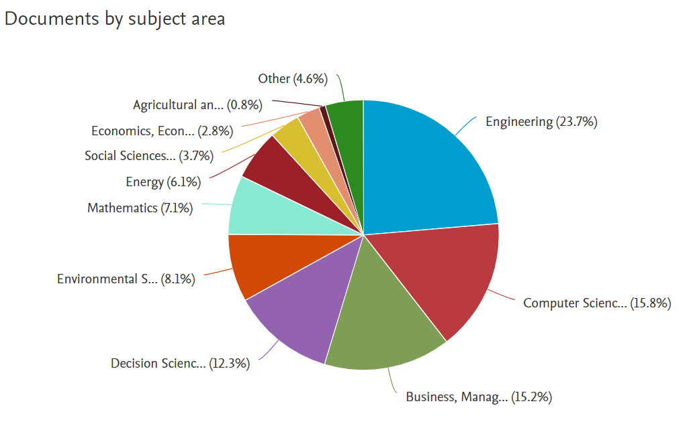
Figure 3. A document by subject area in the field of AI in SSC

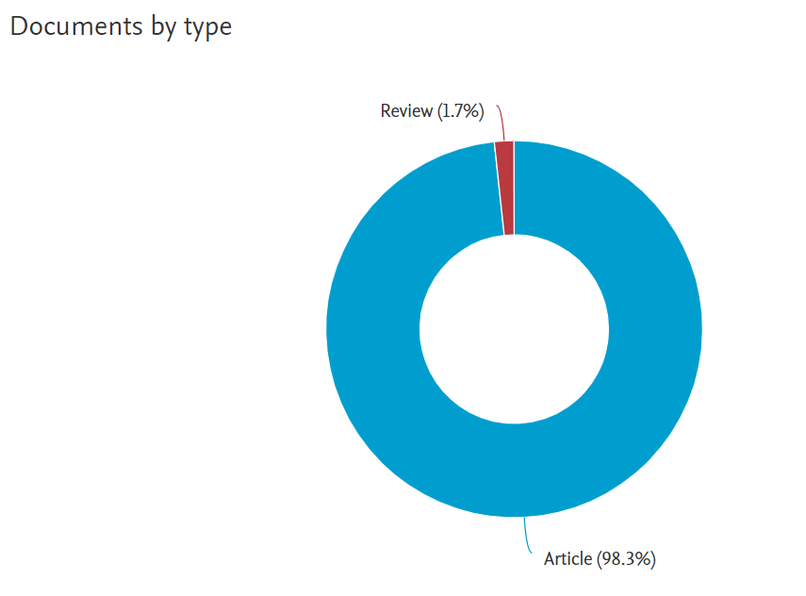
Figure 4. Percentage of review papers and articles in AI in SSC

3.1 Country statistics
The review identifies which countries are most productive and influential in the research field of AI in SSC. From all the countries that contributed to this field of research from 2002 to 2021, Figure 5 illustrates the top ten countries based on the number of published articles and the affiliated country of the first author. As evident from Figure 5, China and Iran are the most productive and influential countries in AI in SSC research with more than 100 published articles. India and the USA contributed with more than 50 articles in this field. Other countries such as South Korea, UK, Denmark, France, Germany and Canada have also made significant contributions by publishing a substantial number of articles related to AI in SSC.
Citation statistics (Table 3) showed that Iran, the USA and China received a large number of citations; these are the top three cited countries in this research field. However, in the case of India and South Africa low average citations and high production volume raise the question of relative visibility of the published articles. Denmark, Turkey and Malaysia have highly cited published papers despite comparatively low production rates. Citation statistics show that countries all around the world are significantly contributing to this field of research and have more citation indexes than the top ten most productive countries e.g. Portugal and Hong Kong. This proves that, though Asian countries dominate AI in the SSC field of research, it is internationally diverse as seen from the significant contribution of many countries from Europe and North America.

Figure 5. Country-wise statistics of articles
Table 3. Country-wise citation statistics
Country | Total Citations | Average Article Citations
Iran | 1438 | 20.54
USA | 1392 | 87.00
China | 1319 | 19.40
Denmark | 974 | 88.55
Turkey | 732 | 91.50
Malaysia | 480 | 68.57
Portugal | 388 | 129.33
India | 382 | 18.19
Canada | 299 | 29.90
Hong Kong | 278 | 34.75
UK | 266 | 24.18
Germany | 256 | 28.44
Greece | 218 | 72.67
Belgium | 178 | 178.00
France | 166 | 20.75
Japan | 145 | 48.33
Australia | 143 | 23.83
Spain | 138 | 46.00
Netherlands | 137 | 68.50
Singapore | 126 | 42.00

3.2 Author statistics
The study investigated the contribution of authors by extracting the author field and assessing the frequency of occurrence. The top ten authors based on their article productivity in AI and SSC as gathered from the SCOPUS database are shown in Table 4. These authors are presented in a hierarchical order based on their total research contributions to this field of research in high quality journals. The total number of publications and citations are highlighted in Table 4. This shows that Kannan G. dominates the list with 13 publications and 1282 citations in this field and is followed by Gen M. with 11 publications and 449 citations in total.
Table 4. Top ten researchers’ published scientific papers in AI in SSC
Authors | No. of Scientific Papers | Total Citations | h-Index
Kannan G | 13 | 1282 | 10
Gen M | 11 | 449 | 7
Soleimani H | 7 | 442 | 6
Zhang Y | 7 | 45 | 3
Min H | 6 | 665 | 6
Lee Je | 6 | 191 | 4
Ko Hj | 5 | 959 | 5
Kannan D | 5 | 302 | 4
Guo J | 5 | 110 | 4
Wang Y | 5 | 47 | 3

3.3 Organization statistics
As far as organizations contributing to the field of AI in SSC research are concerned, Table 5 indicates the top ten organizations/academic institutions with greatest output. It is apparent from Table 5 that the institution with most published articles in the Scopus database is Islamic Azad University, Iran, with a total of 33 publications. Next comes the University of Tehran with 18 publications. Third position is held by the University of Southern Denmark with 15 published papers, followed by Iran University of Science and Technology with 13 publications and Mazandaran University of Science and Technology with 12 publications. Among these top five universities, four of them are situated in Iran, with the other from Denmark.
Table 5. Most influential organizations in research area of AI in SSC
Organizations | No. of Scientific Papers
Islamic Azad University | 33
University of Tehran | 18
University of Southern Denmark | 15
Iran University of Science and Technology | 13
Mazandaran University of Science and Technology | 12
Amirkabir University of Technology | 9
Hong Kong Polytechnic University | 6
Shahid Beheshti University | 6
University of Malaya | 6
Yonsei University | 6

3.4 Journal statistics
The journal statistics presented in Table 6 depict that the “Journal of Cleaner Production” is in first position by publishing 27 scientific papers in the selected field of study. Next are two influential journals in the current field of research, “Computers and Industrial Engineering” and “International Journal of Production Research” with 20 and 18 articles respectively. “Sustainability” is in fourth place in the journal statistics with 13 articles; however, its total of received citations is less than all other top ten journals presented in Table 6. Nevertheless, the “Computers and Operations Research” journal received a high number of citations (n=1056) with only five articles in this field of research.
Table 6. Most influential journals in research area of AI in SSC
Journals | Articles | Total Citations | h-Index
“Journal of Cleaner Production” | 27 | 1086 | 18
“Computers and Industrial Engineering” | 20 | 1061 | 11
“International Journal of Production Research” | 18 | 838 | 12
“Sustainability (Switzerland)” | 13 | 84 | 5
“Expert Systems with Applications” | 12 | 622 | 10
“International Journal of Production Economics” | 10 | 970 | 9
“Applied Soft Computing Journal” | 8 | 529 | 7
“Applied Mathematical Modelling” | 6 | 532 | 5
“European Journal of Operational Research” | 6 | 422 | 6
“Computers and Operations Research” | 5 | 1056 | 5

The current topic of investigation, AI and SSC, has seen significant growth from 1994 to 2020 (as depicted in Fig. 6). However, the dynamic analysis of the most influential sources of the dataset shows that the topic started receiving major attention from 2014. It is evident from Figure 6 that since 2014 there has been a surge in publications in the current field of research in our top four journals (see Table 6); these are “Journal of Cleaner Production”, “Computers and Industrial Engineering”, “International Journal of Production Research” and “Sustainability”. Our study aims to analyse the significance of AI in SSC and it is interesting to note from the research perspective that in 2015 the Paris Agreement of Climate came into existence and the United Nations Agenda 2030 recommended 17 SDGs (sustainable development goals). Our study has revealed that there was a sudden surge in the number of publications in the above-mentioned influential journals, especially in the Journal of Cleaner Productions and Sustainability (Switzerland), after 2015. This substantiates the increased attention given to this field of research to integrate technological development in achieving sustainability by creating an SSC related to various industries and sectors (Di Maria et al., 2022; Khan et al., 2021).
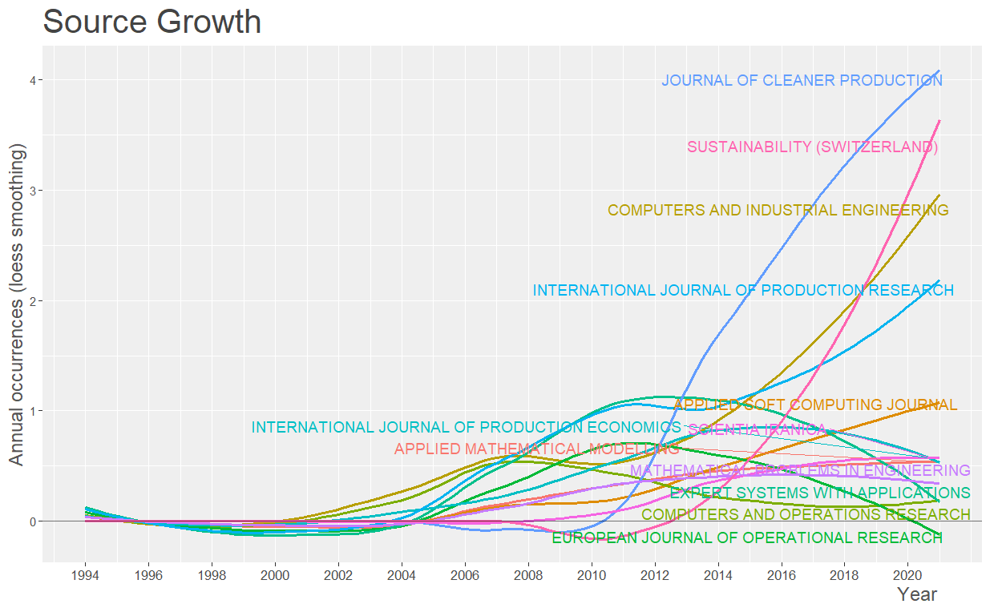
Figure 6. Growth of journals in the field of AI in SSC

3.5 Keyword statistics
The keyword statistics were extracted to investigate top keywords in the research area of AI and SSC; this is presented in Table 7. It shows that keywords ‘Genetic Algorithm’ and ‘Supply Chains’ occurred 137 and 123 times respectively during the search. It is followed by other top keywords such as ‘Logistics’, ‘Closed-Loop Supply-Chains’, ‘Decision Making’, ‘Supply Chain Management’, ‘Sustainable Development’ and ‘Reverse Logistics’. Table 7 depicts the top 20 keywords that were identified during the search for articles related to the current field of research. The keywords related to AI techniques are among the top 20 keywords; they include ‘Optimization’, ‘Integer Programming’, ‘Fuzzy Logic’, ‘Algorithms’ and ‘Particle Swarm Optimization’.

Table 7. Top twenty keywords used in the field of AI in SSC
Keywords | Occurrence | Keywords | Occurrence
Genetic Algorithms | 137 | Recycling | 43
Supply Chains | 123 | SSCs | 38
Logistics | 82 | AI | 35
Closed-Loop Supply Chain | 78 | Fuzzy Logic | 33
Reverse Logistics | 76 | Costs | 30
Supply Chain Management | 76 | Decision Support Systems | 27
Decision Making | 75 | Multi-objective Optimization | 26
Integer Programming | 56 | Particle Swarm Optimization (PSO) | 25
Sustainable Development | 50 | Algorithms | 22
Optimization | 47 | Nonlinear programming | 22

The word cloud of the keywords that appeared in the search of scientific papers is presented in Figure 7. These keywords highlight the most common words present in the abstract, title and keywords of the articles available in the database. The frequency of occurrence of the word in the selected scientific papers is represented by the size of the word (Figure 7). The major keywords of our study are present at the centre of the word map; these are supply chain, genetic algorithms, closed-loop supply chain, SSC, reverse logistics etc.
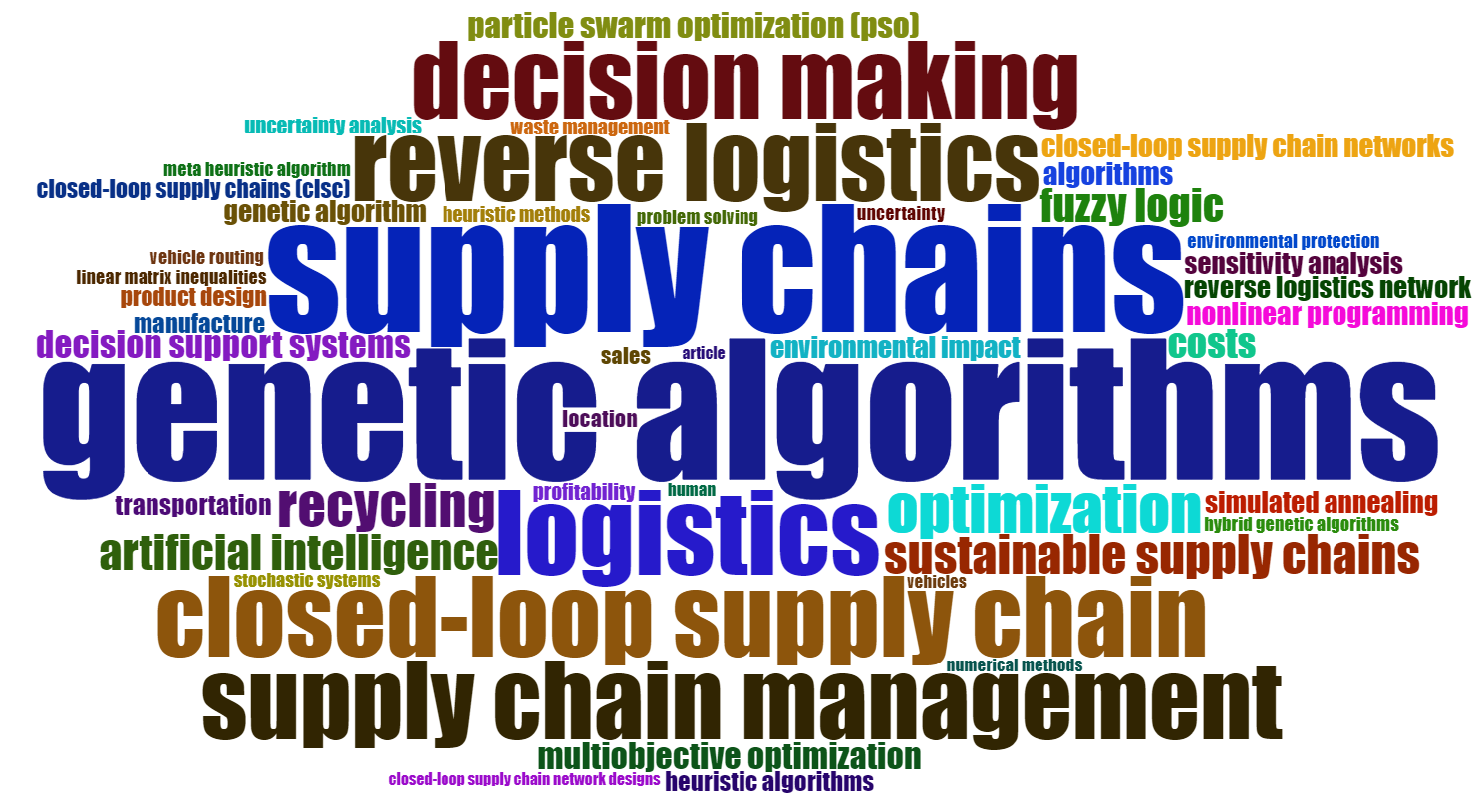
Figure 7. Word cloud of top keywords used in the selected field of study

Apart from the word-cloud shown above, the combination of various keywords is generated in the form of a topic dendrogram by using hierarchical clustering (Figure 8). The dendrogram reveals that research scholars are focusing on adoption of AI to find solutions for problems associated with SCs or to create an SSC model. The dendrogram shows that the second cluster is the dense cluster that comprises keywords; these include closed-loop SC, SSC, vehicle routing, optimization, genetic algorithm etc. The density of the cluster illustrates that a considerable amount of work was published in this area of research.
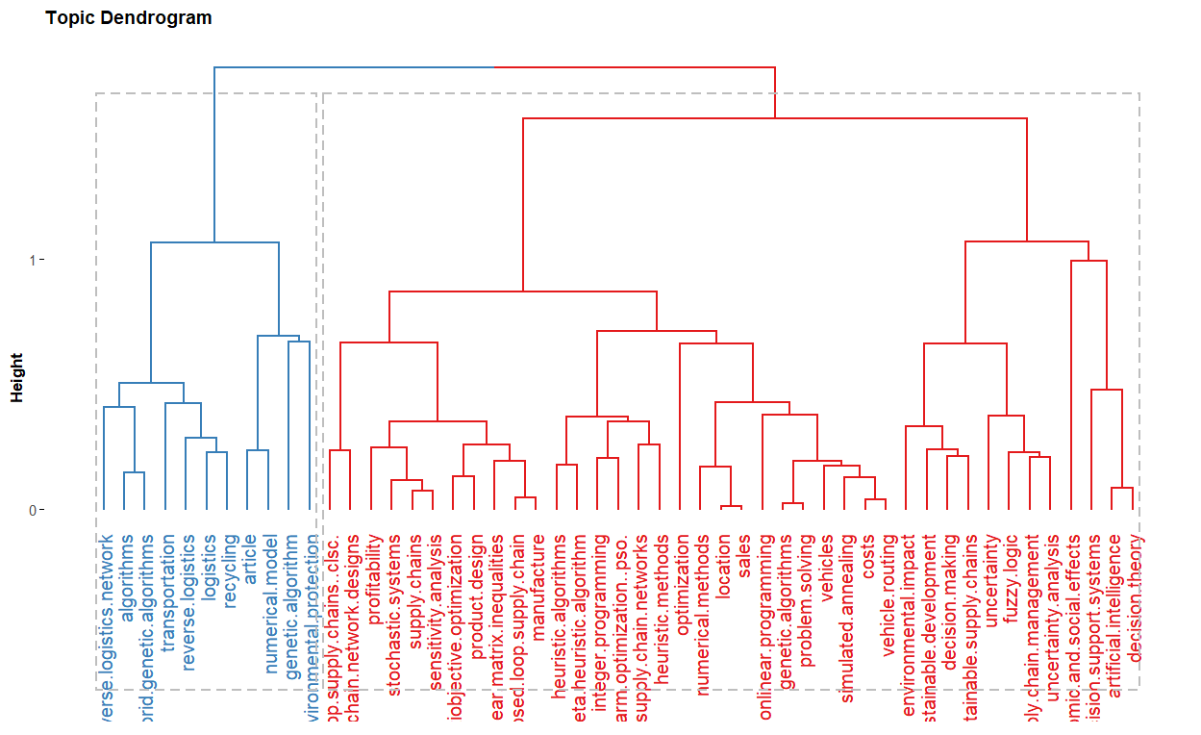
Figure 8. The topic dendrogram in the field of AI in SSC

3.6 Document statistics
As far as most prominent documents are concerned, Table 8 shows the top ten most cited journal articles in the field of AI and SSC. Govindan et al. (2014) received a total of 334 citations; Ko and Evans (2007) followed this with a total of 328 citations. Their studies are published in the “International Journal of Production Economics” and “Computers & Operations Research Journal” respectively; these are included in the list of top ten highly cited journals in the current field of research. The other top-cited documents are presented in Table 8.
Table 8. Top ten highly cited scientific papers in the area of AI in SSC
Articles | Total Citations | Citation per year
Govindan et al. (2014) | 334 | 41.75
Ko and Evans (2007) | 328 | 21.87
Büyüközkan and Çifçi (2011) | 325 | 29.55
Pishvaee et al. (2010) | 321 | 26.75
Amindoust et al. (2012) | 314 | 31.40
Min et al. (2006) | 302 | 18.88
Govindan et al. (2010) | 280 | 23.33
Lu et al. (2007) | 265 | 17.67
Mota et al. (2015) | 216 | 30.86
Wang and Hsu (2010) | 206 | 17.17

- Network analysis
To conduct network analysis, highly recognized and utilized software packages are Gephi, VOS viewer, Pajek, HistCite and Graph Maker. VOS viewer was used in this study to conduct and view bibliometric maps. For bibliometric analysis, VOS viewer is widely used, mostly in thematic analysis, cluster analysis and cartography (Llanos-Herrera and Merigo, 2019). It can construct maps of journals, authors or countries based on co-citation data and also based on co-occurrence data; it can construct keywords maps. VOS viewer can present a map in several ways by highlighting its distinct features. A researcher can examine a wide range of bibliometric networks composed of authors, journals, publications, countries or organizations (Van Eck and Waltman, 2010). Also, a researcher can use five types of bibliometric mapping analysis employing VOS viewer; namely, citation, bibliographic coupling, co-citation, co-occurrence of keywords and co-author. In the analysis of keywords, VOS viewer develops a text-mining technique to examine keywords, abstracts and content of titles. Hence, a different cluster of closely linked items is found, denoted by the same cluster colour.
  - Authors’ collaboration
To identify the collaboration of authors in producing scientific research papers in the chosen field of study, we used our selected 353 articles which comprises 860 authors as mentioned in Table 1. Then, a cluster is made by selecting authors with a minimum of two articles; the number of authors is thus reduced to 140. Thereby, nine clusters were formed, including 74 authors, after removing some authors because of their low connectivity with other authors. Finally, the established network has nine clusters comprising 119 links and 152 total link strengths. As shown in Figure 9, the largest cluster in the red colour has 12 authors, whereas other clusters, in blue and green, are in second position with ten authors each. It is evident from Figure 9 that the ninth cluster (pink) is the smallest in comparison to other clusters and includes only four authors. The network collaboration of authors revealed that the author “Gen M.” has the maximum number of connections with other researchers in the research field of AI in SSC.

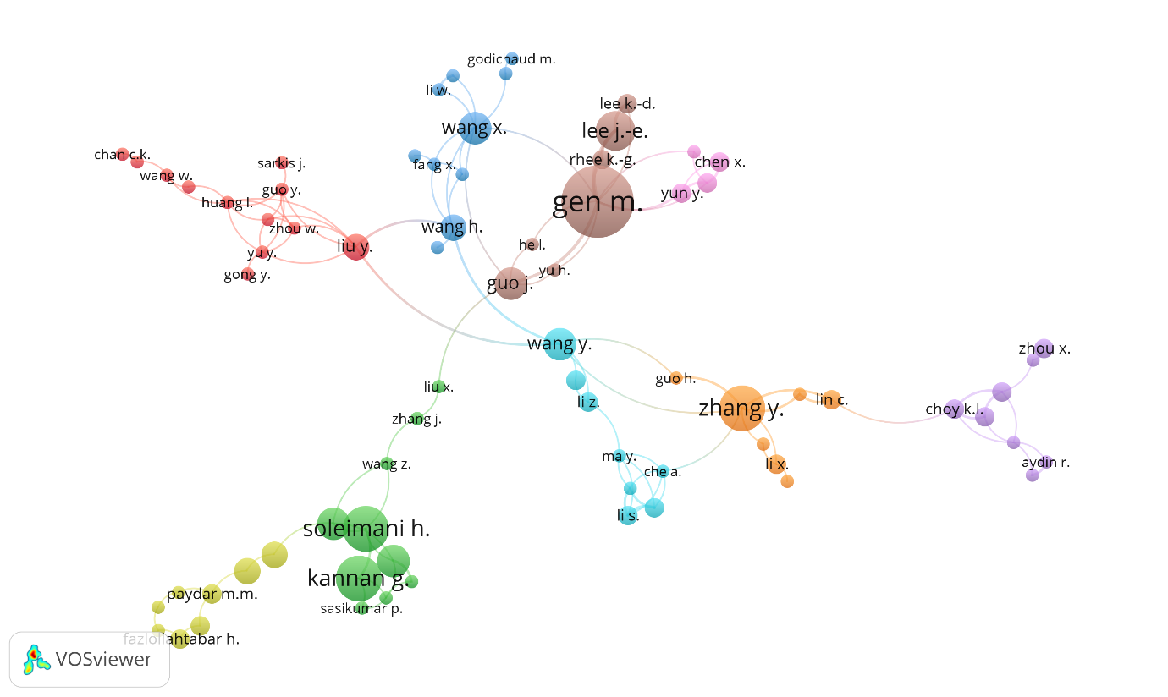
Figure 9. Network of authors collaboration in AI in SSC

  - Country collaboration
In country collaboration related to our research, there are 56 countries in the selected 353 articles. A cluster is made by considering only countries with a minimum of two articles; this reduces the number of countries to 35. As depicted in Figure 10, nine clusters were produced that include only 33 countries. Based on low connectivity, all other countries were removed from the collaboration network. Around 85 links were found in the developed network of nine clusters and 156 total link strengths. As can be seen in Figure 10, blue, green and red are the largest clusters with five countries each. It also indicates that China, with a total of 18 links, has the highest number of connections with other countries; its total link strength is 52.
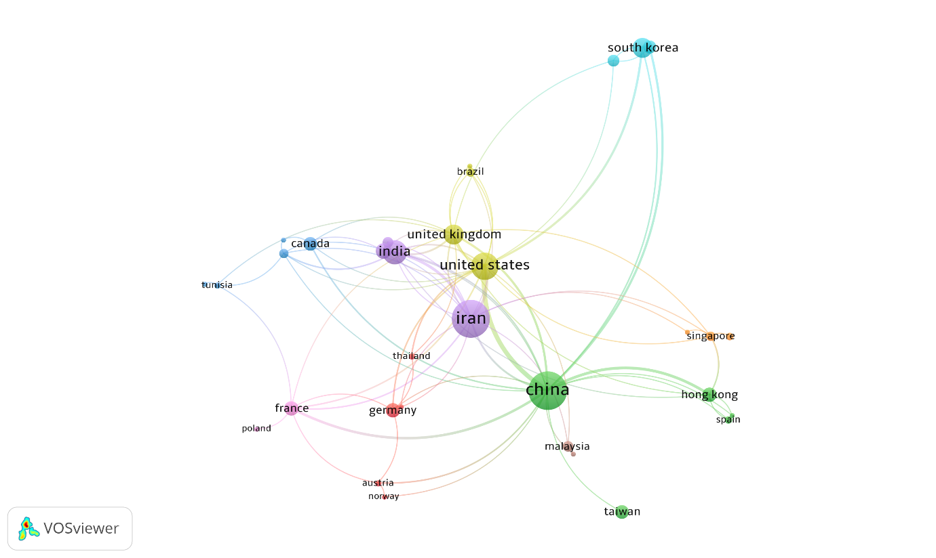
Figure 10. Network of country collaboration in AI in SSC

  - Keyword network
As far as keyword network is concerned, a total of 2587 keywords were obtained from the selected articles. All keywords that appeared a minimum of ten times are considered to make a cluster of keywords, reducing the number of keywords to 72. Finally, a total of five clusters were formed (Figure 11) which includes 72 keywords with 1764 links and 6934 total link strengths. From keyword network analysis, it was found that clusters 1, 2, 3 and 4 consisted of 21, 19, 15 and 14 keywords, respectively. The smallest cluster is the fifth cluster which includes only three keywords.
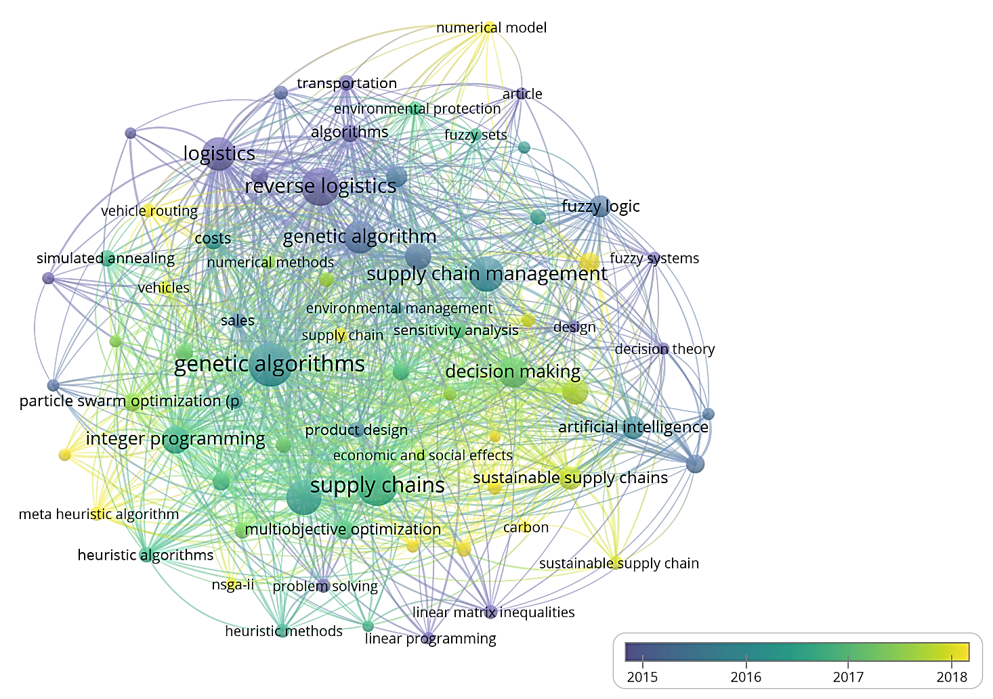
Figure 11. Network of overlay keyword in AI in SSC

- Text Analytics using Structural Topic Modelling (STM)
The purpose of topic modelling is to classify the foremost themes that exist in an unstructured and large dataset (Blei, 2012). This method has recently become prominent as researchers and analysts seek new ways to categorize, assemble and interpret the massive amount of available data in text form (Kuhn, 2018). It is a probabilistic method and a particular form of topic modelling that helps researchers to define topics through organizing and reviewing a large volume of collected documents (Kuhn, 2018). It is considered a critical method that automatically clusters word groups, similar expressions by self-learning and discovers appropriate themes that represent collected documents in the best way (Sharma et. al., 2021). Das et al. (2017) stated that quick, replicable and transparent analyses are provided by STM. STM directly assesses the impacts of metadata on prevalent topics, unlike other topic modelling forms. The findings present interesting trends. They show the occurrence of which topic appears over time, along with the association between word use or topic prevalence and covariates within a topic (Kuhn, 2018).
The current study applied STM to a large number of available documents in the field of AI in SSC. STM generated the thematic topics by investigating the text from the selected documents based on similarity and frequency of words. STM uses document-specific covariate data to describe word use distributions within a topic (Kuhn, 2018). In the model, STM discovers the plausible values for factors by using the data (Roberts et. al., 2019). The text from keywords, title and abstract is used to generate thematic topics by using this as the input in the STM. The steps involved in STM comprise text cleaning by eliminating most common words, stop words, non-English words, equations, special characters and numbers to make the text input compatible with the STM approach. The generative method of STM is considered from Agrawal et al. (2021). The generated thematic topics shown in Figure 12 are obtained by using the inbuilt STM library in R-package.
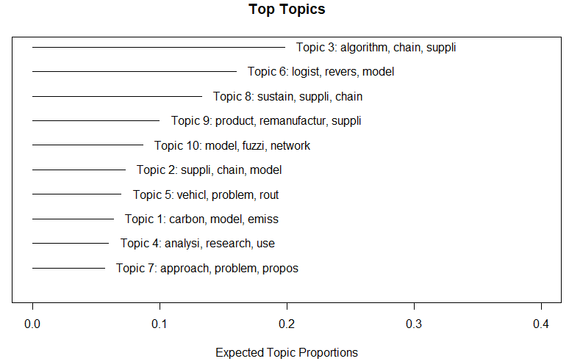
Figure 12. Generated topic labels from the STM approach

Table 9 shows the probabilistic distribution of the most frequently used keywords for the generated topic label. For instance, as given in Table 9, words with the highest probability that generated topic label 1 are ‘carbon’, ‘model’, ‘emission’, ‘recycling’, ‘optimize’, ‘reduce’ and ‘system’. Similarly, in Table 9 other thematic topics and their keywords are shown.

Table 9. Topic labels and their respective keywords
No. | Topic label | Highest probability words in topic label | Frex | Lift
 | Carbon emissions in SC | carbon, model, emission, recycling, optimize, reduce, system | carbon, End of life (EOL), energies, emission, electric, footprint, fruit | feedstock, abstract, carbon-intense, desktop, entail, oblique
 | Sustainable transportation | supplier, chain, model, sustain, environment, cost, design | sustain, environment, multi-object, social, transport, avail, impact | fashion, mass, avail, latest, specific, monitor, hub
 | Optimization in SC | algorithm, chain, supplier, model, problem, proposed, genetic | non-domain, sort, algorithm, particle, non-dominated sorting genetic algorithm II (NSGA-II), compare, inventories | bullwhip, fireflies, flaw, LCA (life cycle assessment), imperialist, ABC analysis
 | Data analytics in SC | analysis, research, use, cluster, construct, logistics, data | cluster, review, intelligent, artificial, driver, sample, bibliometric | Addleton, avenue, keyword, press, statistics
 | Vehicle routing in SC | vehicle, problem, rout, recycle, model, optimal, algorithm | vehicle, rout, pickup, simultaneous, per, fleet, depot | post-consumption, unload, variant, multi-depot, scene
 | Reverse logistics | logistics, revers, model, product, cost, propose, return | centre, logistics, revers, reus, open, priority-bas, retail | Canadian, collection inspect, empty, end-custom, era, forfeit
 | Proposed models in SSC | approach, problem, propose, model, use, algorithm, perform | schedule, code, experiment, approach, distribute, part | deal, line, ambiguity, interact, split
 | Sustainable supplier selection | sustain, supplier, chain, manage, perform, evaluate, research | barrier, risk, criteria, evaluate, agile, attribute, sustain | best-worst method (BWM), commit, compliance, culture
 | Remanufacturing in SC | product, remanufacture, supplier, process, system, chain, management | remanufacture, enterprise, inform, govern, plan, manufacture, Radio Frequency Identification (RFID) | dilemma, automata, cannibalise, fuzzy-bas, obsolete, product-type, shift
 | Decision making in SC | model, fuzzy, network, propose, logistics, return, decision | trade, fuzzy, Taylor and Francis, information, stochastic, forecast | conscious, depart, equilibrium, inexact, petri

The study presents two other metrics, namely Frex and Lift (Table 9). The Lift metric is a commonly used metric and refers to the word occurrence probability restricted to topic divided by the word occurrence probability across the corpus. The Lift metric highlights those words that are more common within a particular topic than in the whole corpus (Kuhn, 2018). Bischof and Airoldi (2012) recommended using the Frex metric - a word frequency restricted to the topic divided by word-topic exclusivity. Therefore, a Frex metric corresponds to the most frequent and exclusive words for a restricted topic (Table 9). The word map of emerging research themes is presented in Figure 13.
Topic 1- Carbon emissions in SC | Topic 2- Sustainable transportation
Topic 3- Optimization in SC | Topic 4- Data analytics in SC
Topic 5- Vehicle routing in SC | Topic 6- Reverse logistics
Topic 7- Proposed models in SSC | Topic 8- Sustainable supplier selection
Topic 9- Remanufacturing in SC | Topic 10- Decision making in SC

Figure 13. Emerging thematic topics of AI in SSC
- Emerging Research Themes of AI and SSC

6.1 Carbon emissions in the supply chain
In the distribution network, the distance between two connections has grown significantly because of globalization of SCs. The result is increased carbon emissions due to longer transportation distances (Elhedhli and Merrick, 2012). The environmental impacts posed by SC processes like designing, producing, sourcing and distributing have created growing concerns about SC environment sustainability (Lee and Choi, 2021). Several stages are involved in producing carbon emissions from a SC and are sometimes affected by the number of agents involved. This makes it challenging to analyse the level of carbon footprints linked with a product along the SC (Lee and Choi, 2021). Hence, it is necessary to design an eco-friendly SC system efficiently and effectively that enhances the bottom line of the firm while considering environmental conditions as well (Elhedhli and Merrick, 2012). According to Li and Wang (2017), technological progress can play an important part in economic development, upgrading industrial structure and adjusting energy structure. This can reduce carbon emissions substantially.

Liu et al. (2021) asserted that AI uses deep learning, machine learning and other technologies to enable companies to introduce human cognition functions through programming and algorithmic processing. Benzidia et al. (2021) conducted their study to identify the role of advanced technology in the integration process of the SC and its influence on the environment. They found that BDA-AI (“big data analytics and artificial intelligence”) technologies make a notable impact on the green SC and integration of environmental processes. It is also noted that AI with the adoption of robotics in industry can significantly reduce carbon intensity (Liu et al., 2021). Likewise, Bastida et al. (2019) found that in household energy use, the intervention of ICT could reduce carbon dioxide emissions in Europe by 0.23-3.3%. Goodarzian et al. (2021) developed two hybrid meta-heuristic algorithm models to optimize large-scale SC problems and minimize carbon emissions. Thus, we make the following propositions:

P1: To successfully implement AI techniques in an SSC, there is a need to develop a framework that integrates AI algorithms and big data analytics with the global SC.
P2: There is a need to compare already developed meta-heuristics algorithms and provide the most sustainable and efficient outcome.
P3: It is necessary to assess the carbon emissions associated with SC; therefore there is a need to conduct a detailed study on the carbon emissions of every dimension of the SC.

6.2 Sustainable transportation
Many adverse consequences like greenhouse gas emissions, air pollution, noise pollution, etc. are associated with transportation - a major contributor to global greenhouse gases (Tchanche, 2021). Transportation has long-lasting and significant impacts on society, the economy and the environment, but it is a crucial element of urban sustainability (Haghshenas and Vaziri, 2012). The numerous detrimental effects of transportation on the environment and society require new activities for the sustainable development of transportation. Sayyadi and Awasthi (2018) asserted that planning for sustainable transportation is essential to minimize noise/air pollution and to manage resources effectively. They presented a simulation-based optimization approach to classify major contributing factors for sustainable transportation. Also, Wang et al. (2021) focused on sustainable transportation and used a hybrid multi-criteria method to identify social, economic and environmental attributes for AI-based SSC and transportation.

Gupta et al. (2018) examined the transportation of mining products which harms the environment by its movement to terminal sites from the mines. As a result, integrated multi-objective optimization model approaches were formulated for sustainable transportation in the coal mining industry. Similarly, Despodov et al. (2011) used the AHP technique for optimal transportation system selection in mining planning. Ji et al. (2016) focused on the transportation eco-design in SSC management and developed a new model based on the DEA (data envelopment analysis) technique to simultaneously select several transporters by utilizing fewer resources and causing less pollution. Similarly, in a recent study, sustainability is considered as a critical component of a transportation system. An examination was made of several scientific methodologies such as optimization, fuzzy sets, simulation and machine learning to design and efficiently operate sustainable transportation systems (Torre et al., 2021). Rajak et al. (2021) used a grey-based decision-making trial and evaluation laboratory method to classify the barriers to sustainable transportation systems. Thus, we hypothesise:

P4: To achieve overall sustainable development goals, there is a need to incorporate both environmental and social dimensions of sustainability in the sustainable transportation model.
P5: A hybrid genetic algorithm that can help in ensuring sustainable transportation should be developed; therefore there is a need to develop a hybrid genetic algorithm model using other approaches to reduce the environmental impacts of transportation.
P6: Since analysing a decision-making problem is a critical task, there is a need to solve decision-making problems by combining other decision-making models.

6.3 Optimization in the supply chain
The optimization technique is an effective tool for data analytics in the SC and can facilitate the understanding of a complex system involving multiple constraints and factors such as huge data volume, route, capacity and demand coverage (Tiwari et al., 2018). Furthermore, the optimization technique can examine multiple objectives and reveal new data that will enhance SC planning accuracy (Tiwari et al., 2018). Goodarzian et al. (2021) highlighted the lack of design and interpretation of optimization for SC problems in many areas despite the vast scope of available big data. They stressed the importance of minimizing carbon emissions linked with the SC by optimizing the appropriate network and developed a mixed-integer non-linear programming (MINLP) model using big data analytics.

Han and Zhang (2021) built a SC risk management model to examine SCM improvement by optimization, basing the model on machine learning and neural network technology. Singh et al. (2021) emphasized that a resilient SC is essential during a pandemic; they also developed a simulation model to determine food SC disruptions. Fathi et al., (2021) considered a location-inventory optimization model for a SC, intending to specify the optimal locations for multiple distribution centres; to achieve this, they employed a two-phase approach involving “stochastic optimization and queuing theory”. Pahlevan et al. (2021) designed a sustainable closed-loop SC network by creating a “three-objective mixed-integer linear mathematical model” in the aluminium industry. Thus, we make the following propositions:

P7: There is a need to identify and compare different optimization algorithms' practical implications and strengths in an SSC.
P8: To achieve overall sustainability, there is a need to consider all three dimensions of sustainability - environmental, social and economic - in the optimization model of the SSC.
P9: There are several optimization models available on SCs in existing literature. There is a need to review and compare the success factors of different optimization SC models to achieve sustainability.

6.4 Data analytics in the supply chain
Big data has gained major prominence recently due to the rapid spread of information technology (Papadopoulos and Gunasekaran, 2018). By its application diversity and recent popularity, big data analytics is difficult to define in a general sense (Benzidia et al., 2021). Mikalef et al. (2018, p.2) defined big data as “a new generation of technologies and architectures, designed to economically extract value from very large volumes of a wide variety of data, by enabling high-velocity capture, discovery and/or analysis”. Regarding the decision-making procedures of companies, the importance of big data has increased because of technological progress throughout industry (Chen et al., 2012). However, research concerning the influence of big data on the environmental dimension of the SC is still in its early stages (Benzidia et al., 2021).

Several studies have emphasized the role of technological infrastructure to enhance the information processing ability of an organization (Benzidia et al., 2021). Zhang et al. (2017) proposed the architecture of big data-based analytics to make improved product lifecycle management. Souza (2014) referred to the advanced analytics techniques application into SC management by focusing on the SCOR (supply chain operations reference) model. In a recent study conducted by Yu et al. (2021), a theoretical framework was developed and empirically tested that focused on SC finance and examined the effect of big data analytics capability; the results showed a positive effect of big data analytics capability on SC finance integration. Kuo et al. (2021) emphasized hybrid 3.5 strategies in the smart SC and developed a material resource management approach based on information sharing. Hence, we make the following propositions:

P10: There is a need to develop a multi-product and multi-horizon approach for SSC to integrate big data and other AI techniques.
P11: A comparison between different data-analytical approaches for SSC under uncertainty is needed to analyse the applicability of other methods in real-time decision-making.
P12: Investigation of the environmental factors of proposed big data based SC models is needed.

6.5 Vehicle routing in the supply chain
In executing SCM, the major problem is to competently regulate the SC’s physical flow (Lee et al., 2006) since in the distribution process, around 30% of the price is incurred (Apte and Viswanathan, 2000). Thus, the vehicle routing problem must be considered for a sustainable and efficient SC. Giallanza and Puma (2020) defined the vehicle routing problem as “determining the optimal routes for a fleet of vehicles under several constraints involving warehouse capacity, temporal priorities, and variable customer demand”. Several analytical models have been presented to overcome vehicle routing problem in SCs. Zheng and Liu (2006) proposed a fuzzy optimization model considering travel times as fuzzy variables to provide optimum solutions for fuzzy vehicle routing problems in a SC. Erbao and Mingyong (2009), based on fuzzy credibility theory, developed a “fuzzy chance-constrained program model”. To solve this model, they created a hybrid intelligent algorithm by using differential evolution algorithm and stochastic simulation. Likewise, Shi et al. (2017) designed a fuzzy chance-constrained model concerning home health care scheduling problems by employing a hybrid genetic algorithm with stochastic simulation. Abdirad et al. (2021) offered a two-stage hybrid algorithm to resolve vehicle routing problems in the SC under the umbrella of industry 4.0. Thus, we propose:

P13: To establish an SC model by considering the environmental impact of vehicle routing problems and solutions for limited use of electric vehicles.
P14: Extending the already proposed model by integrating other algorithms into development of a sustainable solution for vehicle routing problems.
P15: Using different algorithms and AI-enabled approaches to create a sustainable multi-echelon distribution system.

6.6 Reverse logistics
Reverse logistics have received considerable attention from industry because of the potential for value revival from used products (Meade et al., 2007). It is focused on recycling, waste management and remanufacturing (parts or product) (Pokharel and Mutha, 2009). It is defined as “the process of planning, implementing, and controlling the efficient, cost-effective flow of raw materials, in-process inventory, finished goods, and related information from the point of consumption to the point of origin to recapture value or of proper disposal” (Rogers and Tibben-Lembke, 1999, p.2). Banihashemi et al. (2019) asserted that the emerging implications of reverse logistics have made many firms design and recreate processes to align with sustainable development initiatives. The utilization of recycled or remanufactured products in the SC indicates more significant uncertainty and generates more complexity, but recycling or remanufacturing practices have economic and environmental advantages (Tosarkani and Amin, 2018).

Tosarkani and Amin (2018) employed a “multi-objective mixed-integer linear programming model”, applying the fuzzy AHP technique for implementation of green practices, maximizing profit and minimizing the defect rate of efficient delivery in the proposed reverse logistics. Govindan et al. (2019) proposed a hybrid SMAA-ELECTRE I model to identify the most suitable service provider of reverse logistics. Maheswari et al. (2019) used qualitative descriptive approaches to create a Quattro helix model for reverse logistics sustainability of electronic waste in Indonesia. Mishra et al. (2021) introduced a hybrid approach based on EDAS (“Evaluation based on distance from average solution”) and CRITIC (“Criteria Importance Through Inter-criteria Correlation”) methods. Mastrocinque et al. (2020) applied fermatean fuzzy sets to provide solutions for the selection problem of “sustainable third-party reverse logistics providers”. Thus, the following propositions are suggested:

P16: To establish a framework concerning environmental and social factors of reverse logistics and use real-time data of different industries to provide recommendations for managers to reduce detrimental impacts.
P17: Since development of a sustainable reverse logistics model is a critical task, it needs deployment of an AI and network optimization approach in creating a sustainable reverse logistics model.
P18: There is a need to develop an algorithm-based model to identify the consumer and governmental impacts in strategies and barriers of sustainable reverse logistics.

6.7 Proposed models in SSC
Many environmental challenges worldwide are associated with the industrial SC, predominantly in the manufacturing sector (Mathivathanan et al., 2018). Therefore, several studies have recommended SSC models to overcome social, economic or environmental issues. For instance, Che (2010) established an optimal mathematical model to offer solutions for manufacturing and delivery problems in a green SC by using a fuzzy analytic hierarchy process and particle swarm optimization. Ageron et al. (2012) proposed a conceptual model for SSC management explaining the attributes, reasons and obstacles in adopting SSC practices. Boukherroub et al. (2015) offered an integrated approach to transpose sustainable development norms into SC models by using multi-objective mathematical programming and weighted goal programming techniques.

Abdel-Basset and Mohamed (2020) estimated risks in SSC and proposed a novel plithogenic model which concentrated on the renewable energy sector and provided a multi-criteria decision-making framework based on triple bottom line principles. Hasani et al. (2021) recommended a multi-objective optimization model for the SSC by using SPEA2 (“Strength Pareto Evolutionary Algorithm 2”). Thus we propose:
P19: Because literature concerning the social dimension of sustainability in creating AI-based SSC is limited, future studies could focus on this to develop a more robust SSC model with the latest techniques.
P20: Development of a SSC model by integrating different multi-criteria decision-making techniques should be explored.
P21: AI techniques in the real case study should be deployed to identify strengths and barriers in the SSC.

6.8 Sustainable supplier selection
The process of supplier selection enables companies to identify, assess and work with suitable suppliers (Taherdoost and Brard, 2019). This process utilizes the substantial financial resources of a firm but has an essential role in an organization's success (Taherdoost and Brard, 2019). According to Govindan et al. (2013), suppliers could play a crucial role in executing SSC practices and accomplishing social, environmental and economic benefits. It has an influential role in enabling a firm to attain the highest ecological-economic advantages (Kannan et al., 2014). A new decision-aid system was established by Singh et al. (2018) by linking cloud computing technology, big data analytics and operational research methods; this system can measure carbon footprints and greenhouse gas emissions in the supplier selection process.

To evaluate sustainable supplier selection, a framework was proposed using an integrated AHP (“Analytical Hierarchy Process”), VIKOR (“ViseKriterijumska Optimizacija I Kompromisno Resenje”) and multi-criteria optimization approach (Luthra et al., 2017). Shaw et al. (2012) developed a model to evaluate supplier selection decisions concerning carbon emissions by using fuzzy-AHP and fuzzy multi-objective linear programming. Memari et al. (2019) indicated that sustainable supplier selection is the first step towards sustainable industrial processes and suggested an intuitionistic fuzzy TOPSIS (“technique in order of preference by similarity to ideal solution”) method to choose the most suitable sustainable supplier. Fallahpour et al. (2016) emphasized supplier selection with hybrid AI-based models and proposed “data envelopment analysis–artificial neural network” methods with a new genetic programming (GP) AI approach. A study was based on the automobile manufacturing sector to solve problems concerning order allocation and sustainable supplier selection. As a result of the above-mentioned discussion, we propose:

P22: Future studies can concentrate on the social dimension of sustainability while creating a new AI-technique-based sustainable supplier selection model.
P23: Adoption of AI techniques is recommended to develop a sustainable supplier selection model such as Bayesian networks, fuzzy logic, differential evolution or artificial neural networks (ANN).
P24: Utilizing big data analytics to generate optimum solutions to overcome risks associated with sustainable supplier selection.

6.9 Remanufacturing in the supply chain
Remanufacturing is characterized as an industrial process in which used or worn-out products are remanufactured or restored to useful life (Östlin et al., 2008). Hunka et al. (2021) highlighted the benefits of remanufacturing products such as ethical responsibility, maximizing profit, increased market share, legislation compliance and brand protection. Zhou et al. (2021b) developed a game-theoretical model to investigate the direct effect of consumer education implications on willingness to pay for remanufactured products. Dong et al. (2021) considered a two-echelon SC for used product collection from consumers for product remanufacturing under random demands; they used three decision-making structures to generate unique optimal solutions. Another study examined remanufacturing operations and greening efforts, with consideration of governmental reward-penalty mechanisms in their model (Chen and Ulya, 2019). Ullah and Sarkar (2020) created a hybrid manufacturing-remanufacturing mathematical model based on a radio frequency identification (RFID) return channel to maximize recycling rates. Liao and Li (2021) constructed a mathematical model to analyse remanufacturing environmental benefits. Thus, we make the following propositions:

P25: There is a need to identify barriers and strategies associated with remanufacturing; we propose an AI-based framework to overcome such issues.
P26: More literature is required concerning different products to address consumer awareness and governmental aspects in understanding the benefits of remanufactured products.
P27: There is a need to compare remanufacturing strategies using AI techniques of different firms and different countries to identify their strengths and barriers.

6.10 Decision making in the supply chain
The enormity of data, system constraints, decision variables and complex variables’ relationships make SCs highly complex and create challenges for management to make sound business decisions (Manuj and Sahin, 2011). According to Singh et al. (2019), effective decision-making plays a significant role at every stage of the SC; this involves reducing inventory cost, fulfilling customer demands, enhancing consumer service, expanding market share etc. On the other hand, when organizations make decisions concerning the environmental impact of their SC, they face changing decision parameters, information uncertainty and changes in decision boundaries (Matos and Hall, 2007). Hence, the challenge is to stabilize efficient business practices and environmental issues in an uncertain, complex and dynamic setting (Wu and Pagell, 2011). Therefore, decision support system development by the automation of the SC is an optimum decision-making approach (Wang et al., 2013).
Provost and Fawcett (2013) examined the data-driven decision-making and data science relationship and found that apart from providing support to data-driven decision-making, data science also overlaps it. Based on data-driven theory, Long (2016) proposed a “flow-based three-dimensional collaborative decision-making model” for the SC. Tseng et al. (2018) adopted a fuzzy TOPSIS approach to build an SSC finance model to examine financing pattern deficiencies and existing problems under uncertainty. He et al. (2021) formulated a non-linear optimization model by integrating the Kano model and DEMATEL (“decision-making and trial evaluation laboratory”) to attain optimal solutions for the SSC. Olan et al. (2021) analysed the role of AI in SSC finance and established a conceptual framework based on identified literature. Thus, we make the following propositions:
P 28: The COVID-19 pandemic has disrupted SC badly. Therefore, there is a need to propose an AI-enabled SSC model to overcome sudden risks and enable effective decision-making.
P 29: A real-time decision-making model is presently required to deal with sudden risks and disruptions. Therefore, there is a need to adopt innovative big-data analytics techniques in creating a real-time decision-making model when faced with sudden risks and disruptions.
P30: There is a need to employ the internet of things (IoT) approach in communication, collecting real-time data, providing optimum solutions in decision-making and establishing a SSC model.

Some recent studies conducted in the field of AI and SSC are reviewed and summarised in Table 10. These studies are conducted using different algorithms and in different sub-areas. This will provide information to readers about recent work done in a selected field that is not discussed in the above-mentioned themes.
Table 10: Recent studies on AI applications in SSC
Article | Area | Sustainability dimension | Algorithm | Objective
El Amrani et al. (2021) | Overall sustainability of the SC and Sustainable supplier selection | Social, economic, and environmental | Bayesian Network approach | To identify the major issues that impact the overall network’s sustainability and developing a decision-making approach to select/rank sustainable suppliers.
Babaeinesami et al. (2021) | Closed-loop supply chain | Responsiveness, environmental Social, and economic | “Multi-Objective Particle Swarm Optimization” (PMOPSO) and “Multi-objective social engineering optimizer” (MOSEO) | To tackle the routes and facilities disruptions encompassing the entire system and creating resiliency.
NoParast et al. (2021) | Closed-loop supply chain | Environmental | Non-dominated sorting genetic algorithm | Developing a model to minimize greenhouse gas emissions, mining of natural resources, and transport costs.
Cao et al. (2021) | Reverse Logistics | Environmental | Hybrid genetic algorithm with a large-scale neighbourhood search algorithm | To reduce recycling costs, carbon emissions, save resources and protect the environment.
Khan et al. (2021) | Multi-tier SSCs | Social | Hesitant fuzzy sets and VIKOR | To examine the barriers to adopting social sustainability in the multi-tier supply chain.
Klumpp and Zijm, (2019) | Logistics | Social | - | To develop a theoretical framework concerning the growth of the human-computer interface in logistics.
Son et al. (2021) | Closed-loop supply chain and additive manufacturing | Environmental | Genetic Algorithm | To develop a new SC that combines the advantages of both additive manufacturing and conventional manufacturing systems.
Najmi et al. (2021) | Reverse Logistics | Environmental | Artificial Neural Network | To identify the factors influencing consumer behaviour in reverse logistics.
Alavi et al. (2021) | Supplier Selection | Social, economic, and environmental | Machine Learning | To offer a dynamic decision-support system for sustainable supplier selection.
Zhou et al. (2021a) | Vehicle Routing | Environmental | Two-phase-based genetic algorithm | To solve vehicle routing problem by providing a solution framework.
Sadeghi et al. (2021) | Closed-loop supply chain | Environmental | Fuzzy programming approach | To create proper disposal and recycling SC for municipal solid waste.
Naderi et al. (2021) | Supply chain | Environmental and social | Genetic Algorithm and simulated annealing | To design a SSC by developing a mathematical model integrated with exergy and entropy concepts.

7. Discussion and Proposed Research Model
The main objective of this study is to analyse the role of AI in making a SSC. A systematic literature review and STM approach were employed to explore existing literature related to the significance of AI in SSC. A substantial contribution was noted concerning the role of advanced technology such as AI, genetic algorithm, fuzzy logic, big-data analytics, artificial neural network, optimization algorithm etc. to offer optimal solutions for SC problems. The study has generated thematic topics using STM such as carbon emissions in the SC, sustainable transportation, optimization in the SC, data analytics in the SC, vehicle routing in the SC, reverse logistics, proposed models in the SSC, sustainable supplier selection, remanufacturing in the SC and decision-making in the SC. The impact of AI on these topics is considerable and many studies conducted on respective topics have shown its importance.

With regard to SSC, Seuring and Müller (2008) contrasted it with the traditional SC and stated that the traditional SC focuses on financial and economic business performance while SSC aims at integrating social or environmental dimensions to extend the economic aspect of the triple bottom line. The environmental and social criteria in a SSC require to be met while it is expected to maintain competitiveness by meeting respective economic norms and consumer needs (Seuring and Müller (2008). Current literature has provided an insight into SSC management across different areas and dimensions (Sanders et al., 2019; Di Vaio et al., 2020; Nilsson and Göransson, 2021). In addition, previous literature has investigated the role of AI in creating SSC models to integrate different dimensions of sustainability such as social (Klumpp and Zijm, 2019), environmental (Son et al. 2021) as well as social, environmental and economic altogether (El Amrani et al. 2021).

Literature acknowledges that to improve SC performance, AI is regarded as a pathbreaking analytical tool (Grover et al., 2020). Business and big-data analytics play a major role in the network design of the global flexible SSC (Gunasekaran et al., 2016). Managers at all levels are obligated to re-examine the way they manage, view, design, deploy, redesign and calculate SC performance and greening throughout the entire SC to authenticate sustainability (Sanders et al., 2019). Almost every industry and all supply chains are affected by digital applications (Klumpp and Zijm, 2019). It is the trend to attain corporate sustainability through advanced technology like big-data, AI and robotics (Sanders et al., 2019). On the other hand, consumers are keen to validate their products for sustainability and need an open and easy-to-use information portal containing product data (Nikolakis et al., 2018). Hence, suppliers face pressure from this situation as they must follow sustainable practices on local and global levels as a requirement to participate in some supply chains (Parmentola et al., 2021). Other issues related to the SC which directly affect the performance of the SC network are poor communication, lack of information sharing, uncertainties, material flow planning, logistics, transportation and supplier selection. To create an effective SSC, organizations should try to overcome these issues. With this aim in mind, the integration of AI-based technologies like 3D-printing, cloud computing, IoT and big data analytics will facilitate smooth operations in supply chains (Chowdhury et al., 2021).

This study has proposed a research framework (Figure 14) that comprises ten emerging research themes for SSC and the integration of AI-based techniques into the traditional SC to overcome the above-mentioned issues. The research framework defines the advantages of integrating AI to attain sustainability in the SC.

Supply Chain Issues
AI
AI Techniques
Machine Learning,
Bayesian Network,
Artificial Neural
Network, Robotics,
Genetic
Algorithm,
Deep Learning,
Fuzzy Logic,
Robotics,
Particle Swarm Optimization etc.

AI-enabled operations
Reduced carbon emissions,
Real-time manufacturing,
On-time delivery,
Availability of data,
Effective information sharing,
Efficient remanufacturing,
Easy return of goods,
Suitable Supplier Selection,
Demand forecast,
Resilience under uncertainties,
Sustainable network design etc..

SSC
Planning
Supplier Selection
Carbon emissions
Ineffective Logistics/Transportation
Information Sharing
Decision making
Communication
Data availability/evaluation
Sustainable transportation
Carbon emissions in SC
Vehicle routing in SC
Reverse logistics
Sustainable supplier selection
Decision making in SC
Remanufacturing in SC
Proposed models for SSC
Data analytics in SC
Optimization in SC
Return network of products
Delayed deliveries

Figure 14: A proposed research framework for AI in SSC

- Conclusion
The widespread environmental consequences of manufacturing and transportation operations have created a need for a resilient SSC network. In this regard, companies are facing governmental, societal and competitive pressures to integrate sustainability dimensions in their operations. Recent advancements in technology have provided multiple optimal solutions to the environmentally unsustainable operations of businesses. The integration of AI-based techniques in SC processes has transformed their way of working. The current study has emphasized the importance of a thorough evaluation and review of studies conducted in the field of AI and SSC. A bibliometric analysis and STM were employed to generate a systematic literature review in the selected field of study. Ten emerging research themes were produced using STM. These are carbon emissions in SC, sustainable transportation, optimization in SC, data analytics in SC, vehicle routing in SC, reverse logistics, proposed models in SSC, sustainable supplier selection, remanufacturing in SC and decision making in SC. These themes have been thoroughly examined and discussed. This study will deliver a deeper understanding into the SSC through integrating AI and will encourage managers to consider future propositions.
Future studies can develop their review articles by incorporating other dimensions of the SC. This study is limited to only journal articles, so future studies can include other papers for a broader diversification of relevant articles. It will also prove interesting to investigate the challenges and barriers in the review paper based on AI and SSC.

References
Abdel-Basset, M., & Mohamed, R. (2020). A novel plithogenic TOPSIS-CRITIC model for sustainable supply chain risk management. Journal of Cleaner Production, 247, 119586.
Abdirad, M., Krishnan, K., & Gupta, D. (2021). A two-stage metaheuristic algorithm for the dynamic vehicle routing problem in Industry 4.0 approach. Journal of Management Analytics, 8(1), 69-83.
Ageron, B., Gunasekaran, A., & Spalanzani, A. (2012). Sustainable supply management: An empirical study. International Journal of Production Economics, 140(1), 168-182.
Agrawal, R., Wankhede, V. A., Kumar, A., Luthra, S., Majumdar, A., & Kazancoglu, Y. (2021). An exploratory state-of-the-art review of artificial intelligence applications in circular economy using structural topic modeling. Operations Management Research, 1-18.
Alavi, B., Tavana, M., & Mina, H. (2021). A Dynamic Decision Support System for Sustainable Supplier Selection in Circular Economy. Sustainable Production and Consumption, 27, 905-920.
Amindoust, A., Ahmed, S., Saghafinia, A., & Bahreininejad, A. (2012). Sustainable supplier selection: A ranking model based on fuzzy inference system. Applied soft computing, 12(6), 1668-1677.
Apte, U. M., & Viswanathan, S. (2000). Effective cross docking for improving distribution efficiencies. International Journal of Logistics, 3(3), 291-302.
Aria, M., & Cuccurullo, C. (2017). bibliometrix: An R-tool for comprehensive science mapping analysis. Journal of informetrics, 11(4), 959-975.
Babaeinesami, A., Tohidi, H., & Seyedaliakbar, S. M. (2021). Designing a data-driven leagile sustainable closed-loop supply chain network. International Journal of Management Science and Engineering Management, 16(1), 14-26.
Banihashemi, T. A., Fei, J., & Chen, P. S. L. (2019). Exploring the relationship between reverse logistics and sustainability performance: A literature review. Modern Supply Chain Research and Applications. 1(1), 2-27.
Bastida, L., Cohen, J. J., Kollmann, A., Moya, A., & Reichl, J. (2019). Exploring the role of ICT on household behavioural energy efficiency to mitigate global warming. Renewable and Sustainable Energy Reviews, 103, 455-462.
Belhadi, A., Kamble, S., Fosso Wamba, S., & Queiroz, M. M. (2021). Building supply-chain resilience: an artificial intelligence-based technique and decision-making framework. International Journal of Production Research, 1-21.
Benzidia, S., Makaoui, N., & Bentahar, O. (2021). The impact of big data analytics and AI on green supply chain process integration and hospital environmental performance. Technological Forecasting and Social Change, 165, 120557.
Bischof, J., & Airoldi, E. M. (2012). Summarizing topical content with word frequency and exclusivity. In Proceedings of the 29th International Conference on Machine Learning (ICML-12) Edinburgh, Scotland, UK. (pp. 201-208).
Blei, D. M. (2012). Probabilistic topic models. Communications of the ACM, 55(4), 77-84.
Boukherroub, T., Ruiz, A., Guinet, A., & Fondrevelle, J. (2015). An integrated approach for sustainable supply chain planning. Computers & Operations Research, 54, 180-194.
Büyüközkan, G., & Çifçi, G. (2011). A novel fuzzy multi-criteria decision framework for sustainable supplier selection with incomplete information. Computers in industry, 62(2), 164-174.
Cao, S., Liao, W., & Huang, Y. (2021). Heterogeneous fleet recyclables collection routing optimization in a two-echelon collaborative reverse logistics network from circular economic and environmental perspective. Science of the Total Environment, 758, 144062.
Chen, H., Chiang, R. H., & Storey, V. C. (2012). Business intelligence and analytics: From big data to big impact. MIS quarterly, 36(4), 1165-1188.
Chen, C. K., & Akmalul'Ulya, M. (2019). Analyses of the reward-penalty mechanism in green closed-loop supply chains with product remanufacturing. International Journal of Production Economics, 210, 211-223.
Costa, J. (2021). Carrots or Sticks: Which Policies Matter the Most in Sustainable Resource Management?. Resources, 10(2), 12.
Das, S., Dixon, K., Sun, X., Dutta, A., & Zupancich, M. (2017). Trends in transportation research: Exploring content analysis in topics. Transportation Research Record, 2614(1), 27-38.
Despodov, Z., Mitić, S., & Peltečki, D. (2011). Application of the AHP method for selection of a transportation system in mine planning. Underground Mining Engineering, (19), 93-99.
Di Maria, E., De Marchi, V., & Galeazzo, A. (2022). Industry 4.0 technologies and circular economy: The mediating role of supply chain integration. Business Strategy and the Environment, 1– 14. https://doi.org/10.1002/bse.2940
Di Vaio, A., Palladino, R., Hassan, R., & Escobar, O. (2020). AI and business models in the sustainable development goals perspective: A systematic literature review. Journal of Business Research, 121, 283-314.
Dong, J., Jiang, L., Lu, W., & Guo, Q. (2021). Closed-loop supply chain models with product remanufacturing under random demand. Optimization, 70(1), 27-53.
El Amrani, S., Hossain, N. U. I., Karam, S., Jaradat, R., Nur, F., Hamilton, M. A., & Ma, J. (2021). Modelling and assessing sustainability of a supply chain network leveraging multi–Echelon Bayesian Network. Journal of Cleaner Production, 302, 126855.
Elhedhli, S., & Merrick, R. (2012). Green supply chain network design to reduce carbon emissions. Transportation Research Part D: Transport and Environment, 17(5), 370-379.
Erbao, C., & Mingyong, L. (2009). A hybrid differential evolution algorithm to vehicle routing problem with fuzzy demands. Journal of computational and applied mathematics, 231(1), 302-310.
Fahimnia, B., Sarkis, J., & Davarzani, H. (2015). Green supply chain management: A review and bibliometric analysis. International Journal of Production Economics, 162, 101-114.
Fetscherin, M., & Heinrich, D. (2015). Consumer brand relationships research: A bibliometric citation meta-analysis. Journal of Business Research, 68(2), 380-390.
Fink, A. (2005). Conducting Research Literature Reviews: From the Internet to Paper. Sage: Thousand Oaks. California.
Giallanza, A., & Puma, G. L. (2020). Fuzzy green vehicle routing problem for designing a three echelons supply chain. Journal of Cleaner Production, 259, 120774.
Goodarzian, F., Kumar, V., & Abraham, A. (2021). Hybrid meta-heuristic algorithms for a supply chain network considering different carbon emission regulations using big data characteristics. Soft Computing, 25(11), 7527-7557.
Govindan, K., Sasikumar, P., & Devika, K. (2010). A genetic algorithm approach for solving a closed loop supply chain model: A case of battery recycling. Applied mathematical modelling, 34(3), 655-670.
Grover, P., Kar, A. K., & Dwivedi, Y. K. (2020). Understanding AI adoption in operations management: insights from the review of academic literature and social media discussions. Annals of Operations Research, 1-37.
Gupta, P., Mehlawat, M. K., Aggarwal, U., & Charles, V. (2018). An integrated AHP-DEA multi-objective optimization model for sustainable transportation in mining industry. Resources Policy, 101180.
Haghshenas, H., & Vaziri, M. (2012). Urban sustainable transportation indicators for global comparison. Ecological Indicators, 15(1), 115-121.
Han, C., & Zhang, Q. (2021). Optimization of supply chain efficiency management based on machine learning and neural network. Neural Computing and Applications, 33, 1419-1433.
Hartmann, J. (2021). Toward a more complete theory of sustainable supply chain management: the role of media attention. Supply Chain Management: An International Journal, 26(4), 532-547.
Hasani, A., Mokhtari, H., & Fattahi, M. (2021). A multi-objective optimization approach for green and resilient supply chain network design: a real-life Case Study. Journal of Cleaner Production, 278, 123199.
He, L., Wu, Z., Xiang, W., Goh, M., Xu, Z., Song, W., ... & Wu, X. (2021). A novel Kano-QFD-DEMATEL approach to optimise the risk resilience solution for SSC. International Journal of Production Research, 59(6), 1714-1735.
Hunka, A. D., Linder, M., & Habibi, S. (2021). Determinants of consumer demand for circular economy products. A case for reuse and remanufacturing for sustainable development. Business Strategy and the Environment, 30(1), 535-550.
Ivanov, D. (2021). Lean resilience: AURA (Active Usage of Resilience Assets) framework for post-COVID-19 supply chain management. The International Journal of Logistics Management. https://doi.org/10.1108/IJLM-11-2020-0448
Ji, X., Wu, J., & Zhu, Q. (2016). Eco-design of transportation in sustainable supply chain management: A DEA-like method. Transportation Research Part D: Transport and Environment, 48, 451-459.
Kannan, D., de Sousa Jabbour, A. B. L., & Jabbour, C. J. C. (2014). Selecting green suppliers based on GSCM practices: Using fuzzy TOPSIS applied to a Brazilian electronics company. European Journal of operational research, 233(2), 432-447.
Khan, S. A. R., Zkik, K., Belhadi, A., & Kamble, S. S. (2021). Evaluating barriers and solutions for social sustainability adoption in multi-tier supply chains. International Journal of Production Research, 1-20.
Khan, S. A. R., Razzaq, A., Yu, Z., & Miller, S. (2021). Industry 4.0 and circular economy practices: A new era business strategies for environmental sustainability. Business Strategy and the Environment, 30 (8), 4001– 4014.
Klumpp, M., & Zijm, H. (2019). Logistics innovation and social sustainability: How to prevent an artificial divide in Human–Computer Interaction. Journal of Business Logistics, 40(3), 265-278.
Ko, H. J., & Evans, G. W. (2007). A genetic algorithm-based heuristic for the dynamic integrated forward/reverse logistics network for 3PLs. Computers & Operations Research, 34(2), 346-366.
Liu, J., Liu, L., Qian, Y., & Song, S. (2021). The effect of AI on carbon intensity: Evidence from China's industrial sector. Socio-Economic Planning Sciences, 101002. In Press. https://doi.org/10.1016/j.seps.2020.101002
Llanos-Herrera, G.R. and Merigo, J.M. (2019), Overview of brand personality research with bibliometric indicators, Kybernetes, 48(3), 546-569, 0051.
Long, Q. (2016). A flow-based three-dimensional collaborative decision-making model for supply-chain networks. Knowledge-Based Systems, 97, 101-110.
Lu, L. Y., Wu, C. H., & Kuo, T. C. (2007). Environmental principles applicable to green supplier evaluation by using multi-objective decision analysis. International journal of production research, 45(18-19), 4317-4331.
Luthra, S., Govindan, K., Kannan, D., Mangla, S. K., & Garg, C. P. (2017). An integrated framework for sustainable supplier selection and evaluation in supply chains. Journal of Cleaner Production, 140, 1686-1698.
Manuj, I., & Sahin, F. (2011). A model of supply chain and supply chain decision‐making complexity. International Journal of Physical Distribution & Logistics Management, 41(5), 511-549.
Marvuglia, A., Havinga, L., Heidrich, O., Fonseca, J., Gaitani, N., & Reckien, D. (2020). Advances and challenges in assessing urban sustainability: An advanced bibliometric review. Renewable and Sustainable Energy Reviews, 124, 109788.
Mastrocinque, E., Ramírez, F. J., Honrubia-Escribano, A., & Pham, D. T. (2020). An AHP-based multi-criteria model for sustainable supply chain development in the renewable energy sector. Expert Systems with Applications, 150, 113321.
Mathivathanan, D., Kannan, D., & Haq, A. N. (2018). Sustainable supply chain management practices in Indian automotive industry: A multi-stakeholder view. Resources, Conservation and Recycling, 128, 284-305. https://doi.org/10.1016/j.resconrec.2017.01.003
Matos, S., & Hall, J. (2007). Integrating sustainable development in the supply chain: The case of life cycle assessment in oil and gas and agricultural biotechnology. Journal of operations management, 25(6), 1083-1102.
Meade, L., Sarkis, J., & Presley, A. (2007). The theory and practice of reverse logistics. International Journal of Logistics Systems and Management, 3(1), 56-84.
Memari, A., Dargi, A., Jokar, M. R. A., Ahmad, R., & Rahim, A. R. A. (2019). Sustainable supplier selection: A multi-criteria intuitionistic fuzzy TOPSIS method. Journal of manufacturing systems, 50, 9-24.
Mikalef, P., Pappas, I. O., Krogstie, J., & Giannakos, M. (2018). Big data analytics capabilities: a systematic literature review and research agenda. Information Systems and e-Business Management, 16(3), 547-578.
Min, H., Ko, H. J., & Ko, C. S. (2006). A genetic algorithm approach to developing the multi-echelon reverse logistics network for product returns. Omega, 34(1), 56-69.
Mishra, A. R., Rani, P., & Pandey, K. (2021). Fermatean fuzzy CRITIC-EDAS approach for the selection of sustainable third-party reverse logistics providers using improved generalized score function. Journal of Ambient Intelligence and Humanized Computing, 1-17.
Mishra, D., Gunasekaran, A., Papadopoulos, T., & Childe, S. J. (2018). Big Data and supply chain management: a review and bibliometric analysis. Annals of Operations Research, 270(1), 313-336.
Mota, B., Gomes, M. I., Carvalho, A., & Barbosa-Povoa, A. P. (2015). Towards supply chain sustainability: economic, environmental and social design and planning. Journal of cleaner production, 105, 14-27.
Naderi, R., Nikabadi, M. S., Tabriz, A. A., & Pishvaee, M. S. (2021). Supply chain sustainability improvement using exergy analysis. Computers & Industrial Engineering, 154, 107142.
Najmi, A., Kanapathy, K., & Aziz, A. A. (2021). Understanding consumer participation in managing ICT waste: Findings from two-staged Structural Equation Modeling–Artificial Neural Network approach. Environmental Science and Pollution Research, 28(12), 14782-14796.
Nayal, K., Kumar, S., Raut, R. D., Queiroz, M. M., Priyadarshinee, P., & Narkhede, B. E. Supply chain firm performance in circular economy and digital era to achieve sustainable development goals. Business Strategy and the Environment, 1-16. https://doi.org/10.1002/bse.2935
Nikolakis, W., John, L., & Krishnan, H. (2018). How blockchain can shape sustainable global value chains: an evidence, verifiability, and enforceability (EVE) framework. Sustainability, 10(11), 3926.
Nilsson, F., & Göransson, M. (2021). Critical factors for the realization of sustainable supply chain innovations-model development based on a systematic literature review. Journal of Cleaner Production, 296, 126471.
NoParast, M., Hematian, M., Ashrafian, A., Amiri, M. J. T., & AzariJafari, H. (2021). Development of a non-dominated sorting genetic algorithm for implementing circular economy strategies in the concrete industry. Sustainable Production and Consumption, 27, 933-946.
Okoli, C., & Schabram, K. (2010). A guide to conducting a systematic literature review of information systems research. Sprouts: Working Papers on Information Systems, 10(26), 1-49.
Olan, F., Liu, S., Suklan, J., Jayawickrama, U., & Arakpogun, E. O. (2021). The role of Artificial Intelligence networks in sustainable supply chain finance for food and drink industry. International Journal of Production Research, 1-16.
Östlin, J., Sundin, E., & Björkman, M. (2008). Importance of closed-loop supply chain relationships for product remanufacturing. International Journal of Production Economics, 115(2), 336-348.
Pahlevan, S. M., Hosseini, S. M. S., & Goli, A. (2021). Sustainable supply chain network design using products’ life cycle in the aluminum industry. Environmental Science and Pollution Research, 1-25.
Papadopoulos, T., & Gunasekaran, A. (2018). Big data analytics in logistics and supply chain management. Computers & Operations Research, 98, 251-253.
Parmentola, A., Petrillo, A., Tutore, I., & De Felice, F. (2021). Is blockchain able to enhance environmental sustainability? A systematic review and research agenda from the perspective of Sustainable Development Goals (SDGs). Business Strategy and the Environment, 1– 24. https://doi.org/10.1002/bse.2882
Pishvaee, M. S., Farahani, R. Z., & Dullaert, W. (2010). A memetic algorithm for bi-objective integrated forward/reverse logistics network design. Computers & operations research, 37(6), 1100-1112.
Pokharel, S., & Mutha, A. (2009). Perspectives in reverse logistics: a review. Resources, Conservation and Recycling, 53(4), 175-182.
Provost, F., & Fawcett, T. (2013). Data science and its relationship to big data and data-driven decision making. Big data, 1(1), 51-59.
Ripanti, E. F., & Tjahjono, B. (2019). Unveiling the potentials of circular economy values in logistics and supply chain management. The International Journal of Logistics Management, 30(3), 723-742.
Roberts, M. E., Stewart, B. M., & Tingley, D. (2019). Stm: An R package for structural topic models. Journal of Statistical Software, 91(1), 1-40.
Rogers, D. S., & Tibben-Lembke, R. S. G. B. (1999). Reverse logistics trends and practices. Pittsburgh, PA, USA: Reverse Logistics Executive Council.
Sadeghi Ahangar, S., Sadati, A., & Rabbani, M. (2021). Sustainable design of a municipal solid waste management system in an integrated closed-loop supply chain network using a fuzzy approach: A case study. Journal of Industrial and Production Engineering, 1-18.
Sanders, N. R., Boone, T., Ganeshan, R., & Wood, J. D. (2019). Sustainable supply chains in the age of AI and digitization: research challenges and opportunities. Journal of Business Logistics, 40(3), 229-240.
Sayyadi, R., & Awasthi, A. (2018). A simulation-based optimisation approach for identifying key determinants for sustainable transportation planning. International Journal of Systems Science: Operations & Logistics, 5(2), 161-174.
Schneider, S., & Leyer, M. (2019). Me or information technology? Adoption of AI in the delegation of personal strategic decisions. Managerial and Decision Economics, 40(3), 223-231.
Seuring, S., & Müller, M. (2008). From a literature review to a conceptual framework for sustainable supply chain management. Journal of cleaner production, 16(15), 1699-1710.
Sharma, A., Rana, N. P., & Nunkoo, R. (2021). Fifty years of information management research: A conceptual structure analysis using structural topic modeling. International Journal of Information Management, 58, 102316.
Shaw, K., Shankar, R., Yadav, S. S., & Thakur, L. S. (2012). Supplier selection using fuzzy AHP and fuzzy multi-objective linear programming for developing low carbon supply chain. Expert systems with applications, 39(9), 8182-8192.
Shi, J., Li, H., An, H., Guan, J., & Arif, A. (2019). Tracing carbon emissions embodied in 2012 Chinese supply chains. Journal of Cleaner Production, 226, 28-36.
Shi, Y., Boudouh, T., & Grunder, O. (2017). A hybrid genetic algorithm for a home health care routing problem with time window and fuzzy demand. Expert Systems with Applications, 72, 160-176.
Singh, A., Kumari, S., Malekpoor, H., & Mishra, N. (2018). Big data cloud computing framework for low carbon supplier selection in the beef supply chain. Journal of cleaner production, 202, 139-149.
Singh, S., Ghosh, S., Jayaram, J., & Tiwari, M. K. (2019). Enhancing supply chain resilience using ontology-based decision support system. International Journal of Computer Integrated Manufacturing, 32(7), 642-657.
Singh, S., Kumar, R., Panchal, R., & Tiwari, M. K. (2021). Impact of COVID-19 on logistics systems and disruptions in food supply chain. International Journal of Production Research, 59(7), 1993-2008.
Soleimani, H., & Kannan, G. (2015). A hybrid particle swarm optimization and genetic algorithm for closed-loop supply chain network design in large-scale networks. Applied Mathematical Modelling, 39(14), 3990-4012.
Soleimani, H., Govindan, K., Saghafi, H., & Jafari, H. (2017). Fuzzy multi-objective sustainable and green closed-loop supply chain network design. Computers & industrial engineering, 109, 191-203.
Soleimani, H., Seyyed-Esfahani, M., & Shirazi, M. A. (2013). Designing and planning a multi-echelon multi-period multi-product closed-loop supply chain utilizing genetic algorithm. The International Journal of Advanced Manufacturing Technology, 68(1), 917-931.
Son, D., Kim, S., & Jeong, B. (2021). Sustainable part consolidation model for customized products in closed-loop supply chain with additive manufacturing hub. Additive Manufacturing, 37, 101643.
Song, X., Xu, B., & Zhao, Z. (2022). Can People Experience Romantic Love for Artificial Intelligence? An Empirical Study of Intelligent Assistants. Information & Management, 103595.
Souza, G. C. (2014). Supply chain analytics. Business Horizons, 57(5), 595-605.
Taherdoost, H., & Brard, A. (2019). Analyzing the process of supplier selection criteria and methods. Procedia Manufacturing, 32, 1024-1034.
Tchanche, B. (2021). Dynamics of Greenhouse Gas (GHG) Emissions in the Transportation Sector of Senegal. Earth, 2(1), 1-15.
Tiwari, S., Wee, H. M., & Daryanto, Y. (2018). Big data analytics in supply chain management between 2010 and 2016: Insights to industries. Computers & Industrial Engineering, 115, 319-330.
Tseng, M. L., Wu, K. J., Hu, J., & Wang, C. H. (2018). Decision-making model for sustainable supply chain finance under uncertainties. International Journal of Production Economics, 205, 30-36.
Ullah, M., & Sarkar, B. (2020). Recovery-channel selection in a hybrid manufacturing-remanufacturing production model with RFID and product quality. International Journal of Production Economics, 219, 360-374.
Vaisman, E. D., Podshivalova, M. V., & Alola, A. A. Examining the interaction of sustainable innovation activity and the life cycle of small high‐tech enterprises. Business Strategy and the Environment, 1-12. https://doi.org/10.1002/bse.2932.
Van Eck, N. J., & Waltman, L. (2010). Software survey: VOSviewer, a computer program for bibliometric mapping. scientometrics, 84(2), 523-538.
Wang, C. N., Nguyen, N. A. T., Dang, T. T., & Lu, C. M. (2021). A compromised decision-making approach to third-party logistics selection in SSC using fuzzy AHP and fuzzy VIKOR methods. Mathematics, 9(8), 886.
Wang, H. F., & Hsu, H. W. (2010). A closed-loop logistic model with a spanning-tree based genetic algorithm. Computers & operations research, 37(2), 376-389.
Wang, X., Wong, T. N., & Fan, Z. P. (2013). Ontology-based supply chain decision support for steel manufacturers in China. Expert Systems with Applications, 40(18), 7519-7533.
Wu, Z., & Pagell, M. (2011). Balancing priorities: Decision-making in sustainable supply chain management. Journal of operations management, 29(6), 577-590.
Yu, W., Wong, C. Y., Chavez, R., & Jacobs, M. A. (2021). Integrating big data analytics into supply chain finance: The roles of information processing and data-driven culture. International Journal of Production Economics, 236, 108135.
Yun, J. J., & Liu, Z. (2019). Micro-and macro-dynamics of open innovation with a quadruple-helix model. Sustainability, 11(12), 3301.
Zhang, X., Yu, Y., & Zhang, N. (2020). Sustainable supply chain management under big data: a bibliometric analysis. Journal of Enterprise Information Management, 34(1), 427-445.
Zhang, Y., Ren, S., Liu, Y., & Si, S. (2017). A big data analytics architecture for cleaner manufacturing and maintenance processes of complex products. Journal of cleaner production, 142, 626-641.
Zheng, Y., & Liu, B. (2006). Fuzzy vehicle routing model with credibility measure and its hybrid intelligent algorithm. Applied mathematics and computation, 176(2), 673-683.
Zhou, Y., Xiong, Y., & Jin, M. (2021b). Less is more: Consumer education in a closed-loop supply chain with remanufacturing. Omega, 101, 102259.
Zohal, M., & Soleimani, H. (2016). Developing an ant colony approach for green closed-loop supply chain network design: a case study in gold industry. Journal of Cleaner Production, 133, 314-337.

