Evolution of Supply Chain Finance: A Comprehensive Review and Proposed Research Directions with Network Clustering Analysis

Abstract

Over the last decade, Supply Chain Finance (SCF) has gained popularity and increasing attention among academicians and stakeholders in the context of financial flows in the supply chain. However, some research gaps still exist that need to be explored to improve the sustainability of supply chains. Specifically, there is a critical research need to look at the conceptual background of SCF and its potential applicability in various phases of supply chains. Therefore, this article aims to bridge this gap by conducting a comprehensive State-of-the-Art literature review based on 367 papers published from 2006 to 2020. Furthermore, this paper is one of the first attempts to present current and past studies in the domain of SCF in a holistic manner. The analysis highlights the most influential authors, keywords, organizations, leading publications and clusters in existing research areas. This paper also sets out a proposed research framework based on the triangulation approach perspective i.e. financial perspective, buyer perspective and supply chain-oriented perspective. The most important and unique contribution of the paper is the identification of new and emerging research areas where the application of SCF is still in the nascent stage. These findings can guide stakeholders at every stage of the value chain to appropriately use techniques that model policies to better inform investment and operational decisions in line with Sustainable Development Goals.
Keywords: Supply chain finance; Triangulation approach; State-of-the-Art; Sustainable development; Investment and operational decisions; Citation analysis
Paper type: review paper

- Introduction
The emergence of complex and diverse supply chains globally has led to an increase in the number of suppliers as well as a rise in the number of transactions across the value chain (McKinsey, 2015; Forbes, 2020; Qorri et al., 2021). Most studies on supply chains mainly focus on addressing various issues related to the optimization of products and information; there has been little attention paid towards the financial aspect to be incorporated in the supply chain flow (Xu et al., 2018; Jia et al., 2020; Godil et al., 2021). The financial flows in the supply chain, which may be termed as Supply Chain Finance (SCF), have gained more attention in the last decade (Gelsomino et al., 2016; Abdel-Basset et al., 2020). One of the major objectives of SCF is to enable and facilitate the financial and physical flows among supply chain partners for better integration of cash-flow and transparency (Wuttke et al., 2013 b; Jia et al., 2020). According to the report by McKinsey (2020), there is a huge prospective global market of 17 Trillion USD for SCF. Moreover, with the advent of the COVID-19 pandemic, it has been estimated that there is a gap in trade finance of about 1.5 Trillion USD globally which is likely to rise to 2.5 Trillion USD by 2025, thereby worsening the economic and financial systems throughout the world (WEF, 2020). It is also evident that COVID-19 has not only resulted in job losses but has also hugely affected the buyers and suppliers in every sector of the economy (Khan et al., 2020; Allen et al., 2021; Suki et al., 2021). Therefore, this paper aims to highlight the existing SCF studies across various sectors with the help of a comprehensive and systematic literature review. The major benefits of SCF are as follows: (a) help in optimizing working capital (b) unlock tied-up liquidity (c) create value at inter-organizational level (d) improve the credibility of the supply chain by reducing the capital cost etc. (Abdel-Basset et al.,2020; Huang et al., 2020).
Since early 2006, a considerable body of literature has tried to address SCF as a research area (Bals, 2018). It is noted that academic literature has so far paid limited attention to summarizing the extant voluminous research on SCF; there has been more focus on a particular sector (Iacono et al., 2015; Gelsomino et al., 2016). Ideally, the inspiration behind the various research streams, as discussed in the body of literature, is to provide an all-encompassing solution on SCF and to ultimately enhance business performance.
Concerning the existing literature on supply chain finance no other study has undertaken such an extensive combination of keywords as a search criterion for a literature review (Xu, et al., 2018; Bals et al., 2020). The papers on a literature review conducted by Chang et al. (2008), Birge (2015) and Zhao and Huchzermeier (2015) have only focused on a particular theme, either on inventory models, or on the impact of operational decisions on financial decision making or on proposing a framework based on operations and financial interface. Similarly, Jia et al. (2020) have reviewed SCF based on information processing perspective theory as a foundation. Systematic literature reviews by Gelsomino et al. (2016) and Xu et al. (2018) did not consider all the operational and financial issues in SCF. These gaps are the major motivation for conducting a perspective-based literature review on SCF with the aim of identifying emerging research areas. It is imperative that thecurrent literature is still very fragmented and the volume of available quality research needs to be organised into a unified body of literature to make provision for future research (Gelsomino et al., 2016; Xu et al., 2020).
A combination of unique keywords were therefore taken that exclusively focus on SCF research in the context of SCM in studies across the globe (Xu et al., 2018; Bals, 2018). This paper intent to evaluate the existing SCF literature systematically with a particular focus on the core concept of SCM to assess the current state of its development. Against the background of these objectives, the research questions are as defined:
RQ1: What are the trends and scenario in SCF research?
RQ2: How can the main research areas be mapped quantitatively in the field of SCF?
RQ3: What are the prospective developments of research work in SCF to be addressed in future through a triangulation approach?

To address the above-mentioned research questions, bibliometric analysis is chosen as it quantitatively analyses a body of literature through citation and co-citation analysis. It further examines the volume of literature in the domain of SCF in terms of existing and emerging trends. Bibliometric, citation and co-citation analysis are done using the following visualization tools - CiteScape (Chen, 2006), VOSviewer (Van Eck and Waltman 2010), Tableau and CitNetExplorer (Van Eck and Waltman 2014). Pilkington and Meredith (2009) highlighted that citation analysis helps in understanding current research issues on a specific domain by visualizing major articles, prominent authors and identifying the research clusters that have evolved over a period of time (Cancino et al., 2017; Merigo et al., 2018; Amirbagheri et al., 2019). Finally, the research perspectives were presented with the help of a framework using a triangulation approach. The most important and unique contribution of this study is a systematic review into the significant and emerging area of supply chain management to reveal new methods and strategies for financing opportunities.
The remainder of the paper is organized as follows: In the next section, the literature related to SCF, its relevant linkages to SCF strategies and various approaches are discussedSection 3 describes the research methodology and filtering process. Once the final dataset is drawn up, the bibliometric analysis is conducted as presented in Section 4. Section 5 provides the network analysis including the citation, co-citation, cluster analysis and thematic analysis. Section 6 highlights future avenues for research and unique propositions within the area of SCF thereby concluding the paper.

- Literature Review
Many papers in the area of SCF have been written. This study attempts to provide new insights for future researchers based upon earlier studies undertaken in this area. To date, several researchers have made significant contributions to various domains in this area. This section is classified into the following sub-sections.

  - Supply Chain Finance
SCF gained increasing popularity and attention among practitioners and academicians, particularly after the global economic crisis during 2007-2008 (Pfohl and Gomm, 2009; More and Basu, 2013; Wandfluh et al., 2016; Gelsomino et al., 2016; Liebl et al., 2016; Bals, 2019; Jia et al., 2020; Gupta and Soni, 2021). Studies related to SCF can be traced back to the 1970s, with some researchers having studied the impact of net inflows on inventory policies and trade credit (Budin and Eapen, 1970). Moreover, Haley and Higgins (1973) explored the association between the same variables concerning the basic lot-size model. SCF that lies in the intersection of logistics management, SCM and finance has been defined by many researchers in various contexts as presented in Appendix A.
Some interesting studies are available on SCF. A literature review related to trade credit was conducted by Seifert et al. (2013), while Liu et al. (2015) discussed some issues in SCF and derived a future research agenda. Similarly, a comprehensive review of SCF from 2000 to 2014 was carried out by Gelsomino et al. (2016). Recently, bibliometric analysis followed by network and content analysis of 348 works of literature has been presented by Xu et al. (2018). Although these review papers provide some insights into the area of SCF, none have considered a review of the impact of SCF decisions, SCF strategy along with associated approaches and future research agendas. This paper is unique in presenting a new frontier of the emerging areas of research.

  - Supply Chain Finance Strategy
SCF strategy may be defined as a set of financial tools, frequently offered by financial institutions, that connect various supply chain entities such as suppliers, buyers and financial service providers in a transaction to lower financing costs and to optimise working capital (Wang et al., 2020). The adoption of an SCF strategy will thereby improve the financial performance of a firm, secure financial performance, digitise the trade process and facilitate intra-company collaboration (Caniato et al. 2016; Fabbri and Klapper, 2016; Houston et al. 2016). The SCF schemes as highlighted in the literature review are as follows:
- Reverse Factoring (RF): This is the most widely diffused scheme/strategy discussed in current literature. When a supplier receives payment early concerning trade credit obligations from the buyer side, this strategy, known as RF, is implemented. This involves an agreement between a buyer and a financial institution to purchase accounts from a risky supplier which can help the supplier to access short-term credit at a lower cost, thereby reducing the buyer’s supply risk (Wuttke et al., 2013; van der Vliet et al., 2015; Liebl et al., 2016; Grüter and Wuttke, 2017). Pfohl and Gomm (2009) have stated that in terms of the relevance of arbitrage, this is one of the benefits of RF. Further, Iacono et al. (2015) have analysed the adoption procedure of RF and its tangible benefits. Many such studies highlight that the RF strategy is useful for SMEs and vendors in developing countries or a small-scale transport industry (de Goeij et al., 2016; Martínez-Sola et al., 2017).
- Dynamic Discounting (DD): This strategy is addressed in only a few papers. It takes into account the dynamic settlement of invoices of the suppliers that further increase the relationship between buyer and supplier (Nienhuis et al., 2013; Templar et al., 2016).
- Inventory Financing (IF): This forms the alternative basis to traditional credit transactions (Buzacott and Zhang, 2004; Robert and Jerome, 2011). Chen and Cai (2011); Hofmann and Locker (2009) treat this as an innovative scheme/strategy where the legal ownership is retained by the third-party service provider.

  - Supply Chain Finance Decision
Buzacott and Zhang (2004) initially took the lead of introducing asset-based financing and its application into production decisions. Further, Dada and Hu (2008) implemented financing decisions to achieve supply chain collaboration. It was found that inventory decisions are affected by financial constraints and capital structure (Xu and Birge, 2004). Inventory risk-sharing is crucial, helping both manufacturer and retailer with financial constraints (Lai et al., 2009; Raghavan and Mishra, 2011). The most important success factor for decision making is having a good capital structure. According to Hofmann and Belin (2011), the four major actors involved in SCF are a focal company, suppliers, buyers and financial service providers. Usually, the focal company is the leading buyer who dominates in the supply chain. Goods and services are provided to consumers. The service provides loans to the suppliers and thereby generates profits. The service providers are otherwise known as risk-takers who try to mitigate the risk by forming collaterals, such as purchase invoices during pre-shipment finance mechanism, in-transit inventory mechanism and documents during post-shipment mechanism (Zhao and Huchzermeier, 2018; Ali et al., 2020). Managing credit risk is another important factor to be considered while making decisions in SCF (Ma et al., 2020).

  - Supply Chain Finance Approaches
Apart from the quantitative methodologies seen to be adopted in the literature review, several conceptual studies are being undertaken. Dekkers et al. (2020) have highlighted the significance of the use of theoretical concepts in SCF including transaction cost economies, agency theory, network theory, collaborative networks and social exchange theory. Transaction cost economies theory has been studied in SCF literature by many researchers. This not only helps to improve production costs but also improves the productivity of the supply chain as a whole (Hofmann and Locker, 2009; Wuttke et al. 2013b; van der Vliet et al., 2015). Since, information asymmetry is present between buyer and supplier, agency theory acts as a cooperative partnership. This theory further helps to investigate the intentions of the collaborating entities and also reduces the agency costs (Pfohl and Gomm, 2009; Liebl et al. 2016). In addition to this, a long-term stable trust-based relationship will help to contribute value creation, the main focus of network theory (More and Basu, 2013; Song et al. 2016; Wandfluh et al. 2016). Supply chains are one of the forms of collaborative networks that help in both decision making and adoption of new and innovative practices (Chong et al., 2013; Jayaram and Pathak, 2013; Renna, 2013). Moreover, social exchange theory helps to build trust as well as transparency in terms of information and communication between partners to improve performance and efficiency in the supply chain (Klapper and Randall, 2011; Wuttke et al., 2013; Moretto and Caniato, 2021).
As well as these theories, resource dependency, theory contingency theory, game theory, stakeholder theory and business ecosystems have also been explored by researchers.

- Research Methodology
A review of literature may be defined as a way to categorize the content of a docused research area from conceptual point of view thereby providing scope for future research (Raghuram et al., 2010). A review therefore provides valuable insights for investigating research in various emerging areas and helps in framing future research (Tranfield et al., 2003). A structured review methodology has been proposed by Rowley and Slack (2004) through an iterative process of defining the keywords, structuring and producing the literature, thus building the basis for a bibliography. A bibliometric meta-review is further conducted for generating new research perspectives. The idea of bibliometric was first coined by Alan Pritchard in the year 1969 and presented the work titled “Statistical Bibliography or Bibliometric.” Through this analysis, a holistic understanding of the existing literature is based. This study basically follows a step-by-step approach in appraisal of relevant and existing literaure in the area of SCF analysis. The literature review followed the Preferred Reporting Items for Systematic Reviews and Meta-Analyses (PRISMA) guidelines (Moher et al., 2009) as given in the following steps:

  - Selection of Database
The study took into account the published literature from the year 2006 till 2020 dealing with SCF concepts and other relevant literature. The author devised a search strategy to ensure a wide selection of databases. All papers were searched, filtered and collected from databases such as EBSCO Host, Scopus and Web of Science. Literature on supply chain finance in Web of Science (WoS) is limited to 136 pieces; as these are also indexed in Scopus, we considered a total of 367 papers from Scopus for our analysis. This is the most widely used database in almost every domain (Mongeon and Paul-Hus, 2016).

  - Keywords Selection
The keyword selection is based on its combination either in terms of one word from this list or a combination in groups. To start with, an inclusive and unique search terms were found - “Supply Chain” Supply Chain Finance”, “Supply Chain Finance Decision”, “SCF”, “Vendor Financing”, “Supply Chain Finance Technology”, “Supply Chain Finance Strategy”, based on the author's judgment and experience on the subject matter. Both British and American pronounced words are identified and are considered during the initial search methodology which is evident from the use of the question mark symbol (?) during the search This selection of keywords ultimately cited the sorting of the most significant articles.

  - Collection of Articles
In the study, only those full text online research papers with English language were considered for download. The search for similarity was conducted for various categories like abstracts, titles and author keywords with the selected searching criteria which resulted in the gathering of 453 research articles. Mendeley software was used to manage the literature; the author also ensured no duplicacy through manual screening. Screening of the selected research articles was done by the three independent researchers (authors) with consensus judgement, the final list of papers was drawn up (367 papers were chosen for final review and analysis). Through detailed discussion and reasoning on the selection of the literature, and reasoning, disagreements were sorted out . The criteria of the selection were solely based on the terms mentioned; this concept has grown in popularity from 2006, so we included all those papers related to supply chain finance from the body of literature.. Table 1 shows the results after refinement and analysis of the papers.
Table 1. Literature search and refinement result
Type of research paper | Conference articles, Journal papers (primarily), Book chapters
Paper selection medium (Online/Offline) | Online
Selection technique | Systematic bibliometric analysis
Database used | Scopus
Tools referred for analysis | Cytoscape, VOSviewer, Tableau, and CitNetExplorer
Time duration | Between 2006 and 2020
Total number of selected research papers | 367 (from 453 relevant papers)
Note: In some cases, the 2020 statistics were not reported as it may introduce the wrong trend and biasness. This is because the period of data collection was in the middle of 2020 i.e. year was yet to be completed.

  - Initial Data Statistics
Figure 1 presents the incremental increase in the publication of the papers.

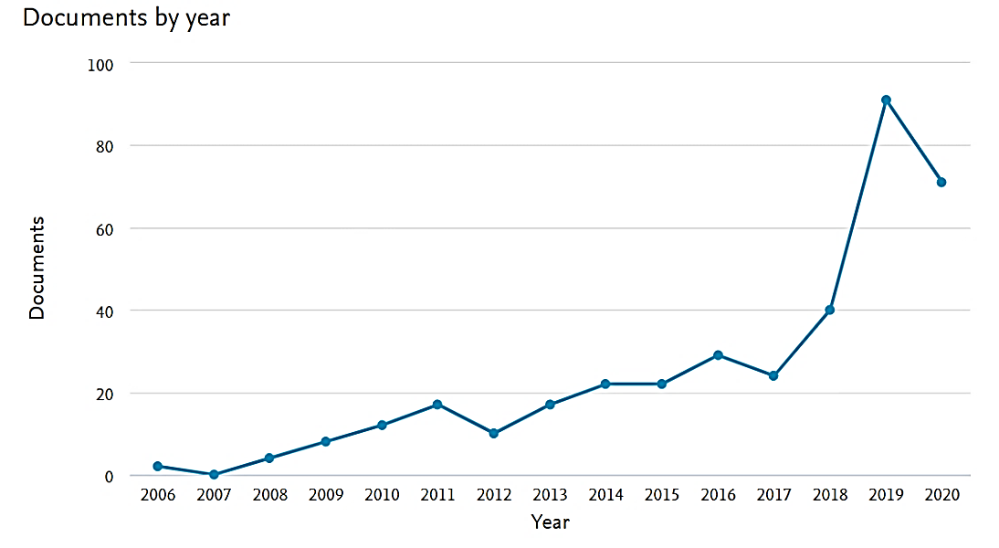
Figure 1. Publication trend report for 367 papers on SCF between 2006 and 2020

Citations have been consistent, averaging in the hundreds over the period. The maximum number of publications cited are from 2019 followed by 2017 then 2016. In the last decade, the number of publications from 2019 was significant with the highest number of publications at 91, an increase of 24.80%.

  - Data Analysis
Analysis of data is carried out to identify the most prolific researchers and their contributions through research papers in journals and throughout institutions. It also helps to identify the number of citations and co-citations of the most significant authors. Therefore, bibliometric and network analysis are carried out as a part of data analysis (Merigó and Yang, 2020); this is documented and presented in Sections 4 and 5 respectively. The bibliometric and network analysis uses software/tools such as CiteSpace, VOSviewer, Tableau and CitNetExplorer to conduct a broad and holistic search of relevant articles in the selected databases to deliver the scientific output (Xu et al., 2020).
The bibliometric analysis may provide holistic results with respect to the classical approach for review (Xu et al., 2018; Xu et al., 2020) thereby providing a wider range of insightful and innovative results for future study in the field of SCF.

- Bibliometric Analysis
Table 2 depicts the summary of 367 documents; of these, 238 are articles, 107 are conference papers and 32 are book chapters.
Table 2. Summary of bibliometric analysis
Description | Results
Documents  Sources (Journals, Books, etc.)  Article  Conference paper  Others  Keywords plus (ID)  - “Supply Chain Finance”  - “Supply Chain Financial”  - “Supply Chain Financing”  - “Financial Supply Chain”  - “Supply Chain Finances”  Period  Total Citations  Organisation  Authors | 367  238  107  32  232  25  32  05  165  2006-2020  2259  583  161

The table also illustrates that the number of keywords cited is Supply chain finance (232 times), Supply chain financial (25 times), Supply chain financing (32 times), Financial supply chain (5 times) and Supply chain finances (165 times). The articles are cited by 161 authors with a total of 2259 citations. Details of the bibliometric analysis are presented in the subsequent sub-sections.

  - Top Contribing Author’s Influence
Table 3 shows the top thirty authors and the number of articles published, either as a single or multiple co-authorship in the area of SCF.
Table 3. Top thirty contributing authors and articles published
S. No. | Authors | Documents | Citations | Total link strength
1 | Yan N. | 11 | 153 | 24
2 | Gelsomino L.M. | 6 | 146 | 18
3 | Perego A. | 4 | 144 | 12
4 | Wuttke D.A. | 4 | 141 | 4
5 | Blome C. | 3 | 141 | 6
6 | Sun B. | 4 | 128 | 9
7 | Liu C. | 4 | 95 | 11
8 | Basu P. | 2 | 94 | 1
9 | Wagner S.M. | 3 | 89 | 0
10 | More D. | 2 | 88 | 1
11 | Mangiaracina R. | 2 | 85 | 6
12 | Tumino A. | 2 | 85 | 6
13 | Zhang H. | 2 | 80 | 6
14 | Hofmann E. | 6 | 79 | 3
15 | Henke M. | 2 | 75 | 3
16 | Caniato F. | 3 | 71 | 5
17 | Chen X. | 8 | 71 | 16
18 | Ronchi S. | 2 | 67 | 4
19 | Jia F. | 4 | 66 | 9
20 | Protopappa-Sieke M. | 2 | 65 | 2
21 | Xu X. | 4 | 58 | 11
22 | Gong Y. | 2 | 54 | 5
23 | Wang G.J. | 3 | 51 | 9
24 | Xie C. | 3 | 51 | 9
25 | Zhu Y. | 3 | 51 | 9
26 | Chen J. | 4 | 48 | 7
27 | Zhou Y.W. | 3 | 45 | 1
28 | Kouvelis P. | 4 | 43 | 3
29 | Zhao X. | 4 | 41 | 4
30 | Yan X.G. | 2 | 40 | 6

As can be inferred from the Table 3, Yan, N. dominates in terms of the publications with a total of 11 documents out of 367 with 153 citations and link strength of 24. However, Gelsomino, L. M., Perego, A., Wuttke, D. A. have 6, 4 and 4 documents with link strength of 18, 12 and 4 respectively; the number of citations are 146, 144 and 141 respectively. Chen X. has published 8 articles with only 71 citations, but the link strength is 16, higher than the author (Wuttke) with 141 citations.

  - Affiliation Statistics
Using the bibliometric tools, affiliation statistics were extracted. The top 10 papers and authors are presented in Appendix E. It is inferred that Pfohl and Gomm (2009) have maximum citations of 137 for the article that highlights SCF along with the optimization of the cost of capital. The next most highly cited article with 82 citations is authored by Gelsomino et al. (2016) who presented a comprehensive literature review from 2000 to 2014. Yan et al. (2016) had 80 citations in the International Journal of Production Economics (IJPE); they concluded that SCF maximised profit and improved supply coordination. Appendix F highlights a comprehensive classification of the literature on the basis of economy and top cited journals,. China has published around 243 articles out of the 367 examined, followed by United States and United Kingdom. The maximum number of articles has been published in IJPE with 22 articles followed by Journal of Purchasing and Supply Management with 10 articles..

  - Geographical (Country-Wise) Statistics
Contributions across economies in terms of number of published papers have been shown in Figure 2. Developed economies such as China, USA and UK have a significant number of collaborative researches. It is evident that the developing economy perceptive is also well incorporated into research alongside work on developed economies.
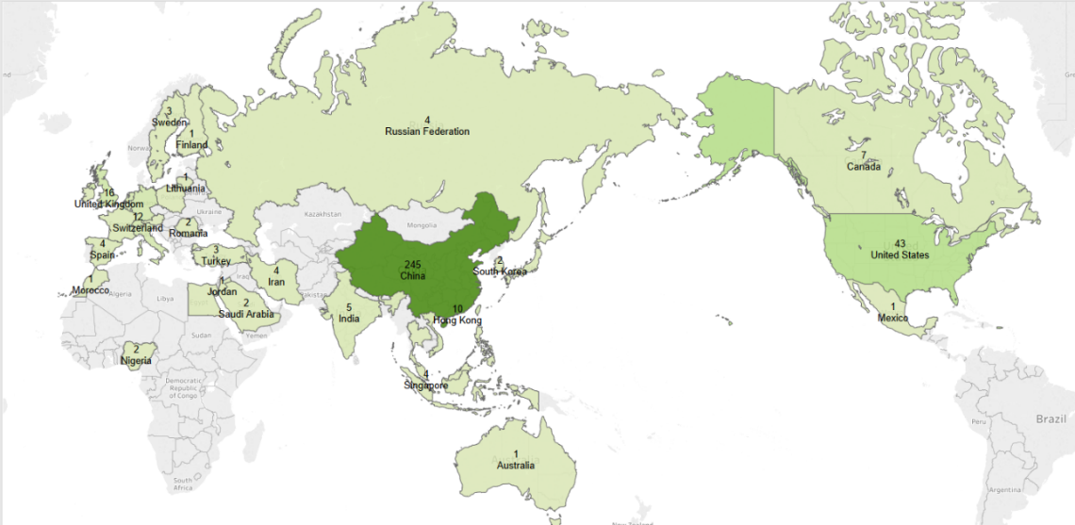
Figure 2. Contributions across economies in terms of number of published papers

From Figure 2, it can be seen that China leads in terms of article production with 245 articles and 831 citations; this is followed by USA with 43 articles and 373 citations and UK with 16 articles with 334 citations. This demonstrates how the topic of SCF is being adopted across a vast number of universities; research is in practice with academics exploring the area in more depth.

  - Geographical (Country-Wise) Statistics
This sub-section identifies the most commonly used keywords, either present in a search or paper title with the help of VOSviewer. A list of the most frequently used words is presented in Table 4.
Table 4. Keyword occurrences with link strength
S. No. | Keyword | Occurrences | Total link strength
1 | Supply Chain Finance | 232 | 1151
2 | Supply Chain Finances | 165 | 1080
3 | Risk Assessment | 50 | 320
4 | Decision Making | 32 | 201
5 | Risk Management | 29 | 210
6 | Supply Chain Financials | 25 | 170
7 | Blockchain | 22 | 85
8 | Capital Constraints | 20 | 149
9 | Electronic Commerce | 19 | 107
10 | Trade Credit | 18 | 113
11 | Credit Risk | 16 | 102
12 | Reverse Factoring | 16 | 67
13 | Credit Risks | 15 | 117
14 | Industry | 15 | 113
15 | Stackelberg Game | 15 | 105
16 | Capital Constraint | 12 | 81
17 | Supply Chain Financings | 12 | 90
18 | Inventory Financing | 10 | 48
19 | Stochastic Systems | 10 | 71
20 | Optimal Order Quantity | 9 | 86

The total link strength specifies the number of articles or documents in which two keywords occur together. In this context, “Supply chain finance” and “Supply chain finances” are found to occur 232 and 165 times in the articles with designated link strength of 1151 and 1080 respectively.
Multiple keywords in the research domain of SCF, such as supply chain finance, risk assessment, blockchain, trade credit and decision making have also been highlighted in Figure 3.
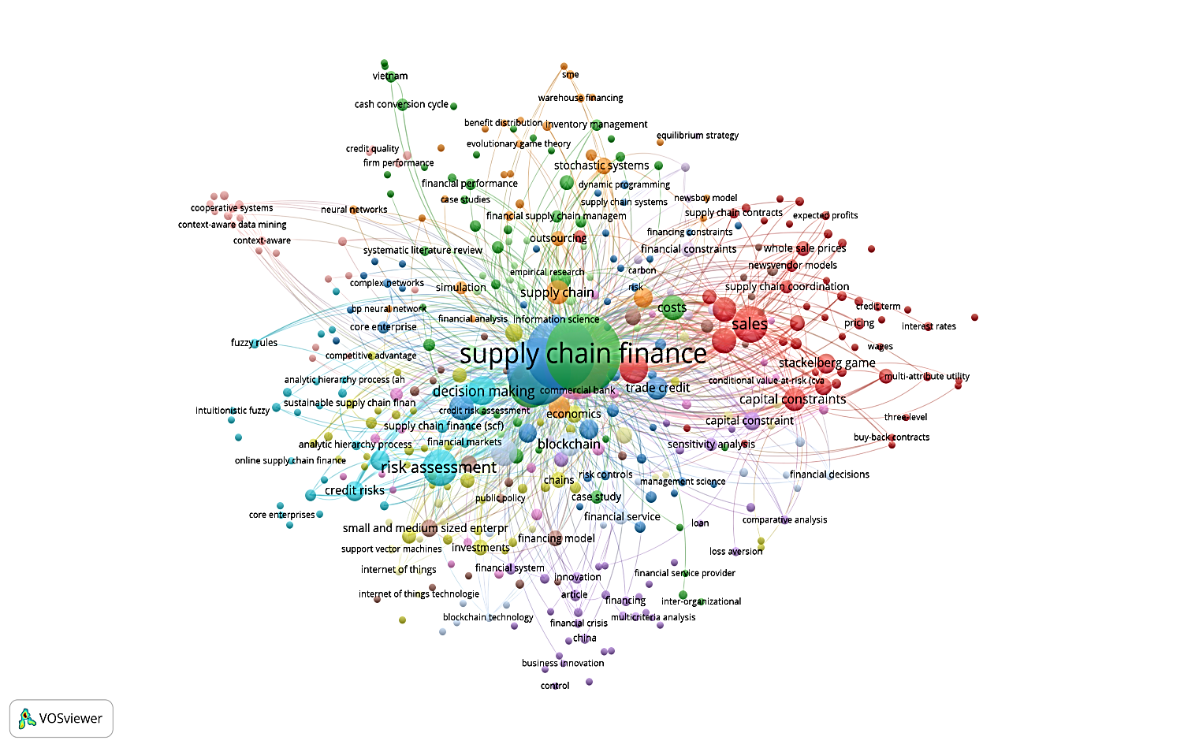
Figure 3. Density visualisation based on the authors' keywords

This shows the growing network and interest among researchers as well as greater use of SCF in more diverse sectors of business.
- Network Analysis of Research Publications
In this section, citation, co-citation analysis, cluster analysis and thematic mapping have been critically assessed and highlighted. The study has used the extracted bibliographic data with the help of VOSviewer and other tools.

  - Citation Analysis
To study the degree of connectivity among articles, citation analysis is used. In citation analysis, as shown in Appendix K, the current study highlights Yan, N. with 11 documents as having most global citations - 153 with a total link strength of 167. Gelsomino L.M. and Perego, A. have global citations of 146 and 144 with link strength of 253 and 234 respectively. Figure 4 shows the author’s citation per year.
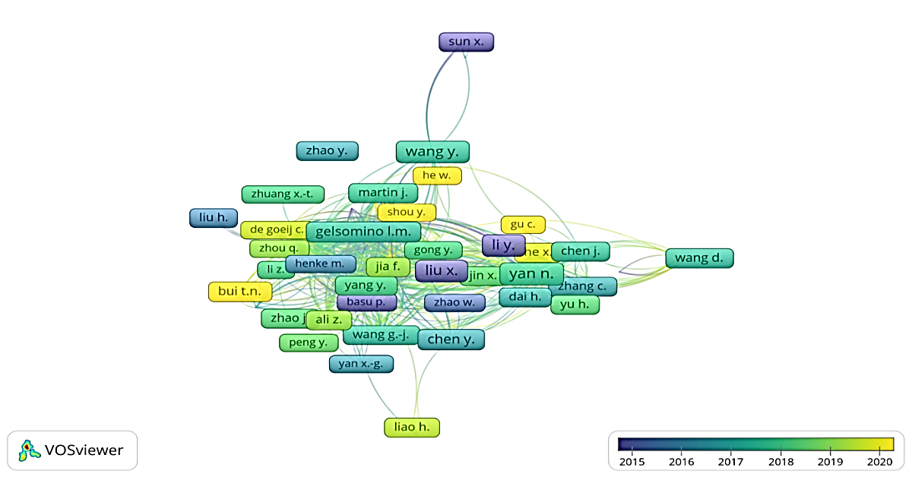

Figure 4. Author citations per year

There is an increase in the number of citations per author from 2018 onwards. Starting from Gelsomino L. M to Bui, T. N., citations are increasing. This demonstrates the growth in this area year on year.

  - Co-Citation Analysis
Co-citation analysis explores the data structure that is dependent on the exploratory data analysis, specifically on graph theory (Pampel, 2004). Figure 5 shows the co-citation of articles by authors based on bibliographic coupling.
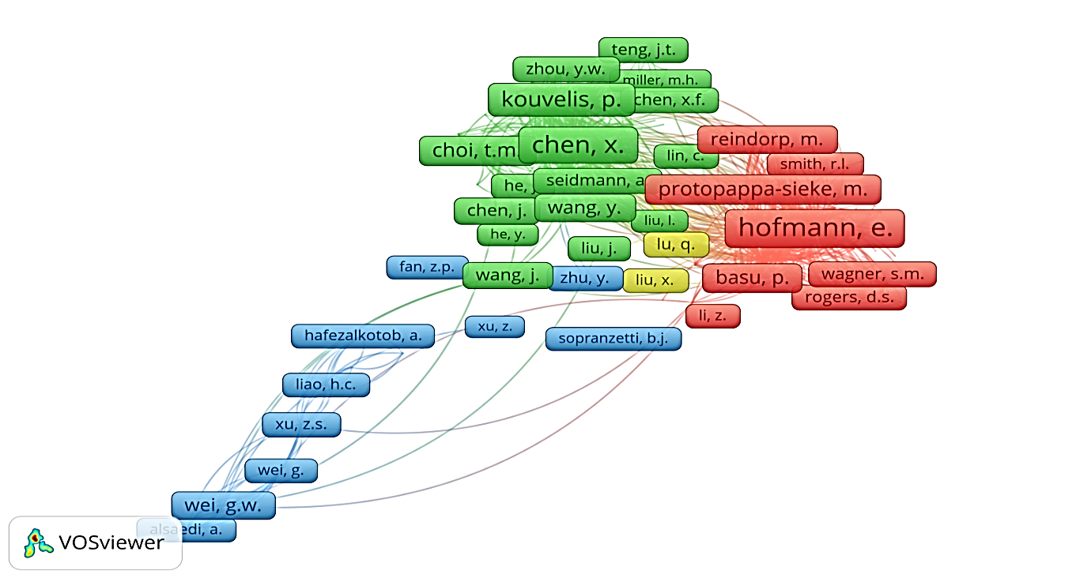
Figure 5. Term Co-Citation based on authors

This shows how two articles may be cited by a third article for example. Authors like Hoffman and Chen are referred to and cited by other authors on many occasions.

    - Cluster analysis
Cluster analysis is considered to be critical in network analysis which mainly includes authors, keywords and articles (Waltman et al., 2010). Figure 6 depicts the various clusters of supply chain finance highlighted with the help of circles.
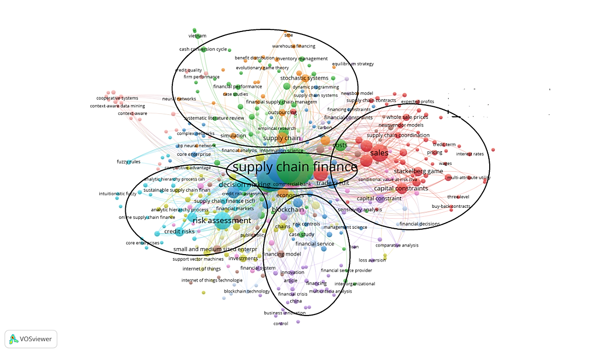
Figure 6. Cluster analysis

Table 5 shows the most important clusters. Four major research clusters were identified - decision, performance, technology and strategy as well as process and modelling.
Table 5. Significant clusters with keywords
Cluster | Name of the cluster | Keywords
Cluster-1 | Decision | Supply Chain Finance Decision
Cluster-2 | Performance | Supply Chain Finance Performance
Cluster-3 | Technology and Strategy | Vendor Financing, Supply Chain Finance Technology, Supply Chain Finance Strategy, Supply Chain Finance theory, Supply Chain Finance Design, Supply Chain Finance Risk, Supply Chain Fiancé Network
Cluster-4 | Process and Modelling | Supply Chain Fiancé Solutions, Supply Chain Finance Modeling, Inventory Financing, Supply Chain Finance Measures, Global Supply Chain Finance, Supply Chain Finance innovation, Supply chain Finance Process, Supply Chain Finance Uncertainty, Supply Chain Finance adoption, Supply Chain Trade Credit, Supply Chain Finance capabilities, Supply Chain Finance Asymmetry, Supply Chain Finance Analytics, Supply Chain Finance Crisis, Supply Chain Finance Drivers, Supply Chain Finance and industry 4.0, Specialising Supply Chain Finance solutions, Supply Chain Finance Instrument, Supply Chain Finance Enabler, Supply Chain Finance Sustainability, Internet Supply Chain Finance, Cross Boarder Supply Chain Finance, Distributor Financing, Supply Chain working Capital Management

Bals (2018) proposed an SCF framework with respect to the life-cycle dimension and stakeholder perspective. However, we have analysed the different dimensions within clusters as per the network analysis and a qualitative assessment of the content in the clusters are discussed.

Cluster 1: SCF Decision: Impact of decision making for SCF collaboration
This cluster constitutes 30.79 % of the total co-citation network (i.e. 113 papers) based on the abstract only. To assess the research avenues in this cluster, the papers need to be explored thoroughly. The majority of papers are in this cluster as every business, while implementing SCF, needs to take decisions at every step. The stakeholders involved in the supply chain financial framework - buyers, suppliers, service providers and financial institutions - need to evaluate their plans of work either through a case study or focus group study (Reverte, 2020). In this regard, it would be wise to implement big data analytics that will facilitate in decision making while improving the performance of the exchange partners.

Cluster 2: SCF Performance
With 72 articles from 2006 to 2020, this cluster constitutes about 19.61 % of the total number of documents searched based on the abstract. Yuan-yuan et al. (2010) have measured the SCF performance of a firm using system dynamics. It is evident that SCF performance will improve once the risk across the supply chain is mitigated. This cluster discusses various strategies to mitigate financial and operational risks. There is a critical need to adopt new, innovative technologies and appropriate methodologies to make the system more robust and be able to react to any unexpected events in the best possible manner (Trollman and Colwill, 2021).

Cluster 3: SCF Technology and Strategy
The keywords related to SCF technology and strategy are searched within the title as well as abstract; this revealed that SCF technology is used 64 times; SCF strategy is used 40 times; SCF theory, design, risk and network appear 62, 70, 222 and 51 times respectively.
Ali et al. (2020) set out to investigate SC risk as a mediator in measuring business performance. Therefore, strengthening the financial risks in a supply chain is the core idea. Li et al. 2016 have conducted a study on banks, developing an SC risk assessment measure. Ling (2014) used fuzzy AHP to predict financial risk in a pharmaceutical supply chain. Zhao et al. (2018) have concluded that a proper understanding of the transmission of credit risk in SCF network is very important for a company. In order to have a responsive supply chain, supply chain design configuration and a proper SC strategy in place is essential (Minh and Osei‐Amponsah, 2021).

Cluster 4: SCF Process and Modelling
This cluster focuses mainly on the processes and modelling of SCF. Supply chain trade credit, information asymmetry, SCF modelling, SC finance flows and framework are highlighted in this cluster. In addition to this, a remarkable number of papers contributed to the practical and analytical development of SCF leading towards sustainability of SCF. Jia et al. (2020) have conducted a literature review on sustainable supply chain finance. Further, Zhou et al. (2018) have studied the use of IT and financial approaches for achieving sustainability in an agriculture supply chain. Therefore, awareness of the benefits of achieving sustainability among customers is very important. Supply chain finance adoption should aim to integrate incoming accounts, inventory and outgoing accounts. The major factors affecting adoption are apparent capital pressure, order fulfilment and inventory turnover (Wang et al., 2020). Alora and Barua (2019) have investigated the critical barriers in SCF adoption. Still, many hurdles exist to achieving sustainability through technology adoption. The best way is to use a combination of IoT, blockchain and smart contracts that can help to provide transparency and trust among all the collaborators in the supply chain.
Appendix M presents the wider areas of application of SCF and the relevant tools and techniques used. The sector most explored is small and medium-sized enterprises (SMEs). The role of SCF in facilitating and promoting SMEs is inevitable. The techniques used most include game theory, SEM and panel data analysis. The next contribution of SCF is seen in 3PL enterprises which handle risks around exchange of data and financial flows across the value chain. In this sector, game theory and neural network are mostly used. Similarly, game theory, big data analytics and simulation are also applied to the banking sector for the application of SCF. New and emerging areas with respect to SCF can be in construction, tobacco supply chains, agricultural SC, judicial system, e-commerce sector and in pharmaceuticals. Figure 7 shows the thematic analysis of current and future research areas in the broad area of SCF using NVivo software. As per the literature review, thematic analysis is done for identifying emerging research areas in this paper which is unique in its own kind and contribute to the body of the literature. It can be seen that the current and ongoing research areas are supply chain credit rating, supply chain contract design, financing decisions, financing models, SMEs financing, military financing models, financing strategy and financing decision-making. Some of the new and emerging areas of research are low-carbon SCF, agricultural SCF, global SCF, block chain-driven SCF and digital SCF.
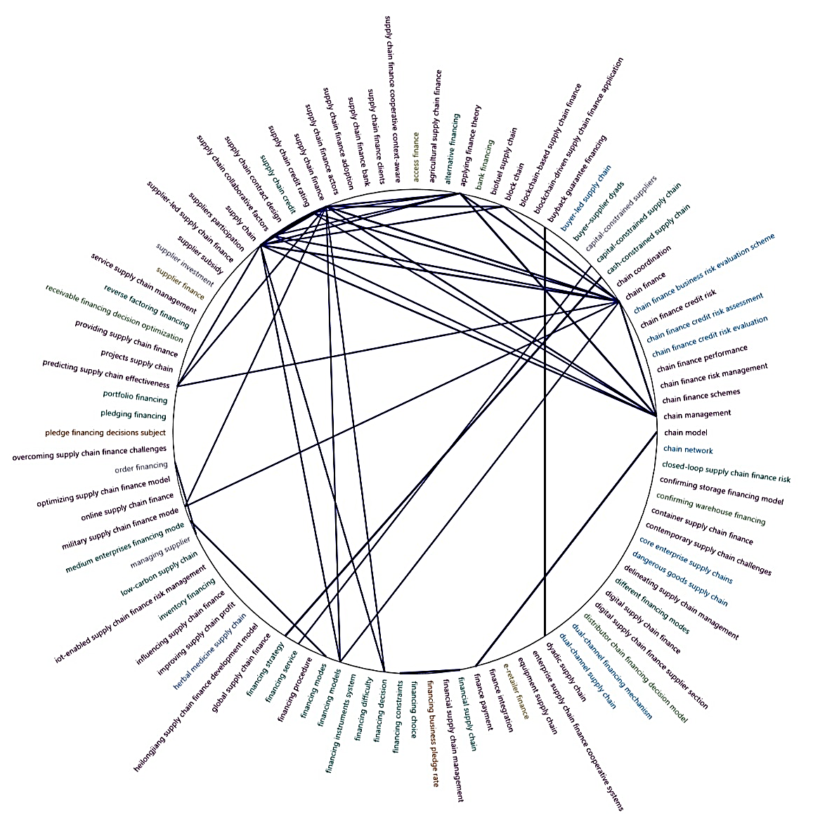
Figure 7. Current and future thematic research mapping

- Research Gaps and Future Research Propositions
With regard to the broad area of SCF based on bibliometric analysis, this section discusses the research gaps and possible future directions for research. This will be helpful for academicians, practitioners and scholars to identify and evaluate the emerging and prospective studies required to be carried out in future; this is presented in Table 6. This table explicitly presents a comparison between Gelsomino’s, Xu’s and this paper.
Table 6: Comparison of SCF Reviews (Author’s compilation)
Criteria | Gelsomino et al. (2016) | Xu et al. (2018) | Our Paper
Time limit set | 2000-2014 | 1970-2016 | 2006-2020
Database | Science Direct, Scopus, Web of Knowledge | Scopus and EBSCO | Scopus
Research Methodology | None | None | PRISMA methodology
Focus | Basic concepts and solutions of SCF | SCF aspects | All aspects of SCF along with SCF decisions, SCF strategy and SCF approaches
Literature Review methods | Methodology pertaining content analysis | Bibliometric, network and content analyses | Bibliometric, citation, co-citation, cluster, and thematic analyses
Findings | Finance and supply chain-based perspectives are discussed | SCF perspectives are highlighted in selection of keywords.  Four research clusters are identified. | Sector-wise application of SCF and used Tools/Techniques are identified.  Four clusters are identified with focus on emerging areas focus.
Gaps and future research directions | Generic theory of SCF is not presented.  Empirical-based analysis is needed.  The impact of SCF on the SCF performance needs to work on further.  --------  --------  -------- | --------  Case study and empirical approaches are required to be done.  Multi-tier SC and different forms of trade credit policies and financing policies need to be introduced.  There should be relaxation of the assumptions.  Discussed the collaboration between SCF and sustainable SCM  SCF should be combined with specific industry sectors | Current and future research areas need to be identified based on the analysis undertaken and future work is proposed.  Future research needs to focus more on emerging tools and techniques and its application on various sectors.  Applications of operational hedging strategies are proposed for various stages of SC.  Assumptions should be made based on various criteria to be considered for a supply chain.  Research framework proposed for achieving viable and sustainable SCF.  SCF should be combined with new and emerging areas to make the SC sustainable.

Based on the gaps identified in this paper, a unique method has been used to enhance the credibility of this research. This is facilitated in terms of unique research propositions by a triangulation approach as shown in Figure 8. The dotted-lined boxes in Figure 8 represent the author’s contributions whereas the full-lined boxes show the data extracted either from the literature review or from different theories. The triangulation approach applied in this paper is unique as it has considered various ways of data collection to provide complete understanding and interpretation (Patton, 1999).
In this paper, we have taken into account the literature reviews, outcomes of the research paper through analysis and the author’s unique contributions. Based on these, the future directions for research are identified and proposed in a step-by-step framework as discussed in subsequent paragraphs.
In order to evaluate the collaboration between finance and SC functions, the first and foremost step is to understand the various entities in the SC, starting from the placement of orders to payment towards the end. The next step is to examine the role of financial institutions with respect to four important criteria viz. funding amount, duration and timing, rate of financing and cost of capital. The same is again applied to various streams of SCF, such as equity-related finance, fixed-asset finance and Working Capital Finance (WCF); this can be made applicable to various sectors with the help of emerging models. These models are then used to determine strategies at different stages of the value chain either at the supplier stage, logistics stage or buyer stage. Much of the current literature shows that more focus has been placed on the material and information flow, whereas very little attention has been given to the financial flow in the value chain; this is a critical research need. In this regard, it is essential to focus on strategies related to financial, buyer and supply chain-oriented perspectives. The major identified areas where the concept can be applied are pharmaceutical SC, low carbon, SC, agricultural SC, digital SC, healthcare SC, food and service SC, bio-fuel SC, etc. There are widely used emerging models like analytical (qualitative and quantitative), case studies, interviews, simulation, game theory, and surveys which will facilitate in understanding the collaboration and application between the entities.

Collaboration between finance and supply chain (SC) function
Understanding the SC and its various entities
- Placement of orders
- Managing inventory
- Production/manufacturing process
- Shipment of final product
- Receipt of product
- Receipt of inventory
- Payment towards the end

Role of Financial Institutions w.r.t various criteria
- Equity-related finance (M&A, IPO, Joint venture)
- Fixed-asset finance (financing of equipment, vendor leasing, subsidies to suppliers)
- WCF (trade credit, reverse factoring)

- Funding amount
- Duration & timing
- Rate of financing
- Cost of Capital
Examining the interplay between Theory and Practice
Application of the concept in various sectors
- Low-carbon SCF
- Pharmaceutical SCF
- Agricultural SCF
- Digital SCF
- Healthcare SCF
- Food SCF
- Service SCF
- Bio-fuel SCF
Application of new/emerging models at various SC parties
- Analytical model
- Conceptual model/framework
- Case studies
- Interviews
- Surveys
- Simulation
- Game theory

Supplier Stage
Logistics Stage
Buyer Stage
Operational hedging strategies as per classification of SCF
- Financial aspect
- Risk analysis
- Wrong capital Management (WCM)
- Innovative & short-term solutions
- Focus on payables & receivables
- Shipment (pre-in transit-post) financing solutions
- Upstream
- Downstream
- Single-buyer-single supplier dyad
- Multi-buyer multi-supplier dyad
- Non-dyadic supply chain setups
- Multi-tier supply chain
- Expansion of Capacity
- Buffering
- Pooling
- Contingency plans
- Resource flexibility
- Capacity reservation
- Buyer Perspective
- Improve/ensure transparency & flexibility
- Providing capital to suppliers at marginal price/rate
- Introduce & involve new players
- Supply chain-oriented Perspective
- Shifting inventories from a supplier
- Fixed-asset financing
Sustainable Supply Chain Finance (SSCF)

Figure 8. Proposed framework for future research direction using triangulation approach
The major contribution of this paper lies in the identification of operational hedging strategies that lead towards Sustainable Supply Chain Finance (SSCF) in line with the Sustainable Development Goals (SDGs). Furthermore, most literature has not considered all the aspects of the supply chain - upstream, downstream, single-buyer-single supplier dyad, multi-buyer multi-supplier dyad, non-dyadic supply chain setups and multi-tier supply chains; this needs to be considered in order to be resilient and sustainable in the long term. The introduction of an efficient feedback loop will monitor the process and update its on-going process. In this context, selected opportunities for future research in SCF are suggested in Table 7.
Table 7: Selected opportunities for future research on SCF
Elements of the SCF clusters | Research gaps | Examples of research questions
SCF Decision | Research has considered a few matrices and models to arrive at a decision | - RQ1: What are the metrics and decision-making models that can achieve sustainable SCF?  - RQ2: What is the impact of consideration of ethical and legal issues in green SCF?  - RQ3: How do big data analytics help in improving the performance between exchange partners?
SCF Performance | Research has rarely investigated the theoretical understanding of SCFs | - RQ4: How do operational management theories contribute to the SCF body of knowledge?
SCF Technology and Strategy | Research has mostly focused on few/limited sectors/industries and countries | - RQ5: What are the various applications of SCF in sectors like bio-fuel, healthcare, pharmaceutical, agriculture, food, digital etc.?  - RQ6: Can SCF help in improving low-carbon SC?  - RQ7: How wil industry 4.0 technologies help in achieving sustainable SCF?  - RQ8: Do the critical success factors in SCF vary for different industries across various countries?  - RQ9: Can a cross-country analysis of SCF help in achieving sustainability across the supply chain partners?
SCF Process and Modelling | Research has considered only single-buyer or single supplier supply chain stage | - RQ10: How do multi-buyer and multi-supplier dyads influence SCF process?  - RQ11: Do the operational hedging strategies affect the SCF stages?  - RQ12: How can we measure the trust between the SCF collaborators?  RQ13: How does IoT, blockchain and smart contracts help in transparency in information and authentication across SCF?

With respect to the important SCF clusters identified through the systematic review, the research gaps are further identified across the clusters, and the areas/topics for future research were identified and stated in the form of the research questions. These research questions will help the researchers and academicians to choose their orientation and contribute to the body of knowledge.

- Conclusion
This paper is valuable in displaying the current research undertaken by authors globally; it also highlights new and emerging research avenues that can eventually help in the application of SCF in various sectors leading towards more sustainable and viable supply chains. The framework illustrated in Section 6 is unique and one-of-its-kind contribution which will help practitioners and stakeholders to make better investment and operational decisions. According to bibliometric analysis, some of the important conclusions are as follows: (1) the total number of publications in the broad area of SCF has been increasing, showing its acceptance and relevance in supply chain decision making; (2) International Journal of Production Economics is the most influential journal; (3) Yan, N. is the most prolific author in terms of publications with a total of 11 documents out of 367 with 153 citations (4) Central University of Finance and Economics imakes the biggest contribution to our research area (5) China is the country publishing the maximum number of publications. Furthermore, a citation analysis, co-citation analysis, co-occurrence and bibliometric coupling have been conducted to discover some meaningful results; insights from these are now drawn.
Looking at the current pandemic situation, the major focus nowadays is to reach out to the SMEs and other sectors like healthcare, agriculture, food SC, service SC and pharma SC which have all been widely disrupted amid this epidemic. Moreover, financial transactions play a major role in mitigating the risks and ripple effects in the SC. In this context, the policy makers and stakeholders need to focus more on the various aspects of the SC to make it more sustainable. However, researchers also need to work on minimising carbon footprints as well as devising a generic model to measure the environmental performance index applicable for all the sectors.
However, there are some limitations to this research work. The data source was from Scopus; this may change over time. This may lead to a change in the trend of bibliometric analysis. The study could be extended by including more articles in the area of SC disruption modelling by exploring other databases such as ProQuest or Google Scholar.

References
Abdel-Basset, M., Mohamed, R., Sallam, K., & Elhoseny, M. (2020). A novel decision-making model for sustainable supply chain finance under uncertainty environment. Journal of Cleaner Production, 269, 122324
Ali, Z., Gongbing, B., & Mehreen, A. (2018). Does supply chain finance improve SMEs performance? the moderating role of trade digitization. Business Process Management Journal, 26(1), 150-167.
Ali, Z., Gongbing, B., & Mehreen, A. (2019). Predicting supply chain effectiveness through supply chain finance: Evidence from small and medium enterprises. International Journal of Logistics Management, 30(2), 488-505.
Ali, Z., Gongbing, B., Mehreen, A., & Ghani, U. (2020). Predicting firm performance through supply chain finance: a moderated and mediated model link. International Journal of Logistics Research and Applications, 23(2), 121-138.
Allen, C., Metternicht, G., and Wiedmann, T. (2021). Priorities for science to support national implementation of the sustainable development goals: A review of progress and gaps. Sustainable Development, Vol. 29 (4), 635-652
Alora, A., & Barua, M. K. (2019). Barrier analysis of supply chain finance adoption in manufacturing companies. Benchmarking: An International Journal, 26(7), 2122-2145.
Amirbagheri, K., Núñez-Carballosa, A., Guitart-Tarrés, L., & Merigó, J. M. (2019). Research on green supply chain: a bibliometric analysis. Clean Technologies and Environmental Policy, 21(1), 3-22.
Bals, C. (2019). Toward a supply chain finance (SCF) ecosystem–Proposing a framework and agenda for future research. Journal of purchasing and supply Management, 25(2), 105-117.
Birge, J.R., 2015. OM forum-Operations and finance interactions. Manufacturing & Service Operations Management, 17, 4-15.
Budin, M., & Eapen, A. T. (1970). Cash generation in business operations: some simulation models. The Journal of Finance, 25(5), 1091-1107.
Bui, T. N. (2020). How do financial leverage and supply chain finance influence firm performance? evidence from construction sector. Uncertain Supply Chain Management, 8(2), 285-290.
Bui, T. N., & Doan, T. (2020). Factors influencing supply chain finance of real estate sector: Evidence using GMM estimation. Uncertain Supply Chain Management, 8(3), 627-632.
Buzacott, J. A., & Zhang, R. Q. (2004). Inventory management with asset-based financing. Management Science, 50(9), 1274-1292.
Cai, Y. J., Chen, Y., Siqin, T., Choi, T. M., & Chung, S. H. (2019). Pay upfront or pay later? Fixed royal payment in sustainable fashion brand franchising. International Journal of Production Economics, 214, 95-105.
Camerinelli, E. (2009). Supply chain finance. Journal of Payments Strategy & Systems, 3(2), 114-128.
Cancino, C., Merigó, J. M., Coronado, F., Dessouky, Y., & Dessouky, M. (2017). Forty years of Computers & Industrial Engineering: A bibliometric analysis. Computers & Industrial Engineering, 113, 614-629.
Caniato, F., Gelsomino, L. M., Perego, A., & Ronchi, S. (2016). Does finance solve the supply chain financing problem?. Supply chain management: an international journal, 21, 534-549.
Chakuu, S., Masi, D., & Godsell, J. (2020). Towards a framework on the factors conditioning the role of logistics service providers in the provision of inventory financing. International Journal of Operations and Production Management. https://doi.org/10.1108/IJOPM-06-2019-0502
Chang, C.T., Teng, J.T., Goyal, S. K., 2008. Inventory lot-size models under trade credits: A review. Asia-Pacific Journal of Operational Research, 25, 89-112.
Chen, C. (2006). CiteSpace II: Detecting and visualizing emerging trends and transient patterns in scientific literature. Journal of the American Society for information Science and Technology, 57(3), 359-377.
Chen, J., Cai, T., He, W., Chen, L., Zhao, G., Zou, W., & Guo, L. (2020). A blockchain-driven supply chain finance application for auto retail industry. Entropy, 22(1), 95.
Chen, T., & Wang, D. (2020). Combined application of blockchain technology in fractional calculus model of supply chain financial system. Chaos, Solitons & Fractals, 131, 109461.
Chen, X., & Hu, C. (2011). The value of supply chain finance. Supply Chain Management-Applications and Simulations, 111-132.
Chen, X., Cai, G., 2011. Joint logistics and financial services by a 3PL firm. European Journal of Operational Research 214, 579–587.
Chen, Y., & Chen, H. (2010). Study on comprehensive evaluation for small and medium enterprises in supply chain finance. In 2010 IEEE International Conference on Industrial Engineering and Engineering Management (pp. 1655-1660). IEEE.
Choi, T. M. (2020). Supply chain financing using blockchain: impacts on supply chains selling fashionable products. Annals of Operations Research, 1-23.
Chong, A. Y. L., Chan, F. T., Goh, M., & Tiwari, M. K. (2013). Do interorganisational relationships and knowledge-management practices enhance collaborative commerce adoption?. International Journal of Production Research, 51(7), 2006-2018.
Dada, M., & Hu, Q. (2008). Financing newsvendor inventory. Operations Research Letters, 36(5), 569-573.
de Goeij, C. A., Onstein, A. T., & Steeman, M. A. (2016). Impediments to the adoption of reverse factoring for logistics service providers. In Logistics and supply chain innovation (pp. 261-277). Springer, Cham.
Dekkers, R. (2015). Applied systems theory. Zurich, Switzerland: Springer International Publishing.
Dekkers, R., de Boer, R., Gelsomino, L. M., de Goeij, C., Steeman, M., Zhou, Q.,Sinclair, S. & Souter, V. (2020). Evaluating theoretical conceptualisations for supply chain and finance integration: A Scottish focus group. International Journal of Production Economics, 220, 107451.
Dong, G., Wei, L., Xie, J., Zhang, W., & Zhang, Z. (2019). Two-echelon supply chain operational strategy under portfolio financing and tax shield. Industrial Management & Data Systems, 120(4), 633-656.
Du, H., Kuang, H., & Zhang, X. (2019). The formation mechanism of SMEs' credit risk under supply chain finance based on game theory. In 2019 International Conference on Economic Management and Model Engineering (ICEMME) (pp. 368-372). IEEE.
Erol, I., Ar, I. M., Ozdemir, A. I., Peker, I., Asgary, A., Medeni, I. T., & Medeni, T. (2020). Assessing the feasibility of blockchain technology in industries: Evidence from Turkey. Journal of Enterprise Information Management. https://doi.org/10.1108/JEIM-09-2019-0309
Fabbri, D., & Klapper, L. F. (2016). Bargaining power and trade credit. Journal of corporate finance, 41, 66-80.
Fayyaz, M. R., Rasouli, M. R., & Amiri, B. (2020). A data-driven and network-aware approach for credit risk prediction in supply chain finance. Industrial Management & Data Systems. https://doi.org/10.1108/IMDS-01-2020-0052
Forbes (Sepetember, 2020). “How Organizations Need To Manage Supply Chain Risk Today”. Retrieved from https://www.forbes.com/sites/benjaminlaker/2020/09/07/why-organizations-need-to-manage-supply-chain-risk-today/?sh=33c758ab3b74
Friemann, F., Wandfluh, M., Schönsleben, P., & Alard, R. (2012). Improving the application of financial measures in supply chain management. In IFIP International Conference on Advances in Production Management Systems (pp. 584-591). Springer, Berlin, Heidelberg.
Gao, J., Zhang, J., Chen, X., Ding, X., Chen, R., & Yang, L. (2019). On supply chain performance and efficiency under purchase order financing together with reverse factoring financing. In 2019 16th International Conference on Service Systems and Service Management (ICSSSM) (pp. 1-6). IEEE.
Gelsomino, L. U. C. A., Mangiaracina, R., Perego, A., & Tumino, A. (2016). Supply chain finance: a literature review, International Journal of Physical Distribution & Logistics, 348-366.
Godil, D. I., Yu, Z., Sharif, A., Usman, R., and Khan, S. A. R. (2021). Investigate the role of technology innovation and renewable energy in reducing transport sector CO2 emission in China: A path toward sustainable development. Sustainable Development, Vol. 29 (4), 694-707.
Gomm, M. L. (2010). Supply chain finance: applying finance theory to supply chain management to enhance finance in supply chains. International Journal of Logistics: Research and Applications, 13(2), 133-142.
Guo, S., & Liu, N. (2020). Influences of supply chain finance on the mass customization program: Risk attitudes and cash flow shortage. International Transactions in Operational Research, 27(5), 2396-2421.
Gupta, N., & Soni, G. (2021). A decision-making framework for sustainable supply chain finance in post-COVID era. International Journal of Global Business and Competitiveness, 1-10.
Haley, C. W., & Higgins, R. C. (1973). Inventory policy and trade credit financing. Management science, 20(4-part-i), 464-471.
Hang, L. T. M., & Tung, N. S. (2019). Supply chain finance for SMEs - case in Danang city. Operations and Supply Chain Management: An International Journal, 12(4), 237-244.
Hautala, P., Lorentz, H., & Töyli, J. (2019). Value chain perspective on the use of trade credit during the 2006–2015 business cycle–evidence from eurozone SMEs. International Journal of Logistics Research and Applications, 22(2), 204-227.
He, J., Kang, L. W., & Ma, Z. H. (2011). Comprehensive evaluation of credit risk of supply chain finance among SMEs: based on FCE. In Applied Mechanics and Materials (Vol. 58, pp. 668-673). Trans Tech Publications Ltd.
He, J., Wang, J., Jiang, X. L., Zhu, D. L., & Liu, X. X. (2015). Inventory portfolio optimization in supply chain finance: A Copula-CVaR-EVT approach. System Engineering Theory and Practice, 35(1), 1-16.
Hofmann, E. (2005). Supply chain finance: some conceptual insights. Beiträge Zu Beschaffung Und Logistik, 203-214.
Hofmann, E., & Belin, O. (2011). Supply chain finance solutions (pp. 644-645). Springer-Velag Berlin Heidelberg.
Hofmann, E., & Locker, A. (2009). Value-based performance measurement in supply chains: a case study from the packaging industry. Production Planning and Control, 20(1), 68-81.
Houston, J. F., Lin, C., & Zhu, Z. (2016). The financial implications of supply chain changes. Management Science, 62(9), 2520-2542.
Hu, Q. (2014). Research on the financing mode of small and medium-sized enterprises. In International Conference on Logistics Engineering, Management and Computer Science (LEMCS 2014). Atlantis Press.
Huang, J., Yang, W., & Tu, Y. (2020). Financing mode decision in a supply chain with financial constraint. International Journal of Production Economics, 220, 107441.
Huang, S., Fan, Z. & Wang, X. (2019). The impact of transportation fee on the performance of capital-constrained supply chain under 3PL financing service. Computers & Industrial Engineering, 130, 358-369.
Hung, J. L., He, W., & Shen, J. (2020). Big data analytics for supply chain relationship in banking. Industrial Marketing Management, 86, 144-153.
Iacono, Dello, U., Reindorp, M., Dellaert, N., 2015. Market Adoption of Reverse Factoring. International Journal of Physical Distribution & Logistics Management, 45, 286-308.
Jayaram, J., & Pathak, S. (2013). A holistic view of knowledge integration in collaborative supply chains. International Journal of Production Research, 51(7), 1958-1972.
Ji, T. (2018). Risk of chemical dangerous goods supply chain based on grey relational model. Chemical Engineering Transactions, 71, 1033-1038.
Jia, F., Blome, C., Sun, H., Yang, Y., & Zhi, B. (2020). Towards an integrated conceptual framework of supply chain finance: An information processing perspective. International Journal of Production Economics, 219, 18-30.
Jia, F., Zhang, T., & Chen, L. (2020). Sustainable supply chain Finance: Towards a research agenda. Journal of Cleaner Production, 243, 118680.
Khan, S.A.R., Zhang, Y., Kumar, A., Zavadskas, E. and Streimikiene, D. (2020), “Measuring the impact of renewable energy, public health expenditure, logistics, and environmental performance on sustainable economic growth”, Sustainable Development, 28 (4), 833–843.
Klapper, L., & Randall, D. (2011). Financial crisis and supply-chain financing. Trade Finance, 73.
Kun, T., Xintian, Z., & He, H. (2017). Research on lending decision and optimization of supply chain finance for commercial banks based on financial constraint. In 2017 29th Chinese Control And Decision Conference (CCDC) (pp. 3340-3345). IEEE.
Lai, G., Debo, L. G., & Sycara, K. (2009). Sharing inventory risk in supply chain: The implication of financial constraint. Omega, 37(4), 811-825.
Lei, S., & Haiying, W. (2020). Case study of how to help manufacturing enterprises obtain loan through supply chain documents on blockchain platform. In 2020 International Conference on Computer Engineering and Application (ICCEA) (pp. 192-195). IEEE.
Lei, S., Haiying, W., Haiyue, L., & Weiyu, T. (2020). Research of innovative business classification in bulk commodity digital supply chain finance. In 2020 International Conference on Computer Engineering and Application (ICCEA) (pp. 170-173). IEEE.
Lekkakos, S. D., Serrano, A., & Ellinger, A. (2016). Supply chain finance for small and medium sized enterprises: the case of reverse factoring. International Journal of Physical Distribution & Logistics Management, 46 (4), 1-34
Li, G. (2017). Research on credit ratings of small and medium-sized enterprises based on supply-chain finance. Agro Food Industry Hi-Tech, 28(3), 2440-2443.
Li, J., Wang, Y., Li, Y., & Li, Q. L. (2019). A simple survey for supply chain finance risk management with applications of blockchain. In International Conference of Celebrating Professor Jinhua Cao's 80th Birthday (pp. 116-133). Springer, Singapore.
Li, X., Zhang, P., Zhang, K., & Li, Y. (2016). Research on supply chain financing risk assessment of China’s commercial banks. ICIC Express Letters, 10(7), 1567-1574.
Liang, X., Zhao, X., Wang, M., & Li, Z. (2018). Small and medium-sized enterprises sustainable supply chain financing decision based on triple bottom line theory. Sustainability, 10(11), 4242.
Liao, H., Wen, Z., & Liu, L. (2019). Integrating BWM and ARAS under hesitant linguistic environment for digital supply chain finance supplier section. Technological and Economic Development of Economy, 25(6), 1188-1212.
Liebl, J., Hartmann, E., Feisel, E., & Ellinger, A. (2016). Reverse factoring in the supply chain: objectives, antecedents and implementation barriers. International Journal of Physical Distribution & Logistics Management, 46, 393-413.
Lin, C. Y. (2020). Optimal core operation in supply chain finance ecosystem by integrating the fuzzy algorithm and hierarchical framework. International Journal of Computational Intelligence Systems, 13(1), 259-274.
Lin, Q. & Peng, Y. (2019). Incentive mechanism to prevent moral hazard in online supply chain finance. Electronic Commerce Research, 1-28.
Lin, X. L., Li, H., & Ruan, C. Y. (2020). Risk measurement of supply chain finance based on the VaR model. In International Conference on Frontier Computing (pp. 1267-1275). Springer, Singapore.
Ling, Z. (2014). Research on supply chain risk evaluation based on the core enterprise-take the pharmaceutical industry for example. Journal of Chemical and Pharmaceutical Research, 6(6), 593-598.
Liu, H., Li, Z., & Cao, N. (2018). Framework design of financial service platform for tobacco supply chain based on blockchain. In International Conference on Algorithms and Architectures for Parallel Processing (pp. 145-150). Springer, Cham.
Liu, J., Li, S., & Zhu, X. (2018). Hydrological layered dialysis research on supply chain financial risk prediction under big data scenario. Discrete Dynamics in Nature and Society, 2018.
Liu, X. (2019). Evolution and simulation analysis of co-opetition behavior of E-business internet platform based on evolutionary game theory. Cluster Computing, 1-10.
Liu, X., Peng, X., & Stuart, M. (2020). Multiparty game research and example analysis in supply chain finance system based on MPDE theory. Alexandria Engineering Journal, 59, 2315–2321.
Lu, Q., & Gu, J. (2018). Effect of trade credit insurance in factoring finance. In 2018 15th International Conference on Service Systems and Service Management (ICSSSM) (pp. 1-6). IEEE.
Ma, H. L., Wang, Z. X., & Chan, F. T. (2020). How important are supply chain collaborative factors in supply chain finance? A view of financial service providers in China. International Journal of Production Economics, 219, 341-346.
Ma, L., Wang, C., Cai, F., Su, X., & Lin, M. (2018). The influence of supply chain finance on inventory management under supply uncertainty. In 2018 15th International Conference on Service Systems and Service Management (ICSSSM) (pp. 1-4). IEEE.
Martínez-Sola, C., García-Teruel, P. J., & Martínez-Solano, P. (2017). SMEs access to finance and the value of supplier financing. Spanish Journal of Finance and Accounting/Revista Espanola de Financiacion y Contabilidad, 46(4), 455-483.
McKinsey (October, 2015). Supply-chain finance: The emergence of a new competitive landscape, pp. 10-16. Retrieved from https://www.mckinsey.com/~/media/McKinsey/Industries/Financial%20Services/Our%20Insights/Supply%20chain%20finance%20The%20emergence%20of%20a%20new%20competitive%20landscape/MoP22_Supply_chain_finance_Emergence_of_a_new_competitive_landscape_2015.pdf
Meng, M. (2018). Research on supply chain financial risk assessment based on BP neural network. Journal of Advanced Oxidation Technologies, 21(2), 1-11
Mentzer, J. T., DeWitt, W., Keebler, J. S., Min, S., Nix, N. W., Smith, C. D., & Zacharia, Z. G. (2001). Defining supply chain management. Journal of Business logistics, 22(2), 1-25.
Merigó, J. M., & Yang, J. B. (2017). A bibliometric analysis of operations research and management science. Omega, 73, 37-48.
Merigó, J. M., Pedrycz, W., Weber, R., & de la Sotta, C. (2018). Fifty years of Information Sciences: A bibliometric overview. Information Sciences, 432, 245-268.
Minh, T. T., & Osei‐Amponsah, C. (2021). Towards poor‐centred value chain for sustainable development: A conceptual framework. Sustainable Development. (in press)
Moher, D., Liberati, A., Tetzlaff, J., Altman, D. G., Altman, D., Antes, G., Atkins, D., Barbour, V., Barrowman, N., Berlin, J.A. & Clark, J. (2009). Preferred reporting items for systematic reviews and meta-analyses: The PRISMA statement (Chinese edition). Journal of Chinese Integrative Medicine, 7(9), 889-896.
Mongeon, P., & Paul-Hus, A. (2016). The journal coverage of Web of Science and Scopus: a comparative analysis. Scientometrics, 106(1), 213-228.
More, D., & Basu, P. (2013). Challenges of supply chain finance: A detailed study and a hierarchical model based on the experiences of an Indian firm. Business Process Management Journal, 19 (4), 624–647.
Moretto, A., & Caniato, F. (2021). Can Supply Chain Finance help mitigate the financial disruption brought by Covid-19?. Journal of Purchasing and Supply Management, 27(4), 100713.
Nienhuis, J. J., Cortet, M., & Lycklama, D. (2013). Real-time financing: Extending e-invoicing to real-time SME financing. Journal of Payments Strategy & Systems, 7(3), 232-245.
Oleghe, O. (2019). System dynamics analysis of supply chain financial management during capacity expansion. Journal of Modelling in Management, 15(2), 623-645.
Pan, Y. M., Tong, Y. L., & Mi, G. X. (2014). The Loan pricing study of supply chain finance based on Cloud Muster Warehouse (CMW). In Applied Mechanics and Materials (Vol. 462, pp. 940-943). Trans Tech Publications Ltd.
Patton, M. Q. (1999). Enhancing the quality and credibility of qualitative analysis. Health services research, 34(5/2), 1189.
Peng, Y., & Zhang, Y. (2018). Data analysis of SMEs financing constraints based on financial supply chain. Journal of Advanced Oxidation Technologies, 21(2), 11-20.
Pérez-Elizundia, G., Delgado-Guzmán, J. A., & Lampón, J. F. (2020). Commercial banking as a key factor for SMEs development in mexico through factoring: A qualitative approach. European Research on Management and Business Economics, 26(3),155-163.
Pfohl, H. C., & Gomm, M. (2009). Supply chain finance: optimizing financial flows in supply chains. Logistics research, 1(3-4), 149-161.
Pilkington, A., & Meredith, J. (2009). The evolution of the intellectual structure of operations management-1980-2006: A citation/co-citation analysis. Journal of Operations Management, 27(3), 185–202.
Qi, L., Liu, L., Jiang, L., Wang, Z., & Zhao, W. (2020). Optimal operation strategies under a carbon cap-and-trade mechanism: A capital-constrained supply chain incorporating risk aversion. Mathematical Problems in Engineering, 2020
Qianhong, W., & Xiaojun, L. (2011, May). Research on screening mechanism for banks under supply chain finance. In 2011 International Conference on E-Business and E-Government (ICEE) (pp. 1-4). IEEE.
Qiao, L. S. H., & Lin, Z. H. (2013). The evaluation study of supply chain financial risk based on the BP neural network. In Applied Mechanics and Materials (Vol. 401, pp. 2306-2309). Trans Tech Publications Ltd.
Qiu, G. F., Zhang, Y., & Wang, C. (2014). Study on information asymmetry and the risks initiated by it in the Supply Chain Finance. In Applied Mechanics and Materials (Vol. 496, pp. 2827-2831). Trans Tech Publications Ltd.
Qorri, A., Gashi, S., and Kraslawski, A. (2021). Performance outcomes of supply chain practices for sustainable development: A meta‐analysis of moderators. Sustainable Development, 29(1),194-216.
Raghavan, N. S., & Mishra, V. K. (2011). Short-term financing in a cash-constrained supply chain. International Journal of Production Economics, 134(2), 407-412.
Raghuram, S., Tuertscher, P., & Garud, R. (2010). Research note—mapping the field of virtual work: A cocitation analysis. Information Systems Research, 21(4), 983-999.
Renna, P. (2013). Decision model to support the SMEs’ decision to participate or leave a collaborative network. International Journal of Production Research, 51(7), 1973-1983.
Reverte, C. (2020). Do investors value the voluntary assurance of sustainability information? Evidence from the Spanish stock market. Sustainable Development. (in press)
Reza-Gharehbagh, R., Hafezalkotob, A., Asian, S., Makui, A., & Zhang, A. N. (2020). Peer-to-peer financing choice of SME entrepreneurs in the re-emergence of supply chain localization. International Transactions in Operational Research, 27(5), 2534-2558.
Sanders, N. R., & Wagner, S. M. (2011). Multidisciplinary and multimethod research for addressing contemporary supply chain challenges. Journal of Business Logistics, 32(4), 317-323.
Seifert, D., Seifert, R. W., & Protopappa-Sieke, M. (2013). A review of trade credit literature: Opportunities for research in operations. European Journal of Operational Research, 231(2), 245-256.
Shaoyu, X. (2009). Study on Supply Chain Finance in E-Business Circumstances. In 2009 International Forum on Computer Science-Technology and Applications (Vol. 3, pp. 322-325). IEEE.
Song, H., Lu, Q., Yu, K., & Qian, C. (2019). How do knowledge spillover and access in supply chain network enhance SMEs’ credit quality? Industrial Management and Data Systems, 119(2), 274-291.
Song, H., Yang, X., & Yu, K. (2020). How do supply chain network and SMEs’ operational capabilities enhance working capital financing? An integrative signaling view. International Journal of Production Economics, 220, 107447.
Song, H., Yu, K., & Lu, Q. (2018). Financial service providers and banks’ role in helping SMEs to access finance. International Journal of Physical Distribution and Logistics Management, 48(1), 69-92.
Song, H., Yu, K., Ganguly, A., & Turson, R. (2016). Supply chain network, information sharing and SME credit quality. Industrial Management & Data Systems, 116 (4), 740–758.
Stemmler, L. (2002). The role of finance in supply chain management. In Cost management in supply chains (pp. 165-176). Physica, Heidelberg.
Suki, N.M., Suki, N.M., Sharif, A. and Afshan, S. (2021). The role of logistics performance for sustainable development in top Asian countries: Evidence from advance panel estimations. Sustainable Development, 29, 4, 595–606.
Tableau. (2019a). Retrieved January 2, 2020, from https://www.tableau.com/.
Tao, Z., Li, X., Liu, X., & Feng, N. (2019). Analysis of signal game for supply chain finance (SCF) of MSEs and banks based on incomplete information model. Discrete Dynamics in Nature and Society. https://doi.org/10.1155/2019/3646097
Templar, S., Findlay, C., Hofmann, E., 2016. Financing the End-to-end Supply Chain: A Reference Guide to Supply Chain Finance. First ed. Kogan Page.
Tranfield, D., Denyer, D., & Smart, P. (2003). Towards a methodology for developing evidence‐informed management knowledge by means of systematic review. British journal of management, 14(3), 207-222.
Trollman, H., & Colwill, J. (2021). The imperative of embedding sustainability in business: A model for transformational sustainable development. Sustainable Development. (in press)
Tseng, M. L., Wu, K. J., Hu, J., & Wang, C. H. (2018). Decision-making model for sustainable supply chain finance under uncertainties. International Journal of Production Economics, 205, 30-36.
Usanti, T. P., Silvia, F., & Setiawati, A. P. (2020). Dispute settlement method for lending in supply chain financial technology in Indonesia. International Journal of Supply Chain Management, 9(3), 435-443.
van Bergen, M., Steeman, M., Reindorp, M., & Gelsomino, L. (2019). Supply chain finance schemes in the procurement of agricultural products. Journal of Purchasing and Supply Management, 25(2), 172-184.
Van der Vliet, K., Reindorp, M. J., & Fransoo, J. C. (2015). The price of reverse factoring: Financing rates vs. payment delays. European Journal of Operational Research, 242(3), 842-853.
Van Eck, N. J., & Waltman, L. (2010). Software survey: VOSviewer, a computer program for bibliometric mapping. scientometrics, 84(2), 523-538.
Van Eck, N.J., & Waltman, L. (2014). CitNetExplorer: A new software tool for analyzing and visualizing citation networks. Journal of Informetrics, 8(4), 802-823.
Wandfluh, M., Hofmann, E., & Schoensleben, P. (2016). Financing buyer–supplier dyads: an empirical analysis on financial collaboration in the supply chain. International Journal of Logistics Research and Applications, 19(3), 200-217.
Wang, F., Yang, X., Zhuo, X., & Xiong, M. (2019). Joint logistics and financial services by a 3PL firm: Effects of risk preference and demand volatility. Transportation Research Part E: Logistics and Transportation Review, 130, 312-328.
Wang, T. R., Lan, Q. G., & Chu, Y. Z. (2013). Supply chain financing model: based on China's agricultural products supply chain. In Applied Mechanics and Materials (Vol. 380, pp. 4417-4421). Trans Tech Publications Ltd.
Wang, Z., & Wang, Y. (2019). Measuring risks of confirming warehouse financing from the third party logistics perspective. Sustainability, 11(23), 6573.
Wang, Z., Wang, Q., Lai, Y., & Liang, C. (2020). Drivers and outcomes of supply chain finance adoption: An empirical investigation in China. International Journal of Production Economics, 220, 107453.
Wei, L. (2019). Research on Sustainability of Supply Chain Financial Model in Fujian Free Trade Zone. In IOP Conference Series: Earth and Environmental Science (Vol. 295, No. 3, p. 032029). IOP Publishing.

World Economic Forum (WEF) (July, 2020). COVID-19 is exacerbating the global trade finance gap. Retrieved from https://www.weforum.org/agenda/2020/07/covid-19-is-exacerbating-the-global-trade-finance-gap-we-must-tackle-it-now/
Wu, Y., Li, Y., & Li, P. (2012). SMEs' financing decision: Based on the supply chain finance. In ICSSSM12 (pp. 248-252). IEEE.
Wuttke, D. A., Blome, C., & Henke, M. (2013). Focusing the financial flow of supply chains: An empirical investigation of financial supply chain management. International Journal of Production Economics, 145(2), 773-789.
Wuttke, D. A., Blome, C., Foerstl, K., & Henke, M. (2013b). Managing the innovation adoption of supply chain finance—Empirical evidence from six European case studies. Journal of Business Logistics, 34(2), 148-166.
Wuttke, D. A., Blome, C., Heese, H. S., & Protopappa-Sieke, M. (2016). Supply chain finance: Optimal introduction and adoption decisions. International Journal of Production Economics, 178, 72-81.
Xiang, L. (2009). A multiple criteria decision-making method for enterprise supply chain finance cooperative systems. In 2009 Fourth International Conference on Systems (pp. 120-125). IEEE.
Xie, X., Yang, Y., Gu, J., & Zhou, Z. (2020). Research on the contagion effect of associated credit risk in supply chain based on dual-channel financing mechanism. Environmental Research, 109356.

Xu, S., Zhang, X., Feng, L., & Yang, W. (2020). Disruption risks in supply chain management: a literature review based on bibliometric analysis. International Journal of Production Research, 58(11), 3508-3526.
Xu, X., & Birge, J. R. (2004). Joint production and financing decisions: Modeling and analysis. Available at SSRN 652562.
Xu, X., Chen, X., Jia, F., Brown, S., Gong, Y., & Xu, Y. (2018). Supply chain finance: A systematic literature review and bibliometric analysis. International Journal of Production Economics, 204, 160-173.
Xue, M., Hu, H., Chen, D., Zhang, L., & Zhang, D. (2019). The complementary effect of commercial credit on bank credit based on panel data model: From the perspective of supply chain finance. In 2019 Chinese Control And Decision Conference (CCDC) (pp. 4330-4334). IEEE.
Yan, N., & Sun, B. (2015). Comparative analysis of supply chain financing strategies between different financing modes. Journal of Industrial & Management Optimization, 11(4), 1073-1087.
Yan, N., Dai, H., & Sun, B. (2014). Optimal bi-level stackelberg strategies for supply chain financing with both capital-constrained buyers and sellers. Applied Stochastic Models in Business and Industry, 30(6), 783-796.
Yan, N., Liu, Y., Xu, X., & He, X. (2020). Strategic dual-channel pricing games with e-retailer finance. European Journal of Operational Research, 283(1), 138-151.
Yan, N., Sun, B., Zhang, H., & Liu, C. (2016). A partial credit guarantee contract in a capital-constrained supply chain: Financing equilibrium and coordinating strategy. International Journal of Production Economics, 173, 122-133.
Yan, N., Tong, T., & Dai, H. (2019). Capital-constrained supply chain with multiple decision attributes: Decision optimization and coordination analysis. Journal of Industrial & Management Optimization, 15(4), 1831.
Yao, Y. J., & Liu, H. (2018). Research on Financing Modes of Small and Medium-Sized Enterprises on the Background of Supply Chain Finance. In 2018 International Conference on Robots & Intelligent System (ICRIS) (pp. 571-576). IEEE.
Ye, F., Xie, Z., Cai, Z., & Lin, Q. (2020). Optimization of the biofuel supply chain with capital-constrained farmers under government subsidies. IEEE Access, 8, 8178-8192.
Ye, X., Ge, D., Bian, X., Xu, Q., & Zhou, Y. (2020). Improving business process efficiency for supply chain finance: Empirical analysis and optimization based on stochastic petri net. IEEE Access, 8, 98430-98448.
Yu, Y., Huang, G., & Guo, X. (2020). Financing strategy analysis for a multi-sided platform with blockchain technology. International Journal of Production Research, 1-20.
Yuan-yuan, K., Sheng, L., Heng-shan, W., & Ke, Z. (2010, December). Supply chain finance performance based on system dynamics. In The 2nd International Conference on Information Science and Engineering, pp. 6211-6214.
Zhang, C. (2016). Small and medium-sized enterprises closed-loop supply chain finance risk based on evolutionary game theory and system dynamics. Journal of Shanghai Jiaotong University (Science), 21(3), 355-364.
Zhang, C., & Fang, Y. (2012). Revenue Sharing Contract Based on Supply Chain Finance. In 2012 Fifth International Conference on Business Intelligence and Financial Engineering (pp. 103-107). IEEE.
Zhang, C., Fan, L. W., & Tian, Y. X. (2020). Optimal operational strategies of capital-constrained supply chain with logistics service and price dependent demand under 3PL financing service. Soft Computing, 24(4), 2793-2806.
Zhang, L., Hu, H., & Zhang, D. (2015). A credit risk assessment model based on SVM for small and medium enterprises in supply chain finance. Financial Innovation, 1(1), 14.
Zhang, Q., Liu, H., & Qi, X. (2014). Research on small and medium enterprises financing mode based on supply chain finance. Journal of Chemical & Pharmaceutical Research, 6(05), 9-16.
Zhao, L. and Huchzermeier, A., 2015. Operations-finance interface models: A literature review and framework. European Journal of Operational Research, 244, 905-917.
Zhao, L., & Huchzermeier, A. (2018). Supply chain finance. In Supply Chain Finance (pp. 105-119). Springer, Cham.
Zhao, L., & Huchzermeier, A. (2019). Managing supplier financial distress with advance payment discount and purchase order financing. Omega, 88, 77-90.
Zhao, Z., Chen, D., Wang, L., & Han, C. (2018). Credit risk diffusion in supply chain finance: a complex networks perspective. Sustainability, 10(12), 4608.
Zhong, S., & Zhao, Y. (2015). A buisness system towards supply chain finance based on complex network. In 2015 International Conference on Logistics, Informatics and Service Sciences (LISS) (pp. 1-6). IEEE.
Zhong, S., Zhao, Y., & Jing, H. (2015). A Risk Control Technology towards Supply Chain Finance in Banking Industry. In 2015 International Conference on Service Science (ICSS) (pp. 49-56). IEEE.
Zhou, Q., Chen, X., & Li, S. (2018). Innovative financial approach for agricultural sustainability: A case study of Alibaba. Sustainability, 10(3), 891.
Zhou, Y., Liu, Y., & Lu, G. (2009). A Cooperative Game Model for the Bank-Leading Third-Party Electronic Marketplace. In Logistics: The Emerging Frontiers of Transportation and Development in China (pp. 3740-3746).
Zhu, Y., Xie, C., Wang, G. J., & Yan, X. G. (2017). Comparison of individual, ensemble and integrated ensemble machine learning methods to predict China’s SME credit risk in supply chain finance. Neural Computing and Applications, 28(1), 41-50.
Zhu, Y., Zhou, L., Xie, C., Wang, G. J., & Nguyen, T. V. (2019). Forecasting SMEs’ credit risk in supply chain finance with an enhanced hybrid ensemble machine learning approach. International Journal of Production Economics, 211, 22-33.

Appendices

Appendix A. Various definitions of supply chain finance
Authors and Year | Definitions
Mentzer et al. (2001) | “A set of three or more entities is involved in the flow, probably having external service providers in mind”
Stemmler (2002) | “The integration of financial flows into the physical supply chain”
Hofmann (2005) | “An approach for two or more organisations in a supply chain, including external service providers, to jointly create value by planning, steering, and controlling the flow of financial resources on an inter-organizational level”
Pfohl and Gomm (2009) | “The inter-company optimization of financing and the integration of financing processes with customers, suppliers, and service providers to increase the value of all participating companies”
Camerinelli (2009) | “The set of products and services that a financial institution offers to facilitate the management of the physical and information flows of a supply chain”
Gomm (2010) | “The objective of SCF is to optimise financing across company borders to decrease the cost of capital and accelerate cash flow”
Chen and Hu (2011) | “An innovative financial solution, bridges the bank and capital-constrained firms in the supply chain, reduces the mismatch risk of supply and demand in the financial flow, and creates value for supply chain with capital constraints”
Wuttke et al. (2013b) | “The optimised planning, managing, and controlling of supply chain cash flows to facilitate efficient supply chain material flows”
Dekkers (2015) | “The financial flows and allocation of financial resources in a supply chain through the collaboration of at least two primary supply chain members, i.e. firms as resources delivering products in the primary process”

Appendix E. Top 10 cited literature related on SCF from the scopus database between 2006 and 2020*
S. No. | Year | Article Name | Journal Title | Citations
1. | Pfohl and Gomm (2009) | Supply chain finance: Optimizing financial flows in supply chains | Logistics Research | 137
2. | Gelsomino et al. (2016) | Supply chain finance: a literature review | International Journal of Physical Distribution and Logistics Management | 82
3. | Yan et al. (2016) | A partial credit guarantee contract in a capital-constrained supply chain: Financing equilibrium and coordinating strategy | International Journal of Production Economics | 80
4. | Wuttke et al. (2013) | Managing the innovation adoption of supply chain finance - Empirical evidence from six European case studies | Journal of Business Logistics | 70
5. | More and Basu (2013) | Challenges of supply chain finance: A detailed study and a hierarchical model based on the experiences of an Indian firm | Business Process Management Journal | 69
6. | Gomm (2010) | Supply chain finance: Applying finance theory to supply chain management to enhance finance in supply chains | International Journal of Logistics Research and Applications | 68
7. | Wuttke et al. (2016) | Supply chain finance: Optimal introduction and adoption decisions | International Journal of Production Economics | 56
8. | Caniato et al (2016) | Does finance solve the supply chain financing problem? | Supply Chain Management | 54
9. | Sanders and Wagner (2011) | Multidisciplinary and multi-method research for addressing contemporary supply chain challenges | Journal of Business Logistics | 52
10. | Lekkakos and Serrano (2016) | Supply chain finance for small and medium-sized enterprises: the case of reverse factoring | International Journal of Physical Distribution and Logistics Management | 50
*2020 papers are limited from January to July publication

Appendix F. Classification of SCF literature with respect to time period
Classification |  | Time Period
 |  | Total (n=367)
Economy | China | 243
 | United States | 42
 | United Kingdom | 16
 | Germany | 12
 | Switzerland | 12
 | Hong Kong | 10
 | Italy | 10
 | Taiwan | 10
 | Netherlands | 9
 | Canada | 7
Number of publications |  | Total (n=367)
Based on Journals | International Journal of Production Economics | 22
 | Journal of Purchasing and Supply Management | 10
 | Sustainability Switzerland | 09
 | Applied Mechanics and Materials | 07
 | Computers and Industrial Engineering | 07
 | International Journal of Physical Distribution and Logistics Management | 07
 | International Journal of Supply Chain Management | 07
 | International Journal of Production Research | 06
 | Others | 301
Affiliation | Central University of Finance and Economics | 15
 | South China University of Technology | 12
 | School of Economics and Management | 10
 | Shanghai University | 09
 | Shenzhen University | 08
 | University of Science and Technology of China | 08
 | Beijing Jiaotong University | 08
 | Northeastern University, China | 08
 | Sichuan University | 07
 | Others | 282

Appendix K. Global citations for top thirty contributing authors
S. No. | Author | Documents | Citations | Total link strength
1 | Yan N. | 11 | 153 | 167
2 | Li Y. | 10 | 9 | 77
3 | Wang Y. | 10 | 26 | 80
4 | Liu X. | 9 | 27 | 45
5 | Chen X. | 8 | 71 | 131
6 | Liu Y. | 8 | 32 | 48
7 | Chen Y. | 7 | 12 | 20
8 | Gelsomino L.M. | 6 | 146 | 253
9 | Hofmann E. | 6 | 79 | 132
10 | Li S. | 6 | 21 | 58
11 | Bui T.N. | 5 | 11 | 38
12 | Wang D. | 5 | 11 | 3
13 | Wang Z. | 5 | 5 | 58
14 | Ali Z. | 4 | 18 | 80
15 | Chen J. | 4 | 48 | 36
16 | Dai H. | 4 | 22 | 23
17 | Gongbing B. | 4 | 18 | 80
18 | Gu J. | 4 | 4 | 9
19 | He J. | 4 | 8 | 10
20 | Jia F. | 4 | 66 | 120
21 | Kouvelis P. | 4 | 43 | 12
22 | Lai K.K. | 4 | 3 | 60
23 | Li H. | 4 | 10 | 10
24 | Lin Q. | 4 | 9 | 16
25 | Liu C. | 4 | 95 | 109
26 | Liu H. | 4 | 5 | 3
27 | Lu Q. | 4 | 34 | 80
28 | Mehreen A. | 4 | 18 | 80
29 | Perego A. | 4 | 144 | 234
30 | Song H. | 4 | 35 | 80

Appendix M. Wide Application of SCF Sector-wise and used Tools/Techniques
Sector | Author and Year | Tools and Techniques
Small and Medium-sized enterprises (SMEs) | Pérez-Elizundia et al. (2020) | Qualitative analysis
 | Reza-Gharehbagh et al. (2020) | Stackelberg game model
 | Ali et al. (2020) | Survey approach (SEM)
 | Huang et al. (2020) | Equilibrium strategies under three financing modes
 | Song et al. (2020) | Qualitative data and social network (UCINET) analysis
 | Liu et al. (2020) | Game theory and information economics theories
 | Yu et al. (2020) | Analytical model
 | Zhu et al. (2019) | Hybrid ensemble machine learning approach (RS-Multi-Boosting)
 | Ali et al. (2019) | Structural equation modeling and hierarchical regression model
 | Alora and Barua (2019) | Delphi technique, analytic hierarchy process methodology
 | Xue et al. (2019) | Panel data analysis
 | Yan et al. (2020) | Conceptual
 | Chen et al. (2020) | Block chain driven conceptual
 | Qi et al. (2020) | Stackelberg game
 | Dong et al. (2019) | Stackelberg game
 | Du et al. (2019) | Game model
 | Zhao and Huchzermeier (2019) | Conceptual
 | Wei (2019) | Conceptual
 | Gao et al. (2019) | Analytical
 | Song et al. (2019) | Theoretical model
 | Hautala et al. (2019) | Panel regression analysis
 | Li et al. (2019) | Conceptual
 | Liao et al. (2019) | Best Worst Method (BWM) and Additive Ratio Assessment (ARAS) method
 | Tao et al. (2019) | Signal gaming model
 | Hang and Tung (2019) | Conceptual
 | Lin and Peng (2019) | Conceptual
 | Liang et al. (2018) | Fuzzy TOPSIS
 | Tseng et al. (2018) | Fuzzy TOPSIS
 | Ali et al. (2018) | Confirmatory factor analysis and hierarchical linear regression model
 | Lu and Gu (2018) | Conceptual
 | Ma et al. (2018) | Conceptual
 | Yao and Liu (2018) | Conceptual
 | Song et al. (2018) | Case study
 | Peng and Zhang (2018) | Conceptual
 | Liu et al. (2018) | Big data analytics
 | Zhu et al. (2017) | Machine learning methods
 | Li (2017) | Conceptual
 | Zhang (2016) | System dynamics
 | Zhu et al. (2016) | Machine learning method
 | Zhong et al. (2015) | Conceptual
 | Zhong and Zhao (2015) | Conceptual
 | Zhang et al. (2015) | Machine learning and neural network
 | Zhang et al. (2014) | Conceptual
 | Pan et al. (2014) | Loan pricing model
 | Ling (2014) | fuzzy analytic hierarchy process
 | Hu (2014) | Conceptual
 | Friemann et al. (2012) | Conceptual
 | Zhang and Fang (2012) | Conceptual
 | Wu et al. (2012) | Newsvendor model
 | He et al. (2011) | Analytical
 | Chen and Chen (2010) | Wavelet Network
 | Zhou et al. (2008) | Game model
Third party logistics (3PL) enterprises | Wang et al. (2020) | stochastic evolutionary game theory
 | Wang et al. (2019) | Mean–standard deviation objective function
 | Zhang et al. (2020) | Stackelberg game models
 | Chakuu et al. (2020) | Case study methodology
 | Huang et al. (2019) | Simulation
 | Wang and Wang (2019) | Back Propagation (BP) neural network
Bank | Chen and Wang (2020) | Three-dimensional supply chain fractional calculus game mode
 | Xie et al. (2020) | Stackelberg game analysis and simulation
 | Lin et al. (2020) | Monte-Carlo simulation
 | Hung et al. (2020) | Big data analytics
 | Liu (2019) | Game Theory
 | Yan et al. (2019) | multi-attribute utility (MAU)
 | Meng (2018) | Neural network
 | Kun et al. (2017) | News vendor model
 | Yan et al. (2016) | Stackelberg game analysis
 | Yan and Sun (2015) | Stackelberg game analysis
 | He et al. (2015) | Copula-CVaR-EVT approach
 | Qiu et al. (2014) | Conceptual
 | Yan et al. (2014) | Stackelberg game analysis
 | Qiao et al. (2013) | Neural Network
 | Qianhong and Xiaojun (2011) | Conceptual
 | Shaoyu (2009) | Conceptual
Automotive industry | Fayyaz et al. (2020) | Social network analysis
e-commerce platform | Lei and Haiying (2020) | Risk and economic analysis
 | Zhou et al. (2018) | Quantitative analysis
Gas industry | Abdel-Basset et al. (2020) | Technique for Order of Preference by Similarity to Ideal Solution (TOPSIS) methods based on the Best-Worst Method (BWM)
Manufacturing | Guo and Liu (2020) | Game-theoretic model
Bulk commodity SC | Lei et al. (2020) | Multiparty process analysis
Focal firm | Ye et al. (2020) | Stochastic Petri Net
Logistics sector | Bui (2020) | Generalised method of moment (GMM)
Smart phone industry | Lin (2020) | Fuzzy AHP
Auto-retail industry | Chen et al. (2020) | Qualitative analysis
Construction sector | Bui (2020) | Generalised method of moment (GMM)
 | Bui and Doan (2020) | Generalised method of moment (GMM)
Biofuel industry | Ye et al. (2020) | Mixed method
Pharmaceutical industry | Ling (2014) | Fuzzy analytical hierarchy process (FAHP) model
Logistics and supply chain, health, energy, finance, automotive, pharmaceutical and agriculture and food | Erol et al. (2020) | Fuzzy AHP and fuzzy TOPSIS
Judicial system | Usanti et al. (2020) | Statute approach, conceptual approach, and comparison dispute settlement
Fashion industry | Choi (2020) | Newsvendor model
 | Cai et al. (2019) | Analytical model
e-business internet platforms and commercial banks | Liu (2019) | Game theory
Agricultural Supply chain | Oleghe (2019) | System dynamics
 | van Bergen et al. (2019) | Conceptual model
 | Wang et al. (2013) | Qualitative and quantitative
Tobacco supply chain | Liu et al. (2018) | Qualitative and quantitative
Liquid chemicals supply chain | Ji (2018) | Subjective and objective structure entropy method
Shoes manufacturing industry | Xiang (2009) | Group decision-making (GDM) approach, cooperative neural network (CNN), multi-agent and service-oriented architecture (SOA)

