How is Blockchain Used in Marketing: A Review and Research Agenda
Abstract
Blockchain technology is the need of the hour today, due to its strong pillars of distribution, decentralisation, encryption, immutability and tokenization. It has a growing scope in various sectors of the economy. With vast data availability, there are challenges of big data, privacy, ransomware attacks, resulting into marketing fraud and spam. The present study reviews the use of blockchain in marketing area and seeks to identify influential aspects, research streams and research questions to propose the future research agenda of emerging market perspectives for blockchain marketing integration. The study analysed 75 articles from the international database of Scopus using bibliometric and network-based analysis. Present study firstly, identified influential aspects of literature in terms of highly cited articles, keywords, authors and publications; Secondly, identified five future research streams: (i) Blockchain and Electronic Commerce, (ii) Blockchain and Marketing; (iii) Blockchain and Data; (iv) Blockchain and Data Analytics and (v) Blockchain-Privacy and Security, Finally, suggested 18 future research questions. The study paved way for future researchers by providing future research agenda in terms of the proposed framework, which needs to be explored further to identify the relationships between five identified streams using proposed research questions. The study is unique in terms of its contribution to the literature publishing literature with an exhaustive focus on ‘identifying the blockchain-marketing integration.’ The present study fills this literature gap and proposed a framework and research questions for future researchers.
Keywords: Blockchain; Bibliometric analysis, Data Analytics; Citation analysis; Marketing integration.

- Introduction

In today’s digital age, information and communication technologies (ICTs) has played a major role to bring a revolution in the virtual business models (Ismagilova et al., 2019). The most promising and disruptive technology discovered was blockchain, which has drastically impacted business models and created new avenues in different areas. Blockchain refers “to a fully distributed system for cryptographically capturing and storing a consistent, immutable, linear event, log of transactions between networked actors” (Risius and Spohrer, 2017). Blockchain was first recognized as a decentralized ledger for bitcoin. However, in recent years blockchain has been found popular in financial technology (Fintech) for being a core technology (Du et al., 2019). The dominant area of blockchain in Fintech has been payment system where there is need a need for a technically sound, safe and effective transaction (Ali et al., 2014). These digital currencies or cryptocurrencies uses encryption techniques, cryptography and pair of keys (private and public) for safe data transfer (Abramova and Böhme, 2016). As a result trust has now shifted to protocols- a decentralized architecture as against traditional architecture of client-server (Karafiloski and Mishev, 2017). With the expansion of digitalization in various fields, marketing shifted from brick and mortar to digital platforms, where an utmost need was felt to study the integration of latest disrupted technology of blockchain in marketing to make this function grow with secure transactions- a future challenge.
Blockchain has been applied in various areas ranging from banks to internet companies for creation of values (Chen et al., 2018; Mačiulienė and Skaržauskienė, 2021); artificial intelligence (Ekramifard et al., 2020; Pillai, Sivathanu and Dwivedi, 2020; Gupta et al., 2020), healthcare (Dimitrov, 2019; Przhedetskiy et al., 2019; Tandon et al., 2020), bitcoin (Nakamoto, 2008; Abramova and Böhme, 2016; Cocco and Marchesi, 2016; Vyshnavi, 2016), Internet of Things (Liu et al., 2019; Krafft et al., 2020), social media (Rathnakar, 2019; Van Osch et al., 2019); circular economy (Kouhizadeh, Zhu and Sarkis, 2020); digital analytics (S. Gupta et al., 2020), financial technology (Ali et al., 2020), businesses (Grover et al., 2018), insurance (Kar and Navin, 2021) , cyber security (Mittal et al., 2021) but its application in marketing function has been studied only with very limited coverage to few articles on operations and supply chain management (Bettín-Díaz et al., 2018; Wamba and Queiroz, 2020); retail market (Miraz et al., 2020) ; online advertising (Parssinen et al., 2018) with little or no work till date to unearth the blockchain use in marketing on a comprehensive level. The literature examining the role and applications of blockchain in marketing is scarce.
As per the knowledge of the researchers, literature examining the presence of blockchain in marketing has not been explored much around the world. The researchers found very limited articles with blockchain and marketing in the Scopus database. A major gap in the published literature with meagre articles on blockchain-marketing literature motivated the researchers to explore this area. To fill this gap, researchers conducted the present study to know the contributions of blockchain in marketing and find the significant literature for the future researchers - An emerging area with future agenda. To give a contribution on this significant and vital topic, researchers conducted present study to answer the following research questions (RQ): RQ1-What are the influential aspects of the literature on blockchain in marketing area? RQ2-Identify the influential research streams? RQ3-What are the future research questions? Thus, the current study aims to highlight the blockchain-marketing integration and contribute to the literature in a significant manner to help the future researchers by identifying the influential aspects of the published literature, future research streams and future research questions.
The rest of article is organized as follows: Firstly, the comprehensive literature review is done to find the key findings and research gaps, then detailed research methodology is presented and afterwards bibliometric analysis, network analysis and discussion is done to find future research agenda- in terms of framework and future research questions and finally, the conclusion is given.

- Literature Review

The blockchain may be understood as a decentralized ledger, storing transaction records on multiple computers simultaneously. Most crypto-currencies transaction records are maintained using blockchain technology. A blockchain is a group of data block-chains in which each of the blocks is meant to record transactions-having a hash of the preceded block, with time stamp -transaction data (Du et al., 2019). A recent study in Malaysia with 512 sample size studied blockchain implementation in the retail market with a focus to study the application of blockchain in retail marketing for improvement of supply chain management; concluded that there are vast options for blockchain in the digital retail market (Miraz et al., 2020). Blockchain application in online advertisement needs to be researched further to provide a trustworthy substitute for a current advertisement (Parssinen et al., 2018). A bibliometric analysis of 3507 documents found that bitcoin, internet of things (IoT), smart contracts and security are most researched topics in the blockchain research and lack of studies on marketing were also found in treemap of keywords (Wamba and Queiroz, 2020).
Blockchain is a one-stop solution to the challenge of distributed trust through the applications of smart contracts, distributed ledger and cryptocurrencies (Hahn et al., 2017). Blockchain was previously applied in the Fintech field but now with new efforts its application also extended to drug supply chain using Gcoin blockchain to provide more trust and value parameters (Tseng et al., 2018). Blockchain may be seen as the heart of bitcoin or other cryptocurrencies that provide a validated log for various transactions, which has a future beyond finance and which needs to be explored further (Mansfield-Devine, 2017). Industrial Internet of Things (IIoT) has changed facets of the retail industry for manufacturers, suppliers, and retailers by demanding to reengineer in trust linkage in efficiency and consumer experience (Liu et al., 2019). A model integrating the product design and supply chain was proposed using a fuzzy approach within a blockchain platform to efficiently deal with tactical decisions (Rahmanzadeh et al., 2020). Blockchain needs to explored and developed before being applied in online advertising as a trusted option on a wider scale (Parssinen et al., 2018). Privacy challenge was also dealt using blockchain-based model through DEPLEST algorithm to give excellent performance as against current “ proof of work (PoW) and proof of stake (PoS) methods” (Chen et al., 2019). Smart contracts require technological up-gradation in industry 4.0, to deal with the challenges of security and privacy, which was investigated using the technique of artificial intelligence (AI) (Gupta et al., 2020). Reputation systems are a game-changer in expanding the trust linkage between various industrial entities and enhancement of confidence of the consumer. Liu et al. (2019) focused on reputation management through consumer feedbacks supported by anonymous reputation system to inculate transparency and reliability in the system. However, the implementation of the system has challenges like blockchain-based architecture and a proof-of-concept prototype system by Parity Ethereum.
Application of blockchain in the food industry was also explored, to make supply chain traceability simple and allow the customer to make a well-informed purchase decision using simple and easy approach (Bettín-Díaz et al., 2018). Dimitrov (2019) provided a conceptual knowledge of blockchain applicability in the healthcare system, to manage vast databases and to provide simple and accurate data processing at a faster pace for a smooth interaction between healthcare service providers and patients. Table 1 highlights some key findings of the studies undertaken in various sectors. It shows that research in various sector highlighted the growing popularity and role of blockchain in future.

Table 1: Blockchain research sector-wise
Sector/Industry | Authors and year | Key finding
Financial | (Du et al., 2019)  (Ali et al., 2020) | - To fill the gap of application of blockchain in the organization, the researcher provided a theoretical contribution to the literature using affordance-actualization (A-A) theory.  - Using SLR a framework of blockchain in the financial service sector has been proposed and future avenues have been highlighted.
Education | (Turlacu et al., 2019)  (Liyuan et al., 2019)  (Grewal et al., 2018)  (Bhaskar et al., 2021) | - A study undertaken in Romania concluded that higher educational institutes need to incorporate new disruptive technologies e.g.- blockchain, AI, IoT to sustain and grow in this digital era.  - To deal with the challenges of education, skill verification and employment- a model based on blockchain was proposed.  - The content covered in retail education has shifted to innovations like IoT, blockchain, Artificial Intelligence which opened future opportunities for researchers in retailing and retail education using blockchain.  - To explore the application of blockchain in education, study was undertaken to find the benefits, barriers and future application areas.
Food | (Bettín-Díaz et al., 2018)  (De Bernardi et al., 2020) | - A methodology was presented to show the integration of blockchain technology in the Columbian food industry to have informed users.  - Authors highlighted the role of ‘disruptive in remodelling the business model’ in the food industry.
Healthcare | (Tandon et al., 2020) | - To fill the gap of the application of blockchain in healthcare at conceptual level researchers performed SLR of 42 articles and concluded that blockchain needs to be studied further for its wide application in healthcare and deal with critical issues in medical.
Business | (Grover et al., 2018) | - To fill the gap regarding role of blockchain in businesses, an SLR covering 40 articles from Scopus database with a focus on business, accounting and management was performed, which highlighted the use of blockchain in businesses.
Insurance | (Kar and Navin, 2021) | - To fill the gap of role of blockchain in insurance sector, an SLR covering 25 articles from Scopus database was conducted by the authors and revealed the scope of blockchain in this area.

Future scope of blockchain in hospitality operations needs to be focused (Filimonau and Naumova, 2020). There is an array of future challenges to be dealt in the field of retail ranging from Internet of things, machine learning, artificial intelligence, blockchain technology, robotics and a need to incorporate blockchain in classroom learning (Grewal et al., 2018). In future, digital marketing will have a new area for development in virtual reality through the application of Distributed Ledger Technologies (Mofokeng and Matima, 2018). Marketing has been an important function of the society, where there is a necessity to introduce blockchain in marketing, to provide new development opportunities in this area. As the literature on the marketing – blockchain integration is scarce, the researcher based on the limited published literature witnessed gaps which are as follows: (1) The exploration of blockchain marketing integration is very scarce (Ghose, 2018; Wamba and Queiroz, 2020); (2) The blockchain has been studied in a limited sense to retail, supply chain, digital money, smart contracts (Wamba and Queiroz, 2020); (3) The studies didn’t set any future research agenda-in terms of future research framework or future research questions (Grover et al., 2018; Kar and Navin, 2021); (4) The studies didn’t identify streams or influential aspects. As can be observed from the above gaps that there is an urgent need to explore the blockchain marketing integration, which has been the true motivation for the present work.

- Research Methodology
A literature review is vital to any research study as it helps in identifying valuable insights into the research area and helps future researchers by providing future research directions and areas to be explored. A detailed investigation of the relevant literature resulted in gaps, which were turned into opportunities to strengthen the present study. The methodology used in the present study is elaborated in Figure 1. Various studies were reviewed to find a suitable database, among the most reputed databases like Scopus and Web of Science (WoS) for extracting the data. Authors found that various studies have supported Scopus as the largest database of peer-reviewed literature (Meester et al., 2017) and found Scopus as the fastest extraction database for bibliometric data (Montoya et al., 2018). Due to its wide coverage from around the globe of peer-reviewed literature, present study selected and used International database of Scopus for data collection. However, researchers initially found only 3 articles with blockchain and marketing in the Scopus database and to attain wider coverage of articles for the current study- significant literature was identified in the field of blockchain- marketing integration, using a combination of keywords for conducting the study as elaborated in the following subsections.

Selection of Database: SCOPUS Database
Keywords selection
- Keywords searched: Blockchain, Blockchain Technology, Distributed Ledger, Digital Ledger, Public Transaction Ledger, Cryptographic Ledger, Marketing, Retail Marketing, Consumer Marketing, Digital Marketing
- Using AND, OR operators

Collection of articles
- Inclusion Criterion: publication stage-"final"; language-"English" resulted into 95 documents
- Then inclusion criterion of document type -“conference paper” OR “article” OR “book” resulted into Final 75 articles

Step 1: Research Questions/Objectives
(1) What are the influential aspects of the literature on blockchain in marketing? (2) Identify the research streams? (3) What are the future research questions?

Step 2: Literature Review
Technique, Analysis and Software: Bibliometric Analysis includes (i) Influential aspects (ii) Co-citation analysis (iii) Co-authorship analysis (iv) Co-occurrence analysis. Software used: (i) VOSviewer

Step 3: Contribution
(1) Identified the influential aspects of the literature on blockchain in marketing. (2) Identified the research streams. (3) Identified the future research questions.

  - Selection of database

Figure 1: Methodology process

  - Keyword selection
As literature related to blockchain - marketing integration was very scarce; authors used an array of keywords to cover comprehensive, significant and cited documents. The International database of Scopus was searched using AND or OR Boolean operators with an array of keywords such as - ("Blockchain" AND "Marketing" ) OR ( "Blockchain" AND "Retail Marketing" ) OR( "Blockchain" AND "Consumer Marketing" ) OR ( "Blockchain" AND "Digital Marketing" ) OR( "Blockchain Technology" AND "Marketing" ) OR ( "Blockchain Technology" AND " Retail Marketing" ) OR ( "Blockchain Technology" AND "Consumer Marketing" ) OR ( "Blockchain Technology" AND "Digital Marketing" ) OR ( "Distributed Ledger" AND "Marketing" ) OR ( "Distributed Ledger" AND "Retail Marketing" ) OR( "Distributed Ledger" AND " Consumer Marketing" ) OR ( "Distributed Ledger" AND " Digital Marketing" ) OR ( "Digital Ledger" AND "Marketing" ) OR( "Digital Ledger" AND "Retail Marketing" ) OR ( "Digital Ledger" AND "Consumer Marketing" ) OR ( "Digital Ledger" AND "Digital Marketing" ) OR( "Public Transaction Ledger" AND "Marketing" ) OR ( "Public Transaction Ledger" AND "Retail Marketing" ) OR( "Public Transaction Ledger" AND "Consumer Marketing" ) OR ( "Public Transaction Ledger" AND "Digital Marketing" ) OR ( "Cryptographic Ledger" AND "Marketing" ) OR ( "Cryptographic Ledger" AND "Retail Marketing" ) OR ( "Cryptographic Ledger" AND "Consumer Marketing" ) OR( "Cryptographic Ledger" AND "Digital Marketing" ). The keywords search in title, abstract and keywords resulted in 100 documents.

  - Filtering
Inclusion criterion of publication stage, "final" AND language, "English" resulted into 95 documents and then inclusion criterion of document type - “conference paper” OR “article” OR “book” resulted into the output of 75 documents.

  - Collection of articles (Initial data statistics)
Finally, these 75 documents were selected by the researchers for the study. All these articles were downloaded in CSV (comma-separated values) format for bibliometric analysis. Keywords selected for the search were also analysed by researchers, separately in title and abstract of the 75 documents. Blockchain occurred 192 and 38 times in abstract and title respectively. However, marketing, retail marketing occurred only 7 and 1 times in abstract with digital marketing, consumer marketing, public transaction ledger and cryptographic ledger with no presence in title and abstract (Table 2). The least occurrences of the above keywords in title and abstract show a major gap of integration of blockchain with marketing, digital marketing and marketing; which justifies present research.

Table 2: Keywords occurrences in title and abstract
KEYWORDS | OCCURRENCES
 | TITLE | ABSTRACT
Blockchain | 38 | 192
Marketing | 7 | 73
Retail Marketing | 1 | 3
Digital Marketing | 0 | 3
Consumer Marketing | 0 | 0
Blockchain Technology | 9 | 47
Distributed Ledger | 1 | 12
Digital Ledger | 0 | 0
Public Transaction Ledger | 0 | 0
Cryptographic Ledger | 0 | 0

  - Data analysis
In the present study, data is analysed using bibliometric analysis and network analysis as presented in section 3 and 4. The bibliometric analysis is performed using VOSviewer software. The VOSviewer software is very popular for constructing and visualizing bibliometric networks.

- Bibliometric analysis
Bibliometric analysis has been used in various studies in past in combination with various software available to overcome the limitations involved as per the approach used. Rouzbahani et al., 2020 used bibliometric analysis to know the application of blockchain in a power system. The current study used VOSviewer software for the bibliometric analysis. The bibliometric analysis is done to perform co-authorship analysis based on author, countries; co-occurrence analysis based on keywords; citation analysis based on sources, documents, authors and countries.
The documents taken under study includes 35 conference paper, 34 articles and 6 books from 59 sources, from 234 authors and 39 countries. Total of 648 keywords were identified from these articles as can be inferred from Table 3, showing the summary of documents selected for bibliometric analysis. The influential aspects of the published literature have been derived in the following subsections using visualization of co-authorship, keywords, sources and country.

Table 3: Summary of bibliometric analysis
Descriptions | Results
Sources | 59
Total Research Documents | 75
Conference Paper  Articles  Books | 35  34  06
Total Authors | 234
Total Countries | 39
Total Funding Sponsor | 19
Total Keywords | 648
Author Keywords | 266
Index Keywords | 478
Cited Sources | 31
Cited Documents | 35
Cited Authors | 113
Cited Countries | 23

  - Year-wise publication trend
The literature is majorly contributed in the year 2019 followed by 2020 with 37 and 23 documents. The concept is very old as the first article in the database is from 1984. The contribution of documents on yearly basis can be observed from Figure 2.

Figure 2: Growth of literature

  - Co-Author influence statistics

Out of 234 authors from 75 articles, the largest set of connected articles author-wise is only 11 articles (Figure 3). These 11 documents belong to 3 different streams as represented in figure 3 with red, blue and green colour.
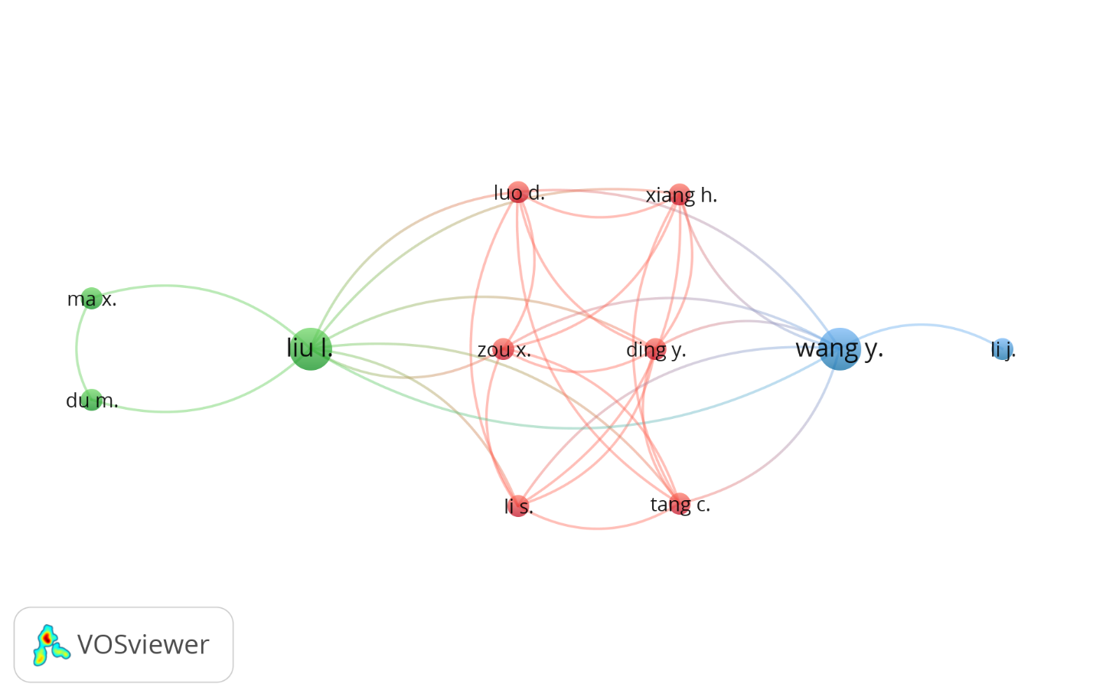
Figure 3: Co-author map
Of the 234 authors, only 113 authors have minimum 1 citation and remaining 121 do not have any citation. Chen S., Hahn A., Liu C. and Singh R. topped the list with 56 citations followed by Chong B., Liao S.-W., Liao S.-W.,Liao Y.-C. and Tseng J.-H. with 43 citations as can be observed from Table 4.
Table 4: Influential Documents based on citations
S. No. | Author | Documents | Citations | Total Link Strength
1 | Chen S. | 1 | 56 | 3
2 | Hahn A. | 1 | 56 | 3
3 | Liu C.-C. | 1 | 56 | 3
4 | Singh R. | 1 | 56 | 3
5 | Chong B. | 1 | 43 | 3
6 | Liao S.-W. | 1 | 43 | 3
7 | Liao Y.-C. | 1 | 43 | 3
8 | Tseng J.-H. | 1 | 43 | 3
9 | Grewal D. | 1 | 22 | 2
10 | Levy M. | 1 | 22 | 2
11 | Motyka S. | 1 | 22 | 2
`12 | Alahmadi A. | 1 | 21 | 4
13 | Lin X. | 1 | 21 | 4
14 | Liu D. | 1 | 21 | 4
15 | Ni J. | 1 | 21 | 4
16 | Shen X. | 1 | 21 | 4
17 | Mansfield-Devine S. | 1 | 20 | 0
18 | Cocco L. | 1 | 16 | 1
19 | Marchesi M. | 1 | 16 | 1
20 | Al-Turjman F. | 1 | 15 | 5

  - Country-wise (geographical region) statistics
This section elaborates the countries, where blockchain research is prominent. Figure 4 shows a country-wise visualization. China, Netherland, United States and a few more countries have shown a fair linkage between their published literature.

Figure 4: Co-country map

Out of 39 countries, China topped the list with 12 documents and 118 citations, followed by the United States with 14 documents and 117 citations with Taiwan at 44 citations and India, United Kingdom and Canada at 23 citations (Table 5).

Table 5: Influential Countries based on citations
S. No. | Country | Documents | Citations | Total Link Strength
1 | China | 12 | 118 | 6
2 | United States | 14 | 117 | 14
3 | Taiwan | 3 | 44 | 1
4 | India | 10 | 23 | 5
5 | United Kingdom | 6 | 23 | 4
6 | Canada | 5 | 23 | 6
7 | Italy | 6 | 16 | 2
8 | Netherlands | 3 | 16 | 5
9 | South Korea | 2 | 16 | 2
10 | Turkey | 1 | 15 | 2
11 | Bulgaria | 1 | 13 | 0
12 | Colombia | 1 | 12 | 0
13 | Russian Federation | 5 | 6 | 3
14 | Chile | 1 | 6 | 2
15 | Finland | 1 | 6 | 2

  - Source-wise statistics

A threshold limit with minimum 1 document and minimum 10 citations resulted in 11 sources as can be observed from Figure 5. However, these sources were not found linked with each other.

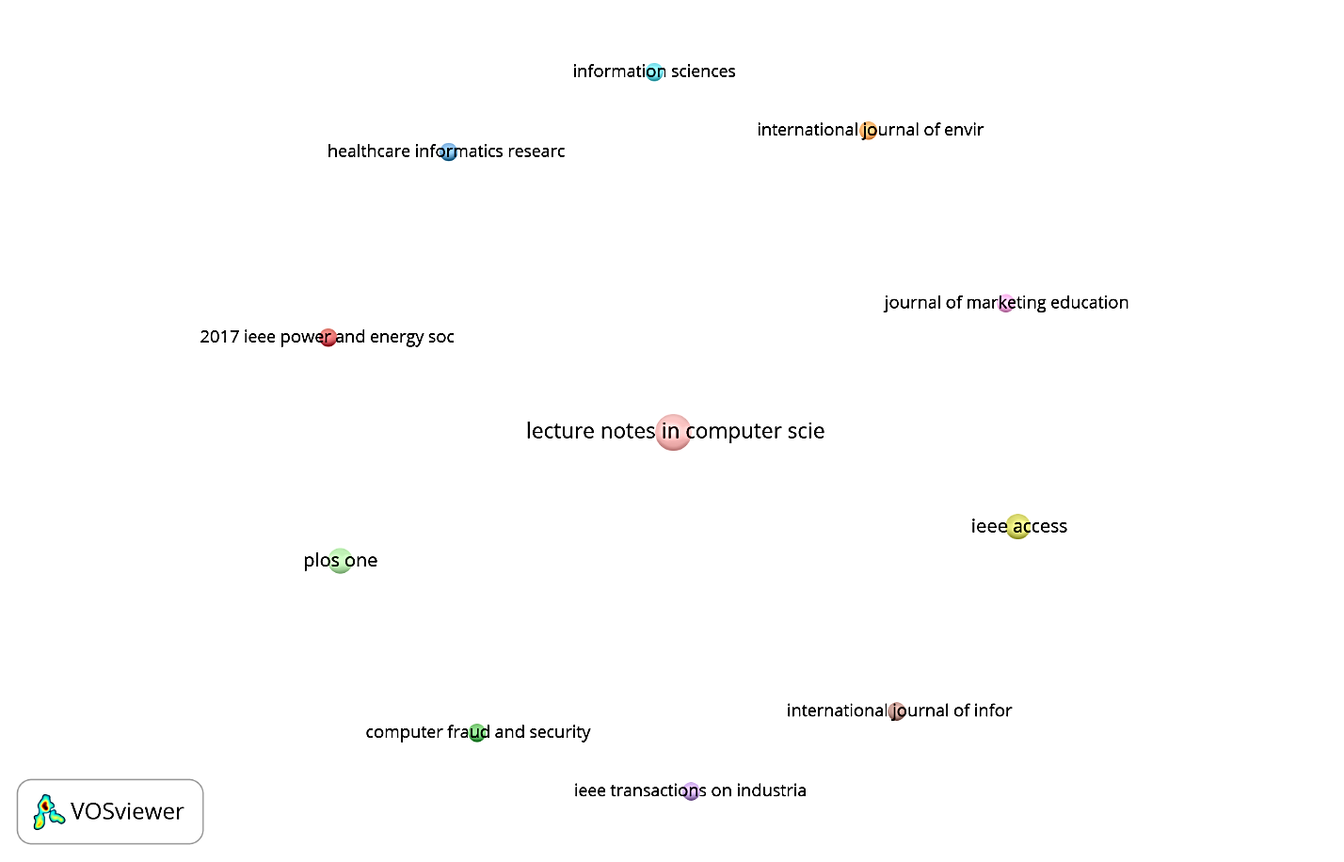

Figure 5: Source map

Source-wise analysis is used to identify highly influential sources or publications based on citations and the number of documents. This section highlights the highly cited sources based on several documents and citations (Table 6). Future researchers can refer these sources in their upcoming work. IEEE Power and Energy Society Innovative Smart Grid, Technologies Conference, ISGT 2017 topped the list with 56 citations, followed by International Journal of Environmental Research and Public Health and Journal of Marketing Education with 43 and 22 citations.

Table 6: Influential Sources based on citations
S. No. | Source | Documents | Citations
1 | 2017 IEEE Power and Energy Society Innovative Smart Grid Technologies Conference, ISGT 2017 | 1 | 56
2 | International Journal of Environmental Research and Public Health | 1 | 43
3 | Journal of Marketing Education | 1 | 22
4 | IEEE Access | 2 | 21
5 | IEEE Transactions on Industrial Informatics | 1 | 21
6 | Computer Fraud and Security | 1 | 20
7 | PLOS One | 2 | 17
8 | Healthcare Informatics Research | 1 | 13
9 | Lecture Notes in Computer Science (Including Subseries Lecture Notes in Artificial Intelligence and Lecture Notes in Bioinformatics) | 4 | 12
10 | Information Sciences | 1 | 11
11 | International Journal of Information Management | 1 | 11
12 | Technological Forecasting and Social Change | 1 | 6
13 | ACM International Conference Proceeding Series | 3 | 5
14 | Journal of Interactive Marketing | 2 | 5
15 | 2019 IEEE Globecom Workshops, GC Wkshps 2019 - Proceedings | 1 | 4
16 | International Journal of Production Research | 1 | 4
17 | African Journal of Hospitality, Tourism and Leisure | 1 | 3
18 | Future Internet | 1 | 3
19 | International Journal of Hospitality Management | 1 | 3
20 | International Journal of Recent Technology and Engineering | 2 | 3

  - Keyword statistics
Keyword statistics is an analysis performed to identify the frequently used or occurred keywords in the keywords and paper titles. This is an important analysis to know highly popular keywords and least explored keywords to identify future research areas. Figure 6 shows 75 keywords found with a minimum of 2 citations.
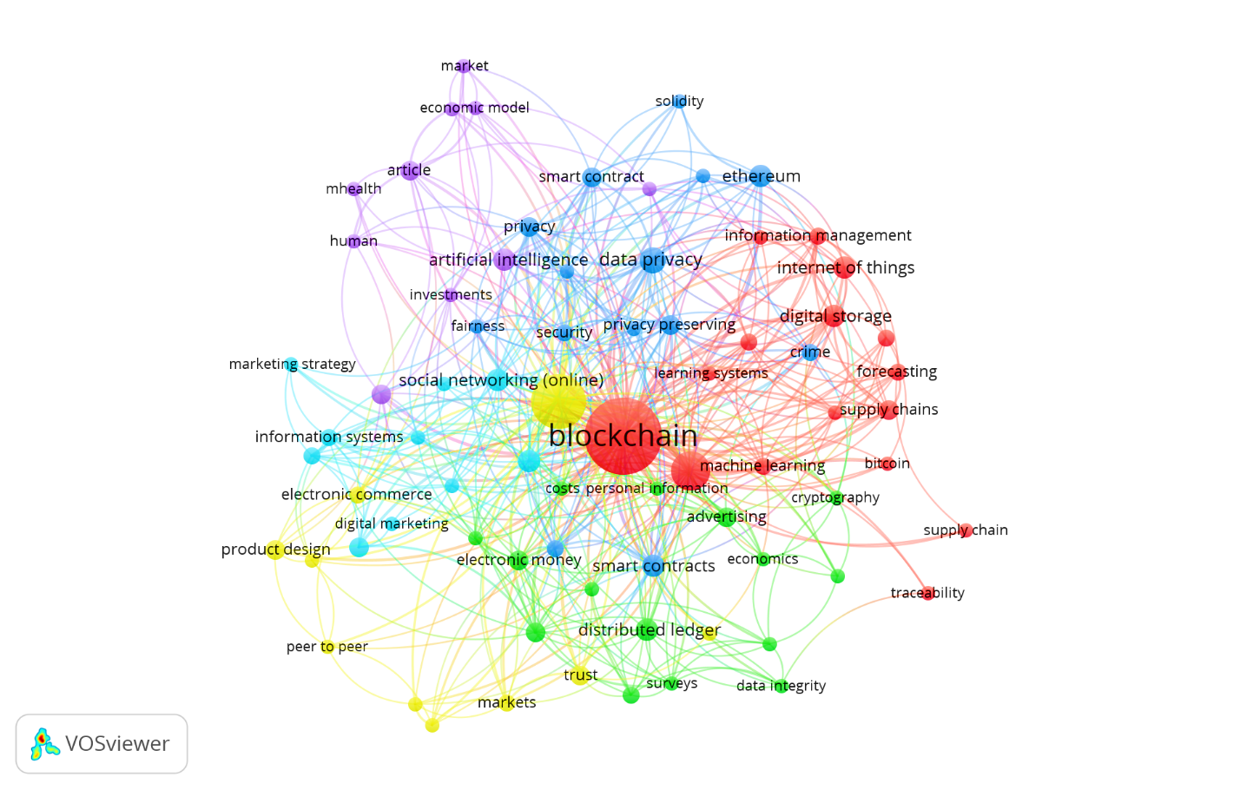
Figure 6: Visualization of keywords map

Table 7 shows highly occurred keywords based on occurrences. Blockchain tops the list with 57 occurrences and total link strength of 570 followed by marketing and commerce with 29 and 15 occurrences and total link strength of 404 and 219.

Table 7: Highly occurred keywords
S. No. | Keyword | Occurrences | Total Link Strength
1 | Blockchain | 57 | 670
2 | Marketing | 29 | 404
3 | Commerce | 15 | 219
4 | Data Privacy | 7 | 102
5 | Artificial Intelligence | 5 | 45
6 | Blockchain Technology | 5 | 62
7 | Digital Storage | 5 | 93
8 | Distributed Ledger | 5 | 40
9 | Ethereum | 5 | 51
10 | Internet of Things | 5 | 51
11 | Smart Contracts | 5 | 60
12 | Social Networking (Online) | 5 | 58
13 | Advertising | 4 | 68
14 | Article | 4 | 66
15 | Cryptocurrency | 4 | 44
16 | Electronic Money | 4 | 50
17 | Privacy | 4 | 69
18 | Privacy-Preserving | 4 | 65
19 | Product Design | 4 | 48
20 | Smart Contract | 4 | 40

- Network analysis of publications

Network analysis is an approach to identify the linkage between various authors and keywords based on citations. In the following sections, authors performed citation and cluster analysis to identify dominant authors and streams.

  - Citation analysis
Figure 7 shows 10 authors connected based on citations. The various linkages can be observed in figure 7. These linkages will help the future researchers to focus on highly cited authors and their related work with other authors to know their contribution in new related areas as well.
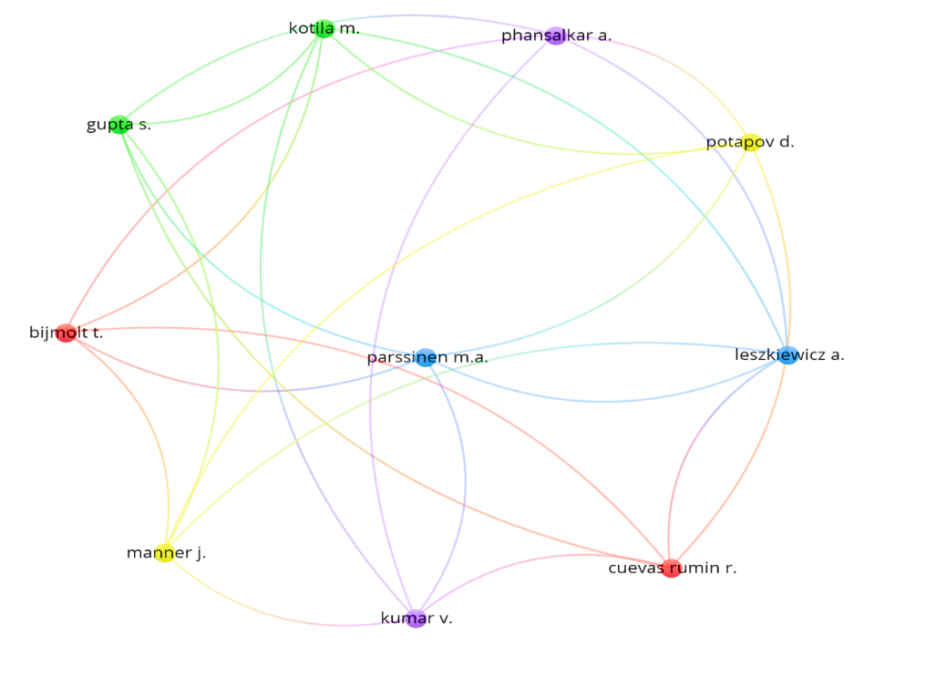
Figure 7: Citation map

  - Cluster analysis

Using the keyword visualization authors identified five clusters. These clusters were labelled as streams based on the detailed investigations. The streams in red, yellow and purple, blue and green were labelled as Blockchain and Electronic Commerce, Blockchain and Marketing; Blockchain and Data; Blockchain and Data Analytics and Blockchain-Privacy and Security (Figure 8). Keywords were also identified under each stream as can be observed from Table 8.

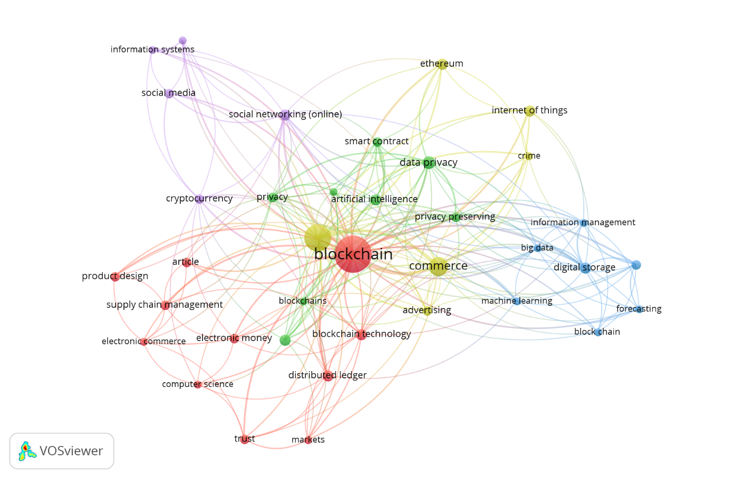

Figure 8: Visualization of keywords map using cluster analysis

Table 8: Streams and keywords identified
Cluster  (Color) | Stream | Keywords
I (RED) | Blockchain and  Electronic Commerce | Blockchain technology, computer science, distributed ledger, electronic commerce, electronic money, markets, product design, supply chain management, trust
II (Yellow) | Blockchain and  Marketing | Advertising, commerce, crime, ethereum, internet of things, marketing
III (Purple) | Blockchain and  Data | Cryptocurrency, information systems, information use, social media, social networking (online), big data
IV (Blue) | Blockchain and  Data Analytics | Digital storage, forecasting, information management, machine learning, supply chains
V (Green) | Blockchain-Privacy and Security | Artificial intelligence, data privacy, privacy-preserving, security, smart contract

Based on cluster analysis, researchers identified five research streams as follows:

5.2.1 Blockchain and Electronic Commerce
The first stream identified is blockchain and electronic commerce. Globally electronic commerce is the most developing field post digitalization. Electronic commerce plays a crucial role in e-commerce development; and with the introduction and support of computer science, distributed ledger, electronic money, markets, product design, supply chain management, it also provided speed and trust. Electronic commerce based on the distributed ledger is a hot topic today (Cha et al., 2019). Although there is growth in the volume of e-commerce transactions, there is little research on factors determining its adoption (Abramova and Böhme, 2016). Researchers need to explore the role of blockchain in electronic commerce

5.2.2 Blockchain and Marketing
The second stream identified is blockchain and marketing. Marketing is the most important aspect in developing and supporting commerce through the internet of things, advertising and ethereum. A future model for agricultural marketing system in India was proposed using ICT, Big Data Analytics and Blockchain to deal with the challenges of unorganized practices and stress prevalent among farmers (Shrivastava and Pal, 2019). A study on blockchain was initiated in India to magnify the role of blockchain in social media to leap towards economic growth (Rathnakar, 2019). Role of blockchain, machine learning, artificial intelligence in retailing education was also highlighted in the research with a suggestion to incorporate these in the education (Grewal, Motyka and Levy, 2018). Study was initiated to find the linkage of artificial intelligence (AI) in marketing using bibliometric analysis to highlight important research directions (Verma et al., 2021). A production and marketing environment for organic vegetables using blockchain was proposed to enhance the reliability of records of the sales(Shih et al., 2019). A reputation system based on blockchain was proposed to enhance consumer experience (Liu et al., 2019). Researchers need to explore the role of blockchain in marketing; as this important linkage (Ghose, 2018) has been least explored in the published literature.

5.2.3 Blockchain and Data
The third stream identified is blockchain and data. Data is the most important part of any transaction. Digital data generated by user as well as machines needs to be managed well and blockchain plays an important role in its management (Karafiloski and Mishev, 2017). The large data available in the online mode on social media and social networking in the form of cryptocurrency has been dealt with the help of information systems (IS) and information use. A study highlighting the synthesis of information system in smart cities has been initiated to bring IS current and future roles (Ismagilova et al., 2019). A model based on blockchain has been proposed to deal with the sensitive information of users using DEPLEST algorithm (Chen et al., 2019). However, the role of blockchain in data needs to be further explored by future researchers.

5.2.4 Blockchain and Data Analytics
The fourth stream identified is blockchain and data analytics. Data analytics field is developing day by day. In management discipline, the application of big data has also gained momentum (Kushwaha, Kar and Dwivedi, 2021). The big data need to be analysed using blockchain, digital storage, forecasting, information management, machine learning for extraction of useful information for further processing. A method based on marketing data analysis was proposed in blockchain for robust decision making in marketing (Wang and Li, 2020). Digital analytics was found as a way to understand customer well and a model was proposed for getting better customer insights in this digital age (Gupta et al., 2020). Future researchers need to explore the significant role of blockchain in data analytics.

5.2.5 Blockchain-Privacy and Security
The fifth stream identified is blockchain-privacy and security. Data tampering is a big challenge in this digital era. Privacy and security are important requirements for big data, which needs to be implemented using artificial intelligence, data privacy, privacy-preserving, security and smart contract to gain user confidence and loyality. A recent study in the retail industry concluded that blockchain-based reputation systems offer higher levels of privacy as compared to traditional systems (Liu et al., 2019). Information security has been explored in Pakistani university libraries using quantitative approach (Khan, Ibrahim and Hussain, 2021). Studies have also been undertaken to explore the information security breaches due to ransomeware attacks (Reshmi, 2021). To deal with these challenges, blockchain provides a well-secured platform for the clients (Omar et al., 2019). Integration of blockchain and artificial intelligence results in higher security (Ekramifard et al., 2020). Future researchers need to explore this important linkage of blockchain with privacy and security.
- Discussion
Marketing is an important pillar in the economy of a country. The disruptive technology of blockchain has been less explored with regard to marketing as a function. Although blockchain has been explored in various areas (Table 1), its presence in marketing has been less explored (Table 2) and has huge future scope. Based on the gaps identified in this blockchain and marketing integration, current study identified influential co-author, country, source, and keywords, which will help the future researcher to focus on important literature. The authors further identified and developed five clusters namely Blockchain and Electronic Commerce, Blockchain and Marketing; Blockchain and Data; Blockchain and Data Analytics and Blockchain-Privacy and Security using network analysis of citations. The identified clusters will give new directions to the future researchers.
Introduction of blockchain has changed the world in terms of social, financial and technological innovations. Blockchain although being characterised as a disrupted technology, is now recognized as a trusted and secured technology. The rapid developments in the internet technologies has raised alarming questions regarding the fraudulent practices at various levels in advertising (Ghose, 2018; Parssinen et al., 2018; Ding et al., 2021), value creation (Mačiulienė and Skaržauskienė, 2021) security of data and many more. The blockchain has dealt with these challenges by providing a transparent and secured platform to stakeholders; providing fast transactions with near -zero transaction cost and minimum role of intermediaries, with increased control over personal information by consumers (Harvey et al., 2018) and further resulting into developing consumer trust and service (Wang et al., 2021). Present article exhibits potential role of blockchain on marketing. A wide scope exists for use of blockchain in marketing area, which is required for smooth conduct of e-commerce with the help of data. This data needs to be analysed using the tools of data analytics along with the foundation of security and privacy for each participant involved in the transactions under the lens of blockchain –marketing integration. The five streams of Electronic Commerce, Marketing; Data; Data Analytics and Privacy and Security involve vital and crucial role of Blockchain for smooth operation of economies. Based on the theses identified clusters the researchers have proposed future agenda in the next section to have exponential presence of marketing- blockchain integration in future strategies. The future agenda will guide the researcher to focus on the identified streams. The research framework will give a big picture of the areas important in blockchain, and how they are interlinked with each other to make the blockchain expand successfully. The research questions will motivate the future researchers to initiate research in the new unexplored dimensions in order to analyse the role of blockchain in vital areas of the economy to make blockchain-marketing integration acceptable by majority.

- Future Agenda
Based on streams identified and literature review, researchers proposed a framework for future researchers which needs to be explored in future to test the complex relationships and come up with some new contributions in blockchain and other five proposed streams.

  - Future research framework
Figure 9 shows the framework for future research with a linkage between five streams. As can be observed from figure 9, Marketing and electronic commerce work in coordination. Marketing plays an important role in advertising and popularizing specific goods or services, which further helps in electronic commerce. Marketing and electronic commerce produce data and this data is also required for the smooth conduct of commerce. Thus, data plays a significant role in electronic commerce and marketing. Electronic commerce and marketing results in big data which needs to analysed using data analytics, which is a vital area to be explored further. Electronic commerce, marketing, data and data analytics require privacy and security at each stage. These 5 streams involve an inseparable role of blockchain individually and collectively. Thus, future researchers need to explore the significant linkages between theses 5 streams by exploring the role of blockchain to have a better perspective of consumers and retailing to make important contributions in the literature.
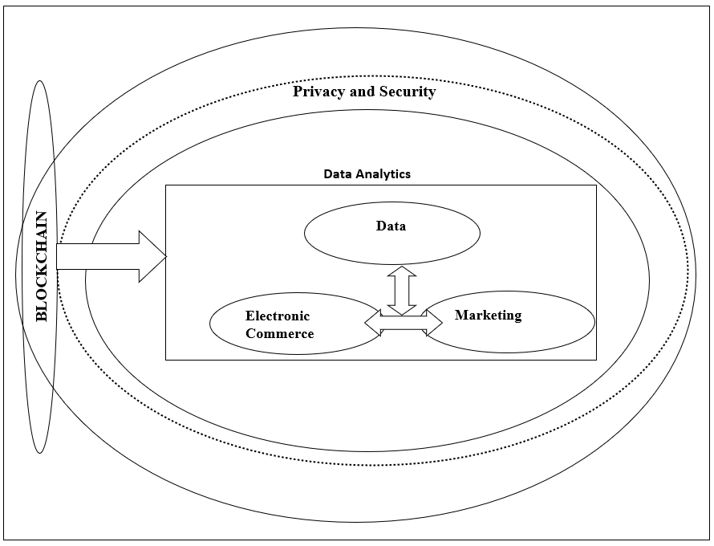
Figure 9: Framework for future research

  - Future research questions
Based on the future research framework, along with gaps researchers have proposed 18 research questions under 5 research streams. Three research questions under electronic commerce, four research questions under marketing, three research questions under data, five research questions under data analytics and three research questions under privacy and security were proposed as depicted in Table 9.

Table 9: Future research questions
Stream | Gap | Future Research Questions
Blockchain and  Electronic Commerce | A hot topic, factors influencing electronic commerce based on blockchain not explored and the interlink between blockchain and electronic commerce not yet explored | - What is the role of blockchain in electronic commerce?  - How distributed ledger will help in electronic commerce?  - What is the role of electronic money in electronic commerce?
Blockchain and  Marketing | Very few articles explored the blockchain marketing integration | - How blockchain and marketing are interlinked?  - What is the role of the internet of things in marketing?  - What is the role of ethereum in e-marketing?  - What is the future of marketing as a result of blockchain integration?
Blockchain and  Data | Very little work to deal with growing data using blockchain was witnessed | - How to deal with data?  - How to make information systems effective?  - What is the role of blockchain in data handling?
Blockchain and  Data Analytics | The role of data analytics concerning blockchain not explored well | - How to deal with the challenge of big data through blockchain?  - How to enhance the effectiveness of digital storage?  - What is the role of data analytics in big data?  - How to use big data for forecasting?  - What is the future role of machine learning in data analytics?
Blockchain-Privacy and Security | The dominant role of blockchain in reducing data corruption and fraudulent practices and enhancing privacy and security of the transactions and the clients -needs the concern of future researchers on an urgent basis | - How to deal with the challenge of privacy and security?  - How artificial intelligence can be used for privacy and security?  - How to deal with security and privacy while making smart contracts?

7. Conclusion
In future, blockchain will be a dominant technology that saves time, reduces cost, lowers risk and most importantly enhance trust. The need of blockchain in marketing is the motivation behind present research. As per the best of researchers understanding, this is the first work to explore the marketing and blockchain integration. In the present study, researchers employed a combination of quantitative techniques using literature review and qualitative technique using bibliometric citation analysis to conduct a detailed analysis of total 75 articles from International database of Scopus to explore the use of blockchain in marketing. VOSviewer software was used for performing the bibliometric analysis. Researchers performed a comprehensive review of the literature to identify influential aspects of the literature on blockchain in marketing, using co-citation analysis, co-authorship analysis, keyword analysis and cluster analysis.
This study makes a significant contribution to the research in the area of blockchain –marketing integration by (i) identifying influential aspects of the literature on blockchain-marketing integration; (2) identifying the research streams; (3) proposing future research framework and; (4) proposing future research questions. The present study identified five research streams: Blockchain and Electronic Commerce, Blockchain and Marketing; Blockchain and Data; Blockchain and Data Analytics and Blockchain-Privacy and Security and proposed 18 research questions to be explored by the future researchers.
The limitations of the study may relate to First, bibliometric citation analysis as highly cited articles were analysed in this study, although some quality work may be present in other articles not selected; Second, to the database selection of Scopus. Therefore, we suggest the future researchers perform bibliometric analysis using some other databases of Web of Science, Google Scholar and many more in combination with some new software for the analysis. Implementation of blockchain technology in marketing is the growing future, which needs to be focused by the future researchers.
References
Abramova, S. and Böhme, R. (2016) ‘Perceived benefit and risk as multidimensional determinants of bitcoin use: A quantitative exploratory study’, in The 37th International Conference on Information Systems, ICIS 2016, pp. 1–20. doi: 10.17705/4icis.00001.
Ali, O. et al. (2020) ‘The state of play of blockchain technology in the financial services sector: A systematic literature review’, International Journal of Information Management. Elsevier, 54(August 2019), p. 102199. doi: 10.1016/j.ijinfomgt.2020.102199.
Ali, R. et al. (2014) ‘Innovations in payment technologies and the emergence of digital currencies’, Quarterly Bulletin, 53(4), pp. 262–275. doi: 10.1080/00397917108081623.
De Bernardi, P. et al. (2020) ‘Innovative and sustainable food business models’, in Contributions to Management Science. Springer, pp. 189–221. doi: 10.1007/978-3-030-33502-1_7.
Bettín-Díaz, R., Rojas, A. E. and Mejía-Moncayo, C. (2018) ‘Methodological approach to the definition of a blockchain system for the food industry supply chain traceability’, in Lecture Notes in Computer Science (including subseries Lecture Notes in Artificial Intelligence and Lecture Notes in Bioinformatics). Springer Verlag, pp. 19–33. doi: 10.1007/978-3-319-95165-2_2.
Bhaskar, P., Tiwari, C. K. and Joshi, A. (2021) ‘Blockchain in education management : present and future applications’, Interactive Technology and Smart Education, 18(1), pp. 1–17. doi: 10.1108/ITSE-07-2020-0102.
Cha, B. R. et al. (2019) ‘Draft design of distributed ledger based peer-to-peer business platform’, in Advances in Intelligent Systems and Computing. Springer Verlag, pp. 865–872. doi: 10.1007/978-3-319-93659-8_79.
Chen, W. et al. (2018) ‘A survey of blockchain applications in different domains’, in ACM International Conference Proceeding Series. Association for Computing Machinery, pp. 17–21. doi: 10.1145/3301403.3301407.
Chen, Y. et al. (2019) ‘DEPLEST: A blockchain-based privacy-preserving distributed database toward user behaviors in social networks’, Information Sciences. Elsevier Inc., 501, pp. 100–117. doi: 10.1016/j.ins.2019.05.092.
Cocco, L. and Marchesi, M. (2016) ‘Modeling and simulation of the economics of mining in the Bitcoin market’, PLoS ONE. Public Library of Science, 11(10). doi: 10.1371/journal.pone.0164603.
Dimitrov, D. V. (2019) ‘Blockchain applications for healthcare data management’, Healthcare Informatics Research. Korean Society of Medical Informatics, 25(1), pp. 51–56. doi: 10.4258/hir.2019.25.1.51.
Ding, Y. et al. (2021) ‘Design and implementation of blockchain-based digital advertising media promotion system’, Peer-to-Peer Networking and Applications. Springer, 14(2), pp. 482–496. doi: 10.1007/S12083-020-00984-5.
Du, W. (Derek) et al. (2019) ‘Affordances, experimentation and actualization of FinTech: A blockchain implementation study’, Journal of Strategic Information Systems. Elsevier B.V., 28(1), pp. 50–65. doi: 10.1016/j.jsis.2018.10.002.
Ekramifard, A. et al. (2020) ‘A systematic literature review of integration of blockchain and artificial intelligence’, in Advances in Information Security. Springer, pp. 147–160. doi: 10.1007/978-3-030-38181-3_8.
Filimonau, V. and Naumova, E. (2020) ‘The blockchain technology and the scope of its application in hospitality operations’, International Journal of Hospitality Management. Elsevier Ltd, 87. doi: 10.1016/j.ijhm.2019.102383.
Ghose, A. (2018) ‘What Blockchain Could Mean for Marketing’, Harvard Business Review, 5, pp. 2–5. Available at: https://hbr.org/2018/05/what-blockchain-could-mean-for-marketing.
Grewal, D., Motyka, S. and Levy, M. (2018) ‘The Evolution and Future of Retailing and Retailing Education’, Journal of Marketing Education. SAGE Publications Inc., 40(1), pp. 85–93. doi: 10.1177/0273475318755838.
Grover, P., Kar, A. and Ilavarasan, P. V. (2018) ‘Blockchain for Businesses : A Systematic Literature Review’, in 17th Conference on e-Business, e-Services and e-Society (I3E). Kuwait: Springer, Cham, pp. 325–336. Available at: 10.1007/978-3-030-02131-3_29.
Gupta, R. et al. (2020) ‘Smart Contract Privacy Protection Using AI in Cyber-Physical Systems: Tools, Techniques and Challenges’, IEEE Access. Institute of Electrical and Electronics Engineers Inc., 8, pp. 24746–24772. doi: 10.1109/ACCESS.2020.2970576.
Gupta, S. et al. (2020) ‘Digital Analytics: Modeling for Insights and New Methods’, Journal of Interactive Marketing. Elsevier Inc., 51, pp. 26–43. doi: 10.1016/j.intmar.2020.04.003.
Hahn, A. et al. (2017) ‘Smart contract-based campus demonstration of decentralized transactive energy auctions’, in 2017 IEEE Power and Energy Society Innovative Smart Grid Technologies Conference, ISGT 2017. Institute of Electrical and Electronics Engineers Inc. doi: 10.1109/ISGT.2017.8086092.
Harvey, C. R., Moorman, C. and Toledo, M. (2018) ‘How blockchain can help marketers build better relationships with their customers. Harv. Bus. Rev.’, Harvard Business Review. Available at: https://bear.warrington.ufl.edu/cheng/ism6485/How Blockchain Can Help Marketers.pdf.
Ismagilova, E. et al. (2019) ‘Smart cities: Advances in research—An information systems perspective’, International Journal of Information Management. Elsevier Ltd, pp. 88–100. doi: 10.1016/j.ijinfomgt.2019.01.004.
Kar, A. K. and Navin, L. (2021) ‘Diffusion of blockchain in insurance industry: An analysis through the review of academic and trade literature’, Telematics and Informatics. Elsevier Ltd, 58(November 2020), p. 101532. doi: 10.1016/j.tele.2020.101532.
Karafiloski, E. and Mishev, A. (2017) ‘Blockchain solutions for big data challenges: A literature review’, in 17th IEEE International Conference on Smart Technologies, EUROCON 2017 - Conference Proceedings. Institute of Electrical and Electronics Engineers Inc., pp. 763–768. doi: 10.1109/EUROCON.2017.8011213.
Khan, A., Ibrahim, M. and Hussain, A. (2021) ‘An exploratory prioritization of factors affecting current state of information security in Pakistani university libraries’, International Journal of Information Management Data Insights. Elsevier Ltd, 1(2), p. 100015. doi: 10.1016/j.jjimei.2021.100015.
Kouhizadeh, M., Zhu, Q. and Sarkis, J. (2020) ‘Blockchain and the circular economy: potential tensions and critical reflections from practice’, Production Planning and Control. Taylor & Francis, 31(11–12), pp. 950–966. doi: 10.1080/09537287.2019.1695925.
Krafft, M., Sajtos, L. and Haenlein, M. (2020) ‘Challenges and Opportunities for Marketing Scholars in Times of the Fourth Industrial Revolution’, Journal of Interactive Marketing. Elsevier Inc., 51, pp. 1–8. doi: 10.1016/j.intmar.2020.06.001.
Kushwaha, A. K., Kar, A. K. and Dwivedi, Y. K. (2021) ‘Applications of big data in emerging management disciplines: A literature review using text mining’, International Journal of Information Management Data Insights. Elsevier Ltd, 1(2), p. 100017. doi: 10.1016/j.jjimei.2021.100017.
Liu, D. et al. (2019) ‘Anonymous reputation system for IIoT-enabled retail marketing atop PoS blockchain’, IEEE Transactions on Industrial Informatics. IEEE Computer Society, 15(6), pp. 3527–3537. doi: 10.1109/TII.2019.2898900.
Liyuan, L. et al. (2019) ‘E2C-Chain: A two-stage incentive education employment and skill certification blockchain’, in Proceedings - 2019 2nd IEEE International Conference on Blockchain, Blockchain 2019. Institute of Electrical and Electronics Engineers Inc., pp. 140–147. doi: 10.1109/Blockchain.2019.00027.
Mačiulienė, M. and Skaržauskienė, A. (2021) ‘Conceptualizing blockchain-based value co-creation: A service science perspective’, Systems Research and Behavioral Science. John Wiley and Sons Ltd, 38(3), pp. 330–341. doi: 10.1002/SRES.2786.
Mansfield-Devine, S. (2017) ‘Beyond Bitcoin: using blockchain technology to provide assurance in the commercial world’, Computer Fraud and Security. Elsevier Ltd, 2017(5), pp. 14–18. doi: 10.1016/S1361-3723(17)30042-8.
Meester, W. J., Steiginga, S., & Ross, C. A. (2017) ‘A brief history of Scopus: The world’s largest abstract and citation database of scientific literature.’, Research analytics: Boosting university productivity and competitiveness through Scientometrics, 31.
Miraz, M. H., Hassan, M. G. and Mohd Sharif, K. I. (2020) ‘Factors affecting implementation of blockchain in retail market in Malaysia’, International Journal of Supply Chain Management. ExcelingTech, 9(1), pp. 385–391.
Mittal, A. et al. (2021) ‘Cybersecurity Enhancement through Blockchain Training (CEBT) – A serious game approach’, International Journal of Information Management Data Insights. Elsevier Ltd, 1(1), p. 100001. doi: 10.1016/j.jjimei.2020.100001.
Mofokeng, N. E. M. and Matima, T. K. (2018) ‘Future tourism trends: Virtual Reality based tourism utilizing Distributed Ledger Technologies’, African Journal of Hospitality, Tourism and Leisure. Africa Journals, 7(3), pp. 1–14.
Montoya, F. G. et al. (2018) ‘A fast method for identifying worldwide scientific collaborations using the Scopus database’, Telematics and Informatics. Elsevier Ltd, 35(1), pp. 168–185. doi: 10.1016/j.tele.2017.10.010.
Nakamoto, S. (2008) ‘Bitcoin: A Peer-to-Peer Electronic Cash System’, pp. 1–24. doi: 10.2139/ssrn.3440802.
Omar, A. Al et al. (2019) ‘Towards Privacy-preserving Recommender System with Blockchains’, in Communications in Computer and Information Science. Springer, pp. 106–118. doi: 10.1007/978-981-15-1304-6_9.
Van Osch, W. et al. (2019) ‘Social Media and the Digital Enterprise’, in Lecture Notes in Computer Science (including subseries Lecture Notes in Artificial Intelligence and Lecture Notes in Bioinformatics). Springer Verlag, pp. 701–705. doi: 10.1007/978-3-030-29390-1_66.
Parssinen, M. A. et al. (2018) ‘Is Blockchain Ready to Revolutionize Online Advertising?’, IEEE Access. Institute of Electrical and Electronics Engineers Inc., 6, pp. 54884–54899. doi: 10.1109/ACCESS.2018.2872694.
Pillai, R., Sivathanu, B. and Dwivedi, Y. K. (2020) ‘Shopping intention at AI-powered automated retail stores (AIPARS)’, Journal of Retailing and Consumer Services. Elsevier Ltd, 57(June), p. 102207. doi: 10.1016/j.jretconser.2020.102207.
Przhedetskiy, Y. V. et al. (2019) ‘Blockchain technologies in healthcare institutions: Focus on security and effective cooperation with the government’, International Journal of Economics and Business Administration. International Strategic Management Association, 7, pp. 92–99. doi: 10.35808/ijeba/373.
Rahmanzadeh, S., Pishvaee, M. S. and Rasouli, M. R. (2020) ‘Integrated innovative product design and supply chain tactical planning within a blockchain platform’, International Journal of Production Research. Taylor and Francis Ltd., 58(7), pp. 2242–2262. doi: 10.1080/00207543.2019.1651947.
Rathnakar, G. (2019) ‘Blockchain marketing through social media surges the economic growth of India’, International Journal of Recent Technology and Engineering. Blue Eyes Intelligence Engineering and Sciences Publication, 8(1 Special Issue4), pp. 78–81.
Reshmi, T. R. (2021) ‘Information security breaches due to ransomware attacks - a systematic literature review’, International Journal of Information Management Data Insights. Elsevier Ltd, 1(2), p. 100013. doi: 10.1016/j.jjimei.2021.100013.
Risius, M. and Spohrer, K. (2017) ‘A Blockchain Research Framework: What We (don’t) Know, Where We Go from Here, and How We Will Get There’, Business and Information Systems Engineering. Gabler Verlag, 59(6), pp. 385–409. doi: 10.1007/s12599-017-0506-0.
Rouzbahani, H. M. et al. (2020) ‘Blockchain applications in power systems: A bibliometric analysis’, in Advances in Information Security. Springer, pp. 129–145. doi: 10.1007/978-3-030-38181-3_7.
Shih, D. H. et al. (2019) ‘A simulated organic vegetable production and marketing environment by using ethereum’, Electronics (Switzerland). MDPI AG, 8(11). doi: 10.3390/electronics8111341.
Shrivastava, S. and Pal, S. N. (2019) ‘A framework for next generation agricultural marketing system in Indian context’, in 2019 5th IEEE International WIE Conference on Electrical and Computer Engineering, WIECON-ECE 2019 - Proceedings. Institute of Electrical and Electronics Engineers Inc. doi: 10.1109/WIECON-ECE48653.2019.9019983.
Tandon, A. et al. (2020) ‘Blockchain in healthcare: A systematic literature review, synthesizing framework and future research agenda’, Computers in Industry, 122. doi: 10.1016/j.compind.2020.103290.
Tseng, J. H. et al. (2018) ‘Governance on the drug supply chain via gcoin blockchain’, International Journal of Environmental Research and Public Health. MDPI AG, 15(6). doi: 10.3390/ijerph15061055.
Turlacu, L. M. et al. (2019) ‘Strategic technologies: Innovation in higher education in Romania’, in eLearning and Software for Education Conference. National Defence University - Carol I Printing House, pp. 400–406. doi: 10.12753/2066-026X-19-053.
Verma, S. et al. (2021) ‘Artificial intelligence in marketing: Systematic review and future research direction’, International Journal of Information Management Data Insights. Elsevier Ltd, 1(1), p. 100002. doi: 10.1016/j.jjimei.2020.100002.
Vyshnavi, R. (2016) ‘Bitcoins as a payment system: Problems and challenges developments with particular reference to India’, International Business Management. Medwell Journals, 10(20), pp. 4873–4878. doi: 10.3923/ibm.2016.4873.4878.
Wamba, S. F. and Queiroz, M. M. (2020) ‘Blockchain in the operations and supply chain management: Benefits, challenges and future research opportunities’, International Journal of Information Management, 52. doi: 10.1016/j.ijinfomgt.2019.102064.
Wang, H. et al. (2021) ‘The impact of blockchain technology on consumer behavior: a multimethod study’, Journal of Management Analytics. Taylor and Francis Ltd., 8(3), pp. 371–390. doi: 10.1080/23270012.2021.1958264.
Wang, Y. and Li, J. (2020) ‘Research on Marketing Data Analysis Based on Contour Curve in Blockchain’, in Communications in Computer and Information Science. Springer, pp. 574–581. doi: 10.1007/978-981-15-2777-7_46.

