21 Years of Sustainable Manufacturing: A Comprehensive Descriptive State-of-the-Art Survey of Research Trends and Transformation

Abstract
Sustainable manufacturing (SM) has become an emerging research topic in sustainability due to strict government policies, social awareness, and rapid information and technology changes. Industries are now adopting Industry 4.0 technologies to compete in the global market competition. Very few studies discussed the evolution of SM and the related research themes that evolved in recent years the different research themes that evolved in SM in the last few years. This study aims to identify the research theme evolution in SM and transformation in the last twenty-one years. The impact of most productive authors, journals and countries is evaluated by citation analysis, while the co-occurrence of keywords is done to identify the thematic evolution and trending topics in SM. The results of this study provide a clear and detailed picture of various research themes that evolved in SM from its evolution to Industry 4.0. The number of publications in related to Sustainability and Industry 4.0 has been increased in the last 3 years. Cluster analysis shows the evolution of many new trending topics in SM i.e., SM in Industry 4.0. The results obtained from this study will be valuable for academia and practitioners to keep informed about the latest developments in SM research.
Keywords: Sustainability; Sustainable manufacturing; Systematic literature review; State-of-the-Art analysis; Descriptive analysis; Challenges.
1. Introduction
Global market competition and increasing carbon emissions have forced many industries to adopt sustainable manufacturing (SM) practices (Haapala et al., 2013). The concept of SM becomes popular from the series of reports and meetings conducted since the 1970s and 1980s to save the environment and now developing across the globe to meet the sustainability 2030 agenda (Malek & Desai, 2020). Due to the negative effect of manufacturing processes on the environment and depletion of natural resources, achieving sustainability has become a crucial issue for the industries and will be a critical issue for future generations (Joung et al., 2013). SM helps in the development and growth of the country which is addressed in the report of Brundtland report termed as “Sustainable development”, which is focused on completing present generation demands without affecting the future generation demands (Dornfeld, 2014).
In the past few years, SM has emerged as an intriguing concept that requires strategic attention from both academia and practitioners (Bhatt et al., 2020). It is found that in existing literature synonyms to SM or similar terms related to SM are used i.e., clean manufacturing; green manufacturing; lean manufacturing (Bhatt et al., 2020; Farel et al., 2016; Jayal et al., 2010a; Malek & Desai, 2020; Mathivathanan et al., 2019). However, these similar terms have some similarities and contrast with SM. As our better understanding, no study reports about the similarities and differences between these terms with the different research areas in SM. The previously published articles having different sustainability perspective and having limited investigations based on a specific research area in SM. As our better understanding and information, there is not study which discuss the evolution of various research themes in SM from its evolution to SM in Industry 4.0. Consequently, there is an urgent need for work that examines the similarities and differences in these search terms and discuss the different research areas related to SM. In the present study, we have addressed these research gaps and complements existing SM literature by conducting an in-depth review of SM articles based on different research themes. The first article related to SM on the Scopus database is published in 1999. Therefore, in the study, we have considered articles published from 1999-2020 in the Scopus database. The research questions of our study are:
RQ1: What is the structure of the citation of research in SM in the last 21 years and which authors are working in this area?
RQ2: What are the key journals, institutes, countries and trending research articles in SM research?
RQ3: What kind of drivers, barriers and sustainability indicators reported in the SM articles?
RQ4: What are the main research themes in the SM and how these themes can be integrated into a conceptual framework?
To find the answers to the above-mentioned research questions, we have used the scientific database Scopus and conducted the comprehensive review and bibliometric analysis. In this study, we have found out the research trends, major research themes and various research gaps in SM research areas.
The next sections of studies are arranged as follows: In section 2 literature review is discussed. In section 3 data and methodology, citation structure, co-citation and cluster analysis are discussed. content analysis is done based on clusters obtained from the bibliometric analysis is discussed in section 4. Lastly, Section 5 proposed research framework is discussed with its implications.

2. Existing review studies on Sustainable Manufacturing
Literature review analysis on the previous work done in the SM area will help in identifying the research gaps and current challenges in the SM. The review studies available on the Scopus database were utilized in which 22 articles were found and considered by applying a review filter in the Scopus database (See Table 1). Inclusion and exclusion criteria for these studies is discussed in Table 3. It is also observed that the past review studies have considered a limited number of papers with a limited research scope i.e., articles are focused on a particular research area of SM. These studies help to identify the research gaps and limitations in previously published studies.
Table 1: Existing literature review on SM (2006-2020)
Author & Publication year | Methodology | Contributions | Shortcomings
(Kaebernick & Kara, 2006) | Literature review | a) Industries are adopting SM with different paths b) Product development and recovery are the major issues in the USA, UK and Europe | b) Study is limited to specific countries  c) No insights for supply chain practices and other manufacturing issues
(Glavič & Lukman, 2007) | Systematic literature review | There is a relationship between all sustainability dimensions but further studies are needed to explore the definitions | a) Different research areas in SM were not discussed
(Rashid et al., 2008) | Comprehensive literature review | a) Material efficiency is a significant characteristic among all strategies of SM b) Energy efficiency and material efficiency can be considered to reduce energy consumption. | a) Differences between SM and similar terms were not discussed.  b) Articles’ collection methodology is not discussed
(Arena et al., 2009) | Systematic Literature review | a) Tools and strategies are required for the smooth implementation of SM  b) Type of corporate function and industry are the major influencing factors to decide adoption of measurement systems in an organization. | a) A limited number of studies were considered  b) Research implications were not discussed
(Jayal et al., 2010a) | Comprehensive literature review | a) Majority of research work is done on the design-related aspects and focused on profit maximization, cost minimization as a single objective b) 6R approaches with societal and environmental consideration should be considered in the future studies c) There is a lack in both societal and environmental impact on the Supply chain practices d) Lack in integrated work of product design with system and supply chain design | a) No insights for practitioners.  b) Only mathematical approaches were considered
(Haapala et al., 2011) | Comprehensive Literature survey | a) Industries can minimize the environmental impacts and resource consumption with SM at the system level | a) Article collection methodology is not discussed  b) No detailed investigation on various definitions of SM
(Despeisse et al., 2012) | Comprehensive literature survey | a) Most studies have done in SM are based on theoretical concepts, there is no proper framework b) Proper documentation is needed for SM practices, d) very few studies are focused on the social aspect of sustainability | a) A limited number of articles were considered for literature review (Articles between 2000-2010)
(Rosen & Kishawy, 2012a) | Systematic literature review | a) Sustainability concepts, environmentally sound practices, tools and approaches for SM can be collaboratively developed by academia and industry collaboration | a) Article collection method was not discussed  b) Shop floor level planning and scheduling is not discussed
(Hahn & Kühnen, 2013) | Systematic literature review | Research on managerial culture and their attitudes is still limited which have to be explored in future studies | a) Only WoS database is considered for data collection  b) Research and Managerial implications were not discussed
(Ibáñez-Forés et al., 2014) | Comprehensive literature review | Hybrid MCDM techniques are mostly used in SM for technology assessment as it helps in the selection process and prioritizes the responses of decision-makers | a) Article collection and screening approach was not discussed  b) Only technological alternatives were discussed  c) Only studies from 2002-2012 were investigated.
(Ocampo & Clark, 2015) | Systematic literature review | a) Conceptual framework is proposed to integrate the SM practices b) Proposed framework provides the comparison between other practices and SM which help the organizations to compete with other firms. | a) Proposed conceptual framework is more focused on MCDM analysis.  b) Other research areas of sustainable manufacturing is not discussed.
(Gupta et al., 2016) | Systematic literature review | The improvement in gear manufacturing industries can be done by waste management, quality improvement, cost reduction and improving tool life. | a) Study is limited to gear manufacturing only.  b) Research findings are related to advanced manufacturing processes.  c) Difference between SM and similar terms is not discussed.
(Ghandehariun et al., 2016) | Systematic literature review | a) Combination of cryogenic machining and MQL is suitable to reduce the environmental impacts in manufacturing systems and processes it will also help to achieve SDG 2030 agenda. | a) Only sustainability in machining processes is discussed.  b) Other research themes are not discussed e.g. Planning and scheduling, supply chain.
(Chan et al., 2017) | Systematic literature review | a) There is a lack of studies that considers both social and environmental aspects b) Most studies have used the simulation-based approaches or algebraic methods for planning and scheduling problems c) In inventory management related articles algebraic methods are used and for network design problems in SM meta-heuristic approaches or linear programming, methods are used. | a) Only mathematical problems in SM are discussed.  c) A limited number of studies were considered without proper exclusion and inclusion criteria of articles.
(Moldavska & Welo, 2017) | Systematic literature review | a) 86% of identified definitions were only used in less than three articles b) This study is further analysed with the bibliometric analysis and SLR by considering major databases. | a) Only various definitions of SM are discussed with content analysis  b) Statistical analysis of articles is not discussed in detail
(Ahmad et al., 2019) | Systematic literature review | a) Solid waste management is the least used and economic assessment is mostly used keyword b) 144 articles discuss the sustainability indicators, c) Developed nations are more focused on sustainability adoption by considering sustainability indicators c) The indicators are mostly used at the product level. | a) No insights for Industry 4.0  b) Article collection procedure was not discussed in detail.
(Akbar & Irohara, 2018a) | Systematic literature review | a) GHG and energy cost are main indicators which were frequently used studies b) No study reported about the future potential of this research area. | a) Study is limited to sustainable planning and scheduling, other research areas for SM were not discussed
(Mathiyazhagan et al., 2019) | Systematic literature review | a) Environmental sustainability and economic sustainability are dependent on each other, b) Government role is very important in the implementation of green and sustainability concepts in industries, c) Very few studies are reported about the practices in South African and South American countries with consideration of environmental dimensions in practices. | a) No WoS or Scopus database was selected  b) Study is limited to Challenges, barriers and drivers to SM  c) Only studies between 2002-2017 were considered.
 | Bibliometric analysis | a) Various research trends in SM are discussed with the WoS database b) Explore existing research areas and citations overview of articles. | a) Different research areas are not discussed in detail.  b) Thematic evolution not discussed
(Bhatt et al., 2020) | Bibliometric analysis | a) Most of the studies in empirical research work focused on the relationship of Lean-Green manufacturing with environmental and organizational performance, b) Study is focused on the Web of Science database only, c) a smaller number of articles was considered in this study. it can be extended by considering more articles and major database like Scopus. Co-citation, cluster analysis can be done for a better understanding of research scopes in SM. | a) Difference between SM and similar terms is not discussed.  b) Different research areas of SM e.g., Planning and scheduling and Industry 4.0 are not discussed.  c) No comprehensive review was presented.
(Malek & Desai, 2020) | Systematic literature review | a) Research on SM is still limited b) Qualitative research is required in SM c) More studies should be carried out in the automobile industries d) There is a need to employ advanced MCDM techniques to assess the SM barriers and enablers. | a) Difference between SM and similar terms is not discussed  b) More focused on MCDM analysis of SM practices  d) No insights for Industry 4.0  e) Other research areas in SM are not discussed
(Machado et al., 2020) | Bibliometric analysis | a) Various research issues related to SM in Industry 4.0 is discussed | a) Bibliometric analysis is not discussed in detail  b) Different research areas except Industry 4.0 is not discussed
(de Sousa Jabbour et al., 2018) | Comprehensive literature review | a) highlights the basic concept of SM and overview of Industry 4.0 b) Based on literature review relationship between SM and Industry 4.0 is explained | a) Article collection method is not discussed  b) Different research areas except Industry 4.0 is not discussed
(Jamwal et al., 2020) | Systematic Literature review | a) Highlights the research progress in SM decision making b) various barriers, enablers and indicators to SM are highlighted. | a) Different research areas other than decision making are not discussed. b) Similarities and differences between the terms are not discussed.

The above-discussed review studies show that most published studies are limited to a specific research area of sustainable manufacturing e.g. Gear manufacturing (Gupta et al., 2016), MCDM modelling in SM (Jamwal et al., 2020), Planning and scheduling (Akbar & Irohara, 2018a). A comprehensive overview of different research areas and thematic evolution of research trends in SM with a larger article dataset is still missing in these review studies. Also, in the above-discussed studies, various search terms have been used for the article collection e.g., “Sustainable Manufacturing”, “Sustainable Production”, “Clean Manufacturing”, “Green Manufacturing”, “Lean Manufacturing” and “Agile Manufacturing” which results in a large number of irrelevant articles. The similarities and differences between these search terms are also not discussed. These search terms have a different appearance in the literature which is shown in Figure 1 which also shows the difference in goals for each term. Also, Table 2 discuss the list of authors explain the similarities between terms which includes Green manufacturing (Melnyk & Smith, 1996), Environment benign manufacturing (Drizo & Pegna, 2006), Environment responsible manufacturing (Curkovic & Sroufe, 2016), Cleaner Production (Siaminwe et al., 2005), Sustainable production (Holdgate, 1987), and Sustainable manufacturing (Joung et al., 2013). These reviews explain the exact definitions of these search terms and appearances in literature.

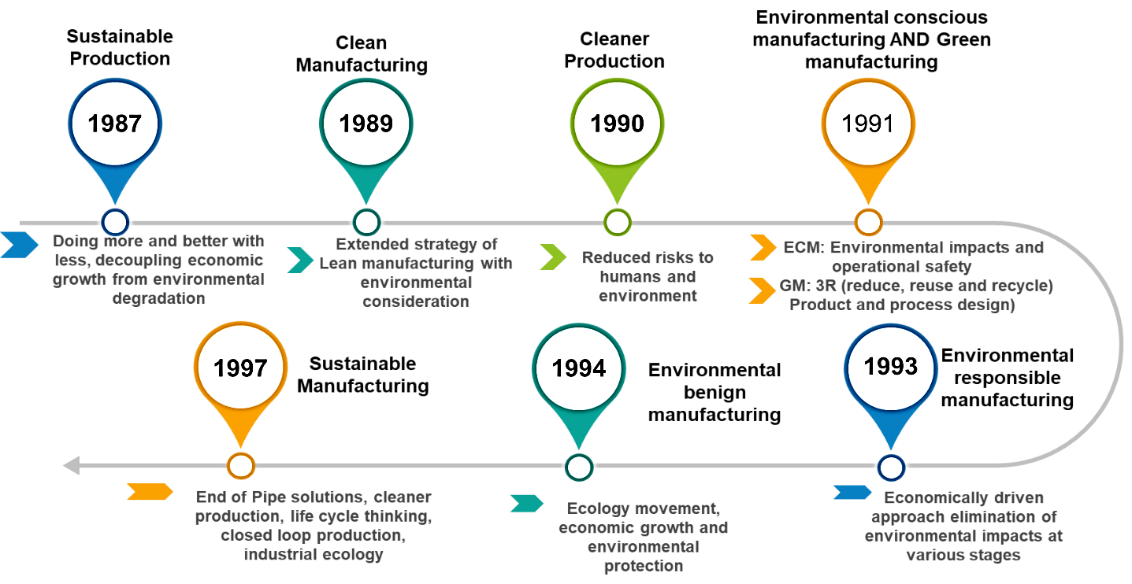
Figure 1: Appearance of Sustainable manufacturing and similar terms in literature

Table 2: Similarities of research keywords by various authors
S. No. | Author | SM | EBM | ERM | CP | GM | ECM | CM | SP
1 | Melnyk & Smith (1996) | Î | Î | P | Î | P | P | P | Î
2 | Mbohwa (2002) | Î | Î | Î | P | P | Î | Î | Î
3 | Drizo & Pegna (2006) | Î | P | Î | Î | P | P | P | Î
4 | Rao (2008) | Î | Î | P | Î | Î | P | Î | Î
5 | Allwood (2009) | P | Î | Î | Î | P | Î | Î | Î
6 | Li et al. (2010) | Î | Î | P | Î | P | P | P | Î
7 | Sangwan (2011) | P | Î | P | Î | P | P | P | Î
8 | Burchart-Korol (2011) | P | P | P | Î | P | P | P | Î
9 | Bansal et al. (2012) | P | P | P | Î | P | P | P | Î
10 | Schmitter (2012) | P | Î | P | Î | P | P | Î | Î
11 | Dornfeld et al. (2013) | Î | P | P | Î | Î | Î | Î | Î
12 | Martin et al. (2004) | P | Î | Î | Î | Î | P | Î | P
SP: Sustainable Production; CM: Clean Manufacturing; CP: Cleaner Production; ECM: Environmentally conscious manufacturing; GM: Green manufacturing; ERM: Environment responsible manufacturing; EBM: Environment benign manufacturing

By following these studies in Table 2 we found that there are many elementary concepts of these terms that supplement and overlap each other. Some basic concepts from the literature that can be standardized to SM definition are:
- Use of life cycle engineering approach (LCE)
- Clarity on the end-of-life strategies used
- Clarity on triple bottom line (TBL) perspective of manufacturing activities.
- Inclusion of supply chain and environmental improvement strategies with the business practices.
The U.S Department of Commerce defined SM as (ITA, 2012):
“The creation of manufactured products that use processes that minimize negative environmental impacts, conserve energy and natural resources, are safe for employees, communities, and consumers and are economically sound.”
OCED defined SM as:
“Manufacturing processes that minimize negative environmental impacts, conserve energy and natural resources, are safe for employees, communities and consumers and are economically sound”
Huang & Badurdeen (2017) proposed a framework for SM practices at the system level presented in Figure 2. In the framework, 6R approaches, total life cycle and triple bottom line (TBL) approaches are the concrete pillars of SM. In the middle performance measurement work is discussed which uses the systematic approach for data collection and analysis. There are other two-pillar products metrics and process metrics are shown which can be used for system-level metrics development. In the middle of the framework, the role of stakeholders is discussed. In the roof of framework four levels in SM i.e., line, plant, enterprise-level and supply chain level is discussed. This framework can be used to understand the SM practices in the actual scenario.
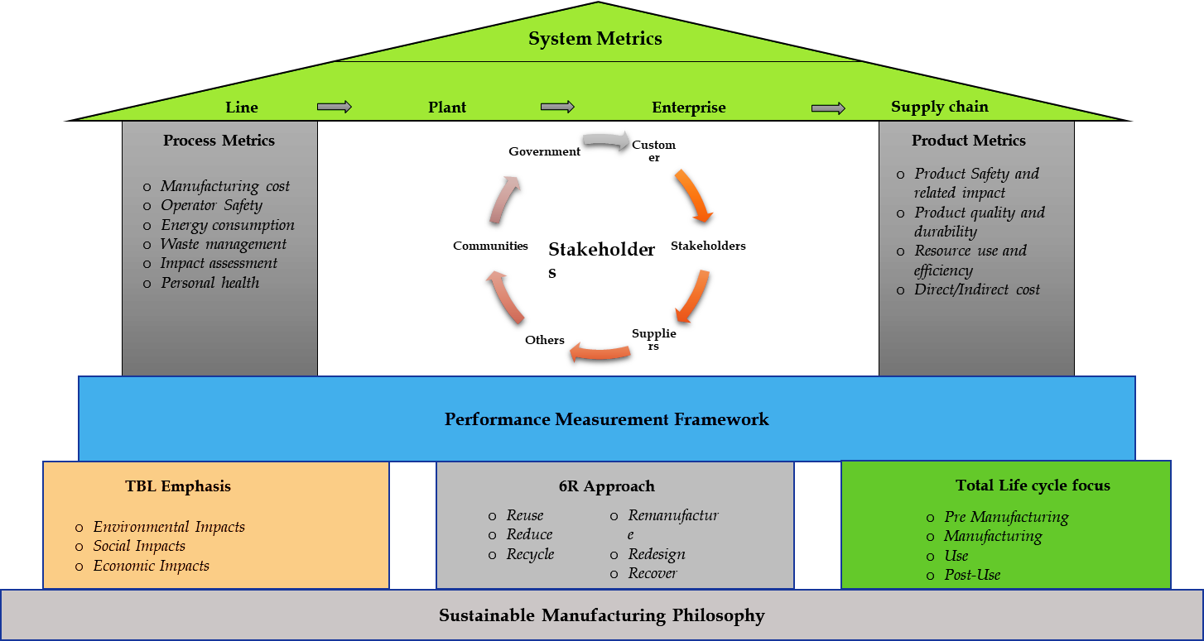

Figure 2: Sustainable manufacturing performance measurement
through the literature review it is also found that, in most previously published studies, SM refers to balancing the TBL approach. SM is more focused on the consideration of all sustainability aspects and maintains the balance between them rather than focus on one aspect. So, with the use of different terms, we have found that many research articles are not related to SM. To maintain the quality of the study we have used the exact search keyword discussed in the next section.

3. Methodology and Data source
Bibliometrics is defined as “The application of mathematical and statistical methods to books and other media of communication” (Pritchard, 1969) which has been expanded in different ways in the last few years. Several authors have defined bibliometric analysis as a statistical method to analyse the research tendencies and structure. According to (Ellegaard & Wallin, 2015) bibliometric is defined as the aspect of science which receives the most contributions from various institutions, journals, authors and countries. The bibliometric analysis can be defined into three categories: (A) Review techniques (B) Evaluation techniques (C) Relational techniques.
Review techniques in bibliometric studies include classical reviews, meta-analysis and systematic literature reviews. Evaluation techniques can be categorized into three groups: (A) impact measurement (number of citations) (B) productivity measurement (number of publications) (C) hybrid measurement (h-index, which includes both impact and productivity measurement). Relational techniques are used to identify the networks among the journals, authors and articles. However, (Zupic & Čater, 2015) argue that it can be classified into four categories: (A) Bibliographic coupling (B) Co-word analysis (C) Co-citation analysis (D) Co-authorship analysis. In the present study, we have focused on all three groups of analysis: Review techniques, evaluation techniques and relational techniques.
3.1. Data processing
Article search was conducted in December 2020 using the search strings on the scientific database Scopus. This database is widely used by researchers for quantitative analysis (Donthu et al., 2020). Scopus database is selected as it is including peer-reviewed articles from journals, book series and conference proceedings. Few authors have discussed the advantage of using the Scopus database over the Web of Science (WoS) database as 84% of the literature on WoS overlaps with Scopus (Mongeon & Paul-Hus, 2016). To select publications for analysis we have used the PRISMA flow introduced by (Moher et al., 2015) and often to conduct a bibliometric analysis of SM. Generally, PRISMA consists of four steps which are: (A) Identification of studies related to topic (B) Screening (C) Eligibility (D) Inclusion.
- Identification of studies related to SM
In this study we have used the following search terms to conduct the article search in the Scopus database:
“Sustainable Manufacturing” OR “Manufacturing” AND “Sustainability” OR “Manufacturing” AND “Sustainable” OR “Manufacturing” AND “TBL”
- Screening of articles
In screening, two criteria were used to conduct the screening. In the first step only, English articles were included in the database. Articles other than the English language were excluded from the database. In the second step other document types e.g., Note, Book series, Conference review, Erratum and undefined documents were excluded.
- Eligibility
In this step publications without International standard serial number (ISSN) number are excluded to analyse the documents from known and identified sources.
- Inclusion and Exclusion criteria
The final database of 523 articles is selected for analysis based on inclusion/exclusion criteria discussed in Table 3.
Further, Figure 3 shows the review protocol of the study. Figure 4 shows the methodology Flow chart of the study.

Table 3: Inclusion and Exclusion criteria for articles considered for analysis
Inclusion/Exclusion | Criteria for the study | Explanation for criteria
Inclusion Criteria | Closely related | CR1: The articles selected only if it is related to the Sustainable manufacturing. The article should discuss sustainability in manufacturing.
Inclusion Criteria | Partially related | PR 1: The article should mention the use of  “Sustainable Manufacturing” OR “Manufacturing” AND “Sustainability”  word in the Title, abstract or keywords.  PR 2: Both the terms  “Sustainable Manufacturing” OR “Manufacturing” AND “Sustainability”  should be used to support the challenges, enablers and research trends in the particular research area.  PR 3: “Sustainable Manufacturing” OR “Manufacturing” AND “Sustainability”  should be one of the research themes in the paper for review.
Exclusion Criteria | Search engine or Data base reason | DBR: A paper must include the  “Sustainable Manufacturing” OR “Manufacturing” AND “Sustainability”  in its Abstract, Title or Keywords and full text for articles are not available.
Exclusion Criteria | Non-related | NR1: An article is not related to an academic research article e.g., editorial, conference review or undefined.  NR2: The presented definitions are not related to Sustainable manufacturing
Exclusion Criteria | Loosely related | LR: A paper doesn’t mention about the  “Sustainable Manufacturing” OR “Manufacturing” AND “Sustainability”  and in which these terms are used as:  LR1: Only as an example  LR2: Only discussed as future scope  LR3: Only used in keywords or abstract without the proper research theme.

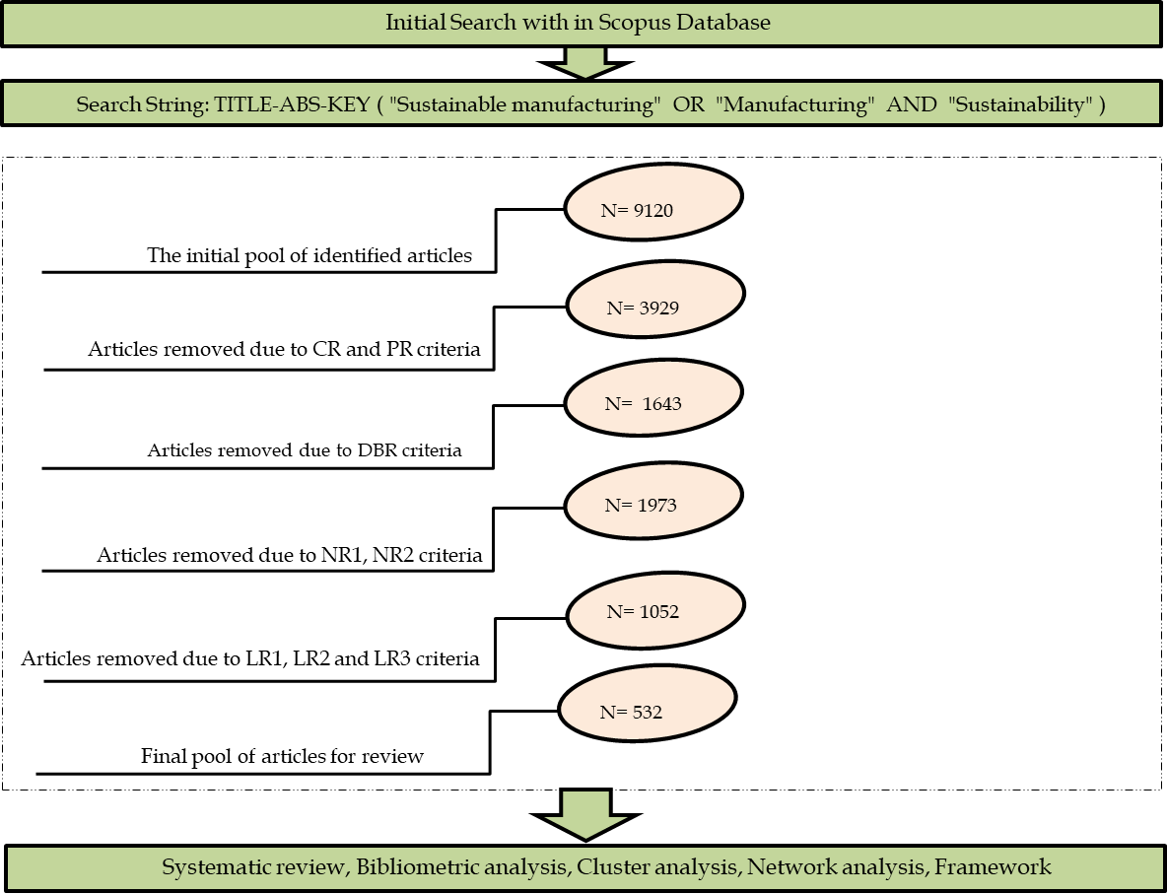
Figure 3: Review Protocol for Article collection

3.2. Analysis procedure and software
In this study, we have used three software programs (VOSviewer, Notepad++ and R language) on MacOS operating system to analyse the data collected from the bibliographic database. Notepad++ software is used to standardized the important keywords in the abstract, keywords and title e.g., we have replaced “Sustainable Manufacture”, “Sustainability in manufacturing”, “Manufacturing sustainability” with “Sustainable Manufacturing”. Similarly, we have replaced other words like “Cyber-physical-systems”, “CPS” and “Cyber physical-system” with “Cyber-physical system”. This type of replacement is done in many words to standardize the format of keywords and abstract. In this study, we have also discussed the various bibliometric techniques which help to understand the strength and weakness of each bibliometric techniques (See Table 4).
Table 4: Bibliographic techniques with their strengths and weakness (Adapted from (Tandon et al., 2021)
Technique | Description | Complemented by | Strength | Weakness
Citation analysis | Assess the level of acceptance of a research document with the help of a quantified assessment approach | Concurrent use of prestigious analysis can help to understand the impact of citation analysis in a better way | Helps to understand the impact and popularity of document and collaborative network between the articles | Less attention has been paid to the visualization of citation analysis. Few studies have raised concern about the prestige and popularity of research document. May having different research trends over the different fields
Co-occurrence | Helps to measure and assess the keyword (Author/Index) occurrence | Concurrent use of co-citation analysis helps to understand the better research development and intellectual configuration of research trends | Helps to visualize the core content of research documents  Helps to identify the emerging research trends | Temporal changes in keywords i.e., similar meaning keywords with different names can lead to instability
Co-authorship analysis | Helps to measure the research patterns between the collaborating authors by identity joint publications | - | Helps to assess the research network between the countries, affiliation and authors by identifying the joint publications | Less attention has been paid to the visualization of co-authorship analysis
Co-citation analysis | Identifies the occurrence where the two research articles have cited in the third article | Co-word analysis | Helps to identify the publication clusters with past publication dates thematic similarity among articles | Limited in terms of description about the cited publications
Page rank analysis | Assess the citation on a document by other highly cited or popular articles | Citation analysis | Helps to identify the prestige and popularity of research article, explore the comprehensive evaluation of articles | Only consider the document impact by citation
Bibliographic coupling | Identifies the relationship between articles when two common articles cite the third document | Co-citation analysis provides a more forward outlook | Helps to identify the emerging research trends, and identify a stronger intellectual foundation | Retrospective directions of references

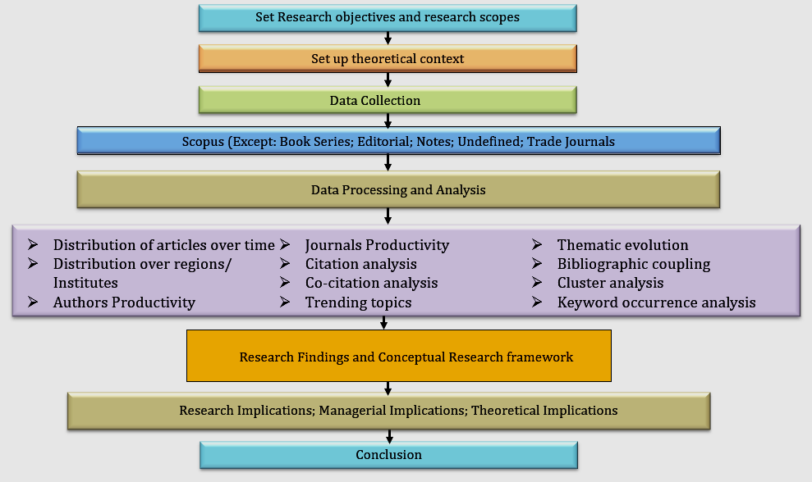

Figure 4: Flowchart for research methodology

4. Results
The analysis of bibliographic data is done by using the Bibliometrix R package on R studio. The summary of bibliographic data on SM is presented in Figure 5 in which Author collaboration, document type, main information about the bibliographic data, document content and information about the authors is discussed.

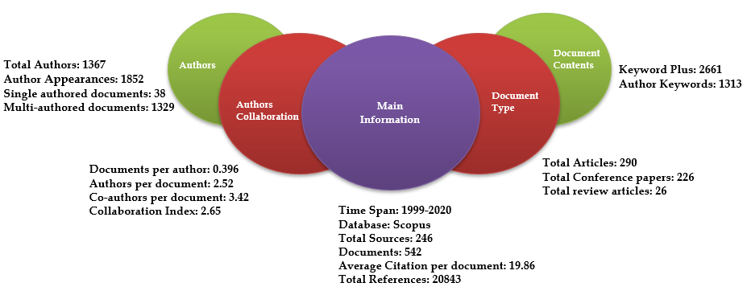

Figure 5: Summary of bibliometric data

4.1. Research growth and citation structure in Sustainable Manufacturing
The research growth in SM in the last 21 years is shown in Figure 2. The term SM was first appeared in the book by (Stephen et al., 1990) and was more focused on economic sustainability rather than SM. However, the term SM firstly appeared on the Scopus database in an article by (Fujita, 1999). The first journal article on SM in published in 2000 and discussed the existing approaches of life cycle management and SM (Westkamper et al., 2000). (Haapala et al., 2013) discussed the research opportunities for SM in industries more extensively. (Stock & Seliger, 2016a) discussed opportunities for SM in the fourth industrial revolution. (Jamwal et al., 2020) discussed the research opportunities for MCDM techniques in SM and proposed a framework for decision making in industries. Figure 6 shows that research in SM is rapidly growing.

Figure 6: Annual scientific production in SM research (no. of articles published)

Table 5 shows the citation analysis of published research articles in SM in the last 21 years. This analysis helps to assess that year-wise research productivity in the area of SM. The citation structure of 2018-2019 shows that now articles with sustainability aspects are gaining interest in the industries due to strict government regulations related to the environment and customer awareness.
Table 5: Year-wise citation structure of SM articles
Year | No. of articles | Mean TC per Article | Mean TC per year | Citable Years
1999 | 1 | 1 | 0.045455 | 22
2000 | 2 | 83 | 3.952381 | 21
2001 | 1 | 63 | 3.15 | 20
2002 | 0 | 0 | 0 | 0
2003 | 0 | 0 | 0 | 0
2004 | 1 | 9 | 0.529412 | 17
2005 | 0 | 0 | 0 | 0
2006 | 6 | 5.666667 | 0.377778 | 15
2007 | 5 | 97.2 | 6.942857 | 14
2008 | 8 | 88.125 | 6.778846 | 13
2009 | 9 | 11.11111 | 0.925926 | 12
2010 | 18 | 48.66667 | 4.424242 | 11
2011 | 28 | 14.57143 | 1.457143 | 10
2012 | 28 | 42.07143 | 4.674603 | 9
2013 | 32 | 36.3125 | 4.539063 | 8
2014 | 33 | 21.18182 | 3.025974 | 7
2015 | 44 | 19.97727 | 3.329545 | 6
2016 | 66 | 25.75758 | 5.151515 | 5
2017 | 60 | 13.41667 | 3.354167 | 4
2018 | 53 | 16.39623 | 5.465409 | 3
2019 | 62 | 6.483871 | 3.241935 | 2
2020 | 75 | 2.613333 | 2.613333 | 1

4.2. Top authors with their affiliation and country
In terms of highly cited and productive authors, Lin Li (g-index: 18, m-index: 0.818, h-index: 9) published most of the studies in this area and published an initial paper in 2011 and published a total of 18 paper between 2011 and 2020. Although, Wenjun Xu has published six papers between 2014 to 2020. From this analysis, we have deduced a strong positive correlation between the authors' productivity and the total number of citations. Only Fazleen Badurdeena and Karl Haapala are still contributing in this area and published articles consistently. Figure 7 shows the productivity of authors over time and Table 6 shows the detailed analysis of authors productivity. It can be seen that most authors are affiliated with institutes from the United States. In Figure 7 larger the circle shows the more publication and dense circles shows the no. of citations on those articles. In this study, we have calculated the h-index, g-index and m-index of top authors which helps to analyze the productivity of each other. The calculation of various indexes is discussed below:
If we have the function f which is in decreasing order from the largest value to the smallest value then the h-index can be calculated by:
$$h-index (f)=max\left\{i∈N: f(i)≥i\right\}$$
g-index is the variant of the h-index in which the evolution of most cited articles overtime is calculated.
$$g={\left(\frac{α-1}{α-2}\right)}^{\frac{α-1}{α}}\frac{1}{T^{α}}$$
Here, T denotes a total number of sources.
If the n denotes the no. of years since the author has published the first paper in his area, then the m-index can be calculated as:
$$m=\frac{h-index}{n}$$

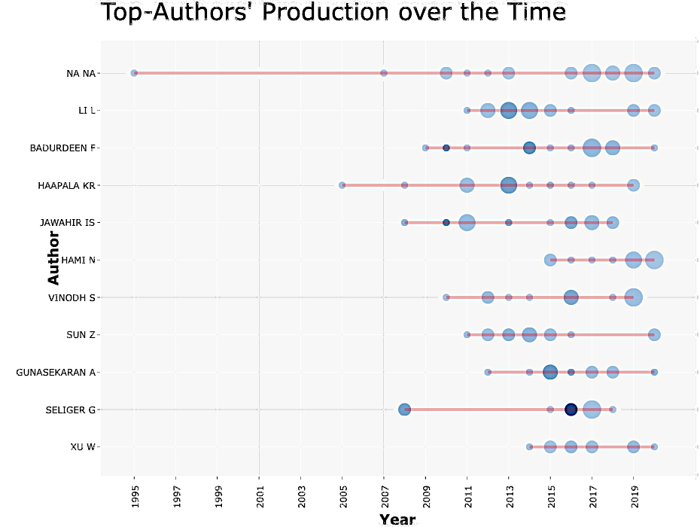
Figure 7: Authors’ productivity in SM research area

Table 6: Top and productive authors working in the SM area
Author | Affiliation | Country | h_index | g_index | m_index | TC | NP | PY_start
Lin Li | University of Illinois at Chicago | United States | 9 | 18 | 0.818 | 426 | 18 | 2011
Fazleen Badurdeen | University of Kentucky | United States | 9 | 16 | 0.692 | 864 | 16 | 2009
Karl Haapala | Oregon State University | United States | 7 | 15 | 0.412 | 385 | 15 | 2005
I.S. Jawahir | University of Kentucky | United States | 10 | 15 | 0.714 | 1010 | 15 | 2008
Norsiah Hami | Universiti Utara Malaysia | Malaysia | 4 | 6 | 0.571 | 42 | 14 | 2015
Sekar Vinodh | National Institute of Technology, Tiruchirappalli | India | 6 | 13 | 0.500 | 195 | 14 | 2010
Zeyi Sun | Missouri University of Science and Technology | United States | 9 | 13 | 0.818 | 261 | 13 | 2011
Angappa Gunasekaran | California State University | United States | 9 | 11 | 0.900 | 463 | 11 | 2012
Günther Seliger | Technische Universität Berlin | Germany | 5 | 11 | 0.357 | 831 | 11 | 2008
Wenjun Xu | Wuhan University of Technology | China | 5 | 9 | 0.625 | 83 | 10 | 2014
TC: Total citations; NP: No. of Publications; PY_Start: Publication year started
4.3. Country and Institute wise distribution
The list of contributing countries and affiliation were extracted using R studio tool (See Fig 8).
USA has most of the publication in the area of SM with 118 publication followed by India with 75 publications. In the top 10 countries only India, China and Brazil were only developing countries which indicate that now industries of developing nations are also focusing on SM implementation. (Yadav et al., 2020) stated that now the MNCs are investing in the developing nations to achieve sustainability in Industry 4.0 practices due to cheap labour costs. This is the reason now developing nations are also focused on the implementation of SM practices. In the most relevant institutes, we found that the University of Kentucky has most of the publication in which the most cited contribution is published in 2010 by (Jayal et al., 2010a) which describes the challenges to SM practices at both process and product level. The University of Johannesburg and National Institute of Standards and Technology are also the major contributing affiliation in SM with 14 and 12 publications respectively.

Figure 8: Country-wise and Affiliation wise articles on SM

4.4. Citation structure of top Journals
In previously published studies only journal articles were considered for the analysis. But, we found that many important contributions in the SM area i.e., (Stock & Seliger, 2016b) not included. Therefore, in this study, we have included peer-reviewed conference articles also and duplicate articles from the database is refined in the MS Excel software. The top 10 journals and Top 5 conference proceedings published in the area of SM are shown in Table 7 with their citation structure. In the top 10 journals, the Journal of Cleaner Production is the most productive journal which published the review, experimental and empirical investigations related to SM. In proceedings journals, Procedia CIRP is the most productive journal which published peer-reviewed conference articles from CIRP conferences. The first contribution which explained the scopes for SM in Industry is published in this journal by (Stock & Seliger, 2016a). In the analysis total of 279 sources were found which has published the articles on the SM but due to fewer space constraints top 10 sources in each category are shown in Table 7

Table 7: Top Journals and Proceeding sources in SM research
Top Journals
Source | NP | h_index | g_index | m_index | TC | PY_start
Journal of Cleaner Production | 43 | 24 | 43 | 1.0434 | 2408 | 1999
Sustainability (Switzerland) | 40 | 13 | 19 | 1.625 | 435 | 2014
International Journal of Production Economics | 10 | 10 | 10 | 1 | 788 | 2012
Journal of Manufacturing Technology Management | 9 | 9 | 9 | 0.6 | 267 | 2007
International Journal of Production Research | 8 | 6 | 8 | 0.4285 | 278 | 2008
CIRP Annals: Manufacturing Technology | 7 | 6 | 7 | 0.6 | 396 | 2012
International Journal of Supply Chain Management | 7 | 2 | 3 | 0.4 | 9 | 2017
International Journal of Advanced Manufacturing Technology | 6 | 5 | 6 | 0.625 | 70 | 2014
International Journal of Sustainable Engineering | 6 | 4 | 6 | 0.4 | 43 | 2012
Benchmarking: An International Journal | 4 | 4 | 4 | 0.4 | 88 | 2012
Top Conference Proceedings Journals
Procedia Manufacturing | 33 | 8 | 13 | 1.142 | 211 | 2015
Procedia CIRP | 27 | 10 | 16 | 1.25 | 306 | 2015
Proceedings of The ASME Design Engineering Technical Conference | 13 | 4 | 7 | 0.307692308 | 57 | 2009
IOP Conference Series: Materials Science and Engineering | 9 | 2 | 2 | 0.222222222 | 8 | 2013
AIP Conference Proceedings | 5 | 2 | 4 | 0.181818 | 22 | 2011

4.5. Network Analysis
Network analysis in bibliometrics helps to examine and visualize the relationships between published articles based on citations, authorship and common research themes. Generally, there are three types of network analysis i.e., citation networks (citation analysis; co-citation analysis and bibliographic coupling), semantic network (keyword co-occurrence analysis) and collaboration network (author; institute and country collaboration). The citation networks help to visualize and identify the future and emerging research themes.
4.5.1. Keyword occurrence analysis
The top used keywords in the SM articles are shown in Table 8. It is found that “Manufacture” is mostly used keyword with a total of 620 occurrences which is followed by “Sustainable manufacturing” and “Sustainable development”. Further, keyword network analysis is shown in Figure 9 in which different clusters of keywords can be seen. It can be seen that Sustainable Manufacture and Sustainable Development are mostly used keywords with maximum node strength. However, some keywords such as green supply chain, resource efficiency, expert systems are less used keywords. It can also be observed that Industry 4.0 related keywords are also developing the strong link strength with keywords like Sustainable Development and Sustainable Manufacture which shows that now the research is more focused on Industry 4.0
Table 8: Top Keywords in SM
Keyword | Occurrence
Manufacture | 620
Sustainable Manufacturing | 566
Sustainable Development | 549
Sustainability | 236
Life cycle | 150
Manufacturing | 135
Industrial Research | 124
Environmental Impact | 98
Decision Making | 95
Energy Utilization | 85
Product Design | 82

Figure 9: Co-occurrence of Keywords in Sustainable manufacturing between 1999-2020

4.5.2. Thematic analysis

The thematic analysis of SM articles done based on author keywords to identify key research themes in SM in the bibliometrix package. In Figure 10 thematic map analysis shows how each keyword in a two-dimensional frame. The input contribution of each keyword is measured with the help of scale. Various themes are further identified based on the clustering algorithm applied to the dataset of keywords. Each cluster is further plotted on the thematic map based on its importance in the field of science and the density of the map measures the growth of the theme(Secinaro et al., 2021). Thus, based on the thematic mapping of results on SM, it has been found Industry 4.0 (Smart manufacturing, IoT, Circular economy) and Sustainability (Simulation, manufacturing systems and supply chain management) are two highly repetitive themes which are found after the Author keyword analysis and these two themes are interlinked with each other. We have found that Sustainability and Industry 4.0 are the highly repetitive themes in the SM at present time and most authors are working on the keywords like smart manufacturing and circular economy. Further research in energy efficiency, life cycle assessment, optimization, lean production systems are linked with each other and are also closest to the centrality which can be interpreted as the important themes in SM. Manufacturing Strategy and Environmental impacts in SM both are niches and the most isolated themes. Lastly, Sustainable design and sustainable development (remanufacturing; product recovery and supply chain) lies in the emerging and declining themes, but the many elements under this theme are also similar to the elements of sustainable manufacturing and sustainability theme.

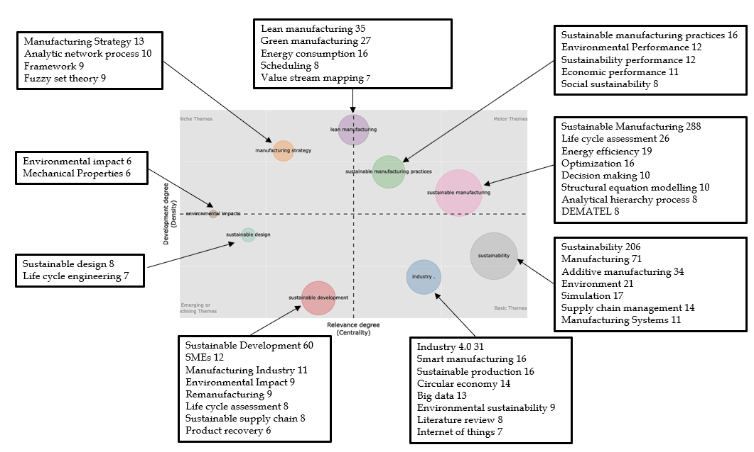

Figure 10: Thematic map analysis

4.5.3. Trending topics

Figure 11 shows the trending topics in SM, based on the authors’ keywords throughout 1999-2020. Figure 11 highlights the change in the trend of issues throughout 1999- 2020. In 1999 research was focused on industrial ecology and eco-efficiency. From 2013 onwards SM research shifted to manufacturing systems and simulation. In this span, many articles discussed the sustainability in the manufacturing systems (Haapala et al., 2013; Jayal et al., 2010a). It is found that 2016 onwards articles started discussing more sustainable development with sustainable manufacturing. The evolution of Industry 4.0 can be traced from 2011 from Hannover fair when the term coined as the high technology plan for Germany. In 2016 first article for SM in Industry 4.0 was published which changed the research trends in SM (Stock & Seliger, 2016b). Now in 2018 onwards, articles are discussing more the Industry 4.0 technologies with SM i.e., IoT, big data and Industry 4.0 (Bag & Pretorius, 2020; Dubey et al., 2016; Machado et al., 2020; Sharma et al., 2020). However, some articles are discussing the integration of SM with a lean concept which helps in waste reduction (Hartini & Ciptomulyono, 2015; Kamble et al., 2020; Swarnakar et al., 2020). DEMATEL decision-making approach is in trending topic after 2018 due to more publications on this from 2016-2020 (Bhanot et al., 2017; Jamwal et al., 2020; Parmar & Desai, 2020). Industry 4.0, additive manufacturing, IoT, energy management, simulation, sustainable supply chain management and energy efficiency are trending research topics in the last five years.

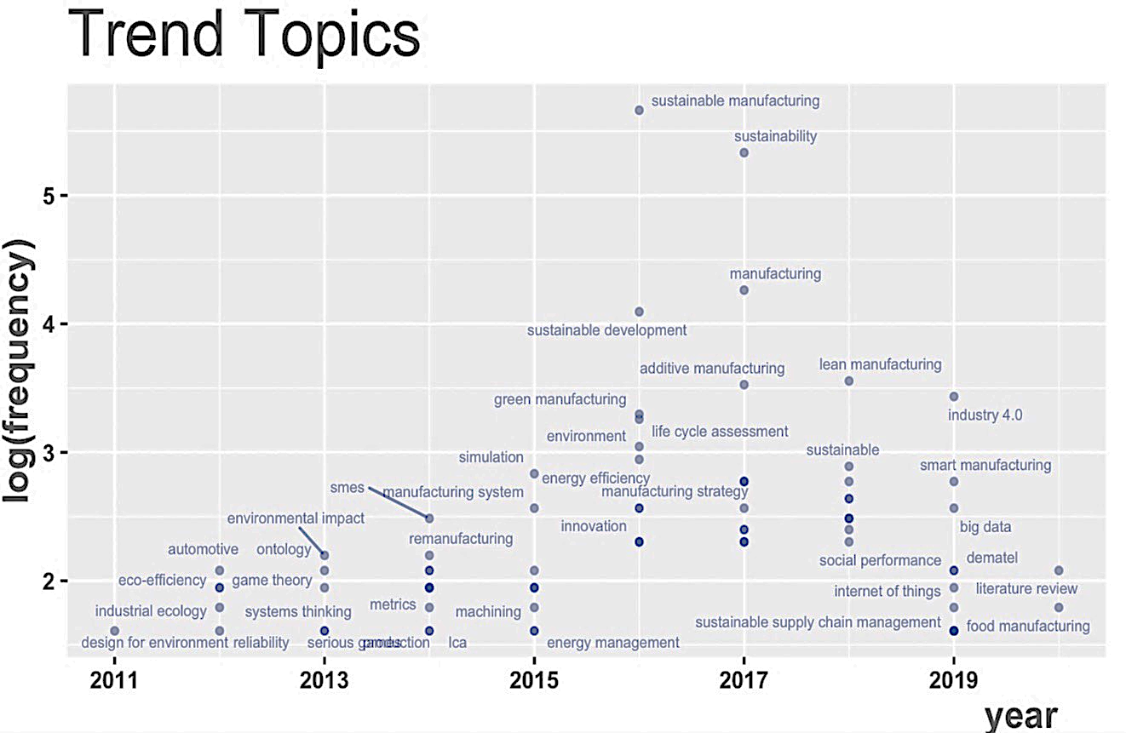

Figure 11: Trend topic analysis

4.5.4. Citation analysis
Citation analysis is a way to measure the relative importance or impact of a journal, research article, country or individual author by counting the number of times that country’s, author or source article is cited (Donthu et al., 2020). The citation network of publications is shown in Figure 12 (a) in which (Jayal et al., 2010a) and (Joung et al., 2013) are the topmost cited articles with maximum link strength in all article. (Jayal et al., 2010b) discussed the optimization and modelling challenges related to SM at the product and system level while (Joung et al., 2013) discussed the list of various indicators related to economic, environmental and social dimensions of manufacturing. The articles with a minimum of 10 citations were considered for analysis in which a total of 308 articles were found. The number of citations on an article generally shows the quality of the article which is validated by the researchers related to particular research areas by citing the articles in their reference section. The categorization based on citations of articles is done to identify the top articles in the area of SM area. The top 10 cited articles in SM are shown in Table 9. It is found that on the (Jayal et al., 2010a) is a most cited article with 481 citations which is followed by (Stock & Seliger, 2016a) with 430 citations.
Table 9: Citation analysis (Local and Global citation analysis)
Year | Local Citations (LC) | Global Citations (GC) | LC/GC Ratio (%) | Normalized Local Citations | Normalized Global Citations | TC per Year
(Stock & Seliger, 2016b) | 16 | 618 | 2.59 | 14.87 | 26.54 | 103
(Jayal et al., 2010a) | 69 | 532 | 12.97 | 13.66 | 11.79 | 44.33
(Garetti & Taisch, 2012) | 51 | 416 | 12.26 | 12.96 | 14.19 | 41.600
(Joung et al., 2013) | 39 | 269 | 14.50 | 14.88 | 9.96 | 29.889
(Rusinko, 2007) | 21 | 238 | 8.82 | 1.91 | 1.97 | 15.866
(Faulkner & Badurdeen, 2014) | 15 | 194 | 7.73 | 9.04 | 10.89 | 24.250
(Rosen & Kishawy, 2012b) | 30 | 182 | 16.48 | 7.62 | 6.21 | 18.200
(de Sousa Jabbour et al., 2018) | 1 | 173 | 0.58 | 1.26 | 9.64 | 43.250
(Le Bourhis et al., 2013) | 4 | 137 | 2.92 | 1.53 | 5.07 | 15.222
(Miller et al., 2010) | 8 | 130 | 6.15 | 1.58 | 2.88 | 10.833

The network analysis for top-cited articles in SM is shown in Figure 12 (a). It can be seen that (Stock & Seliger, 2016a) and (Jayal et al., 2010a) have maximum node strength as both these two articles are highly cited in SM. (Stock & Seliger, 2016a) highlighted the research issues and opportunities for SM in Industry 4.0 by considering both the micro and macro perspective of SM while (Jayal et al., 2010a) discussed the research opportunities for SM at the system and process level.

4.5.5. Co-citation analysis
The concept of co-citation analysis was introduced in 1973 by Small to complement bibliographic coupling. Generally, co-citation analysis used to analyse the structure of literature from the perspective of cited documents. Co-citation between two articles occurs when both these two articles appear together in the reference list of the third article (Baker et al., 2020). By Co-citation analysis we found six major clusters shown in Figure 12 (b) in which red cluster focused on Decision making approaches in SM, Violet colour cluster discuss the articles related to Industry 4.0 technologies, Green colour cluster discuss articles related to manufacturing processes i.e., forging, grinding, sustainable machining, blue cluster discuss the lean production and yellow colour cluster discuss articles related to energy consumption, waste management, process planning, scheduling and carbon emissions.
Figure 12: (a) Citation Network (b) Co-citation Network

4.5.6. Bibliographic coupling
Bibliographic coupling was introduced by Kessler in 1963 which occurs when two documents cite a common third document (e.g., Article A and Article B cite Article C) (Donthu et al., 2020). Our analysis shows six major clusters formed which share common citations. We have followed the approach by (Donthu et al., 2020) in which naming of clusters is done based on subjective judgement and it is also discussed the naming of clusters is conceptually similar to the approach we followed in factor analysis. In this study, we have identified the area of focus of studies reported in these clusters and then naming of clusters is done (See Figure 13).
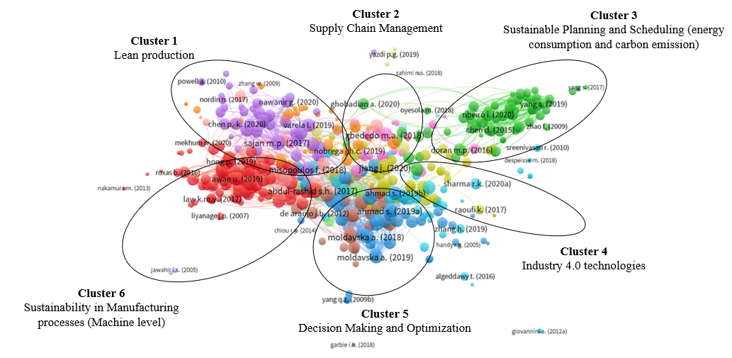
Figure 13: Bibliographic coupling network

5. Content analysis of various research themes in SM
Content analysis and thematic cluster identification of new research areas are adding the knowledge in literature in various research areas. In the SM many focal research themes have evolved and bibliographic coupling can help to identify these research themes. In the past, few authors have used bibliographic coupling to identify focal research themes based on the degree of semantic similarity (Baker et al., 2020; Donthu et al., 2020). Semantic similarity uses the Louvain clustering algorithm for comparative assessment. Based on the analysis we have identified six major research themes in SM discussed in Table 10. The research progress and research gaps in each theme are discussed in this section.

Table 10: Clusters analysis based on keywords
Cluster | Focused research area | Main keywords
Cluster-1 | Sustainability in manufacturing processes | Grinding, Forging, Finishing, cleaning processes, machining. MQL, Cryogenic machining, casting, forming, tool remanufacturing
Cluster-2 | Sustainable planning and scheduling | Job shop scheduling, makespan, machine utilization, total production time, total cost, flexible manufacturing systems, Scheduling, Multi-objective optimization, planning, sustainable planning
Cluster-3 | Sustainable manufacturing in Industry 4.0 | Big data, Industry 4.0, CPS, AI, Deep learning, machine learning, IoT, IIoT, Deep learning, blockchain technology, smart manufacturing, circular economy
Cluster-4 | Sustainable manufacturing and Supply chain | Supplier, supply chain, reverse supply chain, supplier selection, forward supply chain
Cluster-5 | Decision making in Sustainable manufacturing | Barriers, Challenges, maturity model, Fuzzy set theory, KPI, Analytical hierarchy process, TOPSIS, DEMATEL, framework, MCDM, ANP, BWM
Cluster-6 | Sustainable manufacturing and lean production systems | Lean manufacturing, lean production, environmental management, lean tools

5.1. Cluster 1: Sustainable manufacturing processes
Machining processes consume a large amount of energy in manufacturing industries. (Haapala et al., 2013) discussed the role of energy efficiency, lubrication techniques and machining parameters in SM. (Gupta et al., 2016) presented the comprehensive literature review on advancement in gear manufacturing through SM. (Jayal et al., 2010a) discussed the research opportunities for sustainable machining at the process and product level. (Marksberry & Jawahir, 2008) developed a tool performance model for near to dry machining and reported a 10% improvement in tool wear. (Rapeti et al., 2016) investigated the machining performance with vegetable oil-based nano fluids and found that 0.5% of coconut oil with nano molybdenum di sulphide can improve the machining performance. (Jamil et al., 2019) discussed the effect of chemicals and lubricants on health problems and carbon emissions and concluded that it can be minimized with minimum quantity lubrication and dry machining processes. (Cica et al., 2020) concluded that lower carbon emissions and health risks can be achieved with dry machining processes. (Pagone et al., 2020) stated that development in forming techniques such as single point incremental forming having better results in energy and material consumption reduction as compared to other forming operations. (Swarnakar et al., 2020) found that tool remanufacturing from additive manufacturing processes contribute more to sustainability practices as compared to traditional processes. (Gupta et al., 2016) stated that reconfigurable dies can reduce the environmental impacts as well as cycle time. The recent development in die coatings have improved the life cycles and reduced the use of lubricants.
Studies conducted in the last few years revealed that sand casting processes are the major source of pollution which results in toxic fumes and other types of greenhouse gases (Deepak Kumar et al., 2019). This emission can be minimized by IST (integrated sensing technology) and online processing handling which also helps in the reduction of casting restoration and distortions that occurs during the casting processes (Haapala et al., 2011). The developments in both permanent moulds and sand moulds have improved the environmental sustainability performance of the casting products and emerged as an emerging research area. In the analysis of studies, we have found that sustainability aspects in advanced machining processes are still a less explored area. However, (Gupta et al., 2016) has addressed some future research scopes for advanced machining processes discussed in Table 1. has given some future scopes for advanced machining processes with the consideration of sustainability but still detailed investigations are needed to determine the benefits of using MQL and other techniques i.e., cryogenic machining. There is limited research at the process level to minimize the carbon emissions in Industry 4.0 aspects.

5.2. Cluster 2: Sustainable manufacturing planning and scheduling
Sustainable planning and scheduling help to minimize carbon emission, water consumption, energy usage and other environmental impacts at the process planning and machine scheduling stage. A total of 52 papers were reported about the process planning and scheduling in which mostly mathematical modelling approaches were used to formulate the objective functions related to various sustainability indicators presented in Figure 14. These objective functions were identified by the analysis of 52 papers in this area. In these papers, most of the papers discussed the different machine configurations i.e., job shop, flexible job shop, parallel machines and reconfigurable systems. Very few papers discussed the opportunities of planning and scheduling in Industry 4.0. The sustainability level in manufacturing systems can be improved by a sustainable planning and scheduling approaches. Liu et al. (2003) worked on work-piece and machine integration to reduce the noise. Similarly, (Subaï et al., 2006) investigated the scheduling problem at the shop floor level to reduce energy consumption. (Mouzon & Yildirim, 2008) developed a scheduling plan for a single machine to reduce total energy consumption and concluded energy consumption can be reduced by optimizing scheduling plans. (Wang et al., 2009) proposed an optimal scheduling model to minimize energy consumption. (Herrmann & Thiede, 2009) reported that in industries up to 30% energy efficiency improvement can be achieved by the process chain simulation with two same production lines. (Fang et al., 2011) proposed a new production schedule that considers the environmental performance measures and production time. (Valivullah et al., 2014) proposed a production schedule for energy monitoring to increase the quality minimize the production cost. (Shojaeipour, 2015) discussed the three main factors: hazardous materials, waste production and emissions in process planning and scheduling problems. However, few studies use machine utilization, tardiness, makespan as the objective function.
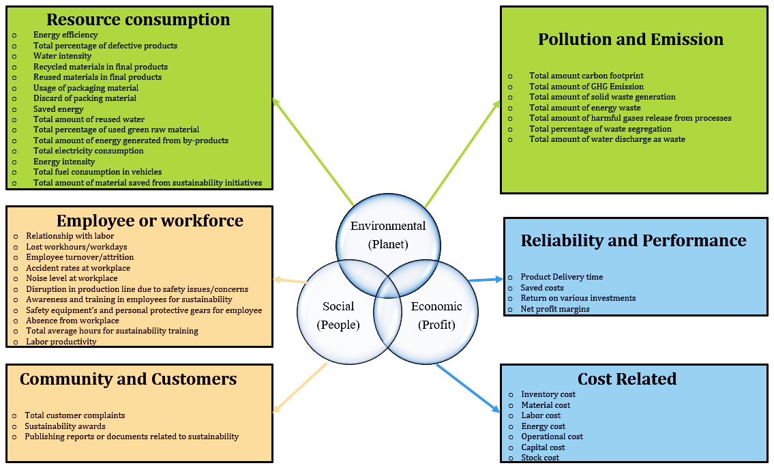
Figure 14: Sustainability indicators related to planning and scheduling

In the analysis, we found that most of the research in sustainable planning and scheduling is based on limited environmental issues i.e., carbon emissions and electricity consumption but many more indicators can be used for future research based on Figure 14. Industries are focusing on environmentally sound technological solutions with socially responsible programs to solve the sustainability issues. There is a need to address a combination of economic indicators with the consideration of at least one environmental indicator with one social indicator in the constraint set or objective function while developing the sustainable scheduling models. In future studies, vehicle fuel consumption as an indicator can be used which is the limitation in the previously published studies.

5.3. Cluster 3: Sustainable manufacturing in Industry 4.0
(Stock & Seliger, 2016b) discussed the research opportunities for SM in Industry 4.0 with macro and micro perspective. (de Sousa Jabbour et al., 2018) discussed how industries can create sustainable value creation through Industry 4.0 technologies. (Carvalho et al., 2018) discussed the collaboration between Industry 4.0 and SM and concluded that CPS, IoT and other technologies of Industry 4.0 has improved product life cycle and waste reduction. (Leng et al., 2020) presented the overview of social challenges and barriers for blockchain empowered SM practices to improve product life cycle. (Machado et al., 2020) discussed various research trends and scopes in SM with Industry 4.0 perspective. (Bag & Pretorius, 2020) proposed a conceptual framework for Industry 4.0, circular economy and SM practices. (Ivascu, 2020) proposed a hierarchical framework to assess the SM practices in Industry 4.0 context and found that stakeholder interest and waste reduction major implications need to be measured. (Yadav et al., 2020) proposed a framework for Industry 4.0 technologies to achieve sustainability in manufacturing and concluded that Industry 4.0 technologies improve the product life cycle and man-machine interaction. (Raj et al., 2020) discussed that Multinational companies are investing more in developing nations to set up industries with new technologies because of less manufacturing costs. (Kamble et al., 2020) found that very few studies reported about the sustainability framework for Industry 4.0. In study proposed framework discussed how the integrated framework of SM and Industry 4.0 improves the man-machine interaction and waste reduction through additive manufacturing. (Sharma et al., 2020) discussed there may be different technological barriers for the developed or developing countries which have still to be explored. The effects of economic and social aspects need further studies in the previously published studies. Also, there is a need to present the sustainability indicators in Industry 4.0 i.e., energy, carbon emissions and wastes. Extensive research work is required on the man-machine interaction which will help to enhance the organizational performance and minimize the information asymmetries.

5.4. Cluster 4: Sustainable supply chains (SSC)
The supply chain articles published in the SM area were classified into different applications areas like sustainable development, environmental supply chain management, and supply chain management under carbon emission policy, green supply chain management and corporate social responsibility SCM. (Haapala et al., 2013) discussed the sustainability in the supply chain is focused on two main aspects i.e., design and production loop. (Despeisse et al., 2012) discussed the improvements in SM due to supply chain, design and technology. (Bhanot et al., 2017) discussed the influence of SSC related factors in SM practices. (Dubey et al., 2016) discussed how sustainability philosophy and supply chain can be integrated to design the SM process. Abdul-Rashid et al. (2017) discussed the impact of SSC practices in the implementation of SM practices. (Garetti & Taisch, 2012) discussed the opportunities for SSC management in the development of SM practices. It is discussed how waste material can be return in supply chains and used as a source of energy or raw materials for replacing the use of non-renewable sources. (Nakano, 2010) developed a conceptual framework for SM by considering the supply chain risks. (Moktadir et al., 2018) discussed the drivers to SM practices in Bangladesh and found industries have started considering the SM and circular economy practices in their supply chain to minimize environmental impacts. (Xu & Wang, 2018) investigated the SM practice in closed-loop supply chain and found that decision of manufacturers and retailers are influenced by carbon emission and remanufacturing policies. From these articles, it is found that SSCM governance and SSCM configurations mechanisms are key factors to achieve sustainability in manufacturing. Very little work reported related to carbon emission policies and remanufacturing issues in the supply chain. In the case of supply chain optimization approaches modern survey analysis techniques such as SEM and optimization techniques such as genetic algorithm, simulated annealing and particle swarm optimization is limited. Also, only a few studies reported the use of hybrid MCDM approaches for the evaluation of supplier performance. Studies on the supply chain are very specific there is still a need for a strong generalized model which can be adopted in the different industry sectors for the successful implementation of SSCM. Business models in Industry 4.0 are different from traditional business models so there is a need to develop assessment tools for managers by which they can improve both the effectiveness and efficiency of supply chain decision making. There is a need for more case studies related to the supply chain in Industry 4.0 which will help to develop the guiding frameworks for developing nations. As Industry is in its development stages in developing nations. Most studies are focused on the consideration of economic and environmental aspects of SSCM but consideration of social aspects is still a limitation that is ignored by practitioners in the different case studies.

5.5. Cluster 5: Sustainable manufacturing decision making
Prioritization and assessment of SM practices, barriers, enablers and indicators have emerged as a complex problem due to the involvement of sustainability benchmarks. Limited literature is available on decision making in SM. However, (Jamwal et al., 2020) has discussed the research progress in SM decision making and concluded that there is a need for studies related to barriers, enablers and maturity models in Industry 4.0 with sustainability aspects. Industries need to assess their current level before the implementation of SM practices. In past review studies, critical challenges and enablers related to SM have not discussed. We have identified the critical enablers and challenges related to SM which will help the industries to assess their current state (See Appendix Table 11, Table 12). By analyzing the review work in decision making we have found that AHP (Analytical hierarchy process) is a widely used decision-making approach in SM. Most of the studies are related to the implementation of SM practices and are from developing nations. Assessment of practices at the local organization level is still a limitation in most of the studies. Also, only a few studies are specific to a particular industry sector. The majority of studies are generalized, so there is a need to develop more robust models for Micro-small and medium enterprises (MSMEs) industries as they contribute more to the GDPs of developing nations. Also, in future studies, local environmental factors with local resources can be addressed. Also, we have found most studies are evaluated based on a single scenario which can be done by considering multiple case scenarios in future studies. Very few studies reported about the identification of challenges and enabling factors related to SM in Industry 4.0 context.

5.6. Cluster 6: Lean practices and Environmental management
(Hartini & Ciptomulyono, 2015) presented the relationship between lean and SM philosophy. (Ben Ruben et al., 2019) presented the state of art on SM and lean manufacturing and discussed research opportunities. (Bhatt et al., 2020) discussed lean manufacturing as the research theme for SM. Vinodh et al. (2016) discussed the integrated LCA-value stream mapping framework for SM practices. Dubey et al. (2015) discussed the impact of SM and lean manufacturing in developing nations. (Pil & Rothenberg, 2003) suggested that operational performance of quality parameters can be enhanced by improving environmental performance. It helps to make the organization more competitive. Pattanaik et al. (2019) proposed a hybrid ELECTRE approach to prioritize conjoint tools for SM and lean practices. Sroufe et al. (2001) investigated the interrelationship between lean tools and environmental performance. Sroufe et al. (2001) found a positive co-relation of operational performance organization with environmental management systems. Studies show that Lean manufacturing tools may have a significant impact on the environmental performance of an organization by it will not reduce the environmental problems. These articles discussed the impact of lean manufacturing tools on environmental management but it fails to discuss the overall impact of environmental management on the performance of the organization. These are some issues that can be addressed in future researches.

6. Proposed sustainable manufacturing framework
Based on the literature review we proposed a conceptual framework (as presented in Figure 15) for SM having five main layers viz. Maturity items and assessment, 6R methodology, Research issues, Decision making and sustainable outcomes. We have found that the shift to the Industry 4.0 paradigm has changed the sustainability trends in manufacturing which is also discussed by (Machado et al., 2020; Sharma et al., 2020; Stock & Seliger, 2016b). The framework explains that Industry 4.0 is expected to improve sustainability in terms of environmental, social and economic aspects by using its advanced technologies. Industry 4.0 facilitates the integration of manufacturing and business practices through CPS and flexibility in manufacturing activities. But industries need to assess their current level before implementation of SM practices. Thus, the framework can be explained as follows:
In the first level, we have considered the critical challenges, enabling factors to SM (Discussed in Appendix) and the maturity dimensions to assess the current level of industries regarding SM implementation. the second level industries highlight the need to adopt 6R (reduce; remanufacturing; reuse; redesign; recycling and recover). The benefits of 6R methodology are discussed by Huang & Badurdeen (2017) and the role of 6R approaches in SM practices is also discussed in the literature review section which explained how 6R approaches help to achieve sustainability.

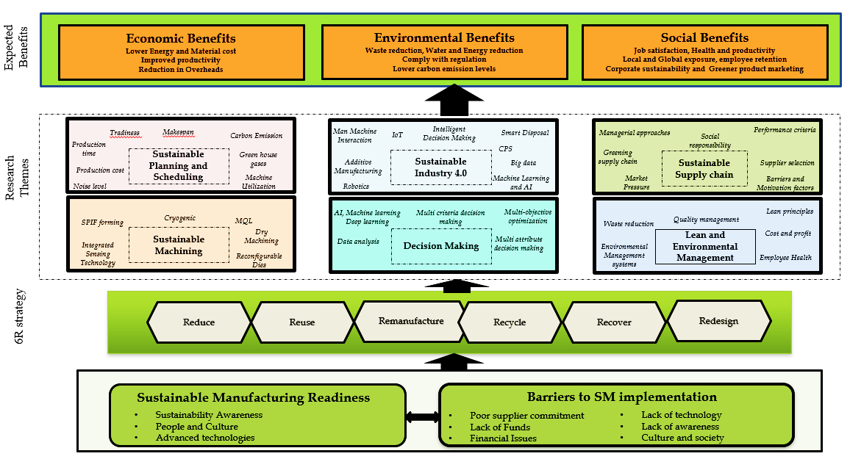
Figure 15: Conceptual Sustainable Manufacturing Framework

In the third level, we have addressed all the research issues and gaps by considering the present manufacturing scenario. This layer discusses the research gaps and issues in each SM research area that can be addressed for the effective and successful implementation of MS practices. In this layer role of decision making is very important. This level also reflects the linkage between Industry4 and SM. Considering the present manufacturing scenario, industries are moving towards the Industry 4.0 practices in which a large amount of data is generated which can be handled by machine learning and deep learning algorithms for better predictive maintenance and intelligent decision making. Further, Sustainable planning and scheduling help to address the process planning and scheduling related issues i.e., energy consumption, waste reduction, makespan, machine utilization at the manufacturing stage. Lean and environmental management helps in quality management and achieving continuous improvement through lean principles. Sustainable machining addresses the carbon emission issues at the machine level i.e., reducing carbon emission, health risks and improve machine quality by cryogenic machining, MQL concept and reconfigurable dies. Sustainable supply chain management helps to evaluate the supplier performance and ensure greening in supply chain practices. Industry 4.0 technologies help to create sustainable value creation in the manufacturing processes. There is a large amount of data generated from the manufacturing activities which can be addressed by decision making approaches for effective decision making in future activities.
The last layer of the framework shows the sustainable outcomes expected from the successful adoption of SM practices. The outcomes are categorised into three dimensions of sustainability.

7. Research Implications
7.1. Implications for researchers
Based on findings from the literature review we present the following broad research areas which can be addressed in future studies:
- The present study provides a comprehensive overview and discussion on emerging research themes in SM which reveals that Industry 4.0 technologies have made new research scopes in SM i.e., sustainable reconfigurable manufacturing systems, energy and resource-efficient supply chains, reduce the use of new materials by remanufacturing and recycled materials. However, the implementation of Industry 4.0 technologies is still lower in developing nations due to technological advancements. Industries need to assess their current state by readiness and maturity models and then prepare them for sustainable operations in Industry 4.0. In future studies industries need to investigate how Industry 4.0 technologies can improve the health and safety of employees? Development of CPS based sustainable production system using IoT can also be the scope for future research. As Industry 4.0 is in its developing stage so cybersecurity issues and standards related to the sustainable production system in Industry 4.0 can be explored in future. MNCs are investing more in developing nations due to cheap labour cost so the design of the SM system for Industry 4.0 can be done which can have a positive impact on all dimensions of sustainability.
- Very few studies have been reported from sustainable planning and scheduling. Planning and scheduling approaches help to minimize carbon emission, water consumption and energy consumption at the process planning and manufacturing scheduling stage. The findings of our study indicate that only a few indicators related to the sustainability dimensions have been used in process planning and scheduling approaches. The research work in reconfigurable manufacturing systems is still limited with sustainability aspects. Reconfigurable manufacturing systems help to adapt to the dynamic changes in the market in minimum time and also a key enabling technology for Industry 4.0. The work-related to social dimensions and vehicle fuel consumption is still very less which can be explored in future studies.
- Adoption of Industry 4.0 technologies in SM enhances the visibility in supply chains and improves the performance of manufacturing industries. Technologies such as IoT and Additive manufacturing are shaping the manufacturing industries to be more sustainable so there is a need to develop assessment tools for managers by which they can improve both the effectiveness and efficiency of supply chain decision making. Maturity models related to SSC can be developed in Industry 4.0 to assess the current state and then research issues such as low carbon supply chain; blockchain-enabled supply chains can be designed. More case studies related to the sustainable supply chain in Industry 4.0 can be explored by identifying the challenges and enabling factors in Industry 4.0 context. However, some studies have reported these factors but having limited applicability. Indicators other than carbon emission related to environmental dimensions (See Figure) can be used as objective functions in supply chain designing. Implementation issues related to blockchain-enabled SSC practices can also be explored in future studies.
- In the study, we have found that lean philosophy tools can help the industries to overcome the challenges of SM. These tools have an impact on the environmental performance of the industry which will help to reduce waste as well as environmental problems. The measure of the overall impact of environmental management on the performance of the industries is still a limitation in past studies which can be addressed in future studies.
- Decision making plays an important role in the development of future strategies related to technology. In literature, the role and application of machine learning, artificial intelligence, deep learning and big data analytics for decision making are discussed but these studies are more theoretical rather than actual implementation. Implementation of these techniques in SM can be an emerging research area for decision making as it can handles and analyse a high volume of data. Most of the studies have used MCDM approaches for prioritization purposes but the use of sensitivity analysis is limited in these studies. Sensitivity analysis helps to analyse the reliability of results. In future studies hybrid MCDM approaches in uncertainty, with sensitivity analysis can be done which will provide a more robust implementation framework for industries.
7.2. Implications for policymakers and practitioners
The findings of our study and proposed in the form of a framework will be helpful for the practitioners and managers in the field of Industry 4.0 and SM. In this study, we have identified that industries are moving towards the adoption of Industry 4.0 technologies in which there is a need to address sustainability challenges. The critical challenges and drivers identified in our study will be helpful to develop an implementation framework for Industry 4.0 environment. There is a need to acknowledge the role of Industry 4.0 technologies to achieve sustainability. It is also found that in Industry 4.0 large amount of data is generated which can be analyzed and refined with the help of machine learning and deep learning algorithms which will be helpful for future decision making. Industry 4.0 technologies and sustainability have better results in process optimization, life cycle and reducing environmental impacts. With both Industry 4.0 technologies and SM approaches practitioners can have better control over the manufacturing activities and agility in processes. Also, real-time decision making, lower carbon emissions and better resource utilization will help the industries to make more competitive in the global market. The framework of our study explains that how the SM problems can be addressed in the present manufacturing scenario. Considering the high investment costs in SM practices and its integration with Industry 4.0 key technologies government and policymakers are expected to subsidize the investments in these key technologies which will help to enhance the SM practices. There is a major gap in education and sources in emerging economies. The lack of skilled labour or trained labour which can work even with new technologies is still limited. Capacity building, investment in human capital and environment awareness programs can play important role in the development of SM. Faculties or researchers having expertise in the SM area can help future engineers by offering the courses which will help in the smooth implementation of the SM practices in the industries in future. Also, the workers will have in better understanding of process and product design, manufacturing and materials processing with the influence of life cycle stages. These approaches will help in the incorporation of economic, policy and social issues in the manufacturing and design processes in industries. Industries are required to assist and provide training programs that will help workers to understand the role of sustainability in new technologies. This will help in enhancing sustainability in the industry by adopting new technologies. It is therefore implied that policymakers should plan to connect the people from rural area and work with technology and government for promoting sustainability practices in the manufacturing area. There is a need to provide advanced and extensive education to the workers in the emerging economies which will help to enhance SM practices in future.

7.3. Theoretical contributions
The literature review conducted in this study reveals that previously published studies were more focused on the basic concepts of SM and explored a limited research area The scarcity of literature review in different research themes of SM was identified. Hence, this study makes a significant contribution to the literature in the form of comprehensive and bibliometric review. We have also proposed a framework for SM in the present scenario by considering the different issues in SM. Future research studies may investigate the impact of SM practices on Industry 4.0 development on process and product level. The findings of our review in the form of a framework are the initial effort to contribute theory for SM in Industry 4.0. The proposed framework can further be used for conducting empirical studies in future. This will also help to address the process planning and scheduling issues related to manufacturing in industries.

8. Conclusions
The strict policies related to environmental protection have constrained the manufacturing industries of developing nations to adopt SM practices that focus on minimizing the negative impact of manufacturing on the environment and consideration of all three sustainability aspects i.e. economic, social and environmental. Industries of developing nations need to consider social and environmental aspects of sustainability with the economic aspect for the smooth implementation of SM practices. The present study discussed the roadmap for SM. The studies which have been conducted in the SM area from January 1999-July 2020 are discussed by considering the Scopus database. This study also discussed that how the SM concept is growing in developing and developed nations over the years through the systematic literature review. Further, sustainable manufacturing processes in the manufacturing industries are discussed. In the study, the articles are categorized based on year, authors, institutes, countries, top-cited articles, top keywords. Further, we have done the content analysis based on cluster analysis. A total of six major keywords clusters are found in which research progress and future research opportunities are discussed. The study reveals that there are many opportunities for Sustainable manufacturing in Industry 4.0. In this study, we have considered the Scopus database for article extraction. In future studies other databases i.e., Web of science can be considered for article extraction with some other tools like Gephi and BibExcel. The proposed framework presented at the end of the study is not empirically tested which can be addressed in future studies by conducting survey-based studies. Also, there is a need to explore the applications of sustainable manufacturing in the emerging technologies of Industry 4.0 in different industry sectors and geographical regions.
References

Abdul-Rashid, S. H., Sakundarini, N., Raja Ghazilla, R. A., & Thurasamy, R. (2017). The impact of sustainable manufacturing practices on sustainability performance: Empirical evidence from Malaysia. International Journal of Operations and Production Management, 37(2), 182–204. https://doi.org/10.1108/IJOPM-04-2015-0223
Ahmad, S., Wong, K. Y., & Rajoo, S. (2019). Sustainability indicators for manufacturing sectors: A literature survey and maturity analysis from the triple-bottom line perspective. Journal of Manufacturing Technology Management, 30(2), 312–334. https://doi.org/10.1108/JMTM-03-2018-0091
Akbar, M., & Irohara, T. (2018a). Scheduling for sustainable manufacturing: A review. Journal of Cleaner Production, 205, 866–883. https://doi.org/10.1016/j.jclepro.2018.09.100
Allwood, J. (2009). Sustainable manufacturing: What would make a big enough difference? Seminar at NIST, May, Department of Engineering, University of Cambridge, Cambridge.
Amrina, E., & Yusof, S. M. (2012). Interpretive structural model of key performance indicators for sustainable manufacturing evaluation in automotive companies. IEEE International Conference on Industrial Engineering and Engineering Management, 656–660. https://doi.org/10.1109/IEEM.2012.6837821
Arena, M., Ciceri, N. D., Terzi, S., Bengo, I., Azzone, G., & Garetti, M. (2009). A state-of-the-art of industrial sustainability: Definitions , tools and metrics Marika Arena * and Natalia Duque Ciceri Sergio Terzi Irene Bengo , Giovanni Azzone and Marco Garetti. Internation Journal Product Lifecycle Management, 4(3), 207–251.
Bag, S., & Pretorius, J. H. C. (2020). Relationships between industry 4.0, sustainable manufacturing and circular economy: Proposal of a research framework. International Journal of Organizational Analysis. https://doi.org/10.1108/IJOA-04-2020-2120
Baker, H. K., Kumar, S., & Pandey, N. (2020). A bibliometric analysis of European Financial Managementʼs first 25 years. European Financial Management, 26(5), 1224–1260.
Bansal, M., Duhan, R. K., & Deshwal, S. (2012). GREEN MANUFACTURING AND USE OF ANALYTICAL NETWORK PROCESS (ANP) DECISION TOOL IN GREEN MANUFACTURING. Int. J. Mech. Eng. & Rob. Res, 1(3).
Ben Ruben, R., Vinodh, S., & Asokan, P. (2019). State of art perspectives of lean and sustainable manufacturing. International Journal of Lean Six Sigma, 10(1), 234–256. https://doi.org/10.1108/IJLSS-11-2016-0070
Bhanot, N., Rao, P. V., & Deshmukh, S. G. (2017). An integrated approach for analysing the enablers and barriers of sustainable manufacturing. Journal of Cleaner Production, 142, 4412–4439. https://doi.org/10.1016/j.jclepro.2016.11.123
Bhatt, Y., Ghuman, K., & Dhir, A. (2020). Sustainable manufacturing. Bibliometrics and content analysis. Journal of Cleaner Production, 260. https://doi.org/10.1016/j.jclepro.2020.120988
Burchart-Korol, D. (2011). Green manufacturing based on life cycle assessment (LCA). Carpathian Logistics Congress CLC.
Caldera, H. T. S., Desha, C., & Dawes, L. (2019). Evaluating the enablers and barriers for successful implementation of sustainable business practice in ‘lean’ SMEs. Journal of Cleaner Production, 218, 575–590. https://doi.org/10.1016/j.jclepro.2019.01.239
Carvalho, N., Chaim, O., Cazarini, E., & Gerolamo, M. (2018). Manufacturing in the fourth industrial revolution: A positive prospect in Sustainable Manufacturing. In K. H. Shpitalni M. Seliger G. ,. Wertheim R. ,. Fischer A. (Ed.), Procedia Manufacturing (Vol. 21, pp. 671–678). Elsevier B.V. https://doi.org/10.1016/j.promfg.2018.02.170
Chan, F. T. S., Li, N., Chung, S. H., & Saadat, M. (2017). Management of sustainable manufacturing systems-a review on mathematical problems. International Journal of Production Research, 55(4), 1210–1225. https://doi.org/10.1080/00207543.2016.1229067
Cica, D., Sredanovic, B., Tesic, S., & Kramar, D. (2020). Predictive modeling of turning operations under different cooling/lubricating conditions for sustainable manufacturing with machine learning techniques. Applied Computing and Informatics. https://doi.org/10.1016/j.aci.2020.02.001
Curkovic, S., & Sroufe, R. (2016). A literature review and taxonomy of environmentally responsible manufacturing. American Journal of Industrial and Business Management, 6(03), 323.
de Sousa Jabbour, A. B. L., Jabbour, C. J. C., Foropon, C., & Filho, M. G. (2018). When titans meet – Can industry 4.0 revolutionise the environmentally-sustainable manufacturing wave? The role of critical success factors. Technological Forecasting and Social Change, 132, 18–25. https://doi.org/10.1016/j.techfore.2018.01.017
Deepak Kumar, S., Ghose, J., & Mandal, A. (2019). Thixoforming of light-weight alloys and composites: An approach toward sustainable manufacturing. In Sustainable Engineering Products and Manufacturing Technologies. Elsevier. https://doi.org/10.1016/B978-0-12-816564-5.00002-5
Despeisse, M., Mbaye, F., Ball, P. D., & Levers, A. (2012). The emergence of sustainable manufacturing practices. Production Planning and Control, 23(5), 354–376. https://doi.org/10.1080/09537287.2011.555425
Donthu, N., Kumar, S., & Pattnaik, D. (2020). Forty-five years of journal of business research: A bibliometric analysis. Journal of Business Research, 109, 1–14.
Dornfeld, D. A. (2014). Moving towards green and sustainable manufacturing. International Journal of Precision Engineering and Manufacturing - Green Technology, 1(1), 63–66. https://doi.org/10.1007/s40684-014-0010-7
Dornfeld, D., Yuan, C., Diaz, N., Zhang, T., & Vijayaraghavan, A. (2013). Introduction to green manufacturing. In Green Manufacturing (pp. 1–23). Springer.
Drizo, A., & Pegna, J. (2006). Environmental impacts of rapid prototyping: An overview of research to date. Rapid Prototyping Journal.
Dubey, R., Gunasekaran, A., & Chakrabarty, A. (2015). World-class sustainable manufacturing: Framework and a performance measurement system. International Journal of Production Research, 53(17), 5207–5223. https://doi.org/10.1080/00207543.2015.1012603
Dubey, R., Gunasekaran, A., Childe, S. J., Wamba, S. F., & Papadopoulos, T. (2016). The impact of big data on world-class sustainable manufacturing. International Journal of Advanced Manufacturing Technology, 84(1–4), 631–645. https://doi.org/10.1007/s00170-015-7674-1
Ellegaard, O., & Wallin, J. A. (2015). The bibliometric analysis of scholarly production: How great is the impact? Scientometrics, 105(3), 1809–1831.
Fang, K., Uhan, N., Zhao, F., & Sutherland, J. W. (2011). A new shop scheduling approach in support of sustainable manufacturing. Glocalized Solutions for Sustainability in Manufacturing - Proceedings of the 18th CIRP International Conference on Life Cycle Engineering, 305–310. https://doi.org/10.1007/978-3-642-19692-8-53
Farel, R., Charrière, B., Thevenet, C., & Yune, J. H. (2016). Sustainable manufacturing through creation and governance of eco-industrial parks. Journal of Manufacturing Science and Engineering, Transactions of the ASME, 138(10). https://doi.org/10.1115/1.4034438
Faulkner, W., & Badurdeen, F. (2014). Sustainable Value Stream Mapping (Sus-VSM): Methodology to visualize and assess manufacturing sustainability performance. Journal of Cleaner Production, 85, 8–18. https://doi.org/10.1016/j.jclepro.2014.05.042
Fujita, M. (1999). Search for two sustainable manufacturing system for construction of “inverse manufacturing system.” In U. Y. K. F. Y. R. Suga T. Yoshikawa H. (Ed.), Proceedings—1st International Symposium on Environmentally Conscious Design and Inverse Manufacturing, EcoDesign 1999 (pp. 16–18). Institute of Electrical and Electronics Engineers Inc. https://doi.org/10.1109/ECODIM.1999.747541
Garetti, M., & Taisch, M. (2012). Sustainable manufacturing: Trends and research challenges. Production Planning and Control, 23(2–3), 83–104. https://doi.org/10.1080/09537287.2011.591619
Ghandehariun, A., Nazzal, Y., & Kishawy, H. (2016). Sustainable manufacturing and its application in machining processes: A review. International Journal of Global Warming, 9(2), 198–228. https://doi.org/10.1504/IJGW.2016.074955
Glavič, P., & Lukman, R. (2007). Review of sustainability terms and their definitions. Journal of Cleaner Production, 15(18), 1875–1885. https://doi.org/10.1016/j.jclepro.2006.12.006
Gupta, K., Laubscher, R. F., Davim, J. P., & Jain, N. K. (2016). Recent developments in sustainable manufacturing of gears: A review. Journal of Cleaner Production, 112, 3320–3330. https://doi.org/10.1016/j.jclepro.2015.09.133
Haapala, K. R., Zhao, F., Camelio, J., Sutherland, J. W., Skerlos, S. J., Dornfeld, D. A., Jawahir, I. S., Clarens, A. F., & Rickli, J. L. (2013). A review of engineering research in sustainable manufacturing. Journal of Manufacturing Science and Engineering, Transactions of the ASME, 135(4). https://doi.org/10.1115/1.4024040
Haapala, K. R., Zhao, F., Camelio, J., Sutherland, J. W., Skerlos, S. J., Dornfeld, D. A., Jawahir, I. S., Zhang, H. C., & Clarens, A. F. (2011). A review of engineering research in sustainable manufacturing. ASME 2011 International Manufacturing Science and Engineering Conference, MSEC 2011, 2, 599–619. https://doi.org/10.1115/MSEC2011-50300
Hahn, R., & Kühnen, M. (2013). Determinants of sustainability reporting: A review of results, trends, theory, and opportunities in an expanding field of research. Journal of Cleaner Production, 59, 5–21. https://doi.org/10.1016/j.jclepro.2013.07.005
Hartini, S., & Ciptomulyono, U. (2015). The Relationship between Lean and Sustainable Manufacturing on Performance: Literature Review. Procedia Manufacturing, 4, 38–45. https://doi.org/10.1016/j.promfg.2015.11.012
Herrmann, C., & Thiede, S. (2009). Process chain simulation to foster energy efficiency in manufacturing. CIRP Journal of Manufacturing Science and Technology, 1(4), 221–229. https://doi.org/10.1016/j.cirpj.2009.06.005
Holdgate, M. (1987). The reality of environmental policy. Journal of the Royal Society of Arts, 135(5368), 310–327.
Huang, A., & Badurdeen, F. (2017). Sustainable Manufacturing Performance Evaluation: Integrating Product and Process Metrics for Systems Level Assessment. Procedia Manufacturing, 8, 563–570. https://doi.org/10.1016/j.promfg.2017.02.072
Ibáñez-Forés, V., Bovea, M. D., & Pérez-Belis, V. (2014). A holistic review of applied methodologies for assessing and selecting the optimal technological alternative from a sustainability perspective. Journal of Cleaner Production, 70, 259–281. https://doi.org/10.1016/j.jclepro.2014.01.082
ITA, U. (2012). How does commerce define sustainable manufacturing? Online] Http://Trade. Gov/Competitiveness/Sustainablemanufacturing/How_doc_defines_SM. Asp.
Ivascu, L. (2020). Measuring the implications of sustainable manufacturing in the context of industry 4.0. Processes, 8(5). https://doi.org/10.3390/PR8050585
Jamil, M., Khan, A. M., He, N., Li, L., Iqbal, A., & Mia, M. (2019). Evaluation of machinability and economic performance in cryogenic-assisted hard turning of α-β titanium: A step towards sustainable manufacturing. Machining Science and Technology, 23(6), 1022–1046. https://doi.org/10.1080/10910344.2019.1652312
Jamwal, A., Agrawal, R., Sharma, M., & Kumar, V. (2020). Review on multi-criteria decision analysis in sustainable manufacturing decision making. International Journal of Sustainable Engineering. https://doi.org/10.1080/19397038.2020.1866708
Jayal, A. D., Badurdeen, F., Dillon Jr., O. W., & Jawahir, I. S. (2010a). Sustainable manufacturing: Modeling and optimization challenges at the product, process and system levels. CIRP Journal of Manufacturing Science and Technology, 2(3), 144–152. https://doi.org/10.1016/j.cirpj.2010.03.006
Jayal, A. D., Badurdeen, F., Dillon Jr., O. W., & Jawahir, I. S. (2010b). Sustainable manufacturing: Modeling and optimization challenges at the product, process and system levels. CIRP Journal of Manufacturing Science and Technology, 2(3), 144–152. https://doi.org/10.1016/j.cirpj.2010.03.006
Joung, C. B., Carrell, J., Sarkar, P., & Feng, S. C. (2013). Categorization of indicators for sustainable manufacturing. Ecological Indicators, 24, 148–157. https://doi.org/10.1016/j.ecolind.2012.05.030
Kaebernick, H., & Kara, S. (2006). Environmentally sustainable manufacturing: A survey on industry practices. Proceedings of the 13th CIRP International Conference on Life Cycle Engineering, LCE 2006, 19–28.
Kamble, S., Gunasekaran, A., & Dhone, N. C. (2020). Industry 4.0 and lean manufacturing practices for sustainable organisational performance in Indian manufacturing companies. International Journal of Production Research, 58(5), 1319–1337. https://doi.org/10.1080/00207543.2019.1630772
Koho, M., Torvinen, S., & Romiguer, A. T. (2011a). Objectives, enablers and challenges of sustainable development and sustainable manufacturing: Views and opinions of Spanish companies. Proceedings - 2011 IEEE International Symposium on Assembly and Manufacturing, ISAM 2011. https://doi.org/10.1109/ISAM.2011.5942343
Koho, M., Torvinen, S., & Romiguer, A. T. (2011b). Objectives, enablers and challenges of sustainable development and sustainable manufacturing: Views and opinions of Spanish companies. Proceedings - 2011 IEEE International Symposium on Assembly and Manufacturing, ISAM 2011. https://doi.org/10.1109/ISAM.2011.5942343
Kulatunga, A. K., Karunatilake, N., Weerasinghe, N., & Ihalawatta, R. K. (2015). Sustainable manufacturing based decision support model for product design and development process. In Mohd. Y. N. Seliger G. (Ed.), Procedia CIRP (Vol. 26, pp. 87–92). Elsevier B.V. https://doi.org/10.1016/j.procir.2015.03.004
Le Bourhis, F., Kerbrat, O., Hascoet, J.-Y., & Mognol, P. (2013). Sustainable manufacturing: Evaluation and modeling of environmental impacts in additive manufacturing. International Journal of Advanced Manufacturing Technology, 69(9–12), 1927–1939. https://doi.org/10.1007/s00170-013-5151-2
Leng, J., Ruan, G., Jiang, P., Xu, K., Liu, Q., Zhou, X., & Liu, C. (2020). Blockchain-empowered sustainable manufacturing and product lifecycle management in industry 4.0: A survey. Renewable and Sustainable Energy Reviews, 132. https://doi.org/10.1016/j.rser.2020.110112
Li, C., Liu, F., & Wang, Q. (2010). Planning and implementing the green manufacturing strategy: Evidences from western China. Journal of Science and Technology Policy in China.
Liu, F., Cao, H., Zhang, H., & Yuan, C. (2003). No Title. Chinese Journal of Mechanical Engineering (English Edition), 16(4), 337–339.
Machado, C. G., Winroth, M. P., & da Silva, E. H. D. (2020). Sustainable manufacturing in Industry 4.0: An emerging research agenda. International Journal of Production Research, 58(5), 1462–1484. https://doi.org/10.1080/00207543.2019.1652777
Madan Shankar, K., Kannan, D., & Udhaya Kumar, P. (2017). Analyzing sustainable manufacturing practices – A case study in Indian context. Journal of Cleaner Production, 164, 1332–1343. https://doi.org/10.1016/j.jclepro.2017.05.097
Malek, J., & Desai, T. N. (2019a). Interpretive structural modelling based analysis of sustainable manufacturing enablers. Journal of Cleaner Production, 238. https://doi.org/10.1016/j.jclepro.2019.117996
Malek, J., & Desai, T. N. (2019b). Prioritization of sustainable manufacturing barriers using Best Worst Method. Journal of Cleaner Production, 226, 589–600. https://doi.org/10.1016/j.jclepro.2019.04.056
Malek, J., & Desai, T. N. (2020). A systematic literature review to map literature focus of sustainable manufacturing. Journal of Cleaner Production, 256. https://doi.org/10.1016/j.jclepro.2020.120345
Marksberry, P. W., & Jawahir, I. S. (2008). A comprehensive tool-wear/tool-life performance model in the evaluation of NDM (near dry machining) for sustainable manufacturing. International Journal of Machine Tools and Manufacture, 48(7–8), 878–886. https://doi.org/10.1016/j.ijmachtools.2007.11.006
Martin, S., Cohen, J., & Martin, M. (2004). Opportunities for Sustainable Development in the Learning and Skills Sector: A policy analysis. Learning and Skills Development Agency.
Mathivathanan, D., Mathiyazhagan, K., Noorul Haq, A., & Kaippillil, V. (2019). Comparative study on adoption of sustainable supply chain management practices in Indian manufacturing industries. Journal of Modelling in Management, 14(4), 1006–1022. https://doi.org/10.1108/JM2-09-2018-0137
Mathiyazhagan, K., Sengupta, S., & Mathivathanan, D. (2019). Challenges for implementing green concept in sustainable manufacturing: A systematic review. OPSEARCH, 56(1), 32–72. https://doi.org/10.1007/s12597-019-00359-2
Mbohwa, C. (2002). Green manufacturing/cleaner production in Zimbabwe: Learning from Japanese experiences. A Paper Presented to the Africa Japan Forum February Session, February, 16.
Melnyk, S. A., & Smith, R. T. (1996). Green manufacturing. Computer Automated Systems of the Society of Manufacturing Engineers.
Miller, G., Pawloski, J., & Standridge, C. (2010). A case study of lean, sustainable manufacturing. Journal of Industrial Engineering and Management, 3(1), 11–32. https://doi.org/10.3926/jiem.2010.v3n1.p11-32
Mittal, V. K., & Sangwan, K. S. (2014a). Prioritizing Barriers to Green Manufacturing: Environmental, Social and Economic Perspectives. Procedia CIRP, 17, 559–564. https://doi.org/10.1016/j.procir.2014.01.075
Mittal, V. K., & Sangwan, K. S. (2014b). Prioritizing Drivers for Green Manufacturing: Environmental, Social and Economic Perspectives. Procedia CIRP, 15, 135–140. https://doi.org/10.1016/j.procir.2014.06.038
Moher, D., Shamseer, L., Clarke, M., Ghersi, D., Liberati, A., Petticrew, M., Shekelle, P., & Stewart, L. A. (2015). Preferred reporting items for systematic review and meta-analysis protocols (PRISMA-P) 2015 statement. Systematic Reviews, 4(1), 1–9.
Moktadir, M. A., Rahman, T., Rahman, M. H., Ali, S. M., & Paul, S. K. (2018). Drivers to sustainable manufacturing practices and circular economy: A perspective of leather industries in Bangladesh. Journal of Cleaner Production, 174, 1366–1380. https://doi.org/10.1016/j.jclepro.2017.11.063
Moldavska, A. (2016). Model-based Sustainability Assessment—An Enabler for Transition to Sustainable Manufacturing. In K. J. Seliger G. (Ed.), Procedia CIRP (Vol. 48, pp. 413–418). Elsevier B.V. https://doi.org/10.1016/j.procir.2016.04.059
Moldavska, A., & Welo, T. (2017). The concept of sustainable manufacturing and its definitions: A content-analysis based literature review. Journal of Cleaner Production, 166, 744–755. https://doi.org/10.1016/j.jclepro.2017.08.006
Mongeon, P., & Paul-Hus, A. (2016). The journal coverage of Web of Science and Scopus: A comparative analysis. Scientometrics, 106(1), 213–228. https://doi.org/10.1007/s11192-015-1765-5
Mouzon, G., & Yildirim, M. B. (2008). A framework to minimise total energy consumption and total tardiness on a single machine. International Journal of Sustainable Engineering, 1(2), 105–116. https://doi.org/10.1080/19397030802257236
Mutingi, M., Musiyarira, H., Mbohwa, C., & Kommula, V. P. (2017a). An analysis of enablers and barriers of sustainable manufacturing in Southern Africa. In D. C. Ao S.I. Grundfest W. S. (Ed.), Lecture Notes in Engineering and Computer Science (Vol. 2, pp. 916–919). Newswood Limited. https://www.scopus.com/inward/record.uri?eid=2-s2.0-85054910999&partnerID=40&md5=0349c18deaf54c0b99060e046fb728eb
Mutingi, M., Musiyarira, H., Mbohwa, C., & Kommula, V. P. (2017b). An analysis of enablers and barriers of sustainable manufacturing in Southern Africa. In D. C. Ao S.I. Grundfest W. S. (Ed.), Lecture Notes in Engineering and Computer Science (Vol. 2, pp. 916–919). Newswood Limited. https://www.scopus.com/inward/record.uri?eid=2-s2.0-85054910999&partnerID=40&md5=0349c18deaf54c0b99060e046fb728eb
Nakano, M. (2010). A conceptual framework for sustainable manufacturing by focusing on risks in supply chains. IFIP Advances in Information and Communication Technology, 338 AICT, 160–167. https://doi.org/10.1007/978-3-642-16358-6_21
Ocampo, L. (2017). The impact of firm size in the formulation of sustainable manufacturing strategy infrastructural decisions under uncertainty. International Journal of Manufacturing, Materials, and Mechanical Engineering, 7(2), 1–18. https://doi.org/10.4018/IJMMME.2017040101
Ocampo, L., & Clark, E. (2015). A sustainable manufacturing strategy decision framework in the context of multi-criteria decision-making. Jordan Journal of Mechanical and Industrial Engineering, 9(3), 177–186.
Pagone, E., Salonitis, K., & Jolly, M. (2020). Automatically weighted high-resolution mapping of multi-criteria decision analysis for sustainable manufacturing systems. Journal of Cleaner Production, 257. https://doi.org/10.1016/j.jclepro.2020.120272
Parmar, P. S., & Desai, T. N. (2020). Evaluating Sustainable Lean Six Sigma enablers using fuzzy DEMATEL: A case of an Indian manufacturing organization. Journal of Cleaner Production, 265. https://doi.org/10.1016/j.jclepro.2020.121802
Pattanaik, L. N., Baug, T. K., & Koteswarapavan, C. (2019). A hybrid ELECTRE based prioritization of conjoint tools for lean and sustainable manufacturing. Production Engineering, 13(6), 665–673. https://doi.org/10.1007/s11740-019-00920-4
Pil, F. K., & Rothenberg, S. (2003). Environmental performance as a driver of superior quality. Production and Operations Management, 12(3), 404–415. https://doi.org/10.1111/j.1937-5956.2003.tb00211.x
Pritchard, A. (1969). Statistical bibliography or bibliometrics. Journal of Documentation, 25(4), 348–349.
Raj, A., Dwivedi, G., Sharma, A., Lopes de Sousa Jabbour, A. B., & Rajak, S. (2020). Barriers to the adoption of industry 4.0 technologies in the manufacturing sector: An inter-country comparative perspective. International Journal of Production Economics, 224(August 2019), 107546. https://doi.org/10.1016/j.ijpe.2019.107546
Rao, R. V. (2008). Evaluation of environmentally conscious manufacturing programs using multiple attribute decision-making methods. Proceedings of the Institution of Mechanical Engineers, Part B: Journal of Engineering Manufacture, 222(3), 441–451.
Rapeti, P., Pasam, V. K., Rao Gurram, K. M., & Revuru, R. S. (2016). Performance evaluation of vegetable oil based nano cutting fluids in machining using grey relational analysis-A step towards sustainable manufacturing. Journal of Cleaner Production, 172, 2862–2875. https://doi.org/10.1016/j.jclepro.2017.11.127
Rashid, S. H. A., Evans, S., & Longhurst, P. (2008). A comparison of four sustainable manufacturing strategies. International Journal of Sustainable Engineering, 1(3), 214–229. https://doi.org/10.1080/19397030802513836
Rosen, M. A., & Kishawy, H. A. (2012a). Sustainable manufacturing and design: Concepts, practices and needs. Sustainability, 4(2), 154–174. https://doi.org/10.3390/su4020154
Rosen, M. A., & Kishawy, H. A. (2012b). Sustainable manufacturing and design: Concepts, practices and needs. Sustainability, 4(2), 154–174. https://doi.org/10.3390/su4020154
Rusinko, C. A. (2007). Green manufacturing: An evaluation of environmentally sustainable manufacturing practices and their impact on competitive outcomes. IEEE Transactions on Engineering Management, 54(3), 445–454. https://doi.org/10.1109/TEM.2007.900806
Sangwan, K. S. (2011). Quantitative and qualitative benefits of green manufacturing: An empirical study of Indian small and medium enterprises. In Glocalized Solutions for Sustainability in Manufacturing (pp. 371–376). Springer.
Schmitter, D. N. (2012). A study of the barriers to the implementation of environmentally responsible practices in Indiana manufacturing businesses.
Secinaro, S., Calandra, D., Petricean, D., & Chmet, F. (2021). Social finance and banking research as a driver for sustainable development: A bibliometric analysis. Sustainability (Switzerland), 13(1), 1–18. https://doi.org/10.3390/su13010330
Sharma, R., Jabbour, C. J. C., & de Sousa Jabbour, A. B. (2020). Sustainable manufacturing and industry 4.0: What we know and what we don’t. Journal of Enterprise Information Management. https://doi.org/10.1108/JEIM-01-2020-0024
Shojaeipour, S. (2015). Sustainable manufacturing process planning. International Journal of Advanced Manufacturing Technology, 78(5–8), 1347–1360. https://doi.org/10.1007/s00170-014-6705-7
Siaminwe, L., Chinsembu, K. C., & Syakalima, M. (2005). Policy and operational constraints for the implementation of cleaner production in Zambia. Journal of Cleaner Production, 13(10–11), 1037–1047.
Sirilertsuwan, P., Hjelmgren, D., & Ekwall, D. (2019). Exploring current enablers and barriers for sustainable proximity manufacturing. Journal of Fashion Marketing and Management, 23(4), 551–571. https://doi.org/10.1108/JFMM-09-2018-0114
Sroufe, R., King, A. A., & Lenox, M. J. (2001). Lean and green? An empirical examination of the relationship between lean pr ... 12(3).
Stephen, B., Maureen, H., & Kathryn, T. (1990). Investing in sustainable manufacturing: A study of the credit needs of Chicago’s metal finishing industry. Jointly published by the Center for Neighborhood Technology and the Woodstock Institute (312/427-8070). Chicago, IL (June 1990).
Stock, T., Obenaus, M., Kunz, S., & Kohl, H. (2018). Industry 4.0 as enabler for a sustainable development: A qualitative assessment of its ecological and social potential. Process Safety and Environmental Protection, 118, 254–267. https://doi.org/10.1016/j.psep.2018.06.026
Stock, T., & Seliger, G. (2016a). Opportunities of Sustainable Manufacturing in Industry 4.0. In M. J. Seliger G. Kohl H. (Ed.), Procedia CIRP (Vol. 40, pp. 536–541). Elsevier B.V. https://doi.org/10.1016/j.procir.2016.01.129
Stock, T., & Seliger, G. (2016b). Opportunities of Sustainable Manufacturing in Industry 4.0. In M. J. Seliger G. Kohl H. (Ed.), Procedia CIRP (Vol. 40, pp. 536–541). Elsevier B.V. https://doi.org/10.1016/j.procir.2016.01.129
Subaï, C., Baptiste, P., & Niel, E. (2006). Scheduling issues for environmentally responsible manufacturing: The case of hoist scheduling in an electroplating line. International Journal of Production Economics, 99(1–2), 74–87. https://doi.org/10.1016/j.ijpe.2004.12.008
Swarnakar, V., Tiwari, A. K., & Singh, A. R. (2020). Evaluating critical failure factors for implementing sustainable lean six sigma framework in manufacturing organization: A case experience. International Journal of Lean Six Sigma. https://doi.org/10.1108/IJLSS-05-2019-0050
Tandon, A., Kaur, P., Mäntymäki, M., & Dhir, A. (2021). Blockchain applications in management: A bibliometric analysis and literature review. Technological Forecasting and Social Change, 166, 120649.
Valivullah, L., Mani, M., Lyons, K. W., & Gupta, S. K. (2014). Manufacturing process information models for sustainable manufacturing. ASME 2014 International Manufacturing Science and Engineering Conference, MSEC 2014 Collocated with the JSME 2014 International Conference on Materials and Processing and the 42nd North American Manufacturing Research Conference, 1. https://doi.org/10.1115/MSEC2014-4105
Vinodh, S., Ben Ruben, R., & Asokan, P. (2016). Life cycle assessment integrated value stream mapping framework to ensure sustainable manufacturing: A case study. Clean Technologies and Environmental Policy, 18(1), 279–295. https://doi.org/10.1007/s10098-015-1016-8
Wang, J., Li, J., & Huang, N. (2009). No Title. ASME 2009 International Manufacturing Science and Engineering Conference, 161–167.
Westkamper, E., Alting, L., & Arndt, G. (2000). Life Cycle Management and Assessment: Approaches and visions towards sustainable manufacturing. CIRP Annals - Manufacturing Technology, 49(2), 501–526. https://doi.org/10.1016/s0007-8506(07)63453-2
Xu, L., & Wang, C. (2018). Sustainable manufacturing in a closed-loop supply chain considering emission reduction and remanufacturing. Resources, Conservation and Recycling, 131, 297–304. https://doi.org/10.1016/j.resconrec.2017.10.012
Yadav, G., Kumar, A., Luthra, S., Garza-Reyes, J. A., Kumar, V., & Batista, L. (2020). A framework to achieve sustainability in manufacturing organisations of developing economies using industry 4.0 technologies’ enablers. Computers in Industry, 122. https://doi.org/10.1016/j.compind.2020.103280
Zupic, I., & Čater, T. (2015). Bibliometric methods in management and organization. Organizational Research Methods, 18(3), 429–472.

Appendix:
Table 11: Critical Enablers for Sustainable manufacturing practices
S.No. | Enabler | Reference | Critical
1 | Market Pressure | (Amrina & Yusof, 2012; Bhanot et al., 2017; Mittal & Sangwan, 2014b) | P
2 | Lower manufacturing cost | (Bhanot et al., 2017; Jamwal et al., 2020) | P
3 | Improved quality | (Bhanot et al., 2017; Mathiyazhagan et al., 2019) | P
4 | Education and Training | (Bhanot et al., 2017; Malek & Desai, 2019a; Mittal & Sangwan, 2014b) | P
5 | Foreign investments | (Bhanot et al., 2017) | P
6 | Infrastructure facilities | (Bhanot et al., 2017; Jamwal et al., 2020; Koho et al., 2011a) | P
7 | Development in E-economy | (Bhanot et al., 2017) | P
8 | Investment in technology and innovation | (Amrina & Yusof, 2012; Bhanot et al., 2017; Jamwal et al., 2020)(Bhanot et al., 2017; Moldavska, 2016; Mutingi et al., 2017a; Sirilertsuwan et al., 2019; Stock et al., 2018) | P
9 | Government policies and regulations | (Bhanot et al., 2017; Malek & Desai, 2019a; Mathiyazhagan et al., 2019) | P
10 | Economic benefits | (Bhatt et al., 2020; Mathiyazhagan et al., 2019) | P
11 | Stakeholder pressure | (Bhanot et al., 2017; Jamwal et al., 2020; Koho et al., 2011a) | P
12 | Top management commitment | (Bhanot et al., 2017; Koho et al., 2011a; Mittal & Sangwan, 2014b) | P
13 | Public concerns | (Bhanot et al., 2017; Jamwal et al., 2020; Koho et al., 2011a) | P
14 | Employee motivation | (Amrina & Yusof, 2012; Garetti & Taisch, 2012; Jamwal et al., 2020) | P
15 | Sustainability metrics | (Bhanot et al., 2017; Jamwal et al., 2020; Joung et al., 2013; Mathiyazhagan et al., 2019) | P
16 | Remanufacturing | (Bhanot et al., 2017) | P
17 | Success stories of SM in other industries | (Bhanot et al., 2017; Malek & Desai, 2019a; Mathiyazhagan et al., 2019) | P

Table 12: Critical barriers for sustainable manufacturing practices

S.No. | Barrier | Reference | Critical
1 | Lack of awareness about sustainability concepts | (Amrina & Yusof, 2012; Bhanot et al., 2017; Jamwal et al., 2020; Koho et al., 2011a) | P
2 | Lack of awareness in programs conducted locally | (Amrina & Yusof, 2012; Bhanot et al., 2017; Kulatunga et al., 2015; Malek & Desai, 2019b) | P
3 | High implementation costs | (Bhanot et al., 2017; Kulatunga et al., 2015) | P
4 | Lack of proper vision | (Jamwal et al., 2020; Kulatunga et al., 2015; Mathiyazhagan et al., 2019) | P
5 | Market Competition | (Bhanot et al., 2017; Kulatunga et al., 2015; Malek & Desai, 2019b) | P
6 | Poor supplier commitment | (Jamwal et al., 2020; Kulatunga et al., 2015) | P
7 | Fear of failure | (Bhanot et al., 2017; Kulatunga et al., 2015) | P
8 | Weak infrastructure | (Kulatunga et al., 2015; Malek & Desai, 2019b; Mathiyazhagan et al., 2019) | P
9 | Lack of organizational resources | (Bhanot et al., 2017; Kulatunga et al., 2015) | P
10 | Lack of funds | (Caldera et al., 2019; Dubey et al., 2015; Koho et al., 2011a; Ocampo, 2017) | P
11 | Lack of support from management | (Bhanot et al., 2017; Jamwal et al., 2020) | P
12 | Political issues | (Bhanot et al., 2017; Malek & Desai, 2019b) | P
13 | Lack of data and standardization | (Jamwal et al., 2020; Kulatunga et al., 2015) | P
14 | Lack of support from employees | (Kulatunga et al., 2015; Malek & Desai, 2019b; Mathiyazhagan et al., 2019) | P
15 | Lack of knowledge about sustainable planning and scheduling | (Akbar & Irohara, 2018b; Jamwal et al., 2020) | P
16 | Resistance of culture change | (Bhanot et al., 2017; Jamwal et al., 2020; Kulatunga et al., 2015) | P
17 | Higher market competition | (Bhanot et al., 2017; Jamwal et al., 2020; Kulatunga et al., 2015; Malek & Desai, 2019b) | P
18 | Lack of technical expertise | (Bhanot et al., 2017; Malek & Desai, 2019b; Mathiyazhagan et al., 2019; Mittal & Sangwan, 2014a) | P

