Tuesday, 15 July 2003
Prof Mary Hickman - Director University of North London Centre for Irish Studies Holloway Road

LONDON

Our Ref: st bridget's festival 030714-2.doc Your Ref:
John McDonnell MP
Member of Parliament for Hayes & Harlington Constituency Office, Pump Lane HAYES, Middlesex. UB3 3NB
- 020 8569 0010
Fax - 020 8569 0109

Dear Professor Hickman

Re: St Bridget's Festival, Barra Hall Park. Hayes – Sunday 7th September 2003

Every year on March 17th the Irish community celebrates St Patrick's Day as the patron saint of Ireland. This is becoming an increasingly popular event in Britain with celebrations across the length and breadth of the country. Such has been the success of St. Patrick's Day that our local Irish community has always wanted to have the opportunity of celebrating it all over again later in the summer. In addition many Irish women have argued that in the interests of gender balance we should also be celebrating an Irish women saint.
Hence in Hayes we have decided to launch the St Bridget's festival and to hold this celebration on 7th September in our local park. This will allow us not only to celebrate our Irishness but especially the role of Irish women in our history.

This initiative is being organised by the Barra Hall Park Regeneration Committee, a group of local residents, largely Irish, who have come together to refurbish their local park and bring it back into community use. I founded and chair this community organisation.
I am writing to ask if your organisation would wish to participate in this first St. Bridget's festival. The festival will comprise music, dance, poetry, art and sports, all held in Barra Hall Park in Hayes,
Middx. To help us make this new initiative a success we are writing to ask if your organisation would
like to participate in the festival by either performing, demonstrating, exhibiting, participating in a sporting activity and/or setting up an information stall about your organisation. The event is open to all ages and all Irish organisations.

If you feel .you would like to participate in our festival in any way I would be very pleased to discuss this proposal with you. Please contact our organiser Helen Lowder on 07903 674 625 or 0208 573 3535.

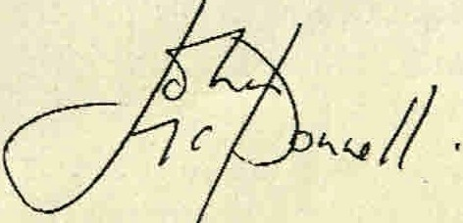
Thank you for your assistance. Yours sincerely

John McDonnell MP

Member of Parliament for Hayes & Harlington
www.john-mcdonnell.net

