8TH
BATTERSEA

IRISH
FESTIVAL

Presented by

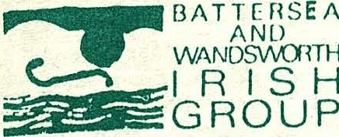
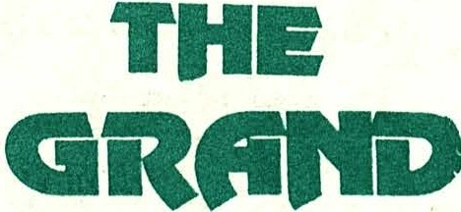
BATTERSEA
_A R T S .

CENTRE

11- 29 MARCH 1992

PROGRAMME OF EVENTS

MARCH
11 BWIG Annual Lecture -
Brendan Bradshaw BAC Free

12 | "The Ildanach" - Ben Haggarty | BAC | £6 | (£5)
13 | "Living Traditions of an Irish Farmer
 | & a Scots Traveller" -  John Campbell & Duncan Williamson | BAC | £6 | (£5)
l3 | BAC TV - Michael Redmond | BAC | £5 | (£4)
17 | Four Men And A Dog | Battersea
 | + Na Buachalainn Bui | Grand Hall | £7.00 | (£4.50)
17 | De Dannan + support The Grand £8
17 - 22 "An Afternoon With Klaus Barbie's Penpal"
24 - 29 Karl MacDermott BAC £6 (£5)
20 Davy Spillane+ Once Upon A Time Battersea
Grand Hall £8 (£5)
20 A House + support The Grand £7

VENUES &TICKETS

Q

OLD TOWN BALL,

LAVENDER HILL, LONDON SWll 5TF

BOX OFFICE AND ENQUIRIES
071-223 2223

THE GRAND

St John's Hill, Clapham Junction,
London SWll lTT
(opposite Clapham Jen Br)
Enquiries 071-738-9000
Credit card bookings 081-963-0940 Free car parking for Grand Patrons

BATTERSEA AND WANDSWORTH IRISH GROUP

... is a local voluntary organisation active in the community and cultural fields. Formed in 1983 to give a voice to Irish people in the area, it is the recognised Irish organisation in Wandsworth borough.

We have campaigned for the recognition of the Irish in Wandsworth as an ethnic minority, but with neither success nor sympathy from the power s that be.

Our aims are to promote a positive identity for the Irish in the area, to combat anti-Irish views and attitudes, and to attempt to deal with related social problems and needs in our community in a self-help way.

Past full-time workers have included the late Miriam James, renowned for her long history of involvement in Irish politics and the womens' movement, and well-known London Irish actress and playwright Maggie Cronin, whose one-woman play "A Most Notorious Woman", based on the life of Grainne Mhaol, was supported by BWI G .

We also support the Mean Fiddler and Workers Beer Company with the Fleadh in Finsbury Park, one of the largest Irish festivals in the world. Locally we are involved with the elderly Irish in the borough and with storytellers in the schools.

This is our eighth Battersea Irish Festival jointly presented with Battersea Arts Centre (BAC), and we are pleased to welcome our friends at the new venue The Grand (not to be confused with Battersea Grand Hall!) as additional co-presenters.

For further information about BWIG, contact us at 177A Lavender Hill, SW11 5TE - or telephone 071-223-7586

ALMOST AN ADVERTISEMENT

This space was originally reserved for an advertisement for the excellent new quarterly arts and cultural magazine IRISH WAYS, but that lazy sod Steve didn’t send us the lay-out. Which is a shame really because it’s very good, issue 2 will be on sale from march 12 for £1.20, and oh yes – we’re in it.
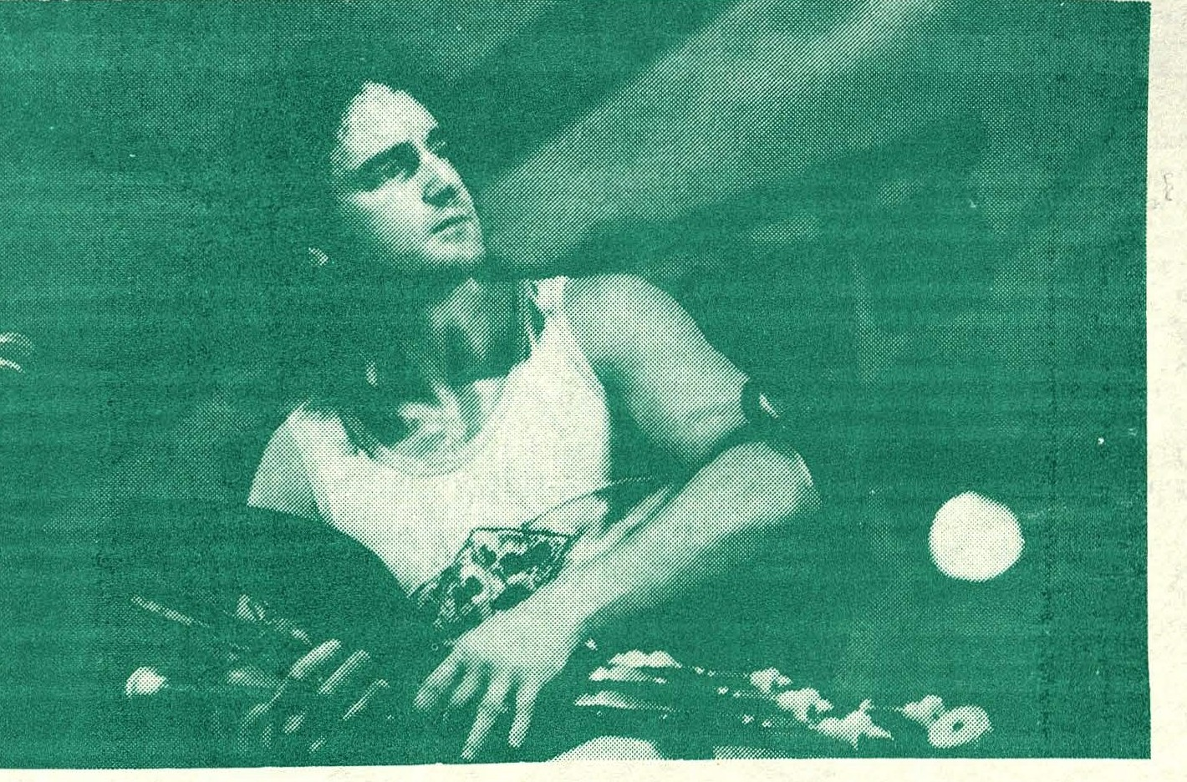

DAVY SPILLANE (see overleaf)

THE GRAND

••• is a Grade II listed building which was originally opened in 1900 as a purpose­ built music hall.

Unused for ten years, it was bought in 1989 by Vince Power, who then faced a two and a half year battle to obtain the licences necessary for public performance and consumption of alcohol on the premises. Also, a £l.5m budget had to be allocated to the total refurbishment programme.

Acoustically perfect, The Grand is also completely soundproofed so that no whisper of sound escapes the facility.

Last December the ground floor opened to the first of a series of sell-out (600 capacity) concerts. By June 1992 both Circle and "Gods" levels will also be completely resto red, allowing a return to the original capacity of 1 ,600.

Unique in that every aspect of the stage is visible from every part of the
auditorium, The Grand provides an oasis of live music in the cultural desert of South
London and is worthy of the title "Flagship of the Mean Fiddler Organisation".

While you are waiting for the festival, you can catch Skint Video at BAC on 21 February, while Macavity's Cat (22 Feb.) and The Stunning (27 Feb.) appear at The Grand.

We wish to acknowledge the help and co-operation of "Irish Lennon" (GLR); The Workers Beer Company; SHARE Community Ltd.

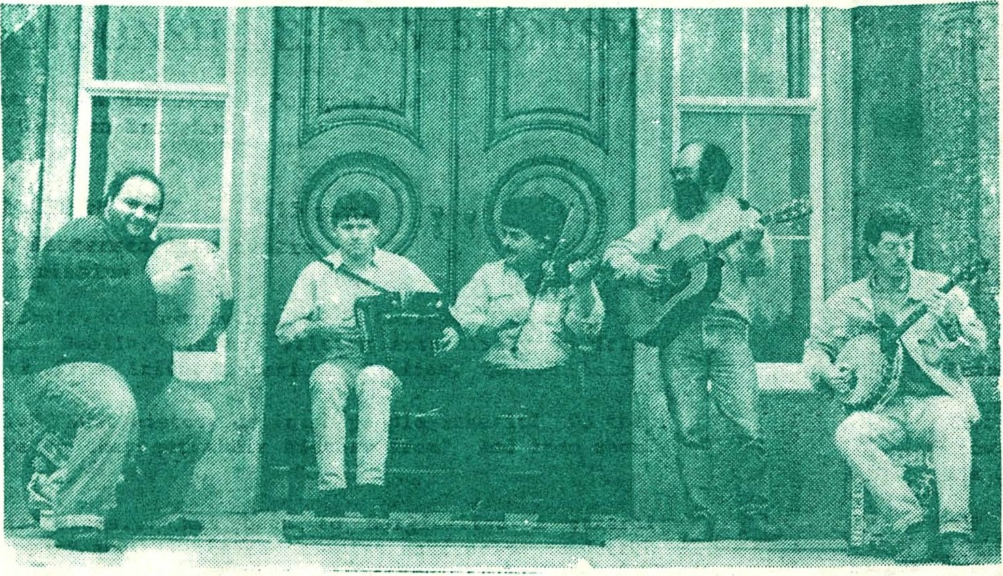
BWIG PRESENTS

Gino Lupari Donal Murphy Cathal Hayden Mick Daly Brian McGrath

FOUR MEN and a - DOG

Tuesday 17th March 1992 8.00 p.m. - Midnight
Battersea Grand Ball (Doors open 7.00 p.m.)

Tickets £7.00 (OAP's £4.50, Children Free)

We are particularly pleased to welcome Four Men And A Dog to Battersea Irish Festival. Since their remarkable debut gig at the 1990 Belfast Folk Festival they have acquired a reputation as the Irish band of the moment, appearing· at several major venues, and festivals such as Cambridge, Towersey and Cork.

Their debut album "Barking Mad" confirmed their status, being voted Best Album of 1991 by Folk Roots magazine, and they are shortly to tour Britain, Europe, North America, Japan and Australia. In more ways than one, they are going places.
So enjoy a special St Patrick's Night treat, with country-style songs, jigs, reels, polkas and plenty craic supplied by five of Ireland's most accomplished musicians. Do not miss!

Providing able support are old friends Na _Buachalainn Bui, the North London
traditional outfit which uniquely features two uileann pipers and will be appearing
at Battersea for the third year in a row.

BWIG ANNUAL LECTURE

CELTIC MYTHS AND MOONSHINE: REVISIONISM
The Irish Identity - An Historical Perspective
by Brendan Bradshaw

Wednesday 11th March 1992 8.15 p.m.
The Cafe, Battersea Arts centre Admission Free
BRENDAN BRADSHAW lectures in the Faculty of History at Queens College, Cambridge and
is a Fellow of University College, Dublin. He has written extensively on Irish
i ss ues, most recently in the work from Irish Historical Studies, quoted below.

What does it mean to be Irish today? What history do Irish people inherit? Do they draw their identity from it? Where do they get their history from? And from whom? The effect ...

"of the school of value-free historians... has been to marginalise a central dimension of the Irish historical experience... the revisionist enterprise conducted in the name of 'value-freeness' has forms of interpretative distortion: invincible scepticism... a corrosive cynicism, iconoclastic assault on a succession of national heroes- Hugh O'Neill, Patrick Pearse.... In what might serve as the revisionists' motto, Irish history is not the past of the modern Irish nation: 'the past is a foreign country'.
My intention is to challenge the interpretative principle of value-free history.... it has served to inhibit rather than enhance the understanding of the Irish historical experience. (from Irish Historical Studies Vol XXVI Nov 89)
If our past is in doubt what future do we have? Are those who disregard the past doomed· to relive it? What duties do historians have? Are they different from those of the rest of us? With the scalpel of questions Brendan Bradshaw analyses these issues.

DAVY SPILLANE
. Friday 20th March 1992 8.00 p.m. - Midnight
Battersea Grand Ball (Doors open 7.00 p.m.)
Tickets £8.00 (OAP's ' £5.00 Children Free)
In welcoming back uileann piper extraordinaire Davy Spillane and his excellent band we stick to a winning formula, as those present at last year's memorable gig will surely testify.

Since then, Davy has featured in Philip King's compelling BBC 2 series "Bringing It All Back Home", appeared at Fleadh '91 in Finsbury Park, and assisted the take-off of Kate Bush's chart single "Rocket Man". His new album, "Pipedreams", showcases Davy's uplifting blend of Irish folk, rock, jazz and blues to the greatest effect.

Davy has certainly come a long way since his days with legendary Moving Hearts, and as well as issuing a series of trailblazing albums has played with the likes of Van Morrison, Chris Rea, Elvis Costello , Mary Coughlan, Gerry Rafferty, Christy Moore and Enya , to name but several.

Support band Once Upon A Time are a unique 7-piece band who combine rhythm & blues, seriously hard rock, some gospel and more than a touch of Irish soul. An excellent pipe-opener, no pun intended.

FESTIVAL EVENTS AT BAC

BAC's long association with this prestigious event continues with events held in both ­ BAC and the Grand Hall, just around the corner.
ANNUAL BATTERSEA AND WANDSWORTH IRISH GROUP LECTURE
Wednesday 11 March In BAC's Main Theatre. Admission is Free (see BWIG Presents)

Ben Haggarty
THE ILDANACH

Thursday 12 March at 8.00pm
This is a saga of invasion of betrayal charged with disturbing images of forgotten Celtic Deities - the story behind the festival of Lughnasa.
"Haggarty tells his stories with enormous gusto and relish.” The Independent

Tickets: £6,00 (5.00 reductions) John Campbell and Duncan Williamson
LIVING TRADITIONS OF AN IRISH FARMER & A SCOTS TRAVELLER
Friday 13 March at 8.00pm

John is Ireland's finest kitchen table storyteller whose ridiculous accounts of local life have been known to make audiences weep with laughter. Duncan, having lived a nomadic existence, has a vast repertoire of folk tales, fairy tales, jokes and ballads.

Tickets: £6.00 (£5.00 reductions)

BAC TV presents
MICHAEL REDMOND
Friday 13 March at 10.30 p.m.

One of Ireland's top comedians in late night live entertainment.

Tickets: f5.00 (£4.00 reductions)
Karl MacDermott
AN AFTERNOON WITH KLAUS BARBIE'S PENPAL
17 -22 March Tuesday to Saturday at 7.30pm Sunday at 5.30pm

Karl MacDermott, who claims to be the last remainin g living home-based Irish s tand up comic, pays an unexpected visit to his buddy, Klaus Barbie, in Bolivia. But that very weekend Klaus himself is throwing a surprise birthday party for his brother Bobbie Barbie, the ex singing cowboy and star of Buckskin Serenade 1936 Forced to crash out in the bathromm, Karl, amongst other things, recalls his friends hip with Klaus, his experiences growing up in Ireland, his love of Shredded Wheat and a chance meeting with Chad Everett.

“A highly entertaining romp through original material.” THE GUARDIAN

“Abundantly talented comic.” THE INDEPENDENT

“See this at all costs.” IRISH TIMES

Tickets: [6.00 (5.00 reductions)

AT THE GRAND
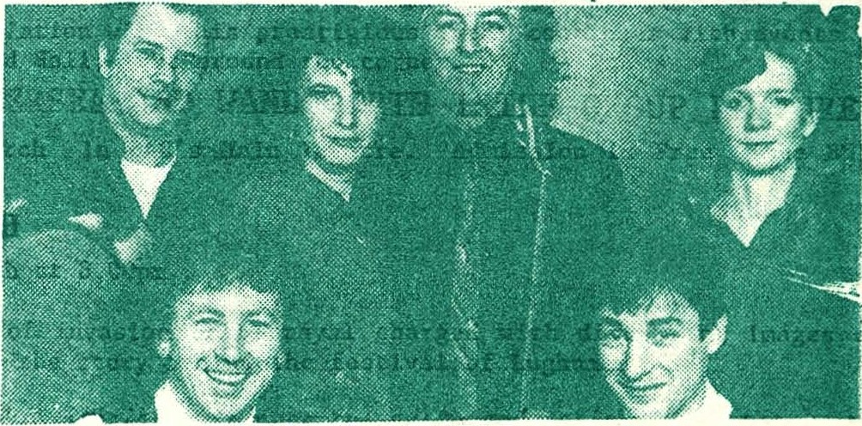
DE DANNAN
Tuesday 17th Karch 1992
8.30 p.m £8
For long one of Ireland's premier traditional bands, De Dannan have during the years consistently introduced new energy and inventiveness into their music, while remaining loyal to the traditions of the west of Ireland. Their recent
album "Half Set in Harlem" and another successful US tour served only to enhance the reputation of this classy outfit, these days fronted by the splendid Eleanor Shanley.

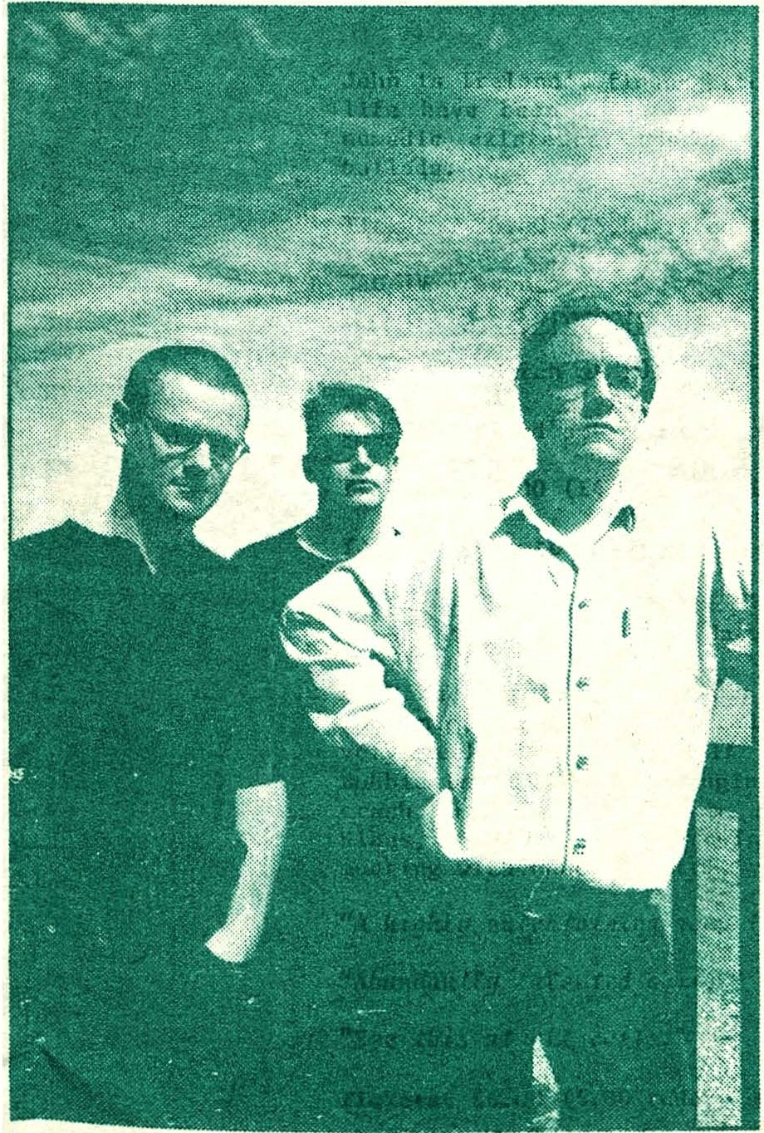
A HOUSE
+
THE DIVINE COMEDY

Friday 20th March 1992
8. 30 p.m. £7

Ever since Dublin's A House released their debut single "Kick Me Again, Jesus" in 1987, this three-piece, who had already toured with The Waterboys, have built a name for stunning live shows and gained much acclaim, particularly from the music press . Five years on, and with their third album "I Am The Greatest" now available, they finally arrive in the Land of the Estate Agent. Take out a mortgage !

