Manchester Irish Festival 2005
National Irish Studies Conference Saturday 12th March 2005 Manchester Town Hall
9.30 am.- 4.00 pm.

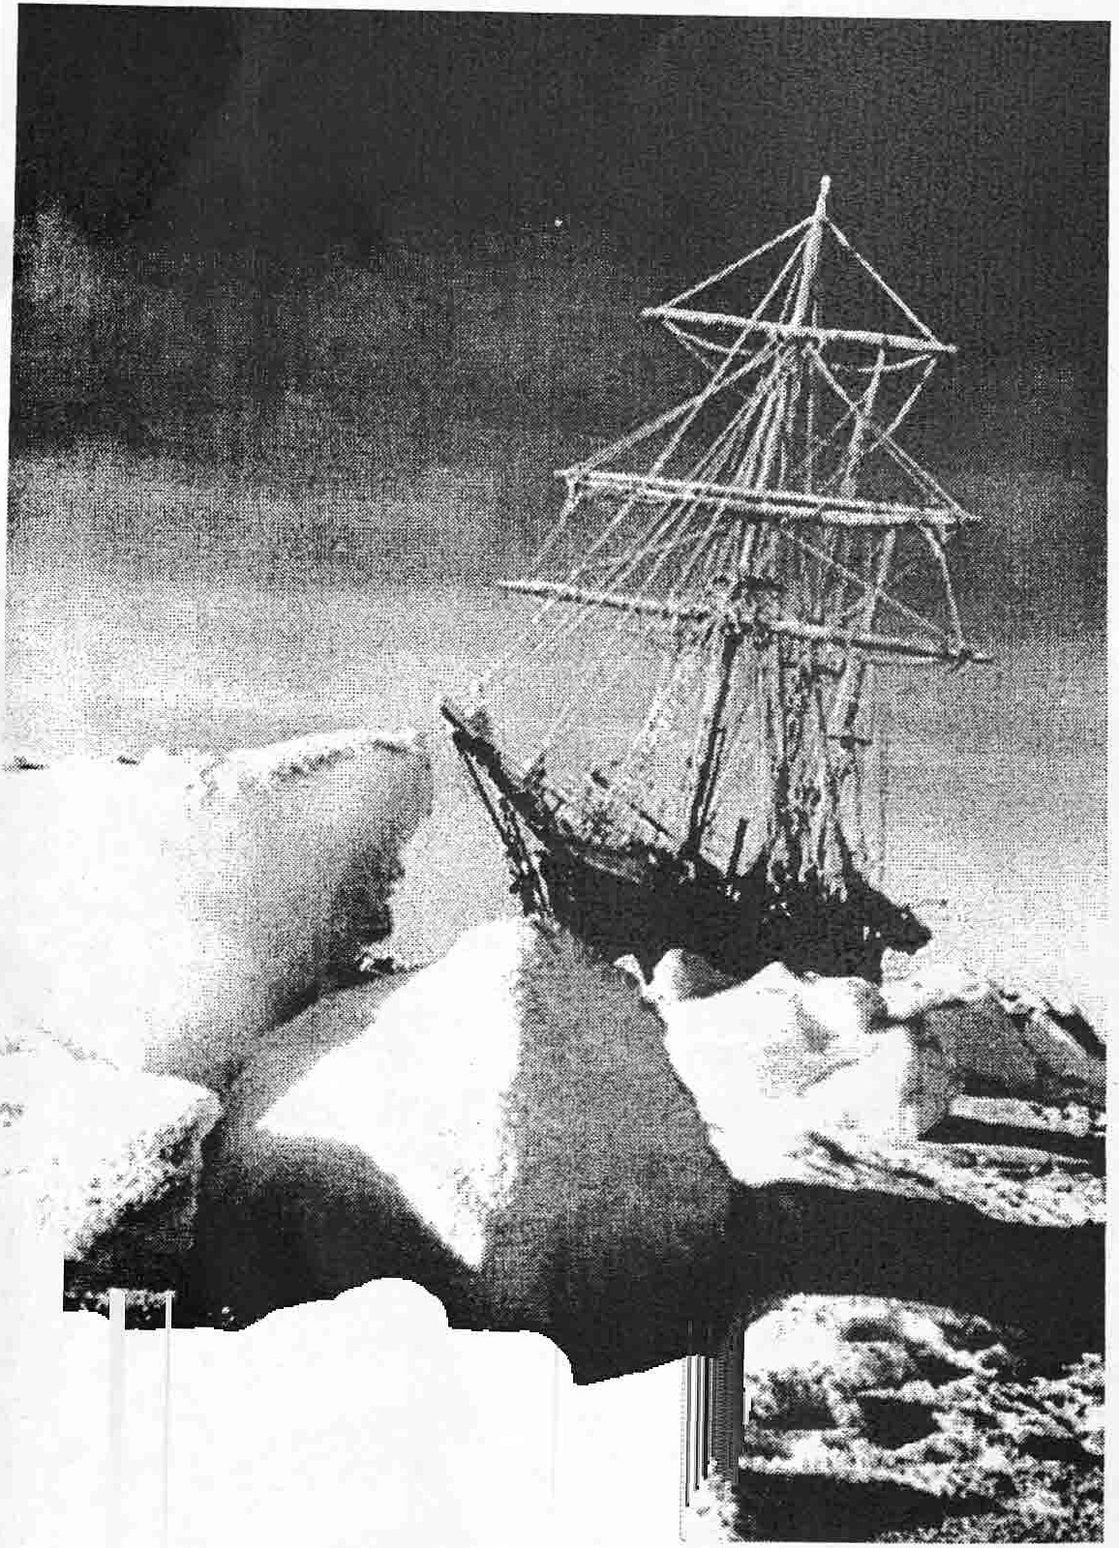
Speakers

Frank Nugent- "South Aris" - His re-enactment of Shackleton's Epic Voyage across the Southern Ocean.

Joe Bradley - Celtic Mind - The history of the Irish dimension of Celtic football club.

David McGuinness - St. Patrick and his Legacy: Early Irish Christianity and the Demise of Paganism.

Fergus O Connor- Derek Hill and the painters of Tory Island, Donegal. Eamonn Coleman - The works of Louis McNiece
Paula Millward - Constance Markievicz - a people's Countess?

This is a community, not for profit, event and the £10 fee covers speakers expenses, equipment, publicity and teas/coffee

Booking; *** ***
or e-mail ***@***.gov.uk
Manchester Irish Education Group _{(CHARITY} _{No} ₁₀₀₀₈₇₆₎

