WICKLOW ASSOCIATION MINUTES OF MEETING DECEMBER 4TH 1990

Meeting opened at 9.30 p.m.

Apologies received from the Treasurer.

Chairman collected monies outstanding on tickets for our dinner and dance. A very enjoyable night was had by everyone present.
Secretary to write and thank the attendees from Wicklow County Council.
Also to advertise our A.G.M. in the usual papers for the last Sunday in
January.

Lill Price to insert a column in the Wicklow People concerning our annual dinner and dance.
We had a new member join and pay his membership fee of £1. He is Mr. John Hickey
Meeting closed at 11 p.m.

£100 donated to Mrs. *** Wood Green to help her
With expenses for travelling to Ireland for her
Brother’s funeral.
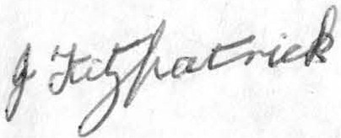

8-1-1991

