WICKLOW ASSOCIATION MINUTES OF MEETING 2ND OCTOBER 1990

Meeting opened 9.25. Correspondence read.

Tom Mc Assy asked why bill for the tent for Irish Festival was still outstanding and as it happens it was never sent to secretary. Tom to enquire.

Main Topic

Annual Dinner & Dance
Traditi onal Christmas menu, ham and turkey etc. will cost £12 per person. Tickets to be priced at £13.

Liz will get us 300 tickets printed.

Mary Stynes will double check with the band re; price and instruct them they must be in the McNamara Hall by 9 p.m.

Two guest tickets allocated as well as Katherine Kinsella's usual one.

On the night we must get an earlier start than we normally do on our dinner. 8 p.m. for 8.15 to go on tickets.

Raffle prises will be discussed at next meeting.

£1 membership fee from Martina Byrne and £1 membership fee from Mrs. Curan.

Next meeting to be brought forward one week as Chairman and Secretary must attend a County of Irish Counties meeting on Tuesday 6th November.

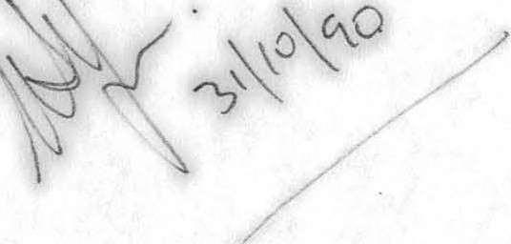
Meeting closed 1050 p.m.

