WICKLOW ASSOCIARTION
MINUTES OF MEETING
2ND JUNE 1987

Meeting commenced at 8.45.

- Takings from dance on 29th May were as follows:

Tickets £281.00 Door £101.00
Raffle £195 plus £40 for football signed by Arsenal football team.
All tickets accounted for.
Band cost £150.

Minutes from last meeting read, agreed and signed.

Dance on 4th July in Hatchard Road to be advertised in free papers. No
tickets to be printed, everyone will pay £1 on the door and members of that club are allowed in for 80p. John Fitzpatrick to go on the door.
We pay for the band which is £130. Liz will get about 10 posters
printed. Jack Kennedy will supply raffle tickets and Liz has agreed to
look after the raffle. Tickets to be 50p a strip or 3 strips for £1.
We already have six prises for the raffle.

Food to be provided for members of Liam Mellows band from Ireland also drinks and raffle takings go to them. John and Lill Fitzpatrick and
Pat and Betty Shay are making the sandwiches. Chairman and Pat Shay
to look after them concerning drinks.

Secretary to telephone Mary Barrett giving her details about the dance
and ask her if a poster could be put up in the church she uses. Also
to write to Tess requesting bar extention and confirming function on
4th July. Mrs Conway’s letter to be answered and AGM minutes enclosed.

Chairman to ask if Liam Mellows Band may perform in the Good Intent Pub
on July 5.

- Complementary tickets to social functions to be provided for guests if
requested by a Committee member and agreed upon by the Committee.

- No cheque book or Building Society Book received from John Byrne yet.
He spoke to Treasurer and said Lill Price would bring the books to our
meeting he also said that the bill to A Herne Sports for £156.80 was paid. Secretary to investigate and send in our 1987 order for
100 caps and 150 rosettes.

- Bills from L. Price for £31 for printing and £10 for postage stamps
however, at the AGM J. Byrne stated that everything was cleared.

- All names of stewards that have volunteered to work at Irish
Festival to be sent to J. Connelly, Secretary of County’s Association
and also names of helpers on our stall for insurance purposes.
Stewards are Pat Byrne, Tommy Timmons, Pat Murphy, Kevin Dunne, Tommy Hanley, Tommy Timmons and Tom Mcassy.

Pat Murphy to price coke. Hats, rosettes and sandwiches may be sold
on the day and maybe Irish Coffee. A sell and return basis for drinks

would be best. Kevin Dunne will organize van and equipment.
A meeting to be held on Monday 22nd June to finalise details.

- 4th December was agreed upon for our Christmas function in the
Mc Namara Hall, Irish Centre. Secretary to confirm in writing.
The JAYBIRDS to be booked again for that night.
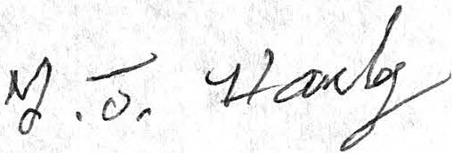
Meeting closed at 11.04 p.m.

MOM/JUNE2

