WICKLOW ASSOCIATION
COMMITTEE MEETING
APRIL 7TH 1987

Meeting opened at 8.45pm.

Minutes of the AGM on March 8th read.

- Chairman asked everyone present for ideas for future functions/events
to be held.

- The point was made by Chairman that any tickets taken to be sold by any
One person should be the responsibility of that particular person.
Also money from tickets sold on the door of a function or from raffle
tickets should be passed to our Treasurer on that same night.

- Previous Treasurer handed in a bag containing correspondence, and told
us that to have the Bank and Building Society account transferred to
present Treasurer we just inform the Branch holding the account.

- Membership forms and book containing some members’ addresses handed in.

- It was suggested a letter should be sent to previous Chairperson requesting any past Minutes of Meetings etc.

- Two dates for dance to be held in Irish Centre, Friday 29th May and
Thursday 14th June. The 29th May was agreed upon. Tickets cost £1
each and some to be sent to members to sell. Lis to get 400 tickets
printed and enquire about cost to have membership cards and headed
paper printed. Lill to get clock room tickets for raffle. Prises to
be decided next meeting. Dance to be advertised through free
newspapers and posters. Music for dance to be decided. Tommy Timmons
and Pat Murphy to enquire about bands and come back to Secretary over
weekend. It was suggested a note be sent top members informing them of the dance.

- Requirements of marquee and chairs for Irish Festival agreed.

- Minutes of AGM March 8th proposed by Tommy Timmons and agreed by Tom
Mcasy.

- New shorter version of the Constitution agreed upon.

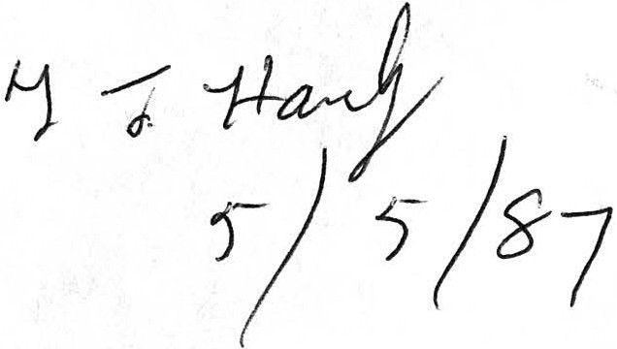
Meeting closed at 10.15pm.

Catherine Mc Evoy, Secretary
MOM/APR7

