WICKLOW ASSOCIATION MINUTES OF MEETING TUESDAY DECEMBER 6TH

Unfortunately the secretary forgot that this was a proper meeting, thinking it was only called for last minute preparations for our dinner and dance. Therefore no November minutes brought to read.

Nicholas had written 12 letters to Irish Associations and Authorities.
•

4 replies with prizes for our raffle.

Board Failte voucher for £50.

Aer Lingus ticket for 2 to go to Ireland up to 4th January from 6th December.

Ryan Air one ticket for any Irish destination prize will be available on the night.

Dan Air sent a travel bag.

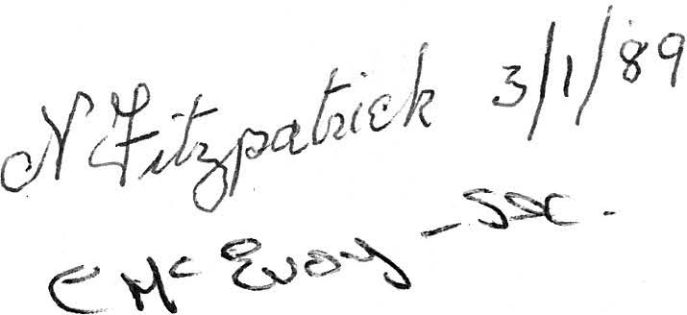
AGM date set for the 29th January 1989.

•

