WICKLOW ASSOCIATION MINUTES OF MEETING 5TH JULY 1988

Meeting opened at 9.05 p.m.
-
- £173 in the Bank before Irish Festival.
£6.98 interest.
£23 taken on the door for 1st July dance.
£116 on raffle
£9.50 membership fees
Band was paid £130.
Liam Mellows Band was given £50.
£16.55 for food
£19.95

- Irish Festival
Irish Coffee made £382.
£277.23.
*** *** donated £5.
No proper figures yet as bills have to come in.

John Fitzpatrick only charged for two dozen soft drinks out of 34
dozen.
Tom Broadrick thanked the Association for allowing him use of
part of our stall but said if we could order a bigger one next
year he would go 50/50 on cost.
Kevin Dunne thanked all those who helped on the day.

- Fr ***'s Farewell Do will be held on Friday 29th July.
John to contact people who know him.
John and Lill and some members from their Committee will
prepare the food. We will use drinks from the bar there and
settle up later. It will cost £25.00 for the music.
The Wicklow Association to donate £100 and buy a wallet to put
it in. Liz will get the card.

- The benefit dance for our late Chairman is on 30th September
in the Kennedy Hall. Liz to get 700 tickets to be printed
which will cost £2.00 each. A bar extension must be applied
for, and advertise in papers. More discussion next meeting
[tickets £1.50]
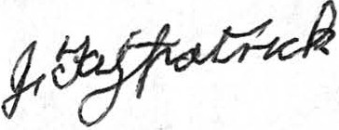
Meeting closed at 11 p.m..

