AN TEACH
===================
IRISH HOUSING
ASSOCIATION LTD

------------------------------------------------------------------------------------

*A PROFILE*

AN TEACH IRISH HOUSING ASSOCIATION

A Profile Table of Contents
1. | Chair's Introduction | 5. | Management Policy
2. | Irish Homelessness in London | 6. | Development Policy
3. | Housing Options for Irish Youth | 7. | Further Reading
4. | An Teach H.A. — A Response

Chair's Introduction
This report has been produced in order to inform and advise agencies with
T
responsibility or concern for young people of an initiative to tackle homelessness amongst young Irish immigrants in Britain.
An Teach means 'the house', and the Association was established to provide exactly that; cheap, temporary housing for young people living in hostels, in squats or sleeping out. It accepts on a short-term licence properties owned by local councils, housing associations or indeed private owners which for one reason or another are temporarily empty. As soon as the owner needs the property again An Teach hands it back, maintained and protected from vandalism or squatting.

An Teach Irish Housing Association is a short-life group, but different from most such groups perhaps, because as a pro-vider of temporary accommodation it is flexible regarding the 'life' of properties it will accept.
Between four and six months in a reasonably secure, cheap (and legitimate) environment can give newly arrived immigrants a real basis on which to build
a life in their adopted home.
Particularly important are the firm roots which An Teach H.A. has within London's Irish community; reflecting that communi- ty's concern with the plight of bright, energetic young people whose potential is threatened by the economic deter- minants of their situation.

An Teach H.A. represents a new initiative within a long tradition of Irish community self-help, and I believe that it has an important role to play within strategic responses to Irish youth homelessness. To fully realise this, however, it needs to have the support of agencies or individuals who can make properties available, and it needs financial support.
Short-life housing is not the full 'answer' but it does provide a valuable non- exploitative six-month respite which offers young new arrivals a better chance of settling securely in London than they might otherwise have. Work to develop a full range of culturally sensitive responses to Irish youth homelessness will continue, and An Teach hopes to use its experience and growing skills to con- tribute to that process.
Gearoid O'Meachair,
founding Chair of An Teach H.A.

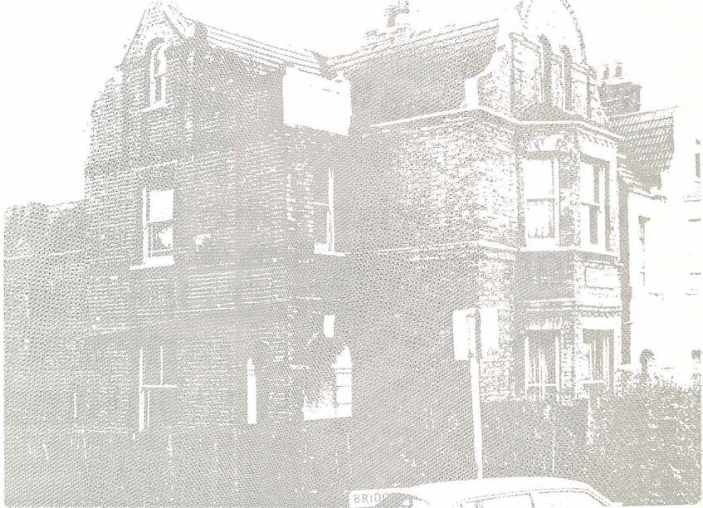

2

Irish Homelessness in London

The Irish have a long tradition of emigration to Britain. This process is for
T
the most part economically determined, and as such has tended to be concen- trated in cycles of mass emigration.

The last period of mass emigration took place after the Second World War and, according to census material, has left Britain with just under 5% of its total population Irish-born. The bulk of those people are concentrated in the south-east, with roughly 32% resident in the Greater London area.
Contrary to popular belief, the Irish in London are not concentrated in only a few areas such as Kilburn, Camden Town or Archway. An analysis of the census figures shows that 10 London boroughs have 4% or more of the city's total Irish population. Indeed, there are only 2,022
more Irish-born people in Camden than in Haringey.
As a community and as individuals, the Irish have made an enormous contribution to Britain. From the post-war reconstruc- tion of the nation's infrastructure to local and national politics, Irish people have been involved and active in many aspects of public life.

However, there is another side to this pic- ture which reveals very different images of the Irish experience. A growing body of evidence indicates clearly that Irish people experience severe disadvantage in employment and in accommodation.
One of the few dependable indicators of Irish homelessness and housing stress derives from census material (see tables).

TABLE 1: HOUSING TENURE IN ENGLAND AND WALES BY BIRTHPLACE OF HOUSEHOLD HEAD
Irish |  |  |  |  |  |  | NC/ %
Tenure | All | UK | Rep. | Carib. | Med. | NC | Pakistan
Owner occupier | 58 | 58 | 44 | 43 | 61 | 59 | 61
Local Authority etc. Rental | 29 | 29 | 38 | 45 | 25 | 26 | 24
Other Rental — mostly private | 13 | 13 | 18 | 12 | 14 | 15 | 15
TABLE 2: LACK OF AMENITIES AND OVERCROWDING IN PRIVATE RENTED SECTOR
Irish  All UK Rep.  Lacking Bath 7.3 7.9 6.2  . Lacking Inside WC 8.5 9.2 5.4  Overcrowding at more than  1.5 persons per room 1.2 0.9 2.9  Source: 1981 Census 'Housing and Households' volume) |  |  |  |  |  |  | NC/ %
 |  |  |  | Carib. | Med. | NC | Pakistan
 |  |  |  | 2.7  2.0 | 3.6  3.1 | 2.6  2.4 | 2.8  2.7
 |  |  |  | 3.8 | 4.2 | 7.6 | 7.9

In terms of single people more specific research data is available and the evidence it presents is particularly stark;
- 26% of 1,156 hostel users in Westminster are Irish. Ref. Cara report
`Irish Homelessness — The Hidden Dimension' 1988
- 38% of the casual users of DHSS Reset- tlement Units are Irish. Ref. DOE report 'Settling Down' 1985

3
- Two out of seven people who sleep out in central London are Irish. Ref. CLOT report 'Sleeping Out In Central London' 1986
These grim statistics are an indication not only of the numbers of Irish people without a home or in poor standard insecure accommodation; they also point towards an experience of isolation and an absence of support structures which can too easily lead to alcohol abuse and/or depression.

Indeed a number of studies have confirm- ed disproportionate rates of Irish admis- sions to mental hospitals with subsequent high rates of diagnosis for alcohol psychosis. In the absence of proper analysis, these findings nevertheless must suggest serious levels of stress and/or real problems of culturally inappropriate diagnosis and health care.
Ireland is now experiencing a new wave of emigration, with estimates of 50,000 leaving each year. Most of these will be young people and again there is growing evidence that while many are settling suc- cessfully, a large proportion are experien- cing homelessness and hardship.

A report produced by the Action Group for Irish Youth in 1985 found that 27% of a sample of 250 young people had spent some time since their arrival in London sleeping out (see Further Reading for details).
  - In 1987 a similar research project amongst young immigrants in Kilburn found that 67 % were either literally homeless or living in some form of unsatisfactory temporary accommodation (Kil- burn Irish Youth Action Group).
  - Cara Irish Homeless Project found that in 1987, 44% of all young women between 18 and 26 in hostels in Westminster were Irish (see Further Reading).
Confronted with the above evidence, it would surely be facetious to claim that the Irish are not disadvantaged, or that their needs have been properly addressed. Being white, and one of the oldest ethnic minority communities in the country, the Irish suffer from a British over-familiarity.
`It is often assumed that with the predominance of a mid-Atlantic culture young Irish people will encounter no dif- ficulties in settling in Britain. However, although Irish and British youth may share tastes in fashion and music, the reality of London, large, anonymous and with a host community which often displays hostility

4
toward the Irish presents difficulties for many young Irish immigrants.' (Ref. Cara Report 'The Housing Position of Young Irish People in London' 1987).

Perhaps because of these same assump- tions there is little or no preparation on the part of new arrivals for the massive culture shock they will face and consequently the first experience of anti-Irish racism, often in a very crude form, and the realisation of being different and alien comes as an unexpected jolt to the new arrival.

Life in England, and London in particular, represents an enormous contrast with the value systems and social traditions which operate in Ireland. The failure of the host community to recognise the different ethnic identity of the Irish, while it con- tinues to stereotype them as stupid and violent, creates and exacerbates a whole range of problems for immigrants attemp- ting to settle in London.

The Community and Church structures set in place by those who came in the
T
1950's seem not to greatly interest today's young immigrants. Perhaps in part because of the educational opportunities available to them in Ireland, these young people have very different expectations of their role and of the contribution which they can make. Yet many are vulnerable to exploitation and are in real danger of following some of their predecessors into a limited, economically determined life style of restricted lateral mobility in employment and accommodation (ref. Cara 'Irish Homelessness — The Hidden Dimension' 1988).

With limited support structures, the dangers of alcohol and drug abuse are heightened and with employment oppor-tunities and access to secure housing limited, there is the added risk of young people being vulnerable to petty crime and prostitution. A common resort for those in housing need is squatting, which immediately 'criminalises' the young person, and is not the start many would think desirable.
Young people from Northern Ireland have added difficulties; while not acknow- ledged as emigrants and, for some, con- trary to their own expectations, they

nevertheless experience the same anti- Irish racism and sense of culture shock as young emigrants from the Republic.
That then is a brief picture of the experiences and circumstances which lie behind the grim statistics of Irish single homelessness. Despite their educational

advantages and their late twentieth cen- tury sophistication, it is clear that there is a very real danger of young arrivals replacing or even outnumbering those Irish men and women living in isolation and neglect in London's outmoded direct access hostels.

•

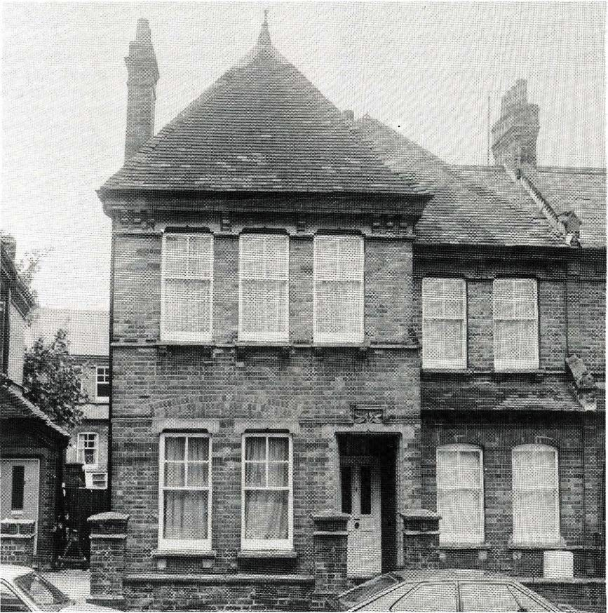
One of the properties licensed to An Teach by the London Borough of Haringey

•

H o u s i n g O p t i on s for Ir i s h Y o u th

The Private Sector
Traditionally, the private sector has been the main avenue to accommoda- tion for young Irish immigrants in London, either in the form of bedsits or in 'lodging- type' houses, often run by Irish people.

5

In terms of the mainstream private rented
sector, this is often characterised by high rents, disrepair and landlord disregard for the tenant's right to privacy and security.
Nevertheless, the private rented sector is diminishing rapidly and now only con-

stitutes 7% of the London housing market (SHELTER estimate 1987).

The consequent increase in the cost of rents, the financial constraints experienced by recent immigrants (who have come, after all, because they do not have any money), and the reluctance of landlords to let accommodation to unemployed people all make it likely that an increasing propor- tion of young Irish immigrants will exper- ience homelessness. In addition, the social security changes in April 1988, which abol- ished single payments for rent in advance and deposits on private rented accom- modation, have added to the problem.

Irish Self-Help
Irish emigration to Britain has always been characterised by a self-help approach, a willingness on the part of those already settled here to provide assistance and support to those arriving. This has frequently meant 'digs' type accommoda- tion in an Irish family home.

In the light of the current crisis, the Welfare Sub-Committee of the Federation of Irish Societies has facilitated a response from the community which revives the tradition of rooms to let. This is a good example of the community wanting to care for its own vulnerable members, but there are dangers of physical and financial exploitation and, as such, the scheme can- not possibly meet the whole area of need.

Bed and Breakfast
Again, bed and breakfast hotels have pro- vided emergency accommodation. However, the introduction of the revised board and lodging regulations and its time limited restrictions on the under 26's has further diminished the availability of this form of emergency housing.

Statutory Resources
In the statutory sector, housing options open to young Irish people are negligible. While local authorities do not have statutory responsibility for single homeless people unless deemed to be in priority need, the residence qualifications operated provide a further barrier to young Irish people who, by nature of their

6
emigration, are unable to establish any kind of local connection.

Hostel Accommodation

Another 'traditional' option for Irish immigrants has always been the city's hostels, despite their temporary nature and frequently poor standards. Clearly, there is not enough emergency hostel accommodation to meet the current influx of young people into the London area. This situation is exacerbated by the lack of move-on resources for hostels under- taking resettlement work, and by the changes in social security legislation relating to single payments which were referred to earlier. Consequently, the limited number of emergency hostel bedspaces available are silting up, with the result that fewer are available to those arriving in London and experiencing accommodation crisis. It is also signifi- cant that, while Irish people feature very prominently among the occupants of direct access hostels, they do not appear to do so within those gaining access to permanent move-on nominations pro- vided by local authorities, housing associations and other voluntary bodies.

Housing Options - No Options?
The housing options open to young Irish people are clearly minimal, and while they share many of these difficulties with other young single people, the added stress of arriving in a new and potentially unfriendly environment adds to the prac- tical problems.

Many young Irish people do not appear in any surveys or estimates of homeless- ness because they simply 'disappear' — sleeping on friends' floors, sleeping out or squatting, they do not seek assistance either because they are afraid of being 'caught' (if squatting) or because they do not know where to go or what is available. The resulting stress is obvious and made worse by the unfamiliarity of London and vulnerability to exploitation.
While the overall picture is bleak, there are new and worthwhile projects being initiated by sections of the Irish com- munity which can contribute positively to the strategic response which is clearly required. An Teach is one of these.

An Teach Irish Housing Association A Response
averages at around 4%).

History
An Teach was set up in 1986 by
Members of the Management Com- mittee of Cara Irish Homeless Project, following discussions with Irish people living in a co-op in Haringey.
They had two objectives in mind;
- To enable young Irish people to have more control over their housing situation
- To develop a practical response to the increase in Irish youth homelessness arising from current Irish emigration.
The Committee of Cara registered An Teach H.A. as an Industrial and Provident Society under Model Rules for Housing Associations approved by the Federation of Housing Associations. During the next two years, efforts were made to secure funding for staff and office premises, while Cara provided an office for the manage- ment of the three properties on licence to An Teach. These funding appeals were unsuccessful, largely because the Association, whilst assessed as too small to need staff, was dependent for its expan- sion upon the resources of a few people all actively involved in many other com- munity projects.

During 1987 the Committee grew, allow- ing it to distribute the tasks involved in getting increased stock and to work towards a sound basis for a renewed fund- ing initiative. By 1988, the Association was managing an average of seven properties in three boroughs — Haringey, Islington and Barnet.

The ideas and aims behind the setting up of An Teach have developed since 1986 and now form the basis for a positive and practical response to the enormous and growing problem of homelessness amongst young Irish immigrants in Britain.

What is Short Life Housing?
All public housing providers have, from time to time, a proportion of their stock which is lying vacant (in London this

7
This may be for a variety of reasons, the most common being that improvements are planned to the property, but may be delayed while capital finance is raised and statutory consents secured. Short life housing is a way of utilising those delays to the benefit of people whom statutory authorities have no responsibility to house.

This form of housing began during the 1960's, when groups of people began to form themselves into groups to live together, perhaps because they had a common housing need or because they were squatting and wanted to resist the attempts of the owners to evict them. These housing co- operatives then negotiated with the owners for a short- term licence for the property.

An Teach H.A. is not a housing co- operative (the Management Committee do not live in the houses), nor does it squat properties. All its properties are passed on by their owners, whether a local authority, housing association or private, after an approach by An Teach or in line with their own policies for supporting ethnic minority housing associations.
The owner grants a licence to occupy to An Teach H.A., which in turn gives a licence to applicants on its waiting list. The Association pays rates on the proper- ty but no rent; it passes on to its own licencees the rates bill plus an additional amount to help cover administration, management and maintenance costs. It is consequently possible to keep the charges much lower than in the private sector generally.

What's In It For The Owner?
Delays are almost inevitable when a public landlord is seeking to modernise or improve its properties and there is a high risk that properties left empty will be squatted or vandalised, or will simply deteriorate.
Short life use of the property prevents these problems, and also removes the owner's responsibility for paying rates.

An Teach guarantees to hand the property back to the owner when requested (with an agreed period of notice), and to do all the day-to-day maintenance.

Short Life Housing — Does It Have A Future?
After a period of rapid expansion, short life housing appears to be in decline. Local authorities are, in fact, taking back properties granted on a long term licence, either to institute repairs, sell them or to use them for homeless families who would otherwise be left in bed and breakfast hotels. However, there is a future for the An Teach option.

Most short life housing groups provide housing for as long as people need or want it — the only time limit on their occupation is the length of the licence on the property (and even then most groups try to organise a replacement). This means that generally they avoid taking on the licence of properties which only have a very short life, say less than one year.
An Teach, on the other hand, operates as temporary housing; applicants are offered approximately six months' accommoda- tion. Consequently, the Association is in a position to accept houses and flats which may be vacant for only a short period of time, and therefore not viable for either homeless families or mainstream short life groups. Leaving a property vacant for only a few months nevertheless leaves it vul- nerable to squatting or vandalism, so the advantages to the owner remain the same.

This flexible approach works with individual houses or flats and also in the context of large-scale improvement pro- grammes. For example, in 1988, An Teach was granted the licences of five flats on a large council estate in Islington which was gradually being decanted for a major modernisation programme.

Irish Youth Homelessness —
How Short Life Housing Can Help
The short life option has particular advan- tages when looking at the crisis of homelessness facing so many young Irish immigrants.
These may be summarised as follows:

8
- The young person has a base, an address from which to look for work, claim benefits, start to make contacts in a local community and, of especial importance for an immigrant, establish a space where they can express their own identity, whether through photo's, pictures or other bits and pieces which connect them with 'home'.
- A comparatively low charge (between
£20 and £25 per week) enables them to put some money aside for a deposit on a privately rented flat.

- Sharing with other young Irish people with a similar experience is of par- ticular importance, both in facilitating the formation of groups of potential flat-sharers, and in the mutual support which the young people can give each other.
- It gives the young person the oppor- tunity, within an environment where support is available, to take respon- sibility for their lives; to budget for essentials and organise meals, clean- ing and household maintenance for themselves, often for the first time in their lives.

- It gives a breathing space; rather than rushing into the first bedsit they can find, the young person has a little more time to explore other options — a flat share with new friends or getting involved in a housing co-operative or exploring possibilities for gaining access to housing association tenure.

- The Irish ethos of the Association pro- vides important community support. Research carried out by Cara has clearly indicated how cultural aliena- tion contributes towards Irish home- lessness. An Teach H.A. believes that, by providing young single Irish people recently arrived in Britain with housing which in its selection criteria and management policies recognises and supports the distinct ethnicity of Irish people, it offers them a spring- board to forming culturally-supportive social networks which will assist in their successful integration into a multi-cultural society.

- It is — almost — instantly available housing. Whilst more shared housing and supported housing for Irish people

is required, the lead-in time for such provision is long and subject to the same kind of delays which gave rise to the whole short life housing move- ment. Given the increase in Irish youth homelessness in London, short life housing can offer an immediate
response for young people on the streets now. A local authority can offer a property to An Teach on Monday and, providing no major repairs are necessary, it can be occupied by the weekend.

Management Policy

ithin the context of its central aim to address homelessness experienced
W
by recent emigrants from Ireland, An Teach H.A. operates an equal opportuni- ties policy in the selection of its licencees. The criteria for application to the Associa- tion are broad in recognition of the variety of ways in which someone can be 'home- less', that is without a secure, decent and affordable place to live, e.g. staying with friends, sleeping in a hostel with no reset- tlement programme but a maximum length of stay, squatting or sleeping out.

The age range runs from 18 to 30, although the Association operates with a degree of flexibility in respect of individual cir- cumstances. The Association aims to provide parity of provision between men and women.

The members of An Teach are responsi- ble for the maintenance of the waiting list; applications are accepted directly from young people as well as from referring agencies such as nightshelters or advice centres. Each applicant who meets the basic criteria is interviewed and, if appropriate, added to the waiting list. Places are allocated on the basis of need.
Licencees are provided with an informa- tion pack on moving into An Teach pro- perty; this includes the licence agree- ment, arrears policy, contact names for Committee members, information on the payment of charges and the procedure and responsibility for reporting and carry- ing out repairs. The licencees are encouraged to use the period in the house constructively, particularly as An Teach is not able to offer any move-on or long term options. Committee members are avail- able to offer help and support if requested and every effort is made to provide advice regarding alternative accommodation.

9
The state of repair of the properties offered to An Teach varies greatly and, given the financial limitations of the Association, it is necessary for licencees to remain responsible for minor maintenance work.
The owner retains responsibility for ensur- ing that the building is wind- and watertight.

Licencees in financial difficulties are given every assistance to claim welfare benefits to meet their charges. An Teach
H.A. has an arrears policy which, given the dependence of the Association on its charge income, is stringently applied. The policy clearly states that repossession of the property will be pursued if necessary.

The emphasis of the arrangement is on encouraging and supporting young people to take responsibility for their own lives so, while support is on hand, a group of people sharing a house or flat are expected to organise between themselves cleaning, maintenance and the payment of charges.
Given the short period of time which the licencees have with An Teach and the limited long term options which await them, every encouragement is given to them to use the opportunity to develop these independent life skills.

Development Policy

Young Irish people settling in London

are spread across a large number of boroughs. Surveys and the experience of advice agencies/welfare centres have identified increases in the numbers of young Irish people in Islington, Brent, Har- ingey, Camden, Lambeth, Southwark and Ealing. This list is by no means exhaustive, but it serves to illustrate the potential geographical spread of housing need.
An Teach's broad development policy is to work in any borough where a need is identified and support for its work secured. Obviously, this policy must be qualified by the resources at the disposal of the Association in terms of staff, revenue funding and the goodwill of voluntary Committee members. The tem- porary nature of the provision inevitably makes the Association more management
intensive than would be the case if An Teach were offering long term housing. We are mindful, therefore, that expansion must be measured to safeguard our objec- tive of a sensitive and accessible manage- ment structure.

The involvement of Irish people at a local level can be of enormous value in achiev- ing this, and An Teach will continue to work alongside a wide range of communi- ty groups and Irish centres.

The future of short life housing is currently an issue for debate, yet is it clear that, while Irish youth immigration continues to result in misery, distress and exploitation for many young people and while property owners are still faced with problems of squatting and vandalism, then it will con- tinue to have a useful role to play.

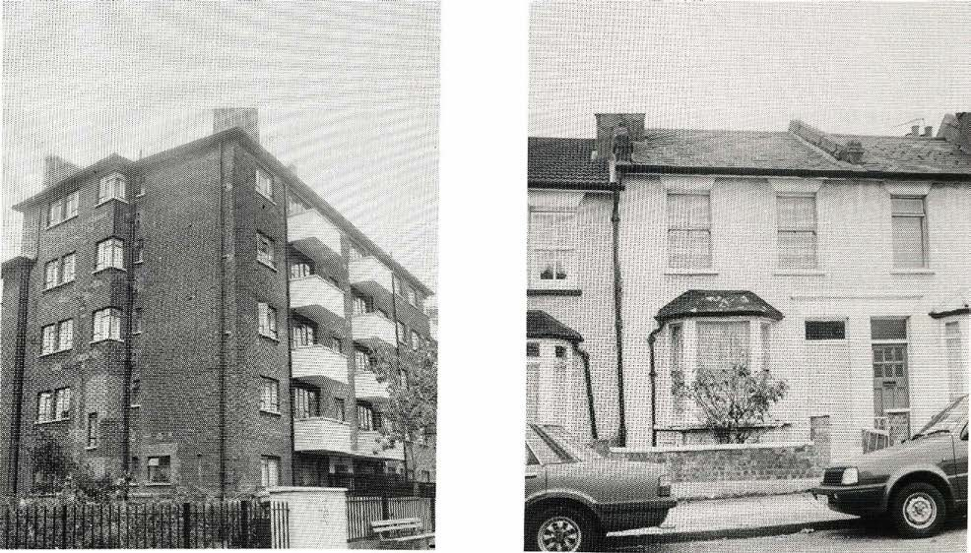

A range of properties licensed to An Teach by the London Boroughs of Islington and Haringey
10

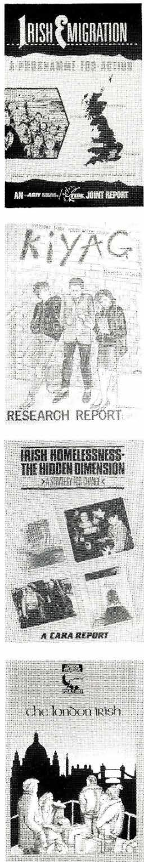Further Reading
RESEARCHREPORT
DERIDDENDIMENSION
HMELISSNESS
The following are recommended as sources of information on the issue of homelessness within the London Irish
T
community.

Cara Irish Homeless Project
`The Housing Position of Young Irish People in London' 1987 £1.00
`Irish Homelessness — The Hidden Dimension' 1988 £1.25
Annual Reports and occasional research papers.

Action Group for Irish Youth
`Irish Youth in London Research Report' 1985 £2.00
`A Guide to London for Young Irish People' 1988
`Irish Emigration — A Programme for Action' 1988 — A joint report with TIDE in Dublin £2.00

Haringey Irish Community Care Centre
Annual Reports

Irish Liaison Unit L.B. Haringey

`The Irish in Haringey' Report of Haringey Irish Consultative Conference 1987

London Strategic Policy Unit
`The London Irish' 1988 and 'Irish Women in London' 1988
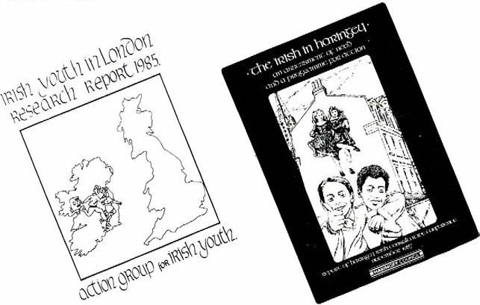

11
[Grab your reader’s attention with a great quote from the document or use this space to emphasize a key point. To place this text box anywhere on the page, just drag it.]
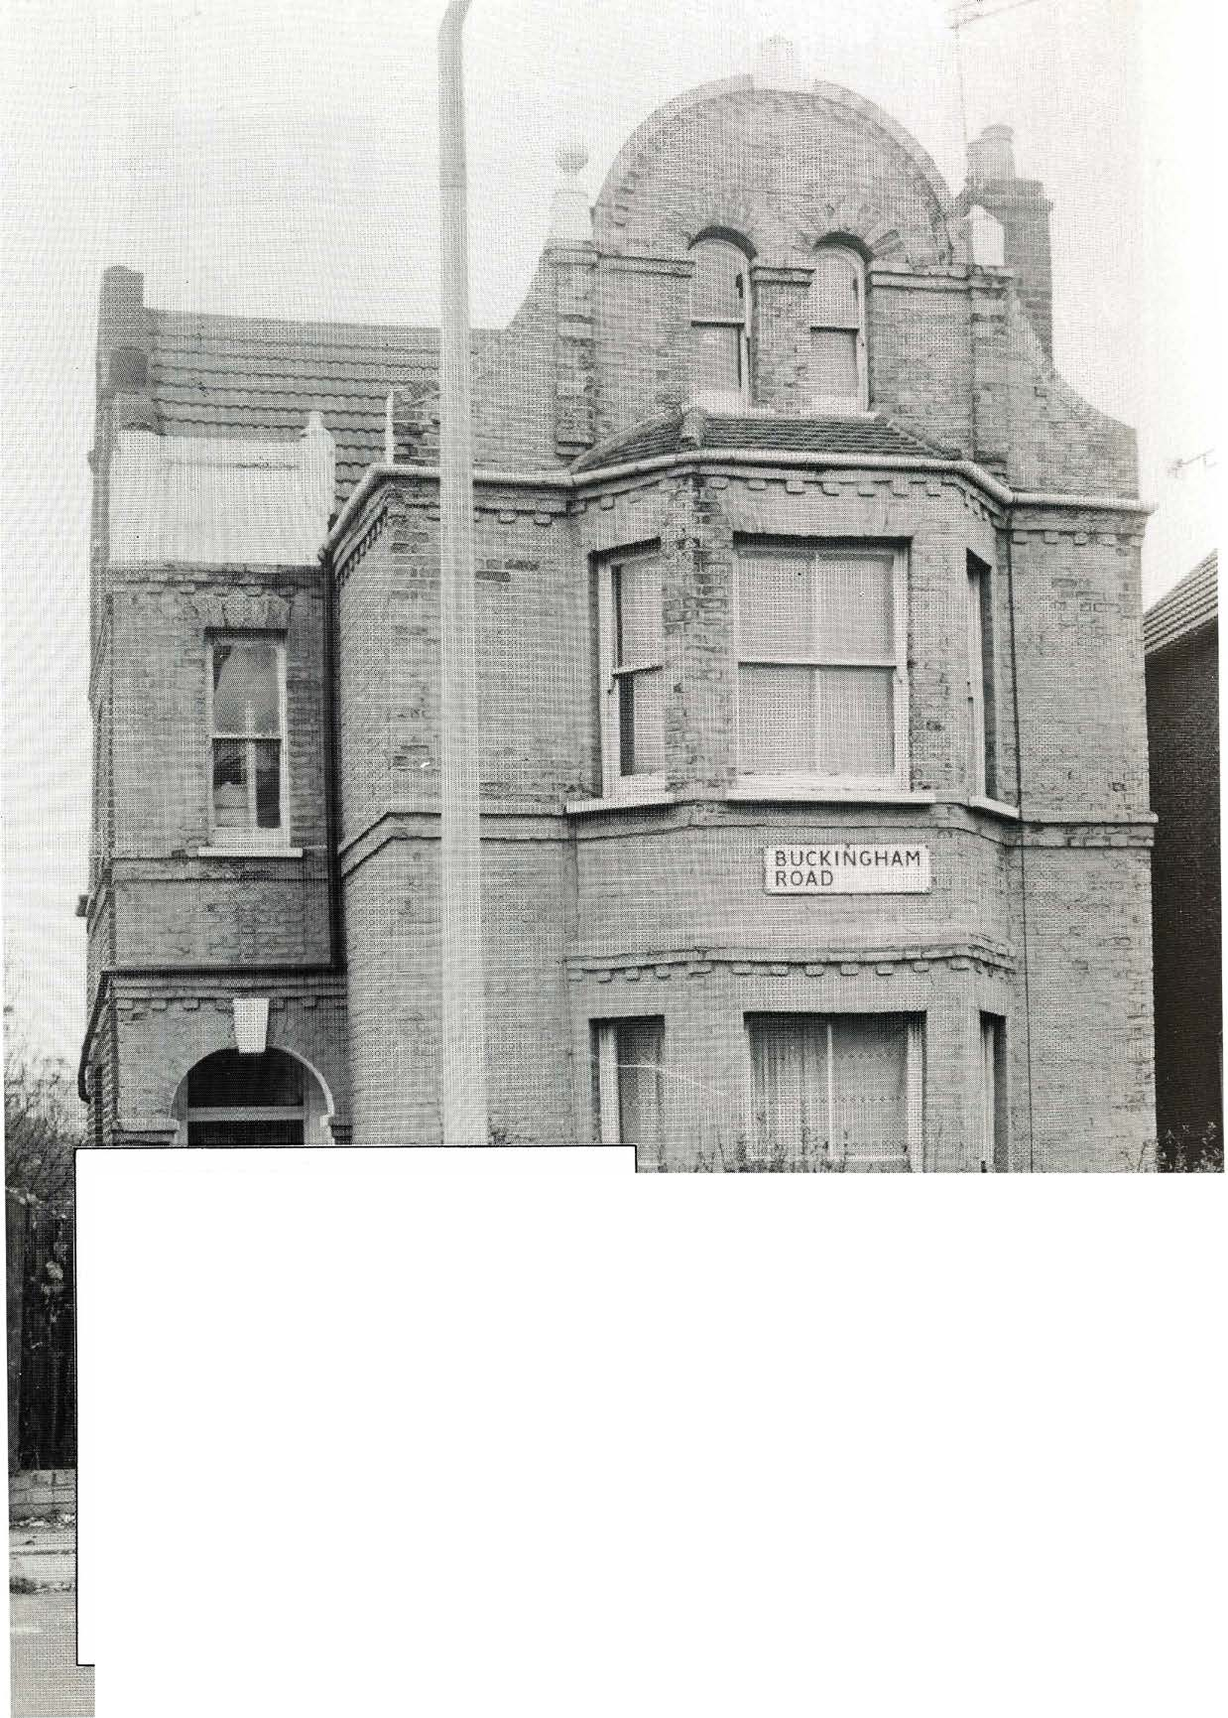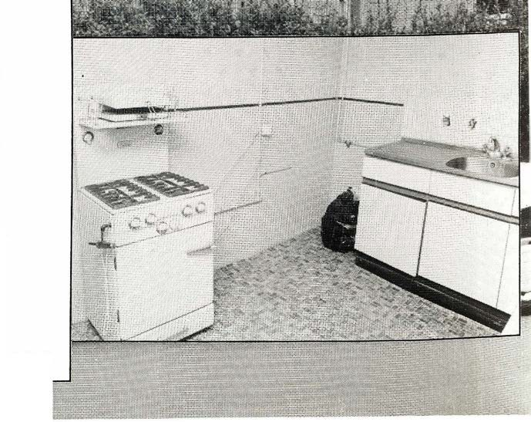
ACKNOWLEDGEMENTS
Cara Irish Housing Project
Action Group for Irish Youth
Haringey Irish Community Care Centre
Irish Chaplaincy in Britain
London Borough of Haringey
London Borough of Islington
Metropolitan Housing Trust
Family Housing Association
Photographs by Evan Jones

© An Teach Irish Housing Association Ltd.
72 Stroud Green Road, London N4 3ER

Cover Design: Joe Boske

Printed by: Adept Press Ltd
273 Abbeydale Road
Wembley, Middlesex HA0 1PZ
ACKNOWLEDGEMENTS
Cara Irish Homeless Project Action Group for Irish Youth
Haringey Irish Community Care Centre Irish Chaplaincy in Britain
London Borough of Haringey London Borough of Islington Metropolitan Housing Trust Family Housing Association
Photographs by Evan Jones
© An Teach Irish Housing Association Ltd. 72 Stroud Green Road, London N4 3ER
Cover Design: Joe Boske Printed by: Adept Press Ltd
273 Abbeydale Road Wembley, Middlesex HAO 1PZ

