IBRG

Irish in Britain Representation Group

Fourth Countrywide Conference on

Irish Perspectives on British Welfare

Saturday 3 November 1990

Lambeth Town Hall, Brixton, South London

This conference is aimed at Social Workers in the statutory and voluntary sectors; community activists, Irish community organisations and all those interested in or affected by the various aspects of Irish welfare in Britain.
Details: (071) 326 4740

Time: 9.30 am to 6.00 pm Transport: Brixton BR/Tube (Victoria Line)

Venue:
Lambeth Town Hall
Acre Lane Brixton London SW2
Fee: £3 lndividuals/£1 Concs
£10 Statutory organisations
Creche: Free but please book in

Disabled Access (Call for further details)
- advance

Guest Speakers
Traolach Brugha on Mental Health and the Irish Community
Raymond Crotty on Irish Economy and Emigration

Liam Greenslade on Health and the Irish Community

Invited speaker: Irish Government Representative

Seminars

Putting AIDS on the Irish Agenda * Mental Health and the Irish * Travelllers

Housing and the Irish Community * Irish Women in Britain * Care in the Community

* Construction Safety * Challenging Racism in the Irish Community

Conference Timetable:  9.30 -10.15 Registration (Tea/Coffee)  10.15 Irish Government Speaker  10.45 Liam Greenslade - Health and the Irish Community  11.30 - 1.00 Morning Seminars  1.00 - 2.00 Lunch  2.00 Traolach Brugha (Psychiatrist) - Mental Health and  the Irish Community  2.45 Afternoon Seminars  4.15 Plenary Session/Report back  4.45 Raymond Crotty-The Irish Economy and Emigration  5.1 5 Close | Morning Seminars:  - Putting Aids on the Irish Agenda  The Positively Irish Project will explore issues around AIDS for the Irish community and will look at ways of putting AIDS on the Irish agenda.  - Mental Health and the Irish  Clare Doherty of the Irish Mental Health Forum will examine the causes of mental health problems In our community and how we can begin to effect changes In policies and resource allocation which would change this pattern.  - Housing In the Irish Community  Ada Burns of An Teach will explore issues of housing needs within the community and what can be done to create more housing resources.  - Care In the Community  Gearoid Mac Gearailt of Lambeth Social Services Home Care Team will examine the implications of the new government plans for care in the community.

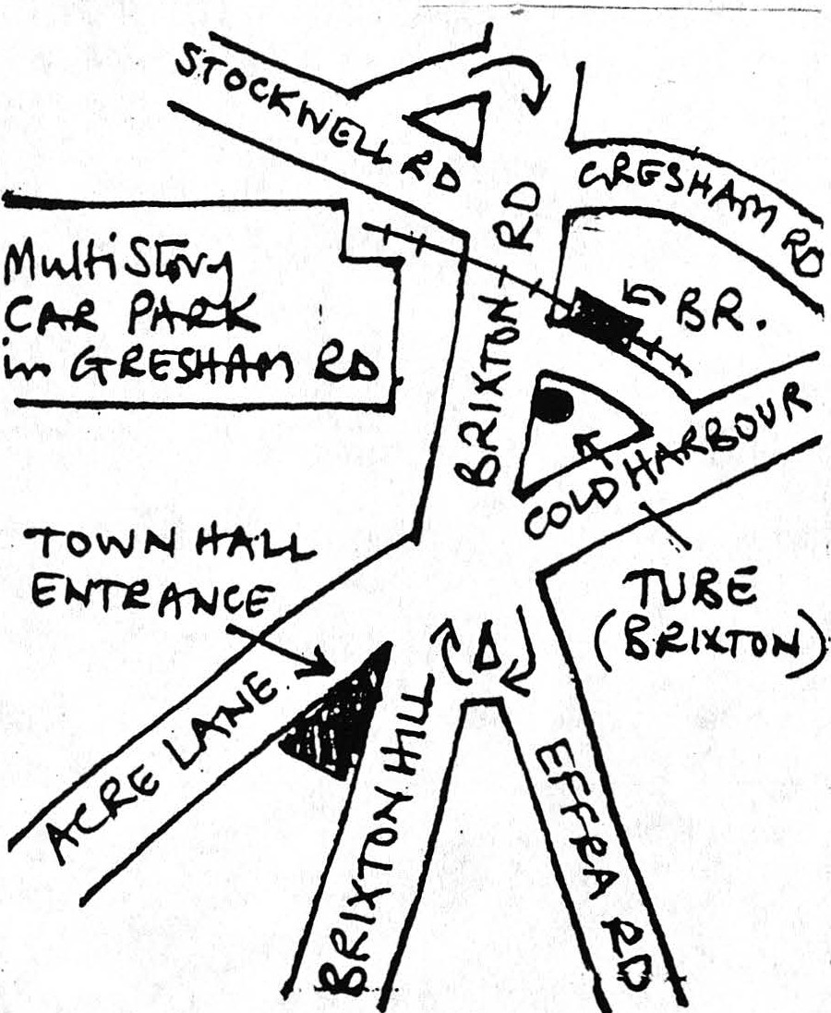

Afternoon Seminars:

- Travellers
Brian Foster from the Teachers for Travellers group will look at the experiences of Travellers in Britain and what changes they want.

- Challenging Racism In the Irish Community
Pat Duffy of Jamaican/Irish background will explore how racism affects the Irish community and what strategies to use to challenge it.

- Construction Safety
The speaker will examine conditions on building sites for workers and what needs to be done to improve health, safety and welfare for workers.

- Irish Women In Britain
Irish women are generally charged with the care and welfare of our children, the elderly and the sick. What demands should Irish women in Britain be making of the statutory services and the services provided by voluntary groups in our community? Brigid Loughran will discuss these and related issues.
---- ------- ------- ------- ----------------------------------------------------
Please return to Lambeth IBRG 245 (a) Coldharbour Lane London SW9 8RR Tel: (071) 326 4740

Name............................................................................................................. Creche: There will be a free creche but you must book in advance as Address.......................................................................................................... soon as possible

............................................................................................. No. of children: Ages:

Fee encl: £3.00 / £1.00 OAP/concs. Stat. Org. £10 Cheques payable to Lambeth IBRG

Please Indicate your first and second choice preferences for the seminars listed above:

If you are representing a statutory authority, community organisation or other body please specify name, address and telephone number:
Name ........ ..................................................... .. ......... Tel:...... ..... ...... ... ....... ...... .
Address............................................................................................................
....................................................................................................................

Morning Session:

Afternoon Session:
Seminar No.
1st preference
2nd preference
1st preference
2nd preference

