Applications of Blockchain in Government Education Sector: A Comprehensive Review and Future Research Potentials
Abstract
Purpose: With the time and increase in usage of Information Technology (IT), blockchain technology is gaining immense attention from researchers, academicians, and practitioners because of its distinctive features such as transference, security, and data reliability. The sole purpose of this research work is to endow with a systematic review of literature on blockchain in context to the government education sector in terms of its usage, benefits, obstacles, and practical implementation in future areas in education.
Design/methodology/approach: The study adopted a bibliometric visualization tool to classify data in yearly publications, highly cited journals, prominent authors, leading publications in countries and institutions, and highly cited papers—the data was extracted from the SCOPUS database by using relevant keywords. Thus, the following research questions developed as (1) How has Blockchain technology been utilized in the government educational sector? (2)What are the benefits examined in the field of education? (3)What were the problems/obstacles faced using the technology in a government education structure?
Research findings: The findings identify and provide a comprehensive review of the technique regarding the present research stream in terms of highest publication, author, Journal, subject wise, and relevance of the technology in government education structure. Thus, the future research potential of the technology in the education sector is much more as it is in the initiation stage. A lot of opportunities and benefits need to be extracted at large.
Implications: The present findings of the study provide a base work for government education institutions, policy developers, and researchers to investigate other areas where the technology can be implemented. Lastly, more technology applications will develop strategies for proper data management and cost-effective decisions.
Originality/value: Lastly, the research explains the relevance of technology in education through bibliometric visualization. The study adopted the review and significance of blockchain technology in the government education sector by identifying its benefits, current scenario, application, and future research potential areas.
Keywords: Systematic literature review; Application, Bibilometric; Education, Blockchain; Government.
1. Introduction
With the advent of the technological revolution, the concept of blockchain technique brought a new course in every field to maintain data integrity and accuracy (Richa, 2019). Blockchain refers to the innovative, decentralized, and distributive approach that preserves privacy, integrity, and accessibility of transactions and data (Chang et al., 2019a; Choi et al., 2019). It is considered one technique that excludes third-party intermediaries and directly allows for authentication and dealings (Bhaskar, Tiwari, and Joshi,2020). Blockchain technology has witnessed a move on in four generations. The first generation focused on cryptocurrency for different payment types such as small-value payments,exchange-based overseas and one-to-one monetary payment systems, etc. The second generation focused on different instruments in the banking sector and other areas of finance. The third generation focused on applying education, science and technology, art, and culture (Swan, 2015). Lastly, the fourth generation of blockchain-focused on integrating business operations and cross-blockchain technology to sustain supply chain management, financial management, and asset management using IT systems and processes (Alladi et al., 2019).
The application of blockchain has extended to various fields like banking(Guo and Liang,2016; Hassani, Huang, and Silva,2018, Garg et al.,2020) healthcare(Dimitrov, 2019; Przhedetskiy et al., 2019; Tandon et al., 2020) supply chain operations, energy generation, education, and so on(Pankaj et al.,2020). On the other hand, blockchain technology resulted in digitalization and decentralization, which created a lifelong learning approach(Loukil, Abed, and Boukadi, 2021). Many studies (Cheng et al.,2018; Skiba,2017; Grather et al.,2018) have analyzed the implications and benefits of blockchain technology in the field of education, but still, there are barriers and obstacles in terms of its usability, security, and privacy (Peck, 2017) and cost (Choi, 2020). Blockchain technology can be considered in two ways. The blockchain, accessible to all users on the network, is defined as a public blockchain through peer to peer network. In contrast, private blockchain elucidates the task-based access to data and supports cloud networks for improving elasticity. It has resulted in immense benefits in the field of the education sector also. It enabled the education sector to create a differentiated online learning platform, develop academic projects, and most importantly, minimize fraud and enhance security and privacy(Chen et al., 2018). In their research work, Upadhyay et al.(2020) analyzed the relationship between blockchain technology-organization-environment. They developed a framework to understand the challenges and benefits of operational excellence and desired results.
Education is one of the pillars of society that shape the present and future of every person living in the community. (Liu and Zou, 2019; Lam and Dongol, 2020). The blockchain concept gained immense attention to develop a secured platform for data transmission and create an intelligent education platform. Malibari (2020), in his research work, provided an accurate idea of how blockchain can be utilized in the field of education to increase the innovation and creative abilities of learners also. Nevertheless, the application of blockchain in the education sector has been advocated for many reasons, such as certificate verification (Grech et al., 2017), data management (Xu et al., 2015), manuscript submission, and timely review for accurate results (Spearpoint, 2017). Hence, it is imperative to understand the relevance of the technology to meet the changes and future challenges in a better and result-oriented manner.
Examining the existing literature on the role and application of blockchain in government education is scarce. The researchers extracted very few articles with blockchain and instruction from the Scopus database. On the other hand, one of the significant gaps in the existing literature (Fedorova and Skobleva, 2020; Mahankali and Chaudhary, 2020) with scarce articles on blockchain education motivated the researchers to explore this area. Thus, the researchers were inspired to develop the present study to find significant contributions of the technique in the education sector and create the research streams for the prospective researchers. Therefore, the vital contribution of the topic led the researchers to conduct the present study based on the following research questions:
RQ1. How can blockchain technology be utilized in the educational sector nd what are the prominent journals, prolific countries, and institutions with leading publications on this topic?
RQ2: Who are the prominent authors in terms of co-authorship with other authors and what are the frequently used keywords, cited articles, and developing cluster analysis on this topic?
RQ3: What are the future research trends of blockchain technology in the field of education?
Based on the above discussion, the following research questions and objectives have been formulated such as:
- To gather and review articles on the application of blockchain in education.
- To develop the research pathways in blockchain in the education sector.
- To put forward future research directions in blockchain in the education sector.
The research identifies and collects articles on blockchain education and integration to achieve the stated objectives. The study focused on re-examining past and present articles on block chain-education to determine the field's present and future research direction. The current research adopted an SLR methodology to reassess the selected papers and analyze the contributions of various authors, countries, and institutions in block chain-education bibilometric and network analysis. To develop the network analysis, the researchers utilized the VOS viewer package. The present research work includes seven sections. First, section one explains the introduction, followed by the research question and research objectives. Second, a review of articles about blockchain and its integration in education is given in section two. Third, the section discussed research methodology, which covers selecting databases, keywords, and articles. The fourth section explains bibilometric analysis and includes network and cluster analysis on the blockchain and its integration in education. The fifth section describes the implications of the research work in the theoretical and practical context. Lastly, section six explains the unique contribution of the research work, section seven explains the scope of the research study, and eight includes a discussion on findings and conclusion of the research work.
2. Background of the study
In this era of cut-throat competition and change in the technological revolution, blockchain technology has emerged as a tool that addresses every issue. The technique has been adopted in every field towards creating a secure and user-friendly platform. Brasil (2019) opined that applying blockchain technology in education approaches to handle and create an innovative learning approach, prevent frauds, and facilitate a forward-looking process among educators. Han et al.(2018) stated that the blockchain technique provides a platform for creating proper documentation management such as certificate management, verification, and ensuring the privacy and security of data.Turkanovi(2018) opined that the application of blockchain would enable the production of a globally simplified, ambitious, and unified platform to create a peer-to-peer learning approach. Alammary et al.(2019) analyzed the benefits and usage of blockchain technology and how the educational sector can develop and mobilize the resources for maximum utilization and create a secured platform for transformation. Harthy et al.(2019) highlighted how the technique could handle student profile and certification. Sharples and Domingue (2016)stated that blockchain can be utilized for student record privacy, management of reputation, and reward management. However, on the contrary, it has been analyzed that the application of blockchain is still in the stage of underdevelopment and lacks community acquaintance, making it tough to have a lucid, innovative vision of its real potential (Radanovic and Likic, 2018). Shah et al.(2021) developed a model to explore the benefits of two critical technologies such as machine learning (ML) and blockchain, to resolve forgeries of educational records and fake certificates. The developed system can provide a platform for managing employee and student records. Raimundo and Rosário(2021) indicated the relevance of blockchain in education and enhanced efficiency, efficiency, and privacy control over data management mechanisms. Kulkarni et al.(2021) explained the importance of blockchain technology for maintaining records and analyzed the importance of the technique above other models and tools. Aini et.al.(2021) in their research work addressed an important aspect that with the span of time blockchain technology is gaining advantage over others as it is one of the system which focus on security and privacy of records and fully protected from any forgery. Lastly, the blockchain technique has entered every sector and field of society, including education; though enormous challenges are there but still their use can be manifested for the growth of community.
The education sector has been a significant segment of society. The measures to introduce blockchain in education became an important tool to enlarge the scope of new development opportunities in this area. Based on the literature review, the researchers identified the following gaps such as (1) The exploration of blockchain integration in the field of education is very scarce(Ma and Fang, 2020) (2) The existing studies didn’t present any future research pathway or future research questions for other researchers( Treiblmaier,2020; Pal,2021). Therefore, from the above gaps, there is a vital need to investigate the incorporation of blockchain in the education sector, which motivates the development of the present research work.
- Methodology of the study
The primary objective of this research work was to methodologically scrutinize and present the existing research literature explored using blockchain technology in context to the educational sector. The research paper is a sincere endeavor to understand the relevance of the technology and facilitate different knowledge-sharing activities such as teaching and learning, including administration activities in the educational sector. It provides an idea and future perspectives through a broad literature review. The sole rationale is to investigate the adoption of such technology in government education and how far the technique enhances the opportunities to maximize student achievement and improve knowledge sharing. A broad mixture of studies was carried out on a range of topics related to blockchain techniques. However, only a few studies have presented a bibliometric analysis or reassessed literature on blockchain techniques in the education sector. The researcher focused on a phased approach to complete the research work through framing the research questions.
Based on the research questions as a first point, the bibliometric analysis of the extant literature was conducted to identify prior research carried out in blockchain technology. The present research work aims to develop citation, cluster, and future research perspectives to answer the research questions. The study can significantly determine current and future blockchain technology trends in education. Lastly, the most crucial reason the blockchain technique needs to be endorsed in other domains is the research gap which motivated the researchers to develop a composite work that can add value to the area. Therefore, the research presents a novel study for professionals and academic practitioners, providing a concrete idea for their future research perspectives. The methodology followed the following steps that are involved in the research study. Figure 1illustrates the research stages adopted in the study.

Step-1 Research Questions and Objectives
RQ1: How can blockchain technology be utilized in educational sector?
RQ2: What are the journals with leading publications on this topic?
RQ3: What are the prolific countries and institutions conducting research?
RQ4: Who are the prominent authors in terms of co-authorship with other authors?
RQ5: What are the most frequently used keywords and developing a cluster analysis?
RQ6: What are the highly cited articles in the area of blockchain with specific to field of education ?
RQ7: What are the future research trends of blockchain technology in the field of education?

Step-2 Literature Review
Analysis and Software: Bibilometric Analysis includes (i) Influential aspects (ii) Co-citation analysis (iii)Co-authorship analysis (iv) keyword co-occurrence analysis.
Software used: VOSviewer

Selection of Database
SCOPUS database
Keyword Searched
Blockchain, Blockchain Technology, Education,Education System,Higher education, Government Education,Distributed ledger and Cryptographic ledger
Using AND, OR operators

Step 3: Contribution of the study
- Identified the dominant aspects of the literature on blockchain in education sector.
- Identified the research pathways.
- Identified the future research questions.

Collection of articles
Inclusion Criterion: publication stage-"final"; language-"English" results into157
Documents
Then inclusion criterion of document type - “article” and “Exact keywords” resulted into Final 135 articles

Selection of articles

Figure: 1Methodology Framework

3.1 Selection of database
The present research study considered the Scopus database because it has been identified that most researchers considered the Scopus database one of the most influential databases for collecting literature (Meester et al., 2017) and the fastest extraction database for bibliometric data (Montoya et al., 2018). Therefore, the present study selected and used the database for data collection because of its comprehensive coverage. To accomplish a broad consideration of literature for the present study, the researchers followed a combination of keywords and discussed them in the following consecutive sections.

3.2 Keywords Selection
The study focused on a systematic review of articles about blockchain in the education sector. The critical concern while identifying articles is through the selection of keywords. Similarly, the following keywords were selected in this present study to collect articles about blockchain and the education sector.

("blockchain" AND "education" ) OR ( "blockchaintechnology" AND "education" )OR ( "blockchain" AND "governmenteducation" )OR ( "blockchain" AND "highereducation" ) OR ( "distributed ledger" AND "education" ) OR ("distributed ledger" AND "higher education" ) OR ("Cryptographic ledger" AND " education").

3.3Filtering of articles
The inclusion criterion of articles is based on the following steps: publication stage, "final" AND language, "English" resulted into 157 documents. After extracting 157 pieces, the researchers followed the next step to include the relevant articles for the analysis and findings of the results. The researchers followed the inclusion criterion in the following manner such as :
First selecting, document type - “article,” second, article type “Journal” third, language, “English” and fourth, keyword type, “Exact keywords” such as “Blockchain,” “Blockchain technology” “Education,” “Higher education,” “Government” which resulted into the extraction of the output of 135 documents. The extracted 135 documents were kept as the final data sheet for data analysis and bibilometric visualization in the present research study.

3.4Articles Collection
The researchers considered the extracted 135 documents for developing the research work. The Scopus database's downloaded CSV(comma-separated values) format was used for bibliometric analysis. The researchers manually checked the concept of “blockchain” and “education” in the abstract and title, respectively.
4. Results and Discussion
4.1 Journals based on highest publication
The consecutive section discusses the result and findings of the research work, which focuses on identifying the journals based on the highest magazines, yearly publications, papers with the highest number of citations, most prolific authors, prolific countries, and institutions who have researched in the field of blockchain technology. Lastly, it also analyzes based on authorship and co-authorship, inter country-wise, and keyword occurrences statistics in network maps. The fundamental objective is to structurize the existing work and develops a plan for upcoming researchers in blockchain technology usage and application in the educational sector.
The identified135 papers in the study fit into around 93 journals. Figure 2 graph identifies the journals with the leading publications on blockchain technology in the educational sector; approximately the top ten journals were considered. The first Journal belongs to Springer. Other Journal belongs to individual publishers etc. The most influential Journal, which has leading publications, was Sustainability Switzerland. It has seven papers, belongs to the Springer Publishers. Blockchain technology has been adopted in every discipline. However, the required articles are still significantly less, specifically in the educational sector, which enhances the scope and provides concrete and transparent ways for others to explore the area and develop more relevant research work.
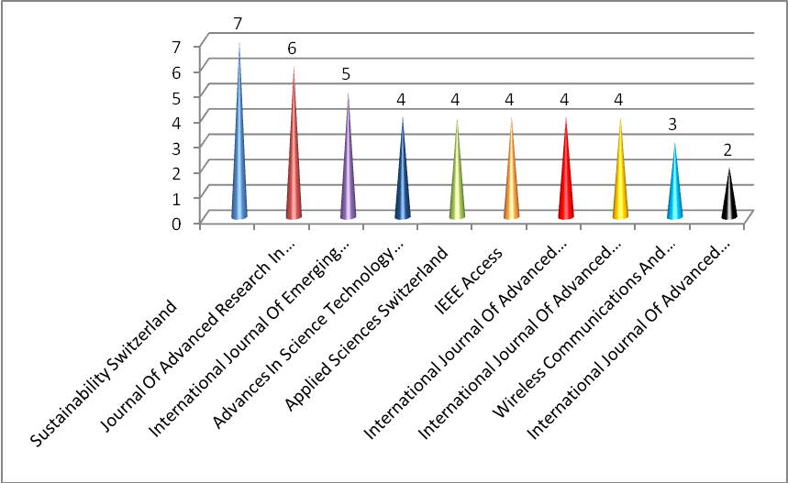
Figure 2: Top 10 journals with leading publications
The result is shown in Table1 ranks the top ten journals and their publications. It indicates that Sustainability Switzerland has leading publications on blockchain technology, and the International Journal of advance science and technology Journal has fewer publications. So, at the outset, the upcoming publications can target all the journals as the publications ratio is very small, which broadens the publication's scope and provides a centrality to the research.
Table: 1 Top 10 journals with leading publications
Rank | Journal Title | Publications
1 | “Sustainability Switzerland” | 7
2 | “Journal Of Advanced Research In Dynamical And Control Systems” | 6
3 | “International Journal Of Emerging Technologies In Learning” | 5
4 | “Advances In Science Technology And Engineering Systems” | 4
5 | “Applied Science Switzerland”
6 | “IEEE Access” | 4
7 | “International Journal Of Advanced Computer Science And Applications” | 4
8 | “International Journal Of Advanced Trends In Computer Science And Engineering” | 4
9 | “Wireless Communications And Mobile Computing” | 3
10 | “International Journal of Advanced Science and Technology” | 2
4.2 Year-wise publication
Figure 3 graph analyzes the papers extracted from the Scopus database published from 2017 to 2021. The extracted graph visualizes that the research on blockchain technology has grown increasingly in consecutive years. On the other hand, there is radical progress in research work in 2020, as the technique is gaining momentum and creating interest among researchers in the current times. Researchers can attempt to apply blockchain techniques to different fields and sectors. Basically, in the education sector, this broadens the scope towards understanding the benefits and usage of the method in every area to achieve the concept for achieving organizational excellence and productive results.
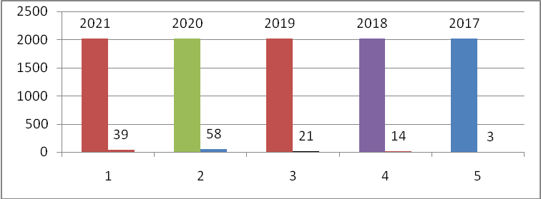
Figure 3:Year-wise Publication
4.3 Highly cited papers
Table 3: Top 10 Most cited papers on blockchain technology
Sl.no | Author name | Paper Title | year | T.C
1. | Turkanovic et.al | “EduCTX: A blockchain-based higher education credit platform.” | 2018 | 189
2. | Kamilaris et.al | “The rise of blockchain technology in agriculture and food supply chains.” | 2019 | 155
3. | Taylor et.al | “A systematic literature review of blockchain cyber security.” | 2020 | 79
4 | Hoy | “An Introduction to the Blockchain and Its Implications for Libraries and Medicine.” | 2018 | 73
5 | Jirgenons and Kapenieks | “Blockchain and the Future of Digital Learning Credential Assessment and Management” | 2018 | 49
6 | Funk et.al | “Blockchain technology: A data framework to improve validity, trust, and accountability of information exchange in health professions education.” | 2018 | 35
7 | Ocheja et.al | “Managing lifelong learning records through blockchain.” | 2019 | 33
8 | Fernandez and Fraga | “Towards next-generation teaching, learning, and context-aware applications for higher education: A review on the blockchain, IoT, Fog and edge computing enabled smart campuses and universities.” | 2019 | 31
9 | Sun, Wang, and Wang | “Application of blockchain technology in online education”  “Blockchain and the evolution of institutional technologies: Implications for innovation policy” | 2018 | 28
10 | Allen et.al |  | 2020 | 27

4.4 Most cited Authors
Figure 4 identifies the ten most prominent authors. In total, 135 papers were extracted from the database, which fit into their respective 152 authors. It was observed that the most noted author on blockchain technology is Professor Qurtoul Aini, with four papers. Presently the author is working as a Professor at the University of Raharaj, Indonesia. His research area explores different dimensions of applying blockchain technology in various financial transactions such as Bitcoin, mobile payment, UTAUT, and next, throwing light on Professor UntungRahardjaat at the University of Raharaj, Indonesia with four papers. His studies are mainly focused on Bitcoin, mobile payment, UTAUT. The third author with three articles is Professor Murad Muhammad khan. The author works at the Government College University, Faisalabad, Pakistan. His research interests are focused on Bitcoin, contributed papers in the health and education sector. Consequently, other researchers have significantly less contribution to the field as the technique is gaining momentum so future researchers can develop their work on measuring the application of the method in different areas, specifically in the education sector, and their implications for better facilities and providing a forward approach for government to adopt the technique for secured data transmission.
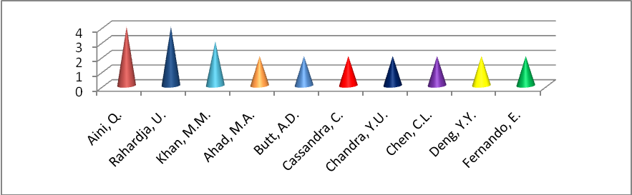
Figure: 4Most prolific authors
4.5 Publications based on countries and institutions
Figure 5graph depicts the ten top countries with the highest number of papers published on blockchain technology. INDIA tops the list of the top ten countries with 21 total articles. United States, China, and South Arabia are the following countries with more than 10. Notably, the first top-five countries have the highest number of publications out of the total documents considered in the study. The graph visualizes the countries whose authors at least contributed around five papers. On the other hand, it is noticed that there is enormous scope for every country to develop research work that will add value to the research and academic fraternity and understand different dimensions of blockchain technology.
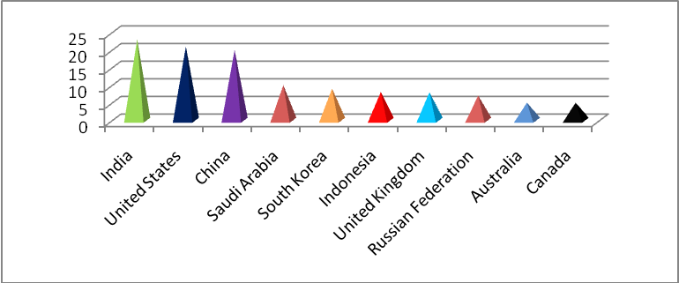
Figure: 5Publications based on countries
Considering the institutions with the highest number of publications in blockchain technology, the University of Raharja and the University of Zagreb are the two universities that have contributed to the field with the highest papers. Figure 6 describes the top institutions that have published more than four papers.
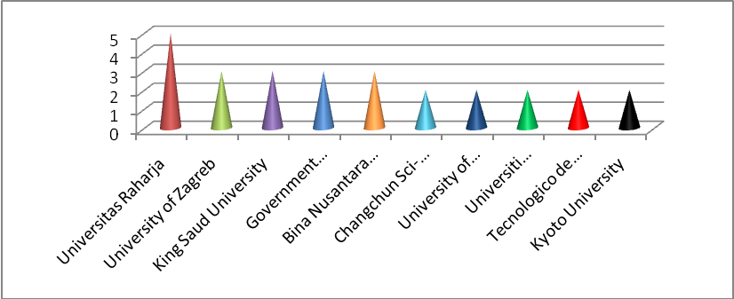
Figure: 6Publications based on institutions
4.6 Most prolific Subject Area
Figure 7 analyzes the subject area and identifies which field research papers have been developed on blockchain technology. The graph depicts that maximum work has been carried in computer science (26%). It signifies that the concept of blockchain technology has expanded to computer science. It measured the application of the technique and its utility. Next to that, engineering (22%), the concept has laid its roots for exploring the benefits and its application towards developing services for creating a competitive advantage. The business and Management area covers only (8%) of the extracted papers. So, it is highly crucial that management researchers can expand their research studies to understand the concept of "Blockchain technology" among different functional activities of an organization. Other subject areas such as environmental science, energy, material science, mathematics, and decision science contributed very few articles. It is clearly illustrated that engineering and computer science are the two major areas where the concept has expanded. But still, there is broad scope to enhance the application of the technique in other regions in an expanded way on conducting research studies which will add value to the research issues and developing new models for other researchers.
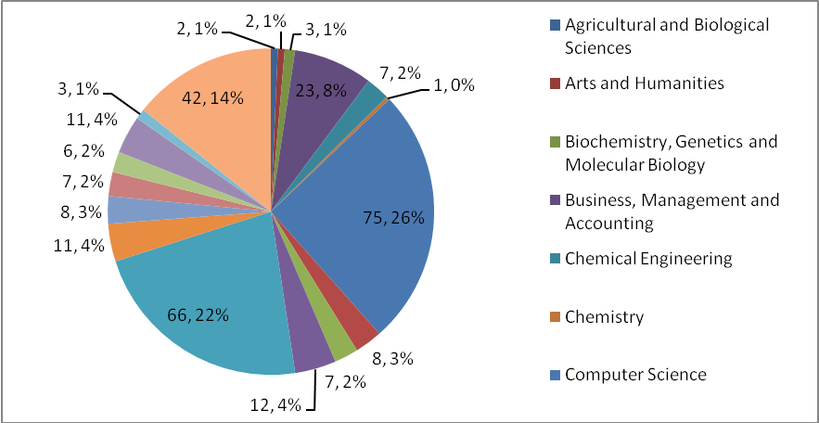
Figure:7Subject area Statistics

4.7 Co-authorship network analysis map
The research advocated developing a network map based on co-authorship through the VOSviewer software. The primary objective is to visualize and create maps based on authorship and co-authorship, keyword co-occurrence, and Inter-country co-authorship (Van Eck and Waltman, 2007). The co-authorship map measures the state of authorship among other authors in the dataset. The paperwork identified a total of 455 authors in the dataset for developing the network map, and only those authors who had co-authored with at least one other author in the dataset were segregated. Assuming the criteria, the researcher viewed around 363 authors who have co-authored among themselves.
Figure 8 visualizes the generated map based on co-authorship by the software. It consists of connected lines to establish the relationship. It has been noticed from the developed map that the authors are grouped into two clusters by the software, such as cluster one consists of thirteen items and cluster two includes nine items. In cluster one, ‘Constantiou I’ has co-authored with a maximum of twelve authors, denoted in red. In contrast, cluster two'ahadm. a' has co-authored with eight authors, indicated in green lines.
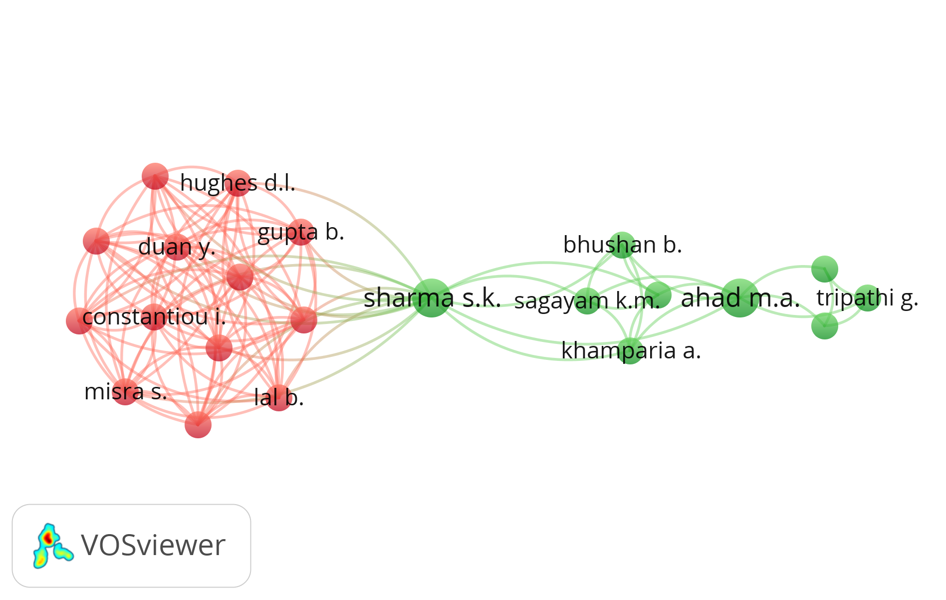
Figure: 8Network map based on Author and Co-authorship
4.7.1 Co-authorship map based on Inter-country
Figure 9illustratesthe co-authorship maps based on Inter-country. The network map visualized fifty countries of the dataset, twenty-nine linked in terms of co-authorship. Following the extraction of the map, it was denoted that the authors of the USA, India, China, and Saudi Arabia are the countries who have maximum co-authored with the authors of other countries. Figure 10analyzesthe countries connected with a maximum number of lines are labeled through circles such as “The United States, 'India' and 'China.’ 'Table 4 enumerates the top ten whose authors have co-authored the highest number of times with authors of other countries.
Table 4:Table on inter-country co-authorship in context to block chain
Sl.No | Countries | Authors
1 | United states | 21
2 | India | 21
3 | China | 20
4 | Saudi Arabia | 10
5 | South Korea | 9
6 | United Kingdom | 8
7 | Indonesia | 8
8 | Russian Federation | 7
9 | Italy | 5
10 | Taiwan | 5
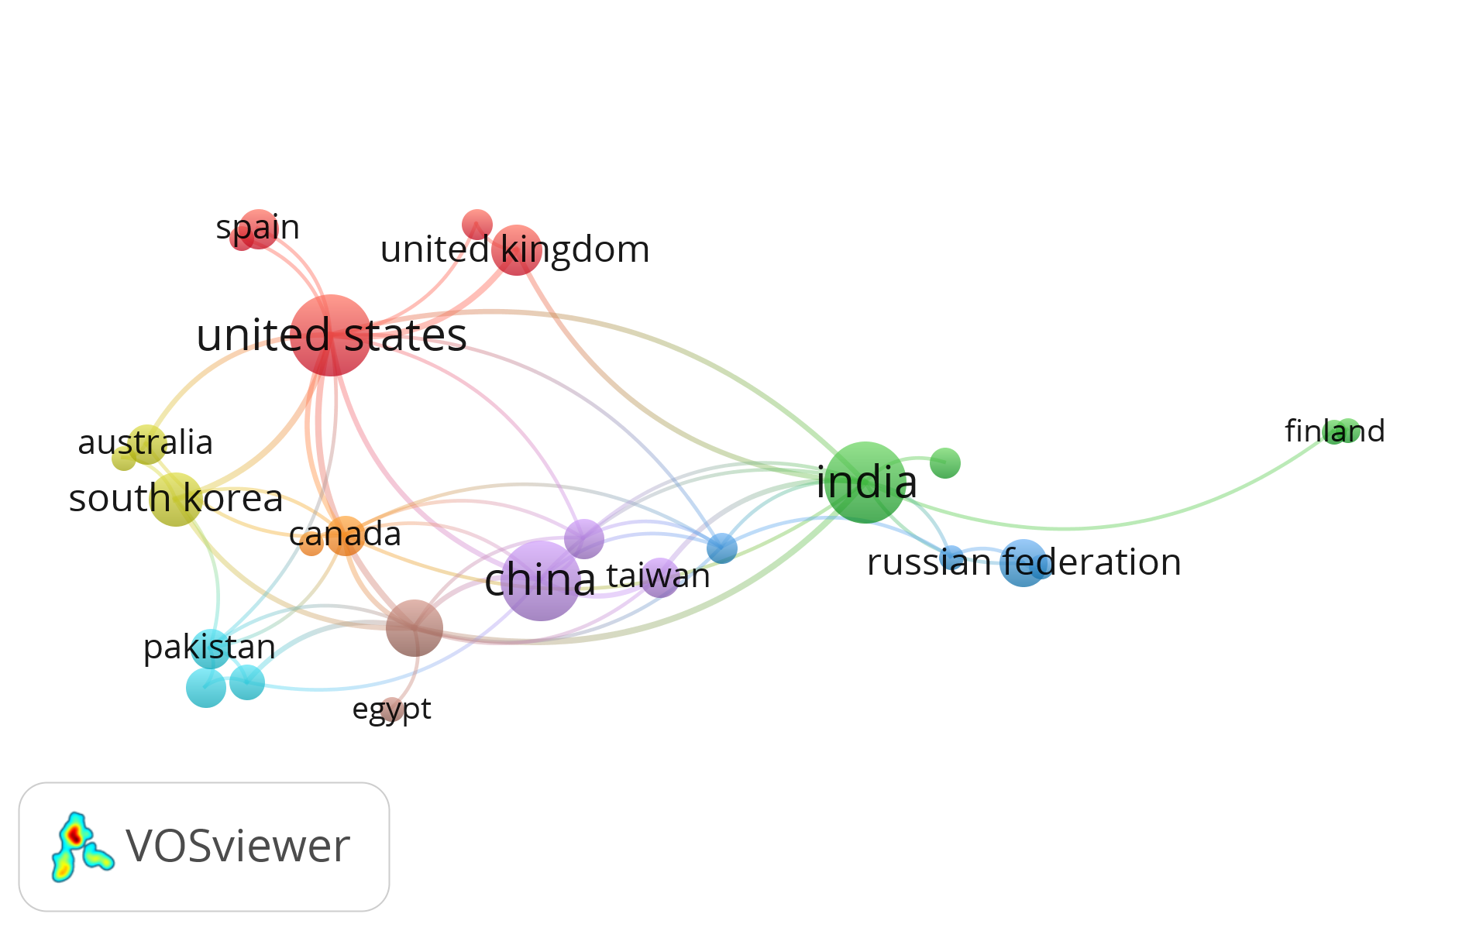
Figure 9: Inter-country co-author network map analysis
The primary objective of the keyword co-occurrence map is to categorize the keywords that have been repetitively used in the existing literature and are used in this research work. It gives the researcher an idea about which type of topic and context has been preferred mainly by other researchers. The connection of the terms and the publications' co-occurrences were analyzed (Van Eck et al., 2010).

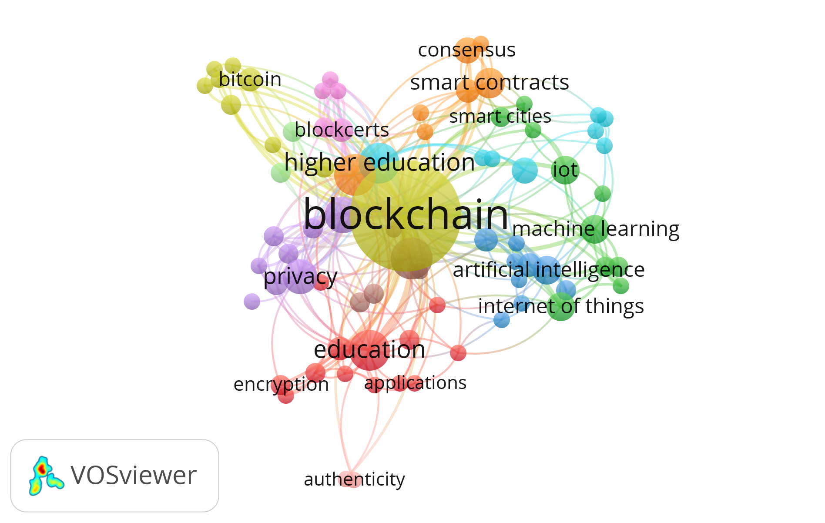
Figure 10: Keyword co-occurrences map
Table 6: Twenty keywords frequency in the dataset
Sl.no | Keyword | O.C | Sl.no | Keyword | O.C
1. | Blockchain | 110 | 11 | Academic records | 5
2 | Education | 17 | 12 | Industry 4.0 | 4
3 | Higher education | 15 | 13 | Big data | 4
4 | Blockchain technology | 5 | 14 | 6g | 5
5 | Privacy | 10 | 15 | Electronic document | 3
6 | Security | 12 | 16 | management | 3
7 | E-learning | 5 | 17 | challenges | 3
8 | IOT | 2 | 18 | Systematic review | 3
9 | Smart Contract | 11 | 19 | Digital education | 2
10 | Digital documents | 5 | 20 | Innovation | 3
Note: *O.C. stands for occurrences.
The keyword' blockchain was identified 110 times in the dataset. Other keywords were also identified in the dataset, identical to 'Education,' 'Higher education,' 'Security,' Privacy,' etc. Figure 10 presents the keyword co-occurrence map. The dataset identified 409 keywords, and the keywords that appeared more than two times were considered for developing the network map. It was viewed only 78 were included meeting the criteria. The identified keywords were connected through various lines. Further, analyzing figure 10, it was considered that almost every other keyword appearing the maximum number of times in Table 6 has co-occurred with the ‘blockchain.' The primary objective is to analyze the highest occurrence of keywords in the data set and provide a perspective for future researchers to use the more minor keywords to develop research studies and add value to the research gateway.
4.8 Analysis based on citation
Citation analysis focuses on identifying the most accepted articles within blockchain technology. It analyzes how often other articles cite a particular study and recognizes the importance and impact in the concerned field (Kumar et al.,2020). Thus, citation analysis measures the relative effects of research work in a particular area and how important they are (Usdiken and Pasadeos 1995). The study analyzed the citation of 135studies. However, the study restricted the minimum threshold citation to five; it assumes that an article must have been cited five times. However, 62 articles were taken for further citation analysis in the study. Figure 11elucidates the studies highly cited in terms of Scopus citations. The most cited research (Turkanovi, 2018) with 189 citations. The work by radanovic et al. (2018), hoy m.b(2017),ocheja. p(2019), sun, wang, and wang(2018) are the most cited papers in the area. So, considering the top-cited articles, it can be concluded that these articles provide an empirical and conceptual clarity towards understanding application, usage, benefits, and different determinants of blockchain technology for enhancing the growth perspectives and providing more security and privacy for achieving end- results.
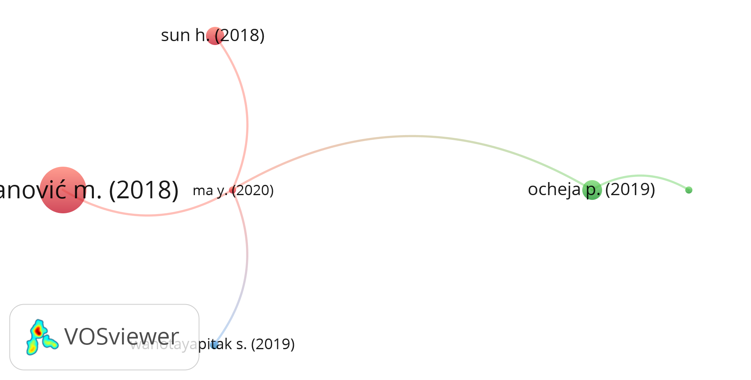
Figure: 11Citation analysis based on Documents
4.8.1 analysis based on Co-Citation
Co-citation analysis is generally used to measure the similarity or associations among sources, articles, or authors in a research field (Vogel 2012; Zupic and Cater 2015). The occurrence of two studies, sources, and authors cited together in one work is measured(Small 1973). The present study performs the co-citation analysis to recognize linkage among the authorities based on an extract done of hundred thirty-five articles from the Scopus database. It was conducted by using the VOSviewer visualization tool. However, the threshold limit has been set to five in this study. The Journal to be included had to be cited at least five times in the research articles. In total, it resulted in the identification of eighty-nine journals that fulfilled the criterion. Figure: 12 shows the results. The“Ieee access” is the most cited Journal with a total of 117citations. Other journals like“Bitcoin: a peer-to-peer electronic cash system” and “International journal of information management” have the highest citation. Therefore, these are the few journals that can be used for future publications and references. The list of journals provides a significant idea for what growth perspectives and gaps exist in the literature for future studies in the blockchain and its application. Lastly, the result that draws considerable interest is about the majorly top-cited journals are from the field of engineering, so it can be a future perspective for management researchers to carry out research studies for inclusion of management journals and adding value to the academic literature and supporting the finding that the"Blockchain technique is an interdisciplinary tool" which can be considerably used in every field of research.
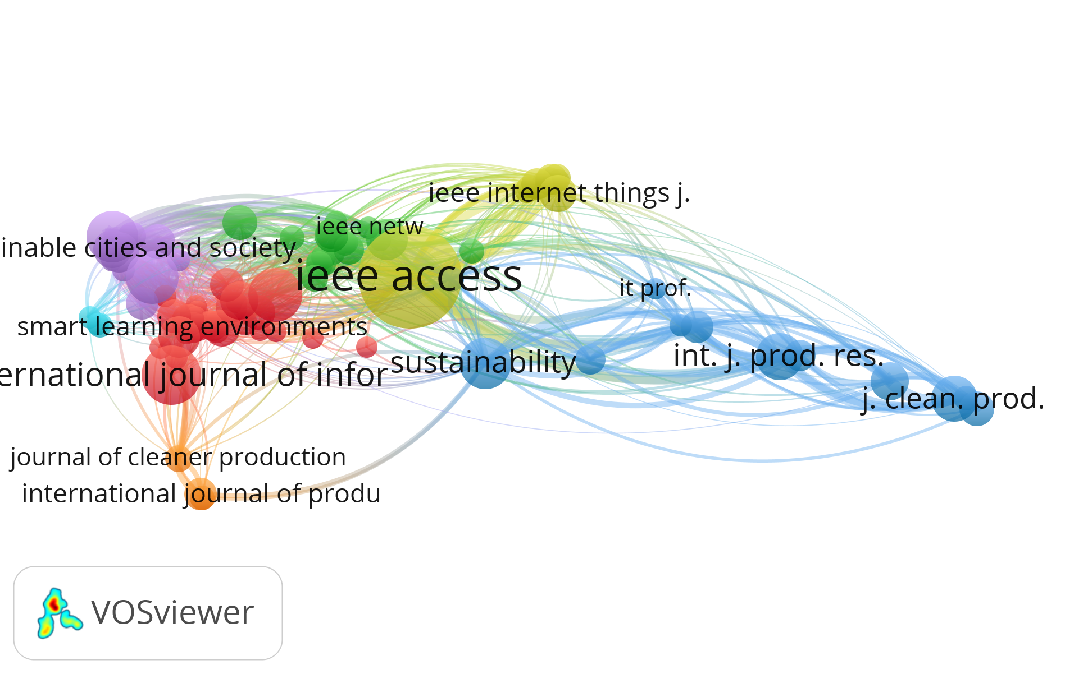
Figure: 12Co-citation analyses based on source

4.9 Cluster analysis
The study conducted a cluster analysis based on keywords using VOSviewer software. The number of occurrences restricted to five leads to a visualization of keywords, as shown in Figure 13. Researchers identified four clusters of research flow based on the repetition of keywords. The formation of groups is based on author keywords. The keywords are clustered into four colors: yellow (Blockchain and smart contract), Blue (Blockchain and tools and techniques IoT, Big data, Artificial intelligence)), purple (Blockchain and Security)maroon (Blockchain and education). Table 7 identifies the crucial clusters with their respective keywords. In continuation, the authors conducted a comprehensive content analysis of the highly cited articles in various areas to identify, clarify and substantiate their linkage among the papers.
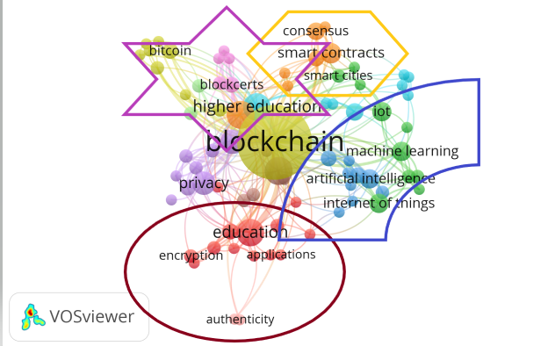
Figure 13: Visualization of cluster analysis using key-word occurrences

Table 7: Developing Clusters using Keywords
Sl.no | Cluster |  | Name of Cluster |  | Keywords
1 |  | Cluster one |  | Blockchain and smart contract |  | Bitcoin, Consensus,higher education
2 |  | Cluster two |  | Block chain and Security |  | e-learning,Privacy,Security
3 |  | Cluster three |  | Blockchain and education |  | Industry 4.0,machine learning,education
4 |  | Cluster four |  | Blockchain and tools and techniques(IoT,Big data,Artificial intelligence) |  | Security,Privacy,Governace,Education,analytics.

4.10 Future research propositions and framed research questions
The development cluster analysis led to the formulation of four research propositions such as(1) Blockchain and Smart contract (2) Blockchain and Security (3) Blockchain and education(4)Blockchain and tools and techniques(IoT, Big data, Artificial intelligence)using content analysis. The derived linkage between the identified areas and developed research propositions will enable upcoming researchers to develop research studies by undermining the benefits of blockchain in different fields, the education sector, and its application for better results and growth perspectives.
4.10.1 Blockchain and Smart contract
Cong (2019) outlined and analyzed that blockchain enlarges the information-sharing ability; the smart contract can compress and mitigate the consumer surplus approach through easy entry and exit. Palma, Pereira, and Martina (2019)developed a model in association with blockchain through smart contracts, increasing the reliability, decentralization, and validation of certificates distribution, enhancing the scope of proper management of resources timely delivery of timely delivery results. Sharples and Domingue (2016) proposed that blockchain and automated intelligent contracts enlarged academic reputation beyond the academic community. On the other hand, although it is well recognized in the literature that the relationship between blockchain and smart contracts is significant for the increase in efficiency in the educational sector, the indication of their effects is still unclear. Therefore, the present discussion enumerated three future research questions from the research pathway to be explored by future researchers which enables to understand the benefits and develop strategies to match the needs and requirements.
4.10.2 Blockchain and security
The increase in sophistication to handle education technology and student database has become essential for every educational institute. Rahardja, Aini, and Hardin (2020) illustrated that blockchain application in proper management enables more data and transmission security. Dasgupta, Shrein and Gupta, (2019) opined that though a blockchain is vulnerable to many obstacles to appropriate identification and management, the challenges can be overcome for effective implementation. In their study, Taylor et al. (2020) opined on measuring the relationship between blockchain and cyber security. Few studies have measured the connection between blockchain and security issues to the best researcher knowledge. Analyzing the security features related to blocking chain application becomes the primary perspective for developing studies and measuring the benefits of its implementation in every area. Therefore, the present discussion extracted three future research questions to be explored by future researchers, which enable them to understand the benefits and develop strategies to match the organizational needs and requirements.
4.10.3 Blockchain and education
The concept of blockchain usage in the education sector is still just like a young child. It requires a thorough understanding and proper analysis of security features. Han et al.(2018) stated that applying the technique can provide enhanced features to store records and provide individual accessibility to maintain security features. Dave et al. (2019) indicated that blockchain application makes data transmission more secure and reliable, but it requires proper understanding and analysis of its management. To the best researcher's knowledge, very few studies have measured the relationship between blockchain and the educational domain. The scarcity of literature in analyzing the blockchain features in education became a significant perspective for developing studies and measuring the benefits of its implementation in every aspect. Therefore, the present discussion extracted two future research questions to be explored by future researchers, which enable them to understand the benefits and develop strategies to match the needs and requirements.
4.10.4 Blockchain and tools and techniques(IoT, Big data, Artificial intelligence)
Singh, Rathore, and Park(2019) opined to develop and understand the relationship between how blockchain enables the management of big data and IoT through artificial intelligence. Rabah (2018) stated that blockchain or similar ledger technologies with (IoT, AI, Big data) customizes towards integrating data in a synchronized manner. Singh et al.(2020) also stated and developed a framework to understand the role of blockchain among these techniques. Still, there are many stones to be uncovered, so understanding the technology more profoundly is the need of the hour. Therefore, the present discussion extracted two future research questions to be explored by future researchers, which enable them to understand the benefits and develop strategies to match the needs and requirements.
4.10.5 Framed future research questions
Table 8: Framed future research questions
Research Flow |  | Future Research Questions
Blockchain and Smart contract | What is the role of blockchain technology to make smart contracts effective?  How to develop effective strategies using blockchain for proper risk assessment?  What should be the strategy to deal with future changes in clients /market requirements?
Blockchain and security | What is security features' role in effectively implementing blockchain in different fields?  What are the challenges to deal with creating a Blockchain culture?  How to measure the benefits of the blockchain application towards enhancement of security of data?
Blockchain and education | What is the role of blockchain in the education sector and effective ways for its implementation?  What is the impact of blockchain in the education sector on maintaining the security, reliability, and validity of different aspects of the education sector?
Blockchain and tools and techniques(IoT, Big data, Artificial intelligence) | What is the role of IoT, big data, and AI for effectively implementing blockchain?  What are the characteristics of blockchain in efficiency measurement?
Thus, future researchers need to examine possible relationships from the developed research questions and contribute to the literature from a new point of view and help the institutions, educationalists, and policymakers in finding the dry areas to be dealt with and assist the long-run performance and to encourage for effective implementation and enhancement to develop at a rapid pace. Thus future research questions give opportunities to future researchers to contribute to the future research agenda and add value to the research and academic fraternity.
5. Implications of the research work
5.1 Implications for educationalists and researchers
This significant implication of the research study focused on measuring the application of the technology in the government education sector. Proper recognition and analysis will facilitate educational institutions to develop a lucid, deliberate plan to take benefit of the technology towards making the institution safe and sound, protected, and sustainable for the future. This study provides an initial work for institutions, government, policymakers, and researchers to get enough idea on existing research conditions and investigate different areas where the technology can be implemented. This study analyzed the application of blockchain technology in the field of the education system. On the other hand, it is in its early stage of application, so more research studies can be developed by future researchers that can provide a pathway to be implemented in the education system and exploit the potential of the technology. Lastly, the application of blockchain technique can broaden the scope of enhancing government educational institutions' facilities and increase student satisfaction for better results.
  - Theoretical implications
The field of education is witnessed with multiple challenges and changes. In the current turbulent conditions, the adoption of enhanced and secured practices can play a significant role in the survival of the sector and performance improvement. Thus, to understand the role of blockchain technique in providing quality education and analyzing the student data in a protected and secured manner, the present aimed to explore the role of blockchain in education from previous studies. The present study also performed a bibilometric analysis to analyze relevant contributions made by authors, institutes, and countries in the research field. The present study would help understand the theoretical aspects of the application of blockchain in education to develop different models that will enable continuous growth among learners and advocate a decentralized model for adopting new technologies and creating an adaptive learning approach. The study also guided the application of blockchain techniques for delivering customized and student-oriented facilities for better learning performance.
  - Practical implications
The current research work performed the literature analysis in a systematic literature review and bibilometric analysis to comprehend the linkage between the application of blockchain in the education sector for improved quality management and performance enhancement. The previous studies explained the application of other technologies such as “IoT, big data, artificial intelligence, cloud computing, and cyber-physical systems” was observed in education. The previous studies suggested improving the performance of the educational sector, such as initiating training activities among teachers, using web-based portals for classroom teaching, and enabling a crosscheck mechanism between existing and new records in the educational sector. The present research work demonstrated the significance of blockchain technology in the administration of quality in the educational system. The educationists and industry practitioners should consider that the technology enhances teaching quality, improves students’ performance, and enhances the administration of different activities for better student-oriented results with better management practices.
6. Distinctive research contribution
The exclusive contribution of the research work is the development of a systematic literature review and bibliometric analysis of the literature on blockchain technology in the educational sector. Thus, the current research deals with the systematic literature review and the bibilometric analysis for majorly developing network maps on authors, countries, and keyword occurrence using the VOS viewer visualization tool. Additionally,bibilometric research developed the citation and co-citation analysis to determine blockchain technology's prolific authors and documents. It also led to the development of the cluster analysis that identifies significant research trends and paves for future research questions for upcoming researchers in the blockchain-educational sector.

7. Scope of the research study

The present study enumerated the benefits of applying blockchain technology in education. The study focused on understanding the current research state of blockchain –education integration. The research paved the way for upcoming researchers to understand the concept of blockchain through a bibilometric visualization. Thus, blockchain technology has entered every domain and field. The study has analyzed different pathways, determining how blockchain can be integrated for smart contracts, security, and other tools such as IoT, Artificial intelligence, and big data. The research focused on understanding the present research state in terms of authors, country-wise and highly cited articles, the occurrence of keywords, and developing a research framework for future researchers to explore the application of the technology in other functionalities and administrative areas in the field of education. Thus, future researchers can consider the research study as a base work and explore other domains in education where the application of blockchain can be integrated for better and concrete results and overcome the loopholes with the traditional data management process and data security.

8. Discussion of Findings and Conclusion
The concluding remarks of this research work indicated that it is a technique that has expanded to different fields and sectors, including education but still many more stones to be uncovered. The research questions framed throw light on a few questions, such as identifying the Journal with the highest number of papers on blockchain technology. The Journal of Sustainability Switzerland belongs to the Springer publisher. The frequency of research shows an increasing trend, specifically in 2020. The highest paper cited is of (Turkanovi 2018). The most prolific author is Qurtoul Aini. The network maps extracted from VOSviewer software identify the country with maximum papers contributed by INDIA.
Further, information on the country’s authors has co-authored the highest number of times, with the authors from other countries and based on institution leading articles contributed by the author of the university of Raharja. Lastly, the keyword co-occurrences state the maximum appearing keywords are 'Block chain' ‘Education,’ ‘Higher education,’ 'Security.' Further, cluster analysis was carried out to identify the research streams and develop future pathways. It led to the development of four research streams: blockchain and smart contracts, blockchain and security, blockchain and education, and blockchain and tools and techniques(IoT, Big data, AI). Based on the above discussions, the Figure:14 which will measure the significant impact of blockchain for better perspectives and management in the education sector.

BLOCK CHAIN
Data Analytics
Data
CustomizedLearning tools
Education

Figure: 14 Analyzing future research pathway
The research study has certain limitations that future research can address and consider despite the above discussions. Firstly, as the area is early, identifying the application and benefits needs a thorough research-oriented approach. Second, the study has been restricted to the Scopus database for searching papers, delineating those published in other journals not indexed in Scopus. So considering the above point in future studies, other databases can be regarded as extracting the data for conducting similar studies. Third, papers written in the English language were included, whereas other languages were excluded. The Scopus results excluded doctoral dissertations, unpublished articles, conference proceedings, and book chapters on blockchain technology. Therefore, the extracted results can include such changes in future studies and compare the results. So considering the above limitations, future studies can be developed. However, a composite bibilometric paper has been designed to provide an en-route for other researchers. The study should act as the basis for future research through empirically testing various models, applications and attempting theory verification; future research may try to quantify and adopt a mixed-method research design. Further, this piece of research was based on a single method, i.e., SLR and bibilometric visualization. Future research may extend on the meta-analysis approach and identify the application of the technique in other fields and further validate the findings of this research and justify the generalizability of the proposed concepts.

References
- Aini, Q., Lutfiani, N., Santoso, N.P.L., Sulistiawati, S. and Astriyani, E., (2021), “Blockchain For Education Purpose: Essential Topology,” Aptisi Transactions on Management (ATM), Vol.5 No.2, pp.112-120.
- Al Harthy, K., Al Shuhaimi, F. and Al Ismaily, K.K.J.,(2019), The upcoming Blockchain adoption in Higher-education: requirements and process. In 2019 4th MEC international conference on big data and smart city (ICBDSC), pp. 1-5, IEEE.
- Alammary, A., Alhazmi, S., Almasri, M. and Gillani, S., (2019) “Blockchain-based applications in education: A systematic review,” Applied Sciences, Vol.9, No.12, p.2400.
- Alladi, T., Chamola, V., Parizi, R.M. and Choo, K.K.R., (2019) “Blockchain applications for industry 4.0 and industrial IoT: A review”, IEEE Access, 7, pp.176935-176951.
- Bhargava, R., (2019), “Blockchain technology and its application: A review,” IUP Journal of Information Technology, Vol.15 No.1, pp.7-15.
- Bhaskar, P., Tiwari, C.K. and Joshi, A.,(2020), “Blockchain in education management: present and future applications,” Interactive Technology and Smart Education, pp. 1–17. Doi: 10.1108/ITSE-07-2020-0102.
- Chen, G., Xu, B., Lu, M. and Chen, N.S., (2018) “Exploring blockchain technology and its potential applications for education,” Smart Learning Environments, Vol.5 No.1, pp.1-10.
- Cong, L.W. and He, Z., (2019), “Blockchain disruption and smart contracts,” The Review of Financial Studies, Vol.32 No.5, pp.1754-1797.
- Dasgupta, D., Shrein, J.M. and Gupta, K.D., (2019), “A survey of blockchain from a security perspective,” Journal of Banking and Financial Technology, Vol.3 No.1, pp.1-17.
- Dimitrov, D.V.,(2019), “Blockchain applications for healthcare data management,” Healthcare informatics research, Vol.25 No.1, pp.51-56.
- Fedorova, E.P. and Skobleva, E.I., (2020), “Application of Blockchain Technology in Higher Education” European Journal of Contemporary Education, Vol.9 No.3, pp.552-571.
- Frizzo-Barker, J., Chow-White, P.A., Adams, P.R., Mentanko, J., Ha, D. and Green, S.,(2020), “Blockchain as a disruptive technology for business: A systematic review” International Journal of Information Management, Vol 51, p.102029.
- Guo, Y. and Liang, C., (2016), “Blockchain application and outlook in the banking industry” Financial innovation, Vol.2 No.1, pp.1-12.
- Han, M., Li, Z., He, J., Wu, D., Xie, Y. and Baba, A., (2018) September. A novel blockchain-based education records verification solution. In Proceedings of the 19th Annual SIG Conference on Information Technology Education, pp. 178-183.
- Joshi, A.P., Han, M., and Wang, Y., (2018), “A survey on security and privacy issues of blockchain technology.” Mathematical foundations of computing, Vol.1 No.2, p.121-147.
- Kulkarni, D.,(2021), “Leveraging Blockchain technology in the Education Sector” Turkish Journal of Computer and Mathematics Education (TURCOMAT), Vol.12 No.10, pp.4578-4583.
- Lam, T.Y. and Dongol, B.,(2020) “A blockchain-enabled e-learning platform,” Interactive Learning Environments, pp.1-23.
- Liu, Q., and Zou, X., (2019), “Research on trust mechanism of cooperation innovation with big data processing based on blockchain,” EURASIP Journal on Wireless Communications and Networking, Vol.1, pp.1-11.
- Loukil, F., Abed, M. and Boukadi, K.,(2021) “Blockchain adoption in education: a systematic literature review. Education and Information Technologies, Vol.26, No.5 pp 5779-5797.
- Ma, Y. and Fang, Y.,(2020), “Current status, issues, and challenges of blockchain applications in education.” International Journal of Emerging Technologies in Learning (IJET), Vol.15 No.12, pp.20-31.
- Ma, Y. and Fang, Y., (2020), “Current status, issues, and challenges of blockchain applications in education. International Journal of Emerging Technologies in Learning (iJET), Vol.15, No.12, pp.20-31.
- Mahankali, S. and Chaudhary, S.,(2020), “Blockchain in education: a comprehensive approach–utility, use cases, and implementation in a university,” Blockchain Technology Applications in Education, pp. 267-293, IGI Global.
- Malibari, N.A., (2020), March. A Survey on Blockchain-based Applications in Education. In 2020 7th International Conference on Computing for Sustainable Global Development (INDIACom), pp. 266-270, IEEE.
- Mittal, R., Pankaj, P., Aggarwal, S., and Kaul, A., 2021. Evaluation of Adoption of Blockchain Technology for Supply Chain Management: A Case of Indian MSME. In Soft Computing for Problem Solving (pp. 621-633). Springer, Singapore.
- Montoya, F.G., Alcayde, A., Baños, R. and Manzano-Agugliaro, F.,(2018), “A fast method for identifying worldwide scientific collaborations using the Scopus database,” Telematics and Informatics, Vol.35 No.1, pp.168-185.
- Pal, K., (2021) “Applications of Secured Blockchain Technology in the Manufacturing Industry” Blockchain and AI Technology in the Industrial Internet of Things, pp. 144-162, IGI Global.
- Palma, L.M., Vigil, M.A., Pereira, F.L. and Martina, J.E., (2019), “ Blockchain and smart contracts for higher education registry in Brazil” International Journal of Network Management, Vol.29 No.3, p.e2061. https://doi.org/10.1002/nem.206.
- Przhedetskiy, Yu. V., Przhedetskaya, N. V., Borzenko, K. V., & Bondarenko, V. A. (2019), “ Blockchain technologies in healthcare institutions: focus on security and effective cooperation with the government,” International Journal of Economics and Business Administration, Vol.7 No 2, pp. 92-99.
- Rabah, K., (2018), “Convergence of AI, IoT, big data and blockchain: a review,” The lake Institute Journal, Vol.1 No.1, pp.1-18.
- Raimundo, R. and Rosário, A.,(2021), “Blockchain System in the Higher Education” European Journal of Investigation in Health, Psychology, and Education, Vol.11 No.1, pp.276-293.
- Schotten, M., Meester, W.J., Steiginga, S. and Ross, C.A., (2017), “A brief history of Scopus: The world’s largest abstract and citation database of scientific literature” Research Analytics,pp. 31-58, Auerbach Publications.
- Shah, D., Patel, D., Adesara, J., Hingu, P. and Shah, M.,(2021), “Exploiting the capabilities of blockchain and machine learning in education,” Augmented Human Research, Vol.6, No.1, pp.1-14.
- Sharples, M. and Domingue, J., (2016), “September. The blockchain and kudos: A distributed system for the educational record, reputation, and reward” European conference on technology enhanced learning, pp. 490-496. Springer.
- Singh, S., Sharma, P.K., Yoon, B., Shojafar, M., Cho, G.H., and Ra, I.H., 2020. Convergence of blockchain and artificial intelligence in IoT network for the sustainable smart city. Sustainable Cities and Society, 63, p.102364.
- Singh, S.K., Rathore, S. and Park, J.H.,(2020), “Blockiotintelligence: A blockchain-enabled intelligent IoT architecture with artificial intelligence,” Future Generation Computer Systems, 110, pp.721-743.
- Small, H., (1973), “Co‐citation in the scientific literature: A new measure of the relationship between two documents” Journal of the American Society for Information Science, Vol.24 No.4, pp.265-269.
- Srivastava, A., Bhattacharya, P., Singh, A., Mathur, A., Pradesh, U., and Pradesh, U., (2018), “A systematic review on the evolution of blockchain generations” International Journal of Information Technology and Electrical Engineering, Vol.7 No.6, pp.1-8.
- Tandon, A., Dhir, A., Islam, N. and Mäntymäki, M., (2020), “Blockchain in healthcare: A systematic literature review, synthesizing framework and future research agenda,” Computers in Industry, 122, p.103290.
- Treiblmaier, H., Rejeb, A. and Strebinger, A.,(2020), “ Blockchain as a driver for smart city development: application fields and a comprehensive research agenda” Smart Cities, Vol 3 No.3, pp.853-872.
- Turkanović, M., Hölbl, M., Košič, K., Heričko, M. and Kamišalić, A., 2018. EduCTX: A blockchain-based higher education credit platform. IEEE access, 6, pp.5112-5127.
- Üsdiken, B. and Pasadeos, Y., (1995), “Organizational analysis in North America and Europe: A comparison of co-citation networks” Organization studies, Vol.16 No.3, pp.503-526.
- Upadhyay, A., Ayodele, J.O., Kumar, A. and Garza-Reyes, J.A., (2020), “ A review of challenges and opportunities of blockchain adoption for operational excellence in the UK automotive industry,” Journal of Global Operations and Strategic Sourcing, Vol. 14 No. 1, pp. 7-60. Doi.org/10.1108/JGOSS-05-2020-0024
- Van Eck, N.J. and Waltman, L., (2010). Software survey: VOSviewer, a computer program for bibliometric mapping. Scientometrics, Vol.84,No.2, pp.523-538.
- Zupic I, Cater T. Bibliometric methods in management and organization. Organizational research methods. (2015) Jul; vol.18,No.3,pp.429-72.

