Ultrasound Sensors for Process Monitoring in Injection Moulding
Mandana Kariminejad, David Tormey, Saif Huq, Jim Morrison, and Marion McAfee
ABSTRACT
Injection moulding is an extremely important industrial process, being one of the most commonly-used plastic formation techniques. However, the industry faces many current challenges associated with demands for greater product customisation, higher precision and most urgently a shift towards more sustainable materials and processing. Accurate real-time sensing of the material and part properties during processing is key to achieving rapid process optimisation and set-up, reducing downtimes, and reducing waste material and energy in the production of defective products. While most commercial processes rely on point measurements of pressure and temperature, ultrasound transducers represent a non-invasive and non-destructive source of rich information on the mould, the cavity, and the polymer melt and its morphology, which affect critical quality parameters such as shrinkage and warpage. In this paper, the relationship between polymer properties and the propagation of ultrasonic waves is described and the application of ultrasound measurements in injection moulding is evaluated. The principles and operation of both conventional and high-temperature ultrasound transducers are reviewed (HTUTs) together with their impact on improving the efficiency of the injection moulding process. The benefits and challenges associated with the recent development of sol-gel methods for HTUT fabrication are described together with a synopsis of further research and development needed to ensure greater industrial uptake of ultrasonic sensing in injection moulding.
Key words: Injection molding, Ultrasonic sensor, Sol-gel technique, Lead free material, Lead-based material
- INTRODUCTION

Injection molding is an exact and economical method for producing large volumes of plastic products. This process does not require any post-processing and has the advantage of being a "net shape" process [1]. It has been estimated that more than one-third of world plastics products are manufactured by this method [2]. The precision of molded components requires improvement, in high-value applications such as medical devices and also because of a need to use more sustainable raw materials such as recyclates and bio-based materials which are more difficult to process. For this purpose, different types of sensors have been developed for real-time and online process monitoring in the injection molding process, such as pressure sensors, temperature sensors, and ultrasonic sensors.
Commercial injection molding processes typically incorporate temperature and pressure sensors. However, these provide limited information and may not be sufficient to enable effective control of the process to avoid common defects such as warpage and shrinkage of the molded components [3]. Conventional thermocouples are known to provide only a surface temperature measurement which is usually dominated by the temperature of the metal mould or barrel rather than reflecting the true bulk temperature of the polymer melt [4]. Knowledge of the bulk melt temperature is, however, important to prevent defects such as polymer degradation or incomplete filling. The cavity pressure should also be monitored to avoid part defects such as flash (overflow of polymer in the mould). However, pressure measurement via conventional diaphragm pressure sensors is influenced by the layer of frozen polymer at the cavity wall and can be lower than the exact melt pressure [4]. Moreover, these sensors are invasive, requiring holes and modifications to be cut into the mould – they are often challenging to fit physically into the mould due to limited space available. Ultrasound sensors have several advantages over conventional temperature and pressure sensors in injection molding. They are developed non-invasively and they can provide not only rich information about polymer morphology [5] and the physical process parameters but also the exact temperature and pressure of the polymer melt. With regard to temperature measurement, ultrasonic sensors are not affected by heat conduction and convention as thermocouples are, nor are they affected by the absorbance of the material as infrared temperature sensors are [6–8]. The exact pressure can also be measured since ultrasonic signals can propagate through the melt and are not affected by the frozen layer fraction. Hence this review paper is explicitly focused on the various research on these types of sensors used within the injection molding process.
The injection molding process comprises four main stages [1]: the first stage is filling when the polymer pellets are melted and conveyed along a screw in a heated barrel. The second stage is packing, extra polymer is injected into the mold cavity to compensate for the polymer shrinkage which occurs on solidification. The next stage is cooling, which provides time for the polymer to cool and solidify. The final stage is ejection when the part is ready to be ejected by the ejector pins which has been inserted in the immobile mold.
There are process control challenges associated with each stage. During the filling stage, the melting behavior of solid polymer in the screw influences the part quality. The screw consists of a feed zone that contains the plastic pellets, a melting zone where the plastic pellets change to a continuous melt, and a metering zone in which the melt should attain uniform temperature and morphology to inject into the cavity. In the melting zone there exists a solid bed and a melt bed, and progression of the solid bed/ melt bed ratio is important in achieving a homogenous melt without viscosity variations and without degrading the polymer. Consequently monitoring of the melting process in the filling stage can be important to prevent issues which affect later stages of the process [2]. The packing stage may be either static or dynamic. Dynamic packing is a method for producing dynamic pressure in the cavity, which improves the mechanical properties of molded products such as tensile strength [9]. Because the melt is injected into the cavity repeatedly by two hydraulic pistons, a highly-oriented polymer morphology is obtained [10, 11]. During the cooling stage due to the decline in cavity pressure, shrinkage occurs, and a gap will be formed between the cavity and mold. Monitoring the gap formation is useful to monitor and optimize the part shrinkage.
All these stages occur quickly, and the cycle time may be less than one minute, depending on the cavity size and shape. There are many process parameters that should be monitored and controlled simultaneously including melt temperature and pressure, cooling rate, packing and cavity temperature and pressure, holding time, polymer morphology, etc. Computer Aided Engineering (CAE) software is well developed for representing the process and off-line optimization of process settings can be carried out using a combination of simulations and Design of Experiments approaches [12–15]. However, variations are inherent in polymer materials and on-line monitoring and control of the process is essential for achieving high precision parts and in any process where variable feedstock is required. Hence, a real-time method that can predict the occurrence of undesired warpage and shrinkage, in-line or just after part ejection is highly desirable.
In the following sections, the ultrasound mechanism, and the relation of ultrasound characterization to different injection molding process parameters is described. The principles and operation of both conventional and high-temperature ultrasound transducers (HTUTs) are reviewed together with their impact on improving the efficiency of the injection moulding process. The benefits and challenges associated with the recent development of sol-gel methods for HTUT fabrication are described together with a synopsis of further research and development needed to inform greater consideration for the industrial uptake of ultrasonic sensing in injection moulding.
- ULTRASOUND MECHANISM

Ultrasound waves are high-frequency mechanical waves in the region above 20 kHz [16]. There are four types of ultrasonic waves which propagate through materials: Longitudinal waves, Shear waves, Rayleigh or surface acoustic waves, and Lamb waves [17]. The Ultrasound wave is known by two characteristics: attenuation and velocity. The attenuation of ultrasound can be defined by the decay in amplitude of the ultrasound signal as it travels through a medium. Attenuation can be due to energy dissipated by conversion to heat, absorption, and scattering of ultrasound waves [18]. The velocity can be measured by time of flight, which is the travel time of an ultrasound signal through a medium.
Longitudinal waves are preferred to shear waves in polymer melts since shear waves attenuate too quickly in polymers, giving little penetration into the media [18]. Various research has been done to determine the relationships between the propagation properties of ultrasound signals to properties of polymer media.
In 1964 Thurston [19] proposed an equation for ultrasound velocity $\left(V_{L}\right)$ of longitudinal wave, based on bulk moduli (K), shear moduli (G), and the density $\left(ρ\right)$ of a polymer media:
$$V_{L}={\left[\frac{1}{⍴}\left(K+\frac{4G}{3}\right)\right]}^{1/2}$$ | (1)
Since the shear moduli in polymers is neglectable, the sound velocity can be expressed as:
$$V_{L}={\left[\frac{K}{⍴}\right]}^{1/2}={\left[\frac{1}{⍴k}\right]}^{1/2}$$ | (2)
$k$ is the adiabatic compressibility, which can be calculated as [20]:
$$k=\left(\frac{1}{v}\right)\left[{\left(\frac{∂v}{∂P}\right)}_{T}+\left(\frac{T}{c_{p}}\right){{\left(\frac{∂v}{∂T}\right)}_{p}}^{2}\right]$$ | (3)
where $v$ is the specific volume and $c_{P}$ is the specific heat capacity at constant pressure P. The specific volume, at temperature T and pressure P can be obtained from the Tait equation [21] , is zero-pressure isotherms, and C is a universal constant:
$$v(T,P)=v_{0}(T)\left\{1-C\ln\left[1+\frac{P}{B(T)}\right]\right\}+v_{t}(T,P)$$ | (4)
Hence by combining equations (2- 4), the longitudinal velocity of ultrasound in the polymer can be derived as a function of pressure and temperature. Praher et al. in 2014 [21] simulated the contour of sound velocity based on temperature and pressure for polypropylene, reproduced in Figure.1.
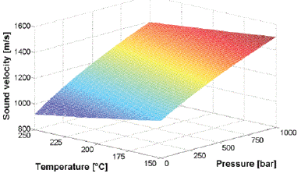
Figure 1. sound velocity based on pressure & temperature in PP [21]
Moreover, in 1964 McSkimin, proposed equations for longitudinal and shear waves, related to material density (⍴), wavelength ($λ)$, attenuation $(α)$, and velocity $\left(c\right)$of ultrasound signals as follows, where $V_{L}$ is longitudinal velocity and $V_{S}$ is the shear velocity [22]:
$$V_{S} =\frac{ρc^{2}\left[1-{\left(\frac{aλ}{2π}\right)}^{2}\right]}{{\left[1+{\left(\frac{aλ}{2π}\right)}^{2}\right]}^{2}}$$ | (5)
$$V_{L}=\frac{2ρc^{2}\left(\frac{aλ}{2π}\right)}{{\left[1+{\left(\frac{aλ}{2π}\right)}^{2}\right]}^{2}}$$ | (6)
Then in 1997, H.Wang et al. calculated the reflection $(R)$ and transmission $(T)$ coefficients of an ultrasound signal between the interface of two media by using values of acoustic impedance as [23]:
$$R=\frac{z_{1}-z_{2}}{z_{1}+z_{2}}$$ | (7)
$$T=1-R$$ | (8)
$z_{i}$ is the ultrasound impedance of the ith medium, which can be defined based on density $ρ_{i}$ and wave velocity $V_{i}$:
$$Z_{i}=⍴_{i}V_{i}$$ | (9)
These equations show the simple method for ultrasonic measurement in which the reflection coefficient indicates the ultrasonic wave reflected back through two media and transmission coefficient is the wave transmitted through the interface. In 2005, He et al. showed that the velocity of a longitudinal ultrasound wave in solid is related to Young’s modulus (E ) poison’s ratio $(σ)$, and material density (⍴) [17]:
$$V_{L}=\sqrt{\frac{E\left(1-σ\right)}{⍴\left(1+σ\right)\left(1-σ\right)}}$$ | (10)
They also calculated the attenuation of the ultrasound signal $(α)$ and its velocity (V) by the ratio of the amplitudes of two echoes through melt as shown in Fig.2(a), $X$ is the thickness of the polymer substrate, $A_{1}$ and $A_{2}$ are the amplitudes of the signals, $t_{1} and t_{2}$ are the corresponding transit times as shown in Fig.2(b).
$$V=\frac{2X}{t_{2}-t_{1}}$$ | (11)
$α=\frac{20\log_{10}{(}A_{1}/A_{2})}{2X}$ | (12)

b)
a)
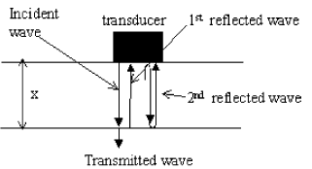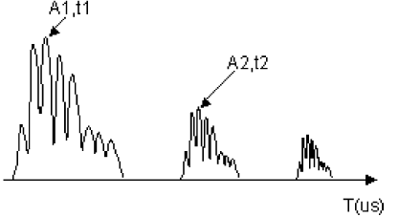
Figure 2. (a) Ultrasound echoes (b) Ultrasound propagation [17]
Hsu, in 1974, suggested that using ultrasound shear waves has some advantages for measuring stress in solids [24]. Zhang in 2019 used this theory and the equation derived by Sayers [25] to estimate the stress (𝜎) of the tie bar in the injection molding process based on the propagating speed of the ultrasonic wave [26]:
$$ρ_{0}.{V_{σ}}^{2}=λ+2μ+\frac{σ}{3λ+2μ}[2l+λ+(λ+μ)(4m+4λ+10μ)]$$ | (13)
Where $ρ_{0}$ is the density of the tie bar, and $V_{σ}$ is the ultrasound velocity when the tie-bar tolerates a stress of 𝜎. The remaining parameters are material constants in which µ and λ are the Lamé constants of the material and $l,m$, and $n$ are the Murnaghan constants of the material.
Therefore, polymer properties and other parameters relating to the injection molding process can be obtained from ultrasound waves. Table (1) gives a summary of the ultrasonic properties which can be obtained from equations (1) to (13), and the related parameters required for calculating each property.

Table 1. Summary of the Ultrasound properties
Equation number | Measured Ultrasonic Properties | Related Material Properties | Related Reference
(1) to (4) | Longitudinal Ultrasonic Velocity | - Bulk Moduli | [20-22]
 |  | - Density
 |  | - Pressure & Temperature
(5)-(6) | Velocity of Longitudinal & Shear Waves | - Density | [23]
 |  | - Wavelength
 |  | - Attenuation
 |  | - Ultrasonic Velocity
(7) to (9) | Reflection & Transmission Coefficient | - Number of mediums | [24]
- Acoustic Impedance
- Density
- Wave velocity
(10) | Longitudinal Ultrasonic Velocity in solid | - Young’s Modulus | [18]
 |  | - Poison’s Ratio
 |  | - Material Density
(11) | Ultrasonic Velocity of two echoes through melt | - Thickness of Sample | [18]
 |  | - Echo time
(12) | Ultrasonic attenuation of two echoes through melt | - Sample thickness | [18]
 |  | - Amplitude of signals
(13) | Ultrasonic Velocity in the tie bar of injection molding | - The stress of tie bar | [25-26]
 |  | - The density of tie bar
 |  | - Lamé and Murnaghan constants of the material

3. Conventional ultrasonic transducer (UT) applications in the injection moulding process
Application of conventional ultrasonic sensors in injection moulding has been investigated since 1997 [23] to monitor the gap formation between the cavity wall and the part. Here, UTs were installed on the mould and the core. The gap was monitored by the change in the ultrasonic reflection and transmission coefficients. The contact time between the cavity wall and polymer based on defined good-contact and partial-contact was also extracted by measuring the signal amplitude. The authors verified that the ultrasonic sensors had better performance for detecting gap development than conventional pressure sensors. Since a cavity pressure sensor can only detect the melt flow arrival by the surge in pressure, during gap formation the pressure drops to zero, so the pressure sensor is not capable of monitoring the development of the gap.
Brown et al. [27] modified an ultrasonic sensor with a buffer rod to make it suitable for mounting in the nozzle of an injection molding machine. Comparing the result with thermocouples and infrared sensors, it was concluded that the ultrasound sensors provide more information about the melt since they propagate through the melt in the cavity. For example, it was shown that the true melt temperature is higher than that measured by the infrared sensor. Michaeli et al. [28] also compared the performance of conventional pressure and temperature sensors to ultrasonic sensors. The molded part and the position of the sensors are shown in Figure 3.(a). Three different types of polymeric materials were investigated: amorphous (ABS, PPMA, PC), crystalline (PP, PA6), and fiber-reinforced crystalline (PA66GF30). In the first part of the experiment, the cooling time was calculated by a cooling equation from [29] for each material, and the holding pressure was selected such that the part detached from the ultrasonic probe location at the end of calculated cooling time. In the second part of the experiment, the influence of process parameters was investigated by varying the cavity wall temperature and injection speed at two levels and holding pressure at three levels. The first experiment illustrated that the ultrasonic signals could provide more information on solidification and part than pressure sensors, since the echoes can propagate through the melt and the time of part detachment from the wall can be accurately determined (Figure 3. (b)). Also, amorphous and crystalline materials could be distinguished by comparison of the ultrasonic amplitude during the different solidification processes for each material. The second experiment indicated that due to the change in the cavity wall temperature at two levels (by fixing other process parameters), as the temperature decreases, the ultrasonic velocity increases significantly. Secondly, the variation in injection speed did not affect the ultrasonic velocity and amplitude considerably. Finally, the variation in holding pressure is the only parameter that directly influences the time of part detachment from the mold wall while not affecting the ultrasonic velocity substantially.

b)
a)
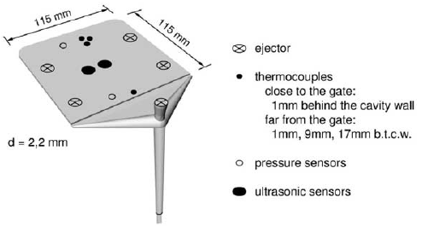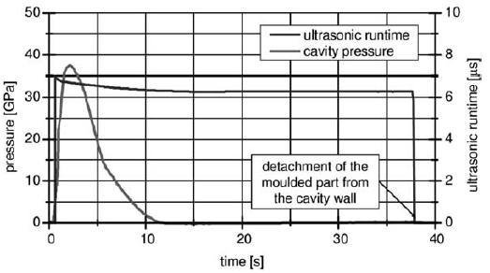
Figure 3. (a) Location of the thermocouples, pressure sensors, and ultrasonic sensors. (b) Comparison of Ultrasound echoes & pressure sensor [28]
He et al. [30] conducted a similar experiment to investigate the effect of injection pressure and temperature on the solidification of three types of polymer materials: crystalline (Linear low-density polyethylene LLDPE), non-crystalline (Polymethacrylate PMMA), and a polymer blend (Isotactic polypropylene/ethylene–octane copolymer iPP/POE). The ultrasonic study of dynamic-packing injection molding was also carried out. The stages of the injection molding process were monitored for different materials by studying ultrasound amplitude and attenuation. In static packing injection molding of PMMA a decline in ultrasonic attenuation and increase in the amplitude was observed after the packing stage. This was attributed to a gradual solidification of the polymer chains resulting in an increase in elasticity. Conversely, for LLDPE, an increase in attenuation and reduction in amplitude was observed, since crystallites start to form on cooling and as the number of crystallites increase the attenuation increases. The effect of mold temperature on solidification was also investigated. The results showed that at a lower mold temperature, and hence higher cooling rate, the faster formation of crystallites in LLDPE could be observed by the more rapid attenuation in ultrasonic velocity as. The phase morphology of the iPE and POE polymer blend was also observed by the ultrasonic attenuation. The dispersed phase particles enhance during solidification which means an increase in scattering loss and hence an increase in ultrasonic attenuation. During the dynamic packing process the fluctuation of cavity pressure is related to ultrasonic velocity and amplitude. An increase in solidification time could be observed in a slow rise in the ultrasonic velocity relative to the solidification phase in the static packing process. In the dynamic packing process melt is injected to the cavity repeatedly which induces more heat and hence prolongs the cooling and solidification.
The application of ultrasonic probes in monitoring the melting and conveying processes in the screw of the injection molding process has also been investigated. Praher et al. [21] proposed a fan-shaped ultrasonic transmitter and receiver array along the barrel for measuring the two-dimensional temperature in the screw antechamber, shown in Figure 5.(a). The temperature of each ring segment in Figure 5(a) has been calculated through numerical simulation by the fact that the transit time of ultrasound echoes in each ring segment is related to the temperature and pressure. For detection of unmelted granules at the screw, two ultrasonic probes, with buffers for tolerating high temperature, were inserted between the nozzle and the barrel (Figure 5. (b)), and the variation in the ultrasonic attenuation was correlated to the number of unmelted granules. The solid bed and melt bed ratio can also be observed from ultrasonic reflection signals; the continuous signal from the experiment clarified the absence of the solid bed.
Real time monitoring of the melting behaviour in the barrel of an injection molding machine was also investigated by Altman et al. [31]. First they proposed a numerical simulation of the melting process of a polyamide 6 (PA6) material based on melting model of Tadmor and Gogos to model the solid/melt bed ratio in the barrel [32]. The solid bed and melt pool were monitored in process with three ultrasonic probes and seven pressure sensors along the barrel. Comparison of the results from the sensors and simulation, indicated good agreement between the experimental data and the simulation.
Ultrasonic probes have also been used for measuring the cavity pressure in tie bar injection molding [26]. For this purpose, ultrasonic probes were glued to the four tie bars of the injection molding machine and the measured ultrasonic velocity was used to calculate the stress in the tie bars using equation (13). The cavity pressure was derived from the stress in the tie bar by the fact that the melt pressure and clamping force is transferred to the tie bars by the mold and platen of the machine. Comparison with a Kistler cavity pressure sensor indicated a measurement error of 4.3%.

b)
a)
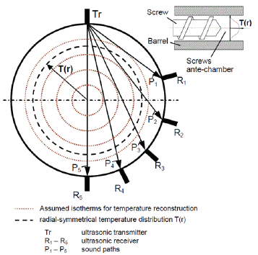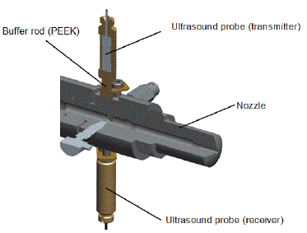
Figure 5. (a) fan-shaped array of the ultrasonic probe (b) Ultrasonic probes between the nozzle and the barrel [21]
Layer thickness in a water-assisted co-injection molding process has also been investigated by ultrasound sensors. They proposed a model for the ultrasound propagation in layered polymer from a co-injection process. By this model they calculated the amplitude of ultrasound signal from the ith interface by defining a transfer function for the medium which can be obtained for each layer. Then, the measured reflected signal from the probe has been compared by two objective functions, with the calculated ultrasonic signal by the defined medium transfer function. By solving the objective function, the optimum thickness will be obtained [33].
Recent work has also indicated the potential application of ultrasonic signals in a microcellular injection molding process [34] which is a process for producing foam plastics. The ultrasonic probe was positioned on the outside surface of the mold and the ultrasonic signals were used for characterization of cell size, surface roughness, and nucleation rate of this non-conventional injection molding process.
In this section, the application of conventional ultrasound probes in the injection molding process is reviewed and comparing this type of sensor is compared to pressure sensors, temperature sensors, and infrared sensors. The process and material parameters which can be monitored by this sensor are summarized in Table (2), showing useful information that can be deduced from ultrasonic probes in different locations in the injection molding machines.

4. High-Temperature Ultrasonic transducers (HTUT) by Sol-Gel technique
Sol-gel is a fabrication method for producing thick or thin films. The films are formed from mixed solutions in a suitable solvent, then a hydrolysis reaction is used to produce a gel. Additives are employed to control the viscosity and surface tension. The gel can be coated on a desired substrate by different methods such as spinning, dip coating, and spray coating. Thermal treatment is also required to develop the structure [35].
The conventional sol-gel method can be used for the fabrication of thin-films up to 0.5µm in a single layer, however it is not possible to produce a thicker film without any cracks. In 1997 Barrow et al. [36] invented a method for the fabrication of a crack-free thick film (thicker than 10µm). The proposed method was to disperse a ceramic powder into the sol-gel solution. Prior to this, ceramic coating was only possible by thermal or plasma spraying and physical vapour deposition [37–39], which are only applicable on flat structures and in the case of plasma spraying further post-deposition is required since the produced films are porous. Barrow’s invention was an important step forward in achieving a more economical and versatile method for ceramic coating without cracks.
The fabrication of an ultrasonic sensor with the sol-gel technique can be divided into the following stages:
- The solution should be prepared, and the desired ceramic powder should be added to the solution and dispersed by a stirrer.
- The film should be deposited on the desired substrate by a coating process, and thermal treatment should be also applied.
- Repeated coating layers should be applied to reach the desired thickness,
- The film's stability and characterization should be investigated and the top electrode for electrical connection should be put.
- The film should be electrically poled with methods like DC Corona poling, high temperature corona poling, DC power.
Fabrication of ultrasonic transducers by sol-gel method has a number of advantages over conventional ultrasonic probes; they are miniature; they can be used on curved and flat shapes; they have higher sensitivity, higher energy densities [40], a high signal- to- noise ratio (SNR) and a high thermal tolerance. Another advantage of this sensor is that no couplant is required, in order to the strong bonds and oxidation layer, which create between the surface of the ceramic powders, the substrate and the sol-gel films, make the film crack-free with good acoustic coupling [35, 41].
This technique can be applied in high temperature and curved areas of the injection molding process such as the wall of the injection screw barrel, which is highly desirable since obtaining the exact melt temperature can help prevent polymer degradation and incomplete filling in this process. In this section, the application of these sensors in the injection molding process will be reviewed. Then, potential materials for fabrication of a sol-gel ultrasonic sensor will be introduced.
4.1 Application of sol-gel ultrasound sensors in the injection molding process
As mentioned in the previous section, the benefits of using these sensors in the injection molding process is that they are miniature, tolerate high temperature, can be applied on curved shapes, and can thus be applied in areas of the machine such as barrel where conventional probes are difficult to fit.
The first use of ultrasonic transducers in the injection molding process was in a micromoulding machine for creating parts with micrometer dimensions by Kobayashi et al. [42]. They fabricated seven ultrasonic transducers on the barrel, six sensors were located on the feeding and heating zones, and they also placed a sensor between them (Figure 6. (a)). Two sensors were also fabricated on the mold insert of the machine, as shown in Figure 6. (b). They successfully measured the ultrasonic signals at the barrel and the velocity of the polymer melt in the cavity during solidification for the Polyethylene molded part.
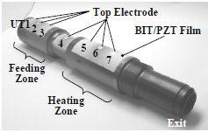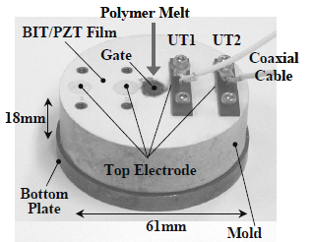
b)
a)
Figure 6. (a) Fabricated ultrasound sensors by sol-gel technique on the barrel and (b) mold insert of micromoulding[42]
In 2005 Whiteside et al. [43] conducted a similar experiment by fabricating sensors on the barrel and in a mold insert to monitor polymer degradation and filling incompleteness in the same process by monitoring the variation of ultrasonic amplitude and velocity over the process time. The in-process degradation of POM (polyoxymethylene) was deliberately induced by setting the melt temperature higher than recommended. The ultrasonic speed in the mold insert and the barrel was monitored during the process. The ultrasonic velocity measured in the mold insert increased suddenly after 6 minutes, which was correlated to the gradual increase in part thickness due to the degradation of the polymer.
Ono et al. [44] also investigated this type of sensor's performance for a simple POM (polyoxymethylene) rectangular part in a micromoulding process. They used seven sensors fabricated by a sol-gel technique on the barrel and two sensors on the mold insert of mobile mold. Figure 7.(a) shows the sensors fabricated on the injection molding machine. The nth round trip longitudinal ultrasonic wave echoes reflected from the cavity surface were called $L^{nm}$, and the ones propagating in the polymer and reflected immobile insert called $L^{2nm}$. Figure 7. (b) shows the ultrasound velocity versus process time for the first ultrasound transducer at the mold insert and the amplitude variation of the first reflected echo from the mold insert ($L^{1m}$). In less than half a second, the polymer arrived in the cavity, and a part of the ultrasound signal propagates through the polymer and reaches the immobile mold. The solidification of the part could be monitored by an increase in ultrasound velocity up to 1500 m/s during the cooling stage. After solidification, the amplitude $L^{1m}$gradually rises, showing the part detaching from the mould wall because of shrinkage. Finally, a reduction in velocity suggested shrinkage since an air gap developed between the cavity and the part.
a)
b)
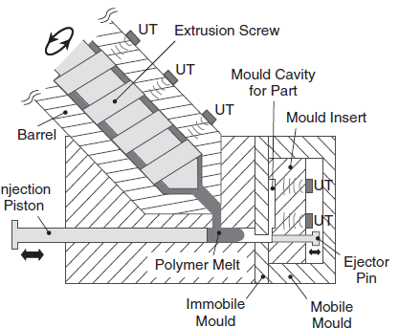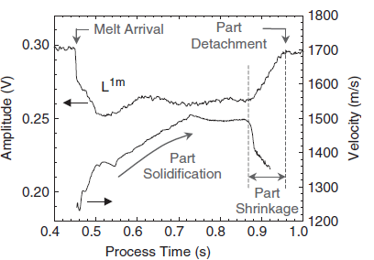
Figure 7. (a) Fabricated sensors on the barrel and mold inset of injection molding (b) the velocity and amplitude graph of ultrasonic sensor vs. Process time [44]
In 2006, Kobayashi used ultrasound transducers fabricated by a sol-gel technique for the first time in a conventional (not micromoulding) injection molding process [45]. He used Bismuth Titanate/Lead Zirconate Titanate (BIT/PZT) film and embedded four sensors in a mold insert of an injection molding machine. The sensors successfully monitored the flow front arrival, the velocity of the flow front, the mold opening time, detachment of the part from the mold walls, and various stages of injection molding by variation in the amplitude of the reflected signal from the HTUT.
Zhao et al. [46] fabricated a novel high-temperature ultrasonic transducer called the sensor$L-S_{⊥}-S_{∥}$ probe, capable of measuring longitudinal and shear waves simultaneously. They inserted two ultrasound probes measuring only longitudinal waves (‘L’ probes) and two $L-S_{⊥}-S_{∥}$ probes in the mold insert of an injection molding machine producing a rectangular High-density Polyethylene (HDPE) molded part. The ultrasonic shear wave velocity for vertical $(V_{V})$ and horizontal ${(V}_{H})$ flow directions based on the shear stiffness $(G_{xy} and G_{zy})$ and material density (⍴) can be expressed as:
$$V_{H}=\sqrt{{G_{xy}}/⍴}$$ | (14)
$$V_{V}=\sqrt{{G_{zy}}/⍴}$$ | (15)
The experiment was conducted over different injection moulding conditions. Besides the observation of different stages of injection molding, the other experimental findings can be summarized as follows:
- The longitudinal velocity increases under higher temperature and higher injection speed, because of the change of HDPE morphology with different process setting.
- A considerable difference in echo time was associated with a higher storage modulus since the slow velocity along the flow directions indicates weak mechanical properties and high velocity along the flow direction indicates strong mechanical properties based on the equations (14) and (15).
- Next, as the injection speed increased, the longitudinal and shear ultrasonic velocities differed significantly.
- Finally, since the crystalline lamellas of HDPE are parallel and grow in a direction vertical to the melt flow (seen by Scanning Electron Microscopy), the storage modulus along the axis vertical to the melt flow is higher than in the parallel direction.
The high-temperature and non-destructive features of HTUTs facilitated their application in evaluating the process at the nozzle of the injection molding process which is not feasible with conventional ultrasonic sensor because of the limited space, high pressure, and temperature. Wu et al. [47] fabricated a pair of HTUT sol gel films in the nozzle side of an injection molding process to monitor the dynamic characteristics of the nozzle, including the dynamic flow speed and the static density of the polymer melt in real-time.
In 2017 [48], they modified the extension nozzle of an injection molding machine to a T-shaped nozzle which provides a space for installing sensors. Figure 8 indicates the designed extension nozzle with the ultrasonic transducer and the signal echoes for the polypropylene (PP) molded part. They used the sol-gel spray technique to fabricate an ultrasonic film at the nozzle, capable of tolerating temperatures up to 350 °C and pressure up to 300 bar.
b)
a)
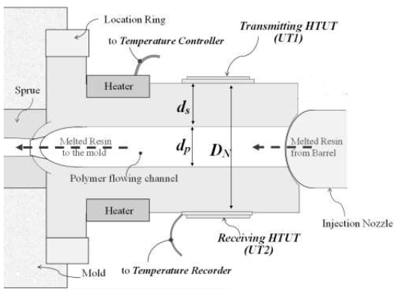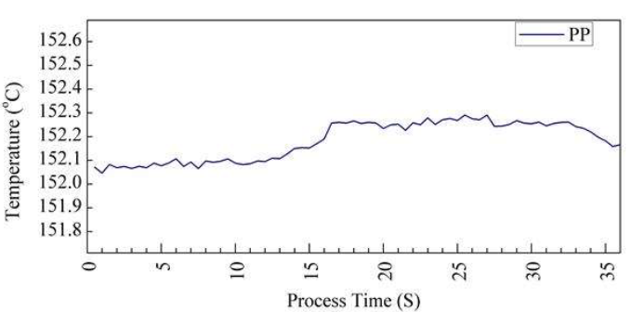
Figure 8. (a) cross-section of the nozzle with the probes (b) the measured temperature for PP by a thermocouple [48]
They investigated the ultrasound echoes reflected and transmitted through the extension nozzle, molten polymer, and air interface. A thermocouple was also installed at the surface of the extension nozzle for comparison. The result showed that the thermocouple lacked sufficient sensitivity for effective monitoring of the process. As shown in Figure 8.(b), where the setting temperatures for polypropylene at the extension nozzle was about 225 °C, the thermocouple measured a temperature around 152 °C. In contrast the ultrasonic sensors at the nozzle were capable of monitoring different stages of injection molding (Figure 9) including the mold close time, injection, packing, solidification and ejection stages, screw movements and the mold open time by the variation of velocity and amplitude in regard to process time of the ultrasonic signal.
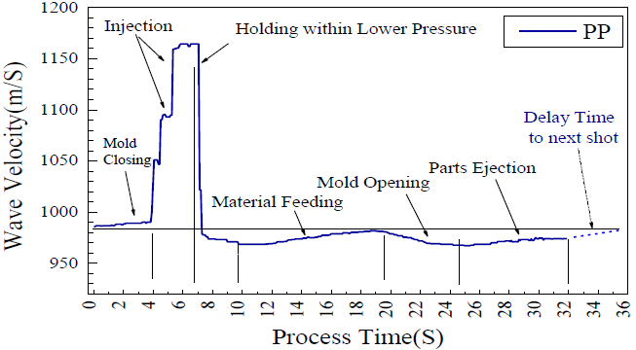
Figure 9. Velocity of ultrasonic signal during injection molding process [48]
Recently, in 2020 Cheng et al. [49] further developed the research on the application of a T-shaped extension nozzle by investigating the effect of material type and various process setting on the part quality. Two HTUTs were fabricated on the extension nozzle and different injection speeds and heating temperatures were investigated for Polypropylene (PP) and ABS. Figure 10.(a) shows the experimental set-up for measuring the ultrasound velocity. Figure 10.(b) shows the ultrasound velocity versus process time plot for the ABS material with different injection speeds, ABS #1 injection speed is 45/65 m/s, and ABS #2 is 45/85 m/s. At the injection stage from 1.1 to 2.3 s, the two types of ABS exhibit the same ultrasound velocity because of the high viscosity of ABS. In the packing stage from 2.3 to 3.2 s, the ultrasonic velocity increased significantly. The ultrasound velocity decreased at 3.2s due to the retraction of the screw. Finally, from 3.3 s to 12.5s, a low ultrasonic velocity can be observed during the feeding stage for both ABS #1 and ABS #2.

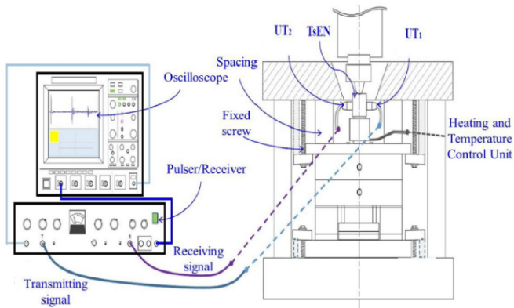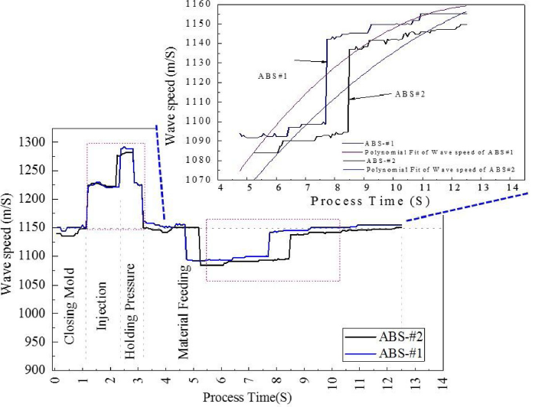
b)
a)
Figure 10. (a) the T-shaped extension nozzle and data acquisition system for ultrasound sensor (b) ultrasonic velocity vs. process time for ABS #1 and ABS #2 with different injection speed [49]
A polynomial fit was applied to the ultrasound velocity against time for both types of ABS in the feeding stage and is illustrated in Figure10. (b) to underscore the variation of velocity for ABS #1 and ABS #2. The same experiment for PP showed that the ultrasonic velocity in ABS was higher than in PP because of different compressibility and density, and secondly the variation in ultrasonic velocity over the process at different injection speeds in the feeding stage was higher in PP than that in the ABS. A tensile test was also applied to investigate the relationship between the process parameters, ultrasound signal, and the part quality in the feeding stage. The tensile test result showed that for PP, a ductile material, the components produced at higher injection speed did not break as they did for the components produced at the lower injection speed. However, for the ABS, a brittle material, the components produced at greater injection speed had a higher deflection distance (Figure 11). Also, the variation of pull strength as the injection speed changed was greater for ABS than for PP, which correlated to tensile differences in the ultrasound signals at the feeding stage for ABS and PP. The results suggest that the changes in ultrasonic velocity observed at different injection speeds are a good indicator of the resulting tensile properties of the components.
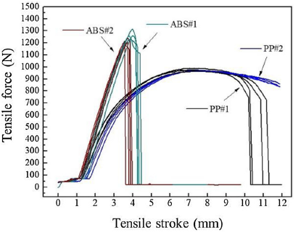
Figure 11. Tensile test for the PP and ABS molded parts with different injection speed [49]
Table 2. Deduced information from different types of Ultrasonic probes in different locations of the Injection molding
Sensor’s type | Sensor Location | Extracted information from the IM | Related References
Conventional Ultrasonic Probe | Mold | - Gap formation | [23]
 |  | - Contact time | [23]
 |  | - Different stages | [23,28,30]
 |  | - Part detachment | [28]
 |  | - Dynamic packing | [28]
 |  | - Detection of crystalline & amorphous | [28]
 |  | 7. Phase morphology of polymer blend | [28]
 | Barrel | - Melting behaviour | [31]
 | Nozzle | - Different stages of IM | [27]
 | Screw | - Unmelted granules | [21]
 |  | - The solid & bed melt ratio | [21]
 | Tie bar | - Cavity Pressure | [26]
Sol-Gel Ultrasound Sensors | Barrel  &  Mold-insert | - Velocity of polymer melt during solidification | [42]
 |  | - Different stages of IM | [42,44–46]
 |  | - Polymer degradation | [43]
 |  | - Incomplete filling | [43]
 |  | - shrinkage | [44]
 |  | - Part detachment | [44]
 |  | - Velocity of flow front | [45]
 |  | - Mold opening & closing time | [45]
 |  | - Effects of different process setting on morphology | [46]
 |  | - Storage modulus | [46]
 | Nozzle | - Screw movements | [48]
 |  | - Different stages of IM | [48,49]
 |  | - Static density | [47]
 |  | - Flow speed | [47]
 |  | - Effect of feeding stage on part quality | [49]

4.2 Materials overview for the fabrication of ultrasonic sensors by sol-gel technique
The potential of sol-gel US sensors for IM process monitoring is clearly good due to both the richness of material and process information that can be extrapolated from the variation in US signal properties and also due to the non-invasive nature of the sensors and the flexibility to apply as a coating in almost any part of the IM machine and tool. However, a drawback of the sol gel sensors developed to date is the toxicity and environmentally harmful nature of the materials used. One of most commonly used materials is lead zirconate titanate (PZT), because of its excellent piezoelectric constant $\left(d_{33}\right)$ 233 $⍴C/N$ and a considerable relative dielectric constant, about 1180 [40]. Finding a replacement lead-free material has been of recent interest in the literature. The material should contain specific characteristics including high curie temperature to be applicable in high temperature, high dielectric constant, and piezoelectrical effect to be sensitive as an ultrasonic sensor [50]. In this section the lead-based materials and their performance as ultrasonic sensors is outlined, and then potential lead-free alternatives are discussed.
One of the common lead-based composites used in ultrasonic sensors is PZT/PZT which has a wide range of center frequency from 17 to 160 MHz and a - 6dB bandwidth ranging from 14 to 37.5 MHz. PZT/PZT has been fabricated on various substrates including steel and aluminum [51–53]. BiT (Bismuth Titanate) has a high curie temperature of 675°C and has been applied in a BiT/ PZT composite. BiT/PZT film fabricated on a steel substrate exhibited a signal to noise ratio of 31dB, and a center frequency of 8 MHz to 13MHz [45,54]. CaBiT (Calcium-Bismuth-Titanate) ceramic also has a high curie temperature of 788°C and has also been combined with PZT in fabrication of ultrasound sensors. A 50µm film composite of CaBiT/PZT was fabricated on titanium substrate as an ultrasonic transducer with center frequency of 6.3 MHz [55].
Another lead-based sol-gel composite is PMN/PT (Lead Magnesium Niobium-lead titanate), fabricated as a free-standing film with 30 µm thickness and 80MHz centre frequency [56]. A PT/BT film composite (Lead Titanate /Barium Titanate) with a temperature durability of 300°C was fabricated as an ultrasonic sensor on a titanium substrate with 60µm thickness and a centre frequency of 32MHz [57]. The lead-based composite materials used in ultrasonic sensors and their performance are summarized in Table (3).
Lead-free sol-gel composites have been developed in an effort to produce more environmentally friendly sensors. Two lead-free materials are the KNN (Potassium-Sodium-Niobate), which has a high curie temperature of 358°C, and BNT (Bismuth Sodium Titanate) with high ferroelectrical and polarization properties. The combination of these two lead-free ceramics has been studied by Lau et al. for ultrasonic sensor fabrication [58]. They fabricated a KNN/BNT sensor of 5µm thickness on a platinum-buffered-Si substrate. This showed good performance as an ultrasonic transducer with 193 MHz center frequency and -6 dB bandwidth of 34%. Ho Lam et al. [59] developed a KNN/BNT sensor with a higher center frequency of 170 to 320 MHz, and a -6 dB bandwidth of 34% to 64%. The application of BNT alone as an ultrasonic transducer has also been studied [60]; an 11µm thickness BNT sensor exhibited suitable dielectric and ferroelectric properties and a frequency-bandwidth of 98 MHz.
Three other promising and lead-free materials are CaBiT (Calcium-Bismuth-Titanate) and BiT (Bismuth-Titanate) with high curie temperature of 788°C and 675°C, respectively and BST (Barium-Strontium-Titanate) with a very high dielectric constant. A BiT/BiT fabricated sensor indicated high thermal durability up to 600°C, but has a low relative dielectric constant of about 180 [61]. The performance of CBiT/BST and CBiT/BiT ceramic composites as ultrasonic sensors was investigated in [55]. The results showed that CBiT/BST exhibited high dielectric properties although the film quality was poor due to high surface roughness. CBiT/BiT exhibited good sensitivity as a sensor although the poling is challenging due to the low dielectric constant of BiT.
TiO₂ with a high dielectric constant has been used to boost the application of BiT as an ultrasonic transducer, and the performance of fabricated $BiT/TiO_{2}$ on a titanium substrate has been evaluated [62]. The result indicated a temperature durability of about 450°C and a signal to noise ratio of 20dB. Another sol-gel material applied with BiT to enhance the properties for application as an ultrasonic transducer is ST (Strontium-Titanate),because of its reasonable dielectric constant and being paraelectric [63]. A 100 µm BiT/ST film presented high-temperature durability of 500°C and reasonable ultrasonic performance.
LN (Lithium niobate (LiNbO₃)) has also been evaluated as a potential material in a LN/BiT composite, due to its considerable curie temperature (1200 °C)[64]. A high operating temperature of 600°C was shown and comparing the performance to BiT/BiT, the Ln/BiT performed better either as high-temperature sensor or ultrasonic sensor.
Lead-free materials investigated for ultrasonic performance are summarized in Table (3). These materials are promising for fabrication of sensors suitable for the injection molding process, however to date most sensors developed for this application are lead-based such as PZT/PZT or BiT/PZT.
Table 3. Lead-free and Lead based sol-gel composites and the ultrasonic properties
Sol-gel composite material | Center frequency  (MHz) | Temperature-durability  (°C) | -6dB Bandwidth  (%-MHz) | Film Thickness  (µm) | Composite Type | Reference
PZT/PZT | 17-160 | 380 | 16%-52% | 11-25 | Lead-based | [51–53]
BiT/PZT | 8-13 | 600 | 6-8 MHz | - | Lead-based | [45,54]
CaBiT/PZT | 6.3 | 600 | - | 50 | Lead-based | [55]
PMN/PT | 82 | - | 65% | 30 | Lead-based | [56]
PT/BT | 32 | 300 | 18 MHz | 60 | Lead-based | [57]
KNN/BNT | 170- 320 | 320 | 34%- 64% | 6 | Lead-free | [52,53]
BNT | 98 | 320 | 84% | 11 | Lead-free | [54]
BiT/BiT | - | 600 | - | 50 | Lead-free | [55]
CBiT/BiT | 6.5 | 600 | - | 50 | Lead-free | [49]
CBiT/BST | 24.9 | 600 | - | 50 | Lead-free | [49]
BiT/TiO2 | 10.9 | 450 | 4.1% | 100 | Lead-free | [56]
BiT/ST | - | 500 | - | 100 | Lead-free | [57]
LN/BiT | - | 700 | - | 50 | Lead-free | [58]

5. CONCLUSION
This review investigates different types of ultrasonic sensors and their applications in the injection molding process. The advantages of ultrasonic sensors over conventional temperature and pressure sensors are elaborated. For example, pressure sensors cannot monitor parameters related to the cooling stage, despite this stage being the most crucial in relation to the quality of the product, since the pressure declines to the zero during cooling. Temperature sensors like thermocouples are not exact in measurement since they just measure the surface temperature, not the bulk temperature of the melt. Further, ultrasonic sensors have been shown to be sensitive to other physical properties of the material including the degree of the crystallinity in the polymer and the shear and tensile properties of the material.
Conventional ultrasonic probes can monitor various process parameters in real-time (See Table (2)), while they have some limitations including being unsuitable for high-temperature areas, requiring modifications in the machine tools, and operating in a limited frequency range. Hence, the ultrasonic sensors fabricated by sol-gel technique emerged to compensate for the limitations of conventional ones. Different piezoelectric materials (See table (3)) can be employed for the fabrication of these sensors; the more recent exploration of lead-free materials is desired due to the toxicity and environmental damage associated with lead-based materials.
Although currently the application of ultrasonic sensors in the injection molding has achieved considerable progress, further studies are needed to meet the demands for zero defect injection molded parts.
First, different parameters like pressure and temperature can be deduced from ultrasonic sensors indirectly. While the ultrasound signals are very sensitive to variation in the parameters it is difficult to measure the exact value from the ultrasonic properties. Extension of research for developing smart calibration techniques to extract these parameters more conveniently is essential. Second, the fabricated ultrasonic sensors are not commercially available, and further study is required to make them consistent, reliable and practical to use in industry. Finally, the potential of using this sensor in advanced injection molding processes such as microcellular injection molding, which has several advantages over conventional injection molding for producing more economical lightweight parts with higher mechanical properties, needs further investigation.

REFERENCES

1. Kazmer, D.O. Injection Mold Design Engineering. In Injection Mold Design Engineering; Carl Hanser Verlag GmbH &amp; Co. KG: München, 2007; pp. I–XX ISBN 9781569905708.
2. Rosato, D.V., Rosato, M.G. Injection Molding Handbook; Rosato, D. V., Rosato, D. V., Rosato, M.G., Eds.; Springer US: Boston, MA, 2000; ISBN 978-1-4613-7077-2.
3. Pacher, G.A.; Berger, G.R.; Friesenbichler, W.; Gruber, D.P.; Macher, J. In-mold sensor concept to calculate process-specific rheological properties. AIP Conf. Proc. 2014, 1593, 179–182, doi:10.1063/1.4873759.
4. Ono, Y.; Whiteside, B.R.; Brown, E.C.; Kobayashi, M.; Cheng, C.; Jen, C.; Coates, P.D. Real-time process monitoring of micromoulding using integrated ultrasonic sensors. 2007, 5, 383–401.
5. Edwards, R.; Thomas, C. On-line measurement of polymer orientation using ultrasonic technology. Polym. Eng. Sci. 2001, 41, 1644–1653, doi:10.1002/pen.10862.
6. Praher, B.; Straka, K.; Steinbichler, G. An ultrasound-based system for temperature distribution measurements in injection moulding: System design, simulations and off-line test measurements in water. Meas. Sci. Technol. 2013, 24, doi:10.1088/0957-0233/24/8/084004.
7. Fan, Z.; Gao, R.X.; Kazmer, D.O. Self-energized acoustic wireless sensor for pressure-temperature measurement in injection molding cavity. Proc. IEEE Sensors 2009, 65–68, doi:10.1109/ICSENS.2009.5398527.
8. Ageyeva, T.; Horváth, S.; Kovács, J.G. In-mold sensors for injection molding: On theway to industry 4.0. Sensors (Switzerland) 2019, 19, doi:10.3390/s19163551.
9. Zhang, G.; Jiang, L.; Shen, K.; Guan, Q. The self-reinforcement of low density polyethylene by oscillating packing injection molding under low pressure. J. Appl. Polym. Sci. 1999, 71, 799–804, doi:10.1002/(SICI)1097-4628.
10. Zhang, Q.; Wang, Y.; Fu, Q. Shear-induced change of exfoliation and orientation in polypropylene/montmorillonite nanocomposites. J. Polym. Sci. Part B Polym. Phys. 2002, 41, 1–10, doi:10.1002/polb.10350.
11. Na, B.; Zhang, Q.; Wang, Y.; Fu, Q. Orientation effects on the deformation and fracture properties of high-density polyethylene/ethylene vinyl acetate (HDPE/EVA) blends. Polym. Int. 2004, 53, 1078–1086, doi:10.1002/pi.1495.
12. Ozcelik, B.; Erzurumlu, T. Comparison of the warpage optimization in the plastic injection molding using ANOVA, neural network model and genetic algorithm. J. Mater. Process. Technol. 2006, 171, 437–445, doi:10.1016/j.jmatprotec.2005.04.120.
13. Jin, K.; Jeong, T.; Kim, T.; Kim, N.; Kim, B. Analysis and design for reducing residual stress and distortion after ejection of injection molded part with metal-insert. Int. J. Precis. Eng. Manuf. 2014, 15, 2533–2542, doi:10.1007/s12541-014-0624-2.
14. Hentati, F.; Hadriche, I.; Masmoudi, N.; Bradai, C. Optimization of the injection molding process for the PC/ABS parts by integrating Taguchi approach and CAE simulation. Int. J. Adv. Manuf. Technol. 2019, 104, 4353–4363, doi:10.1007/s00170-019-04283-z.
15. Oliaei, E.; Heidari, B.S.; Davachi, S.M.; Bahrami, M.; Davoodi, S.; Hejazi, I.; Seyfi, J. Warpage and Shrinkage Optimization of Injection-Molded Plastic Spoon Parts for Biodegradable Polymers Using Taguchi, ANOVA and Artificial Neural Network Methods. J. Mater. Sci. Technol. 2016, 32, 710–720, doi:10.1016/j.jmst.2016.05.010.
16. Wang, J.; Mao, Q. Methodology Based on the PVT Behavior of Polymer for Injection Molding. Adv. Polym. Technol. 2012, 32, 474–485, doi:10.1002/adv.
17. He, B.; Yang, Y.; Zou, H.; Zhang, Q.; Fu, Q. Fast determination of phase inversion in polymer blends using ultrasonic technique. Polymer (Guildf). 2005, 46, 7624–7631, doi:10.1016/j.polymer.2005.06.012.
18. Lionetto, F.; Maffezzoli, A. Polymer characterization by ultrasonic wave propagation. Adv. Polym. Technol. 2009, 27, 63–73, doi:10.1002/adv.20124.
19. THURSTON, R.N. Wave Propagation in Fluids and Normal Solids. In Physical Acoustics; 1964; pp. 1–110.
20. Oakley, B.A.; Barber, G.; Worden, T.; Hanna, D. Ultrasonic Parameters as a Function of Absolute Hydrostatic Pressure. I. A Review of the Data for Organic Liquids. J. Phys. Chem. Ref. Data 2003, 32, 1501–1534, doi:10.1063/1.1555588.
21. Praher, B.; Straka, K.; Usanovic, J.; Steinbichler, G. Ultrasound based monitoring of the injection moulding process - Methods, applications and limitations. AIP Conf. Proc. 2014, 1593, 159–162, doi:10.1063/1.4873755.
22. McSKIMIN, H.J. Ultrasonic Methods for Measuring the Mechanical Properties of Liquids and Solids. In Physical Acoustics; Elsevier, 1964; pp. 271–334.
23. Wang, H.; Cao, B.; Jen, C.K.; Nguyen, K.T.; Viens, M. On-line ultrasonic monitoring of the injection molding process. Polym. Eng. Sci. 1997, 37, 363–376, doi:10.1002/pen.11679.
24. Hsu, N.N. Acoustical birefringence and the use of ultrasonic waves for experimental stress analysis. Exp. Mech. 1974, 14, 169–176, doi:10.1007/BF02323061.
25. Sayers, C.M. Ultrasonic velocities in anisotropic polycrystalline aggregates. J. Phys. D. Appl. Phys. 1982, 15, 2157–2167, doi:10.1088/0022-3727/15/11/011.
26. Zhang, J.; Zhao, P.; Zhao, Y.; Huang, J.; Xia, N.; Fu, J. On-line measurement of cavity pressure during injection molding via ultrasonic investigation of tie bar. Sensors Actuators A Phys. 2019, 285, 118–126, doi:10.1016/j.sna.2018.11.009.
27. Brown, E.C.; Dawson, A.J.; Coates, P.D. Ultrasonic monitoring of nozzle and cavity during injection moulding. J. Reinf. Plast. Compos. 2002, 21, 441–450, doi:10.1177/0731684402021005444.
28. Michaeli, W.; Starke, C. Ultrasonic investigations of the thermoplastics injection moulding process. Polym. Test. 2005, 24, 205–209, doi:10.1016/j.polymertesting.2004.08.009.
29. Goerg Menges Werkstoffkunde Kunststoffe; Carl Hanser Verlag: Mu¨nchen, Wien, 1990;
30. He, B.; Zhang, X.; Zhang, Q.; Fu, Q. Real-time ultrasonic monitoring of the injection-molding process. J. Appl. Polym. Sci. 2008, 107, 94–101, doi:10.1002/app.27000.
31. Altmann, D.; Praher, B.; Steinbichler, G. Simulation of the melting behavior in an injection molding plasticizing unit as measured by pressure and ultrasound measurement technology. AIP Conf. Proc. 2019, 2055, doi:10.1063/1.5084818.
32. Tadmor, Z.; Gogos, C.G. Principles of polymer processing. Choice Rev. Online 2007, 44, 44-2729-44–2729, doi:10.5860/choice.44-2729.
33. Xia, N.; Zhao, P.; Kuang, T.; Zhao, Y.; Zhang, J.; Fu, J. Nondestructive measurement of layer thickness in water-assisted coinjection-molded product by ultrasonic technology. J. Appl. Polym. Sci. 2018, 135, 2–9, doi:10.1002/app.46540.
34. Zhao, P.; Zhao, Y.; Kharbas, H.; Zhang, J.; Wu, T.; Yang, W.; Fu, J.; Turng, L.S. In-situ ultrasonic characterization of microcellular injection molding. J. Mater. Process. Technol. 2019, 270, 254–264, doi:10.1016/j.jmatprotec.2019.03.012.
35. Barrow, D.A.; Petroff, T.E.; Sayer, M. Thick ceramic coatings using a sol gel based ceramic-ceramic 0–3 composite. Surf. Coatings Technol. 1995, 76–77, 113–118, doi:10.1016/0257-8972(95)02562-6.
36. Barrow, D. A., Petroff, T. E., & Sayer, M. Method For Producing Thick Ceramic Films By a Sol Gel Coating Process. U.S. Pat. 5,585,136 1997.
37. Boulos, M.I. RF induction plasma spraying: State-of-the-art review. J. Therm. Spray Technol. 1992, 1, 33–40, doi:10.1007/BF02657015.
38. Pierlot, C.; Pawlowski, L.; Bigan, M.; Chagnon, P. Design of experiments in thermal spraying: A review. Surf. Coatings Technol. 2008, 202, 4483–4490, doi:10.1016/j.surfcoat.2008.04.031.
39. Reichelt, K.; Jiang, X. The preparation of thin films by physical vapour deposition methods. Thin Solid Films 1990, 191, 91–126, doi:10.1016/0040-6090(90)90277-K.
40. Shilpa, G.D.; Sreelakshmi, K.; Ananthaprasad, M.G. PZT thin film deposition techniques, properties and its application in ultrasonic MEMS sensors: A review. IOP Conf. Ser. Mater. Sci. Eng. 2016, 149, 0–8, doi:10.1088/1757-899X/149/1/012190.
41. Hara, T.; Furukawa, M.; Nozawa, S.; Nakatsuma, K.; Kobayashi, M. Polarity effect of corona discharge poling for sol-gel composite-based ultrasonic transducers. Jpn. J. Appl. Phys. 2020, 59, doi:10.35848/1347-4065/ab87f1.
42. Kobayashi, M.; Jen, C.-K.; Corbeil, C.; Ono, Y.; Hebert, H.; Derdouri, A. High temperature ultrasonic transducers for monitoring of micro-molding. In Proceedings of the IEEE Symposium on Ultrasonics, 2003; IEEE, 2003; Vol. 2, pp. 693–698.
43. Whiteside, B.R.; Brown, E.C.; Ono, Y.; Jen, C.K.; Coates, P.D. Real-time ultrasonic diagnosis of polymer degradation and filling incompleteness in micromoulding. Plast. Rubber Compos. 2005, 34, 387–392, doi:10.1179/174328905X71977.
44. Ono, Y.; Whiteside, B.R.; Brown, E.C.; Kobayashi, M.; Cheng, C.C.; Jen, C.K.; Coates, P.D. Real-time process monitoring of micromoulding using integrated ultrasonic sensors. Trans. Inst. Meas. Control 2007, 29, 383–401, doi:10.1177/0142331207080153.
45. Kobayashi, M.; Ono, Y.; Jen, C.K.; Cheng, C.C. High-temperature piezoelectric film ultrasonic transducers by a sol-gel spray technique and their application to process monitoring of polymer injection molding. IEEE Sens. J. 2006, 6, 55–62, doi:10.1109/JSEN.2005.856119.
46. Zhao, L.; Lai, Y.; Pei, C.; Jen, C.-K.; Wu, K.-D. Real-time diagnosing polymer processing in injection molding using ultrasound. J. Appl. Polym. Sci. 2012, 126, 2059–2066, doi:10.1002/app.36868.
47. Wu, Y.L.; Yang, C.H.; Cheng, C.C.; Kobayashi, M. Novel real-time diagnostic of injection molding process at nozzle by high-temperature ultrasonic transducer. 2015 IEEE Int. Ultrason. Symp. IUS 2015 2015, 2, 3–5, doi:10.1109/ULTSYM.2015.0163.
48. Wu, Y.-L.; Cheng, C.-C.; Kobayashi, M.; Yang, C.-H. Novel design of extension nozzle and its application on real-time injection molding process diagnosed by ultrasound. Sensors Actuators A Phys. 2017, 263, 430–438, doi:10.1016/j.sna.2017.06.023.
49. Cheng, C.C.; Wu, Y.L. Diagnosis of multi-stage injection molding process by ultrasonic technology at a T-shape extension nozzle. J. Mater. Process. Technol. 2020, 282, 116650, doi:10.1016/j.jmatprotec.2020.116650.
50. Kobayashi, M.; Olding, T.R.; Sayer, M.; Jen, C.K. Piezoelectric thick film ultrasonic transducers fabricated by a sol-gel spray technique. Ultrasonics 2002, 39, 675–680, doi:10.1016/S0041-624X(02)00390-6.
51. Ono, Y.; Jen, C.K.; Cheng, C.C.; Kobayashi, M. Real-time monitoring of injection molding for microfluidic devices using ultrasound. Polym. Eng. Sci. 2005, 45, 606–612, doi:10.1002/pen.20310.
52. Lukacs, M.; Sayer, M.; Foster, S. Single element and linear array PZT ultrasound biomicroscopy transducers. In Proceedings of the 1997 IEEE Ultrasonics Symposium Proceedings. An International Symposium (Cat. No.97CH36118); IEEE, 1997; Vol. 2, pp. 1709–1712.
53. Lukacs, M.; Sayer, M.; Foster, S. High frequency ultrasonics using PZT sol gel composites. Integr. Ferroelectr. 1999, 24, 95–106, doi:10.1080/10584589908215582.
54. Kobayashi, M.; Jen, C.K.; Bussiere, J.F.; Wu, K.T. High-temperature integrated and flexible ultrasonic transducers for nondestructive testing. NDT E Int. 2009, 42, 157–161, doi:10.1016/j.ndteint.2008.11.003.
55. Yamamoto, T.; Kobayashi, M. CaBi4Ti4O15-based lead-free sol–gel composites for high-temperature application. Jpn. J. Appl. Phys. 2018, 57, 07LB16, doi:10.7567/jjap.57.07lb16.
56. Xiang Li; Wei Wu; Youngsoo Chung; Shih, W.Y.; Wei-Heng Shih; Qifa Zhou; Shung, K.K. 80-MHz intravascular ultrasound transducer using PMN-PT free-standing film. IEEE Trans. Ultrason. Ferroelectr. Freq. Control 2011, 58, 2281–2288, doi:10.1109/TUFFC.2011.2085.
57. Kimoto, K.; Kibe, T.; Kobayashi, M. High Temperature Performance of PbTiO3/BaTiO3 Ultrasonic Transducer. In Proceedings of the 2016 IEEE International Ultrasonics Symposium (IUS); IEEE, 2016; pp. 1–4.
58. Lau, S.T.; Ji, H.F.; Li, X.; Ren, W.; Zhou, Q.; Shung, K.K. KNN/BNT composite lead-free films for high-frequency ultrasonic transducer applications. IEEE Trans. Ultrason. Ferroelectr. Freq. Control 2011, 58, 249–254, doi:10.1109/TUFFC.2011.1793.
59. Lam, K.H.; Ji, H.F.; Zheng, F.; Ren, W.; Zhou, Q.; Shung, K.K. Development of lead-free single-element ultrahigh frequency (170-320 MHz) ultrasonic transducers. Ultrasonics 2013, 53, 1033–1038, doi:10.1016/j.ultras.2013.01.012.
60. Yan, X.; Ji, H.; Lam, K.; Chen, R.; Zheng, F.; Ren, W.; Zhou, Q.; Shung, K. Lead-free BNT composite film for high-frequency broadband ultrasonic transducer applications. IEEE Trans. Ultrason. Ferroelectr. Freq. Control 2013, 60, 1533–1537, doi:10.1109/TUFFC.2013.2726.
61. Masaki Yugawa, T.Y.; Kobayashi, and M. Bi4Ti3O12 Based Lead-Free Sol-Gel Composite Ultrasonic Transducers. Proc. Symp. Ultrason. Electron. 2017, 38, 3–4.
62. Nozawa, S.; Yamamoto, T.; Kobayashi, M. New Lead-Free Bi4Ti3O12 Based Sol-Gel Composites for Ultrasonic Transducers. In Proceedings of the 2018 IEEE International Ultrasonics Symposium (IUS); IEEE, 2018; Vol. 1, pp. 1–9.
63. Nozawa, S.; Yamamoto, T.; Kobayashi, M. Bi4Ti3O12/SrTiO3 Sol-Gel Composite for Ultrasonic Transducers. In Proceedings of the 2018 IEEE ISAF-FMA-AMF-AMEC-PFM Joint Conference (IFAAP); IEEE, 2018; pp. 1–4.
64. Daichi, M.; Kobayashi, M. High performance ultrasonic transducers made by LiNbO3/Bi4Ti3O12. IEEE Int. Ultrason. Symp. IUS 2019, 2019-Octob, 100–103, doi:10.1109/ULTSYM.2019.8926082.

