Developing a Transfer Point Location Problem Considering Normal Demands Distribution
Ammar Mollaie ª, Soroush Avakh Darestani ^{b,*,a}, Deneise Dadd ^{c}
ª Department of Industrial Engineering, Faculty of Industrial and Mechanical Engineering, Qazvin Branch, Islamic Azad University, Qazvin, Iran
^{b} Guidhall School of Business and Law, London Metropolitan University, London, United Kingdom, s.avakhdarestani@londonmet.ac.uk
^{c} School of Strategy and Leadership, Faculty of Business and Law, Coventry University, Coventry, United Kingdom
QJIE use only: Received date here; revised date here; accepted date here

Abstract
As related to the center location problem, transfer point location problems (TPLP) are gaining attention as a reliable prediction model. For this, one normally assumes no transformation directly from a demand point to the service facility location, which leads to the transfer point being constantly engaged. We propose a method for finding the best location for the transfer point so that the maximum expected weighted distance to all demand points through the transfer point is minimized. A mathematical solution is employed for demand points follow normal distribution, with some points of demands being in regions. Then, this model was validated using real data under real conditions. We used the Maple software to solve the optimization problem, as well as MATLAB software to solve this model numerically.
Keywords: Transfer point location problem, Normal distribution

- Introduction
Locations are highlighted in order to determine the location of a device for achieving the desired objectives. It is done to identify important criteria, such as proximity to main roads, consumption market, supplies of raw materials, availability of essential human requirements, conditions environment, developmental possibilities, regulations and state laws, and so on. The problem of locating and deploying facilities is one of the research issues that should be considered in the early stages of designing industrial systems.
Facility design defines how the constants of activity would provide the best support for its purposes. Issues around facility planning are divided into four major categories: location, routing, allocation, and design. By combining these components, location-routing, and location-allocation issues are achieved. Also, there are two attitudes to classifying location problems, traditional attitude and a new attitude.
In the realm of the transfer point location problem (TPLP), the main objective is to establish a new facility which serves n demand points. This allows the applicants to be conveyed to the transfer point at regular speed and then from there they can be taken to the facility at a greater speed. Transfer incur a cost that nevertheless may be compensated by savings both in costs of the installation and distribution (Corberána et al., 2020). Its purpose is to find the best location for the transfer point in order to minimize the sum of distance to all the demand points through the transfer point. TPLP is typically used in hospitals, which involve the transference of patients through a helicopter pad. Patients are transferred by ambulance to the transfer point (the 'helicopter pad') at regular speed. Then they are flown to the hospital at a greater speed from there. These problems include some variants: in the multiple locations of transfer points (MLTP), the location of the facility is known, and we need to cluster the points into subsets, each served via a single transfer point.
In this work, the location of the facility is assumed to be known and the objective is to make it accessible with a minimum time and cost. Demand points are locations which are taken for granted as some nodes. These points are also assumed to be known here. Hubs or transfer points are the nodes which combine the service with the demand points. Campbell et al (2002) defined them as "the facilities that are servicing many origin-destination pairs as transformation and trade off nodes, and are used in traffic systems and telecommunications". Unit traveling cost from the transfer point to the facility is reduced by a factor of 0<?<1 (Cambell et al., 2002).
In this paper, we consider a case study, where in demand points are weighted and their coordinates assumed to have a normal distribution. This scheme is employed to make the model more applicable in real world situations. The problem is to find the best location for the transfer points so that the maximum expected weighted distance to all demand points through the transfer point is minimized.
The main contribution is the consideration made on the location of the facility and the set of demand points, namely demand points being weighted based on a normal distribution.
As probabilistic parameters of model may have different type of probability distribution functions, but for simplicity (Yousefi et al., 2018), normal distribution is employed for all demand points in this work. Here, two models are discussed; the one in which all the points are considered in one area and the second one which includes several areas. The research is to find the best location for the transfer point so that the maximum expected weighted distance to all demand points through the transfer point is minimized.
- Literature review
The hub location problem is employed for many real applications, including delivery, airline and telecommunication systems and so on (Avakh and Rajabi, 2018). Different kinds of location problems related to centre location problem. They can be categorized as follows: Hub and Spoke Location Model (HSLM), Location-Routing Problem (LRP) and TPLP.
- The hub and spoke model:
The hub and spoke model, first suggested for airline travel, seeks to select a set of hubs so that travellers will use one or more hubs as stops on the way to their destination (Toh & Higgins, 1985). The hub-and-spoke design problem is customarily called the hub location problem (HLP) (Campbell and O’Kelly 2012; Roni et al., 2017). O’Kelly (1986) presented the first recognized mathematical formulation for a HLP by studying airline passenger networks. HLP is a device that assists with settling on vital choices. An HLP includes a set of nodes: origins, destinations, and hub candidates. The HLP is concerned with locating hub facilities and allocating demand nodes to hubs in order to route the traffic between origin–destination pairs (O’Kelly, 1986; Osorio-Mora et al., 2020). Hub location modelling has many applications in airline travel and the transportation industry. Barid (2005) worked on the application of hub location modelling in transportation industry. Contreras et al. (2011) studied on stochastic uncapacitated hub location problems on the uncertainty in relationship between demand and expenses. The stochastic problem with unknown or dependent demands on transportation expenses is equal to indefinite expected value problem (Contreras et al., 2011). Remote facilities and fixed ones are the parking places, which are used to reach public transportations in order to get the final destination. Later on, Aros-Vera et al. (2013) developed a mixed linear formulation to determine the location of a number of fixed and remote facilities so that the best efficiency is achieved.
2-2- Location routing problem:
Travelling to the demand point is not a traffic travelling but a rotator. These models are used in distribution systems. As an example, if in a LRP a multilayer diagram encountered in the distribution system, its analysis allocates the first layer to the factory, the second layer to stores, distribution centers, as well as demand points, and the third one to the final customers.
In most cases, the location of primary facilities and demand points are known. The numbers and location of secondary facilities should be determined as hubs in distribution systems. Albareda et al. (2007) introduced stochastic location-routing problems in two parts. In the first part, locating factory machinery is discussed and in the second, they used active sources to regulate routes in real locating.
One of the most important strategic decisions in supply is the dependence of supply systems on facility locations. Structure and management organization are other important decision points. Yong (2008) studied the composition of these two problems. He found a solution to minimize expenses through genetic algorithm (Yong, 2008). Li et al. (2009) studied LRP in three level distribution network. They located two level’s facilities simultaneously and proposed related mathematical formulation. Yang and Zi-Xia (2009) proposed a two-step method based on point’s optimization for LRP problems. Mingang et al. (2009) split the LRP problem into two sub-problems: locating critical facilities problem and routing critical source problem. They used a two-step heuristic algorithm to solve the problem in order to minimize total expenses. In 2010, Jafari and Golzari (2010) proposed a solution to locate store in distribution network for allocating customers and routing decision. Wang et al. (2018) provided a low-carbon and environmental protection point of view, based on the characteristics of perishable products, and combines with the overall optimization idea of cold chain logistics distribution network. Zhang et al (2018) presented an exploration of the sustainable multi-depot emergency facilities location-routing problem with uncertain information. Zhang et al (2019) studied a novel location-routing problem in electric vehicle transportation with stochastic demands.
2-3 - Transfer Point Location Problem
Berman et al. (2004b) introduced the hub locating problems. Also they proposed a heuristic algorithm to optimize the hub locating problem in the network. In 2008, a heuristic method was employed for solving MLTP but it was not an accurate technique given the problems with different sizes (Berman et al., 2008). Sasaki et al. (2008) showed that locating MLTPs problems can be formulated as p-median. In addition, they presented a new formulation of facility hub locating in the network problems.
In addition, Sylvester proposed single centre problems for the first time in 1975 (Sylvester, 1957). Wesolowsky (1977) presented probable weights in single dimension locating problems. Berman et al. (2003) considered weighted minimax single center locating problems in which weights are unknown but independent from uniform distributions. Averbakh and Bereg (2005) considered weighted center locating problems with indefinite weights and customers coordinate. Foul (2006) considered a center locating problem with demand points in a rectangular distribution.
Berman et al. (2004c) studied hub locating problem to solve a minimax optimization in situations, where no weights were devoted to demand points, and with known location. Shiode and Derezner (2003) considered a tree network with n demand points. They assumed that demand points are weighted and these weights are stochastic in arrival. Furthermore, they assumed that each customer utilizes the nearest facility to him/her; and finally introduced competitive facility location problem with stochastic weights (Shiode & Derezner, 2003).
Masson et al. (2014) investigated the dial-a-ride problem with transfers (DARPT). They extended the large neighbourhood search technique to solve the problem. They also studied the quality of servicing the applicants through constrains on the maximum ride time. Hoseseinijou and Bashiri (2012) extended a model in which demand points are weighted and the coordinates have rectangular bivarient distribution. They developed a conceptual view and some stochastic models. Their models found the best location for transfer point by minimizing the maximum expected weighted distance to all demand points through the transfer points. Two models were considered based on uniform distribution assumptions (Hosseinijou & Bashiri, 2012). Berman et al. (2007) introduced point location problem.
A set of demand points providing services from one facility (such as hospital) generates demand for emergency service. Their model includes the location p helicopter pad and one facility. The location of facility (hospital) is known and the location of one transfer point that serves a set of demand point (Yusefli et al., 2018).
Yousefli et al (2018) studied stochastic transfer point location problem using a probabilistic rule-based approach. The procedure was employed to infer the optimum or near optimum values of all decision variables without solving nonlinear programming model directly. Finally, to approve the yield of the extended algorithm, a numerical example was dedicated and the results are compared with the optimum solution. Based on the studies conducted to date, it can be claimed that distribution function of demand points has not been covered thoroughly. Table 1 shows a brief review of this matter and about pertinent exploration on TPLP to date, utilizing normal characterizations.

Table 1: Some studies related to the transfer point location

Problem | Solution | Objective | Topology | Modelling | Authors
The transfer point location problem | Exact | Minisum/minimax | Plan/network | Determinism | Berman et al, 2007
Heuristic and lower bound for a Stochastic location –routing problem | Heuristic | Minisum | Network | Stochastic | Albareda et al., 2007
Integrated location-routing problem modelling and GA Algorithm Solving | Exact | Minisum | Network | Determinism | Yong, 2008; Yong & Zi-Xia, 2009
An improved branch and bound algorithm for location-routing problems | Heuristic | Minisum | Network | Determinism | Li et al., 2009
Two-phase particle swarm optimization for multi-depot location- routing problem | Heuristic | Minisum | Network | Determinism | Yong & Zi-Xia, 2009
Research on location-routing problem of relief system based on emergency logistic | Heuristic | Minisum | Network | Determinism | Mingang et al., 2009
Application of ranking function to solve Fuzzy Location-Routing Problem with L-R Fuzzy Numbers | Exact | Minisum | Network | Determinism | Jafari & Golzari, 2010
A competitive facility location problem on a tree network with stochastic weights | Exact | Minimax | Tree | Stochastic / Determinism | Shiode & Derezner, 2010
Stochastic uncapacitated hub location | Approximation | Minisum | Network | Stochastic / Determinism | Contreras et al., 2011
Stochastic models for transfer point location problem | Exact | Minimax | Plan | Stochastic | Hosseinijou & Bashiri, 2012
p-Hub approach for the optimal park-and-ride facility location problem | Exact | Maximize | Network | Determinism | Aros-Vera et al., 2014
Stochastic transfer point location problem: A probabilistic rule-based approach | Probabilistic Role Base | Minisum | Network | stochastic | Yousefli et al., 2018
Optimal Transfer Point Locations in Two-Stage Distribution Systems | Exact | Minimum | Plan | Determinism | Mcdougall & Otero., 2018
Developing a model transfer point location problem considering normal demands distribution | Exact | Minimax | Plan | Stochastic | This paper

3. Problem definition and gap of research
The issue of location is one of the oldest research issues in operations. The study in this field began in the early twentieth century by Alfred Weber. The work is considered to be the basis of modern location principles (Rodrigue, 2020). Demand for crisis service is produced at a set of demand points who need the services of a central facility. Demand for emergency service is generated at a set of demand points who need the services of a central facility (Berman et al., 2007). Classical TPLP problems include some variants: in MLTP, the location of the facility is known. It needs to cluster the points into subsets, with each of them being served via a single transfer point. The general model is to make a facility and a set of transfer points that is called the Facility and Transfer Points Location Problem (FTPLP).
In hub center problems we deal with the following three items:
- Facility center
- Demand points
- Hubs
Service facility is the point where applicants demand to be there. Based on the studies reviewed above, there is no work demand points in TPLP models by considering normal distribution. In this paper, the location of the facility is assumed to be known and the objective is to make it accessible with a minimum time and cost. Demand points are locations that are taken for granted as some nodes. These points are also assumed to be known here.
3.1. Research methodology
First of all, the mathematical model is developed due to the problem statement. Demand points follow a normal distribution with some points of demands being in regions. After that, this model is solved by replacing real number with a real condition. Maple software is used to solve this objective function as well as MATLAB software to solve this model numerically.
3.1.1. Transfer point location problem with deterministic demand points
In center location problem we have:
n: Number of demand points, α: the factor by which travel to the transfer point is multiplied by (x₀,y₀): the location of facility, (x,y): the location of transfer point, d(x,y): the distance between the transfer point and the facility, D_{i}: the distance between demand point i and facility, d_{i}(x,y): the distance between demand point i and the transfer point.
Figure 1 is a geometric display of the transfer point location and where demands point is in one city.
Facility
(x₀,y₀)
Transfer point
(x,y)
D_{i}
α
d(x,y)
d_{i}(x,y)
P_{i}
P₂
P₁

Figure 1: Geometric display of the transfer point location (Yousefli et al., 2018)
This study considers the following situation. First, the location of the facility is known and each demand point has coordinates of P_{i}. Second, weights demand points are equal. Therefore, no weights are included in the model. Third, the demand points use the transfer point and distance is Euclidean. It is assumed that transfusion should effect the transfer point with no rectilinear motion between demand points to facility. The problem is to find the optimal location for the transfer point leading to a maximum distance between the facility so that demand points via transfer point is minimum. The problem formulization is as follows:
min _{x,y}F(x,y) = max _{1≤i≤n}{d_{i}(x,y)+αd(x,y)} | (1)
The simple model is:
min _{x,y}F(x,y) = max _{1≤i≤n}{d_{i}(x,y)}+αd(x,y) | (2)
Since the distance between d and d_{i} is convex function and maximum set convex function is convex, therefore a local optimization is the global one.
3.1.2. Transfer point location problem with stochastic weights at demand points
The following relations are considered for problem formulation:
w_{i}: Weight associated with the demand point I, P_{i}(U_{i},V_{i}): Coordinates of demand point i
One can assume that the location of the facility, (x,y),is known and all demand point i has coordinates of P=(U,V) so that U_{i},V_{i} are in reliant accidental variables. Thus, we can find the optimal transfer point location. The problem formulation is as follows:
Min_{x,y}EF(x,y) = Max_{1≤i≤n}{w_{i}E[d_{i}(x,y)]+αd(x,y)} | (3)
Where [d(x,y)] hinge the probability distribution of demand points.
We survey the problem under situation that coordinates of demand points have a normal distribution. In the real world, it is safe to assume that occurrence demand points have a normal distribution. Two models are noted in this study. First, distribution demand points in a zone. Second, distribution demand points in several zones. In each case, distance between demand points and transfer point is orthogonal linear and distance between transfer point and facility is Euclidean.
3.1.3. Transfer point location problem when there are demand points sit in quadrangular region and repartition of demand points is normal distribution
Initially we consider the simple model in which there is one demand location with coordinates U, V that are located in dependent random variables with normal distribution in [a,b].
U, V ~ N(x;μ,σ)
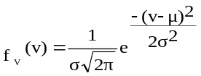 ,
P = (U, V), P є [a,b]×[a,b]

The target is to find optimum location for the transfer point.
d_{i}(x,y)=|U-x|+|V-y| , d(x,y)=[(x-x₀)²+(y-y₀)²]^{1/2}
Now the weight for value of traveled distance from demand i to transfer point can be frame follows:
E[d_{i}(x,y)]=E[|U-x|+|V-y|]=E[|U-x|]+E[|V-y|]
We have:
(4) | 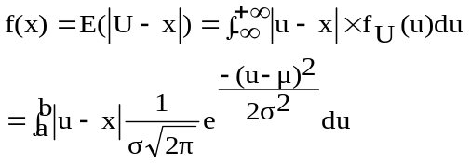
We have similarly:
(5) | 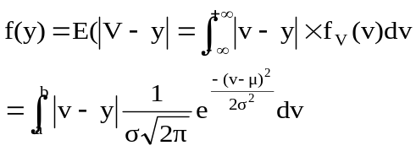
If distributed demand points be normal, we have:
(6) | 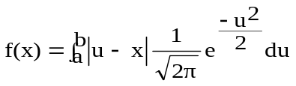
(7) | 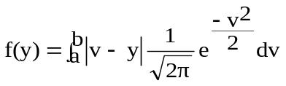
Objective function is:
(8) | 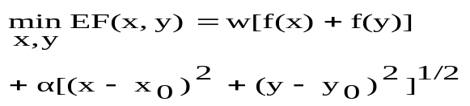
Since the Euclidean distance is convex function and maximum of bundle functions are convex. Thus, objective function model is convex and each optimal resolvent of problem is a global one.
The optimal resolvent is a function of α/w and if this factor tends to zero, the second objective function will have senseless.
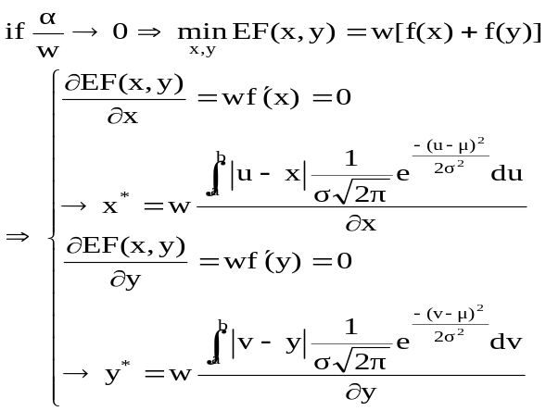
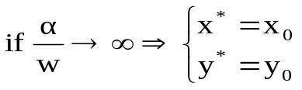

Condition of optimality is:
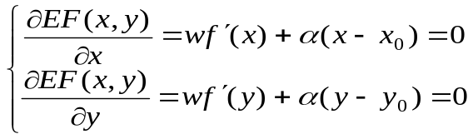
By differentiation of function, we have:
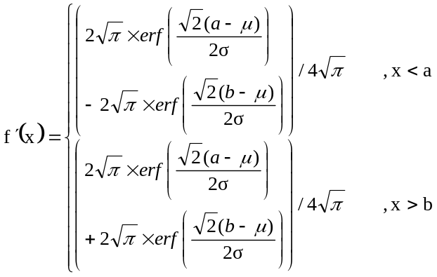
Now it allocates the optimal location transfer point as for location of facility. While region disport to four zones, we have:
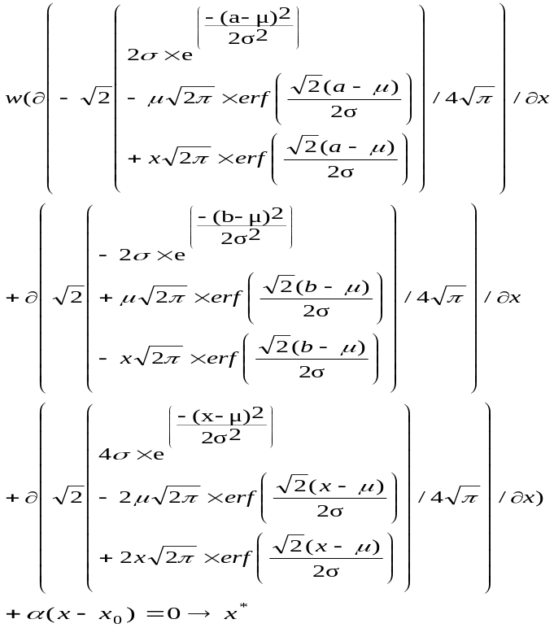
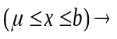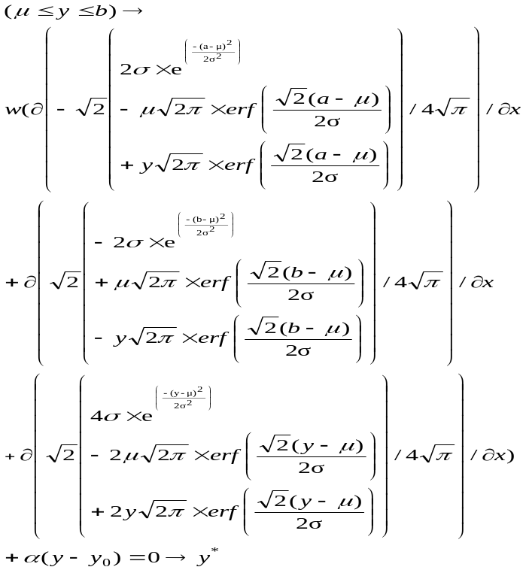
When the facility is located in A1 and demand point is located in S3 then:
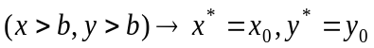
Proof: if demand points are located in S3 region with regards to ratio α/w tend to intolerable then the transfer point set position of the facility location. (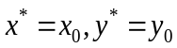) It means that do not required to transfer point.
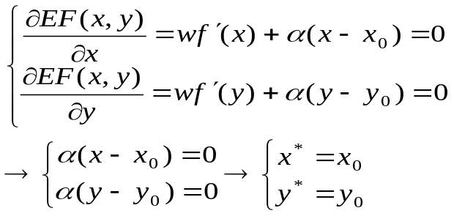
Similarly, we could account optimal transfer point in condition the facility located in other area (A2, A3, A4) and demand points located in S regions. Break down region solution problem is shown in Figure 2.
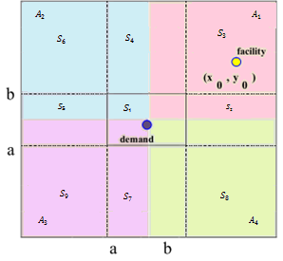
Figure 2: Break down region solution problem
3.1.4. The transfer point location problem when the demand points in several rectangles and demand distributed is normal distribution
The demand points’ coordinates are assumed to be between [a_{i},b_{i}] and [c_{i},d_{i}] by normal distribution.
All cities have demand area. Demands of each city have normal distribution. The objective is to find transfer point when distance between demand points and transfer point is Euclidean and distance between transfer point and facility is Euclidean. Figure 3 represents this case.
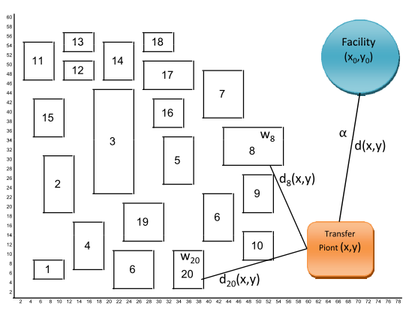
Figure 3: The transfer point location in multiple cities
f_{i}(x), f_{i}(y) can be formulated as follows:
(9) | 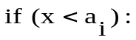
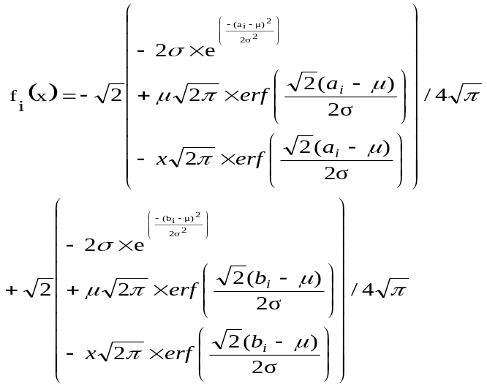
(10) | 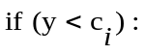
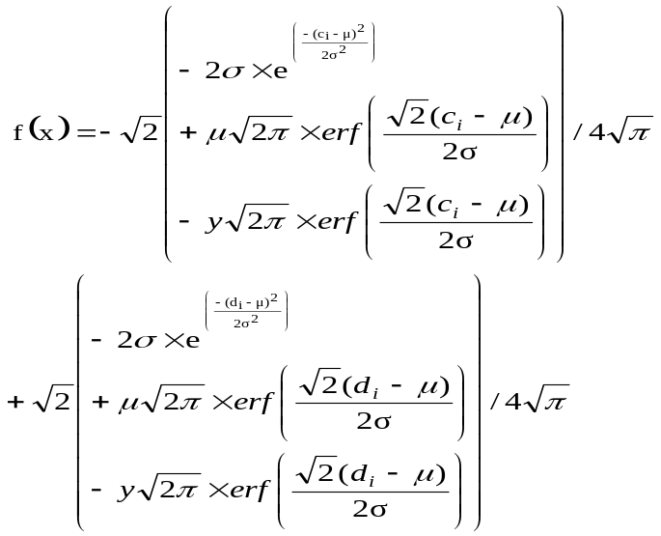
Objective function is formulated as follows:
(11) | 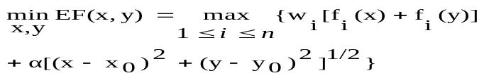
Function 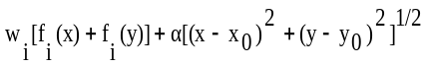 is convex function and there for maximum of a convex function is convex function. Thus, a local optimum is the global one.
4. Computational experiences
In this work, a numerical example is used to demonstrate the credibility and efficiency of the proposed algorithm, and the results are compared with the optimal solution.
4.1. Transfer point location determine in terms of demand points occur in the city.
Parameters for emplacement transfer point consist of the following: facility location (x₀, y₀), weights transfer demand points to transfer point (w), weight relocation from transfer point to facility (α), demand points mean (μ), demand points standard deviation (σ). Three states are considered for demand points in the city.
In first state, mean of demand points weights, demand points standard deviation and facility coordinate are specified (Table 2). In second case, demand points mean and demand points standard deviation are changed and other parameter are fixed (Table 3). In the third case, facility location is changed and other parameters are the as in the second case (Table 4).
Table 2: Initial value in the city (first case)
μ | σ | b | a | y₀ | x₀
15 | 5 | 40 | 10 | 70 | 65

In Table 3 we assume mean and standard deviation equal 10, 20.
Table 3: Initial value in the city with variation mean and variation standard deviation (second case)
μ | σ | b | a | y₀ | x₀
20 | 10 | 40 | 10 | 70 | 65
In third case coordinate facility is equal (50, 45).
Table 4: Initial value in the city with variation coordinate facility (third case)
μ | σ | b | a | y₀ | x₀
20 | 10 | 40 | 10 | 45 | 50

4.2. Transfer point location determine in terms of demand points occur in multiple cities.
In this case value parameters consider according to Table 5.
Table 5: Value of parameters in multiple cities
Row | w | μ | σ | (x₀,y₀) | d | c | b | a
1 | 0.3 | 6 | .66 | 70,65)) | 8 | 4 | 10 | 4
2 | 0.2 | 24 | 2 | 70,65)) | 30 | 18 | 12 | 6
3 | 0.5 | 33 | 3.7 | 70,65)) | 44 | 22 | 26 | 16
6 | 0.6 | 11 | 1.66 | 70,65)) | 16 | 6 | 18 | 12
5 | 0.2 | 29 | 1.66 | 70,65)) | 34 | 24 | 36 | 30
6 | 0.3 | 6 | 1.33 | 70,65)) | 10 | 2 | 28 | 20

4.3. Result of solution
Transfer point location problem when demands are in the city
Result of solution transfer point location problem when demands are in the city with value parameters are given in Table 6.
Table 6: Result of solution in the city
EF*(x,y) | y* | x* | α | w | Row
2.2406 | 8.36.80 | 10 | 0.1 | 0.9 | 1
15.7068 | 10 | 9.6397 | 0.2 | 0.8 | 2
25.2274 | 18.1857 | 17.9644 | 0.3 | 0.7 | 3
31.4832 | 19.6921 | 19.2716 | 0.4 | 0.6 | 4
9.9272 | 16.9723 | 16.8798 | 0.1 | 0.5 | 5
17.0183 | 18.0250 | 17.8220 | 0.2 | 0.5 | 6
23.9596 | 19.2327 | 18.8789 | 0.3 | 0.5 | 7
30.7239 | 20.7535 | 20.1533 | 0.4 | 0.5 | 8
37.2508 | 23.1105 | 21.9426 | 0.5 | 0.5 | 9
42.9607 | 70 | 65 | 0.6 | 0.5 | 10
42.9607 | 70 | 65 | 0.7 | 0.5 | 11
42.9607 | 70 | 65 | 0.8 | 0.5 | 12
42.9607 | 70 | 65 | 0.9 | 0.5 | 13
8.5921 | 70 | 65 | 0.5 | 0.1 | 14
17.1843 | 70 | 65 | 0.5 | 0.2 | 15
25.7764 | 70 | 65 | 0.5 | 0.3 | 16
34.3686 | 70 | 65 | 0.5 | 0.4 | 17
38.1969 | 21.0613 | 20.4013 | 0.5 | 0.6 | 18
38.9889 | 20.0455 | 19.5697 | 0.5 | 0.7 | 19
39.7050 | 19.4007 | 19.0232 | 0.5 | 0.8 | 20
40.3761 | 18.9452 | 18.6301 | 0.5 | 0.9 | 21
34.3686 | 70 | 65 | 0.6 | 0.4 | 22
125.7764 | 70 | 65 | 0.7 | 0.3 | 23
17.1843 | 70 | 65 | 0.8 | 0.2 | 24
8.5921 | 70 | 65 | 0.9 | 0.1 | 25

Figure 4: represents outcome diagram of objective function EF* for row 4 of Table 6 when α=0.4 and w=0.6. Coordinates of facility is equal (65, 70).
Under conditions where the displacement of a point from the point of demand to a transfer point (w) and the displacement weight from the transfer point to a facilitator (α) is 0.6 and 0.4. The optimal target function is 31.4832 and the point x = 19.2716 and y = 19.6921. It would be the best point for considering the location of the transfer point. Also, the surface under the curve of its target function is as shown in Figure. 4.
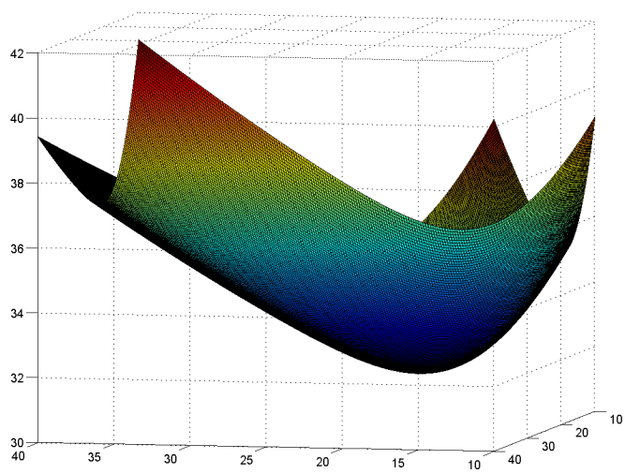
Figure 4: Surface of objective function when α=0.4 and w=0.6
Figure 5 presented as for contour lines for regions had equal objective function. Also, it represents the defensive line of the target function in areas where the objective function has similar values. The best place can be chosen to move the point in that range.

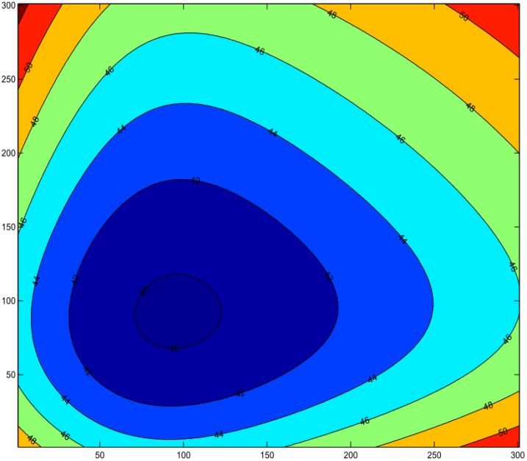
Figure 5: Contour lines for regions when α=0.5 and w=0.8
Result of solution transfer point location problem when demands are in the city with variation mean and standard deviation of Table 3 (Table 7).
Table 7: Solution result of the city with variation mean and standard deviation.
EF*(x,y) | y* | x* | α | w | Row
5.3095 | 10 | 9.7312 | 0.1 | 0.9 | 1
13.8183 | 9.9998 | 9.5891 | 0.2 | 0.8 | 2
25.4718 | 26.0510 | 25.5649 | 0.3 | 0.7 | 3
30.0004 | 28.9920 | 28.0965 | 0.4 | 0.6 | 4
6.5902 | 9.9959 | 9.6254 | 0.1 | 0.5 | 5
14.9196 | 8.8827 | 10 | 0.2 | 0.5 | 6
23.1417 | 28.1012 | 27.3394 | 0.3 | 0.5 | 7
28.5930 | 31.0199 | 29.7854 | 0.4 | 0.5 | 8
33.5972 | 35.2590 | 33.1531 | 0.5 | 0.5 | 9
37.0035 | 69.9999 | 64.9999 | 0.6 | 0.5 | 10
37.0034 | 70 | 65 | 0.7 | 0.5 | 11
37.0034 | 70 | 65 | 0.8 | 0.5 | 12
37.0031 | 70 | 65 | 0.9 | 0.5 | 13
7.4007 | 70 | 65 | 0.5 | 0.1 | 14
14.8014 | 70 | 65 | 0.5 | 0.2 | 15
22.2021 | 70 | 65 | 0.5 | 0.3 | 16
29.6028 | 70 | 65 | 0.5 | 0.4 | 17
35.3548 | 31.5979 | 30.2575 | 0.5 | 0.6 | 18
36.8248 | 29.6726 | 28.6692 | 0.5 | 0.7 | 19
38.1492 | 28.4278 | 27.6178 | 0.5 | 0.8 | 20
39.3868 | 27.5407 | 26.8581 | 0.5 | 0.9 | 21
29.6028 | 70 | 65 | 0.6 | 0.4 | 22
22.2021 | 70 | 65 | 0.7 | 0.3 | 23
14.8014 | 70 | 65 | 0.8 | 0.2 | 24
7.4007 | 70 | 65 | 0.9 | 0.1 | 25

Also, outcome diagram based on the objective function EF* for row 7 in Table 7 when α=0.3 and w=0.5 are presented in Figure 6. Figure 7 depicts contour lines for regions had equal objective function.
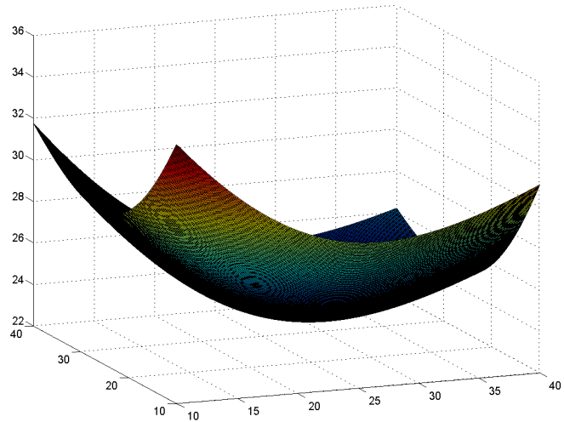
Figure 6: Surface of objective function when α=0.3 and w=0.5
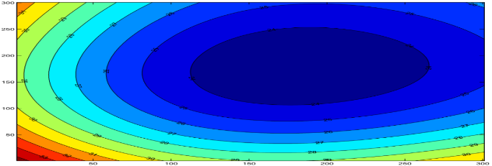
Figure 7: Contour lines for regions when α=0.3 and w=0.5
Result on the solution transfer point location problem, when demands are in the city with variation coordinate facility of Table 4, in Table 8.
Table 8: Solution in the city with variation coordinate facility
EF*(x,y) | y* | x* | α | w | Row
2.5057 | 9.6201 | 9.9998 | 0.1 | 0.9 | 1
8.2096 | 9.4193 | 9.9987 | 0.2 | 0.8 | 2
17.0083 | 25.3706 | 26.2250 | 0.3 | 0.7 | 3
18.7138 | 27.7657 | 29.3099 | 0.4 | 0.6 | 4
3.7847 | 9.4765 | 10 | 0.1 | 0.5 | 5
11.7053 | 25.1079 | 25.8942 | 0.2 | 0.5 | 6
14.6773 | 27.0489 | 28.3731 | 0.3 | 0.5 | 7
17.3037 | 29.3717 | 31.4487 | 0.4 | 0.5 | 8
19.4754 | 32.6627 | 35.9074 | 0.5 | 0.5 | 9
20.6316 | 45 | 50 | 0.6 | 0.5 | 10
20.6316 | 45 | 50 | 0.7 | 0.5 | 11
20.6316 | 45 | 50 | 0.8 | 0.5 | 12
20.6316 | 45 | 50 | 0.9 | 0.5 | 13
4.1263 | 45 | 50 | 0.5 | 0.1 | 14
8.2526 | 45 | 50 | 0.5 | 0.2 | 15
12.3789 | 45 | 50 | 0.5 | 0.3 | 16
16.5052 | 45 | 50 | 0.5 | 0.4 | 17
21.2421 | 29.8241 | 32.0588 | 0.5 | 0.6 | 18
22.7155 | 28.3086 | 30.0270 | 0.5 | 0.7 | 19
24.0416 | 27.3124 | 28.7162 | 0.5 | 0.8 | 20
25.2800 | 26.5938 | 27.7846 | 0.5 | 0.9 | 21
16.5052 | 45 | 50 | 0.6 | 0.4 | 22
12.3789 | 45 | 50 | 0.7 | 0.3 | 23
8.2526 | 45 | 50 | 0.8 | 0.2 | 24
4.1263 | 45 | 50 | 0.9 | 0.1 | 25

4.4. Result of solution when demands be in multiple cities
Result of solution transfer point location problem when demands are in multiple cities are given in Table 5 and Table 9.
Figure 8 shows equal objective function for row 8 of Table 9 when α=0.5. Also, it illustrates the line between the target function and several areas where the objective function has the same values and the best location for the transmission point in that range may select.
Table 9: Result of solution in multiple cities
EF(x*,y*) | y* | x* | α | Row
2.2604 | 0.0260 | 13.2575 | 0.001 | 1
3.0098 | 3.9993 | 13.2412 | 0.01 | 2
4.6760 | 4 | 13.2666 | 0.03 | 3
10.4967 | 6 | 13.1964 | 0.1 | 4
18.6926 | 6 | 13.2334 | 0.2 | 5
26.7678 | 7.3679 | 12.3310 | 0.3 | 6
34.9209 | 7.3637 | 12.3349 | 0.4 | 7
39.1337 | 43.7747 | 58.6644 | 0.5 | 8
40.2556 | 45.3670 | 62.1714 | 0.55 | 9
41.2687 | 46.3549 | 64.3473 | 0.6 | 10
41.6550 | 46.7386 | 65.1921 | 0.62 | 11
41.6643 | 65 | 70 | 0.64 | 12
41.6643 | 65 | 70 | 0.65 | 13
41.6643 | 65 | 70 | 0.7 | 14
41.6643 | 65 | 70 | 0.8 | 15
41.6643 | 65 | 70 | 0.9 | 16

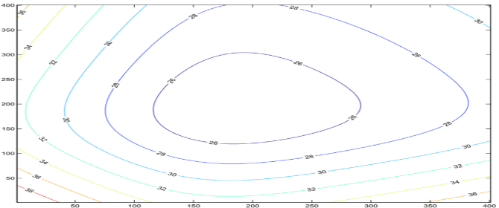
Figure 8: Contour lies for regions with equal objective function when α=0.5
4.5. checking time solution with grow-up condition
For checking time solution with grow up conditions, we test the model when number of cities are 10 and over. Then exploit results with 1.61 GHz processor and one GB of RAM. The results are presented in Table10.
Table 10: time solution of model
Duplication Number | CPU time (s) | Number of Cities
10 | 0.8125 | 10
14 | 1.4219 | 20
18 | 3.2656 | 40
24 | 6.0781 | 80
26 | 7.6250 | 100
13 | 15.6406 | 200
30 | 29.5469 | 400
29 | 39.1563 | 800

5. Conclusion
Network transmission and distribution systems are able to deliver high quality and reliable services in such a way that under normal conditions they would meet various operating restrictions in the network. In development planning, one should consider new lines to meet the needs of consumers at the lowest cost. Applicants are transferred to the transfer point at the usual speed and then transferred to the service center at dual speeds. The goal is to find the best point for the transfer locations. Using a transfer point can increase the transfer speed from the transfer centers to the service centers in proportion to the transfer rates. One of the application domains is to determine the transfer points in cities to reach service centers. Considering the large population in the city center, the accumulation of individuals can reduce, by taking into account the normal distribution of popular locations. Accordingly, in the event of an increase in the number of people in the city center, the probability of occurrence of accidents also increases and this is very important for determining the centers for the transfer to service centers. Moreover, in the real world, this hypothesis leads to a more appropriate model than the theory
In the real world, in some applications, the demand distribution is in a normal condition. Solving TPLP can be used as a decision support system for decision makers. Tools assisting to establish transfer points ensure the best exploitation of resources and decrease costs incurred to the company as they set up distribution networks.
One limitation or challenge for future research is the lack of modeling the disaster distribution, which can be probably dealt with by investigating the distribution of demand and then solve the problem by distributing demand points.

References
ALBAREDA, M., FERNANDEZ, E., LAPORTE, G. (2007). Heuristic and lower bound for a stochastic location-routing problem, European Journal of Operational Research, V. 179, p. 940-955.
AROS-VERA, F., MARIANOV, V., MITCHELL, J.E. (2013). P-Hub Approach for the optimal park-and-ride facility location problem, European Journal of Operational Research, V. 226, p. 277-285.
AVAKH DARESTANI, S.., RAJABI, Z. (2018). Bi-objective Optimization of a Multi-product multi-period Fuzzy Possibilistic Capacitated Hub Covering Problem: NSGA-II and NRGA Solutions, Journal of Optimization in Industrial Engineering, Available Online from 21 October 2018
AVERBAKH, I., BEREG, S. (2005). Facility location problem with uncertainty on the plane, Discrete Optimization, V. 2, N. 1, p. 3-34.
BARID, A.J. (2005). Optimising the container transhipment hub location in northern Europe, Journal of Transport Geography.
BERMAN, O., DREZNER, Z., WESOLOWSKY, G.O. (2003). The minimax and maxim in location problems on a network with uniform distributed weights, IIE Transactions, V. 35, p. 1017-25.
BERMAN, O., DREZNER, Z., WESOLOWSKY, G.O. (2004b). The hub location-allocation problem, Working paper.
BERMAN, O., DREZNER, Z., WESOLOWSKY, G.O. (2004c). The facility and hub location-allocation problem, Working paper.
BERMAN, O., DREZNER, Z., WESOLOWSKY, G.O. (2007). The transfer point location problem, Eur J Opr Res, V. 179, N. 3, p. 978-989.
BERMAN, O., DREZNER, Z., WESOLOWSKY, G.O. (2008). The multiple location of transfer point, J Oper Res Soc, V. 59, p. 805-811.
CAMBELL, J.F., EMMEST, A.T., KRISHNAMOORTHY, M. (2005). Hub Arc Location Problems: Part I-Introduction and Results, Management Science, V. 51, N. 10.
CAMPBELL, J. F., & O'KELLY, M. E. (2012). Twenty-five years of hub location research. Transportation Science, V. 46, N. 2, p.153-169.
CONTRERAS, I., CORDEAU, J.F., LAPORTE, G. (2011). Stochastic uncapacitated hub location, European Journal of Operational Research, V. 212, p. 518-528.
CORBERÁNA, A., LANDETE, M., PEIRÓ, J., SALDANHA-DA-GAMA, F. (2020). The facility location problem with capacity transfers, Transportation Research Part E, V. 138.
FOUL, A. (2006). A 1-center problem on the plane with uniformly distributed demand points, Oper Res Lett, V. 34, p. 264-268.
HOSSEINIJOU, S.A., BASHIRI, M. (2012). Stochastic models for transfer point location problem, Int J Advanced Manufacturing Technology, V. 58, p. 211-225.
JAFARI, A., GOLOZARI, F. (2010). Application of Ranking Function to Solve Fuzzy Location-Routing Problem with L-R Fuzzy Numbers, International Forum on computer Science-Technology and Applications. 978-1-4244-6928-4/10 IEEE
Li, J., YUNLONG, Z., HAI, S. (2009). An Improved Branch and Bound Algorithm for Location-routing Problems, International Forum on Computer Science-Technology and Applications. 978-0-7695-3930-0/09IEEE
MASSON, R., LEHUEDE, F., PETON, O. (2014). The Dial-A-Ride Problem with Transfers, Computers & Operations Research, 0305-0548-41-12-23.
MCDOUGALL, J.A., OTERO, L.D.(2018). Optimal Transfer Point Locations in Two-Stage Distribution Systems, IEEE Access, V.6. p.1974-1984.
MINGANG, Z., ZENGSHOUL, C., ZENGSHOU, W. (2009). Research on Location-Routing Problem of System Relief Based on Emergency Logistics, International Forum on Computer Science-Technology and Applications. 978-1-4244-3672-9/09 IEEE
O'KELLY, M.E. (1986). The location of interacting hub facilities, TranspSci, V. 20, p. 92-106.
OSORIO-MORA, A., NÚÑEZ-CERDA, F., GATICA, G AND LINFATI, R.(2020), Multimodal Capacitated Hub Location Problems with Multi-Commodities: An Application in Freight Transport, Journal of Advanced Transportation, V. 2020, p.1-9.
Rodrigue J. P. (2020), The geography of transport systems (fifth edition), New York: Routledge.
RONI, M.S., EKSIOGLU, S.D., CAFFERTY, K.G. , JACOBSON, J. J .( 2017). A multi-objective, hub-and-spoke model to design and manage biofuel supply chains. Ann Oper Res 249, p. 351-380.
SASAKI, M., FURUTA, T., SUZUKI, A. (2008). Exact optimal solutions of the minimum facility and transfer point's location problems on a network, Intl Trans Op Res, V. 15.
SHIODE, S., DEREZNER, Z. (2003). A competitive facility location problem on a tree network with stochastic Weight, European journal of Operational Research, V. 149, p. 47-52.
SYLVESTER, J.J. (1957). A question in geometry of situation, Quarterly Journal of Pure Applied Mathematics, V. 1.
TOH, R.S., HIGGINS, R.C. (1985). The impact of hub and spoke network centralization and route monopoly on domestic airline profitability, Transportation Journal, V. 108, p.118-126.
WANG, S., TAO, F AND SHI, Y. (2018). Optimization of Location-Routing Problem for Cold Chain Logistics Considering Carbon Footprint, Int. J. Environ. Res. Public Health, V.15, N. 86; p. 1-17.
WESOLOWSKY, G.O. (1977). Probabilistic weights in the one-dimensional facility location problem, Management Sci, V. 24, p. 224-229.
YANG, P., ZI-XIA, C. (2009). Two-Phase Particle Swarm Optimization for Multi-Depot Location-Routing Problem, School of Computer & Information Engineering School of Computer & Information Engineering. 978-0-7695-3687-3/09 IEEE
YONG, P. (2008). Integrated Location-Routing Problem Modelling and GA Algorithm Solving, International Conference on Intelligent Computation Technology and Automation. 978-0-7695-3357-5/08IEEE
Yusefli, A., Kalantari, H., Ghazanfari, M., (2018). Stochastic transfer point location problem: A probabilistic rule-based approach. Uncertain Supply Chain Managemnt, V. 6, p. 65-74.
ZHANG, B., LI, H.,LI, SH., PENG, J. (2018). Sustainable multi-depot emergency facilities location-routing problem with uncertain information, Applied Mathematics and Computation, V. 333, N.15, 506-520.
ZHANG, SH., CHEN, M., ZHANG, W. (2019). A novel location-routing problem in electric vehicle transportation with stochastic demands, Journal of Cleaner Production, Vol. 221, 1, 567-581.

