Image mining applications for underwater environment management - A review and research agenda

Abstract
The underwater environment is gaining importance due to its role in enhancing the economy of the world and improving relationships between different countries across the world. There are several applications for underwater imaging, which are affected by the underwater environment. The review and bibliometric analysis provide a systematic understanding of various applications and problems faced by different underwater imaging techniques. It provides potential directions for future research as it provides an insight into the efficiency and sustainability of the proposed solutions for underwater imaging problems. The review consists of identifying relevant published articles from SCOPUS. The literature review included papers from underwater image denoising, detection, recognition, restoration, generation, dehazing, deblurring, quality assessment, classification, compression, and image processing. Analysis of network, recognition of pivot research topics, correlation and pattern combinations of accepted and recent research were identified with the help of bibliometric software. It also helped in identifying key authors, journals, influential institutions, and impactful keywords. The systematic reviews and bibliometric analysis exhibits and recognize the current and potential underwater image processing research interest for the future. The review and bibliometric analysis are considered relevant as they exhibit an organized and systematic underwater image processing study which could help in future research. A research framework is proposed for systematically organizing the main underwater techniques and their relationships to maximize the benefits offered in different underwater imaging fields. The study will help researchers and engineers in developing practical strategic plans for underwater environment cleaning operations.
Keywords: Underwater Imaging; Systematic review; Bibliometric Analysis; Underwater Image Processing; Environment Cleaning.

- Introduction
The underwater environment plays a significant role in improving and enhancing the economy and relationships between different countries across the world (Han et al., 2018). Applications of underwater environment involve underwater image detection (Gaudron et al., 2013), resource exploration (Bailey and Flemming, 2008), protection of the underwater environment (Alippi et al., 2010), ocean mining, minerals, energy resources, the wild fish stock which involves counting and monitoring fish species (Harvey et al., 2010) and underwater environment monitoring (Tascini et al., 1996) the effects of climatic changes such as high temperature and increasing CO₂ content (Mahmood et al., 2018).
The complexity of the underwater environment leads to difficulty in the exploration of underwater research and engineering (Jiang et al., 2020). Many factors such as the sand, underwater plants, organic elements, and water particles themselves may cause scattering and absorption of light (Prabhakar and Kumar, 2010). This may indirectly affect the quality of the captured image causing noise, low contrast, and diminished color (Schettini and Corchs, 2010). As the natural light can’t penetrate deep into the ocean, artificial lights on AUVs are used to capture the underwater image. These images are affected by non-uniform illumination and shading (Bindhu et al., 2020).
Different underwater image sensors deployed in Autonomous Underwater Vehicles (AUVs) and Remotely Operated Vehicles (ROVs) make use of imaging techniques such as sonar, laser, and optical imaging for capturing underwater environment information (Lu et al., 2017a). The bandwidth of the underwater acoustic channel is comparatively lower than the bandwidth of the terrestrial communication channel (Iqbal and Lee, 2016). Another disadvantage of the acoustic channel is that they are subjected to high path loss (Poncela et al., 2012). To overcome the shortcomings of underwater communication channels, underwater images are subjected to compression. But compression comes at the cost of image quality (Cai et al., 2019).
Customer-generated data can also be used for enhancing production and business operations (Grover and Kar, 2017). Underwater images captured using underwater sensors are the source of underwater environment information. It helps in observing or monitoring the underwater environment to find whether the environment is conducive for both human beings and marine life. The sustainability of life underwater is of significant concern for aqua agriculture. Big data is considered an essential source for data-driven decisions (Kushwaha et al., 2021). Social and digital innovations with the help of big data will enable sustainable development (Kar et al., 2019). Big data is defined as the continuous production of enormous data, analysis of which can maximize profit (Gupta et al., 2018). Big Data analytics gives information about the underwater environment by using data mining, which is considered a part of big data.
Utilizing the data exploratory techniques integrated with a large amount of unrelated data, data mining provides knowledge from data. Big data analytics techniques integrated with statistical techniques can learn autonomously to produce results equivalent to human intelligence. The application of data mining involves analyzing video watching patterns to improve web multimedia systems (Su et al.,2021). Availability of unstructured data in the form of digitized text on the online platform provides a significant advantage in service management. Some of the recent application of text mining involves product planning and digital marketing (Kumar et al.,2021).
Opinion mining is a form of text mining that doctors use to understand patient feedback on the medical treatment received. This can be used to understand the attitude of the patient and his satisfaction with the treatment being delivered (Chintalapudi et al.,2021). Document clustering is another application of data mining. It involves collecting documents with similar content to classify them based on repetitive word tokens (Jalal et al., 2021). Data mining techniques can also be used for predicting learning outcomes (Kim et al., 2021). It can also help comprehend the reason for diseases, determination of treatment, and forecast disease (Mohamed et al., 2018). Web data mining, the sub-discipline of data mining, is considered a valuable means of retrieving meaningful information (Mughal, 2018; Jalal, 2018).
Another application of data mining, i.e., image mining, involves information mining from images without the knowledge of image content. Different patterns such as classification, description, correlation, spatial and temporal are produced by image mining. Image mining involves integrating data mining, image retrieval, indexing techniques, and pattern recognition (Sudhir, 2011). Therefore, image mining can be classified as domain-specific and general application-based. Domain-specific image mining involves extracting patterns from image features. General image mining involves processes that help to generate image patterns (Hsu et al., 2002).
Image mining involves image processing, transformations, and feature extraction. Data mining techniques can be applied to extracted features to generate patterns that provide knowledge that can be used for various applications (Foschi et al., 2002). Image mining can be applied for oncological and non-oncological applications (Sollini et al., 2019). Image mining differs from image processing. Image mining involves extracting patterns from extensive collections of images, whereas image processing techniques involve extracting features from a single image. In the view of increasing underwater image research papers, finding meaningful publications for researchers by normal search process is considered a big challenge and time-consuming problem. Image analytics which is a part of data analytics helps in analysing underwater images to understand the impact of the underwater environment on living organisms (Chauhan et al., 2016). For the successful implementation of image analytics, there is a need for a large number of images. Image classification, a part of image analytics, helps analyse the different species of marine life, organic and inorganic matter present in the underwater images. Underwater Image analytics helps in monitoring the underwater environment for fish breeding and feeding. Image analytics also helps keep an account of underwater cultural heritage by mining information from the collected images. For sustainable accessibility of underwater pipelines, cables, off-shore structures in the future, image mining plays a vital role.
Considering the increasing need in the field of underwater environment exploration, this paper explores the research trends in the different fields of underwater image processing. A Systematic Literature Review (SLR) of published articles provided a better understanding of the current trends and the research gaps. The published articles in the field of in underwater image processing were collected from the SCOPUS database using suitable keywords. The literature review was carried out on 110 published articles. Based on the SLR methodology the literature review was accomplished. Further bibliometric study and network analysis was carried out to analyze the research trends in the field of underwater image processing techniques.
The following research questions motivated in carrying out the study:
RQ1. What are the effective underwater image processing techniques which help in underwater environment cleaning applications?
RQ2. What are the current trends in the publication of technological advances to capture and transfer a noise-free, color image of the underwater environment?
RQ3. What is the future scope for research in underwater image processing for the underwater environment cleaning aspect?
To analyse these research questions, this study serves several objectives. It starts with, identification of important underwater image processing techniques and their applications. The next objective is to analyse the trends and technical advancements in underwater image processing techniques. Further, this article proposes future research directions in underwater image processing for the underwater environment cleaning aspect.

This article starts with identifying and collecting important articles in the field of underwater image processing techniques. SCOPUS database was used to identify the published research articles. The shortlisted articles from the SCOPUS database were categorized into different techniques of underwater image processing. A detailed review was carried out on each technique of underwater image processing. Further, a bibliometric and network study was carried out to analyse the current research trends and networks among researchers in underwater image processing. Finally, discussions have been made, and future research directions have been proposed in underwater image processing, which enables industry practitioners to utilize image processing techniques in different underwater cleaning applications.

The systematic organization of the paper consists of introduction along with research questions and objectives as section 1, literature review methodology is presented in section 2, review of articles related to underwater images are presented in section 3, bibliometric analysis is shown in section 4, network analysis is shown in section 5, study implications in section 6 followed by the conclusion, limitation, and future work are presented in section 7.
- Systematic Literature Review
The most important part of a research study is the literature review. It helps in understanding the current trends and provides an insight towards the potential research interest in the future (Junior and Godinho Filho, 2010; Vinodh et al., 2021; Reshmi, 2021). Research must be more concentrated on research gaps in the current trends (Tranfield et al., 2003). A Systematic Literature Review (SLR) is considered a process consisting of searching relevant keywords, shortlist relevant literature, and carrying out a systematic study. Figure 1 shows the flow of the SLR methodology.
SLR has been used in several areas of study like the systematic review for the use of blockchain in healthcare (Hölbl et al., 2018), SLR and bibliometric analysis on green warehousing (Bartolini et al., 2019), big data analytics (Inamdar et al., 2020), supply chain finance (Xu et al., 2018), the psychological process of contextual cues (Zhao et al., 2020).

- Selection of Database
SCOPUS is chosen as the database for the systematic literature review and bibliometric analysis of the research topic under study. SCOPUS is considered one of the largest databases containing peer-reviewed literature (Geraldi et al., 2011). SCOPUS contains articles related to computer science, social science, business, management and accounting, decision sciences, engineering, chemistry, and many more (Mongeon and Paul-Hus, 2016). These articles are from renowned publishers such as IEEE, Springer, Elsevier, Taylor and Francis, Wiley, Emerald.
Identifying Research Objectives
Database Selection
Keyword Selection
Criteria for inclusion and exclusion of articles
Collection of articles based on selected keywords and relevance
Review and Bibliometric study of collected articles
Implications and conclusion
Suggestions on future research directions

Figure 1: SLR methodology framework used in the study

- Selection of Keywords
This study aims to get insights on the past, current trends, and future scope of underwater image processing on underwater environment exploration. The keywords used to search for the most relevant and important articles chosen for the study are: Underwater and “Image Denoising”, Underwater and “Image Classification”, Underwater and “Image Compression”, Underwater and “Image Deblurring”, Underwater and “Image Dehazing”, Underwater and “Image Detection”, Underwater and “Image Generation”, Underwater and “Image quality assessment”, Underwater and “Image Recognition”, Underwater and “Image Restoration” and “Underwater and Image Processing”.

- Defining inclusion and exclusion criteria
The search for articles on SCOPUS was conducted in September 2020. The literature review and bibliometric analysis were carried out on articles in the time interval of 2001-2020. The articles are selected based on current relevance and importance regarding the area of study. Non-referred conferences and journals, magazine articles have been excluded from the study, and only journal articles written in the English language are considered. Articles not pertaining specifically to the area of the study are excluded.
- Collection of articles
Using the selected keywords mentioned in Section 2.2 and the inclusion-exclusion criteria mentioned in Section 2.3, articles related to underwater imaging are shortlisted from the SCOPUS database. Search results amounted to a total of 1056 articles. Table 1 presents the number of articles found for each keyword.
Table 1: Search results of articles
Input keywords | Available papers
Underwater AND “Image denoising” | 94
Underwater AND “Image detection” | 37
Underwater AND “Image recognition” | 81
Underwater AND “Image restoration” | 233
Underwater AND “Image generation” | 42
Underwater AND “Image dehazing” | 65
Underwater AND “Image deblurring” | 15
Underwater AND “Image quality assessment” | 46
Underwater AND “Image classification” | 204
Underwater AND “Image compression” | 132
“Underwater image processing” | 107
Total | 1056

- Refinement of articles and further shortlisting
Based on at most relevant and important articles, further refinement on the searched articles is carried out. As a result of which a total of 970 articles were shortlisted for the study. Duplicate articles present in different combinations of search keywords and incomplete data on bibliometric were excluded.

- Literature Survey
This section describes the various areas in the field of underwater image processing. This section is divided in ten sub-section which includes major underwater image processing techniques such as underwater image denoising, underwater image classification, underwater image compression, underwater image blurring, underwater image dehazing, underwater image detection, underwater image generation, underwater image quality assessment, underwater image recognition, and underwater restoration and underwater image processing. The literature survey helps understand the challenges, techniques, and strategies used to overcome the disadvantages posed by the underwater environment and transmission medium in various applications of underwater image processing.
  - Underwater image denoising
Underwater images are affected by various underwater environmental factors, image processing, and image transmission techniques. Underwater image acquisition, compression, transmission, and decompression lead to information loss (Jin and Liang, 2017). Thus, leading to blinding noise (natural image noise), spot noise caused by underwater particles. In this regard, Prabhakar and Kumar (2010) proposed an image contrast enhancement, smoothing, and denoising technique using three filters, respectively. Homomorphic filters help to enhance image contrast. Anisotropic filters remove the artifacts caused by homomorphic filters by smoothing the homogeneous image region. Adaptive wavelet sub-band is used to detect noise and Modified Bayes Shrink helps modify the noisy image pixels. Kim et al. (2017) proposed an unsupervised, six-layer encoder-decoder CNN network to reduce the noise effect on sonar images. Srividhya and Ramya (2017) proposed an adaptive fuzzy-based noise removal technique. The pixels in noisy images are detected and replaced by fuzzy filters. Noisy pixels are replaced by the average value of adjacent pixels. It maintains the sharp edge features of the image and, at the same time, helps to remove noise.
Wu et al. (2018) proposed a signal-dependent additive noise removal technique for sonar images. A sparse representation of the image to be transmitted is created with the help of Discrete Cosine Transform (DCT) and Orthogonal Matching Pursuit (OMP). The reconstructed image at the receiver side is subjected to logarithmic transformation to overcome the disadvantages of the sparse model used for encoding. Sung et al. (2018) proposed a two-step denoising technique for Sonar images that makes use of You Only Look Once (YOLO) deep CNN. The first step involves YOLO deep CNN, which helps to detect the regions of the images affected by crosstalk by analyzing the high-level extracted image features. The second step involves post-processing by filling the detected crosstalk regions with the nearby pixel values. The image is further subjected to Gaussian smoothing to give the detected filled region a natural look. Ma et al. (2019) proposed a four-step impulse noise detection and removal technique. A difference-based median filter (DBMF) is used to detect and localize the impulse noise in the original image. The affected pixels are replaced by the median filter pixel values to reduce the impulse noise effect. Jin et al. (2019) proposed a denoising technique for side-scan sonar images affected by non-homogenous noise. Covariance matrix containing the pixel intensity value, geometric and texture features are subjected to local and non-local models. This helps to detect the noisy patches in the image and helps to compute the non-noisy patches by which they can be replaced.
Jiang et al. (2020) proposed a denoising technique to remove spot noise, and at the same time, it also preserves finer details and sharp edge information of the image. The deep learning framework is based on Generative Adversarial Network (GAN) with added features such as skip connections, self-attention, and spectral normalization. Skip connections help preserve the low- and high-level features of the image. Self-attention helps to maintain the finer details of each position in the image. The training is stabilized by spectral normalization. Hou et al. (2020a) proposed an integrated approach for denoising of images. The integrated approach consisting of image formation and image variation restoration helps derive information related to background light and map for image transmission. For this, the Retinex model, along with the Alternating Direction Method of Multipliers (ADMM), is used to provide a computationally efficient model. Lyu et al. (2020) proposed a denoising technique to overcome Gaussian and blinding noise using Convolutional Neural Network (CNN). CNN has the shape of U-Net Main components of U-Net-shaped CNN consist of Non-Subsampled Contourlet Transform (NSCT) and reverses NSCT. NSCT helps to preserve the image details and reduces the feature map size

  - Underwater image classification
Underwater Image Classification is used for scientific study that requires the knowledge of the location and distribution of underwater pipelines, cables, offshore structures, mines, planktons, benthic organisms, and coral reefs (Foresti and Gentili (2002), Tang et al. (2006), Mahmood et al. (2018). Image processing is one of the emerging applications of Generated Adversarial Networks (GAN) (Aggarwal et al., 2021).
The images of these underwater images are captured by image sensors in Autonomous Underwater Vehicles (AUVs). In this regard, Foresti and Gentili (2002) proposed a neural tree-based hierarchical classifier to classify deep-sea objects such as pipelines and cables. The proposed classifier requires no information regarding the number of internal nodes, hidden neurons, hidden layers, etc., for classification purposes. Tang et al. (2006) proposed a classification technique based on extraction and combination of Eigen feature vectors of plankton organisms. The multilevel normalized estimation technique helps to remove the unwanted feature vectors for binary classification of planktons. Li et al. (2016a) proposed enhancement techniques and classification for underwater images. These enhanced images are subject to classification using Support Vector Machines and CNNs. Williams (2016) proposed a ten-layer CNN for the classification of different objects in sonar images. For training purposes, augmented data is used to proportion real images to overcome overfitting and provide robustness.
Zhu et al. (2017) proposed a classification technique of objects in sonar images captured using Unmanned Underwater Vehicles (UVVs). AlexNet, along with Support Vector Machines (SVMs) and matched filters, are used to classify the preprocessed sonar images. Mahmood et al. (2018) proposed a supervised classification technique for coral reefs for automatic annotation. This method uses Convolutional Neural Network features and features from residual networks to perform classification and analysis of coral population. Wang et al. (2019a) proposed an Adaptive Weighted CNN object-based classification technique for sonar images. The input filter weights, and dimension conversion of CNN and dense network are unified using the increment-dimension function. The adaptive weights of CNN are normalized using Local Response Normalization (LRN) to provide an efficient classification technique.
Gómez-Ríos et al. (2019) proposed a comparison on ImageNet and Coral dataset transfer learning for coral image classification. It also compares the effect of data augmentation on the performance of classification. Comparison of coral classification techniques based on state-of-the-art CNNs, transfer learning, and data augmentation. Inception V3, ResNet, and DenseNet are the three state-of-the-art CNNs chosen for comparison. ImageNet and Coral dataset transfer learning are used for classification comparison. Mahmood et al. (2020) proposed a classification technique based on Deep Residual Network features extracted from pre-trained Residual Networks (ResNets). Outputs of each convolution layer of 50 layered ResNet are combined to form a feature vector that improves the classification efficiency. Bindhu et al. (2020) proposed nine features to classify the underwater image into seven degradation classes. The proposed technique first involves extracting input features from the input fed into the neural network for degradation classification.

  - Underwater image compression
Underwater images captured by Autonomous Underwater Vehicles (AUVs) are transmitted via low-bandwidth acoustic channels, which are inadequate compared to terrestrial transmission channels. Acoustic channels are affected by the low-speed high path loss. So, there is a need to compress images to overcome the disadvantages posed by the transmission channels. In this regard, Rubino et al. (2015) proposed a transmission model for providing variable rate compressed images. Multiple channels working in parallel along with receiver feedback are used to control the transmission bit rate. A low-resolution image is sent through the first channel, and based on receiver feedback, additional information regarding the image is sent through other channels. Zhang et al. (2016) proposed a compression model for underwater images. To maintain texture information, intra coding of images is performed. To improve the compression rates, inter coding is performed between the different frames of video. Inter coding consists of Spatio-temporal just noticeable distortion, motion interpolation, and variable-precision quantization. Ali et al. (2017) proposed an efficient compression model for underwater image transmission. The model tries to provide high-quality images at the receiver side by reducing the error in the transmission bit rate. Application of Reed Solomon and Set Partitioning in Hierarchical Trees (SPIHT) on Wavelet Packet (WP) decomposition of input image provides compression and error-free best image representation. Transmission of data is done using Orthogonal Frequency Division Multiplexing (OFDM) with Differential Quadrature Phase Shift Keying (DQPSK).
Rubino et al. (2017) proposed an embedded compression model to transmit underwater images through low bandwidth channels. It makes use of Depth Embedded Block Tree (DEBT) with progressive compression and region-of-interest to provide variable compression rates based on available channel bandwidth. Ahn et al. (2018) proposed an image enhancement, interesting image selection, image compression, and reconstruction model. Retinex is used for image enhancement, saliency map is used to select the interesting parts in the image, and color depth is used for image compression and reconstruction. Priyadharsini et al. (2018) proposed an enhancement model based on Stationary Wavelet Transform and Laplacian Filter. The Low-Low component obtained from SWT on the input image is subjected to Laplacian Filter. The difference between filtered image and LL component is treated as a mask that enhances the LL component quality at the receiver side.
Cai et al. (2019) proposed an adaptive compression technique based on input images' quality. The characteristics of the input image are computed using Image Measurement Activity (IMA). Embedded coding and compressive sensing are used to measure the quality of compressed images. Linear Fitting is used to estimating the quality of compressed images based on the IMA value of that image. Zhang et al. (2019) proposed an image enhancement and compression technique. Pre-processing involves applying a homomorphic filter, whitening, discarding the boundary pixels, and standardization of images for image enhancement. The compression model is trained on Principal Component Analysis (PCA) and tested on Extreme Learning Machine (ELM). Monika et al. (2020) proposed a compression-reconstruction model for underwater images. Energy-Based Adaptive Block Compressive Sensing (EBABCS) is used for compression and orthogonal matching to reconstruct the image.
  - Underwater Image Blurring
The quality of underwater images is affected by turbidity caused by suspended particles. These particles in seawater cause forward and backward scattering of light causing image blur.
Chen et al. (2014) proposed a deblurring technique that can be implemented in a smartphone. The acquired images are subjected to image averaging. These images are further deblurred using the Lucy Richardson algorithm. Farhadifard et al. (2016) proposed a deblurring technique based on sparse representation of image patches. A unique dictionary with a blur level is generated for each image patch, and a blur map is estimated for the whole image. Ding et al. (2017) proposed a two-step image enhancement method. The first step involves colour correction by using the white balance method. In the second step, the color-corrected images are subjected to a super-resolution convolutional network for blur removal.
Pan et al. (2017) proposed a deblurring technique that removes the blur and enhances the edges of underwater images. It makes use of Hybrid Wavelets and Directional filter banks (HWD) to eliminate turbulence blur. DehazeNet is used to compute the transmission map for images subjected to an adaptive bilateral filter to obtain an enhanced transmission map. Jiji and Ramrao (2018) proposed a deep learning technique that involves image restoration and enhancement. Image is restored by the use of Adaptive Sparse Domain Selection (ASDS) system, which makes use of Principal Component Analysis (PCA), Auto-Regressive (AR) models, and non-local (NL) self-similarity constraint. Image enhancement is done using the weighted Gray Edge method. Huo et al. (2018) proposed an image enhancement method to remove blur. The images were subjected to the Retinex algorithm to remove the effect of uneven illumination. Unwanted colour from the light source is estimated and removed. The image was finally deblurred by the use of the Red Channel Prior method.

  - Underwater Image Restoration
Underwater image quality is affected by suspended particles in underwater, underwater currents, and low-light illumination. So, there is a requirement for restoring the underwater images, which helps in various applications such as wreckage detection, mine detection, etc. In this regard, Liu et al. (2001) proposed a technique to measure Point Spread Function (PSF) underwater Modulation Transfer Function for image restoration. Wiener filters are used to improve the quality of the image further. Trucco and Olmos-Antillon (2006) proposed an image restoration method that can be self-tuned based on the input image. Tenengrad criterion helps select the tuning filter values based on the image formation Jaffe-McGlameray model. Galdran et al. (2015) proposed a Red Channel method for image restoration. Advantages of the techniques are: they require fewer parameters, improve colour contrast, and simple to implement and adaptable to the artificial light source. Peng and Cosman (2017) proposed an image restoration method based on underwater scene depth calculation. The scene depth is calculated using both image blur and light absorption. This helps in the formation of the underwater image.
Peng et al. (2018) proposed an image restoration technique based on improved Dark Channel Prior. Estimate of scene depth and transmission and adaptive contour correction methods are used to restore underwater images efficiently. Yang et al. (2019) proposed a Retinex-decomposition based image restoration technique. To improve the restoration quality, offshore optical properties and estimates of backscattering light are taken into consideration. Liu et al. (2020a) proposed a polarization-based image restoration technique. The polarization-based restoration method makes use of logarithmic image transformation and the dark channel. To improve the image details, dark channels determine backscattering. Chang (2020) proposed an Adaptive transmission Fusion based image restoration technique. Transmission maps generated using optical and image processing information, respectively. These maps are fused adaptively based on the weights of their saliency maps. Dai et al. (2020) proposed an image restoration method that combines estimation of quad-tree-based scoring formula, transmission maps, and color balance techniques. This method helps to improve the scene radiance and naturalness of the image. Sethi and Indu (2020) proposed Fusion based method to enhance and restore the quality of underwater images. The input images are subjected to Histogram Equalization (HE) for image enhancement. The same input image is separately subjected to contrast stretching and dark channel before imagery dehazing. Both these images are combined using the Laplacian Pyramid-based method to restore the image.

  - Underwater Image Recognition
Automated recognition of planktons and coral reefs is necessary to understand the condition of the underwater environment. Recognition of underwater objects helps in the smooth navigation of AUVs. In this regard, Yu (2008) proposed a real-time acoustic image recognition method. A template consisting of object shape is realized using the position determined by underwater deployed High-resolution Acoustic Camera (HAC) for recognition and inverted binary image label for detection. Chaung et al. (2016) proposed a framework consisting of an unsupervised saliency-based feature learning and error-resistant unsupervised hierarchical clustering-based classifier for underwater image recognition. Corgnati et al. (2016) proposed an autonomous, un-cabled imaging system called GAURDI to acquire and recognize gelatinous zooplankton. GAURDI system consists of image enhancement, extraction of the region of interest, and image recognition using ElasticNet based on Genetic Programming. Marini et al. (2018) proposed a supervised machine learning technique for image recognition for monitoring and tracking fishes. The proposed work is based on a binary classifier that is a combination of Genetic Programming and stratified K-fold cross-validation.
Bi et al. (2020) proposed a Generalised Robust graph-Laplacian Principal Component Analysis (GRgLPCA) using an iterative non-greedy method to reduce the difference. This indirectly enhances the recognition of objects in underwater images. Cao et al. (2020) proposed a real-time underwater live crab’s recognition technique based on Faster MSSDLite. The input images are pre-processed using image enhancement techniques and fed as input to the Faster MSSDLite for crab recognition. To improve the recognition rate Faster MSSDLite makes use of a quantized convolutional neural network. Raphael et al. (2020) conducted a study on the efficiency of various machine learning and deep learning techniques for Marine Benthos and Coral Recognition. The work also proposes some frameworks on applications of image recognition for improving coral reef ecology. Xu et al. (2019) proposed a robust principal component analysis network for image recognition. The proposed method employs an FP-norm that retains the properties of PCA while it is immune to noise and outlets. Zhao et al. (2019) proposed a CNN embedded Field-Programmable Gate Array (FPGA) based image recognition technique. The input layer of CNN is implemented on the ARM CPU, and the hidden and output layers are embedded on the FPGA.

  - Underwater an Image Quality Assessment
Various image artifact removal techniques have been proposed as underwater images are subjected to various artifacts due to the underwater environment and low light illumination. To realize the effectiveness of these methods, an assessment of the image quality is required. In this regard, Sarisaray-Boluk et al. (2011) proposed an image quality assessment metric to control the retransmission of images over the transmission channel adaptively. Image quality is evaluated based on packet loss during transmission and block-based Peak Signal To Noise Ratio (PSNR). Ye et al. (2013) proposed a quality assessment technique for a watermark embedded original image transmitted we are distorted acoustic communication channel. The quality of the original image is evaluated based on the degradation of the embedded watermark image to the original watermark image at the receiver end. Yang and Sowmya (2015) proposed an image quality assessment metric based on a discriminator ‘C’ and a patch-based Q metric for images with similar sharpness. Discriminator ‘C’ is measured based on images taken under different underwater environment conditions. The Q metric helps predict the quality of images.
Chen et al. (2018) proposed a partial-reference sonar image quality predictor metric which is based on Human Visual System (HVS) and Image Activity Measurement (IAM). This metric helps to evaluate the quality of underwater sonar images. Wang et al. (2018b) proposed a no-reference metric known as Colorfulness Contrast Fog (CCF) metric for underwater image quality assessment. This metric can measure the amount of image information loss caused due to scattering and absorption. Weighted coefficients are calculated using multiple regression on CCF index values to determine the effect on image quality. Sánchez-Ferreira et al. (2019) proposed bio-inspired image reconstruction based on No-Reference Image Quality Metric (NR-IQA) as its optimization cost function. Comparison of various NR-IQA matrix, to find the best optimization cost function for the bio-inspired image restoration process. Hou et al. (2020b) proposed the development of Synthetic Underwater Image Dataset (SUID) using an underwater image synthesis algorithm for testing the performance of full-reference image quality assessment metric. Liu et al. (2020b) proposed a no-reference enhanced image quality assessment technique based on the distribution of colour space. The Colour transfer technique is used for the construction of reference images to be used for quality assessment. The quality of both colour and grayscale images can be measured using the proposed Feature Similarity and difference in colour metric.
  - Underwater Image Generation
Underwater drones having 360⁰ panoramic cameras, planar-array of sensors, Dual-frequency identification sonar, and Adaptive resolution imaging sonar are some of the devices used for underwater image generation. In this regard, Johnson and Hebert (1996) proposed image generation based on an elevation map. An elevation map is generated using the information from side-scan sonar images and information embedded in the image, such as sparse bathymetric points. Murino and Trucco (1999) proposed a beam formation technique for image generation. By comparing the confidence measure between apriori models of the scene image with the beam signal envelope. The image formation quality can be improved. Palmese and Trucco (2007) proposed Chirp Zeta Transform (CZT) for 3D image generation. CZT is incorporated with Fresnel approximation to reduce the computational delay, and a non-conventional technique has been integrated to define azimuth and elevation angle. Palmese and Trucco (2010) proposed a 3D image generation technique based on Chirp Zeta Transform (CZT) with Fresnel approximation. Dynamic range resolution helps reduce the operations required for beam computation and also generates cells with cubic resolution.
Allais et al. (2011) proposed a 3D simulator for image synthesis known as simulator optic pour la Formation d’Image (SOFI) for underwater devices. Radiative transfer model and modeling of the global image are integrated into SOFI. The radiative transfer model computes radiance and polarization. The global image model gives information regarding deterioration due to the underwater environment respectively. Sardemann and Maas (2016) proposed plenoptic cameras with 100-meter depth determination for image generation. It made use of Spatio-temporal filters to remove outliers introduced due to an increase in range of depth. King et al. (2018) propose a technique for guiding autonomous underwater vehicles using the teach and repeat the method. Zheng et al. (2018) proposed a denoising Generative Adversarial Network (GAN) based image generation technique. Generation of overlapped objects is controlled using one hot semantic label map. The loss function of GAN is improved by considering both perturbed and cascade layer loss. Terayama et al. (2019) proposed a Generative Adversarial Network (GAN) based image generation technique. Training of the network is done using sonar and camera images.

  - Underwater Image Detection
Navigation of autonomous underwater vehicles requires the detection of close objects for accurate path planning. They are also required for the detection of pipelines, wreckages, mines for ocean survey and investigation. In this regard, Barat and Phlypo (2010) proposed a contour-based method for underwater mines segmentation and detection. This method uses saliency maps, visual attention method, active contour, and statistical approach for segmenting and determining the underwater minds. Lee et al. (2012) proposed an image enhancement method. Colour restoration is used for underwater image enhancement, and comparison of various object detections are carried out to find suitability to the underwater environment; feature-based, template-based, target object tracking techniques are compared. Fang et al. (2015) propose an underwater image detection technique for Autonomous Underwater Vehicles (AUVs) for avoiding obstacles in their path. The obstacle detection is done by using the BK triangle sub-product of fuzzy relations.
Wang et al. (2015) proposed a frequency and time domain-based underwater object detection technique known as Fuzzy Clustering Algorithm (FCA). The image is pre-processed to remove noise and is transformed using Fourier Transform before being subjected to FCM. Lin et al. (2017) propose underwater obstacle detection and dynamic routing method. Underwater optical detection is based on depth-map estimation using stereo-vision detection, and dynamic routing is based on PSO. Xinyu et al. (2017) proposed an underwater object detection method that first pre-processes the image by subjecting it to fast curve transform to remove noise. The denoised image is subjected to iteration conditions model algorithm for segmentation and object contour method for object detection. Wang et al. (2017b) proposed a method to denoise the sonar image before subjecting the image to underwater object detection. It makes use of two threshold values as a decision parameter for noise filters. A combination of Shuffled Frog Leaping Algorithm (SFLA) with Quantum-Behaved Particle Swarm Optimization (QPSO) is utilized to improve object detection accuracy.
Wang et al. (2017a) proposed a sonar image detection technique along with the new communication protocol. Image detection is improved by using the Adaptive Cultural Algorithm with Improved Quantum-Behaved Particle Swarm Optimization (ACA-IQPSO). The population is Space and Shuffled Frog Leaping Algorithm (SFLA) belief space. Wang et al. (2018a) proposed sonar underwater image detection using Noble Quantum-Inspired Shuffled Frog Leaping Algorithm (NQSFLA). The algorithm is enhanced by adopting a new fitness function and quantum evolution update strategy. Wang et al. (2019b) propose denoising and underwater object detection technique. Denoising of the underwater image is done based on the Golden ratio method. Detection depends on Adaptive Initialization Algorithm Based on Data Field (AIA-DF) and update strategy based on Quantum-Inspired Shuffled Frog Leaping Algorithm (QSFLA).

  - Underwater Image Dehazing
Underwater images are affected by low illumination or underwater attenuation. To overcome artifacts caused by these, image dehazing is required. Backward scattering of light causes haze on the image. In this regard, Chiang and Chen (2011) proposed an image dehazing method based on the depth map and wavelength compensation. The difference between the foreground and background intensity is used to estimate the presence of artificial light to reduce its effect on the image. Color balance is restored by compensating for color change in each color wavelength. Li et al. (2016b) proposed an image dehazing and enhancement method that uses the principle of minimum information loss. This method makes use of Global background light estimation, Medium Transmission Map to dehaze the image. The dehazed image is enhanced using histogram distribution prior. Liu et al. (2018) proposed a residual architecture that combines domain knowledge and haze distribution to reduce image dehazing. Transmission maps generated from the above residual network are compared with ground truth image transmission maps. The proposed model is provided with additional features to provide image enhancement and remove rain droplets.
Li et al. (2018) proposed a sea-cucumber image dehazing technique based on the combination of Dark Channel Prior and Retinex. The proposed method is combined with HSV color space theory to prevent color distortion. Ancuti et al. (2019) proposed a color channel compensation technique to enhance the quality of the image. The color channel information that has been greatly affected by the underwater environment conditions is reconstructed using information from other image channels. It makes use of Gray World assumptions. Instead of working on each image channel independently, it tries to bring each component of the opponent color back with respect to the origin. Xu et al. (2020) proposed a combination of Deep Channel Prior (DCP) with Markov Random Field (MRF) for image dehazing. MRF helps to overcome the disadvantages of DCP. The smoothing function of MRF correctly estimates the wrongly estimated transmittance pixels.
Pérez et al. (2020) proposed a deep learning technique for dehazing image. CNN is used to compute the depth map of the image, which is further enhanced using a guided filter. The final estimate is used with an inverse IMF model to dehaze the image. Hassan et al. (2020) proposed a haze-imaging model for image dehazing in real-time applications. The proposed model takes advantage of a hazy region and refined transmission map to provide a haze-free image. Cho et al. (2020) proposed a cyclic network that combines two generator-discriminator networks for image dehazing. The different loss functions used for training purposes are Adversarial loss, cyclic consistency losses. Training is performed on unpaired images.
- Bibliometric Analysis
The bibliometric study and network analysis can help us in analysing the research evolution, current research trends, and potential interest for the future in the investigating field (Agrawal et al., 2021; Verma et al., 2021). In this paper, topics considered for the bibliometric study are (1) Document study, (2) Authors statistics, (3) Institutions statistics, (4) Country-wise Statistics, (5) Citation statistics, and (6) Keyword statistics. Year-wise publication count is present in Figure 2. An increasing trend can be inferred from the count of published articles.

Figure 2: Year-wise publications on underwater image processing

  - Document Study
Literature review and bibliometric analysis are carried out on 904 published articles. Table 2 represents the summary of bibliometric analysis carried out on the shortlisted articles. These articles published in the timespan of 2001:2020 have been retrieved from the SCOPUS database. The document study consists of (1) Overall bibliometric information, (2) Document types, (3) Document contents, (4) Authors, and (5) Author's collaboration.
Table 2: Summary result from bibliometric analysis
Description | Results
Overall bibliometric information
Timespan | 2001:2020
Sources (Journals, Books, etc.) | 480
Documents | 904
Average years from publication | 4.91
Average citations per documents | 8.155
Average citations per year per doc | 1.328
References | 17992
Document Types
Article | 375
Book chapter | 7
Conference paper | 449
Conference review | 63
Review | 10
Document Contents
Keywords Plus (ID) | 5125
Author's Keywords (DE) | 1816
Authors
Authors | 1922
Author Appearances | 3227
Authors of single-authored documents | 25
Authors of multi-authored documents | 1897
Authors Collaboration
Single-authored documents | 90
Documents per Author | 0.47
Authors per Document | 2.13
Co-Authors per Documents | 3.57
Collaboration Index | 2.33

There are 1.328 average citations per document. 375 articles, 7 book chapters, 449 conference papers, 63 conference reviews, and 10 reviews were the types of documents considered for bibliometric analysis. Out of these, 25 were single-authored documents, and the remaining were multi-authored. 2.33 is the author collaboration index.
Table 3 enlists the top five publishing sources in which these articles appeared. “Proceedings of SPIE-The International Society for Optical Engineering” is found to be the most significant publishing source in the area of underwater image processing.
Table 3: Top five publishing source in the area of underwater image processing
Year | Proceedings of SPIE - The International Society for Optical Engineering | Lecture Notes in Computer Science | IEEE Access | IEEE Journal of Oceanic Engineering | IEEE Transactions on Image Processing | Total
2001 | 2 | 0 | 0 | 1 | 0 | 3
2002 | 0 | 0 | 0 | 1 | 0 | 1
2003 | 4 | 0 | 0 | 0 | 0 | 4
2004 | 1 | 0 | 0 | 0 | 0 | 1
2005 | 0 | 0 | 0 | 0 | 0 | 0
2006 | 1 | 0 | 0 | 2 | 0 | 3
2007 | 3 | 0 | 0 | 0 | 0 | 3
2008 | 0 | 2 | 0 | 0 | 0 | 2
2009 | 2 | 0 | 0 | 0 | 1 | 3
2010 | 0 | 0 | 0 | 2 | 1 | 3
2011 | 1 | 1 | 0 | 0 | 0 | 2
2012 | 2 | 0 | 0 | 0 | 1 | 3
2013 | 2 | 0 | 0 | 0 | 0 | 2
2014 | 4 | 1 | 0 | 0 | 0 | 5
2015 | 2 | 1 | 0 | 0 | 0 | 3
2016 | 1 | 1 | 0 | 2 | 2 | 6
2017 | 7 | 3 | 2 | 0 | 1 | 13
2018 | 5 | 6 | 5 | 2 | 1 | 19
2019 | 6 | 13 | 7 | 3 | 1 | 30
2020 | 5 | 2 | 5 | 4 | 1 | 17
Total | 48 | 30 | 19 | 17 | 9 | 3

  - Authors Statistics
R package was used to analyze the author’s data collected from the SCOPUS database. The top ten author’s names have been enlisted in Table 4. Out of the top ten authors, Li Y has the highest contribution of a total of 32 articles, followed by Wang Y. and Wang X.
Li Y. has co-authored with other authors in 32 articles from the shortlisted articles for the study.

Table 4: Top ten contributing author in the field of underwater image processing
Authors | Articles
Li Y | 32
Wang Y | 25
Wang X | 20
Zhang Y | 18
Huang H | 16
Li J | 15
Zheng B | 14
Wang H | 13
Cheng E | 12
Li C | 12

Dominance Factor (DF) provides insight into an author's dominance in publishing articles (Kumar and Kumar, 2008).
DF is calculated as:
DF = $α/β$
$α$ is the number of collective-authored papers in which the author is the first author.
$β$ is the number of collective-authored papers by the author.
Contributing author’s dominance factor is shown in Table 5. Yang M has a dominance factor and rank of one as he is the first author of all the 9 total multi-authored articles. Chen W. has a dominance factor of 0.909 and second rank by DF as he is the first author of 10 articles out of 11 multi-authored articles.
Table 5: Contributing author’s dominance factor
Author | Dominance Factor | Tot Articles | Single-Authored | Multi-Authored | First Authored | Rank by Articles | Rank by DF
Yang M | 1 | 9 | 0 | 9 | 9 | 10 | 1
Chen W | 0.909 | 11 | 0 | 11 | 10 | 9 | 2
Lu H | 0.75 | 12 | 0 | 12 | 9 | 8 | 3
Wang X | 0.55 | 20 | 0 | 20 | 11 | 3 | 4
Wang Y | 0.4 | 25 | 0 | 25 | 10 | 2 | 5
Zhang Y | 0.277 | 18 | 0 | 18 | 5 | 4 | 6
Wang H | 0.231 | 13 | 0 | 13 | 3 | 7 | 7
Li Y | 0.187 | 32 | 0 | 32 | 6 | 1 | 8
Li J | 0.133 | 15 | 0 | 15 | 2 | 6 | 9
Huang H | 0.125 | 16 | 0 | 16 | 2 | 5 | 10

  - Institutions Statistics
The r package is input with the institution data file to get insight into the top contributing institution in underwater image processing. The name of the top 10 contributing institutions with the number of articles published is enlisted in Table 6. Harbin Engineering University in China has the maximum number of article contributions. In the second position, there is the Ocean University of China with a contribution of 56 articles.
Table 6: Top contributing organization in the field of underwater image processing
Affiliations with Country | Articles
Harbin Engineering University, China | 67
Ocean University of China, China | 56
Northwestern Polytechnical University, China | 19
Kyushu Institute of Technology, Japan | 18
Xiamen University, China | 18
Hohai University, China | 17
Huazhong University of Science and Technology, China | 17
University of Chinese Academy of Sciences, China | 14
Zhejiang University, China | 13
Tianjin University, China | 12

  - Country-wise Statistics
Table 7 enlists the top 10 prominent countries which have contributed towards the field of underwater image processing. The country-wise statistics are analyzed using the data file taken from the SCOPUS database. From Table 7, it is found that China has the maximum contributing authors in this field, followed by the USA and Korea.
Table 7: Top ten countries publishing articles in the field of underwater image processing
Country | No. of Articles
China | 659
USA | 163
India | 119
Japan | 72
Australia | 66
Spain | 48
France | 47
Germany | 46
Italy | 39
Brazil | 37

A total number of published articles corresponding to the author’s country and article citations are used for country-wise statistics. The frequency of articles and the count of published articles are used to analyze country statistics for corresponding authors, top 10 corresponding author’s countries in underwater image processing shown in Table 8. SCP in the Table 8 shows number of article with authors from single country, also called as single country publication (SCP). MCP shows the number of article with authors from multiple countries, also called as multiple country publication (MCP). From the table 8, it is found that most of the corresponding authors are from China, followed by the USA and Korea.
Table 8: Corresponding authors countries in the field of underwater image processing
Country | Articles | Frequency | SCP | MCP | MCP Ratio
China | 130 | 0.44369 | 127 | 3 | 0.0231
USA | 35 | 0.11945 | 32 | 3 | 0.0857
Korea | 22 | 0.07509 | 16 | 6 | 0.2727
France | 15 | 0.05119 | 11 | 4 | 0.2667
Italy | 11 | 0.03754 | 10 | 1 | 0.0909
India | 9 | 0.03072 | 9 | 0 | 0
Australia | 8 | 0.0273 | 6 | 2 | 0.25
Spain | 8 | 0.0273 | 3 | 5 | 0.625
Brazil | 7 | 0.02389 | 5 | 2 | 0.2857
Canada | 6 | 0.02048 | 4 | 2 | 0.3333

Table 9 enlists the top 10 countries that have the highest citations and average citations per article. China again tops the list with 962 citations with 7.40 average article citations, followed by the USA and Italy.
Table 9: Top ten countries having highest citations in the field of underwater image processing
Country | Total Citations | Average Article Citations
China | 962 | 7.40
USA | 766 | 21.89
Italy | 546 | 49.64
Spain | 284 | 35.50
Australia | 273 | 34.12
Portugal | 217 | 217.00
France | 206 | 13.73
Korea | 154 | 7.00
United Kingdom | 153 | 38.25
Brazil | 135 | 19.29

  - Citation Statistics
Year-wise citation in the field of underwater image processing is shown in Table 10. To get an insight into the citation statistics, statistical analysis is carried out on year-wise citation data collected from the SCOPUS database. The results show that the year 2010 saw the highest average total citation per article, followed by the year 2001 and year 2009, respectively. The main objective of citation statistics is to recognize and search the most prominent and distinctly cited articles.
Table 10: Year-wise citation in the field of underwater image processing
Year | No. of Articles | Average total citation per article | Average total citation per year | Citable Years
2001 | 8 | 21.875 | 1.151 | 19
2002 | 3 | 8 | 0.444 | 18
2003 | 14 | 10.5 | 0.618 | 17
2004 | 5 | 2.6 | 0.163 | 16
2005 | 5 | 7.8 | 0.52 | 15
2006 | 20 | 10.9 | 0.779 | 14
2007 | 23 | 18.217 | 1.401 | 13
2008 | 39 | 8.256 | 0.688 | 12
2009 | 22 | 20.591 | 1.872 | 11
2010 | 32 | 35.313 | 3.531 | 10
2011 | 23 | 7.652 | 0.85 | 9
2012 | 30 | 22.1 | 2.763 | 8
2013 | 38 | 5.421 | 0.774 | 7
2014 | 54 | 9.963 | 1.66 | 6
2015 | 46 | 12.261 | 2.452 | 5
2016 | 74 | 12.635 | 3.159 | 4
2017 | 95 | 6.274 | 2.091 | 3
2018 | 110 | 3.182 | 1.591 | 2
2019 | 163 | 2.147 | 2.147 | 1
2020 | 100 | 0.54 |  | 0

Table 11 presents the top ten most globally cited documents in the field of underwater processing. Global citation can be defined as the total number of citations obtained by considering all the articles in the SCOPUS database. The highest total global citation of 368 is received by article Chiang and Chen (2011), followed by Schettini and Corchs (2010) and Serikawa and Lu (2014), respectively.
Table 11: Top ten most global cited documents in the area of underwater image processing
Cited References | Total Citations | TC per Year
Chiang and Chen (2011) | 368 | 40.8889
Schettini and Corchs (2010) | 318 | 28.9091
Serikawa and Lu (2014) | 263 | 37.5714
Bioucas-Dias and Figueiredo (2010) | 217 | 19.7273
Galdran et al. (2015) | 191 | 31.8333
Carlevaris-Bianco et al. (2010) | 169 | 15.3636
Guidi et al. (2009) | 136 | 11.3333
Li et al. (2016a) | 122 | 24.4
Peng and Cosman (2017) | 118 | 29.5
Panetta et al. (2015) | 109 | 21.8

A graphical representation of the global citation network is shown in Figure 3.
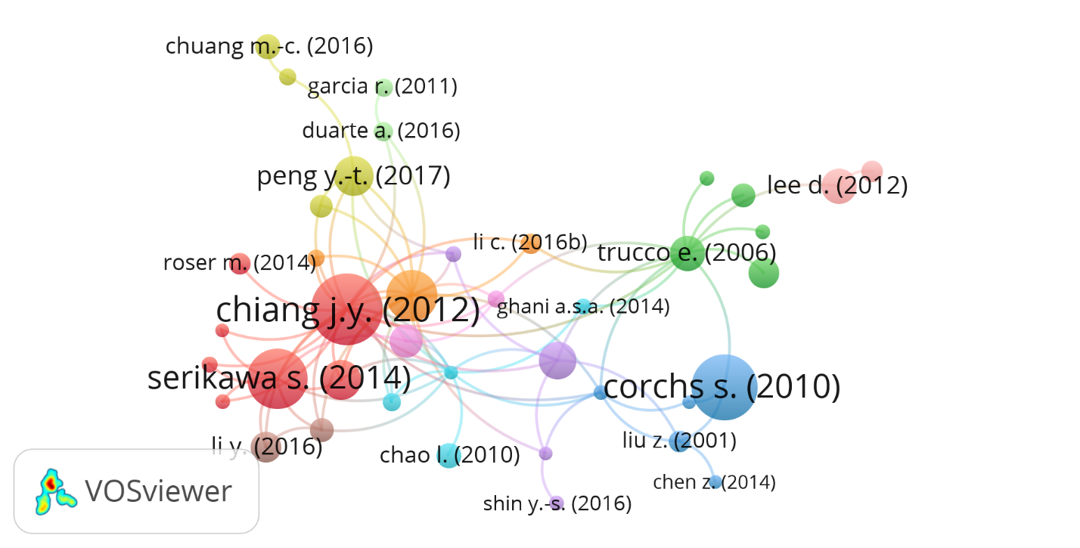
Figure 3: Global citation network in the field of underwater image processing

Table 12 represents the top ten most local cited documents in the field of underwater image processing. Local citation can be defined as the total number of citations obtained by considering the shortlisted articles for the literature review and bibliometric analysis. The highest total local citation of 22 is received by He et al. (2010), followed by Jaffe (1990) and Krizhevsky et al. (2012), respectively.
Table 12: Top ten most local cited documents in the field of underwater image processing
Cited References | Citations
He et al. (2010) | 22
Jaffe (1990) | 20
Krizhevsky et al. (2012) | 16
Yang and Sowmya (2015) | 14
Peng and Cosman (2017) | 13
Chiang and Chen (2011) | 12
Schechner and Karpel (2005) | 10
Galdran et al. (2015) | 9
Lu et al. (2017b) | 9
Wang et al. (2017c) | 9

  - Keyword Statistics
Keyword statistics determine the most prominent and distinctly used keywords in the article titles and keywords section. Table 13 enlists the top twenty keywords used in underwater image processing out of 5125 keywords.
Table 13: Top twenty keywords used in the field of underwater image processing
Words | Occurrences | Words | Occurrences
Underwater Imaging | 258 | Color | 89
Image Reconstruction | 219 | Image Compression | 82
Underwater Acoustics | 209 | Underwater Environments | 74
Image Enhancement | 203 | Demulsification | 71
Image Classification | 159 | Algorithms | 66
Restoration | 155 | Image Denoising | 65
Image Processing | 128 | Image Segmentation | 63
Sonar | 119 | Image Recognition | 62
Neural Networks | 98 | Image Quality | 60
Autonomous Underwater Vehicles | 90 | Convolution | 59

Figure 4 represents the word cloud of the most prominent keywords. The word cloud has been generated using the R package with the help of an input data file.
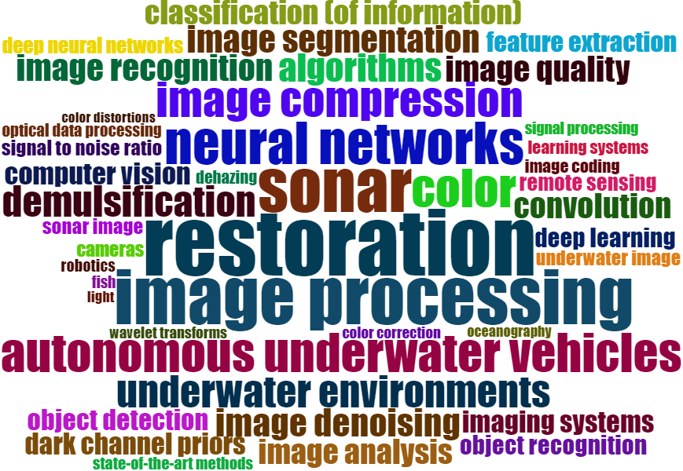
Figure 4: Word cloud of top keywords used in the field of I4.0 and CE

VOS Viewer presents an overlay visualization of words in Figure 5. This visualization conveys the occurrence and connection between keywords based on articles in the field of underwater image processing.
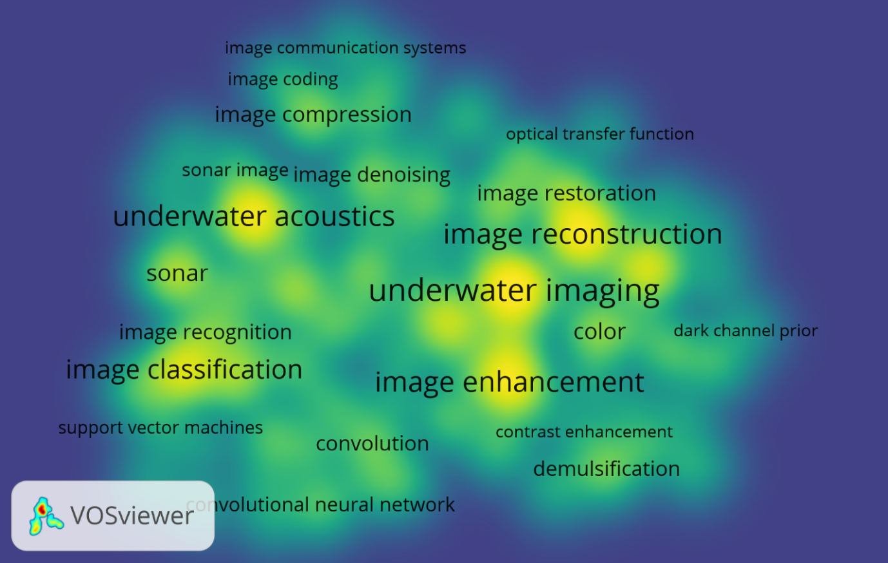
Figure 5: Density Visualisation of top keywords in the field of underwater image processing

The most prominent keywords from Table 13 and Figure 5 are underwater imaging, image reconstruction, and underwater acoustics, respectively.
- Network Analysis
Open-source software such as R and VOS Viewer is used for performing network analysis of publications. Dataset consisting of bibliographic data is saved in Comma Separated Values (CSV) format, which is used for citation analysis.

  - Co-citation analysis

Based on the citation of articles, co-citation analysis helps identify the relationship between articles, numbers, and key authors in a specific work area. Co-citation analysis is graph-based Exploratory Data Analysis [EDA] (Pampel, 2004). The outcome of a co-citation analysis is a graph that consists of nodes and edges. The nodes represent the articles, and edges depict the co-occurrence of articles (Leydesdorff and Welbers, 2011). Co-citation of two or more papers in the selected articles for review occurs if they appeared together in the reference list of any third paper of the same sample. Figure 6 represents the co-citation analysis in the field of underwater image processing.
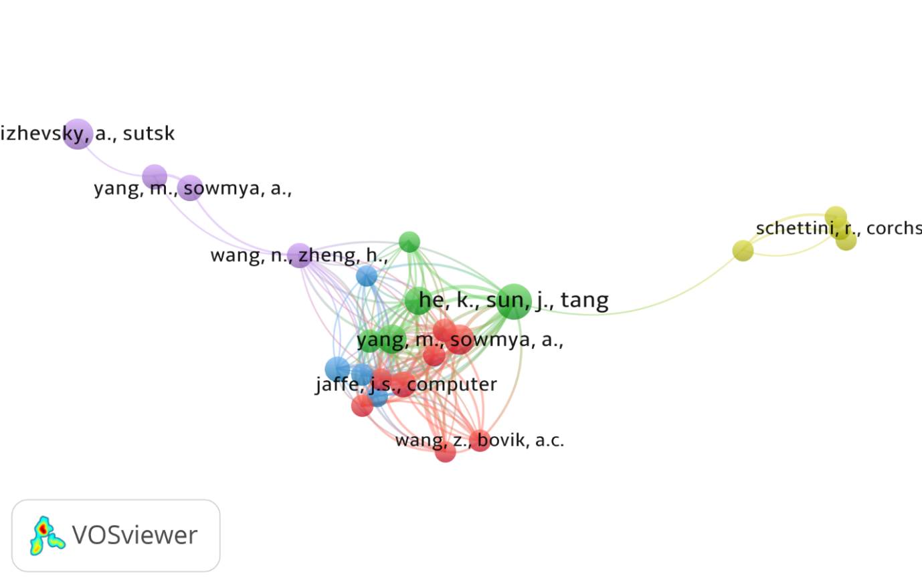
Figure 6: Co-citation analysis in the field of underwater image processing

  - Country Collaboration
Country collaborations provide information regarding the collaboration of researchers of different countries across the world. Figure 7 presents the country's collaboration in the field of underwater image processing. The highest collaboration can be seen between China and the United States of America from Figure 7.
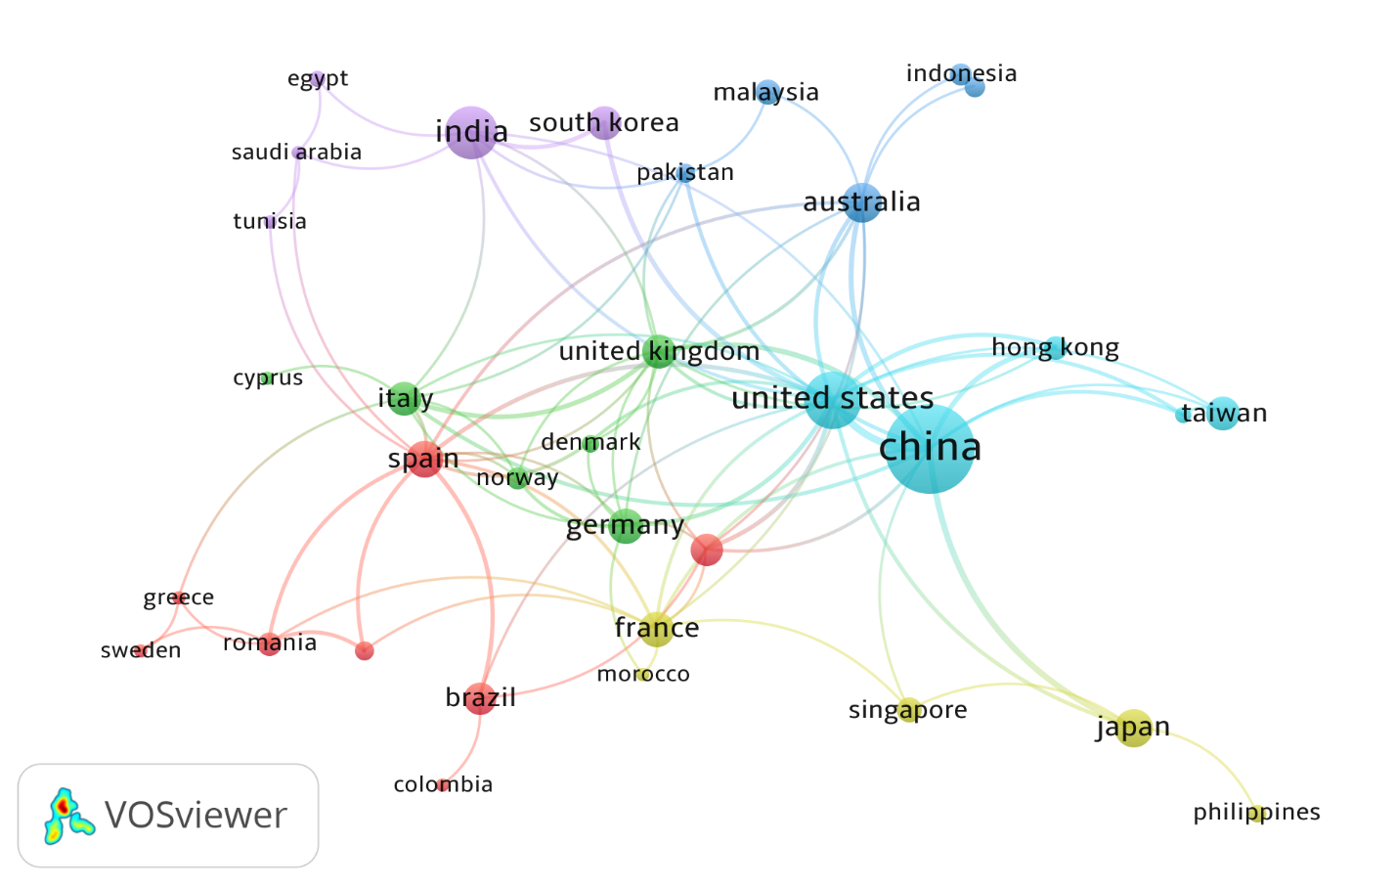
Figure 7: Country author collaboration

- Discussion of Findings
The complexity of the underwater environment leads to difficulty in the exploration of underwater research and engineering. There are several applications for underwater imaging, which are affected by the underwater environment. The underwater environment plays a significant role in improving and enhancing the economy and relationships between different countries across the world. Applications of underwater environment involve underwater image detection, resource exploration, protection of the underwater environment, ocean mining, minerals, energy resources, a wild fish stock which involves counting and monitoring fish species, and underwater environment monitoring the effects of climatic changes such as high temperature and increasing CO₂ content.
The systematic underwater literature review provides an insight into the current and future research interest in underwater image sensing. The literature review included papers from underwater image denoising, detection, recognition, restoration, generation, dehazing, deblurring, quality assessment, classification, compression, and image processing. In this regard, a literature review and a bibliometric analysis was carried out on 970 articles collected from the SCOPUS database. To carry out the review in a systematic way, several factors were considered, such as the selection of a database of research papers and keywords, criteria for inclusion and exclusion of articles.
This systematic underwater literature review and bibliometric analysis are carried out to understand the applications and problems faced by underwater imaging techniques. Exploration of the underwater environment is inhibited by the disadvantages caused by several natural conditions such as underwater organic and inorganic elements, water particles, depth, temperature variation, etc. All these factors directly or indirectly affect the quality of images captured using underwater sensors. The transmission of underwater images is affected by the bandwidth and high path loss communication channels. The bibliometric analysis helped in identifying key authors, journals, influential institutions, and impactful keywords. Chiang and Chen (2011) have obtained the highest global citation of 368 (see Table 12). The most prominent keywords are underwater imaging, image construction, and underwater acoustics (see Table 13). Li Y has been identified as one of the most prominent authors with a contribution of 32 articles. Harbin Engineering University, China, is among the most influential institutions.
6.1 Emerging research themes
The emerging research themes in the area of underwater image processing applications has been identified by utilizing cluster analysis (Waltman et al., 2010). Based on Total Link Strength (TLS), five major research clusters have been identified from cluster analysis. Table 14 presents the lead articles from clusters in the field of underwater image processing.
Table 14: Lead articles from clusters
Cluster 1 articles | Link | Total Link strength
Yang and Sowmya (2015) | 17 | 84
Jaffe (1990) | 17 | 69
Ancuti et al. (2012) | 17 | 59
Galdran et al. (2015) | 17 | 56
Li et al. (2016b) | 16 | 53
Schechner and Karpel (2005) | 17 | 49
Mittal et al. (2012) | 14 | 38
Wang et al. (2004) | 13 | 30
Cluster 2 articles | Link | Total Link strength
He et al. (2010) | 18 | 91
Chiang and Chen (2011) | 17 | 75
Peng and Cosman (2017) | 17 | 74
Zhao et al. (2015) | 17 | 63
Carlevaris-Bianco et al. (2010) | 12 | 24
Cluster 3 articles | Link | Total Link strength
Panetta et al. (2015) | 17 | 49
Ancuti and Ancuti (2013) | 16 | 43
Lu et al. (2017b) | 15 | 18
Cluster 4 articles | Link | Total Link strength
Liu et al. (2001) | 4 | 8
Trucco and Olmos-Antillon (2006) | 3 | 8
Hou et al. (2008) | 2 | 5
Schettini and Corchs (2010) | 2 | 2
Cluster 5 articles | Link | Total Link strength
Wang et al. (2017c) | 17 | 24
Yang and Sowmya (2015) | 2 | 7
Krizhevsky et al. (2012) | 1 | 1

Cluster 1 basically consists of articles which concentrates on image quality assessment. Cluster 2 consists of articles which concentrates on image enhancement. Cluster 3 consists of articles which concentrates on fusion techniques which can improve the quality of the image by dehazing. Cluster 4 consists of articles which concentrate on image restoration. Cluster 4 consists of articles which concentrates on degraded images.
Cluster 1 has the highest TLS of 84 for Yang and Soumya (2015). The study proposes an effective subjective metric for evaluating the quality of underwater images based on chroma, saturation, and contrast. Jaffe (1990) has a TLS of 69 and proposed an optimal underwater computer model and design to form an underwater image using incoherent light. Ancuti et al. (2012) has a TLS of 59 and proposed an underwater enhancement technique. It is based on the fusion of color corrected and contrast-enhanced images and weights derived from a single degraded image. Galdran et al. (2015) has a TLS of 56. The paper proposes an underwater image color contrast recovery technique by restoring the shorter wavelength. Li et al. (2016b) have a TLS of 53. This study proposes an image dehazing technique to enhance the quality of the underwater image. It uses the information loss principle and histogram distribution prior respectively to generate two types of output images. Schencher and Karpel (2005) has a TLS of 49. This study proposes an image enhancement technique by removing the causes of degradation in underwater images. This method reverses the process of image formation and captures images through a polarizer positioned at different angles. Mittal et al. (2012) have a TLS of 38. This study proposes a blind image quality assessment technique. It provides metrics to measure the “naturalness” of the image by using statistics of the scene. Wang et al. (2004) have a TLS of 30. This study proposes an image quality assessment technique based on the loss of structural information. The structural similarity of the reference image is compared with the degraded image to get the image quality metric.
Cluster 2 has the highest TLS of 91 for He et al. (2010). The study proposed a methodology to dehaze the image using a dark channel before the physical haze imaging model. Chiang and Chen (2011) have a TLS of 75. This paper proposed an image enhancement technique. This method uses the dehazing technique and wavelength compensation to restore color contrast and quality of underwater images. Peng and Cosman (2017) has a TLS of 74. In this paper, depth estimation is combined with the Image Formation Model (IFM) to provide image enhancement. Zhao et al. (2015) have a TLS of 63. This paper proposes an image enhancement method based on optical properties derived from the background color of underwater images. Carlevaris-Bianco et al. (2010) has a TLS of 24. This paper proposes using prior information regarding the attenuation found in the three-color channels of the image to compute the depth information. This is used to estimate and reduce the amount of haze present in the scene.
Cluster 3 has the highest TLS of 49 for Panetta et al. (2015). This paper proposed a non-reference underwater image quality measure that uses colorfulness, sharpness, and contrast information in an image. Ancutti and Ancutti (2013) have a TLS of 43. The paper proposed a pixel-based Multi-scale fusion technique to reduce dehazing in underwater images. Lu et al. (2017b) have a TLS of 18. This paper proposes an image enhancement method based on self-similarity and convex fusion to recover high-resolution underwater images.
Cluster 4 has the highest TLS of 8 for Liu et al. (2001). This paper proposes a methodology to measure Point Spread Fusion (PSF) and Modulation Transfer Function (MTF) to compute the light propagation in the underwater environment. MTF, along with the Wiener filter, is used to reduce the haze found in underwater images. Trucco and Olmos-Antillon (2006) has a TLS of 8. This paper proposed a self-tuned underwater image restoration based on the simplified version of the Jaffe-Mc Glamery image formation model. Hou et al. (2008) have a TLS of 5. This paper presents a comparison and validation of the Point Spread Function (PSF) used to restore the quality of degraded underwater images. Schettini and Corchs (2010) have a TLS of 2. This paper is a review of various techniques available for underwater image processing.
Cluster 5 has the highest TLS of 24 for Wang et al. (2017c). This paper proposed an image restoration technique based on Maximum Attenuation Identification (MAI) from the depth map of degraded underwater images. Yang and Soumya (2015) has a TLS of 7. This paper proposes a real-time image quality evaluation metric based on chroma, contrast, and saturation of underwater images to measure the degree of degradation. Krizhevsky et al. (2012) has a TLS of 1. This paper presents a deep learning model for ImageNet Classification.
Three field diagrams in Figure 8 is used to represent the graphical relationship between countries, top contributing authors, and keywords.
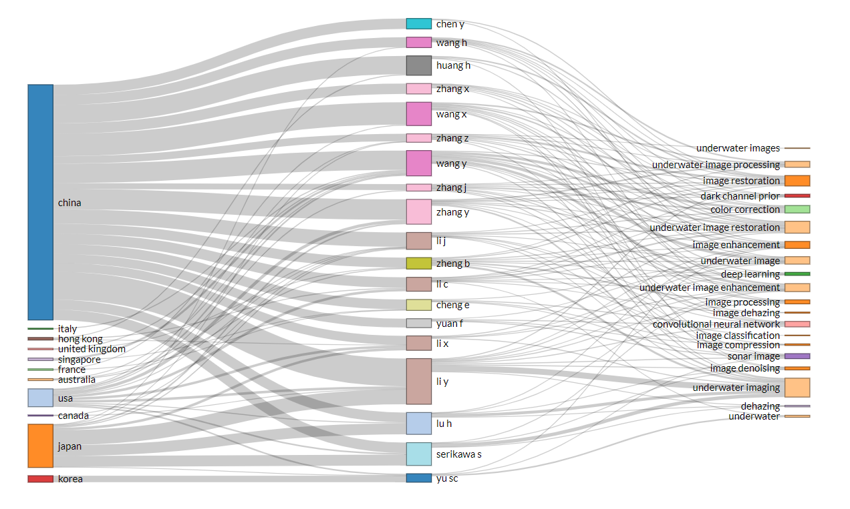
Figure 8. Three field diagram

6.2 Theoretical Contribution
Underwater environment cleaning applications require capturing clear underwater images for proper diagnosis of debris, biofouling of ship hulls, oil pipes, valves, risers, and detecting ship wreckage and mine detection.
Underwater images are affected by natural and spot noise. Various deep learning frameworks, filter, fuzzy, and Retinex model-based techniques have been discussed to overcome noise magnitude. Underwater surveillance requires underwater image classification for explicit knowledge of the location and distribution of underwater pipelines, cables, offshore structures, mines, planktons, benthic organisms, and coral reefs. ResNets, transfer learning using ImageNet, Adaptive weighted neural networks, Support vector machines, tree-based hierarchical classifier techniques are proposed for efficient underwater image classification.
Turbidity caused by suspended particles causes underwater image blur. Image restoration techniques such as deep learning techniques utilizing Adaptive sparse domain selection, Red channel prior, color correction, and DehazeNet helps to reduce the magnitude of blur in underwater images. Underwater image quality can be restored using Histogram Equalization combined with Laplacian Pyramid, Fusion-based quad-tree, polarization, Retinex decomposition-based techniques. Underwater image recognition is accompanied by Generalized Robust graph-Laplacian PCA, Faster MSSDLite, FP-norm based PCA, CNN embedded FPGA, ElasticNet based on genetic programming techniques. Full-reference, non-reference, HVS, IAM discriminator ‘C’, and patch-based Q metric are discussed image quality assessment metrics. Image generation involves GANs trained on Sonar and camera images, Plenoptic cameras using Spatio-temporal filters, 3D simulators known as SOFI, and CZT techniques for generating underwater images.
Underwater image compression techniques are reviewed that overcome the bandwidth and high path loss caused due to underwater communication channels. These include energy-based adaptive block compression, adaptive compression based on image measurement activity, principal component analysis, stationary wavelet transform based, SPIHT on wavelet packet, Depth embedded block tree.
For accurate path planning, there is a need for underwater image detection. The techniques available for the same are ACA-IQPSO, AIA-DF, NQSFLA, depth-map estimation using stereo-vision detection, SFLA with QPSO, and FCA. Artefacts caused due to low illumination can be removed with DCP with MRF, CNN with inverse IMF model, an integration of DCP, variational Retinex model, ADMM and IFM, residual architecture with domain knowledge, and haze distribution. The quality of the acquired images can be evaluated using image quality assessment techniques. This is done to check if the acquired images comply with the standards required for further image processing used for image detection and classification.

  - Practical Implications
This study provides systematic knowledge based on different techniques in underwater image processing. This study provides the following two significant implications for researchers, scientists, and end-users:
- From the literature review and bibliometric analysis, it can be found that universities and researchers all over the world have tremendously worked on various disadvantages faced by underwater imaging as underwater imaging has a significant role in enhancing the economy and relationships between the different countries around the world. This study will further help them inappropriate decision-making to face the challenges in underwater image processing.
- The study would enable the identification of effective underwater image processing techniques which could help in decision-making for underwater environment cleaning applications.
- This study highlights the most influential and impactful technologies and keywords in the field of underwater image processing. This would help in the better understanding of the applications of underwater image processing.
Figure 9 proposes a research framework by systematically organizing the main underwater techniques and their relationships to maximize the benefits offered in different underwater imaging fields.
Image Generation
Image Denoising
Image Dehazing
Image Deblurring
Image Recognition
Image Compression
Image Detection
Image Restoration
Image Classification
Storage
Image Quality Assessment
Figure 9: A proposed research framework

- Conclusion and Future Research Directions
The exploration of underwater research and engineering is affected the complex nature of underwater environment. Underwater image detection, resource and underwater environment exploration and monitoring, and ocean mining are some of the well-known applications of underwater environment. A systematic underwater literature review and a bibliometric analysis was carried out on 970 articles collected from the SCOPUS database. Underwater image denoising, detection, recognition, restoration, generation, dehazing, deblurring, quality assessment, classification, compression, and image processing were the topics chosen for the literature review. Key authors, journals, influential institutions, and impactful keywords were identified using bibliometric analysis. Bibliometric analysis shows that Li Y is the most prominent author and Harbin Engineering University, China is the most influential institution. Underwater imaging, image construction, and underwater acoustics are the most prominent keywords. Detailed literature review helped in understanding the applications and problems faced by underwater imaging techniques. The presence of underwater organic and inorganic elements, water particles, depth, temperature variation, etc., directly, or indirectly affect the quality and transmission of image captured. The study will help researchers and engineers in developing practical strategic plans for underwater environment cleaning operations.
  - Future research directions
From the literature survey, many methodologies have been provided in various fields of underwater image processing. From the bibliometric analysis, it has been found that several countries need to implement underwater image processing techniques for their economic growth. Underwater imaging has found its importance in a scientific study that requires collecting information regarding the location and distribution of underwater pipelines, cables, offshore structures, mines, and life beneath the deep sea. The underwater environment and low bandwidth transmission channels are considered as the significant barriers in collecting this information. Underwater applications require capturing clear underwater images for proper diagnosis of debris, biofouling of ship hulls, oil pipes, valves, risers, and ship wreckage, and mine detection. All these applications require clear underwater images transmitted via low-bandwidth acoustic channels. therefore, there is a vital requirement for various underwater image processing techniques such as image denoising, image dehazing, image restoration, and image deblurring techniques. For better knowledge of the location and distribution of underwater pipelines, cables, structures, benthic organisms, and coral reefs, good image classification and recognition techniques are required. There is a need to develop underwater image compression techniques, which play a significant role in transmitting these images via low-bandwidth acoustic channels.
References
Aggarwal, A., Mittal, M., & Battineni, G. (2021). Generative adversarial network: An overview of theory and applications. International Journal of Information Management Data Insights, 100004.
Agrawal, R., Wankhede, V. A., Kumar, A., Upadhyay, A., & Garza-Reyes, J. A. (2021). Nexus of circular economy and sustainable business performance in the era of digitalization. International Journal of Productivity and Performance Management. (DOI: 10.1108/IJPPM-12-2020-0676)
Ahn, J., Yasukawa, S., Sonoda, T., Nishida, Y., Ishii, K., & Ura, T. (2018). An optical image transmission system for deep sea creature sampling missions using autonomous underwater vehicle. IEEE Journal of Oceanic Engineering.
Ali, H. S., Atallah, A. M., & Abdalla, M. I. (2017). An efficient source–channel coding for wireless image transmission over underwater acoustic channel. Wireless Personal Communications, 96(1), 291-302.
Alippi, C., Camplani, R., Galperti, C., & Roveri, M. (2010). A robust, adaptive, solar-powered WSN framework for aquatic environmental monitoring. IEEE Sensors Journal, 11(1), 45-55.
Allais, A. G., Bouhier, M. E., Edmond, T., Boffety, M., Galland, F., Maciol, N., ... & Ebert, K. (2011, June). SOFI: A 3D simulator for the generation of underwater optical images. In OCEANS 2011 IEEE-Spain (pp. 1-6). IEEE.
Ancuti, C. O., & Ancuti, C. (2013). Single image dehazing by multi-scale fusion. IEEE Transactions on Image Processing, 22(8), 3271-3282.
Ancuti, C. O., Ancuti, C., De Vleeschouwer, C., & Sbert, M. (2019). Color Channel Compensation (3C): A fundamental pre-processing step for image enhancement. IEEE Transactions on Image Processing, 29, 2653-2665.
Ancuti, C., Ancuti, C. O., Haber, T., & Bekaert, P. (2012, June). Enhancing underwater images and videos by fusion. In 2012 IEEE Conference on Computer Vision and Pattern Recognition (pp. 81-88). IEEE.
Bailey, G. N., & Flemming, N. C. (2008). Archaeology of the continental shelf: marine resources, submerged landscapes and underwater archaeology. Quaternary Science Reviews, 27(23-24), 2153-2165.
Barat, C., & Phlypo, R. (2010). A fully automated method to detect and segment a manufactured object in an underwater color image. EURASIP Journal on Advances in Signal Processing, 2010, 1-10.
Bartolini, M., Bottani, E., & Grosse, E. H. (2019). Green warehousing: Systematic literature review and bibliometric analysis. Journal of Cleaner Production, 226, 242-258.
Bi, P., Xu, J., Du, X., & Li, J. (2020). Generalized robust graph-Laplacian PCA and underwater image recognition. Neural Computing and Applications, 1-18.
Bindhu, A., Lakshmipriya, K., & Maheswari, O. U. (2020). Classification based on underwater degradation using neural network. Journal of Ambient Intelligence and Humanized Computing, 1-8.
Bioucas-Dias, J. M., & Figueiredo, M. A. (2010). Multiplicative noise removal using variable splitting and constrained optimization. IEEE Transactions on Image Processing, 19(7), 1720-1730.
Cai, Y. Q., Zou, H. X., & Yuan, F. (2019). Adaptive compression method for underwater images based on perceived quality estimation. Frontiers of Information Technology & Electronic Engineering, 20(5), 716-730.
Cao, S., Zhao, D., Liu, X., & Sun, Y. (2020). Real-time robust detector for underwater live crabs based on deep learning. Computers and Electronics in Agriculture, 172, 105339.
Carlevaris-Bianco, N., Mohan, A., & Eustice, R. M. (2010, September). Initial results in underwater single image dehazing. In Oceans 2010 Mts/IEEE Seattle (pp. 1-8). IEEE. (DOI: 10.1109/OCEANS.2010.5664428).
Chang, H. H. (2020). Single Underwater Image Restoration Based on Adaptive Transmission Fusion. IEEE Access, 8, 38650-38662.
Chauhan, S., Agarwal, N., & Kar, A. K. (2016). Addressing big data challenges in smart cities: a systematic literature review. info. 18(4), 73-90.
Chen, M. F., Kung, Y. C., Chou, S. J., Lo, W. S., & Wang, C. K. (2014). Real-time image acquisition and deblurring for underwater gravel extraction by smartphone. International Journal of Automation and Smart Technology, 4(1), 5-11.
Chen, W., Gu, K., Min, X., Yuan, F., Cheng, E., & Zhang, W. (2018). Partial-reference sonar image quality assessment for underwater transmission. IEEE Transactions on Aerospace and Electronic Systems, 54(6), 2776-2787.
Chiang, J. Y., & Chen, Y. C. (2011). Underwater image enhancement by wavelength compensation and dehazing. IEEE Transactions on Image Processing, 21(4), 1756-1769.
Chintalapudi, N., Battineni, G., Di Canio, M., Sagaro, G. G., & Amenta, F. (2021). Text mining with sentiment analysis on seafarers’ medical documents. International Journal of Information Management Data Insights, 1(1), 100005.
Cho, Y., Jang, H., Malav, R., Pandey, G., & Kim, A. (2020). Underwater Image Dehazing via Unpaired Image-to-image Translation. International Journal of Control, Automation and Systems, 18(3), 605-614.
Chuang, M. C., Hwang, J. N., & Williams, K. (2016). A feature learning and object recognition framework for underwater fish images. IEEE Transactions on Image Processing, 25(4), 1862-1872.
Corgnati, L., Marini, S., Mazzei, L., Ottaviani, E., Aliani, S., Conversi, A., & Griffa, A. (2016). Looking inside the ocean: Toward an autonomous imaging system for monitoring gelatinous zooplankton. Sensors, 16(12), 2124.
Dai, C., Lin, M., Wu, X., Wang, Z., & Guan, Z. (2020). Single underwater image restoration by decomposing curves of attenuating color. Optics & Laser Technology, 123, 105947.
Ding, X., Wang, Y., Liang, Z., Zhang, J., & Fu, X. (2017, August). Towards underwater image enhancement using super-resolution convolutional neural networks. In International Conference on Internet Multimedia Computing and Service (pp. 479-486). Springer, Singapore.
Fang, M. C., Wang, S. M., Mu-Chen, W., & Lin, Y. H. (2015). Applying the self-tuning fuzzy control with the image detection technique on the obstacle-avoidance for autonomous underwater vehicles. Ocean Engineering, 93, 11-24.
Farhadifard, F., Radolko, M., Bashford-Rogers, T., & Santos, L. P. (2016, May). Adaptive UW Image Deblurring via Sparse Representation. In Eurographics (Short Papers) (pp. 41-44).
Foresti, G. L., & Gentili, S. (2002). A hierarchical classification system for object recognition in underwater environments. IEEE Journal of oceanic engineering, 27(1), 66-78.
Foschi, P. G., Kolippakkam, D., Liu, H., & Mandvikar, A. (2002, October). Feature Extraction for Image Mining. In Multimedia Information Systems (pp. 103-109).
Galdran, A., Pardo, D., Picón, A., & Alvarez-Gila, A. (2015). Automatic red-channel underwater image restoration. Journal of Visual Communication and Image Representation, 26, 132-145.
Gaudron, J. O., Surre, F., Sun, T., & Grattan, K. T. V. (2013). Long period grating-based optical fibre sensor for the underwater detection of acoustic waves. Sensors and Actuators A: Physical, 201, 289-293.
Geraldi, J., Maylor, H., & Williams, T. (2011). Now, let's make it really complex (complicated). International journal of operations & production management, 31(9), 966-990.
Gómez-Ríos, A., Tabik, S., Luengo, J., Shihavuddin, A. S. M., Krawczyk, B., & Herrera, F. (2019). Towards highly accurate coral texture images classification using deep convolutional neural networks and data augmentation. Expert Systems with Applications, 118, 315-328.
Grover, P., & Kar, A. K. (2017). Big data analytics: A review on theoretical contributions and tools used in literature. Global Journal of Flexible Systems Management, 18(3), 203-229.
Guidi, L., Stemmann, L., Jackson, G. A., Ibanez, F., Claustre, H., Legendre, L., ... & Gorskya, G. (2009). Effects of phytoplankton community on production, size, and export of large aggregates: A world‐ocean analysis. Limnology and Oceanography, 54(6), 1951-1963.
Gupta, S., Kar, A. K., Baabdullah, A., & Al-Khowaiter, W. A. (2018). Big data with cognitive computing: A review for the future. International Journal of Information Management, 42, 78-89.
Han, M., Lyu, Z., Qiu, T., & Xu, M. (2018). A review on intelligence dehazing and color restoration for underwater images. IEEE Transactions on Systems, Man, and Cybernetics: Systems.
Harvey, E. S., Goetze, J., McLaren, B., Langlois, T., & Shortis, M. R. (2010). Influence of range, angle of view, image resolution and image compression on underwater stereo-video measurements: high-definition and broadcast-resolution video cameras compared. Marine Technology Society Journal, 44(1), 75-85
Hassan, H., Bashir, A. K., Ahmad, M., Menon, V. G., Afridi, I. U., Nawaz, R., & Luo, B. (2020). Real-time image dehazing by superpixels segmentation and guidance filter. Journal of Real-Time Image Processing, 1-21.
He, K., Sun, J., & Tang, X. (2010). Single image haze removal using dark channel prior. IEEE transactions on pattern analysis and machine intelligence, 33(12), 2341-2353.
Hölbl, M., Kompara, M., Kamišalić, A., & Nemec Zlatolas, L. (2018). A systematic review of the use of blockchain in healthcare. Symmetry, 10(10), 470.
Hou, G., Li, J., Wang, G., Pan, Z., & Zhao, X. (2020a). Underwater image dehazing and denoising via curvature variation regularization. Multimedia Tools and Applications, 79(27), 20199-20219.
Hou, G., Zhao, X., Pan, Z., Yang, H., Tan, L., & Li, J. (2020b). Benchmarking Underwater Image Enhancement and Restoration, and Beyond. IEEE Access, 8, 122078-122091.
Hou, W., Gray, D. J., Weidemann, A. D., & Arnone, R. A. (2008). Comparison and validation of point spread models for imaging in natural waters. Optics Express, 16(13), 9958-9965.
Hsu, W., Lee, M. L., & Zhang, J. (2002). Image mining: Trends and developments. Journal of intelligent information systems, 19(1), 7-23.
Huo, G., Wu, Z., & Li, J. (2018, October). Underwater Image Restoration Based on Color Correction and Red Channel Prior. In 2018 IEEE International Conference on Systems, Man, and Cybernetics (SMC) (pp. 3975-3980). IEEE.
Inamdar, Z., Raut, R., Narwane, V. S., Gardas, B., Narkhede, B., & Sagnak, M. (2020). A systematic literature review with bibliometric analysis of big data analytics adoption from period 2014 to 2018. Journal of Enterprise Information Management.
Jaffe, J. S. (1990). Computer modeling and the design of optimal underwater imaging systems. IEEE Journal of Oceanic Engineering, 15(2), 101-111.
Jalal, A. A. (2018). Big data and intelligent software systems. International Journal of Knowledge-based and Intelligent Engineering Systems, 22(3), 177-193.
Jalal, A. A., & Ali, B. H. (2021). Text documents clustering using data mining techniques. International Journal of Electrical & Computer Engineering (2088-8708), 11(1).
Jiang, Q., Chen, Y., Wang, G., & Ji, T. (2020). A novel deep neural network for noise removal from underwater image. Signal Processing: Image Communication, 87, 115921.
Jiji, C., & Ramrao, N. (2018). A novel technique for enhancing color of undersea deblurred imagery. Advances in Science, Technology and Engineering Systems, 3(6), 97-104.
Jin, L., & Liang, H. (2017, June). Deep learning for underwater image recognition in small sample size situations. In OCEANS 2017-Aberdeen (pp. 1-4). IEEE.
Jin, Y., Ku, B., Ahn, J., Kim, S., & Ko, H. (2019). Nonhomogeneous Noise Removal From Side-Scan Sonar Images Using Structural Sparsity. IEEE Geoscience and Remote Sensing Letters, 16(8), 1215-1219.
Johnson, A. E., & Hebert, M. (1996). Seafloor map generation for autonomous underwater vehicle navigation. Autonomous Robots, 3(2-3), 145-168.
Junior, M. L., & Godinho Filho, M. (2010). Variations of the kanban system: Literature review and classification. International Journal of Production Economics, 125(1), 13-21.
Kar, A. K., Ilavarasan, V., Gupta, M. P., Janssen, M., & Kothari, R. (2019). Moving beyond smart cities: Digital nations for social innovation & sustainability. Information Systems Frontiers, 21(3), 495-501.
Kim, J., Song, S., & Yu, S. C. (2017, February). Denoising auto-encoder based image enhancement for high resolution sonar image. In 2017 IEEE Underwater Technology (UT) (pp. 1-5). IEEE.
Kim, K., Kim, H. S., Shim, J., & Park, J. S. (2021). A Study in the Early Prediction of ICT Literacy Ratings Using Sustainability in Data Mining Techniques. Sustainability, 13(4), 2141.
King, P., Vardy, A., & Forrest, A. L. (2018). Teach‐and‐repeat path following for an autonomous underwater vehicle. Journal of Field Robotics, 35(5), 748-763.
Krizhevsky, A., Sutskever, I., & Hinton, G. E. (2012). Imagenet classification with deep convolutional neural networks. In Advances in neural information processing systems (pp. 1097-1105).
Kumar, S., & Kumar, S. (2008, July). Collaboration in research productivity in oil seed research institutes of India. In Proceedings of Fourth International Conference on Webometrics, Informetrics and Scientometrics (Vol. 28).
Kumar, S., Kar, A. K., & Ilavarasan, P. V. (2021). Applications of text mining in services management: A systematic literature review. International Journal of Information Management Data Insights, 1(1), 100008.
Kushwaha, A. K., Kar, A. K., & Dwivedi, Y. K. (2021). Applications of big data in emerging management disciplines: A literature review using text mining. International Journal of Information Management Data Insights, 1(2), 100017.
Lee, D., Kim, G., Kim, D., Myung, H., & Choi, H. T. (2012). Vision-based object detection and tracking for autonomous navigation of underwater robots. Ocean Engineering, 48, 59-68.
Leydesdorff, L., & Welbers, K. (2011). The semantic mapping of words and co-words in contexts. Journal of informetrics, 5(3), 469-475.
Li, C. Y., Guo, J. C., Cong, R. M., Pang, Y. W., & Wang, B. (2016a). Underwater image enhancement by dehazing with minimum information loss and histogram distribution prior. IEEE Transactions on Image Processing, 25(12), 5664-5677.
Li, Y., Lu, H., Li, J., Li, X., Li, Y., & Serikawa, S. (2016b). Underwater image de-scattering and classification by deep neural network. Computers & Electrical Engineering, 54, 68-77.
Li, Z., Li, G., Niu, B., & Peng, F. (2018). Sea cucumber image dehazing method by fusion of Retinex and dark channel. IFAC-PapersOnLine, 51(17), 796-801.
Lin, Y. H., Wang, S. M., Huang, L. C., & Fang, M. C. (2017). Applying the stereo-vision detection technique to the development of underwater inspection task with PSO-based dynamic routing algorithm for autonomous underwater vehicles. Ocean Engineering, 139, 127-139.
Liu, H., Li, C., Zhang, D., Zhou, Y., & Du, S. (2020b). Enhanced image no-reference quality assessment based on colour space distribution. IET Image Processing, 14(5), 807-817.
Liu, R., Fan, X., Hou, M., Jiang, Z., Luo, Z., & Zhang, L. (2018). Learning aggregated transmission propagation networks for haze removal and beyond. IEEE transactions on neural networks and learning systems, 30(10), 2973-2986.
Liu, X. Y., Zhang, J. L., Yin, Y. F., Yang, Y., Zhang, C., & Wu, X. X. (2020a). Underwater polarization image restoration based on logarithmic transformation and dark channel. Optoelectronics Letters, 16, 149-153.
Liu, Z., Yu, Y., Zhang, K., & Huang, H. (2001). Underwater image transmission and blurred image restoration. Optical Engineering, 40(6), 1125-1131.
Lu, H., Li, Y., Nakashima, S., Kim, H., & Serikawa, S. (2017b). Underwater image super-resolution by descattering and fusion. IEEE Access, 5, 670-679.
Lu, H., Li, Y., Zhang, Y., Chen, M., Serikawa, S., & Kim, H. (2017a). Underwater optical image processing: a comprehensive review. Mobile networks and applications, 22(6), 1204-1211.
Lyu, Z., Zhang, C., & Han, M. (2020). A nonsubsampled countourlet transform based CNN for real image denoising. Signal Processing: Image Communication, 82, 115727.
Ma, C., Lv, X., & Ao, J. (2019). Difference based median filter for removal of random value impulse noise in images. Multimedia Tools and Applications, 78(1), 1131-1148.
Mahmood, A., Bennamoun, M., An, S., Sohel, F. A., Boussaid, F., Hovey, R., ... & Fisher, R. B. (2018). Deep image representations for coral image classification. IEEE Journal of Oceanic Engineering, 44(1), 121-131.
Mahmood, A., Bennamoun, M., An, S., Sohel, F., & Boussaid, F. (2020). ResFeats: Residual network based features for underwater image classification. Image and Vision Computing, 93, 103811.
Marini, S., Fanelli, E., Sbragaglia, V., Azzurro, E., Fernandez, J. D. R., & Aguzzi, J. (2018). Tracking fish abundance by underwater image recognition. Scientific reports, 8(1), 1-12.
Mittal, A., Moorthy, A. K., & Bovik, A. C. (2012). No-reference image quality assessment in the spatial domain. IEEE Transactions on image processing, 21(12), 4695-4708.
Mohamed, S., Huang, B., & Kechadi, T. (2018). Use of Data Mining Techniques to Predict Short Term Adverse Events Occurrence in NB-UVB Phototherapy Treatments. International Journal of Machine Learning and Computing, 8(2), 104-111.
Mongeon, P., & Paul-Hus, A. (2016). The journal coverage of Web of Science and Scopus: a comparative analysis. Scientometrics, 106(1), 213-228.
Monika, R., Samiappan, D., & Kumar, R. (2020). Underwater image compression using energy based adaptive block compressive sensing for IoUT applications. The Visual Computer, 1-17.
Mughal, M. J. H. (2018). Data mining: web data mining techniques, tools and algorithms: an overview. Information Retrieval, 9(6).
Murino, V., & Trucco, A. (1999). A confidence-based approach to enhancing underwater acoustic image formation. IEEE transactions on image processing, 8(2), 270-285.
Palmese, M., & Trucco, A. (2007, May). Digital near field beamforming for efficient 3-D underwater acoustic image generation. In 2007 IEEE International Workshop on Imaging Systems and Techniques (pp. 1-5). IEEE.
Palmese, M., & Trucco, A. (2010). An efficient digital CZT beamforming design for near-field 3-D sonar imaging. IEEE Journal of Oceanic Engineering, 35(3), 584-594.
Pampel, F.C. (2004), Exploratory Data Analysis, Encyclopedia of Social Science Research Methods, SAGE Publications, London.
Pan, P. W., Yuan, F., Guo, J., & Cheng, E. (2017, October). Underwater image visibility improving algorithm based on HWD and DehazeNet. In 2017 IEEE International Conference on Signal Processing, Communications and Computing (ICSPCC) (pp. 1-4). IEEE.
Panetta, K., Gao, C., & Agaian, S. (2015). Human-visual-system-inspired underwater image quality measures. IEEE Journal of Oceanic Engineering, 41(3), 541-551.
Peng, Y. T., & Cosman, P. C. (2017). Underwater image restoration based on image blurriness and light absorption. IEEE transactions on image processing, 26(4), 1579-1594.
Peng, Y. T., Cao, K., & Cosman, P. C. (2018). Generalization of the dark channel prior for single image restoration. IEEE Transactions on Image Processing, 27(6), 2856-2868.
Pérez, J., Bryson, M., Williams, S. B., & Sanz, P. J. (2020). Recovering Depth from Still Images for Underwater Dehazing Using Deep Learning. Sensors, 20(16), 4580.
Poncela, J., Aguayo, M. C., & Otero, P. (2012). Wireless underwater communications. Wireless Personal Communications, 64(3), 547-560.
Prabhakar, C. J., & Kumar, P. P. (2010, December). Underwater image denoising using adaptive wavelet subband thresholding. In 2010 International Conference on Signal and Image Processing (pp. 322-327). IEEE.
Priyadharsini, R., Sharmila, T. S., & Rajendran, V. (2018). A wavelet transform based contrast enhancement method for underwater acoustic images. Multidimensional Systems and Signal Processing, 29(4), 1845-1859.
Raphael, A., Dubinsky, Z., Iluz, D., & Netanyahu, N. S. (2020). Neural Network Recognition of Marine Benthos and Corals. Diversity, 12(1), 29.
Reshmi, T. R. (2021). Information security breaches due to ransomware attacks-a systematic literature review. International Journal of Information Management Data Insights, 1(2), 100013.
Rubino, E. M., Centelles, D., Sales, J., Marti, J. V., Marin, R., & Sanz, P. J. (2015). Wireless Image Compression and Transmission for Underwater Robotic Applications?. IFAC-PapersOnLine, 48(2), 288-293.
Rubino, E. M., Centelles, D., Sales, J., Martí, J. V., Marín, R., Sanz, P. J., & Álvares, A. J. (2017). Underwater radio frequency image sensor using progressive image compression and region of interest. Journal of the Brazilian Society of Mechanical Sciences and Engineering, 39(10), 4115-4134.
Sánchez-Ferreira, C., Coelho, L. S., Ayala, H. V., Farias, M. C., & Llanos, C. H. (2019). Bio-inspired optimization algorithms for real underwater image restoration. Signal Processing: Image Communication, 77, 49-65.
Sardemann, H., & Maas, H. G. (2016). On the accuracy potential of focused plenoptic camera range determination in long distance operation. ISPRS Journal of Photogrammetry and Remote Sensing, 114, 1-9.
Sarisaray-Boluk, P., Gungor, V. C., Baydere, S., & Harmanci, A. E. (2011). Quality aware image transmission over underwater multimedia sensor networks. Ad Hoc Networks, 9(7), 1287-1301.
Schechner, Y. Y., & Karpel, N. (2005). Recovery of underwater visibility and structure by polarization analysis. IEEE Journal of oceanic engineering, 30(3), 570-587.
Schettini, R., & Corchs, S. (2010). Underwater image processing: state of the art of restoration and image enhancement methods. EURASIP Journal on Advances in Signal Processing, 2010, 1-14.
Serikawa, S., & Lu, H. (2014). Underwater image dehazing using joint trilateral filter. Computers & Electrical Engineering, 40(1), 41-50.
Sethi, R., & Indu, S. (2020). Fusion of Underwater Image Enhancement and Restoration. International Journal of Pattern Recognition and Artificial Intelligence, 34(03), 2054007.
Sollini, M., Antunovic, L., Chiti, A., & Kirienko, M. (2019). Towards clinical application of image mining: a systematic review on artificial intelligence and radiomics. European journal of nuclear medicine and molecular imaging, 46(13), 2656-2672.
Srividhya, K., & Ramya, M. M. (2017). Fuzzy-based adaptive denoising of underwater images. International Journal of Fuzzy Systems, 19(4), 1132-1143.
Su, Y. S., & Wu, S. Y. (2021). Applying data mining techniques to explore user behaviors and watching video patterns in converged IT environments. Journal of Ambient Intelligence and Humanized Computing, 1-8.
Sudhir, R. (2011). A survey on image mining techniques: theory and applications. Computer Engineering and Intelligent Systems, 2(6), 44-52.
Sung, M., Cho, H., Joe, H., Kim, B., & Yu, S. C. (2018, October). Crosstalk noise detection and removal in multi-beam sonar images using convolutional neural network. In OCEANS 2018 MTS/IEEE Charleston (pp. 1-6). IEEE.
Tang, X., Lin, F., Samson, S., & Remsen, A. (2006). Binary plankton image classification. IEEE Journal of Oceanic Engineering, 31(3), 728-735.
Tascini, G., Zingaretti, P., & Conte, G. (1996). Real-time inspection by submarine images. Journal of Electronic Imaging, 5(4), 432-443.
Terayama, K., Shin, K., Mizuno, K., & Tsuda, K. (2019). Integration of sonar and optical camera images using deep neural network for fish monitoring. Aquacultural Engineering, 86, 102000.
Tranfield, D., Denyer, D., & Smart, P. (2003). Towards a methodology for developing evidence‐informed management knowledge by means of systematic review. British journal of management, 14(3), 207-222.
Trucco, E., & Olmos-Antillon, A. T. (2006). Self-tuning underwater image restoration. IEEE Journal of Oceanic Engineering, 31(2), 511-519.
Verma, S., Sharma, R., Deb, S., & Maitra, D. (2021). Artificial intelligence in marketing: Systematic review and future research direction. International Journal of Information Management Data Insights, 100002.
Vinodh, S., Antony, J., Agrawal, R., & Douglas, J. A. (2021). Integration of continuous improvement strategies with Industry 4.0: a systematic review and agenda for further research. The TQM Journal, 33(2), 441-472.
Waltman, L., Van Eck, N. J., & Noyons, E. C. (2010). A unified approach to mapping and clustering of bibliometric networks. Journal of informetrics, 4(4), 629-635.
Wang, N., Zheng, H., & Zheng, B. (2017c). Underwater image restoration via maximum attenuation identification. IEEE Access, 5, 18941-18952.
Wang, X., Hao, W., & Li, Q. (2017a). An adaptive cultural algorithm with improved quantum-behaved particle swarm optimization for sonar image detection. Scientific Reports, 7(1), 1-16.
Wang, X., Jiao, J., Yin, J., Zhao, W., Han, X., & Sun, B. (2019a). Underwater sonar image classification using adaptive weights convolutional neural network. Applied Acoustics, 146, 145-154.
Wang, X., Li, Q., Yin, J., Han, X., & Hao, W. (2019b). An adaptive denoising and detection approach for underwater sonar image. Remote Sensing, 11(4), 396.
Wang, X., Liu, G., Li, L., & Jiang, S. (2015, January). Detection of underwater objects by adaptive threshold FCM based on frequency domain and time domain. In International Conference of Young Computer Scientists, Engineers and Educators (pp. 196-203). Springer, Berlin, Heidelberg.
Wang, X., Liu, S., & Liu, Z. (2017b). Underwater sonar image detection: A combination of non-local spatial information and quantum-inspired shuffled frog leaping algorithm. Plos one, 12(5), e0177666.
Wang, X., Liu, S., Li, Q., & Liu, Z. (2018a). Underwater sonar image detection: A novel quantum-inspired shuffled frog leaping algorithm. Chinese Journal of Electronics, 27(3), 588-594.
Wang, Y., Li, N., Li, Z., Gu, Z., Zheng, H., Zheng, B., & Sun, M. (2018b). An imaging-inspired no-reference underwater color image quality assessment metric. Computers & Electrical Engineering, 70, 904-913.
Wang, Z., Bovik, A. C., Sheikh, H. R., & Simoncelli, E. P. (2004). Image quality assessment: from error visibility to structural similarity. IEEE transactions on image processing, 13(4), 600-612.
Williams, D. P. (2016, December). Underwater target classification in synthetic aperture sonar imagery using deep convolutional neural networks. In 2016 23rd international conference on pattern recognition (ICPR) (pp. 2497-2502). IEEE.
Wu, D., Du, X., & Wang, K. (2018, June). An effective approach for underwater sonar image denoising based on sparse representation. In 2018 IEEE 3rd International Conference on Image, Vision and Computing (ICIVC) (pp. 389-393). IEEE.
Xinyu, T., Xuewu, Z., Xiaolong, X., Jinbao, S., & Yan, X. (2017, December). Methods for underwater sonar image processing in objection detection. In 2017 International Conference on Computer Systems, Electronics and Control (ICCSEC) (pp. 941-944). IEEE.
Xu, H., Tan, Y., Wang, W., & Wang, G. (2020). Image Dehazing by Incorporating Markov Random Field with Dark Channel Prior. Journal of Ocean University of China, 19, 551-560.
Xu, J., Bi, P., Du, X., & Li, J. (2019). Robust PCANet on target recognition via the UUV optical vision system. Optik, 181, 588-597.
Xu, X., Chen, X., Jia, F., Brown, S., Gong, Y., & Xu, Y. (2018). Supply chain finance: A systematic literature review and bibliometric analysis. International Journal of Production Economics, 204, 160-173.
Yang, M., & Sowmya, A. (2014). New image quality evaluation metric for underwater video. IEEE Signal Processing Letters, 21(10), 1215-1219.
Yang, M., & Sowmya, A. (2015). An underwater color image quality evaluation metric. IEEE Transactions on Image Processing, 24(12), 6062-6071.
Yang, M., Sowmya, A., Wei, Z., & Zheng, B. (2019). Offshore underwater image restoration using reflection-decomposition-based transmission map estimation. IEEE Journal of Oceanic Engineering, 45(2), 521-533.
Ye, Z. S., Yuan, F., Cheng, E., & Lin, C. R. (2013). Image Quality Assessment Method for Underwater Acoustic Communication Based on Digital Watermarking. In Advanced Materials Research (Vol. 765, pp. 562-566). Trans Tech Publications Ltd.
Yu, S. C. (2008). Development of real-time acoustic image recognition system using by autonomous marine vehicle. Ocean Engineering, 35(1), 90-105.
Zhang, S., Zhang, M., Cui, Y., Liu, X., He, B., & Chen, J. (2019). A fast ELM-based machine compression scheme for underwater image transmission on a low-bandwidth acoustic channel. Sensor Review.
Zhang, Y., Negahdaripour, S., & Li, Q. (2016). Low bit-rate compression of underwater imagery based on adaptive hybrid wavelets and directional filter banks. Signal Processing: Image Communication, 47, 96-114.
Zhao, M., Hu, C., Wei, F., Wang, K., Wang, C., & Jiang, Y. (2019). Real-time underwater image recognition with FPGA embedded system for convolutional neural network. Sensors, 19(2), 350.
Zhao, X., Jin, T., & Qu, S. (2015). Deriving inherent optical properties from background color and underwater image enhancement. Ocean Engineering, 94, 163-172.
Zhao, Y., Wang, L., & Zhang, Y. (2020). Research thematic and emerging trends of contextual cues: a bibliometrics and visualization approach. Library Hi Tech.
Zheng, Z., Wang, C., Yu, Z., Zheng, H., & Zheng, B. (2018). Instance map based image synthesis with a denoising generative adversarial network. IEEE Access, 6, 33654-33665.
Zhu, P., Isaacs, J., Fu, B., & Ferrari, S. (2017, December). Deep learning feature extraction for target recognition and classification in underwater sonar images. In 2017 IEEE 56th Annual Conference on Decision and Control (CDC) (pp. 2724-2731). IEEE.

