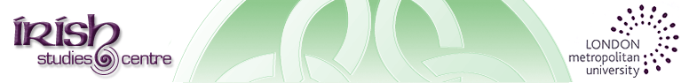

7th Annual Irish in Britain Seminar Series
22 Oct – 19 Nov 2015
Over the last three centuries, Irish migration to Britain has been marked by a number of recurring social and cultural characteristics. These features are often reflected in the lives of individual migrants but the personal experience of migration invariably reveals nuances and differences to these norms which encourage us to continually reassess our understanding and appreciation of the subject. This year’s seminar series focusses on five key public figures and how migration to Britain became a formative and enduring influence on the shape of their careers and sense of Irish identity.

22 Oct: Brothers of the Quill: Oliver Goldsmith and Friends, London, 1757-64

Prof. Norma Clarke, Kingston University, London

29 Oct: Drama of Migration?: Nancy Harris and the Dublin and London Stage
Dr. Michelle Paull, St. Mary’s University, Twickenham

5 Nov: Wild Irish Woman: The Life and Times of Charlotte Despard
Marian Broderick, independent scholar

12 Nov: The Irishness of Francis Bacon
Bernard Canavan, independent scholar

19 Nov: Jerry O’Neill: publican, playwright, novelist & founder of The Sugawn Theatre, Balls Pond Road
Prof. Ken Worpole, London Metropolitan University

The Irish Studies Centre has provided a forum for teaching, learning and research since 1986. The Irish in Britain Seminar Series offers an opportunity for members of the public as well as students and scholars to debate and disseminate the latest research on Ireland,
migration and the diaspora.

Thursday evenings from 6.30 – 8.00 p.m

Attendance is FREE and there is no requirement to register in advance.
However, places are limited so please ensure you arrive early to guarantee a seat.
Room TM1-45, London Metropolitan University, Tower Building, 166-220 Holloway Road, N7 8DB
For further information contact Tony Murray: t.murray@londonmet.ac.uk
www.londonmet.ac.uk/irishstudiescentre

