Preschoolers fast map and retain artifact functions as efficiently as artifact names but artifact actions are the most easily learnt

Abstract
To become skilled artifact users, children must learn the actions and functions associated with artifacts. We investigated preschoolers’ ability to fast-map an action, function and name associated with a novel artifact and retain the new mapping long-term, following brief incidental exposure to the artifact’s use. In Experiment 1, 3-and 5-year-olds were tested one week after two exposures to a novel action, function and name (n=144). Participants performed well on comprehension tests of all three kinds of information. In Experiment 2, 3-year-olds (n=100) were exposed to these three kinds of information only once. Retention of the action-artifact link was above chance levels, while that for function and the name were not. Finally, in Experiment 3, 4-year-olds (n=128) performed well on an action production task, a week after brief exposure. In contrast, their performance on a name production task immediately after exposure was poor. Our data suggest that preschool children can retain function information about a novel artifact from brief exposure, similar to their ability to learn an artifact name. Crucially, their ability to remember an action-artifact mapping is markedly better than functions and names.

Keywords: Fast Mapping; Word Learning; Actions; Functions of Artifacts; Tool Use; Preschool Age (2-5 yrs).

Word count: 7,967

Introduction
Following Carey and Bartlett’s (1978) introduction of the concept of ‘fast mapping’ and Markson and Bloom’s (1997) demonstration of the long-term retention of fast-mapped object names and facts, there has been renewed interest in what kinds of information are learnt from limited exposure (e.g., Casler, 2014; Deák & Toney, 2013; Holland, Simpson & Riggs, 2015; Horst & Samuelson, 2008; Riggs, Mather, Hyde & Simpson 2015; Vlach & Sandhofer, 2012). Fast mapping describes the learning that takes place from brief exposure (one or a few exposures) to novel information about an object. It would seem that some words (e.g., object names) and some other kinds of information (e.g., actions made with objects) can be retained long term by young children (2-4yrs) following brief exposure, at least under certain circumstances. Most recently, Riggs and colleagues (2015) compared fast mapping and retention of actions and object names, introducing preschool children to either a novel word which named a novel object, or a novel action employed to use the novel object. A week later, children recognized the target object linked with the novel action at above chance levels and their comprehension of the object-action link was as good as their comprehension of the object-name link.
The current research investigated the fast mapping of the functions associated with artifacts (i.e., manufactured objects), in addition to actions and names. The function of an artifact is the effect it has when used (e.g., slicing is the function of a knife), and is encoded conceptually. In contrast, all actions are the product of sensorimotor representations. Although many actions do not utilize objects (e.g., dancing), artifact use usually combines a specific action with a specific artifact. When encoding the action made with an artifact, the sensorimotor representation formed must incorporate both the action made by the body and the artifact on which the body acts. A specific action-artifact combination brings about a specific effect. This is often a change to an object or a substance, which we refer to here as the artifact’s ‘substrate’. For example, when a hammer (the artifact) is used, it is grasped by its handle with the head oriented away from the body, and the arm and wrist are moved in such a way (the artifact’s action) as to bring the head of the hammer into contact with a nail on a surface (the artifact’s substrate). This contact drives the nail into that surface (the artifact’s function).
Our definition of artifact function is consistent with that of previous theorists (e.g., Bloom, 1996; Kelemen, 1999; Kemler Nelson, Frankenfield, Morris & Blair, 2000). Like these theorists, we propose that an artifact’s function is encoded in a conceptual representation that encompasses what it means to use the artifact (e.g., a knife slices bread when used). A considerable amount of previous research has investigated the ‘richness’ of young children’s conceptual understanding of artifact function. For example, do children conceptualize an artifact’s function as reflecting the intention of the specific person who originally designed it (e.g., Jaswal, 2006)? In contrast, we focus on the basic understanding that the function of an artifact reflects the effect it has when used. This basic understanding of function (in combination with the necessary sensorimotor representation) is sufficient to use most artifacts.
The actions and functions associated with an artifact’s use are of particular interest when investigating the scope of fast mapping for two reasons. First, artifact use has a central role in human behavior. As with language, skilled artifact use separates humans from the rest of the animal kingdom. In comparison to other animals, even other primates, we use a staggering number of sophisticated artifacts, each with a dedicated function (Casler and Kelemen, 2005). Fast mapping could facilitate children’s acquisition of the knowledge needed to use them. Indeed, their ability to fast map this knowledge could help explain, in part, why humans’ use of artifacts so greatly exceeds that of other animals.
Second, the order in which children learn artifact-action and artifact-function associations is relevant to a fundamental question about the nature of children’s learning. Embodied cognition suggests that conceptual knowledge develops from motor behaviour (e.g., Marshall, 2016; Piaget & Inhelder, 1969; Shapiro, 2011). From this perspective young children’s artifact knowledge will be built on sensorimotor representations formed from the actions made with them. There is considerable evidence to suggest that actions are central to the artifact representations of adults (e.g., Beauchamp & Martin, 2007; van Elk, van Schie & Bekkering, 2009), but this account of artifact representation has received less attention in the developmental literature (although see Hahn & Gershkoff-Stowe, 2010). In contrast, the developmental literature has focused on the role of function knowledge in defining artifact categories. This research suggests that children think of artifacts as being created for a specific purpose and categorize them accordingly (e.g., Bloom, 2004; Casler & Kelemen, 2005; Jaswal, 2006). While children may recognize the importance of an artifact’s function from an early age, this does not preclude the possibility that they first learn the action associated with it.
We investigated what children fast map and retain when they observe a novel artifact being used under conditions of brief and incidental exposure. There are a number of possibilities. Do children form a mental representation with no motor component? Children could form a simple perceptual association between the artifact and its substrate. For example, they could learn to associate a hammer with a nail, without any information concerning how to act on them or what this action will achieve. Alternatively, children could form a more sophisticated conceptual representation which links the artifact and its function (e.g., the hammer is used to fix the nail to the wall). A third possibility is that learning is exclusively sensorimotor, integrating only the action and the artifact (e.g., how to grip and swing a hammer), or perhaps incorporating the substrate as well (e.g., how to grip and swing the hammer so that it strikes the nail). Children may learn any number of these pieces of information, or indeed other information, integrated in any combination.
What does the literature tell us about what children learn from their first encounter with a novel artifact’s use? While it provides evidence that they learn something, it does not clearly demonstrate what that something is. Previous studies have investigated either action learning or function learning, but not both. Riggs and colleagues (2015) provide evidence that 3- and 4-year-olds can fast map an action (rubbing the left arm with a novel object held in the right hand) and retain it long term. They did not test function learning, and in fact argued that the action was ‘functionless’, as it did not have any obvious effect (Riggs et al, 2015, p.6). Using similar actions, Childers and Tomasello (2002) found evidence for action learning (in 2-year-olds) and suggested that these actions did have a function but did not test function separately. In contrast, Casler and Kelemen (2005) investigated the long-term retention of function, and obtained some evidence for learning in 2-, 3-, 4- and 5-year-olds. However, their study did not report action learning, even though actions were incorporated into the exposure session, and children were encouraged to produce them.
That no study has simultaneously tested both action and function learning would be of little concern if these studies clearly distinguished them (i.e., one showed that action was learnt and another that function was learnt). However, we suggest that the way learning has been tested in these three studies makes it difficult to be sure what was learnt. When testing learning, children were given the choice of two or more artifacts, and were asked to identify which one was associated with the novel action or function. It is unclear what children had learnt when they responded correctly on these tests of comprehension. Their good performance could have been due to a memory linking the artifact and its substrate (a perceptual representation), or a memory of the artifact and its associated function (a conceptual representation), or a memory of the artifact and its associated action (a sensorimotor representation).
For example, in the study by Riggs et al. (2015) children were asked, “Which one do we do this with?” while the experimenter performed the action. Children could have selected the appropriate artifact by remembering the artifact-action association. Alternatively, they could have remembered the artifact-function association: remembering the target as an ‘arm-scratcher’. When asked “Which one do we do this with?” they could select the target artifact, because the action the experimenter performed was the one you would make with an arm scratcher. Finally, they could have remembered the artifact-substrate association (e.g., target artifact-arm): that is neither the action nor the function. They could then assume that the experimenter must be referring to the target artifact, because this artifact was associated with an arm. In this way it was possible for children to pass the Riggs et al. (2015) ‘action’ comprehension test by remembering the action or the function or the substrate associated with the target artifact.
Our purpose for the present study was to determine what preschoolers do fast map and retain when they observe an artifact being used for the first time. This age group were tested to match previous research (e.g., Casler & Kelemen, 2005; Holland et. al., 2015; Riggs et. al., 2015). Specific procedures were employed to ensure that correct responses in tests of comprehension could distinguish between an artifact-action association and an artifact-function association and, in addition, rule out an artifact-substrate association. The first two experiments compared preschoolers’ ability to retain an action, function and object name (word), after a significant time delay, following brief and incidental exposure. The first experiment provided children with two exposures to the novel action, function and name. The second experiment reduced the number of exposures to just one. These experiments tested children’s comprehension. The third experiment compared retention for actions and words only, but investigated production as well as comprehension.

Experiment 1
In order to investigate what children fast map and retain when they observe an artifact being used for the first time, we introduced preschool children to a novel artifact, word, action, substrate and function. In the exposure session the target novel artifact was named and was used with a specific arcing action (the artifact’s action) on top of a music box (the artifact’s substrate) which appeared to cause music to play (the artifact’s function). This task was designed to ensure that passing a comprehension question about a specific kind of artifact knowledge was only possible if that specific knowledge was remembered. As is usually the case the name (‘koba’) was unrelated to the action and function. In addition, the artifact-action could not be inferred from a memory of its function, and its function could not be inferred from a memory of the action. Another important feature of the procedure was that when the comprehension question was asked, the substrate (the box) was not in sight. This ensured that children could not answer correctly based on some perceptual memory of the association between the artifact and substrate alone.
We presented the novel artifact being used in an incidental context. Learning about its use was not the stated goal of the experimenter-child interaction. The experimenter said that they were ‘teaching’ a puppet about colors and shapes. The puppet requested that the experimenter use the artifact: a request that the child observed. Some authors regard incidental learning as an essential feature of fast mapping (e.g., Markson & Bloom, 1997) and others do not (e.g., Deák & Toney, 2013). Unlike previous research which has investigated artifact-use (e.g., Casler & Kelemen, 2005; Childers and Tomasello, 2002; Riggs et al., 2015), we assessed incidental learning to provide a stringent test of young children’s fast mapping ability. It is likely that this reflects children’s real-world exposure to artifacts in many situations: they are ‘incidentally present’ when the artifact is used.

In Experiment 1 we tested 3- to 5-year-olds: reflecting the age groups tested in the literature to date (excluding referent selection studies). They received two incidental demonstrations of the action, function and name associated with a novel artifact. Children’s knowledge of either the action-artifact, function-artifact and word-artifact mapping was then assessed with a comprehension test presented either immediately or after one week. Word retention, the traditional focus for fast mapping studies, was tested for comparison purposes.

Method

Participants
One hundred and forty-four children (24 per condition) were tested who attended a nursery or infant school in an outer-city borough of London, England (mean age=4,5; age range 3,1 to 5,6; 69 girls). All children spoke English as a first language and none were reported as having any behavioral or learning difficulties. The sample was predominantly white and of mixed social background.

Design
A between-participants design was used with factors of Time Interval (Immediate, Delay) and Knowledge Type (Action, Function, Word). The dependent variable was comprehension accuracy - picking the target item from an array of four artifacts.

Stimuli
The stimuli comprised a ginger cat hand puppet called Mittens (See Fig. 1a), four novel artifacts and a music box (a white cube containing a concealed audio speaker, 13 x 14 x 25cm). The novel artifacts were a yellow four-way radiator key, a green disc shaped air-vent cover, a red trapezium-shaped plastering tool, and a blue tumble dryer ball – all between 6 and 9 cm in size. There were also four black and white photographs of these artifacts for the shape-matching game (See Fig. 1b) and four colored pieces of card (yellow, green, red and blue) for the color-matching game. The Music Box appeared to play a tune when the novel action was performed on it with the target novel artifact (it was actually activated by the experimenter using a concealed foot pedal). The music was a 20-second sound clip from a popular children’s television program.

Figure 1. Stimuli and Materials
Fig. 1b – four novel artifacts: radiator key,
air-vent cover, tumble dryer ball, plastering tool
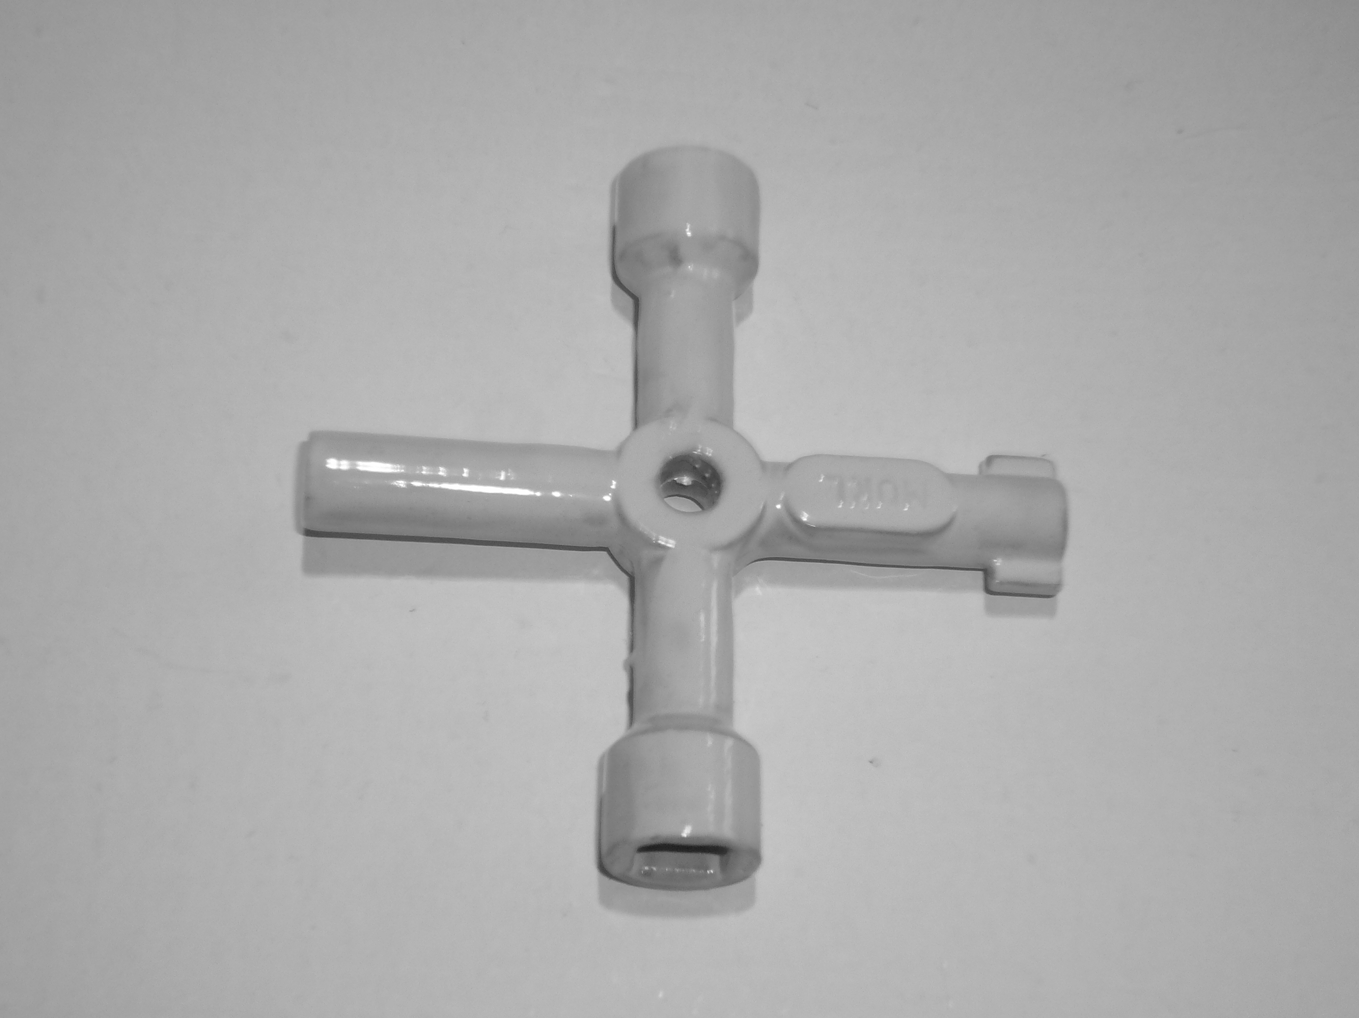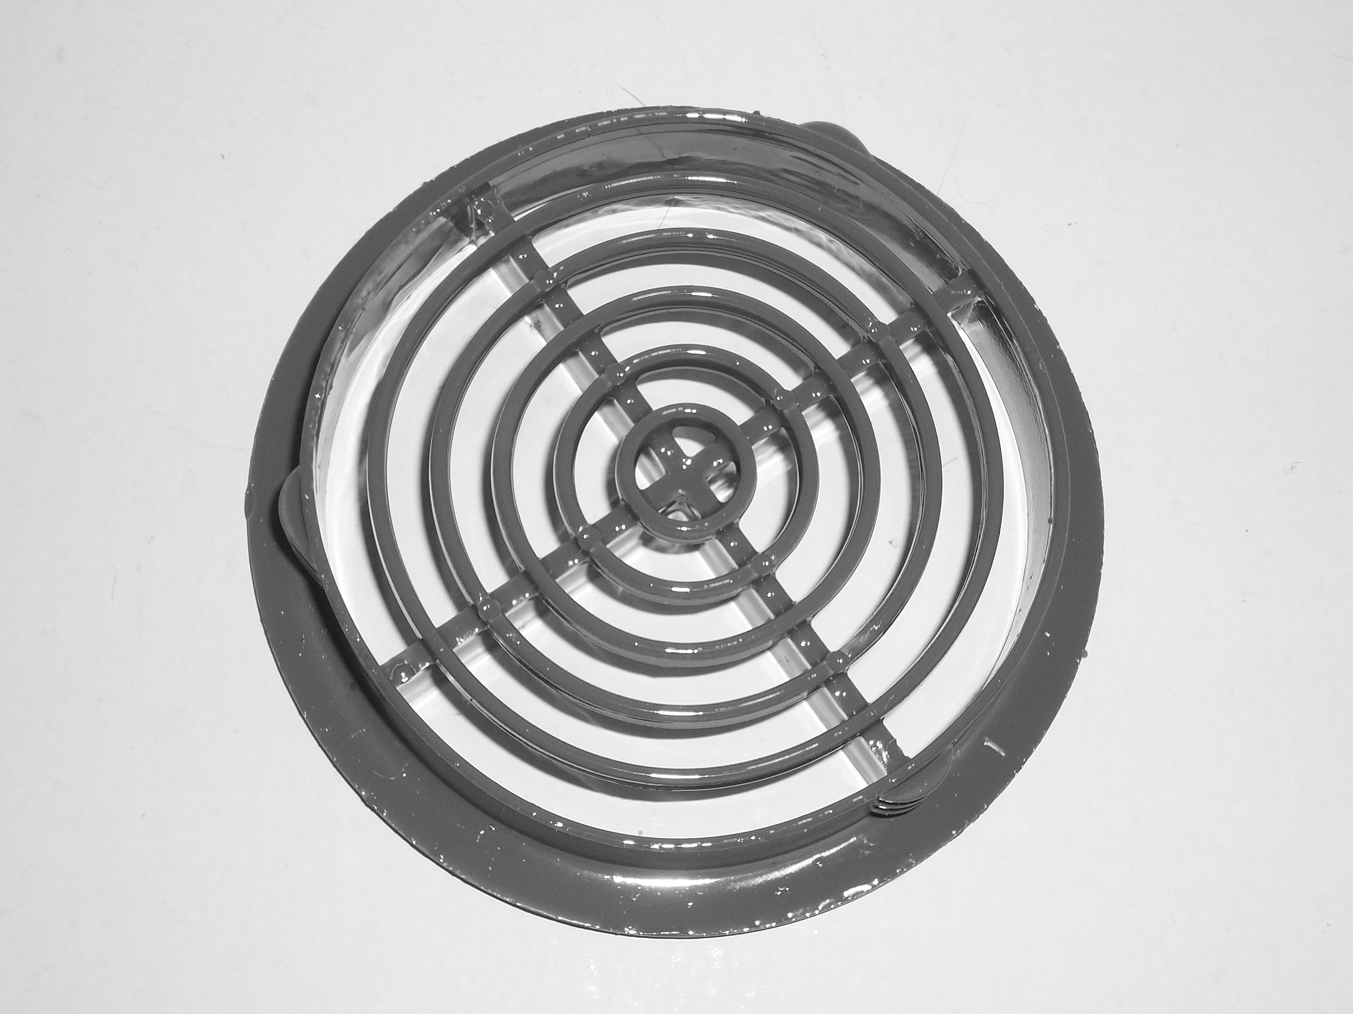

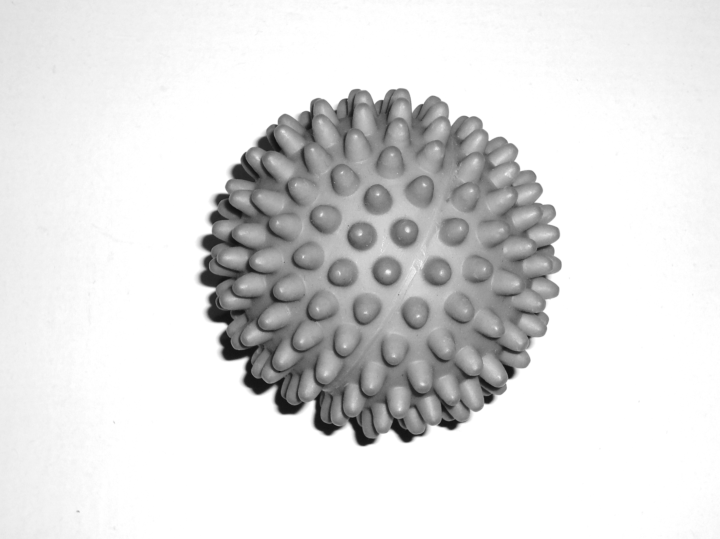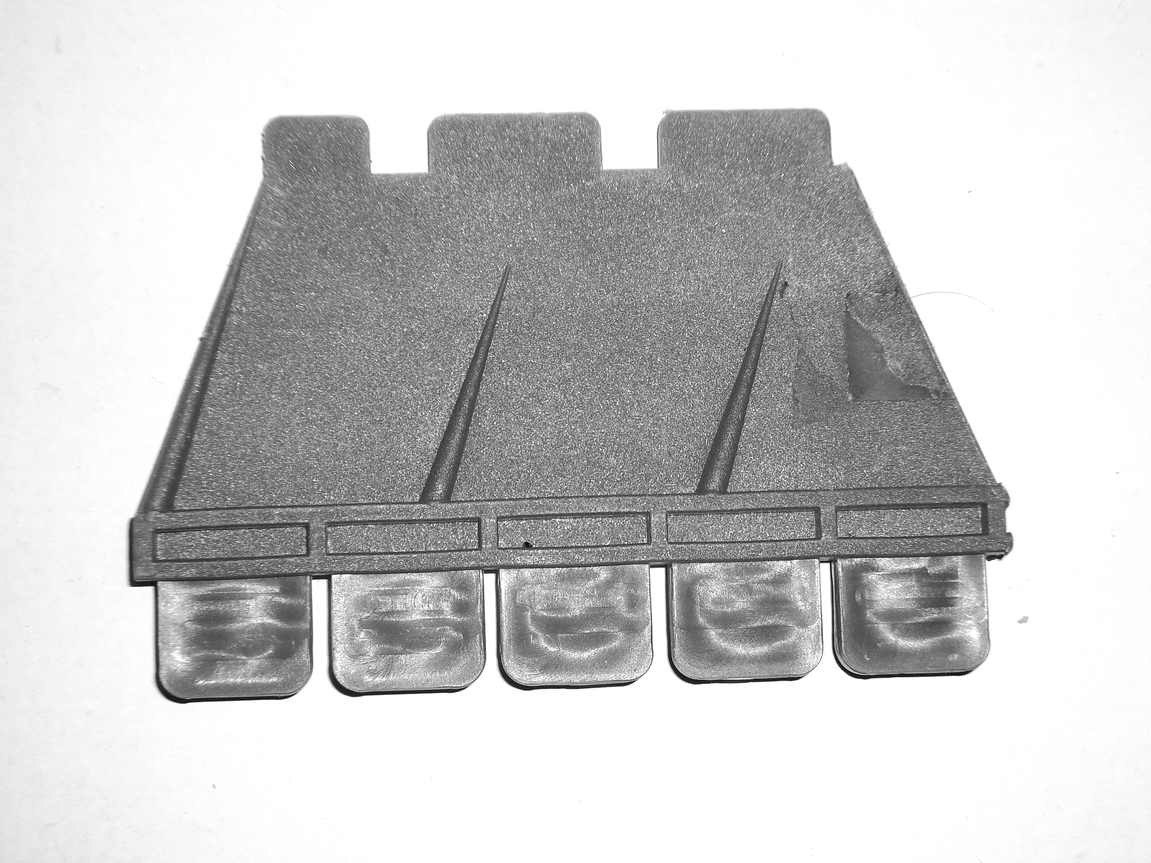

Fig. 1a – Mittens, the puppet
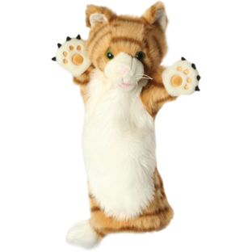

Procedure
Ethical approval was granted by the ethics committee of the University of Essex for all experiments. Informed consent was obtained from all the parents of the children who participated. Testing took place, one on one, in a separate room near the child’s classroom. The task was designed to ensure that the action, function and word (object label) associated with the target artifact were introduced in an incidental context. The focus of the task from the participant’s perspective was to help teach a puppet called ‘Mittens’ about shapes and colors. The experimental task was sandwiched between two distracter tasks. These distracter tasks also ensured that each participant focused on each of the four novel artifacts for roughly equal amounts of time.
The experimental session started with the experimenter passing the child a box containing the four novel artifacts described above and asking her/him to put the contents on the table. Then the experimenter and child played a shape-matching game, the first of two distracter tasks. In this game, children were asked to help Mittens learn his shapes by matching the artifacts to the black and white photographs (see Fig. 1b). Next, Mittens appeared to whisper in the experimenter’s ear. The experimenter then said, “OK, but we’ll have to use the koba” whilst selecting the target artifact (counterbalancing the four artifacts across participants). The experimenter demonstrated a specific action with the target object – holding it in thumb and forefinger and moving it along the top of the Music Box in three arcing motions, touching the surface of the Music Box each time. The action needed to be sufficiently complex (comprising 3 arcs and 3 contacts with the substrate) so that observers would interpret the action as meaningful (i.e. used in conjunction with the artifact to cause music to play), rather than just a random movement on the part of the Experimenter such as a hand-wave. For brevity, this action will be referred to as “arc” or “arcing” from now on. At the end of this action, and unseen by the child, the experimenter pressed a foot pedal that activated the music. Mittens then ‘whispered’ in the experimenter’s ear once again and the experimenter said, “OK, but this is the last time. We have lots to do. We have to use the koba”, thereby repeating the novel word and the experimenter demonstrated the action (3 arcs and 3 contacts) and function once more. The Music Box was then placed on the floor under the table, removing the substrate from view. The demonstration phase was completed with the color matching game, the second distracter task. Children were asked to help Mittens match the artifacts to cards of the same color.
In the Immediate condition the test phase followed the color matching game, which took approximately 5 minutes. In the Delay condition children were tested 6-7 days later and, just prior to the test phase, the Experimenter said “Hi! We met a week ago. I’m going to ask you a question about what we did”. In the test phase in both the Immediate and Delay conditions, children were presented with the four novel artifacts from the demonstration phase. Participants were asked one of three questions according to condition: (1) Action condition, “Which one do we do this with?”, whilst the experimenter demonstrated the action (using a neutral hand position so as not to indicate which of the four objects was the target); (2) Function condition, “Which one starts the music playing?”; (3) Word condition, “Which one is the koba?”.

Results and Discussion
Children were either assessed immediately or after a delay of one week on retention of the novel word-artifact, action-artifact or function-artifact mapping. Comprehension accuracy was uniformly high, ranging from 75%-88% across all knowledge types and both time intervals (Fig. 2). Log-Linear Analysis revealed no significant effects involving gender (p=.61) or age (p=.29). The chance of selecting the correct target at test was 25% (1 of 4 novel objects) and binomial comparisons demonstrated that performance was significantly above chance in all of the Knowledge Type and Time Interval conditions (p<.001).
With a between-participants design and more than two categorical variables a Log-Linear Analysis is the appropriate statistical test. Categorical data can be expressed in the form of a linear model using log values. When data are categorical and all the main effects and interactions are included, the model is saturated i.e. there is no error. Log-Linear Analysis tries to fit a simpler model to the data, without any significant loss of predictive power. It works on the principle of backward elimination and does so hierarchically. Starting with the highest-order interaction, interactions are removed one by one until removing an interaction (or main effect) has a significant effect on the fit of the model. A three-way log–linear analysis (Time Delay, Knowledge Type and Comprehension Accuracy) produced a final model that did not retain any significant main effects or interactions (p≥0.74). The likelihood ratio of this model was χ² (10)=1.34, p=0.999, the non-significant finding indicating that the model was a good fit of the data.

Figure 2. Experiment 1 - Comprehension accuracy for actions, functions and words, following two incidental exposures, immediately and after one week.

The purpose of this experiment was to investigate what children fast map and retain when they incidentally observe an artifact being used for the first time under brief exposure conditions. We compared preschoolers learning of action-artifact, function-artifact and word-artifact mappings. Our data suggest that young children can fast map actions and functions as well as words. Observing an adult naming and using an artifact only twice was sufficient for preschoolers to pass a test of action, function or word comprehension one week later.
Looking at the literature, long term word retention varies across fast mapping studies. For example, Markson and Bloom (1997), Waxman and Booth (2000) and Holland et. al. (2015) evidence retention of object names significantly above chance at least a week after relatively brief exposure to a novel word (but note that Holland et. al. (2015) failed to evidence any long-term retention of color, shape or texture words). In contrast, Horst and Samuelson (2008, Study 1C) and Vlach and Sandhofer (2012) found that preschoolers struggled to retain a single object name from brief exposure. Given this variation, there was no certainty that children would remember the novel word after one week with our new task. With only two incidental exposures and no obvious aids to retention (see Vlach & Sandhofer, 2012, for a discussion of this), it is impressive how good the rate of word retention was. Perhaps, children pay particular attention when they see a novel artifact being used (see General Discussion).
Two concerns from this experiment were addressed in Experiment 2. First, there were no differences between the Knowledge Type conditions. It was impressive that performance was good for all three types of knowledge, however this ceiling performance tells us nothing about whether children find one knowledge type easier to learn than another. Second, only one substrate and one function was used. Perhaps children performed well in Experiment 1, because the Music Box or the playing of music were particularly salient.

Experiment 2
In order to distinguish between children’s ability to fast map and retain actions, functions and words, a more challenging test of learning was employed. In previous fast mapping research, Markson and Bloom (1997) observed much better word retention than Vlach and Sandhofer (2012), despite using almost identical procedures. The principal difference was in the number of times participants were exposed to the novel words: three times in Markson & Bloom’s study and once in Vlach & Sandhofer’s. Based on these findings we reduced the number of exposures to just one. In addition, to test whether learning generalized to other substrates and functions, half the participants were tested with a different substrate and function. Three-year-olds were tested on their action, function or words knowledge after a delay of one week.

Method

Participants
Sixty 3-year-olds (20 per condition) participated in the experiment (mean age=3,6; age range 3,1 to 3,11; 25 girls). All the children attended a nursery or infant school in the county of Essex, England. All children spoke English as a first language, and none were reported as having any behavioral or learning difficulties. The sample was predominantly white and of mixed social background.

Design
A between-participants design was used with Knowledge Type (Function, Action, Word) and Substrate (Music-Box, Drawer-Box) as the factor. The dependent variable was accuracy.

Stimuli
The stimuli from Experiment 1 were used for the Music-Box condition. The Drawer-Box condition used Mittens and the same novel artifact array as Experiment 1 but the substrate differed. It was the same size as the Music-Box but contained a motorised drawer and, like the Music-Box, was operated by a foot pedal. The Drawer box contained a plastic necklace.

Procedure
The procedure was identical to Experiment 1 except that the novel object was labelled only once and the action and function were demonstrated only once. As before, Mittens whispered to the experimenter following the initial demonstration, but this time the experimenter said “No, we can’t do it again, we have lots to do!” and placed the Music box or the Drawer box on the floor under the table. The Drawer-Box condition was very similar to the Music-Box condition. On selecting the target artifact, the experimenter said, “OK but we need to use the Koba” and demonstrated a specific action with it (three arcs moving along the top of the Drawer-Box). At the end of this action the experimenter pressed a foot pedal, unseen by the child, that opened the drawer. The experimenter took a necklace from it, which she placed around Mitten’s neck.
All children were tested 6-7 days after the initial exposure. During the testing session, with the original four novel artifacts on display (not the substrate), children were asked one of three questions: “Which one is the Koba?” (Word condition), “Which one do we do this with?” (Action condition) whilst the Experimenter mimed the action or “Which one starts the music playing/opens the drawer?” (Function condition).

Results and Discussion
Children were assessed after one week on retention of the novel action-artifact, function-artifact and word-artifact mappings. Comprehension accuracy was good for the action-artifact mapping (65%), but poor with the other two mappings (30% and 15% - See Fig. 3). Binominal comparisons revealed that action-artifact mappings were retained significantly above chance (p<.001). In contrast, performance did not differ from chance in the Function (p=0.383) or Word (p=0.909) conditions.
A hierarchical three-way log–linear analysis (Knowledge Type, Substrate and Comprehension Accuracy) produced a final model that retained one of the two-way interactions: Knowledge Type x Comprehension Accuracy. The likelihood ratio of this model was not significant (χ² (6)=4.689, p=.584) indicating that the model was a good fit of the data. The Substrate x Accuracy interaction was not significant (p=0.283) so Comprehension accuracy performance was not affected by whether children were demonstrated an action with the Music-Box or Drawer-Box.

Figure 3. Experiment 2 - Comprehension accuracy for actions, functions and words, following a single incidental exposure, after one week.

Consistent with the log–linear analysis, chi-square analysis revealed that Knowledge Type did affect Comprehension Accuracy, χ²(2)=11.6, p=.003. Individual chi squares compared performance in the action condition to the function and the word conditions, respectively. Both comparisons were significant: action-function χ²(1)=4.91, p=.027 (odds ratio 4.3) and action-word χ²(1)=10.4, p=.001 (odds ratio 10.3). Thus, the data suggest that children, from just one incidental exposure, were four times more likely to retain the newly learned action than the function, and 10 times more likely to retain the newly learned action than the word.
In Experiment 1 with two exposures, performance across the three knowledge types was indistinguishable. In Experiment 2, however, using a more challenging test of learning with just one exposure, comprehension accuracy fell to chance levels for words and functions. Comprehension accuracy in the Action condition was significantly above chance levels, and significantly higher than in the Function and Word conditions. These results suggest that preschool children find action-artifact mappings easier to retain long-term than they do a function-artifact mapping or a word-artifact mapping. Why this might be the case is considered in the General Discussion. Finally, the results provide no evidence that the nature of the substrate and function affect comprehension accuracy – there were no significant differences in retention between the Music-Box and Drawer-Box tasks.
It could be argued that function learning and action learning were not clearly differentiated in Experiment 2. In general, on seeing the action, participants may assume that it is the physical action and not the use of the specific novel artifact that caused the box to play music or drawer to open. For example, when switching on a computer I may use my finger, or a pen or a number of different objects to press the button – it is the action of pressing the button that is paramount. In Experiment 1 the act of repeating the exposure may have helped to fix the idea that the target artifact needs to be used, because it was employed on both occasions. However, just before initiating the action with the target artifact, the Experimenter said “OK, but we’ll have to use the koba”, indicating that it was the specific ‘tool’ needed to turn on the music/open the drawer.

A question arising from these results is how substantial the action-artifact mapping advantage is? Our next experiment addressed this question by investigating how well preschoolers could reproduce an action, following brief exposure and a significant time delay.

Experiment 3
The results from Experiment 2 suggest that pre-schoolers’ action-artifact mappings, created from brief exposure, are more robust than word-artifact and function-artifact mappings formed under identical conditions. However, both Experiment 1 and 2 only tested comprehension. An obvious question is how robust are these mappings? Production is a much more stringent test of fast mapping, especially as children find word production notoriously difficult in comparison to comprehension (e.g., Carey & Bartlett, 1978; Childers & Tomasello, 2002; Dollaghan, 1985; Fenson & colleagues, 1993; Gershkoff-Stowe & Hahn, 2013; Hahn & Gershkoff-Stowe, 2010; Heibeck & Markman, 1987). Indeed, for words, learning sufficient for production does not seem to be possible in a fast mapping context, especially after a delay.
For example, Hahn and Gershkoff-Stowe (2010) have previously investigated children’s learning of word-artifact and action-artifact mappings. They exposed 2- and 3-year-olds to either four novel word-artifacts mappings or four novel action-object mappings, each presented approximately six times in an explicit context (i.e. learning the words and actions was clearly the focus of the experiment-child interaction). Participants were tested for receptive (comprehension) and productive knowledge immediately after training. Word production was minimal (8%-16%). In contrast, action production was impressive (75%-95%). However, Hahn and Gershkoff-Stowe (2010) did not test after any kind of delay, and exposure was neither brief nor incidental.
Childers and Tomasello (2002) tested 2-½-year-olds’ production of either words or actions following a significant delay and found that actions (69%) were reproduced significantly more than words (39%). However, each participant was tested in all three time delays (immediate, one day, one week later) and each child experienced either four or eight exposures of explicit naming. Similarly, Gershkoff-Stowe and Hahn’s study (2013) also involved repeated testing and numerous exposures to explicit naming. Horst and Samuelson (2008) demonstrated that ostensive naming can have a significant effect on word recognition compared to implicit (follow-in) labelling. We wanted to investigate whether good action production would persist under incidental and brief exposure conditions after a week’s delay. If so, this would demonstrate a considerable advantage in action learning over word learning.
It is not possible to test function production separately from action production. Action production is transparent. If the child produces the action in response to the question “Can you show me what to do with this?”, we can be sure the action has been mapped and retained accurately. This is not true for function however. If the child is asked “What is this for?” and demonstrates the action, we cannot be sure that the function has been mapped. Children may interpret the question “What is this for?”, as a request to produce the action. They may have no expectation as to whether that action will produce the function. Alternatively, children could be asked to describe the function verbally, but their ability to do so could be limited by their verbal skills. Poor performance would not necessarily demonstrate poor function knowledge. Consequently, only action production was tested here, along with word production as a comparison.
This final experiment compared action and word comprehension and production in 4-year-olds, following two incidental exposures, tested either immediately or after one week. Using the fast mapping task from Experiment 1 we expected to replicate the good action and word comprehension across both time intervals. In addition, we predicted poor word production in line with the literature. Given previous action production data (Childers & Tomasello, 2002; Hahn & Gershkoff-Stowe, 2010) and the robustness of the action-artifact mapping indicated in Experiment 2, we predicted good action production in the immediate condition (when testing occurred soon after the exposure session). However, it was not clear whether 4-year-olds would produce actions following brief incidental exposure and a week’s delay between exposure and test.

Method

Participants
One hundred and twenty-eight 4-year-olds (16 per condition) participated in the experiment (mean age=4,7; age range 4,0-4,11; 59 girls). All the children attended a nursery or infant school in an outer-city borough of London, England.
Design

A between-participants design was used with factors of Time Interval (Immediate, Delay) and Knowledge Type (Action, Word). The dependent variable was accuracy: the number of children who selected the target artifact for the comprehension tasks, and who produced the correct action or word for the production tasks.
Stimuli
The materials were the same as those used in Experiment 1.
Procedure
The distracter tasks, experimental demonstration phase and comprehension tests followed the same procedure as Experiment 1. In the test of production, participants were asked to produce either the novel action or the novel word. The production test presented the music-box (in contrast to the test of comprehension) and the child was asked to demonstrate the target artifact’s use (“Can you show me what to do with this?”) or to name this artifact (“What is this called, what is its name?”). Pilot data showed that children would act on and name familiar artifacts in response to these production questions, and that it was possible for the experimenter to record the child’s response accurately (as with the comprehension test). Most children produced either the modeled behavior (action or name) or no response at all. In order be scored as correct, children had to produce the complete action (three and only three in-line arcs on the upper surface of the music box) or the complete word (all four phonemes of “koba” in the correct order). Any partial performance was also noted.

Results and Discussion
As expected, comprehension scores were impressive (81%-87%) in both time intervals and for both Knowledge Types with two exposures to the novel word or action (see Figure 4), replicating Experiment 1’s results. Binomial comparisons to chance (25%) were significantly above chance in all the Knowledge Type and Time Interval conditions (p<.001). There were no significant effects involving gender (p=.50). An hierarchical three-way log-linear analysis (Time Delay, Knowledge Type and Comprehension Accuracy) produced a final model that did not retain any significant main effects or interactions (p≥0.72). The likelihood ratio of this model was χ² (6)=0.368, p=0.999, indicating that the model was a good fit of the data. Thus, there were no significant differences in comprehension accuracy between the two time intervals and neither was there any significant difference in accuracy across Knowledge Types. Word comprehension was as good as action comprehension.

Figure 4. Experiment 3 - Comprehension and production accuracy for actions and words, following two incidental exposures, immediately and after one week.

The production data profile differed. Production scores for actions were high across both time intervals (75%-94%). In contrast, word production was poor - immediately after exposure as well as one week later (0%-6%). There were no significant effects involving gender (p=.31) or age (p=.36). Binomial comparisons to chance do not apply to production scores.
A hierarchical three-way log–linear analysis (Knowledge Type, Time Interval and Accuracy) produced a final model that retained one of the two-way interactions: Knowledge Type x Accuracy. The likelihood ratio of this model was χ² (4)=3.68, p=.45, indicating that the model was a good fit of the data. Although there were no significant differences in production across Time Interval for action or word production, there were significant differences across Knowledge Type (χ² (1)=51.08, p<.001). Action production was significantly better than word production. The odds ratio indicated that the likelihood of children producing the newly learned action was 169 times more likely than producing a word.
In addition to correct performance, it is also informative to consider partial performance. As noted in the procedure section for the pilot data, children who did not produce the correct response to production question tended not to respond at all. For the action production question (across the Immediate and Week Delay conditions), five children did not respond correctly. Three made no response, one tapped the music box with the artifact once on the side, and one described its function verbally. Of the 31 failures to say “koba” in the Word condition across both time delays (n=32), 19 did not respond at all, 5 produced real words which were verbal descriptions of the target artifact’s appearance (e.g. ‘ball’), 2 produced non-words containing none of the target phonemes, and 5 produced non-words containing some of the target phonemes. Thus, there were more partially correct responses in the word condition. Nonetheless, even if all the partially correct non-words were treated as correct, this only gives five correct words versus 27 correct actions.
This is the first experiment to test children’s production of novel actions following two incidental exposures and a testing delay of one week. Three-quarters of preschoolers could reproduce the action with the appropriate target object in the week delay condition, imitating all three arcs across the top of the music box. This suggests that children’s initial action-artifact mapping is strong and stable. In addition, the action-artifact mapping seems to be far more robust than the word-artifact mapping: of the 16 children in the delay condition, only one produced a non-word with any correct phonemes (“quata”, the same final phoneme as “koba”).
General Discussion
We investigated what preschool children fast map and retain when a novel artifact is named and used for the first time. Comprehension of novel action, function and word mappings was tested following a substantial time delay of one week. Over three experiments, the number of exposures was varied and production, as well as comprehension, was tested. With two exposures in Experiment 1, comprehension was significantly above chance and similar for all three knowledge types (actions, functions and words). When the number of exposures was reduced to just one, preschoolers only retained action-artifact mappings at above chance levels. Finally, using a test of production, the superiority of the action-artifact mapping was further emphasized as three-quarters of children (12 of 16) reproduced the novel action with the appropriate artifact after one week. In contrast, not one child produced the novel word after a week’s delay (only one produced it in the immediate condition).

Methodological considerations
Before interpreting our data, a number of methodological considerations need to be addressed. First, it could be argued that selection of the target artifact reflected that the target object was treated differently from the other artifacts, rather than good memory for artifact-information mappings (word, action or function). Indeed, it was the only the target artifact that was named and acted upon during the exposure session. In the word learning literature, it has been suggested that naming an artifact makes it different or more salient and, therefore, more likely to be selected in a comprehension test, despite no word-artifact mapping having been formed (Axelsson & Horst, 2013; Baldwin & Markman, 1989).
In our task, however, the experimenter and child interacted extensively with all four novel artifacts. In comparison, the demonstration of the target artifact’s use was relatively brief, and not directed towards the child. Moreover, there is evidence that whether or not the target artifact is named during the exposure session has no effect on its subsequent selection in a comprehension task (Hyde, 2016). Hyde’s findings are clearly inconsistent with the proposal that naming the target object makes it different or more salient and leads to its selection at test. Axelsson and Horst (2013) acknowledge that introducing children to just one word is a sensible procedure when the learning context is difficult or incidental or production is tested: we introduced children to a novel word just once in an incidental context and tested their knowledge a whole week after initial exposure. Finally, the difference or salience explanation cannot explain why action comprehension was better than function and word comprehension (in Experiment 2); nor indeed can it explain why action production was even possible (in Experiment 3). Our data across all three experiments strongly suggest that children are remembering specific pieces of information about the target artifact.
Another methodological concern relates to the novelty of the three types of knowledge. Were the actions and the functions used really as novel as the novel word? ‘Koba” is a novel word which participants would not have experienced before, but it could be argued that the bouncing action and the function of making music play (or opening a drawer) were not novel to the same extent. However, the non-word “koba” uses a combination of familiar phonemes, just as the action combines familiar sub-actions (e.g., grasping an object and a ‘bouncing’ motion) to make the novel action sequence. Likewise, music playing is not novel but using the target artifact to act upon a white box (substrate) to produce music is. Certainly, the novelty of the actions and functions in this study were similar to those used in previous research (e.g. rolling a novel artifact object on your knee, Childers and Tomasello, 2002; or the function of crushing a cracker, Casler, 2014).
Another concern is that functions are intrinsically harder to learn than actions and words. Unlike actions and words, functions cannot be perceived directly during incidental observation. Functions must always be inferred: the observer must make the link between the action-artifact combination and the outcome achieved, in order to infer the artifact’s function. While recognizing the necessity of having to make an inference, we made the outcomes themselves as easy to perceive as possible (e.g. making music play and opening a drawer). By presenting a very simple observable outcome, we had no reason to suppose that children would be unable to learn the artifact-function mapping as easily as the word or action mappings. Thus, we think it unlikely that we have underestimated children’s function learning. Indeed, many real-world artifacts produce outcomes that are harder to observe (e.g. collecting dust or drying hair) and are presumably harder to learn.
In a similar vein it could be argued that our function test was more difficult than the tests for actions and words. For actions and words, the presentation at test matched the presentation during the exposure session. The word ‘koba’ was spoken by the experimenter during the exposure session and at test. Similarly, the same action was produced at both exposure and test (albeit a pantomime of the action at test). In contrast, in the function test participants were not presented with the function they had witnessed during the exposure session (e.g. they did not observe the box playing the music). Instead, the function was described verbally (e.g., “Which one starts the music playing?”) and children had to make the link between this description and the target artifact’s inferred function. We did this so that the substrate was absent during testing. In this way, we could be sure that target artifact selection was based upon retention of the function-artifact mapping and not just an association between the substrate and the target artifact (see the Introduction for a discussion of this point).
However, despite the relative difficulty of the function test question, children did demonstrate impressive rates of retention of the function-artifact mapping in Experiment 1. The retention of function was above chance levels, and not significantly different from retention of actions or words – strongly suggesting that participants were able to understand the function test question. That is, they were able to link the question’s description of the function (…starts the music playing…) to the function they had encoded. This in turn suggests that when children failed the function test in Experiment 2, they did so because they had failed to retain the function-artifact mapping, and not because they did not understand the question.
Interpretation of results
Having addressed the methodological aspects of our study, we now turn our attention to interpreting the results. Preschoolers can fast map and retain a link between a novel artifact and its novel action, its novel function and its novel name at rates well above chance (Experiment 1). These results provide further evidence that fast mapping and retention extends beyond words, supporting Bloom’s (2000) claim that fast mapping is a domain-general process. In addition, our data suggest that (i) preschool children can fast map functions and actions when they incidentally observe a novel artifact being used for the first time (Experiment 1), and (ii) they have a particular proclivity for learning action-artifact mappings (Experiments 2 and 3). We now expand on both of these points in turn.
First, early research on the fast mapping of words suggested that it is a robust phenomenon, which leads to good performance on comprehension tests following a delay (e.g., Goodman, McDonough & Brown, 1998; Heibeck & Markman, 1987; Markson & Bloom, 1997; Woodward, Markman & Fitzsimmons, 1994). However, more recent data has suggested that long-term retention of a novel name is poor, without the addition of memory aids during the exposure session (Horst & Samuelson, 2008; Vlach & Sandhofer, 2012). Thus, fast mapping (with retention) is poor, unless the conditions are right. Our data suggest that observing how a novel artifact is used, as opposed to merely being shown a novel object, may be one way to provide the right conditions for fast mapping and retention. One hypothesis, based on these findings, is that preschoolers are particularly likely to engage in fast mapping and retention when observing a novel artifact being acted upon and its consequential function revealed. We suggest that preschoolers may be drawn to learning when artifact use is demonstrated and that this benefits the learning of the artifact’s name, as well as its action and function information.
Second, actions were retained after a week’s delay from just one exposure, when word (and function) retention fell to chance levels. Most participants were even able to reproduce actions accurately after a week’s delay (from just two incidental exposures). In contrast, not one child could articulate the new word, despite the impressive rates of word learning almost every child displays in life – by the age of eighteen years the average vocabulary is 60,000 words (Bloom & Markson, 1998). Clearly, children are excellent learners of words, but it would appear that they are even better learners of actions. The tougher the test of learning, the more children’s learning of actions stood out.
Why would action learning, in a fast mapping context, exceed learning of words and functions? One possibility is that actions simply contain less information, and are therefore easier for children to learn. Certainly, saying a word is more demanding than making many actions. A word is a rapidly produced sequence of specific sounds – produced by the coordination of largely unseen body parts. These factors would certainly help explain why action production exceeded word production in Experiment 3. They may also explain the superior action comprehension evidenced in Experiment 2. That words are more complex than actions may make them harder for children to recognize as well as recall. As previously noted, functions are more complex than actions as well.
Our findings here are also consistent with the various theories of action imitation which argue that imitation is automatic – for example, Associative Sequence Learning (Heyes & Ray, 2000) and Hebbian learning (Keysers & Perrett, 2004). These theories posit that when we see an action, the activation of a perceptual representation of this action produces at least some activation of the corresponding motor representation. There is convincing evidence that action imitation is automatic in preschool children (e.g. Diamond & Taylor, 1996; Simpson & Riggs, 2011). In contrast, recent data suggest that verbal imitation is not automatic (Simpson & Carroll, 2014; Simpson, Cooper, Gillmeister & Riggs, 2013). Indeed, based on the greater automaticity of action imitation over verbal imitation, it has been argued that preschoolers may learn to produce actions more easily than words (Simpson et al., 2013). These authors argued that merely seeing an action creates a motor output representation of that action, whereas hearing a word does not create a motor output representation of the word. Following perception of the action or word, preschoolers are thus able to produce the action (using the automatically generated motor representation) but not the word. The evidence presented here, that children can produce actions so much better than words following minimal exposure, is consistent with this proposal.
More broadly, our findings are consistent with embodied cognition which suggests that conceptual knowledge develops from action (see Marshall, 2016, and Shapiro, 2011, for reviews). Our data suggest that children may learn the actions associated with a novel artifact the first time they see it used, and that function knowledge is only added to these representations following additional exposure.

Conclusion
This study provides the first evidence that preschoolers fast map and retain both actions and functions, when they observe a novel artifact being used. The data suggest that observing an artifact being used may provide an effective context for fast mapping and retention. This study also evidences that children can reproduce actions after a delay of at least a week following minimal and incidental exposure. Our data suggest that preschoolers have a particular proclivity for learning artifact-action mappings. This advantage is consistent with the long-standing proposal that early knowledge development makes particular use of sensorimotor processes (e.g., Piaget & Inhelder, 1969; Rakison & Woodward, 2008): with the artifact-action mapping the first to form.

References

Axelsson, E. L. & Horst, J. S. (2013). Testing a word is not a test of word learning. Acta Psychologica, 144(2), 264-268.
Baldwin, D. A. & Markman, E. M. (1989). Establishing Word-Object Relations: A First Step. Child Development, 60, 381-398
Beauchamp, M.S., & Martin, A. (2007). Grounding object concepts in perception and action: evidence from fMRI studies of tools. Cortex, 43, 461-468.
Bloom, P. (1996). Intention, history, and artifact concepts. Cognition, 60, 1-29.
Bloom, P. (2000). How Children Learn the Meanings of Words. Cambridge, MA: MIT Press
Bloom, P. (2004). Descartes’ baby. New York: Basic Books.
Bloom, P. & Markson, L. (1998). Capacities underlying word learning. Trends in Cognitive Sciences, 2(2), 67-73.
Carey, S. & Bartlett, E. (1978). Acquiring a single new word. Papers and Reports on Child Language Development, 15, 17–29.
Casler, K. (2014). New Tool, New Function? Toddlers’ Use of Mutual Exclusivity When Mapping Information to Objects. Infancy, 19(2), 162–178.
Casler, K. & Kelemen, D. (2005). Young children’s rapid learning about artifacts. Developmental Science, 8:6, 472 – 480.
Childers, J.B. & Tomasello, M. (2002). Two-year-olds learn novel nouns, verbs and conventional actions from massed or distributed exposures. Developmental Psychology, 38(6), 967-978.
Deák, G.O. & Toney, A.J. (2013). Young children’s fast mapping and generalization of words, facts, and pictograms. Journal of Experimental Child Psychology, 115(2), 273-296.
Diamond, A., & Taylor, C. (1996). Development of an aspect of executive control: Development of the ability to remember what I said and to “do as I say, not as I do.” Developmental Psychobiology, 29, 315–334.
Dollaghan, C. (1985). Child meets word: 'Fast mapping' in preschool children. Journal of Speech and Hearing Research, 28(3), 449-454.
Fenson, L., Dale, P. S., Reznick, J. S., Thal, D., Bates, E., Hartung, J. P., et al (1993). The MacArthur Communicative Development Inventories: User’s guide and technical manual. San Diego: Singular.
Gershkoff-Stowe, L. & Hahn, E. R. (2013). Word comprehension and production asymmetries in children and adults. Journal of Experimental Child Psychology, 114 (4), 489-509.
Goodman, J. C., McDonough, L., & Brown, N. B. (1998). The role of semantic context and memory in the acquisition of novel nouns. Child Development, 69(5), 1330-1344.
Hahn, E. R. & Gershkoff-Stowe, L. (2010). Children and adults learn actions for objects more readily than labels. Language Learning and Development, 6(4),
283-308.
Heibeck, T.H. & Markman, E.M. (1987). Word learning in children: An examination of fast mapping. Child Development, 58(4), 1021-1034.
Heyes, C., & Ray, E. (2000). What is the significance of imitation in animals? Advances in the study of Behaviour, 29, 215–245.
Holland, A.K., Simpson, A. & Riggs, K.J. (2015). Young children retain fast mapped object labels better than shape, color, and texture words. Journal of Experimental Child Psychology, 134, 1–11.
Horst, J.S. & Samuelson, L.K. (2008). Fast mapping but poor retention by 24-month-old infants. Infancy, 13(2), 128-157.
Hyde, G. (2016). Using a fast mapping Approach to Investigate Children’s Learning about Artefacts. Unpublished PhD thesis.
Jaswal, V. (2006). Preschoolers favor the creator's label when reasoning about an artifact function. Cognition, 99, B83-92.
Kelemen, D. (1999). Function, goals and intention: children’s teleological reasoning about objects. Trends in Cognitive Science, 3, 461-468.
Kemler Nelson, D.G., Frankenfield, A., Morris, C. & Blair, E. (2000). Young children's use of functional information to categorize artifacts: three factors that matter. Cognition, 77, 133-168.
Keysers, C. & Perrett, D. I. (2004). Demystifying social cognition: A Hebbian perspective. Trends in Cognitive Science, 8, 501–507.
Markson, L., & Bloom, P. (1997). Evidence against a dedicated system for word learning in children. Nature, 385(6619), 813–815.
Marshall, P.J. (2016). Embodiment and Human Development. Child Development Perspectives, 10, 245-250.
Piaget, J., & Inhelder (1969). Psychology of the child. London: Routledge and Kegan Paul.
Rakison, D.H., & Woodward, A.L. (2008). New perspectives on the effects of action on perceptual and cognitive development. Developmental Psychology, 44, 1209-1213.
Riggs, K. J., Mather, E., Hyde, G. and Simpson, A. (2015). Parallels Between Action-Object Mapping and Word-Object Mapping in Young Children. Cognitive Science, doi:10.1111/cogs.12262.
Shapiro, L., 2011, Embodied Cognition. New York: Routledge.
Simpson, A., & Carroll, D. (2014). What’s so special about verbal imitation? Investigating the effect of modality on automaticity in children. Journal of Experimental Child Psychology, 121, 1-11.
Simpson, A., & Riggs, K.J. (2011). Under what conditions do children have difficulty inhibiting imitation? Evidence for the importance of planning specific responses. Journal of Experimental Child Psychology, 109, 512–524.
Simpson, A., Cooper, N. R., Gillmeister H. & Riggs K. J. (2013). Seeing triggers acting, hearing does not trigger saying: Evidence from children’s weak inhibition. Cognition, 128, 103–112.
van Elk, M., van Schie, H.T., & Bekkering, H. (2009). Semantic knowledge about objects is supported by functional motor activation. Journal of Experimental Psychology: Human Perception and Performance, 35, 1118-1128.
Vlach, H.A, & Sandhofer, C.M. (2012). Fast mapping across time: Memory processes support children's retention of learned words. Frontiers in Psychology, 3, Article 46.
Waxman, S.R. & Booth, A.E. (2000) Principles that are invoked in the acquisition of words, but not facts. Cognition, 77(2), B33-B43.
Woodward, A.L., Markman, E.M. & Fitzsimmons, C.M. (1994). Rapid Word Learning in 13- and 18-Month-Olds. Developmental Psychology, 30(4), 553-566.

