Festa della Chinea: Tradition and the ‘Exotic’ in Roman Festival Design
Nicholas Temple

Outline
The Festa della Chinea, which roughly translates as ‘Festival of the Wandering Nag’, was a historic festival held in Rome bi-annually until the late 18th century (1788), in which the viceroy of the Kingdom of Naples was required to pay his homage to the pope. This entailed, among other things, the offering of a white horse (‘nag’) that formed part of a procession through the streets of Rome. The destination of the procession was the Basilica of St Peters, where the horse was traditionally allowed to roam within the basilica before finally being guided to the cathedra of the pontiff for a formal blessing. The peculiarity of this festival has never really been properly explained. By the early 18th century it gave rise to the most elaborate ephemeral constructions in the city, culminating in a huge firework display in the Piazza Farnese, the location of the embassy of the Bourbon Kingdom of Naples and Sicily from the late 17th century. In this paper, I will examine the Festa della Chinea in the context of the tradition of festivals in Rome, tracing changes in the symbolic and ceremonial meanings of these extravagant events with specific focus on equine and water symbolism. As one of the oldest festivals in Rome, which was held annually over a period of about 600 years, the Festa della Chinea provides a rich source of material about how such events were celebrated and understood, both by the organisers and the spectators.
Key words: Roman festa, procession, equine symbolism, fluvial symbolism, papal homage, macchine

Introduction
The development of festival events in early modern Rome has a long and complex history, whose influences can be traced back to antiquity. Understanding the meaning and significance of the Festa della Chinea - probably the longest continuously running festival in Rome held on 28th June and 8th September - is best appreciated in the context of this historical background as it relates to equine symbolism, and the various meanings attributed to the term festa. Derived from the Latin words ‘festus’ or ‘festum’ (meaning feast day in memory of a particular saint, hero or event) - also closely connected to the ancient tradition of feriae (holidays) - the Roman festa entailed processions and commemorative acts, whether annual/cyclic or one-off events. Alessandro Falassi explains the more complex meanings of the term:

“Etymologically the term festival derives ultimately from the Latin festum. But
originally Latin had two terms for festive events: festum, for “public joy, merriment, revelry,” and feria, meaning “abstinence from work in honor of the gods.” Both terms were used in the plural, festa and feriae, which indicates that at that time festivals already lasted many days and included many events. In classical Latin, the two terms tended to become synonyms, as the two types of festivals tended to merge.”

Hence, festivals were historically ‘Janus faced’, characterised by two complementary associations: one stern and serious, reflecting a state of reverence and self-restraint, and the other light-hearted and jovial that encourages public indulgence and excessive behaviour. Festive processions involved the whole city (its urban topography and its citizens), by momentarily suspending the everyday activities of urban life to create an auspicious occasion for collective participation. This typically required the fabrication of ephemeral architectural constructs and ornamental elements that embellished the urban fabric of the city, transforming it into a veritable stage-set for the main ceremonial procession which usually traversed the city (or parts of it), passing through key public spaces and culminating in a major ceremonial/ritual event.
Perhaps the most celebrated festival event in the ancient Roman calendar, whose themes and ritual practices can be traced to later medieval and early modern events, was the feast of Saturnalia (December 17 of the Julian Calendar). Noted for its popularity across all spectrums of Roman society, the Saturnalia annually celebrated the archaic Roman god Saturn, and commemorated the winter sowing season, serving as a pagan predecessor to Christmas. A key feature of the feast was public indulgence through various hedonistic pursuits and wild revelry (later refashioned into the more familiar ‘Martedi Grasso’ – or Shrove Tuesday in the Christian calendar). The Saturnalia was an opportunity to relax authority and even invert the social/political structures by allowing slaves to be given temporary freedom and parade as important Roman citizens. As Henk Versnel states:

“Gambling and dice-playing, normally prohibited or at least frowned upon, were permitted for all, ’even slaves’. Coins and nuts were the stakes. On the Calendar of Philocalus, the Saturnalia is represented by a man wearing a fur-trimmed coat next to a table with dice, and a caption reading: “Now you have license, slave, to game with your master.” Rampant overeating and drunkenness became the rule, and a sober person the exception.”

The main spectacle of the Saturnalia was probably the procession of a mock king (Saturnalicius princeps) through the streets of the city that became the basis of many modern satirical reconstructions. Many of the key features of the Saturnalia, such as masquerading and exchanging gifts, pervaded later Roman festivals including the Festa della Chinea, where the more solemn and orderly aspect of ceremony was accompanied by public merrymaking. As will become clearer later, this aspect of the festival was to become more dominant and conspicuous, as the religious associations of the procession gradually declined in the late 17th and 18th centuries.

The White Chinea and Equine Symbolism
Of the many features of the Chinea, the most important symbolically (and one which constituted the central act of gift-making in the whole event) was the presence of a white horse, the ‘ambling nag’ referred to earlier, that served as a mascot in the procession to St Peter’s Basilica. The role of animals in Roman festivals formed part of an ancient tradition that can be traced back to festival practices in archaic Rome. Drawing upon often familiar mythological and historical models/antecedents, animals were intended to be read as an integral part of the urban scenography, carefully orchestrated in the form of a tableau vivant inscribed upon the fabric of the street. The choice of animals moreover for these events, and how they were dressed and paraded through the city, reveals much about the intended meanings and associations of the ceremonies. Perhaps the most celebrated occasion in Ancient Rome, in which horses played a pivotal role in the spectacle, was the Roman triumph when victorious generals or emperors paraded as deities, heroes and other venerated figures following a military conquest.

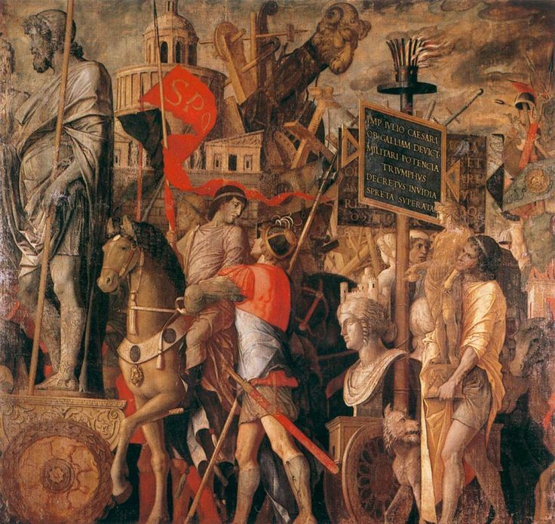
Figure 1: Andrea Mantegna (1431-1506), Triumphs of Caesar (c.1486-94), Bearers of Standards, Courtesy of Hampton Court, London.

We see this conveyed for example in Livy’s phrase ornatus Iovis (‘host Jupiter’) in which a costume commemorating the presence of the divine Jupiter was adopted for the imperial procession. This entailed the victor riding a chariot drawn by white horses which Mary Beard appropriately calls the ceremony’s “standard repertoire”. The pagan practice of horse-drawn chariots, with their Apollonian or solar symbolism, became the model for subsequent processional floats (or carri) from the Renaissance onwards, as we see for example in representations of triumphal processions under pope Paul III (1534-1549), such as the famous reconstruction of the Triumph of Lucius Aemilius Paullus Macedonicus who was a consul of the Roman Republic famous for his conquest of Macedon. In these and other Renaissance pictorial reconstructions of the Roman triumph, the topography of Renaissance Rome figures prominently in the background, reinforcing the temporal and spatial registers between allegorical/historiographical depiction and contemporary (sometimes idealised) representations of the papal city.
In the Festa della Chinea, as in other festivals of the medieval and early modern periods, we see how these pagan associations underlie the symbolism of the occasion; to reinforce the elevated status of the pope (Pontifex Maximus) as recipient of the annual gift from the viceroy of the Kingdom Naples, which also included the offer of tribute money. Votive offerings to deities, in the form of sacrifices or live animals, were a common feature of ancient Roman and early Christian life, in which the principal sacrificiant or donor was usually the emperor or chief priest (pontifex maximus). This mortuary (or proto-mortuary) practice, moreover, needs to be seen in the context of animal worship in the ancient world and the gradual desacralization of animals that was partly introduced by Christianity.

Figure 2: Procession of the Chinea from the Palazzo Farnese (1756), etching by G. Vasi, Museo di Roma. GS295.

But unlike most ancient Roman festivals, and their later Renaissance reinterpretations, where horses paraded in groups or in pairs pulling chariots or ceremonial floats, the ceremony of the Chinea was led by a lone white horse whose symbolic purity was no doubt intended to reaffirm the piety of the receiving pope and the virtuous intent of the donor. There are several aspects of this equine symbolism that suggest ancient/early Christian references. We see this first in the special reverence attached to the white horse as a symbol of the sacrificed and triumphant Christ. This relates to an account in Revelations (19:11-14):

“I saw heaven standing open and there before me was a white horse, whose rider is called Faithful and True. With justice he judges and makes war. His eyes are like blazing fire, and on his head are many crowns. He has a name written on him that no-one knows but he himself. He is dressed in a robe dipped in blood, and his name is the Word of God.”

This account also finds parallels in the portrayal of the more famous four horses of the Apocalypse (6:1-8), that also incorporated a white horse. The image was particularly popular in Medieval and Renaissance artistic representations, as evidenced in Durer’s famous etching. Whilst there is no certainty that biblical associations between the white horse and Christ directly influenced the Chinea, it seems more than plausible that such divine attributes of the animal contributed in some way to the intended symbolism of the procession.

Chinea as ‘Sacrificial’ Offering
The culminating part of the journey of the nag entailed entering the central portal of St Peter’s and passing between the two stoups in the narthex of the basilica, before finally coming to rest before the pope’s cathedra where the horse was blessed by the pope. According to John Moore:

“Unlike other tokens of homage, the horse of the Chinea was usually not presented to the pope in private but was led through the tortuous streets of Rome in a splendid procession witnessed by the populace of the city that came to a halt in the very nave of St. Peter's between the two holy water stoups, at the feet of the pontiff borne high in his gestatorial chair. When the Holy See stood vacant, other homages could be received by the Reverend Apostolic Chamber; the Chinea alone was deferred until that holy seat was once again occupied.”

As basins containing holy water, where worshippers ritually blessed themselves before entering the nave of the basilica, these stoups that flanked the horse’s approach to the papal cathedra reiterate baptismal waters and their mortuary symbolism. It is easy therefore to recognise how the purity of the Chinea, as a ritual offering to the pope, was further amplified by its spatial and thematic relationships to the holy water.
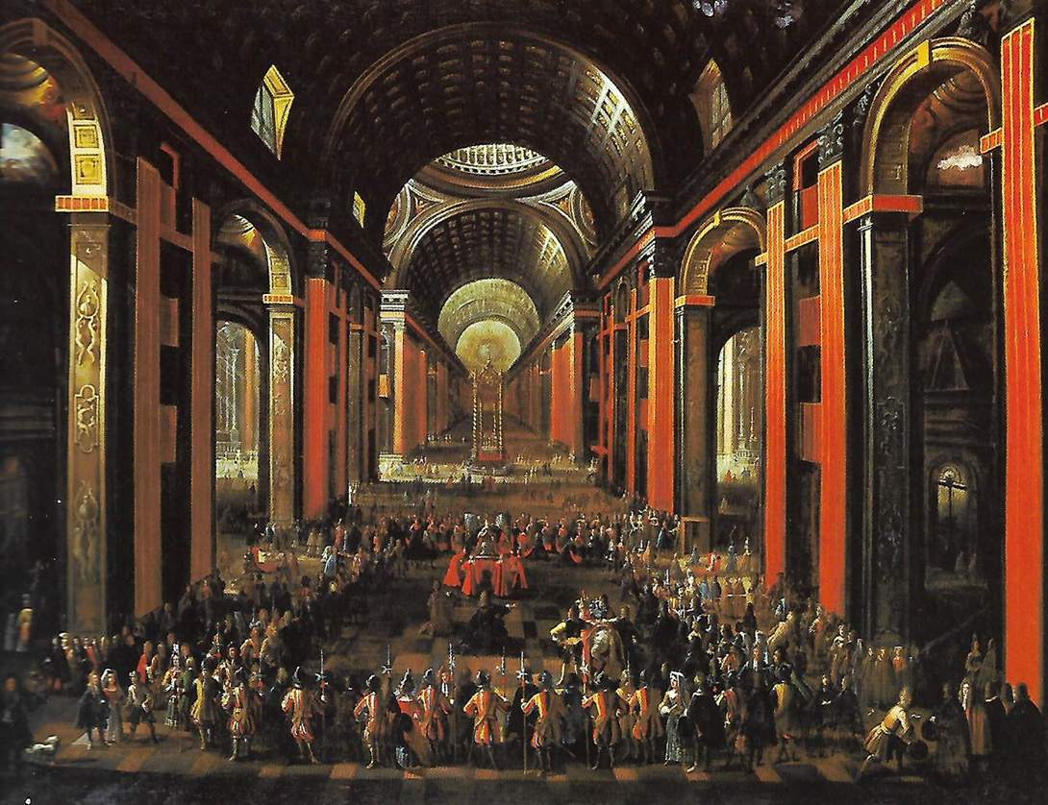
Figure 3: Offering of the Chinea to the Pope in the Basilica of St. Peters. Anonymous, oil on canvas (17th century), Museo di Roma. MR4120.

At the same time, the allusion of the lone horse as a symbolic ‘sacrificial’ offering to the key-bearer of the Roman Catholic Church has a much more ancient precedent. We see this for example in the so-called “October Horse”, which was annually sacrificed to the god Mars on the Campus Martius on the Ides of October (fifteenth day of the Julian Calendar).
Importantly, as C. Bennett Pascal points out, the horse selected for sacrifice was “the right-hand horse of the winning pair in a chariot race”, in an act that formed part of a larger festival that is without a name (incorporating a chariot race, a spearing and then decapitation). It seems that there was some inter-changeability between horses, bulls, cattle and oxen as sacrificial animals in the ancient world, although the use of horses for such ritual acts was generally rare. Indeed, this is also perhaps the only instance where a lone horse served as the focus of a ritual in ancient Rome.
When understood symbolically, the sacrificial and pious themes underlying the Chinea remind us not only of Christ’s martyrdom but also of the mortuary symbolism of the Vatican itself, which was originally the staging ground of returning victorious armies and their cavalry in antiquity - before their triumphal entry into Rome. Importantly, this symbolism also relates to the date of the Chinea in the Christian calendar; during the vigil of the Feast of Saints Peter and Paul which annually commemorates the martyrdom of the two ‘Princes of the Church’. To quote John Moore again:

“Each year on 28 June, the vigil of the feast of Sts. Peter and Paul, the pope received various feudal homages, either at the Quirinal Palace or at St. Peter's Basilica, where he might preside at Vespers service on the vigil and high mass on the feast day. The pope thus received homage on the eve of the day that commemorated the lives and ministries of two men upon whom the papacy had based its claims to spiritual and temporal authority since at least the days of Constantine.”

The liturgical feast of Peter and Paul, observed on 29th June, was memorialised in the places where the two apostles were thought to have been martyred and buried - on the north and south banks of the Tiber river respectively. As I have argued elsewhere, by the 15th century there emerged a corresponding relationship between the military/mortuary associations of the Vatican and its significance as the supposed site of Peter’s martyrdom.

Fluvial Symbolism
A guiding theme in the mortuary associations of the Vatican was the fluvial symbolism of the Tiber River and its tributaries, and how the flow of water was deemed to convey levels of purity within the liturgical and ritual contexts of the city. The redemptive associations of the Chinea, in its journey to the Vatican, probably drew upon this fluvial symbolism in ways that extended beyond the holy water of St Peter’s Basilica referred to earlier. A good starting point in this study of water symbolism is an account by the 4th century Roman poet Aurelius Prudentius Clemens:

“The quarter on the right bank took Peter into its charge and keep him in the golden dwelling [basilica], where there is the grey of the olive-trees and the sound of a stream; for the water rising from the brow of a rock [mons Vaticanus] has revealed a perennial spring which makes them fruitful in the holy oil. Now it runs over costly marbles, gliding smoothly down the slope till it bellows in a green basin [catharus]. There is an inner part of the memorial where the stream falls with a loud sound and rolls along a deep, cool pool [baptistery].”

Whilst this poetic work describes an underground stream in the Vatican feeding the baptistery of St. Peter’s Basilica, it could just as easily convey a larger topography of fountains and water courses in Rome that were deemed to possess rejuvenating (or miasmic) qualities. In all likelihood, the underground stream described by Prudentius was originally the source of water used to supply the stoups. Seen in the context of the processional itinerary of the salvific white nag, the stages of its journey to the papal cathedra in St Peter’s Basilica were probably signalled in part by the availability of running water that combined the activities of nuptial blessings and relieving the animal’s thirst. A frequently cited Biblical reference to the symbolism of water, used in church mosaics and baptismal iconography (including St Peter’s Baptistery), is the famous description in Psalm 42:1 of a deer quivering before drinking from a stream, symbolic of the waters of Paradise.
The close association between the topography/terrain of Rome and mortuary symbolism, specifically in regard to the approach to the Vatican across the Tiber river, formed a key part of the ritual itinerary of the Chinea. Unlike, however, other major ceremonial events in Rome, such as the papal possesso and imperial entries (such as Charles V, Holy Roman Emperor), the Festa della Chinea did not entail traversing the whole city – between the Vatican to the west and the Lateran to the east – but was rather localised to the area extending east-west from the Quirinale (former location of the embassy of the Bourbon Kingdom of Naples) to the Vatican. This zone of Rome encompassed a number of major piazzas that were known for their abundant fountains and drinking troughs; notably Piazza del Quirinale, Piazza di Trevi, Piazza Farnese, Piazza Navona and Piazza di S. Pietro. Prior to the construction of new St. Peter’s Basilica in the 16th century, the Chinea would have encountered one of the most exquisite fountains in the atrium of old St. Peter’s. Constructed in bronze and crowned by an elaborate canopy, the centre-piece of the fountain was a large pine-cone (pigna) spouting water with peacocks at each corner. Used by pilgrims to replenish themselves before entering the basilica, the fountain symbolised the pre-baptismal nuptials of the neophyte, whose water was originally supplied by the same underground stream that Prudentius describes.
Whilst we have little documentary evidence of the known routes of the procession before the 18th century, it seems likely that the wandering nag and its entourage of floats and riders would have paraded through the principal public spaces in the city, between the Quirinal and Vatican. This would have included circumnavigating the linear space of Piazza Navona, the focus of numerous other festive events including the Festa di Agone.

Divination through Wandering
This brings us to the intriguing issue of the ‘ambling’ movements of the nag in the Chinea procession, affirmed in the etymology of the term (derived from the Old French ‘haguenée’ meaning “horse of ambling gait” from which the English term ‘hackney’ is thought to originate). As already mentioned, in the ceremonial parades through the streets of Rome, animals would typically be yoked to a carriage, float or chariot, and adorned in such a way that their appearance blended into the overall iconographic machinery of the procession.
In many ways, the Chinea alludes to a rather different tradition from that of mainstream Roman festival events. Whether the white horse was originally allowed to literally ‘wander’ the streets of Rome, the meaning of Chinea suggests that its meandering movements formed a central feature of the whole spectacle. There is of course a tradition of allowing animals to roam the streets of a city, as we see for example in the famous Encierro (Running of the Bulls) in Pamplona in Spain that takes place before the bull-fight. This annual spectacle, however, is an agonic event – a contest between citizens who seek to provoke the bulls in their race to the bullring. By contrast, the relaxed and informal demeanour of the Chinea serves as a solitary roaming of the city (Rome) without outward provocation. This style of parade also marks a significant difference to the formality of the triumphal march, and other analogous military/imperial style parades in the ancient and early modern city. One could construe from this difference, a conscious distinction between two modes of representing the redeemed city. In the case of the triumphal march, the city comprised a series of carefully staged and formally constructed ceremonial spaces. Whilst we know that the route of the triumph march in antiquity changed through time, the itinerary of each procession was clearly intended to serve as a unified ‘set-piece’. In contrast, the procession of the Chinea presented Rome as a labyrinth of routes and public spaces, whose encounters are perhaps more analogous to the experience of a wandering pilgrim that a pacified war-horse. The Roman triumph, moreover, treats parading horses as part of the military and ceremonial armoury that has been subject to the miasma of conflict, thereby being disciplined and compliant; the Chinea on the other hand presents the lone horse as pious and innocent, like a newly baptised infant.
There is an interesting historical precedent to the roaming horse which may have a bearing on the underlying symbolism of the Festa della Chinea, but one which is not directly related to equine symbolism - nor indeed to festival iconography. According to numerous accounts, Emperor Constantine’s foundation of the new imperial capital on the Bosporus (Constantinople) followed the archaic Roman practice of yoking a white ox and a cow to a bronze plough that cut a furrow forming the sacred pomerium (religious boundary) of the future city walls. The tradition however of the founder directing the plough was suspended on this occasion in favour of allowing the ox and cow to follow their own path, thereby famously deviating from the pre-determined boundary line of the new city. As Joseph Rykwert reminds us: “In the various accounts of Constantine’s foundation of Constantinople, there are stories of his divinely inspired enlargement of the city boundary which had been fixed previously. It is not unnatural, therefore, to assume that divination was applied topographically.” Whilst the lone white horse, that headed the ceremony of the Festa della Chinea, did not have a role in defining/redefining the city boundaries, it seems plausible that the animal was intended to be ‘divinely’ guided through the labyrinthine streets of Rome and thereby reaffirm the solemnity and sanctity of the papal offering, whatever underlying political objectives were intended in this ceremonial gesture.
We can only speculate to what extent the procession of the Chinea consciously drew upon these different influences, many of which had their roots in ancient Roman traditions. Paying homage to the pope, particularly during the Feast of Saints Peter and Paul, was a major annual event that in many ways was a form of ceremonial panegyric, and which can also be traced in papal homages granted by other ruling kingdoms.

Changes in the 17th and 18th Centuries
By the late 17th century significant changes took place in the staging of the Festa della Chinea, as a result of a combination of two factors; firstly by the relocation of the residence of the ambassadors of the Kingdom of Southern Italy and Sicily to the Palazzo Farnese, which permitted a more focused display of public spectacle within the city, and secondly by the increasing extravagance of the festival event itself, through the construction of highly elaborate set pieces (macchine).
A conspicuous feature of these changes is what I describe as an ‘exotic turn’, a term that probably requires some explanation. According to the Oxford Concise English Dictionary, ‘exotic’ refers to something that has been introduced from, or originated in, “a foreign country” or something that is “attractively or remarkably strange or unusual”; in essence something “bizarre”. During the period of the Enlightenment (17th and 18th centuries), there was increasing fascination in bizarre or extraordinary discoveries and encounters, from empirical experiments and the exhibit of ethnic objects to the experience of sublime landscapes (whether natural or man-made). The ‘foreign’ (however fabricated or manicured) constituted a desirable aspect of 18th century European society, as we see for example in the proliferation of Chinoiserie in private collections that reflected an imagined Chinese artistic sensibility. It is in the context of this search for the exotic that the transformations in the design and purpose of the Festa della Chinea become most interesting.
The culmination of the two-day festivities of the Chinea was a major firework display, which also became a common spectacle of other similar festival events in late Baroque Rome. These public pyrotechnic displays were focused on the Piazza Farnese, fronting the east façade of the palace which was adorned with temporary balconies that provided a privileged vantage point from which to view the ‘palco allestito’ (staged event) below. The set pieces, or temporary installations, in the piazza were based on a series of themes conceived by a committee of organisers, located in the Palazzo Farnese, who also held an annual design competition. By the mid-18th century, we get a distinct impression that these macchine take precedence over the Chinea procession itself and its equine symbolism, by dominating the spectacle with their architectural invenzione and bombastic pyrotechnic climaxes. This dominating influence of spectacle was in many ways characteristic of the ‘exotic turn’ I referred to earlier, in the way extravagance and subliminal emotions are prioritised at the expense of participatory experience in religious or civic events. Many of the themes of the Festa della Chinea were conceived around the idea of reinventing the urban topography of the city through capriccio, such as the construction of a miniature Mount Vesuvius with smoking crater or a Chinese tea-house with pagodas. In many ways these macchine, which are recorded in a series of prints, serve as testimony to a decisive shift in the meaning of the Festa della Chinea, from a ritualistic event (with its religious, civic and political meanings), to a pure aesthetic spectacle.

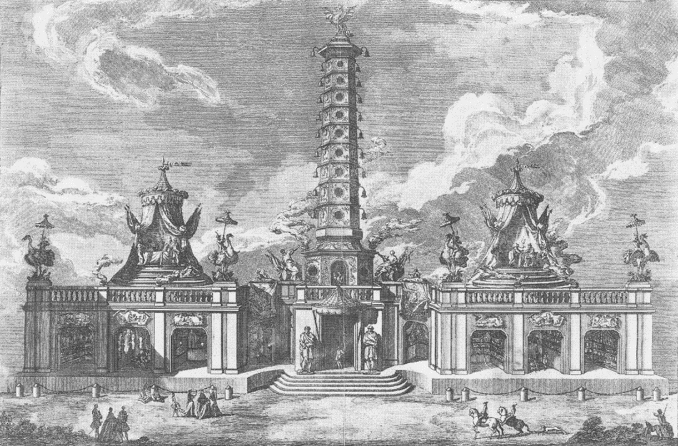
Figure 4: View of the 2nd macchina erected for the Festa della Chinea on 8th September 1758, showing aspects of chinoiserie in 18th century Rome including a reconstruction of the Nanking Pagoda. Designed by Paolo Posi and Giuseppe Palazzi. Engraving taken from the Raccolta di tutte le Machine de Fuochi Artifiziali (plate 74), Biblioteca Casanatense, Rome

The organisational demands of the bi-annual Festa della Chinea, during the 18th century, are attested by a series of detailed etchings of the design and construction of the macchine. This valuable record demonstrates the planning involved, and expertise needed, in hosting such a major event. Whilst in the Renaissance, those involved in the design and fabrication of architectural ephemera for the festival (as was also the case with other similar events such as the Festa di Agone in Piazza Navona) were primarily Italian artists and craftsmen, by the early 18th century this responsibility was increasing given to foreign residents, mainly pensionnaires based at the French Academy and itinerant artists visiting the Holy City. The change, moreover, reflects a more general transformation in the status and meaning of Rome itself during this time, from its historical role as the centre of Roman Christendom (and therefore destination of pilgrims), to a museum of cultural artefacts that served as the culmination of the Grand Tour for artists and tourists. Importantly, the Festa della Chinea became one of the main spectacles in the itinerary of the Grand Tour, which also formed part of a more general initiative to periodically transform the Holy City into a theatrical stage set. Another prime example of this transformation can be seen in the annual carnival, such as the one held in 1735 when a series of floats were paraded through the streets of Rome modelled on an earlier pseudo-Chinese barge used for a Venetian regatta in 1716.
This exotic feature of festivals during the 18th century reaches a climax in the masquerade held in 1751. Recorded in a very long painting by Jean Barbault (1718-1762), the procession passed along the Corso in Rome and celebrated the four continents of the world through a series of elaborately festooned carri. Each float carried costumed figures which were designed to convey the distinctive aesthetic and ethnographic qualities of the different regions of the world, redolent of the allegorical figures portrayed in the contemporaneously executed ceiling fresco of the four continents by Giovanni Battista Tiepolo in the Residenz of the prince-bishop in Würzburg. Like the rather ‘eclectic’ representations highlighted in the macchine of the Festa della Chinea during the 18th century, these processions underline the perception of the world as essentially a scenography of exotic references, reflecting in part the impact of the activities of traders and missionaries in Asia on the Papal City (and other cities in Europe) during the Age of Discovery.
In conclusion, the history and symbolism of the Festa della Chinea provides a remarkable testimony to the changing face of Rome itself, as a venerated religious centre, deeply rooted in the traditions of antiquity and early Christianity (exemplified in the underlying symbolic associations of the Chinea), and as a cultural capital that appealed to an ever-expanding audience of foreign tourists and artists. It was during this later period that the papacy became virtually bankrupt, and therefore unable (and perhaps unwilling) to commission major religious and civic buildings and urban projects, in the way it did in the 16th and 17th centuries. In many ways, the 18th century Festa della Chinea provided opportunities for architects and artists, in this environment of declining patronage, to experiment using the ingenuities offered by capriccio, which resulted in extravagant and novel ephemeral interventions. This drive for invenzione in the Festa, as I have sought to demonstrate, diverted attention away from the central purpose of the event itself; embodied in the wandering ‘nag’ and its blessing by the Pope in St Peter’s Basilica.
In the end, however, all the effort invested in this long-standing bi-annual festival would simply go up in smoke, through the spectacular pyrotechnic displays that signalled the culmination (and conclusion) of each event.

Notes

Alessandro Falassi, ‘Festival: Definition and Morphology’, in Time Out of Time: Essays on the Festival, edited by Alessandro Falassi (Albuquerque, NM: University of New Mexico Press, 1987), pp.1-10, pp.1-2.
This dual characterisation of the festival could also be framed in ‘Apollonian’ and ‘Dionysian’ terms, which constitutes key impulses in ancient religious and public life. See in particular, Friedrich Wilhelm Nietzsche, The Birth of Tragedy, translated by Douglas Smith (Oxford: Oxford University Press, 2008).
Beryl Rawson, ‘Celebrating the Saturnalia: Religious Ritual and Roman Domestic Life’ in A Companion to Families in the Greek and Roman Worlds, edited by Fanny Dolansky (Oxford: Blackwell Publishing, 2011), Chapter 29. The broader issue however of the influence of ancient festival practices on the modern carnival is more contested. See Max Harris, ‘Claiming Pagan Origins for Carnival: Bacchanalia, Saturnalia, and Kalends’, European Medieval Drama, Volume 10, (2006), pp. 57-107.
“On the feast of the Saturnalia, Horace's slave Davus takes the customary license to tell him some home truths, proving that his adulteries, his gluttony, and social climbing make him the real slave…” (Horace, Satires, II, vii). Anthony Close, ‘A Poet's Vanity: Thoughts on the Friendly Ethos of Cervantine Satire’, Cervantes: Bulletin of the Cervantes Society of America, 13.1 (1993): 31-63, p33.
H.S. Versnel, ‘Saturnus and the Saturnalia’, in H.S.Versnel, Inconsistencies in Greek and Roman Religion, Volume 2: Transition and Reversal in Myth and Ritual (Leiden: Brill, 1992), pp 136-227.
See in particular, H.S. Versnel, Triumphus: An Enquiry into the Origin, Development and Meaning of the Roman Triumph (Leiden: E.J. Brill, 1970).
Mary Beard, The Roman Triumph (Cambridge, Mass: The Belknap Press of Harvard University Press, 2007), p235.
Marcello Fagiolo, La Festa a Roma: Dal Rinascimento al 1870 (Turin: Umberto Allemandi & C, 1997), pp.34-41.
Ingvild Saelid Gilhus, Animals, Gods and Humans: Changing Attitudes to Animals in Greek, Roman and Early Christian Thought (London: Routledge, 2006)
Ibid., Chapters 6&7.
For an examination of the symbolism see J. S. Considine, ‘The Rider on the White Horse: Apocalypse 6:1-8’, The Catholic Biblical Quarterly, Vol. 6, No. 4 (October, 1944), pp. 406-422.
John E. Moore, ‘Building Set Pieces in Eighteenth-Century Rome: The Case of the Chinea’, Memoirs of the American Academy in Rome, Vol. 43/44 (1998/1999), pp. 183-292, p184.
On the different meanings and associations of baptism, see Jean Danielou, S.J., The Bible and the Liturgy (Ann Arbor, Michigan: Servant Books, 1956).
C. Bennett Pascal, ‘October Horse’, Harvard Studies in Classical Philology, Vol.85 (1981), pp.261-291.
Ibid., p261. The famous chariot races of the Roman circus “were managed by factions, whose distinguishing colours – white, red, blue and green – were thought by Tertullian (De spect. 9.5) to represent the seasons.” ‘horse – and chariot-races’, The Oxford Classical Dictionary, edited by Simon Hornblower and Antony Spawforth (New York: Oxford University Press, 1996) p727.
This relates specifically to the agricultural symbolism of animals in the ancient world that traditionally formed the basis of most sacrificial rites. Significantly, the horse was usually singled out as the exception to this rule, which was more commonly associated with war and military prowess. Pascal, ‘October Horse’, pp.274-276.
Nicholas Temple, renovatio urbis: Architecture, Urbanism and Ceremony in the Rome of Julius II (London: Routledge, 2011), pp. 162-167.
Moore, ‘Building Set Pieces in Eighteenth-Century Rome’, p183.
Temple, renovatio urbis, pp.7-33.
Prudentius, trans. H.J. Thomson, Loeb Classical Library (Cambridge, MA: Harvard University Press, 1949), pp.325-27.
John E. Moore, ‘Prints, Salami, and Cheese: Savoring the Roman Festival of the Chinea’, The Art Bulletin, Vol.77, Issue 4 (1995), pp.584-608, p584.
Joseph Rykwert, The Idea of a Town: The Anthropology of Urban Form in Rome, Italy and the Ancient World (London: Faber and Faber, 1976), p65.
Ibid., p58, note 83.
Ibid. The rituals surrounding the Consecratio in antiquity, that differentiated in Roman law between human and divine things, was also applied to the act of tracing the city walls with the yoked ox and cow. The Oxford Classical Dictionary, pp.376-377; Richard Krautheimer, Three Christian Capitals: Topography & Politics: Rome, Constantinople, Milan (Berkeley: University of California Press, 1983), p42.
Benedict G. E. Wiedemann, ‘The Kingdom of Portugal, Homage and Papal ‘Fiefdom’ in the Second Half of the Twelfth Century’, Journal of Medieval History, Volume 41, Issue 4 (2015), pp.432-445, p432.
Giulio Ferrari, Bellezze architettoniche per le feste della chinea in Roma nei secoli XVII e XVIII (Turin: C. Crudo, 1919).
This ‘Chinese’ masquerade was in honour of the special ambassador to Rome of the king of France, Paul-Hippolyte de Beauvilliers who was Duke of Saint Aignan. For an account of Chinoiserie in Italy, see Francesco Morena, Chinoiserie: The Evolution of the Oriental Style in Italy from the 14th to the 19th Century (Florence: Centro Di, 2009).
The painting is displayed in the Musée des Beaux-Arts et d’Archéologie in Besançon.
For an interpretation of this fresco see in particular Mark Aston, ‘Allegory, Fact, and Meaning in Giambattista Tiepolo’s Four Continents in Würzburg’, The Art Bulletin, Vol.60, No.1 (March, 1978), pp.109-25
For a discussion of patronage in 18th century Rome see Heather Hyde Minor, The Culture of Architecture in Enlightenment Rome (University Park, PA: Pennsylvania State University Press, 2010). Bibliography Beard, Mary, The Roman Triumph (Cambridge, MA: The Belknap Press of Harvard University Press, 2007) Fagiolo, Marcello, La Festa a Roma: Dal Rinascimento al 1870 (Turin: Umberto Allemandi & C, 1997) Falassi, Alessandro (ed.), Time Out of Time: Essays on the Festival (Albuquerque, NM: University of New Mexico Press, 1987) Gilhus, Saelid, Animals, Gods and Humans: Changing Attitudes to Animals in Greek, Roman and Early Christian Thought (London: Routledge, 2006) Moore, John E., ‘Building Set Pieces in Eighteenth-Century Rome: The Case of the Chinea,’ Memoirs of the American Academy in Rome, Vol.43/44 (1998-1999), pp.183-292. Moore, John E., ‘Prints, Salami, and Cheese: Savoring the Roman Festival of the Chinea.’ The Art Bulletin, Vol.77, Issue 4 (1995), pp.584-608. Pascal, C. Bennett, ‘October Horse’, Harvard Studies in Classical Philology, Vol.85 (1981), pp.261-91. Rykwert, Joseph, The Idea of a Town: The Anthropology of Urban Form in Rome, Italy and the Ancient World (London: Faber and Faber, 1976) Temple, Nicholas, renovatio urbis: Architecture, Ceremony and Urbanism in the Rome of Julius II (London: Routledge, 2011) Versnel, H.S.,‘Saturnus and the Saturnalia’, in H.S.Versnel, Inconsistencies in Greek and Roman Religion, Volume 2: Transition and Reversal in Myth and Ritual (Leiden: Brill, 1992), pp 136-227. Versnel, H.S., Triumphus: An Enquiry into the Origin, Development and Meaning of the Roman Triumph (Leiden: E.J. Brill, 1970)

