WICKLOW ASSOCIATION
MINUTES OF MEETING
1ST DEC 1987

- Meeting opened at 9.05 p.m.

- £644. 89 in our account.

- New Banner costs £70.

- John Fitzpatrick purchased the clock for to be presented to Lil Price at our dinner and dance in recognition of her work as Chairperson for many years. It cost £49. It has been inscribed on a plate which is
attached to the back of the clock.

- John Fitzpatrick and Kevin Dunne to work on the door at our dinner and dance. The price for the JAYBIRDS band is £150. Liz is looking after the raffle for us. John Fitzpatrick to bring the tickets which will be 50p a strip of £1 for three strips. Prises donated by Committee members and some outsiders. The first prise to be £50 cash or maybe B
& I voucher. 12 places needed for top table. Ask the Priest to bless
the new banner. Kevin Dunne will bring the smaller banner.
Secretary to bring membership forms. Chairman proposed Tom McAssy
be our spokesman for the night, Tom agreed. He will also arrange for sandwiches to be laid on for the band during their break.

- Liz to be paid £7.20 for stationery. She has agreed to get a get well
card for *** *** and bring it to our dinner and dance and colleagues can sign it on the night.

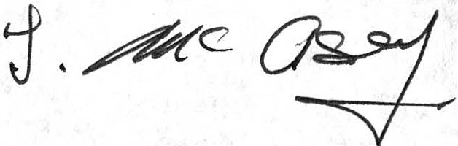
Meeting closed at 11 p.m.

