WICKLOW ASSOCIATION
MINUTES OF MEETING
1ST SEPT ‘87

Meeting opened at 9.05 p.m.

- £705 pounds in the bank.

- It was proposed and agreed that Lil Price would be paid for the bills
for stationery she sent in.

- Dinner dance confirmed for 4th December, arrangements to be made next meeting. Write to *** *** informing her of the date as she
requested.

- July minutes read and agreed.

- Pat Shay enquired about a benefit dance for a man who is out of work for years, his wife is fran Wicklow. It was discussed but no decision made.

- Wicklow is drawn against Meath in the quiz, Kevin Dunne will be back from holidays and is bringing someone and Jack Kennedy's daughter and Tan Mc Assy will go on panel.

Meeting closed 10.20 p.m.

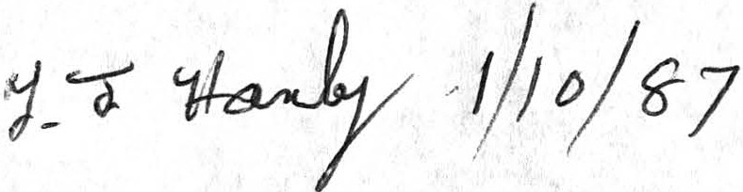
MOMSEPT1

