WICKLOW ASSOCIATION MINUTES OF MEETING
1 NOV.. 1988

Meeting opened at 9 p.m.

Apologies received from Tom Mc Asey. October's minutes read, agreed and signed.
- Letter received from *** *** enclosinng £6 for Benefit dance for our late Chairman.

- Treasurer's report : £660 put into the bank from benefit dance and
£6.00 received tonight. John to meet Tom Mc Asey at the weekend and collect any outstanding money. Nicholas said the money should be paid now and he endorsed his earlier request of paying out a cheque for £1,000 to Mrs ***.

- Annual Dinner Dance
The band for the night confirmed as Mc Lone and Sidetrackers. Conserning prises it was agreed that we should have one main prise but no decision to be made until Nicholas writes to B & I, Aer Lingus, Ryan Air

Board Failte are giving us a voucher for £50 for our raffle and also paying for the video of Faces and Places we are purchasing, thanks to Nicholas.

Nicholas wrote to Board Failte and enquired as to how the 4 million they received from the Irish Government was spent. They would not commit themselves but said it was spread around in different circles. Nicholas thinks *** their promoter should be invited to our dinner dance, Pat Shay seconded that proposal, and it was agreed.

Blaze Tracy has accepted his invitation and will be happy to come over with his wife and he will speak about Wicklow.

Pat Shay proposed two complementary tickets to be sent to our President and his wife for all the work he does during the year.
Proposal was agreed.

Complementary ticket to be sent to *** ***.

Printing of the tickets cost only £5.00, thanks to our ever faithful Liz, and once again she has agreed to look after the raffle on the night. John will bring alone the raffle tickets (10 books). John and Kevin will be our doormen. Each individual attending our function will receive a free ticket as they enter and there will be a prise to be won, probably a bottle.

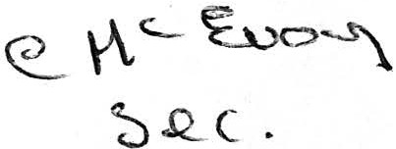
There will be wine provided on the top table for quests.

John will ring *** *** and ask if she would like some tickets.
Due to the disapearance of our assistant secretary the only
members address we have is *** ***'s and John will see if she would like tickets.

Bouquets of flowers will be presented to each speakers' wife. We need three.

Speaking time should be brief and we shall ask our President to limit speaking to about 5 minutes per person.

*** is leaving the Irish Centre and we believe all Counties is contributing £20 for her, through The County of Counties we are waiting to hear more on this.

Nicholas suggested we should have a verbal report of The County of Counties monthly meeting. Kevin will oblige. He also said that an old member called *** ***, from Avoca would like to come along to our monthly meetings, he will be at our dinner and dance.

Nicholas briefed us on the happenings in Wicklow over the last few months. Stratford on Slaney won the best tidy town competition for 1988, they have won it 13 years in a row now. Tinehealy won Senior Farm Task. Glenmalure won Make and Model competition. Aughrim got the highest score in 10 pin bowling. Roundwood won the double quix. Newcastle came 3rd in national ploughing competition. Nicholas suggested maybe some committee members should write to the place they come from and say "well done". He has ordered the video of Faces and Places but has not received it yet. A 4 million project has been started in Blane Row.

Meeting Tuesday before dance, which will be the first Tuesday in December.

It was suggested that we should bank in an Irish Bank. it was decided to let the next Committee sort that one out.

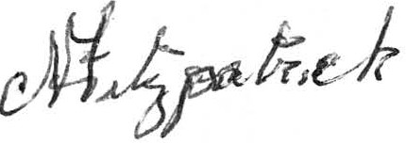
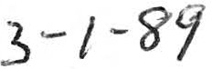
Meeting closed at 11.10 p.m.

