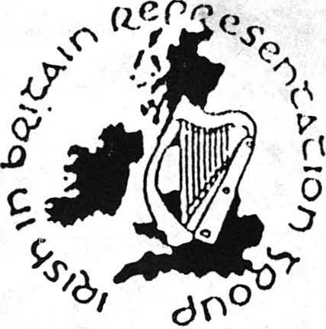
Irish in Britain Representation Group ( IBRG)
Cumann Ionadaíochta na n-Éirerannach sa Bhreatain

Education Policy

IBRG recognises that the Imperialist and colonial policies of Britain have been and continue to be the primary determinant of racism In this country and that racism Is not and never has been based exclusively on perceived differences between racial groups.

Racism is a practice which assumes Innate superiority by a dominant people or nation towards a subject people or nation and which also assumes the Innate Inferiority of the subject people.

In Britain this racism is endemic and is interwoven into the culture, history and traditions of Britain. The structures and Institutions arising from this Ideology have been created by Britain both at home and in it's colonies to maintain it's colonial domination and have developed forces Intended to divide and thereby rule those subjected to it's colonial ambitions.

IBRG therefore recognises that the colonial domination by Britain of Ireland has underscored and dictated the educational policies and practices toward the teaching or languages, history and culture in British schools. This has led to the suppression of Irish culture within the education system and has
re-inforced anti-Irish racism.

IBRG therefore calls for :

- recognition or ethnic/colonial minority status for the Irish community in total

- equal opportunities monitoring or all Irish staff at all levels within the education service

- monitoring of the numbers, performances and achievement or Irish students In schools

- a) the monitoring of texts and other teaching materials and the re-evaluation of curriculum lo eradicate anti-Irish racism

b) the adoption of a policy and effective procedures to deal with anti -Irish racism In language and behaviour of staff and pupils

- the provision or Irish perspectives throughout all subject areas (especially British/Irish history) and the Introduction of Irish language, mu·s1c and dance as optional subjects In schools with a significant number of Irish students

- the provision of Irish studies courses in schools with a significant number of Irish students

- the introduction of training to acquaint staff with the needs of the Irish. This to include day schools and courses to raise awareness of an-ti Irish racism and to Include appropriate staff secondment for these courses. This to also Include Irish studies courses up to degree level and courses for Irish games, dance, music and language teachers with staff secondment as appropriate

- the commissioning of teaching packs, videos and exhibitions that could be developed and used in schools to help combat anti -Irish racism. The promotion of existing resources and their distribution or availability to all teaching staff

- the provision of funding for adult and community education initiatives by Irish community groups

- all Education Authorities to appoint an Education Officer with responsibility for Irish curriculum and Irish students and who will be accountable to the Irish community with responsibility for implementing these policies within the local education service.
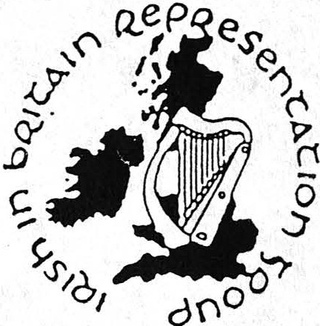
)

Irish in Britain Representation Group ( IBRG)
Cumann Ionadaíochta na n-Éirerannach sa Bhreatain

Irish Language - An Ghaeilge

The Irish language is important because it is one of the most fundamental expressions of separate nationhood and ethnicity. It also serves as a vehicle for the integration of the Irish people with their geographical and cultural environment. Almost all place names in Ireland are corruptions or translations of the Irish and in many cases Irish explains the construction of English as spoken by Irish people.

The language was nearly destroyed as a vernacular by both conscious policy of English/British colonial administration and by effects arising out of it's other policies.

The language continues to be lost by foreign cultural domination, emigration and the depopulation of the countryside, all of which are the effects of the twenty six county government policies. The Irish people are not to blame for the loss of their language and both British and Irish governments should be called upon to go some way towards redressing their wrong.

In pursuance of this the Irish government should directly promote· by way of grants and paying teachers· the learning of Irish in Ireland and in Britain. These grants should be payable to organisations who show a committment to education in the language and scholarships could also be offered to those who show promise.

All Irish social, cultural, political and commercial groups within Ireland and Britain should be encouraged to facilitate dealing in Irish with members of the public who wish to do so, to advertise such readiness and to give their staff time off in lieu as a minimum for attending lessons/courses and workshops on Irish.

Continued high emigration with a disproportionately higher loss in Irish speaking areas further undermines the use of the language.

Addresses in Irish should be given where possible.

Irish languages should be available within the curriculum in the Six Counties. Facilities for the teaching of it should be encouraged and funds should be withdrawn on academic or linguistic grounds only. The twenty six county government should insist on these provisions in their talks with unionist politicians.

Organisations should support a campaign of promoting the use of the Irish language in all walks of life in Ireland, from using it themselves whenever possible, to joining a campaign to get an Irish language facility in the provision of all services to the public, supported by training, posters (eg .'Failte roimh Gaeilge anseo'), badges etc.

Organisations such as Irish airlines, shipping companies, travel agents, banks, pubs and centres which deal mainly or significantly with the Irish community in Britain should be encouraged to do as above by organisations in Ireland and by Irish expatriate organisations.

Irish language programming should be significantly increased in Ireland on RTE.

Irish language programming should be included on British radio and TV and representations to that effect should be made by Irish organisations and the Irish government.

Irish language organisations should work with IBRG and others to promote the teaching and use of Irish, to lobby the relevant authorities etc.

