Irish Perspectives on British Education

A National Conference organised by the Irish in Britain Representation Group
Saturday 13 October 1990
Haringey Irish Centre, North London
Bookstall - Exhibitions - Information stalls
Food - Creche

This conference is aimed at parents, students, providers of education, community activists and all those interested in education provision for the Irish in Britain. There will be

9.30am to 5.30pm
Haringey Irish Centre
Pretoria Road (off White Hart Lane) Tottenham
London N17
Disabled Access and WC
Wood Green Tube (Picadilly Line) then W3 bus or
Seven Sisters Tube (Victoria Line) then bus no.s 279, 259 or 149
or
White Hart Lane BR
(See map overleaf)
£3.00 Individuals/L1.00 concessions £5 Statutory organisations
Free but please book in advance
Lunch available but please indicate on booking form
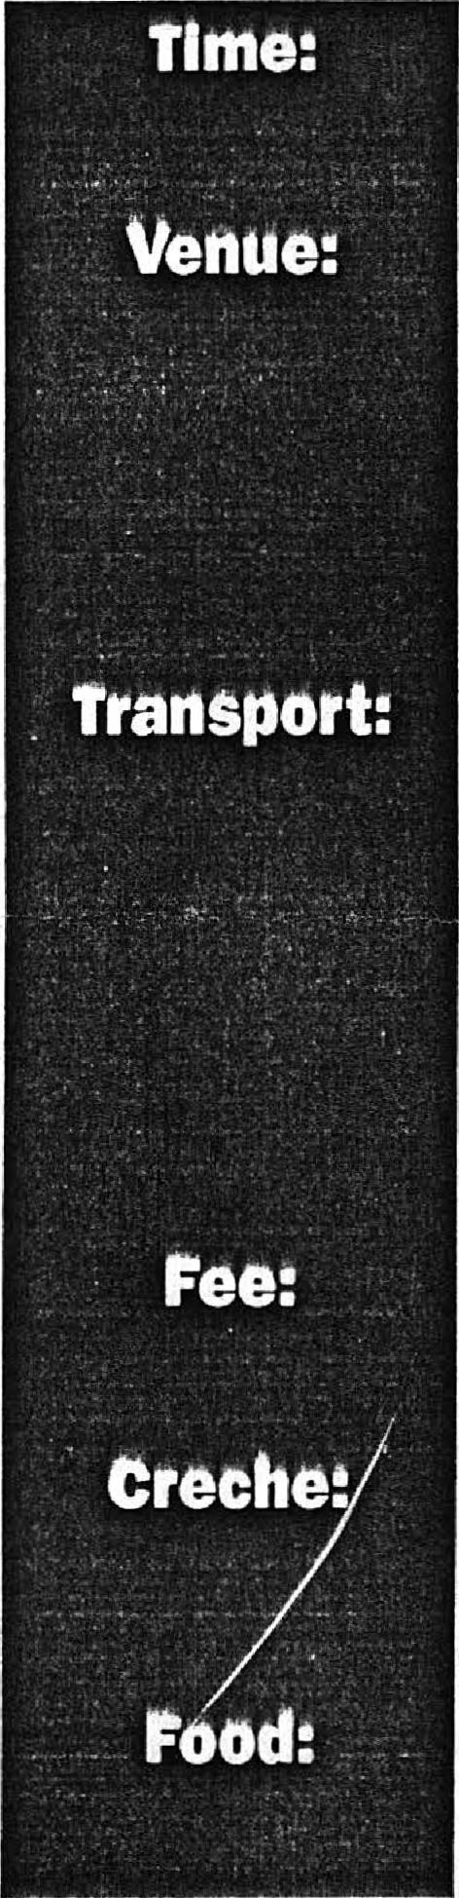
seminars on Travellers, Youth Provision, Women and
Education, History, Anti-Irish racism, the Irish language and Censorship/Self-Censorship.
Guest Speakers:
Gearaid 0 Caireallain from La, the Irish language daily published in Belfast, will
speak on Rebuilding the Irish Speaking Community.
Dr Elinor Kelly of Manchester University, researcher for the MacDonald enquiry into racism in Manchester schools, will address the conference on Racism - The Experience of Irish Children in British Schools.
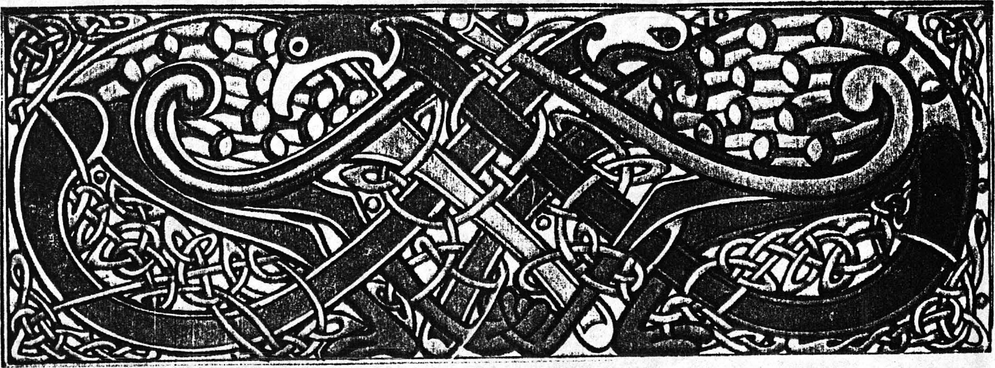
Name Tel⁻
9.30 – 10.30 Registration (Tea, Coffee)
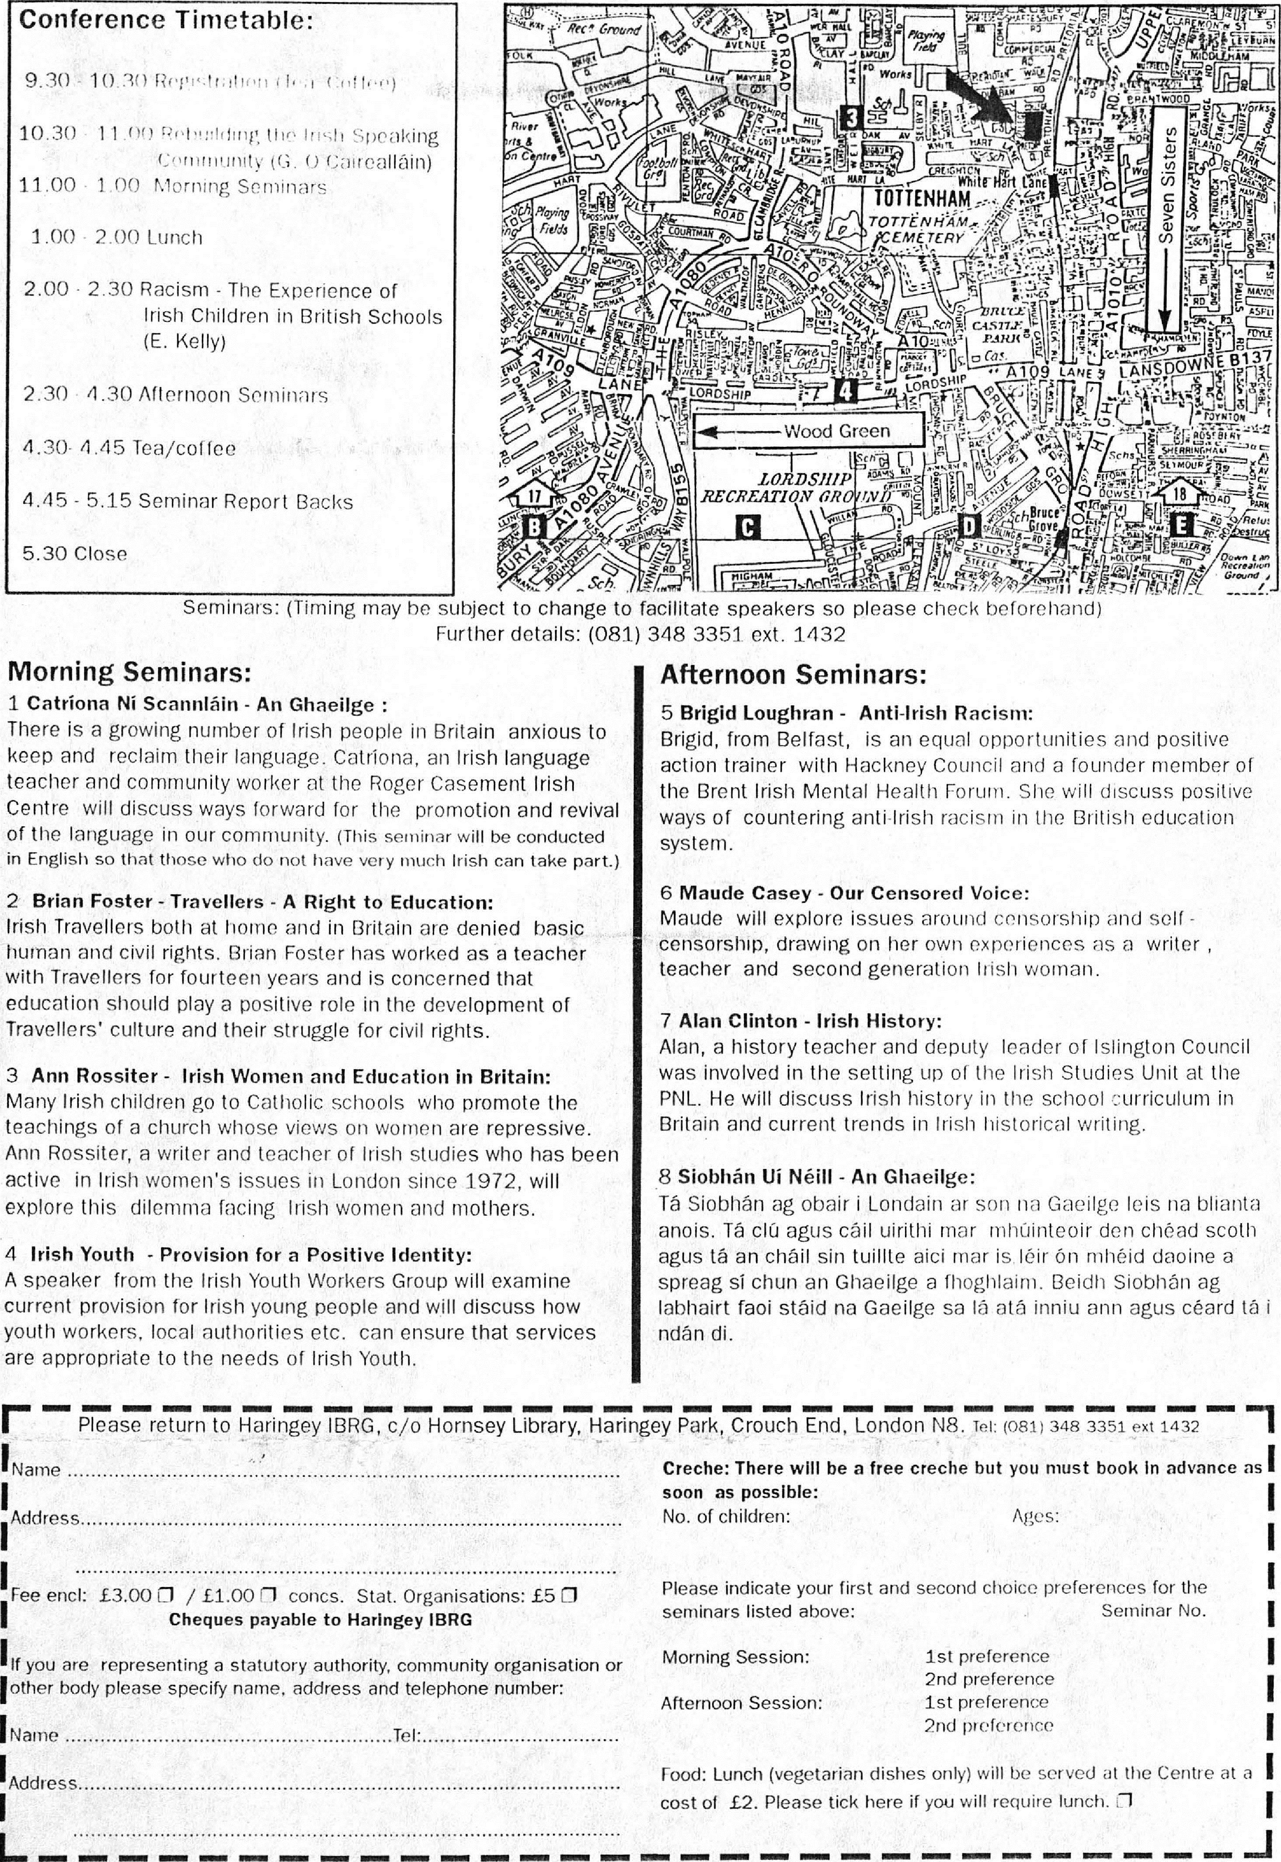
1st preference 2nd preference 1st preference 2nd preference
Morning Session:
Afternoon Session:
Wood Green
.n
Seminars: (Timing may he subject to change to facilitate speakers so please Further details: (081) 348 3351 ext. 1432

Afternoon Seminars:
5 Brigid Loughran - Anti-Irish Racism:
Brigid, from Belfast, is an equal opportunities and positive action trainer with Hackney Council and a founder member of the Brent Irish Mental Health Forum. She will discuss positive ways of countering anti-Irish racism in the British education system.
c-,1t1
trasos^{HIP}
Pal
3.1.
LORDSIHP
RECREATION ORO /Niro'
o
^{R}__7,72211 i:?:=3frAcie
Gador4d
check beforehand)
Morning Seminars:
1 Catriona Ni Scannlain - An Ghaeilge :
There is a growing number of Irish people in Britain anxious to keep and reclaim their language. Catriona, an Irish language teacher and community worker at the Roger Casement Irish Centre will discuss ways forward for the promotion and revival of the language in our community. (This seminar will be conducted in English so that those who do not have very much Irish can take part.)
2 Brian Foster - Travellers - A Right to Education:
Irish Travellers both at home and in Britain are denied basic human and civil rights. Brian Foster has worked as a teacher with Travellers for fourteen years and is concerned that education should play a positive role in the development of Travellers' culture and their struggle for civil rights.
3 Ann Rossiter - Irish Women and Education in Britain: Many Irish children go to Catholic schools who promote the teachings of a church whose views on women are repressive.
Ann Rossiter, a writer and teacher of Irish studies who has been active in Irish women's issues in London since 1972, will explore this dilemma facing Irish women and mothers.
4 Irish Youth - Provision for a Positive Identity:
A speaker from the Irish Youth Workers Group will examine current provision for Irish young people and will discuss how youth workers, local authorities etc. can ensure that services are appropriate to the needs of Irish Youth.
6 Maude Casey - Our Censored Voice:
Maude will explore issues around censorship and self -censorship, drawing on her on experiences as a writer , teacher and second generation Irish woman.
7 Alan Clinton - Irish History:
Alan, a history teacher and deputy leader of Islington Council was involved in the setting up of the Irish Studies Unit at the PNL. He will discuss Irish history in the school curriculum in Britain and current trends in Irish historical writing.
8 Siobhan Ui Neill - An Ghaeilge:
Ta Siobhan ag obair i Londain ar son na Gaeilge leis na blianta anois. Ta clu agus cail uirithi mar InhCiinteoir den choad scoth agus ta an chail sin tuillte aici mar is. leir On mheid daoine a spreag si chun an Ghaeilge a fhoghlaim. Beidh Siobhan ag Iabhairt faoi staid na Gaeilge sa la ata inniu ann agus ceard ta i ndan di.
Please return to Haringey IBRG, c/o Hornsey Library, Haringey Park, Crouch End, London N8. Tel: (081) 348 3351 ext 1432
r
01111011 11.0111 Ells= WWII IMMO
Creche: There will be a free creche but you must book In advance as soon as possible:
No. of children: Ages:
Please indicate your first and second choice preferences for the
seminars listed above: Seminar No.
Food: Lunch (vegetarian dishes only) will be served at the Centre at a cost of .E2. Please tick here if you will require lunch.
Conference Timetable:
10.30 11.00 Rebuilding the Irish Speaking
communIty (G.O Caireallain) 11.00 • 1.00 Morning Seminars
1.00 2.00 Lunch
2.00 2.30 Racism - The Experience of Irish Children in British Schools (E. Kelly)
2.30 4.30 Afternoon Seminars 4.30- 4.45 Tea/coffee
4.15 - 5.15 Seminar Report Backs 5.30 Close
Name
Address
Fee encl: £3.00 / £1.00 concs. Stat. Organisations: £5
Cheques payable to Haringey IBRG
If you are representing a statutory authority, community organisation or other body please specify name, address and telephone number:
Address

