Flow at Work as a Moderator of the Self-Determination Model of Work Engagement
Author's Accepted Manuscript (AAM)
De Fraga, D. , & Moneta, G. B. (2016). Flow in work as a moderator of the self-determination model of work engagement. In L. Harmat, F. Ørsted Andersen, F. Ullén, F., J. Wright, & G. Sadlo (Eds.), The flow experience: Empirical research and applications (pp. 105–123). New York: Springer. ISBN: 978-3-319-28632-7. DOI: 10.1007/978-3-319-28634-1.
Submitted: January 4, 2015
Revised: May 16, 2015
Accepted: May 26, 2015
Published: May 2016
Daniela De Fraga and Giovanni B. Moneta♣
Abstract
This study extends the self-determination model of work engagement. Based on flow theory and self-determination theory, it was hypothesised that the extent to which workers experience flow at work would moderate the positive association between perceived managerial autonomy support and work engagement, in such a way that for employees with more flow the association would be weaker (H1), and the positive associations between autonomy support and satisfaction of intrinsic psychological needs, in such a way that for employees with more flow these associations would be weaker (H2). A sample of 177 workers completed the Work Climate Questionnaire, Basic Need Satisfaction at Work Scale, Utrecht Work Engagement Scale, and Flow Short Scale. Moderated mediation modelling supported hypothesis 1 and hypothesis 2 limitedly to the needs for competence and relatedness. The findings indicate that workers with more flow at work are more likely to engage in the job regardless of autonomy support.
Keywords
Autonomy support, intrinsic psychological needs, flow, self-determination theory, work engagement.
Introduction
Workers’ psychological connection with their jobs has become the core research theme in the field of organisational psychology (Leiter and Bakker 2010). One of the reasons is that workers who are engaged have a propensity for working to their full potential, perform to a high standard, are committed, and interested in the company’s success (Harter et al. 2002). Moreover, work engagement has benefits for the employee, as it entails a positive and fulfilling job-related state of mind (Sonnentag et al. 2010), which is characterised by a sense of energetic, effective, and enthusiastic connection with the activities in the job (Leiter and Bakker 2010). Work engagement is a cognitive-affective state that involves employees' perception of being able to deal successfully with the demands of their work with vigour, dedication, and absorption (Schaufeli and Bakker 2003). This state is theorised to contribute to employees’ overall well-being, which in turn helps to prevent undesired outcomes such as job burnout (Leiter and Bakker 2010).
Where does work engagement come from? The self-determination model of work engagement (Deci et al. 2001) states that the primary factors influencing work engagement are perceived managerial autonomy support and satisfaction of the intrinsic psychological needs for autonomy, competence and relatedness. However, nothing is known about individual factors that may influence the extent to which contextual factors, such as perceived managerial autonomy support, are conducive to need satisfaction and work engagement. The aim of the present study is to gain a better understanding of when perceived managerial autonomy support leads to need satisfaction and work engagement. In particular, this study proposes and tests an extended self-determination model of work engagement (Deci et al. 2001) that includes flow (Csikszentmihalyi 1975/2000) as a moderating variable.
The Self-Determination Model of Engagement
Self-determination theory (SDT; Deci and Ryan 1985; Ryan and Deci 2000) defines need satisfaction in terms of cognitions, emotions, and behaviour. Autonomy need satisfaction involves performing with a sense of volition and initiation of one’s own actions (Deci et al. 2001), as well as the feeling of having choice (Gagné and Deci 2005). Competence need satisfaction entails succeeding at tasks which are challenging and the accomplishment of desired results. Relatedness need satisfaction relies on a sense of mutual respect, care, and consideration with others (Deci et al. 2001).
Although there are various facets of work autonomy (e.g., work schedule autonomy or work criterion autonomy) that are associated with more work commitment and work satisfaction (Sadler-Smith et al. 2003), the self-determination model of work engagement (Deci et al. 2001) posits that the main contributor to both work engagement and fulfillment of the intrinsic needs is managerial autonomy support (Deci et al. 2001). A worker’s perception of managerial autonomy support can be achieved when managers or most immediate supervisors understand and recognise the viewpoint of their employees (Deci and Ryan 1985), offer information which is meaningful, and allow for choice (Baard et al. 2004).
The self-determination model of work engagement posits that perceived managerial autonomy support fosters satisfaction of intrinsic psychological needs and, in turn, satisfaction of these needs fosters work engagement. Several studies found that perceived autonomy support (e.g., Deci and Ryan 1985; Ryan and Deci 2000; Deci and Vansteenkiste 2004) and perceived managerial autonomy support (e.g., Deci et al. 2001; Baard et al. 2004) explain satisfaction of the intrinsic psychological needs. Moreover, Deci et al. (2001) found in two workers samples, one from the U.S.A. and the other from Bulgaria, that satisfaction of the intrinsic psychological needs explains work engagement and mediates the positive relation between perceived managerial autonomy support and work engagement. Therefore, perceived managerial autonomy support appears to be a core promoter of both intrinsic psychological need satisfaction and work engagement.
However, the relations between perceptions of managerial autonomy support in the job, intrinsic need satisfaction, and engagement might be more complex. Task enjoyment, experience during the activity, and challenge intensity seem also important for workers' optimal functioning and engagement. In particular, as captured by the term autotelic experience (Csikszentmihalyi 1992/2002), individuals may engage in an activity purely by its own sake because they provide inner rewards for themselves by developing the ability to find enjoyment in the task regardless of external encouragements such as perceptions of autonomy support in the work climate.
Flow as a Moderator of the Self-Determination Model of Engagement
Flow is an optimal experience wherein the person acts with total involvement in an intrinsically motivated activity; the experience is characterised by a state of complete absorption in the task (Nakamura and Csikszentmihalyi 2002), profound intrinsic enjoyment and enriched cognitive efficiency (Moneta 2014). The flow state involves deep and undivided concentration and low self-awareness, which is often accompanied by a distorted perception of time (Ullen et al. 2012). Flow is expected to occur more often when the person identifies greater opportunities for action and has the necessary skills to engage in them (Nakamura and Csikszentmihalyi 2002) and hence experiences a balance between perceived challenges and skills (Csikszentmihalyi 1975/2000; Loubris et al. 1995). Moreover, flow is more likely to occur when goals are clear and feedback from the activity is immediate (Csikszentmihalyi 1975/2000).
Although flow appears to be easier to achieve in supportive work contexts, some employees may be able to enjoy their work and experience flow even in an austere and limited work climate by viewing environmental constraints as opportunities to express their creativity and self-determination (Csikszentmihalyi 1990). These individuals possibly have developed an autotelic personality, and tend to be more resilient than others when faced with non-supportive work contexts, and are particularly active in pursuing challenging tasks in which they can see themselves as very skilled (Csikszentmihalyi 1990). Furthermore, autotelic persons are capable of converting pressure into enjoyable challenges and control their minds so as to continually perceive anything as a potential motive of joy (Csikszentmihalyi 1990). Accordingly, autotelic workers may experience flow more frequently and intensely than others (Csikszentmihalyi 1990) particularly in poor work climates.
Flow in the work context has been defined by Bakker (2005) as a short-term peak experience which is characterised by absorption, enjoyment, and intrinsic motivation. The element of absorption refers to a state of profound concentration in which workers are completely immersed in their job (Bakker 2005), entirely forget what is happening around them, and have a sensation that time is flying (Csikszentmihalyi 1990). As such, flow in the job may work as a buffer that isolates employees from the environment, making them less sensitive to perceptions of the work context. In turn, workers’ perception of managerial autonomy support may be less predictive of work engagement for employees with more flow in the job. Therefore, the following hypothesis is proposed:
H1: The positive association between perceived managerial autonomy support and work engagement will be moderated (buffered) by flow at work, in such a way that the association will be weaker for those with higher levels of flow.
The enjoyment element of flow stems from the employees performing a work-related task purely because they find it intrinsically rewarding, as flow makes the activity inherently rewarding (Csikszentmihalyi 1990), with no need for external recompenses. Because the flow experience is self rewarding, entails a sense of freedom during the task, and involves the feeling of achievement in carrying out challenging tasks to the best of one’s abilities, it should facilitate the satisfaction of intrinsic psychological needs on its own, independent of contextual factors such as perceived managerial autonomy support. Therefore, the following hypothesis is proposed:
H2: The positive association between perceived managerial autonomy support at work and intrinsic needs satisfaction for (a) autonomy, (b) competence, and (c) relatedness will be moderated (buffered) by flow at work, in such a way that the association will be weaker for higher levels of flow.
Goals of the Study
The two research hypotheses in combination constitute the moderated mediation model shown in Fig. 4.1, which illustrates the proposed moderating role of flow on the paths from perceived managerial autonomy support to work engagement, as well as on the paths from perceived autonomy support to intrinsic needs satisfaction for autonomy, competence, and relatedness. The model posits that flow at work will buffer the effect of perceived autonomy support on work engagement (H1) and on intrinsic need satisfaction for autonomy (H2a), competence (H2b), and relatedness (H2c). The goal of the present study is to test this extended self-determination model of work engagement.
Fig. 4.1 Conceptual diagram of the hypothesised moderating effects of flow on the self-determination model of work engagement (Deci et al. 2001)
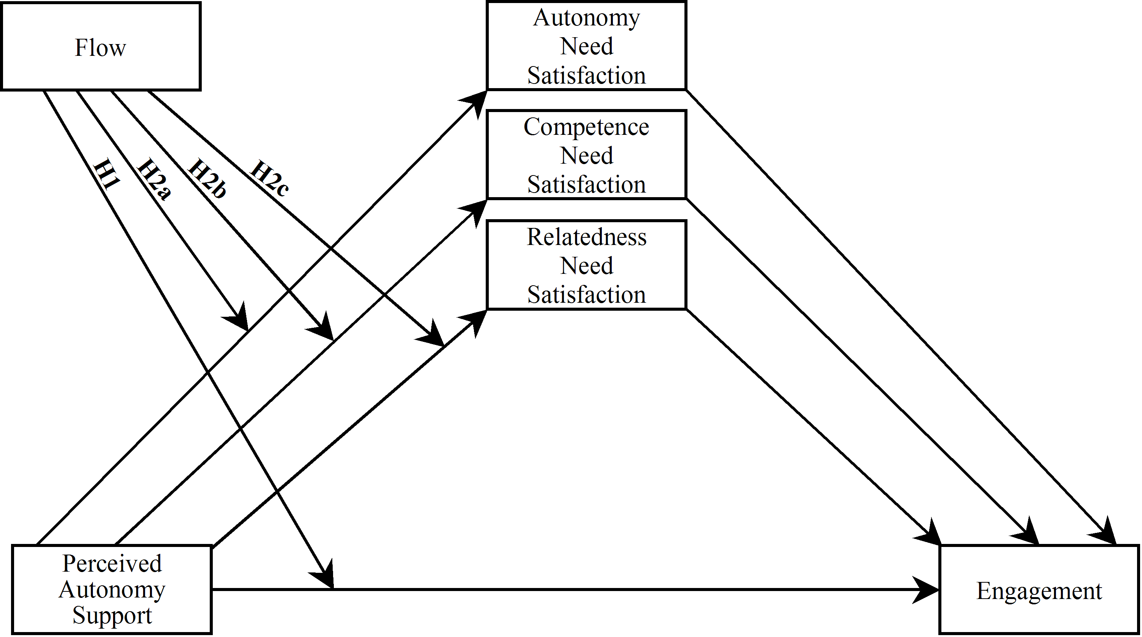
Method
Participants
A convenience sample of 177 workers participated in the study. There were 67 males (37.9%) and 110 females (62.1%) with ages ranging from 19 to 74 (M = 37.33; SD = 13.21). There were 120 (67.8%) Whites, 24 (13.6%) Blacks, 3 (1.7%) Chinese, 5 (2.8%) Indians, 1 (.6%) Japanese, 12 (6.8%) from other ethnic backgrounds, and 12 (6.8%) participants of mixed ethnicity. The nationality distribution was 67 (37.9 %) British citizens and 110 (62.1%) participants from other nationalities. In relation to educational background, 111 (62.7%) participants earned an undergraduate degree, and 57 (32.2%) also held a postgraduate degree.
Participants were from a wide variety of occupations, such as engineer, customer services assistant, care worker, recruiter, and lecturer. The employment type distribution was 102 full-time workers (57.6%), 63 part-time workers (35.6%), and 12 workers who had special working arrangements (6.8%). The weekly working hours average was 42.57 (SD = 13.67) for full-time employees, 19.51 (SD = 10.86) for part-time employees, and 27.04 (SD = 14.53) for employees with other types of working hours. The majority of the participants were employed by a company (n = 150; 84.7%), whilst the others were self-employed (n = 20; 11.3%) or owned their own company or business (n = 7; 4 %). Job tenure varied from 0 to 52 years (M = 5.42 years, SD = 7.40).
Measures
This research was approved by a university ethics panel and the data were collected through an online survey, which contained the following questionnaires.
Perceived Autonomy Support Scale (PAS); also called Work Climate Questionnaire (WCQ)
The PAS measures perceptions of the degree of autonomy supportiveness of workers' most immediate supervisor or manager (Baard et al. 2004) through 15 self-report items (e.g., “I feel that my manager provides me choices and options”) rated on a scale ranging from 1 (“strongly disagree”) to 7 (“strongly agree”). The scale score was calculated by averaging all the items, with higher scores indicating more perceived autonomy support. The Cronbach’s alpha of the scale ranged from .92 to .96 in previous studies in which the target person (e.g., doctor, instructor, or manager) varied (Williams et al. 1996; Williams and Deci 1996).
Basic Need Satisfaction at Work scale (BNSW; also named Intrinsic Need Satisfaction Scale)
The BNSW measures the extent to which workers experience satisfaction of their three intrinsic needs (autonomy, competence, and relatedness) at work (Kasser et al. 1992) through 21 self-report items (e.g., “I feel like I can make a lot of inputs to deciding how my job gets done” [autonomy], “I have been able to learn interesting new skills on my job” [competence], and “I really like the people I work with” [relatedness] on a scale ranging from 1 (“not at all true”) to 7 (“very true”). The subscale scores were calculated by averaging their constituent items, with higher scores indicating more need satisfaction. The Cronbach’s alpha reported in previous studies ranged between .62 to .79 for autonomy, between .73 to .81 for competence, and between .57 to .84 for relatedness (Leone 1995; Deci et al. 2001; Baard et al. 2004).

Utrecht Work Engagement Scale 9 (UWES-9)
The UWES-9 measures work engagement (Schaufeli et al. 2006) through 9 self-report items (e.g., “At my work, I feel bursting with energy”) on a scale ranging from 0 (“never”) to 6 (“always/every day”). The scale score was calculated by averaging all the items, with higher scores indicating more work engagement. In the original validation study, the Cronbach’s alpha ranged between .85 and .92 across 10 investigated countries (Schaufeli et al. 2006).
Flow Short Scale (FSS)
The FSS measures levels of flow experienced during an activity (Engeser and Rheinberg 2008) through 10 self-report items (e.g., “I am totally absorbed in what I am doing”) on a scale ranging from 0 (“not at all”) to 6 (“very much”). In this study, participants were instructed to complete the scale thinking of their experience at work. The scale score was calculated by averaging all the items, with higher scores indicating more flow at work. In the original validation study, the Cronbach’s alpha was .92 (Engeser and Rheinberg 2008).
Overview of Statistical Analyses
The analysis used Hayes’ (2013) regression modeling approach to multiple and moderated mediation, which is robust to non-normality, and Hayes' (n.d.) PROCESS Macro for SPSS. Hayes’s model 4 (multiple mediation model) was used to partially replicate Deci and co-workers' (2001) self-determination model of engagement. Hayes' model 8 (multiple moderated mediation model) was used to test the hypothesised extension of the self-determination model of engagement.
In order to reduce collinearity, the scores of all variables were standardised prior to fitting the models; so that, all the estimated coefficients are standardised regression coefficients. The models were estimated using 50,000 bootstrap permutations for bias correction. The indirect effects were tested using 95% confidence intervals.
The proposed extension of the self-determination model of engagement includes four hypothesised interactions. These were simultaneously estimated in a single run. Nevertheless, for the sake of clarity, the results are presented separately by each specific path. The standard convention is used to identify the various paths of the models: a represents paths from the predictors to the mediators, b represents paths from the mediators to the outcome variable, and c represents paths from the predictors to the outcome variable.
Results
Data Description
Table 4.1 shows the descriptive statistics of the study variables. With the exception of competence need satisfaction, Cronbach’s alpha of the scales exceeded .7, reflecting satisfactory to good internal consistency (e.g., Kline 2013). As expected, all the variables were positively correlated with one another.
Table 4.1 Means, standard deviations, correlation coefficients and Cronbach’s alpha coefficients (in parentheses) of the study variables
Variables | M | SD | 1. | 2. | 3. | 4. | 5. |  | 6.
1. Perceived autonomy supportª | 4.87 | 1.49 | (.97)
2. Autonomy need satisfactionª | 4.54 | 1.15 | .68** | (.78)
3. Competence need satisfactionª | 5.26 | 1.00 | .49** | .61** | (.64)
4. Relatedness need satisfactionª | 4.98 | 1.05 | .47** | .57** | .54** | (.82)
5. Engagement^{b} | 4.08 | 1.16 | .47** | .63** | .64** | .48** |  | (.91)
6. Flow^{b} | 3.59 | .98 | .38** | .48** | .52** | .36** |  | .66** | (.85)
Note. N=177.
**p < .01 (1-tailed)
ªRange of the scale = 1 - 7
^{b}Range of the scale = 0 - 6
Replication of the Self-Determination Model of Work Engagement
In accordance with Deci et al.’s (2001) model, engagement was the outcome variable (Y), perceived autonomy support was the predictor variable (X), and the three intrinsic needs – (M₁) autonomy, (M₂) competence, and (M₃) relatedness – were the mediating variables. Table 4.2 shows the estimated regression coefficients, their standard errors, the significance levels of each direct effect and the overall model summary.
The estimated coefficients for paths a₁ and b₁ were both positive. The indirect effect of perceived autonomy support on engagement through autonomy need satisfaction was positive (0.227) and significant (95% CI: 0.118 - 0.351). Likewise,
the estimated coefficients for paths a₂ and b₂ were both positive. The indirect effect of perceived autonomy support on engagement through competence need satisfaction was positive (0.193) and significant (95% CI: 0.111 - 0.297). The estimated coefficients for paths a₃ and b₃ were both positive. However, the indirect effect of perceived autonomy support on engagement through relatedness need

Table 4.2 Standardised regression coefficients, standard errors, and model summary information for the self-determination mediation model of engagement
Predictor | Outcome
 | M₁ (Autonomy) |  |  |  | M₂ (Competence) |  |  |  | M₃ (Relatedness) |  |  |  | Y (Engagement)
 |  | Coeff. | SE | p |  | Coeff. | SE | p |  | Coeff. | SE | p |  | Coeff. | SE | p
X (PAS) | a₁ | 0.676 | 0.056 | < .001 | a₂ | 0.493 | 0.066 | < .001 | a₃ | 0.468 | 0.067 | < .001 | c’ | 0.020 | 0.074 | .789
M₁ (Autonomy) |  | _ | _ | _ |  | _ | _ | _ |  | _ | _ | _ | b₁ | 0.336 | 0.084 | .001
M₂ (Competence) |  | _ | _ | _ |  | _ | _ | _ |  | _ | _ | _ | b₂ | 0.391 | 0.072 | < .001
M₃ (Relatedness) |  | _ | _ | _ |  | _ | _ | _ |  | _ | _ | _ | b₃ | 0.066 | 0.069 | .342
 | R² = 0.457  F(1, 175) = 147.373, p < .001 |  |  |  | R² = 0.243  F(1, 175) = 56.160, p < .001 |  |  |  | R² = 0.219  F(1, 175) = 49.044, p < .001 |  |  |  | R² = 0.501  F(4, 172) = 43.125, p < .001
Note. (N= 177) (PAS) = perceived autonomy support, (Autonomy) = autonomy need satisfaction, (Competence) = competence need satisfaction, and (Relatedness) = relatedness need satisfaction.
satisfaction was positive (0.031) but not significant (95% CI: -0.036 - 0.115). Finally, the total indirect effect of perceived autonomy support on engagement through the three needs satisfaction was positive (0.450) and significant (95% CI: 0.317 - 0.610). In all, the analysis replicated the self-determination model of engagement, with the caveat that relatedness need satisfaction did not turn out to be a mediator.
Test of the Moderated Mediation Model of Work Engagement
Moderation of the path from perceived autonomy support to engagement (H1)
In this part of the model, engagement was the outcome variable, perceived autonomy support was the predictor variable (X), and flow (W) was the moderator and predictor variable. Table 4.3 shows the regression estimates. Flow and the interaction of flow and perceived autonomy support were significant predictors of engagement, whereas perceived autonomy support was not a significant predictor.

Table 4.3 Regression of work engagement on perceived autonomy support and flow: Estimated standardised regression coefficients, their standard errors and significance levels, and model summary
 | Coeff. | Std.Error | t | p
Perceived Autonomy Support (X) c₁ | -0.007 | 0.066 | -0.108 | .914
Flow (W) c₂ | 0.390 | 0.058 | 6.684 | < .001
Perceived Autonomy Support x Flow (XW) c₃ | -0.099 | 0.046 | -2.132 | .035
R² = 0.609
F(6,170) = 44.087, p < .001
Note. N=177.

Fig. 4.2 shows the interaction between perceived autonomy support and flow in the prediction of engagement. The negative association for high flow illustrated in the figure was not significant. The figure shows that flow moderates the association between perceived autonomy support and engagement in such a way that perceived autonomy support is positively associated with engagement for low flow, and it is not associated with engagement for high flow. These findings indicate that perceived autonomy support predicts engagement only for those with low levels of flow in the job, and hence support hypothesis 1. Moreover, the figure shows that the effect of perceived autonomy support on engagement was way weaker than that of flow.
Fig. 4.2 Interaction plot of engagement as a function of PAS (perceived autonomy support) for low (-1SD) and high (+1SD) levels of flow
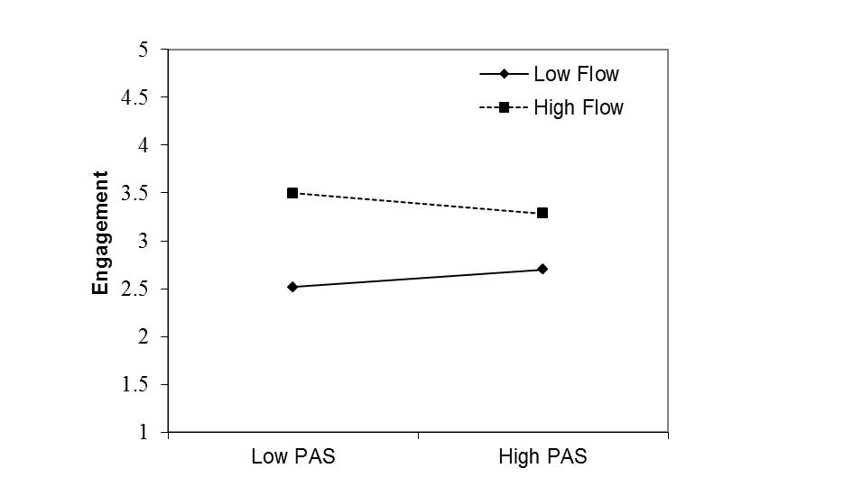
Moderation of the path from perceived autonomy support to autonomy need satisfaction (H2a)
In this part of the model, autonomy need satisfaction was the outcome variable, perceived autonomy support was the predictor variable (X), and flow was the moderator and predictor variable (W). Table 4.4 shows the regression estimates. Flow and perceived autonomy support were significant predictors of autonomy need satisfaction, whereas the interaction of flow and perceived autonomy support was not a significant predictor. These findings indicate that flow does not moderate the relationship between perceived autonomy support and autonomy need satisfaction, and hence do not support hypothesis 2a.
Table 4.4 Regression of autonomy need satisfaction on perceived autonomy support and flow: Estimated standardised regression coefficients, their standard errors and significance levels, and model summary
 | Coeff. | Std.Error | t | p
Perceived Autonomy Support (X) a₁ | 0.560 | 0.058 | 9.606 | < .001
Flow (W) a₂ | 0.267 | 0.057 | 4.700 | < .001
Perceived Autonomy Support x Flow (XW) a₃ | -0.061 | 0.050 | -1.236 | .218
R² = 0.522
F(3,173) = 63.016, p < .001
Note. N=177.

Moderation of the path from perceived autonomy support to competence need satisfaction (H2b)
In this part of the model, competence need satisfaction was the outcome variable, perceived autonomy support was the predictor variable (X), and flow was the moderator and predictor variable (W). Table 4.5 shows the regression estimates. Flow, perceived autonomy support, and the interaction of flow and perceived autonomy support were significant predictors of competence need satisfaction.

Table 4.5 Regression of competence need satisfaction on perceived autonomy support and flow: Estimated standardised regression coefficients, their standard errors and significance levels, and model summary
 | Coeff. | Std.Error | t | p
Perceived Autonomy Support (X) a₁ | 0.307 | 0.065 | 4.698 | < .001
Flow (W) a₂ | 0.395 | 0.064 | 6.199 | < .001
Perceived Autonomy Support x Flow (XW) a₃ | -0.141 | 0.056 | -2.530 | .012
R² = 0.398
F(3,173) = 38.150, p < .001
Note. N=177.
Fig. 4.3 shows the interaction between perceived autonomy support and flow in the prediction of competence need satisfaction. The figure shows that flow moderates the association between perceived autonomy support and competence need satisfaction in such a way that perceived autonomy support is positively associated with competence need satisfaction for low flow, and it is less associated with competence need satisfaction for high flow. These findings indicate that perceived autonomy support is a better predictor of competence need satisfaction for those with low levels of flow in the job, and hence support hypothesis 2b.
Fig. 4.3 Interaction plot of competence need satisfaction as a function of PAS (perceived autonomy support) for low (-1SD) and high (+1SD) levels of flow
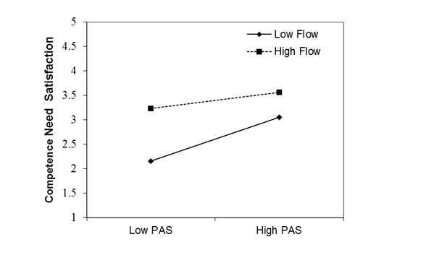
Moderation of the path from perceived autonomy support to relatedness need satisfaction (H2c)
In this part of the model, relatedness need satisfaction was the outcome variable, perceived autonomy support was the predictor variable (X), and flow was the moderator and predictor variable (W). Table 4.6 shows the regression estimates. Flow, perceived autonomy support, and the interaction of flow and perceived autonomy support were significant predictors of relatedness need satisfaction.
Table 4.6 Regression of relatedness need satisfaction on perceived autonomy support and flow: Estimated standardised regression coefficients, their standard errors and significance levels, and model summary
 | Coeff. | Std.Error | t | p
Perceived Autonomy Support (X) a₁ | 0.347 | 0.071 | 4.864 | < .001
Flow (W) a₂ | 0.217 | 0.070 | 3.124 | .002
Perceived Autonomy Support x Flow (XW) a₃ | -0.148 | 0.061 | -2.446 | .015
R² = 0.284
F(3,173) = 22.835, p < .001
Note. N=177.

Fig. 4.4 shows the interaction between perceived autonomy support and flow in the prediction of relatedness need satisfaction. The figure shows that flow moderates the association between perceived autonomy support and relatedness need satisfaction in such a way that perceived autonomy support is positively associated with relatedness need satisfaction for low flow, and it is less associated with relatedness need satisfaction for high flow. These findings indicate that perceived autonomy support is a better predictor of relatedness need satisfaction for those with low levels of flow in the job, and hence support hypothesis 2c.
Fig. 4.4 Interaction plot of relatedness need satisfaction as a function of PAS (perceived autonomy support) for low (-1SD) and high (+1SD) levels of flow
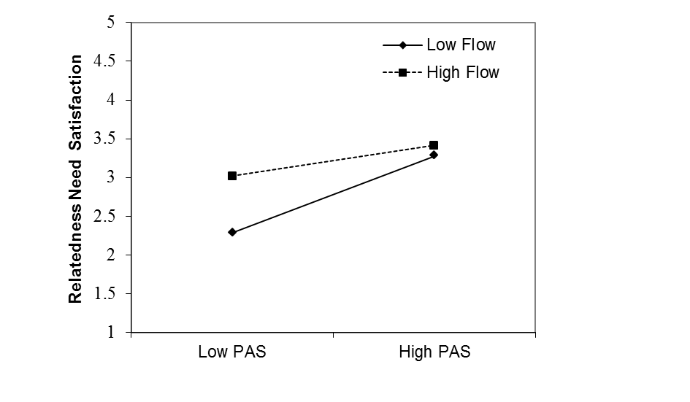
Discussion
This study examined the buffering role of flow on the self-determination mediation model of work engagement (Deci et al. 2001) using a multicultural sample of workers from a variety of professions. Mediation analysis substantially replicated Deci and co-workers' findings. Moderated mediation analysis fully supported hypothesis 1, and partially supported hypothesis 2. These findings provide preliminary support for an extended model of work engagement, and suggest that flow functions as a personal resource that isolates employees from the work environment and hence helps them to engage in work independently of perceptions of managerial autonomy support.
Replication of the Self-Determination Model of Engagement
The patterns of correlations between variables from this study were consistent with those in Deci and co-workers' (2001) study. The analysis of the mediation model of engagement revealed that all the hypothesised paths were significant except for that from relatedness need satisfaction to engagement, which was not significant. This difference in findings between the two studies may be due to either chance or small differences in the research methods used. In all, the self-determination mediation model of work engagement worked well on the sample of the present study, indicating that perceived managerial autonomy support promotes work engagement through the satisfaction of intrinsic psychological needs.
The extended moderated mediation model of work engagement
The moderated mediation analysis fully supported hypothesis 1, revealing that there was no association between perceived managerial autonomy support and work engagement for employees with high flow in the job. Consistent with flow theory (e.g., Csikszentmihalyi 1990; Bakker 2005), this finding suggests that employees who experience high levels of flow in the job are less reliant on their work atmosphere due to a state of profound task absorption and heightened concentration that makes them more self-motivated and less aware of the environment.
In particular, once in flow, individual’s attention is freely invested in accomplishing the task at hand (Csikszentmihalyi 1990), and the concentration is so intense that the person is less able to detect and take in consideration contextual cues (Moneta 2014). A plausible explanation is that the nervous system has a limited capacity of how much information can be processed at each time. For example, it is estimated that individuals can process a maximum of 126 bits of information per second (Csikszentmihalyi 1990). Given that to understand what another person is saying involves processing about 40 bits of information per second (Csikszentmihalyi 1990), it seems almost impossible for employees high in flow to keep track of what is happening in the work environment due to limits in attentional resources. As a result, workers who experience high levels of flow are more likely to remain engaged in work independently of the degree of autonomy supportiveness in their job.
The moderated mediation analysis supported hypothesis 2 for the needs of competence and relatedness, but not for the need of autonomy. On the one hand, the analysis revealed that the positive relations between perceived managerial autonomy support and competence need satisfaction and relatedness need satisfaction were weaker for workers with more flow in the job. On the other hand, the analysis revealed that the positive relation between perceived managerial autonomy support and autonomy need satisfaction had virtually the same strength for workers with different levels of flow in the job.
The finding that flow buffers the association between perceived managerial autonomy support and competence need satisfaction has a straightforward interpretation within flow theory. As competence need satisfaction involves mastering tasks (Gagné 2003), flow is likely to facilitate the satisfaction of this need through workers’ sense of capability in carrying out challenging tasks (Csikszentmihalyi 1990) and perceptions of greater opportunities for action when holding the basic skills to engage in them (Nakamura and Csikszentmihalyi 2002). Through either paths, flow is likely to foster satisfaction of the need for competence independent of external rewards and conditions.
The finding that flow buffers the association between perceived managerial autonomy support and relatedness need satisfaction requires a more speculative interpretation. Undertaking pleasant and intrinsically motivated activities can help to enhance relatedness feelings (Reis et al. 2000). As such, workers high in flow are likely to benefit from this optimal experience in satisfying their need for relatedness without relying as much as those low in flow in social activities and the provision of contextual cues.
The finding that flow does not buffer the positive relation between perceived managerial autonomy support and autonomy need satisfaction is somewhat at odds with flow theory but is congruent with self-determination theory (Deci and Ryan 1985; Ryan and Deci 2000), which posits that perceived autonomy support is a key facilitator for autonomy need satisfaction. Although flow entails a sense of freedom during the absorption in intrinsically rewarding work activities, and hence can predict autonomy need satisfaction on its own, perceived managerial autonomy support is the strongest predictor of autonomy need satisfaction, and its predictive power is unaffected by flow.
What does cause work flow-ers to be more independent from environmental influences in their work engagement? Two complementary answers can be suggested. On the one hand, work flow-ers may have had developmental experiences that helped them to learn how to self regulate flow in achievement contexts. In particular, they may have developed a metacognition of flow (Wilson and Moneta, 2012, 2015), meant as knowledge and beliefs about the flow experience and one’s own ability to make it happen at will, through, for example, vicarious learning derived from the observation of successful role models. On the other hand, work flow-ers may be predisposed genetically to develop an autotelic personality. In particular, research on twins found that flow pronness has a sizeable heritability of 41% (Mosing et al. 2012), and individuals who are genetically predisposed for experiencing flow also tend to have personality traits such as low neuroticism, high conscientiousness (Ullén et. al 2012), openness to experience (Butkoviæ, Ullén, and Mosing 2015), and internal locus of control (Mosing et al. 2012), which are likely to support volitional behaviour and task focus in achievement contexts. As such, genetic factors may influence both flow in work and independence from the work environment. Moreover, even perceptions of the work environment were found to have fairly large heritability (Butkoviæ, Ullén, and Mosing 2015; Mosing et al. 2012). Therefore, work flow-ers' genetic makeup may help them simultaneously to reach flow in work and to perceive the work environment as being more flow-conducive or less flow-disruptive than deemed by their colleagues. In all, it is likely that environmental and genetic factors interact in the development of the autotelic independence from the work environment found in this study.
Limitations
The present study is limited by the small sample size with mixed occupations, the correlational design, and the total reliance on self-reported measures. Moreover, this study did not consider individual differences that are known to influence both flow and work engagement, such as Big Five personality traits (Ullen et al. 2012) and autotelic traits (Baumann 2012). Finally, this study ignored potentially relevant work environment factors. For instance, the occurrence of both flow and work engagement is likely to be facilitated by environmental circumstances such as adequate levels of difficulty in the job, clarity of goals, and opportunity for creativity in the job (Moneta 2012). The investigation of individual and environmental factors could bring a more thorough understanding of the moderating roles of flow on the self-determination model of work engagement.
Theoretical and practical implications
Although self-determination theory (Ryan and Deci 2000) and flow theory (Csikszentmihalyi 1992/2002) share various common goals, such as the interest in human strengths and their positive development (Deci and Vansteenkiste 2004), they have somewhat different theoretical tenets. For example, self-determination theorists argue that for individuals to actualise and be optimally active they need nutriments from the social environment (e.g., perceived autonomy support) in order to fulfill their intrinsic needs (Ryan and Deci 2000; Deci et al. 2001; Deci and Vansteenkiste 2004), whereas flow theorists posit that there need to be a balance between challenges and capabilities, and focus on the involvement of individuals with their tasks (Csikszentmihalyi 1990; Loubris et al. 1995; Bakker 2005). The present study contributes to the integration of these theoretical frameworks.
The main finding of the present study is that there is no relationship between perceived managerial autonomy support and work engagement for those with high flow in work, suggesting that the contextual factor of perceived managerial autonomy support is less important, or even irrelevant, in fostering work engagement for this particular group of workers. Therefore, this study shows that synergism between flow theory and self-determination theory can lead to more insightful and comprehensive models of engagement with potential applications to work settings.
In particular, for those companies which are unable to provide adequate levels of managerial autonomy support for their workers, the provision of clear goals and optimally challenging tasks may be the key for keeping employees intrinsically satisfied and engaged in their jobs. In turn, workers high in flow may be good candidates for companies lacking resources or model managements (Moneta in press).
Conclusions
This pilot study provides preliminary evidence in support of an extended self-determination model of work engagement that includes flow as a buffer to poor managerial autonomy support. The findings from this study indicate that workers with higher levels of flow at work are less reliant on their work conditions and more likely to engage in the job regardless of work environment factors that fall under the umbrella of autonomy support. These findings are consistent with the notions of autotelic self and autotelic experience, which imply that external forces do not rule whether the person will be able to find enjoyment and task focus in adverse situations, and that what matters most is the way a person perceives challenges. Because autotelic persons are more resilient in challenging situations, they may be ideal candidates for startup and other companies facing shortness of resources and unpredictability. Future research should assess the robustness of the extended self-determination model of work engagement across a range of work environments and its sensitivity to individual and cultural differences.
References
Baard, P. P., Deci, E. L., & Ryan, R. M. (2004). Intrinsic need satisfaction: A motivational basis of performance and well-being in two work settings. Journal of Applied Social Psychology, 34(10), 2045-2068.
Bakker, A. B. (2005). Flow among music teachers and their students: The crossover of peak experiences. Journal of vocational behavior, 66(1), 26-44.
Baumann, N. (2012). Autotelic personality. In S. Engeser (Ed.), Advances in flow research (pp. 165-186). New York: Springer.
Butkoviæ, A., Ullén, F., & Mosing, M.A. (2015). Personality and related traits as predictors of music practice: Underlying environmental and genetic influences. Personality and Individual Differences, 74, 133-138.
Csikszentmihalyi, M. (1975/2000). Beyond boredom and anxiety: Experiencing flow in work and play (2nd ed.). San Francisco: Jossey-Bass.
Csikszentmihalyi, M. (1990). Flow: The psychology of optimal experience. New York: Harper & Row.
Csikszentmihalyi, M. (1992/2002). Flow: The psychology of happiness (2nd ed.). Kent, UK: Mackays of Chatham.
Deci, E. L., & Ryan, R. M. (1985). Intrinsic motivation and self-determination in human behavior. New York: Plenum.
Deci, E. L., Ryan, R. M., Gagné, M., Leone, D. R., Usunov, J., & Kornazheva, B. P. (2001). Need satisfaction, motivation, and well-being in the work organizations of a former eastern bloc country: A cross-cultural study of self-determination. Personality and Social Psychology Bulletin, 27(8), 930-942.
Deci, E. L., & Vansteenkiste, M. (2004). Self-determination theory and basic need satisfaction: Understanding human development in positive psychology. Ricerche di Psicologia, 1(27), 23-40.
Engeser, S., & Rheinberg, F. (2008). Flow, performance and moderators of challenge-skill balance. Motivation and Emotion, 32(3), 158-172.
Gagné, M. (2003). The role of autonomy support and autonomy orientation in prosocial behavior engagement. Motivation and Emotion, 27(3), 199-223.
Gagné, M., & Deci, E. L. (2005). Self-determination theory and work motivation. Journal of Organizational behavior, 26(4), 331-362.
Harter, J. K., Schmidt, F. L., & Hayes, T. L. (2002). Business-unit-level relationship between employee satisfaction, employee engagement, and business outcomes: A meta-analysis. Journal of applied psychology, 87(2), 268.
Hayes, A. F. (2013). Introduction to mediation, moderation, and conditional process analysis: A regression-based approach. New York: Guilford Press.
Hayes, A. F. (n.d.). SPSS PROCESS macro syntax reference. Accessed July 3, 2011.
Kasser, T., Davey, J., & Ryan, R. M. (1992). Motivation and employee-supervisor discrepancies in a psychiatric vocational rehabilitation setting. Rehabilitation Psychology, 37(3), 175-187.
Kline, P. (2013). Handbook of psychological testing. London: Routledge.
Leiter, M. P., & Bakker, A. B. (2010). Work engagement: Introduction. In M. P. Leiter, & A. B. Bakker (Eds.), Work engagement: A handbook of essential theory and research (pp. 1-9). New York: Psychology Press.
Leone, D. R. (1995). The relation of work climate, higher order need satisfaction, need salience, and causality orientations to work engagement, psychological adjustment, and job satisfaction. University of Rochester,
Loubris, S., Crous, F., & Schepers, J. (1995). Management by objectives in relation to optimal experience in the workplace. Journal of Industrial Psychology, 2(21), 12-17.
Moneta, G. B. (2012). Opportunity for creativity in the job as a moderator of the relation between trait intrinsic motivation and flow in work. Motivation and Emotion, 36(4), 491-503.
Moneta, G. B. (2014). Positive psychology: A critical introduction. Hampshire: Palgrave Macmillan.
Moneta, G. B. (in press). Applications of flow to work. In C. Fullagar, & A. Delle Fave (Eds.), The positive psychology of flow at work: Basic Books.
Mosing, M. A., Cesarini, D., Johannesson, M., Magnusson, P. K. E., Pedersen, N.L., Nakamura, J., Madison, G., & Ullén, F. (2012). Genetic and environmental influences on the relationship between flow proneness, locus of control and behavioral inhibition. PLoS One 7, e47958.
Nakamura, J., & Csikszentmihalyi, M. (2005). The concept of flow. In C. R. Snyder, & S. J. Lopez (Eds.), Handbook of positive psychology (pp. 89-105). New York: Oxford University Press.
Reis, H. T., Sheldon, K. M., Gable, S. L., Roscoe, J., & Ryan, R. M. (2000). Daily well-being: The role of autonomy, competence, and relatedness. Personality and Social Psychology Bulletin, 26(4), 419-435.
Ryan, R. M., & Deci, E. L. (2000). Self-determination theory and the facilitation of intrinsic motivation, social development, and well-being. American psychologist, 55(1), 68-78.
Sadler-Smith, E., El-Kot, G., & Leat, M. (2003). Differentiating work autonomy facets in a non-Western context. Journal of Organizational Behavior, 24(6), 709-731.
Schaufeli, W. B., & Bakker, A. B. (2003). UWES–Utrecht Work Engagement Scale: Test manual. Unpublished Manuscript: Department of Psychology, Utrecht University.
Schaufeli, W. B., Bakker, A. B., & Salanova, M. (2006). The measurement of work engagement with a short questionnaire: A cross-national study. Educational and psychological measurement, 66(4), 701-716.
Sonnentag, S., Dormann, C., & Demerouti, E. (2010). Not all days are created equal: The concept of state work engagement. In M. P. Leiter, & A. B. Bakker (Eds.), Work engagement: A handbook of essential theory and research (pp. 25-38). New York: Psychology Press.
Ullén, F., de Manzano, Ö., Almeida, R., Magnusson, P. K., Pedersen, N. L., Nakamura, J., et al. (2012). Proneness for psychological flow in everyday life: Associations with personality and intelligence. Personality and Individual Differences, 52(2), 167-172.
Wilson, E. E., & Moneta, G. B. (2012). Flow as a way of coping: A qualitative study of the metacognitions of flow. In B. Molinelli, & Grimaldo, V. (Ed.), Handbook of the psychology of coping: New research (pp. 133-150). Hauppauge, NY: Nova Science Publishers.
Wilson, E. E., & Moneta, G. B. (2015). The Flow Metacognitions Questionnaire (FMQ): A two factor model of flow metacognitions. Manuscript submitted for publication. London, UK: London Metropolitan University.

▪ London Metropolitan University. This chapter was adapted from an undergraduate thesis written by the first author and supervised by the second author. Corresponding author: Giovanni B. Moneta, School of Psychology, Room T6-20, Tower Building, 166-220 Holloway Road, London N7 8DB, United Kingdom, email g.moneta@londonmet.ac.uk.

